MOSES Tracking Guide
for the
Mass Rehab Training Fund (MRTF)

February 2019

Mass Rehab Training Fund (MRTF) Referral to MassHire Career Center

MOSES DATA ENTRY INSTRUCTIONS

Create or Update the MOSES Registration: Go to the Job Seeker Search screen and add (or update) the referral in MOSES. If the referral is new to MOSES, click the Add button, enter the SSN and change the registration date to the date of the referral. Complete data entry on all tabs as thoroughly as possible and click OK to save changes.

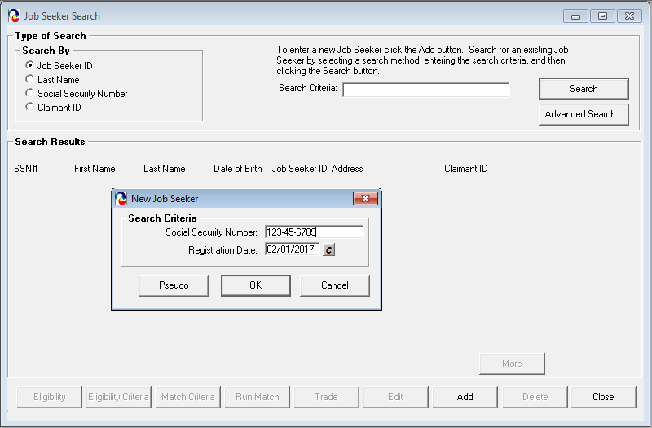

Enrollment into the statewide Mass Rehab program and MRTF Career Center Specific Program

- After a MOSES registration has been added and/or updated in MOSES, the participant must be determined eligible for the MRTF program. Open the Job Seeker Membership window and click the Eligibility button located at the bottom of the Job Seeker Membership window.

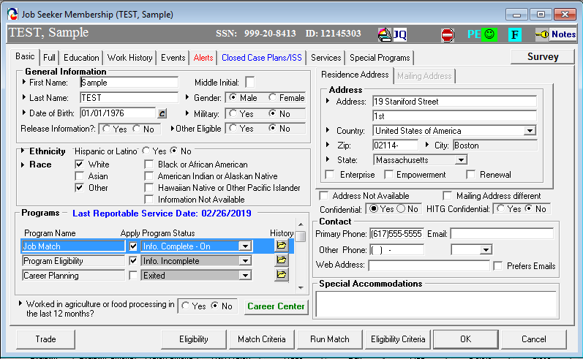

MOSES will display the Eligibility window:

- Click the Initial or Update Eligibility button. Select Mass Rehab Training Fund (MRTF) in the Potential Non-System Calculated Eligibility panel on the left, then click the >> button to move it to the Actual Non-System Calculated Eligibility panel on the right.

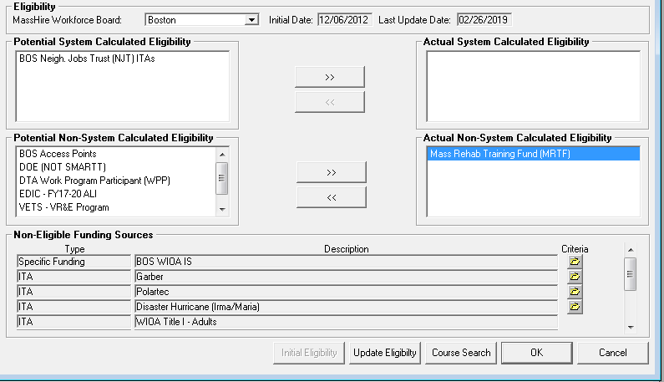

Mass Rehab and MRTF Program Enrollments

- To enroll the participant in the Mass Rehab and MRTF programs, go to Job Seeker Membership window, Basic tab. In the programs sections scroll down to the Mass Rehab program and check the apply box. Next you should click on the Career Center button to display the Career Center Specific Programs, check the apply box next to the MRTF program.
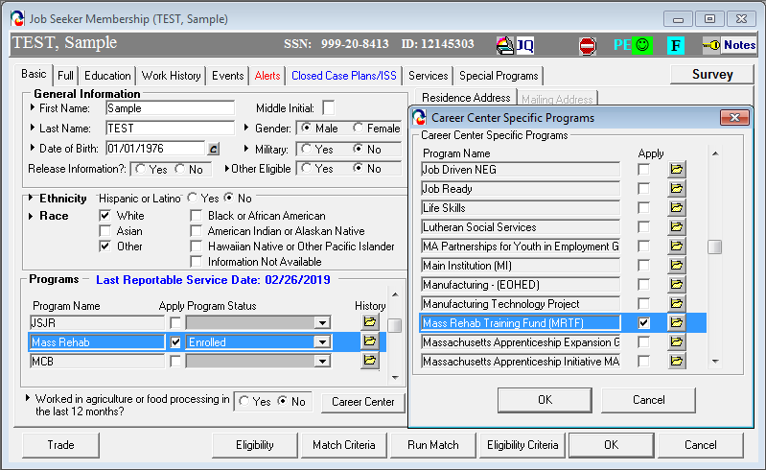

Program History Folder

- To verify the enrollment or to adjust the start date of enrollment, click on the yellow folder to display the Program History, click in the Start Date box to change the date to an earlier date if necessary.

Mass Rehab Program Exit Service

Auto Exit after 90 Days with No Reportable Service (Blue/Bold)
MRTF participants will be automatically exited from the statewide Mass Rehab and the Career Center Specific Program after 90 days of not receiving a reportable service. The exit date reflected will be the date of the last reportable service. Relevant reportable services should be entered timely to avoid inadvertent exit from the programs. The last reportable service date is shown on the basic tab and is updated each time a new reportable service is added.

