Attachment A
SWDI and SWDI-P Designation
Added a new Authorized SWDI Not Private/Private radio button to the basic tab of the training course.
Private will be selected if the course should not be shown on MJQ when searching (e.g. MassHire developed training including TOJs).
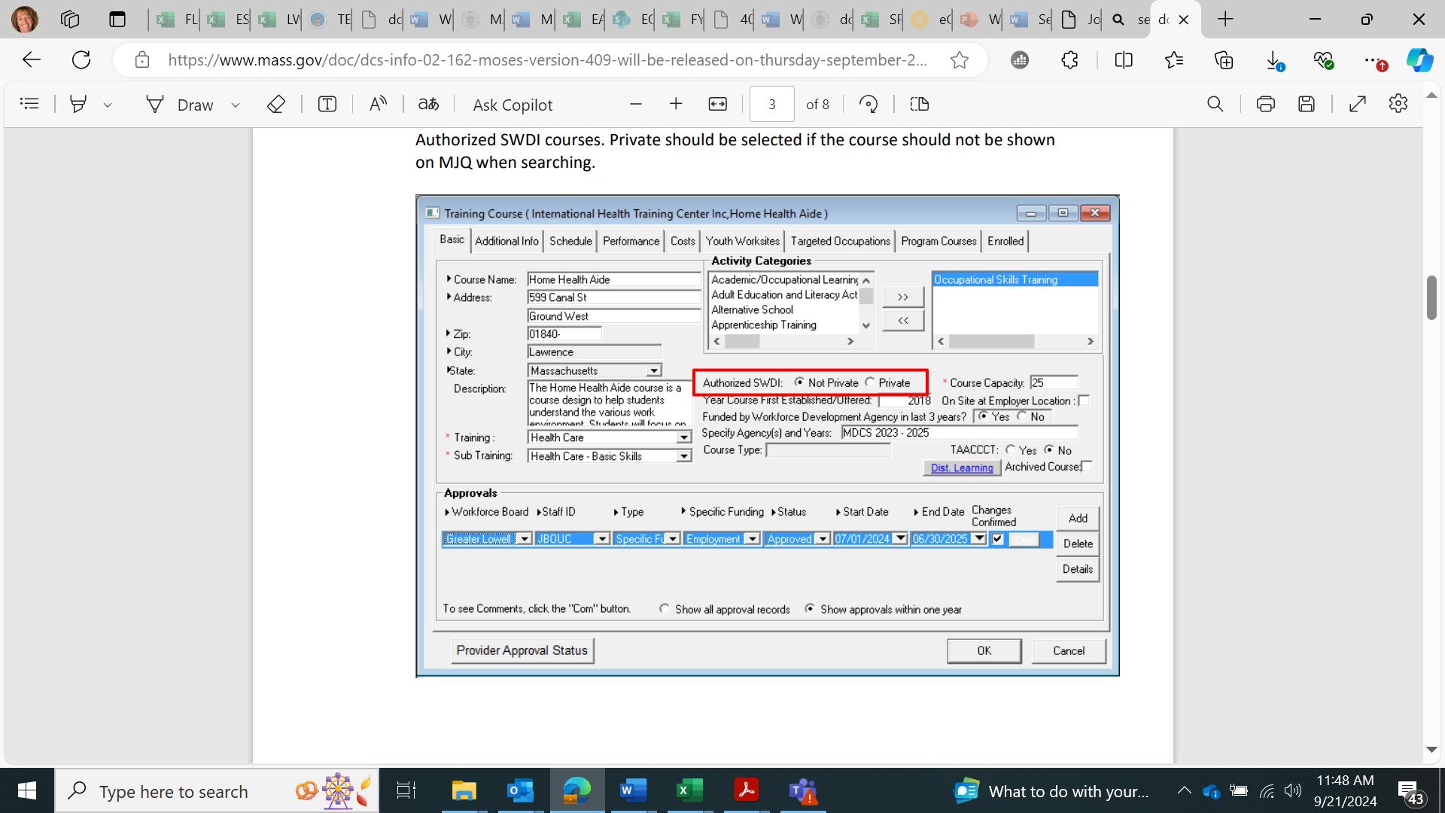

Not Private will be selected and marked by MDCS if the course will be searchable on MassHire JobQuest when searching for Authorized SWDI courses.
