INDOOR AIR QUALITY ASSESSMENT

Dean Luce Elementary School
45 Independence Street
Canton, Massachusetts

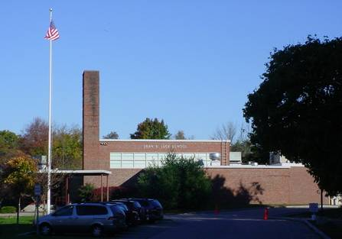

Prepared by:
Massachusetts Department of Public Health
Bureau of Environmental Health
Indoor Air Quality Program
February 2008

Background/Introduction
At the request of Mr. Dana Cotto, Facilities Director for the Canton School Department (CSD), the Massachusetts Department of Public Health (MDPH), Bureau of Environmental Health (BEH) provided assistance and consultation regarding indoor air quality concerns at Luce Elementary School (LES), 45 Independence Street, Canton, Massachusetts. The request was prompted by staff concerns of mold related to previous/current roof leaks. Staff were particularly concerned with reported vapors and dizziness experienced by an occupant in room 75 during hot, humid weather.
On Friday November 2, 2007, Cory Holmes, an Environmental Analyst in BEH’s Indoor Air Quality (IAQ) Program, visited the LES to conduct an IAQ assessment. Mr. Holmes returned to the LES on Monday November 5, 2007 following a weekend of heavy rain and winds (remnants of Hurricane Noel; Weather Underground, 2007) to finish the assessment and to examine the building for water damage and/or current leaks. The building was previously assessed by BEH staff in October 1999, while the building was under construction/renovation. A report detailing conditions observed at the time of the visit and recommendations for improving IAQ was issued (MDPH, 1999). The school originally consisted of a single-story building constructed in 1954; a second wing was added during the 1999 construction.

Methods
Air tests for carbon monoxide, carbon dioxide, temperature and relative humidity were conducted with the TSI, Q-Trak, IAQ Monitor, Model 8551. Air tests for airborne particle matter with a diameter less than 2.5 micrometers were taken with the TSI, DUSTTRAK™ Aerosol Monitor Model 8520. Screening for total volatile organic compounds (TVOCs) was conducted using a Thermo Environmental Instruments Inc., Model 580 Series Photo Ionization Detector (PID). BEH staff also performed visual inspection of building materials for water damage and/or microbial growth. Water content of porous building materials was measured with a Delmhorst, BD-2000 Model, Moisture Detector with a Delmhorst Standard Probe.

Results
The school houses a student population of approximately 390 and a staff of approximately 80. The tests were taken during normal operations at the school and results appear in Table 1.

Discussion
Ventilation
It can be seen from Tables 1 and 2 that carbon dioxide levels were below 800 parts per million (ppm) in all areas surveyed on November 2, 2007, and in 26 of 28 areas surveyed on November 5, 2007, indicating adequate air exchange in the majority of areas surveyed during both days of assessment. In both cases where carbon dioxide levels exceeded 800 ppm on November 5, 2007, mechanical supply ventilation was deactivated; therefore, no fresh air was being introduced at the time of the assessment.
Fresh air in classrooms is supplied by unit ventilator (univent) systems (Picture 1). A univent draws air from outdoors through a fresh air intake located on the exterior wall of the building (Picture 2) and returns air through an air intake located at the base of the unit (Figure 1). Fresh and return air are mixed, filtered, heated and provided to classrooms through an air diffuser located in the top of the unit. In a number of classrooms, items placed on and/or in front of univents and exhaust vents obstructed normal airflow (Picture 3).
Exhaust ventilation for classrooms in the 1999 addition is provided by ceiling vents ducted to rooftop motors (Pictures 4 and 5). The location of some exhaust vents (i.e. above hallway door) can limit exhaust efficiency (Picture 4). When a classroom door is open, exhaust vents tend to draw air from both the hallway and the classroom. The open hallway door reduces the effectiveness of the exhaust vent to remove common environmental pollutants from classrooms. Exhaust vents in the 1954 wing are located in floor level “cubbies” ducted to rooftop motors. Many of the exhaust cubbies were obstructed and/or being used for storage of items, limiting airflow (Pictures 6 and 7). Without exhaust ventilation, normally occurring environmental pollutants can build up, leading to indoor air complaints.
Mechanical ventilation in interior rooms and common areas (e.g., gym, auditorium) is provided by rooftop or ceiling-mounted air-handling units (AHUs). Fresh air is distributed via ceiling-mounted air diffusers (Picture 8) and ducted back to AHUs via ceiling or wall-mounted return vents (Picture 8).
To maximize air exchange, the MDPH recommends that both supply and exhaust ventilation operate continuously during periods of school occupancy. In order to have proper ventilation with a mechanical supply and exhaust system, the systems must be balanced to provide an adequate amount of fresh air to the interior of a room while removing stale air from the room. It is recommended that HVAC systems be re-balanced every five years to ensure adequate air systems function (SMACNA, 1994). The mechanical ventilation systems at LES were last balanced in 2004.
The Massachusetts Building Code requires a minimum ventilation rate of 15 cubic feet per minute (cfm) per occupant of fresh outside air or have openable windows in each room (SBBRS, 1997; BOCA, 1993). The ventilation must be on at all times that the room is occupied. Providing adequate fresh air ventilation with open windows and maintaining the temperature in the comfort range during the cold weather season is impractical. Mechanical ventilation is usually required to provide adequate fresh air ventilation.
Carbon dioxide is not a problem in and of itself. It is used as an indicator of the adequacy of the fresh air ventilation. As carbon dioxide levels rise, it indicates that the ventilating system is malfunctioning or the design occupancy of the room is being exceeded. When this happens, a buildup of common indoor air pollutants can occur, leading to discomfort or health complaints. The Occupational Safety and Health Administration (OSHA) standard for carbon dioxide is 5,000 parts per million parts of air (ppm). Workers may be exposed to this level for 40 hours/week, based on a time-weighted average (OSHA, 1997).
The MDPH uses a guideline of 800 ppm for publicly occupied buildings. A guideline of 600 ppm or less is preferred in schools due to the fact that the majority of occupants are young and considered to be a more sensitive population in the evaluation of environmental health status. Inadequate ventilation and/or elevated temperatures are major causes of complaints such as respiratory, eye, nose and throat irritation, lethargy and headaches. For more information concerning carbon dioxide, consult Appendix A.
On November 2, 2007, temperature measurements ranged from 64º F to 76º F (Table 1), and on November 5, 2007, from 69º F to 77º F (Table 2). The readings were below the MDPH recommended comfort range in a few of the areas surveyed on both days of assessments. The MDPH recommends that indoor air temperatures be maintained in a range of 70º F to 78º F in order to provide for the comfort of building occupants. In many cases concerning indoor air quality, fluctuations of temperature in occupied spaces are typically experienced, even in a building with an adequate fresh air supply. With univents and exhaust vents obstructed, airflow is limited; therefore, it is difficult to maintain temperature/comfort.
The relative humidity ranged from 22 to 35 percent on November 2, 2007 (Table 1) and from 23 to 35 percent on November 5, 2007 (Table 2). These measurements were below the MDPH recommended comfort range. The MDPH recommends a comfort range of 40 to 60 percent for indoor air relative humidity. Relative humidity levels in the building would be expected to drop during the winter months due to heating. The sensation of dryness and irritation is common in a low relative humidity environment. Low relative humidity is a very common problem during the heating season in the northeast part of the United States.

Microbial/Moisture Concerns
As previously mentioned, BEH staff returned to the LES on Monday November 5th following a weekend of heavy rain and winds (remnants of Hurricane Noel; Weather Underground, 2007) to finish the assessment and to examine the building for water damage, mold growth and/or current leaks. As reported by occupants, the three primary areas of concern were the main corridor above ceiling tiles near former skylights; above the ceiling in the library hallway and along the ceiling in room 75.
- The leaks in the main hallway were most likely due to water penetration around skylights, which were sealed over by the roof membrane during the construction renovation project. No current water damage or mold growth was observed above the ceiling in this area.
- The water damage experienced previously in the library hallway was due to water penetration around a ducted vent on the exterior wall of the building. To mitigate water penetration into the building, Canton School Department (CSD) maintenance staff installed a rain/wind shield around the vent (Picture 9). No current water damage or mold growth was observed above the ceiling in this area.
- In classroom 75, evidence of water penetration was found in the form of stained GW along the ceiling and above the ceiling tiles (Picture 10). On November 2, 2007, the GW above the ceiling tile system was found to have low (i.e., normal) moisture content. It was reported by school maintenance staff that leaks were experienced in this area from water penetration along a joint where the lower roof of the 1999 wing meets the gymnasium exterior wall (Picture 11). This area was reportedly resealed to prevent further water damage. On November 5, 2007, the GW had an elevated moisture content indicating that despite efforts to eliminate leaks, water continues to penetrate into this area. BEH staff recommended to Mr. Cotto that the moistened GW be removed to prevent mold growth and that CSD work with their roofing contractor to determine potential pathways for water penetration. During a November 28, 2007 conversation, Mr. Cotto reported this GW was removed.
The US Environmental Protection Agency (US EPA) and the American Conference of Governmental Industrial Hygienists (ACGIH) recommend that porous materials be dried with fans and heating within 24 to 48 hours of becoming wet (US EPA, 2001; ACGIH, 1989). If not dried within this time frame, mold growth may occur. Once mold has colonized porous materials, they are difficult to clean and should be removed/discarded.
CSD staff reported that the building experiences problems with condensation during periods of elevated relative humidity (>70%). Introduction of uncontrolled hot, moist air via univents and/or windows likely generates condensation on chilled non-porous surfaces (e.g., floor tiles, windows). In order to decrease humidity in classrooms, floor model portable dehumidifiers are utilized (Picture 12). Dehumidifiers should be cleaned/maintained as per the manufacturer’s instructions to prevent mold/bacterial growth and associated odors.
Several classrooms had a number of plants. Moistened plant soil and drip pans can be a source of mold growth. Plants should be equipped with drip pans; the lack of drip pans can lead to water pooling and mold growth on windowsills. Plants are also a source of pollen. Plants should be located away from the air stream of ventilation sources to prevent the aerosolization of mold, pollen or particulate matter throughout the classroom (Picture 1).
Water damaged wall plaster and peeling paint was observed below the windows near the exterior door in classroom 12 (Picture 13). It was reported that this damage was a result of previous water infiltration prior to windows being replaced during the 1999 renovation. At the time of the assessment no current water penetration was observed nor were elevated moisture reading measured.

Other IAQ Evaluations
Indoor air quality can be negatively influenced by the presence of respiratory irritants, such as products of combustion. The process of combustion produces a number of pollutants. Common combustion emissions include carbon monoxide, carbon dioxide, water vapor and smoke (fine airborne particle material). Of these materials, exposure to carbon monoxide and particulate matter with a diameter of 2.5 micrometers (μm) or less (PM2.5) can produce immediate and acute health effects upon exposure. To determine whether combustion products were present in the school environment, BEH staff obtained measurements for carbon monoxide and PM2.5.
Carbon monoxide is a by-product of incomplete combustion of organic matter (e.g., gasoline, wood and tobacco). Exposure to carbon monoxide can produce immediate and acute health affects. Several air quality standards have been established to address carbon monoxide and prevent symptoms from exposure to these substances. The MDPH established a corrective action level concerning carbon monoxide in ice skating rinks that use fossil-fueled ice resurfacing equipment. If an operator of an indoor ice rink measures a carbon monoxide level over 30 ppm, taken 20 minutes after resurfacing within a rink, that operator must take actions to reduce carbon monoxide levels (MDPH, 1997).
The American Society of Heating Refrigeration and Air-Conditioning Engineers (ASHRAE) has adopted the National Ambient Air Quality Standards (NAAQS) as one set of criteria for assessing indoor air quality and monitoring of fresh air introduced by HVAC systems (ASHRAE, 1989). The NAAQS are standards established by the US EPA to protect the public health from six criteria pollutants, including carbon monoxide and particulate matter (US EPA, 2006). As recommended by ASHRAE, pollutant levels of fresh air introduced to a building should not exceed the NAAQS levels (ASHRAE, 1989). The NAAQS were adopted by reference in the Building Officials & Code Administrators (BOCA) National Mechanical Code of 1993 (BOCA, 1993), which is now an HVAC standard included in the Massachusetts State Building Code (SBBRS, 1997). According to the NAAQS, carbon monoxide levels in outdoor air should not exceed 9 ppm in an eight-hour average (US EPA, 2006).
Carbon monoxide should not be present in a typical, indoor environment. If it is present, indoor carbon monoxide levels should be less than or equal to outdoor levels. On both November 2 and 5, 2007, outdoor carbon monoxide concentrations were non-detect (ND) (Tables 1 and 2). Carbon monoxide levels measured in the school were ND on both days of the assessment (Tables 1 and 2).
The US EPA has established NAAQS limits for exposure to particulate matter. Particulate matter is airborne solids that can be irritating to the eyes, nose and throat. The NAAQS originally established exposure limits to particulate matter with a diameter of 10 μm or less (PM10). According to the NAAQS, PM10 levels should not exceed 150 microgram per cubic meter (μg/m³) in a 24-hour average (US EPA, 2006). These standards were adopted by both ASHRAE and BOCA. Since the issuance of the ASHRAE standard and BOCA Code, US EPA established a more protective standard for fine airborne particles. This more stringent PM2.5 standard requires outdoor air particle levels be maintained below 35 μg/m³ over a 24-hour average (US EPA, 2006). Although both the ASHRAE standard and BOCA Code adopted the PM10 standard for evaluating air quality, MDPH uses the more protective PM2.5 standard for evaluating airborne particulate matter concentrations in the indoor environment.
On November 2, 2007, outdoor PM2.5 concentrations were measured at 4 μg/m³ and indoor PM2.5 levels were measured between 2 to 11 μg/m³ (Table 1). On November 5, 2007, outdoor PM2.5 concentrations were measured at 11 μg/m³ and indoor PM2.5 levels were measured between 8 to 16 μg/m³ (Table 2). On both days of assessment, the indoor PM2.5 levels were below the NAAQS PM2.5 level of 35 μg/m³. Frequently, indoor air levels of particulates (including PM2.5) can be at higher levels than those measured outdoors. A number of mechanical devices and/or activities that occur in schools can generate particulates during normal operations. Sources of indoor airborne particulates may include but are not limited to particles generated during the operation of fan belts in the HVAC system, cooking in the cafeteria stoves and microwave ovens; use of photocopiers, fax machines and computer printing devices; operation of an ordinary vacuum cleaner and heavy foot traffic indoors. Although no measurable levels of carbon monoxide or elevated PM2.5 were detected, the potential for combustion products to migrate into the hallway from the boiler room was observed via a space under the boiler room door (Picture 14).
Indoor air quality can also be negatively influenced by the presence of materials containing volatile organic compounds (VOCs). VOCs are carbon-containing substances that have the ability to evaporate at room temperature. Frequently, exposure to low levels of total VOCs (TVOCs) may produce eye, nose, throat and/or respiratory irritation in some sensitive individuals. For example, chemicals evaporating from a paint can stored at room temperature would most likely contain VOCs. In an effort to determine whether VOCs were present in the building, air monitoring for TVOCs was conducted. An outdoor air sample was taken for comparison. On both November 2 and 5, 2007, outdoor TVOC concentrations were ND (Tables 1 & 2). Similarly, on assessment days indoor TVOC concentrations were ND (Tables 1 & 2).
Please note, TVOC air measurements are only reflective of the indoor air concentrations present at the time of sampling. Indoor air concentrations can be greatly impacted by the use of TVOC containing products. In an effort to identify materials that can potentially increase indoor TVOC concentrations, BEH staff examined classrooms for products containing these respiratory irritants. Several classrooms contained dry erase boards and dry erase board markers. Materials such as dry erase markers and dry erase board cleaners may contain VOCs, such as methyl isobutyl ketone, n-butyl acetate and butyl-cellusolve (Sanford, 1999), which can be irritating to the eyes, nose and throat. Cleaning products were also found on countertops and in unlocked cabinets beneath sinks in some classrooms (Picture 15). Like dry erase materials, cleaning products contain VOCs and other chemicals that can be irritating to the eyes, nose and throat of sensitive individuals.
In a few classrooms, items were observed on windowsills, tabletops, counters, bookcases and desks (Pictures 3 and 16). The large number of items stored in classrooms provides a source for dusts to accumulate. These items (e.g., papers, folders, boxes) make it difficult for custodial staff to clean. Items should be relocated and/or be cleaned periodically to avoid excessive dust build up. In addition, these materials can accumulate on flat surfaces (e.g., desktops, shelving and carpets) in occupied areas and subsequently be re-aerosolized causing further irritation.
A number of univent air diffusers, supply vents, personal fans and exhaust/return vents were observed to have accumulated dust (Pictures 17 through 19). If exhaust vents are not functioning, backdrafting can occur, which can re-aerosolize accumulated dust particles. Re-activated univents and fans can also aerosolize dust accumulated on vents/fan blades. A hole was also observed in a ceiling tile in room 19, which can serve as a pathway for dirt, dust and debris that accumulates in the ceiling plenum into the classroom (Picture 20).
The occupant in classroom 82 had concerns of dirt/debris build-up on/around the univent. BEH staff examined the unit and its relationship to the exterior of the building. This classroom is located at the terminus of an alcove where two wings intersect outside the building (Picture 21). Loose dirt and plant debris was also observed below and accumulated on the univent fresh air intake outside the building (Pictures 22 and 23). BEH staff opened the univent cabinet to examine the interior and found similar accumulations of dirt and debris inside as to that outside (Picture 24). It is likely that dirt dust/debris accumulates in this area due to the configuration of the outside of the building, an alcove that can trap air currents and stir up loose dirt/debris, which can than be drawn into the classroom via the univent.
A number of classrooms had window-mounted air conditioners (ACs) or wall-mounted units (Picture 25). ACs are normally equipped with filters, which should be cleaned or changed as per manufacturer’s instructions to avoid the build-up and re-aerosolization of dirt, dust and particulate matter.
Finally, occupants reported concern regarding the condition of carpeting in classroom 75. According to an occupant, the carpet had become soiled from bodily fluids (i.e., excrement). Although the carpet was reportedly cleaned at the time of the assessment the carpet was visibly soiled/stained (Picture 26). The Institute of Inspection, Cleaning and Restoration Certification (IICRC), who provide guidance concerning professional restoration of water damaged materials, any porous materials damaged by category 3 water (also known as “black” water) should be removed. Category 3 water is defined as grossly unsanitary water containing pathogenic agents arising from sewage or similar contaminated water sources (IICRC, 1999).

Conclusions/Recommendations
In view of the findings at the time of the visit, the following recommendations are made:
- Operate both supply and exhaust ventilation continuously during periods of school occupancy, independent of classroom thermostat control to maximize air exchange.
- Remove all blockages from univents and exhaust cubbies to ensure adequate airflow.
- Close classroom doors to maximize air exchange.
- Consider adopting a balancing schedule of every 5 years for all mechanical ventilation systems, as recommended by ventilation industrial standards (SMACNA, 1994).
- For buildings in New England, periods of low relative humidity during the winter are often unavoidable. Therefore, scrupulous cleaning practices should be adopted to minimize common indoor air contaminants whose irritant effects can be enhanced when the relative humidity is low. To control for dusts, a high efficiency particulate arrestance (HEPA) filter equipped vacuum cleaner in conjunction with wet wiping of all surfaces is recommended. Avoid the use of feather dusters. Drinking water during the day can help ease some symptoms associated with a dry environment (throat and sinus irritations).
- Continue working with building maintenance staff and roofing contractor to investigate/monitor leak causing damage in room 75 (e.g., roof/gym wall junction), make repairs as needed.
- Ensure windows are closed during hot, humid weather to maintain indoor temperatures and avoid condensation problems.
- Utilize ACs and/or dehumidifiers to reduce relative humidity during periods of excessive relative humidity (e.g., over 70% for extended periods of time).
- Ensure dehumidifiers are cleaned/maintained as per the manufacturer’s instructions to prevent mold/bacterial growth.
- Consider stationing dehumidifiers on countertops so they drain directly into sinks to prevent overflow and reduce maintenance.
- Move plants away from univents in classrooms. Avoid over-watering and examine drip pans periodically for mold growth. Disinfect with an appropriate antimicrobial where necessary.
- Make repairs to water damaged wall plaster near exterior door in classroom 12.
- Relocate or consider reducing the amount of materials stored in classrooms to allow for more thorough cleaning of classrooms. Clean items regularly with a wet cloth or sponge to prevent excessive dust build-up.
- Clean personal fans, univent air diffusers, return vents and exhaust vents periodically of accumulated dust. Particular attention should be paid in classroom 82.
- Replace damaged ceiling tile in classroom 19.
- Clean/change filters for ACs as per the manufacture’s instructions or more frequently if needed.
- Install weather stripping underneath boiler room/hallway door to prevent the migration of odors and particulates.
- Store cleaning products properly and out of reach of students.
- Replace soiled portion of carpeting in classroom 75 in accordance with recommendations by the Institute of Inspection, Cleaning and Restoration Certification (IICRC, 1999).
- Clean carpeting annually (or semi-annually in soiled high traffic areas) as per recommendations of the IICRC. Copies of the IICRC fact sheet can be downloaded at: http://www.cleancareseminars.com/carpet_cleaning_faq4.htm (IICRC, 2005)
- If complaints/symptoms return/persist in classroom 75 during the hot humid weather, please contact the BEH IAQ Program for additional assistance at (617) 624-5757.
- For more advice on mold please consult the document “Mold Remediation in Schools and Commercial Buildings” published by the US Environmental Protection Agency (US EPA, 2001). Copies of this document can be downloaded from the US EPA website at: http://www.epa.gov/iaq/molds/mold_remediation.html.
- Consider adopting the US EPA (2000) document, “Tools for Schools”, as an instrument for maintaining a good indoor air quality environment in the building. This document is available at: http://www.epa.gov/iaq/schools/index.html.
- Refer to resource manual and other related indoor air quality documents located on the MDPH’s website for further building-wide evaluations and advice on maintaining public buildings. These documents are available at: http://www.state.ma.us/dph/MDPH/iaq/iaqhome.htm.

References
ACGIH. 1989. Guidelines for the Assessment of Bioaerosols in the Indoor Environment. American Conference of Governmental Industrial Hygienists, Cincinnati, OH.
ASHRAE. 1989. Ventilation for Acceptable Indoor Air Quality. American Society of Heating, Refrigeration and Air Conditioning Engineers. ANSI/ASHRAE 62-1989
BOCA. 1993. The BOCA National Mechanical Code/1993. 8th ed. Building Officials & Code Administrators International, Inc., Country Club Hills, IL.
IICRC. 1999. IICRC S500. Standard and Reference Guide for Professional Water Damage Restoration, 2nd Edition,. Institute of Inspection Cleaning and Restoration, Vancouver, WA.
IICRC. 2005. Carpet Cleaning FAQ 4 Institute of Inspection, Cleaning and Restoration Certification. Institute of Inspection Cleaning and Restoration, Vancouver, WA.
MDPH. 1997. Requirements to Maintain Air Quality in Indoor Skating Rinks (State Sanitary Code, Chapter XI). 105 CMR 675.000. Massachusetts Department of Public Health, Boston, MA.
MDPH. 1999. Indoor Air Quality Assessment, Dean Luce Elementary School, Canton, MA. Massachusetts Department of Public Health, Bureau of Environmental Health Assessment, Boston, MA. November 1999.
OSHA. 1997. Limits for Air Contaminants. Occupational Safety and Health Administration. Code of Federal Regulations. 29 C.F.R 1910.1000 Table Z-1-A.
Sanford. 1999. Material Safety Data Sheet (MSDS No: 198-17). Expo® Dry Erase Markers Bullet, Chisel, and Ultra Fine Tip. Sanford Corporation. Bellwood, IL.
SBBRS. 1997. Mechanical Ventilation. State Board of Building Regulations and Standards. Code of Massachusetts Regulations. 780 CMR 1209.0
SMACNA. 1994. HVAC Systems Commissioning Manual. 1st ed. Sheet Metal and Air Conditioning Contractors’ National Association, Inc., Chantilly, VA.
US EPA. 2000. Tools for Schools. Office of Air and Radiation, Office of Radiation and Indoor Air, Indoor Environments Division (6609J). EPA 402-K-95-001, Second Edition. http://www.epa.gov/iaq/schools/tools4s2.html
US EPA. 2001. “Mold Remediation in Schools and Commercial Buildings”. Office of Air and Radiation, Indoor Environments Division, Washington, DC. EPA 402-K-01-001. March 2001. Available at: http://www.epa.gov/iaq/molds/mold_remediation.html
US EPA. 2006. National Ambient Air Quality Standards (NAAQS). US Environmental Protection Agency, Office of Air Quality Planning and Standards, Washington, DC. http://www.epa.gov/air/criteria.html.
Weather Underground, The. 2007. Weather History for Canton, Massachusetts, November 3, 2007. Available at: http://www.wunderground.com/history/airport/KOWD/2007/11/5/DailyHistory.html?req_city=NA&req_state=NA&req_statename=NA
Picture 1

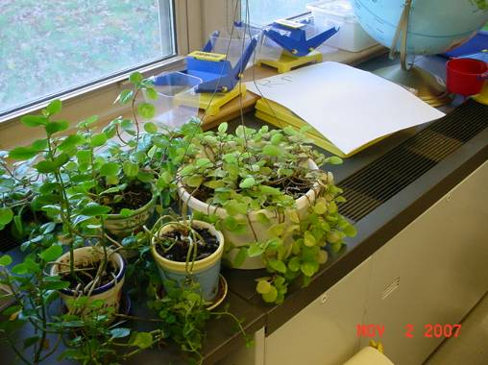

Classroom Univent, Note Plants Near Air Diffuser

Picture 2

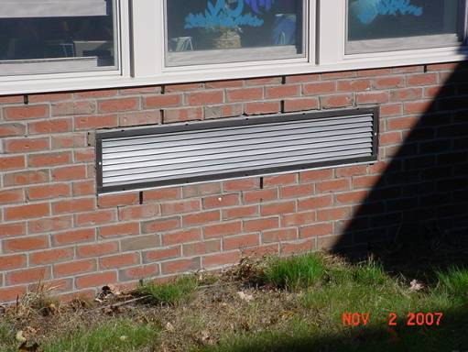

Univent Fresh Air Intake Vent
Picture 3



Accumulated Classroom Items Obstructing Univent Return Vent (Bottom Front of Unit)

Picture 4

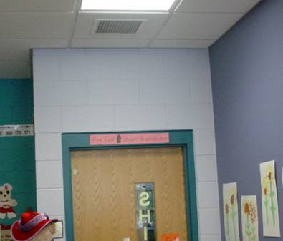

1999 Addition Classroom Exhaust Vent, Note Proximity to Hallway Door
Picture 5

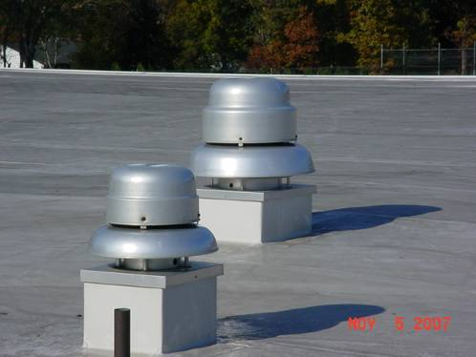

Rooftop Exhaust Motors

Picture 6

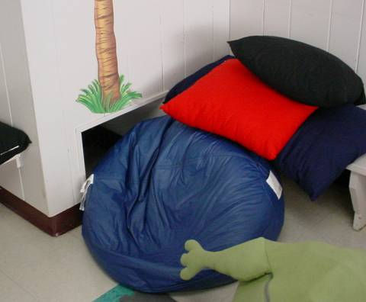

Obstructed Exhaust “Cubby” in 1954 Wing
Picture 7

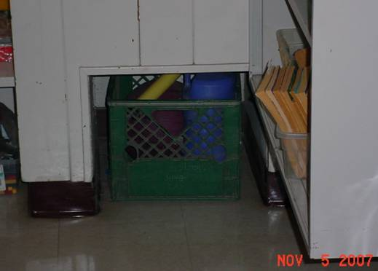

Exhaust “Cubby” in 1954 Wing Used for Storage

Picture 8

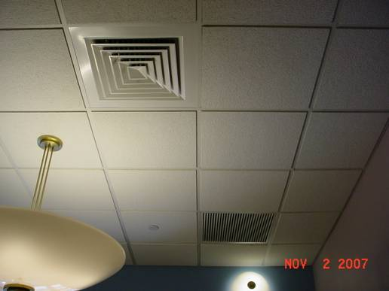

Supply Air Diffuser and Return Vent
Picture 9

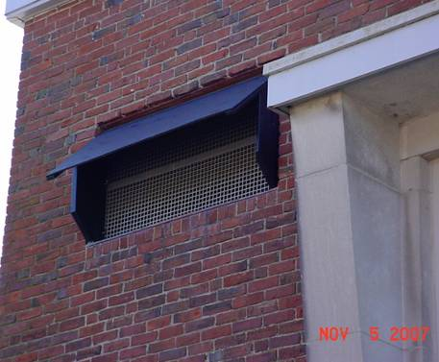

Rain/Wind Shield Installed over Vent Outside of Library Hallway

Picture 10

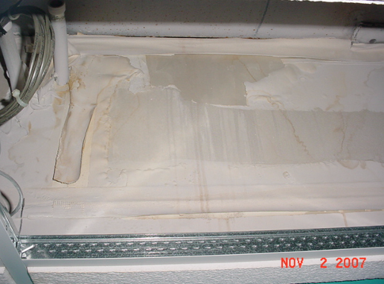

Water Damaged GW above Ceiling in Room 75
Picture 11

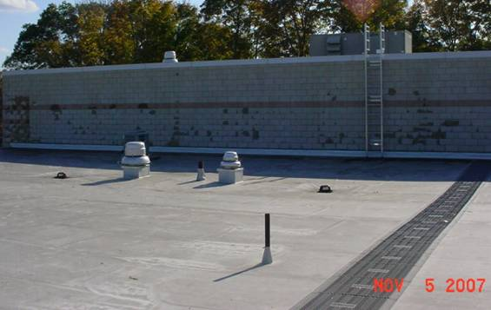

Junction/Seam along 1999 Wing Roof and Gymnasium Wall

Picture 12

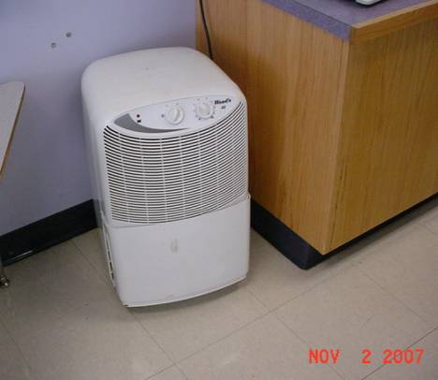

Floor Model Dehumidifier in Classroom
Picture 13

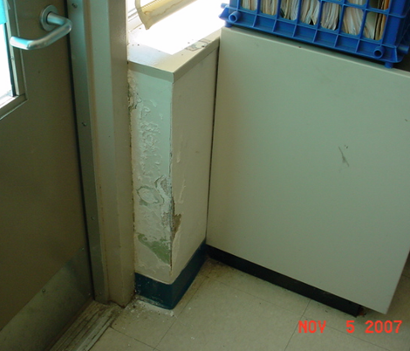

Water Damaged Wall Plaster and Peeling Paint in Classroom 12

Picture 14

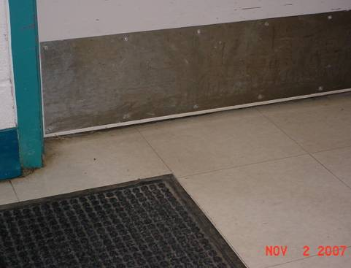

Space below Boiler Room/Hallway Door
Picture 15

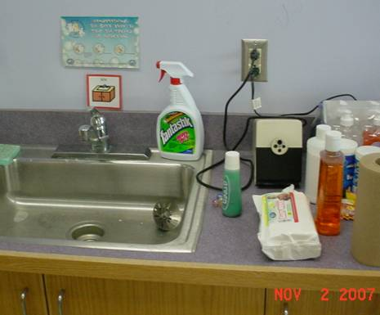

Spray Cleaning Products on Countertop in Classroom

Picture 16



Accumulated Items on Flat Surfaces in Classroom
Picture 17

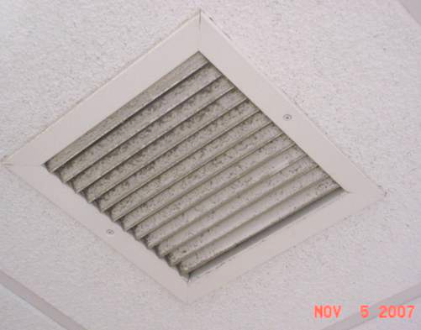

Accumulated Dust/Debris on Return/Exhaust Vent

Picture 18

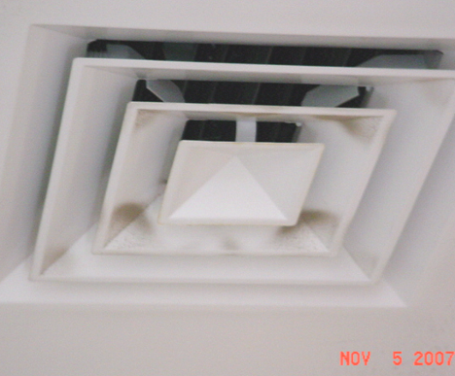
Accumulated Dust/Debris on Supply Diffuser
Picture 19

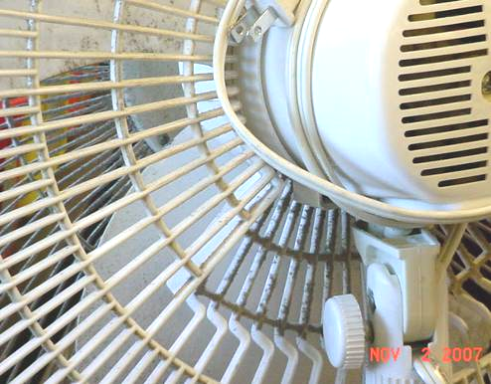

Accumulated Dust/Debris on Personal Fan

Picture 20

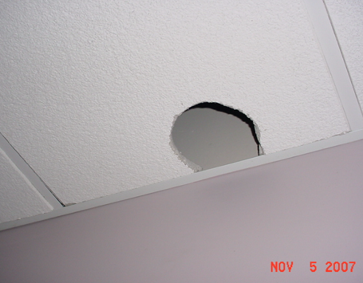

Hole in Ceiling Tile in Room 19
Picture 21

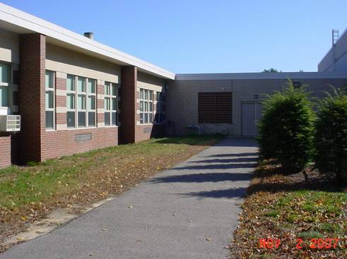

Alcove Where Classroom 82 is Located

Picture 22

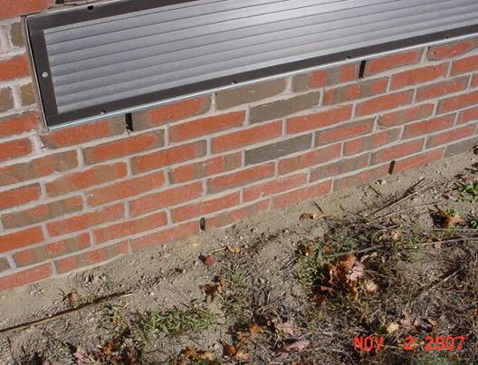

Loose Dirt and Plant Debris beneath Univent Fresh Air Intake of Classroom 82
Picture 23

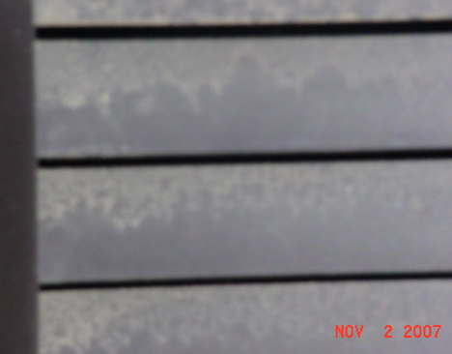

Accumulated Dirt/Debris on Exterior Surface of Univent Fresh Air Intake of Classroom 82

Picture 24

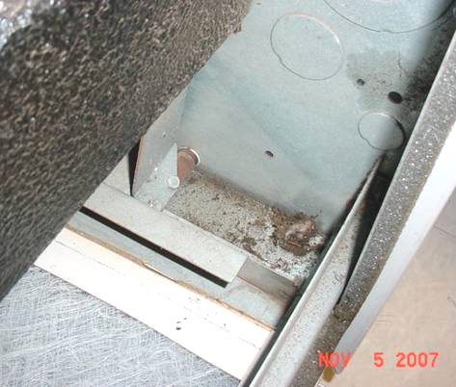

Accumulated Dirt/Debris inside Cabinet of Univent in Classroom 82
Picture 25

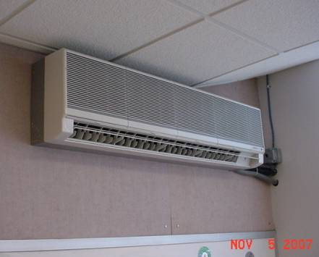

Wall-Mounted AC Unit

Picture 26

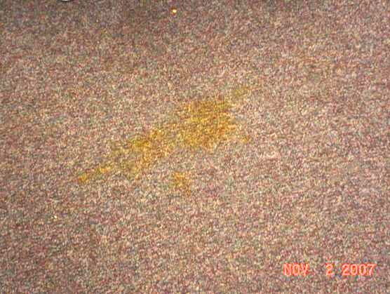

Soiled Carpeting in Classroom 75
Location/ Room | Occupants  in Room | Temp  (°F) | Relative  Humidity  (%) | Carbon  Dioxide  (ppm) | Carbon Monoxide  (ppm) | TVOCs  (ppm) | PM2.5  (µg/m3) | Windows  Openable | Ventilation |  | Remarks
 |  |  |  |  |  |  |  |  | Supply | Exhaust | Remarks
background |  | 60 | 26 | 348 | ND | ND | 4 |  |  |  | Clear, cool, sunny
Gym | 25 | 68 | 33 | 681 | ND | ND | 11 | N | Y | Y
Boiler Room | 0 | 68 | 33 | 681 | ND | ND | 7 | N | Y | Y | Space under hallway door
75 | 20 | 71 | 29 | 678 | ND | ND | 6 | Y | Y | Y | WD GW above CT-roof leak-low moisture, light mold growth
74 | 19 | 73 | 26 | 622 | ND | ND | 2 | Y | Y | Y
82 | 17 | 76 | 27 | 730 | ND | ND | 9 | Y | Y | Y | Dehumidifier on floor Particulate build-up on/in UV
89 | 6 | 69 | 30 | 461 | ND | ND | 5 | Y | Y | Y
88 | 22 | 65 | 28 | 530 | ND | ND | 7 | Y | Y | Y
87 | 24 | 64 | 32 | 603 | ND | ND | 9 | Y | Y | Y | Items near UV, plants on UV
84 | 20 | 70 | 34 | 541 | ND | ND | 6 | Y | Y | Y | Furniture near UV, 2 ACs
83 | 19 | 71 | 31 | 532 | ND | ND | 5 | Y | Y | Y | Dehumidifier, plants
94 | 3 | 71 | 29 | 431 | ND | ND | 5 | Y | Y | Y | PF
95 | 20 | 68 | 29 | 600 | ND | ND | 6 | Y | Y | Y | PF
97 | 0 | 71 | 28 | 467 | ND | ND | 6 | Y | Y | Y | Accumulated items, UV-return obstructed, occupants @ lunch,
96 | 0 | 70 | 28 | 450 | ND | ND | 5 | Y | Y | Y | occupants @ lunch, dehumidifier-full, 25 occupants gone 20 mins
100 | 0 | 70 | 22 | 432 | ND | ND | 4 | Y | Y | Y | 15 occupants gone 2 mins
101 | 0 | 69 | 27 | 404 | ND | ND | 5 | Y | Y | Y | Occupants @ lunch, accumulated items
102 | 2 | 72 | 30 | 660 | ND | ND | 6 | Y | Y | Y | PF, 28 occupants gone 15 mins, dehumidifier
Library | 25 | 70 | 35 | 641 | ND | ND | 2 | Y | Y | Y | Dusty vents
58 | 7 | 70 | 35 | 611 | ND | ND | 3 | Y | Y | Y
56 | 0 | 71 | 34 | 579 | ND | ND | 4 | Y | Y | Y | AP, dusty vents
Library Hallway |  |  |  |  |  |  |  |  |  |  | Site of previous leaks-Exterior vent, no current WD or visible mold growth above CTs
Main Hallway |  |  |  |  |  |  |  |  |  |  | Site of previous leaks-skylights, no current WD or visible mold growth above CTs
108 | 0 | 72 | 31 | 439 | ND | ND | 4 | N | Y | Y (2)

Location/ Room | Occupants  in Room | Temp  (°F) | Relative  Humidity  (%) | Carbon  Dioxide  (ppm) | Carbon Monoxide  (ppm) | TVOCs  (ppm) | PM2.5  (µg/m3) | Windows  Openable | Ventilation |  | Remarks
 |  |  |  |  |  |  |  |  | Supply | Exhaust | Remarks
background |  | 61 | 30 | 344 | ND | ND | 11 |  |  |  | Clear, cool, sunny
Library hallway |  |  |  |  |  |  |  |  |  |  | Site of former WD, no current WD or visible mold growth above CT
75 | 21 | 69 | 35 | 614 | ND | ND | 12 | Y | Y | Y | WD GW-Elevated moisture above CT
19 | 1 | 72 | 31 | 430 | ND | ND | 9 | N | Y | Y
22 | 9 | 72 | 33 | 842 | ND | ND | 15 | Y | Y | Y | UV-off, items in exhaust cubby, CP
17 | 9 | 76 | 30 | 587 | ND | ND | 11 | Y | Y | Y | Items on UV, exhaust partially blocked, DO
23 | 22 | 75 | 30 | 752 | ND | ND | 12 | Y | Y | Y | Items in exhaust cubby
16 | 22 | 76 | 29 | 720 | ND | ND | 15 | Y | Y | Y
24 | 27 | 72 | 25 | 694 | ND | ND | 11 | Y | Y | Y
19 | 0 | 73 | 26 | 494 | ND | ND | 10 | N | Y | Y | Hole in CT, dust build-up on CTs near supply vent, 2 occupants gone 5 mins
15 | 22 | 75 | 26 | 566 | ND | ND | 12 | Y | Y | Y | UV-obstructed
25 | 30 | 75 | 27 | 768 | ND | ND | 12 | Y | Y | Y | DO, exhaust-obstructed
14 | 27 | 76 | 25 | 618 | ND | ND | 12 | Y | Y | Y | DO
26 | 1 | 72 | 24 | 550 | ND | ND | 11 | Y | Y | Y | 30 occupants gone 20 mins, PF, DO
13 | 0 | 73 | 23 | 431 | ND | ND | 9 | Y | Y | Y | Occupants @ lunch, furniture around UV
27 | 1 | 75 | 23 | 511 | ND | ND | 11 | Y | Y | Y
12 | 1 | 74 | 23 | 438 | ND | ND | 10 | Y | Y | Y | 30 occupants gone 20 mins, UV-off/obstructed, WD wall plaster near ext door-previous window leak-low moisture
Nurse | 3 | 72 | 27 | 499 | ND | ND | 13 | Y | Y | Y | Dusty vents
34 Computer Room | 0 | 72 | 24 | 406 | ND | ND | 10 | Y | Y | Y | Wall :AC, PF
Cafeteria | 155 | 73 | 27 | 622 | ND | ND | 12 | N | Y | Y | 2 AHU-loft
Main Office | 2 | 73 | 29 | 615 | ND | ND | 8 | Y | Y | Y | Window open
Office Annex | 1 | 73 | 29 | 558 | ND | ND | 9 | Y | Y | Y | Dusty vents
Principals Office | 0 | 73 | 29 | 549 | ND | ND |  | Y | Y | Y
48 | 20 | 75 | 27 | 502 | ND | ND | 16 | Y | Y | Y
Music | 1 | 77 | 24 | 393 | ND | ND | 11 | Y | Y | Y
49 | 24 | 75 | 26 | 648 | ND | ND | 11 | Y | Y | Y | Dehumidifier, DO
44 | 7 | 74 | 23 | 478 | ND | ND | 10 | Y | Y | Y | Exhaust-obstructed, DO
50 | 27 | 74 | 30 | 836 | ND | ND | 15 | Y | Y | Y | UV-off, DO, exhaust-obstructed
43 | 0 | 72 | 26 | 455 | ND | ND | 11 | Y | Y | Y | UV-off
48 | 3 | 76 | 26 | 486 | ND | ND | 12 | Y | Y | Y | Drafts near AC-rags
82 |  |  |  |  |  |  |  |  |  |  | Dirt/debris interior of UV, loose dirt/debris outside/on/near univent fresh air intake vent

