INDOOR AIR QUALITY ASSESSMENT

John William Decas Elementary School
760 Main Street
Wareham, Massachusetts

Prepared by:
Massachusetts Department of Public Health
Bureau of Environmental Health
Indoor Air Quality Program
December 2016

Background
Building: | John William Decas Elementary School (DES)
Address: | 760 Main Street, Wareham, MA
Requested by: | Parent request; coordinated through Wareham Board of Health Director, Robert Ethier and Wareham Public Schools Business Manager, Mike MacMillan
Reason for Request: | Mold concerns and construction/roof replacement concerns.
Date of Assessment: | November 29, 2016
Massachusetts Department of Public Health/Bureau of Environmental Health (MDPH/BEH) Staff Conducting Assessment: | Cory Holmes, Environmental Analyst, Indoor Air Quality (IAQ) Program
Building Description: | Single-story school building that was constructed in 1969. An addition was built in 1974 and a modular classroom wing was added in 1994.
Building Population: | Approximately 611 students and 90 staff.
Windows: | Not openable

Background and Discussion
No significant renovations have reportedly been done to the school over the years. Currently, the school is involved with two capital improvement projects; boiler replacement and a new roof over the 1974 wing (Picture 1), which will include an asbestos removal project (ceiling tiles). Both projects are much needed, particularly the new roof project as indicated by the condition of the roof surface (Picture 2) and evidenced during the assessment by multiple buckets/containers used to catch leaks (Picture 3).
In any major construction/renovation project, there are guidelines that should be followed to reduce the exposure risk of construction-related pollutants to occupants of the building. Two of the suggested guidelines are: "IAQ Guidelines for Occupied Buildings Under Construction" published by the Sheet Metal and Air Conditioning Contractors National Association, Inc. (SMACNA, 2007) and “Methods Used to Reduce/Prevent Exposure to Construction/Renovation Generated Pollutants in Occupied Buildings” (MDPH, 2006). The MDPH guidelines are derived from the SMACNA document and were provided on-site during the visit and are included as Appendix A to this report.
Due to the configuration of the 1974 wing to the remainder of the school (Picture 1), exposure should be minimal. More importantly, it is reported that occupants will be temporarily located to other areas of the school (i.e., gym, empty classrooms) during the roofing project, which will greatly reduce, if not eliminate potential exposure. The 1974 wing is connected to the main portion of the school via a corridor with double doors (Pictures 1 and 4), BEH/IAQ staff recommended that these doors be sealed with plastic polyurethane sheeting and duct tape (on both sides) to create a physical barrier between occupied areas and the construction zone.

Ventilation
Mechanical ventilation for the gym is provided by air-handling units (AHUs) located behind the stage. Heated/supply air is provided by wall-mounted diffusers and drawn back to the units via return vents (Pictures 5 through 7). The AHUs were deactivated during the visit, however school maintenance personal were able to reactivate one of the units via a wall panel. Mechanical ventilation for the modular classroom wing is provided by rooftop AHUs (Picture 8). Air is distributed/returned via ceiling-mounted vents. The BEH recommends that AHUs are operating in the fan “on” mode to provide continuous circulation/filtration during occupied hours.

Microbial/Moisture Concerns
As mentioned, the roof is being replaced due to chronic/excessive leakage. During the project it is recommended that any water-damaged porous building materials (e.g., insulation material) be replaced and any non-porous materials be cleaned with an appropriate antimicrobial.

Conclusions/Recommendations
Based on observations at the time of assessment, the following is recommended:
- Continue with plans to relocate occupants of the 1974 wing during the roof replacement project.
- Continue with plans to remove asbestos-containing materials (i.e., ceiling tiles) as scheduled in conformance with Massachusetts asbestos remediation and hazardous waste disposal laws (MDLI, 1993).
- Install construction barriers of poly ethylene plastic and duct tape on double doors separating the 1974 wing and the main school building. Seal these barriers on the construction, as well as the occupied side to provide a dual barrier. Inspect daily to ensure tightness/integrity of barriers by monitoring for light penetration and drafts around seams.
- Operate supply and exhaust ventilation continuously in all occupied areas during school hours. Ensure that all mechanical ventilation units are in proper working order (i.e., gym, classrooms); make repairs as necessary.
- Develop a notification system to provide building occupants immediately adjacent to construction activities a means to report construction/renovation related odors and/or dusts problems to the building administrator. Have these concerns relayed to the contractor in a manner to allow for a timely remediation of the problem.
- Ensure faculty are aware of construction activities that may be conducted in close proximity to their classrooms. In certain cases, HVAC equipment and windows to classrooms adjacent to construction activities may need to be deactivated/closed periodically to prevent unfiltered air and vehicle exhaust from entering the building. For this reason, prior notification(s) should be made.
- Disseminate scheduling itinerary to all affected parties through meetings, newsletters and/or weekly bulletins.
- Maintain Material Safety Data Sheets (MSDS) for all construction materials used during renovations and keep them in an area that is accessible to all individuals during periods of building operations as required by the Massachusetts Right-To-Know Act (MGL, 1983).
- During the project it is recommended that any water-damaged porous building materials (e.g., insulation material) be replaced and any non-porous materials be cleaned with an appropriate antimicrobial.
- For advice on mold please consult the document “Mold Remediation in Schools and Commercial Buildings” published by the US Environmental Protection Agency (US EPA, 2008). Copies of this document can be downloaded from the US EPA available at: http://www.epa.gov/mold/mold-remediation-schools-and-commercial-buildings-guide.
- Refer to resource manual and other related IAQ documents located on the MDPH’s website for further building-wide evaluations and advice on maintaining public buildings. These documents are available at: http://mass.gov/dph/iaq.

References
MDLI. 1993. Regulation of the Removal, Containment or Encapsulation of Asbestos, Appendix 2. 453 CMR 6,92(I)(i).
MDPH. 2006. Methods Used to Reduce/Prevent Exposure to Construction/Renovation Generated Pollutants in Occupied Buildings. Massachusetts Department of Public Health. November, 2006.
MDPH. 2015. Massachusetts Department of Public Health. Indoor Air Quality Manual: Chapters I-III. Available at: http://www.mass.gov/eohhs/gov/departments/dph/programs/environmental-health/exposure-topics/iaq/iaq-manual/.
MGL. 1983. Hazardous Substances Disclosure by Employers. Massachusetts General Laws. M.G.L. c. 111F.
SMACNA. 2007. IAQ Guidelines for Occupied Buildings Under Construction. Sheet Metal and Air Conditioning Contractors National Association, Inc. Chantilly, VA.
US EPA. 2008. “Mold Remediation in Schools and Commercial Buildings”. Office of Air and Radiation, Indoor Environments Division, Washington, DC. EPA 402-K-01-001. September 2008. Available at: http://www.epa.gov/mold/mold-remediation-schools-and-commercial-buildings-guide.
Picture 1
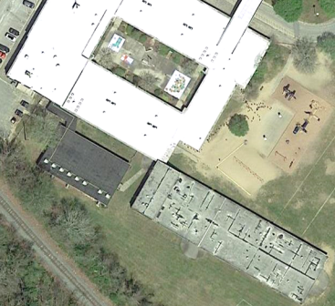
Ariel view of Decas Elementary School, 1974 wing (lower right), arrow indicates area of containment barrier separating occupied wing from construction zone
Picture 2
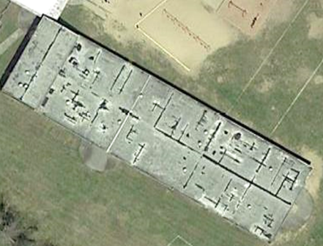
Close-up of weathered roof surface 1974 wing
Picture 3
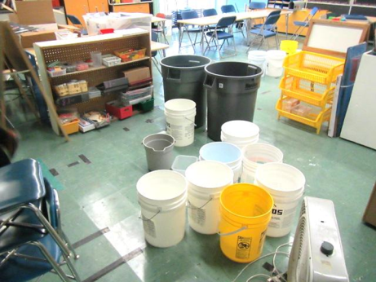
Buckets/containers used to catch active leaks in 1974 wing
Picture 4
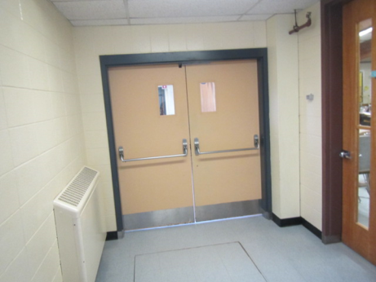
Double doors to the 1974 wing
Picture 5
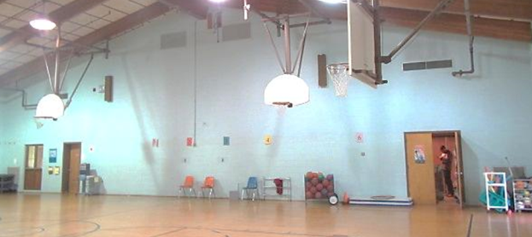
Supply (top) and return (bottom) vents for gymnasium (arrows)

Picture 6
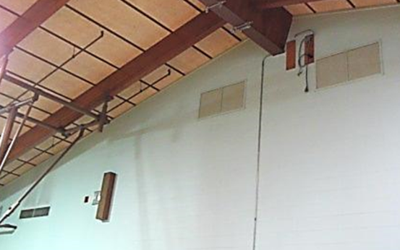
Supply vents (arrows) for gymnasium (3 of 4)

Picture 7
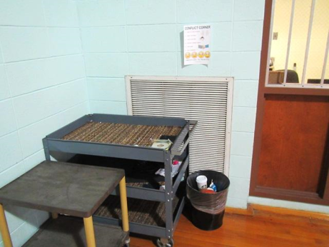
Return/exhaust vent for gymnasium
Picture 8
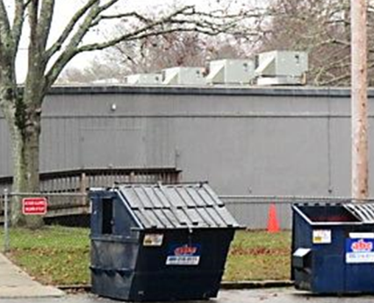
Rooftop air handling units for the modular classroom wing

