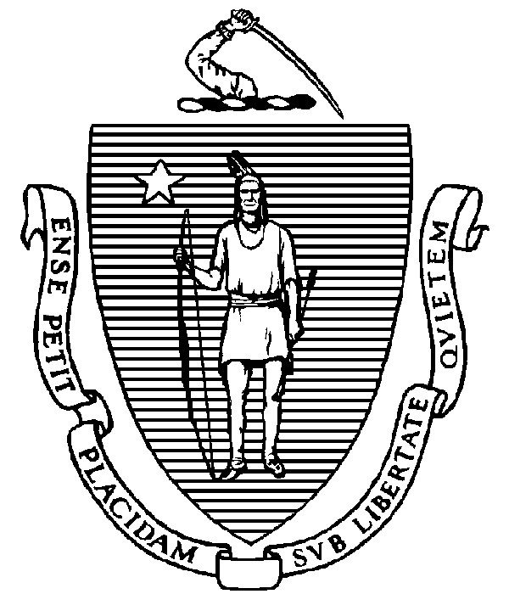
THE COMMONWEALTH OF MASSACHUSETTS
EXECUTIVE OFFICE FOR ADMINISTRATION AND FINANCE
STATE HOUSE ▪ ROOM 373
BOSTON, MA 02133
TEL: (617) 727-2040
FAX: (617) 727-2779
www.mass.gov/eoaf

NOTICE OF PUBLIC MEETING

Capital Debt Affordability Committee

Friday, December 1, 2023 1:00 p.m.
In accordance with Section 20 of Chapter 20 of the Acts of 2021, as extended by Chapter 107 of the Acts of 2022, this meeting will be conducted, and open to the public, via Zoom and Teleconference.
Zoom URL: https://zoom.us/j/94925274482?pwd=RUpxMm0zeEN1UFJhOTFOZ1Y2dFRhUT09 Meeting ID: 949 2527 4482; Passcode: 577432
Teleconference line: 1-646-931-3860; Passcode: 259987

AGENDA

- Administrative Matters
• Adoption of meeting minutes from November 20, 2023 (Vote)

- Debt Affordability Modeling & Discussion
- Adjournment

