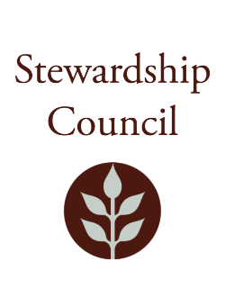

Stewardship Council Meeting
Thursday, December 11, 2025| 1:00PM to 3:00PM
DCR Headquarters, 10 Park Plaza, Boston, MA 02116
Second Floor Conference Room 1

Agenda

TOPIC | SEGMENT
Welcome and Chair’s Update – Dicken Crane, Chair | 1:00 – 1:10 PM
DCR Report – Nicole LaChapelle, Commissioner | 1:10 – 1:30 PM
Regular Business I  - MassTrails Presentation – Amanda Lewis, MassTrails Director  - Approve Minutes: November 13, 2025  - Public Comment | 1:30 – 2:15 PM
Regular Business II  - Update from Policy Committee on RMPs, FRMPs, and Landscape Designations  - Vote on Approval of Otter River Complex RMPs  - Vote on Approval of Erving Complex RMPs  - Election of Officers for 2026  - Discussion of Committees  - Councilor Comments | 2:15 – 3:00 PM
Adjourn | 3:00 PM

Zoom Observation Information

Meeting of the DCR Stewardship Council
You are invited to register for a Zoom webinar!

When: Dec 11, 2025 01:00 PM Eastern Time (US and Canada)
Topic: December 11, 2025 DCR Stewardship Council Meeting

Register in advance for this webinar.

After registering, you will receive a confirmation email containing information about joining the webinar.

12/5/2025 2:30 PM

