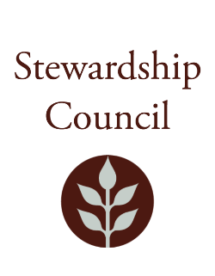

Stewardship Council Meeting
Thursday, December 12, 2024 | 10:00 AM to 12:00 PM
Massachusetts State House, Room 428

Agenda

TOPIC | SEGMENT
Welcome and Chair’s Update – Jack Buckley, Chair | 10:00 – 10:10 AM
DCR Report – Brian Arrigo, Commissioner | 10:10 – 10:25 AM
Regular Business I  - DCR Summer Nights Presentation, Julie Martin, Director of Visitor Engagement and Programs  - Approve Minutes: November 2024  - Public Comment | 10:25-11:00 AM
Regular Business II  - Election of Council Officers for 2025  - Committee Updates  - Councilor Comments | 11:00 – 12:00 PM
Adjourn | 12:00 PM

December Meeting of the DCR Stewardship Council Observation (Public Comments cannot be taken via Zoom)
Join Zoom Meeting
https://zoom.us/j/94692469990?pwd=OTBxbzg2Z09leDhKSm15YnZUaXBtQT09

Meeting ID: 946 9246 9990
Passcode: 681523

One tap mobile
+13092053325,,94692469990#,,,,*681523# US
+13126266799,,94692469990#,,,,*681523# US (Chicago)
Please contact Matt Perry at matthew.s.perry1@mass.gov for accessibility information.
Updated: 12/4/24 12:21 PM

