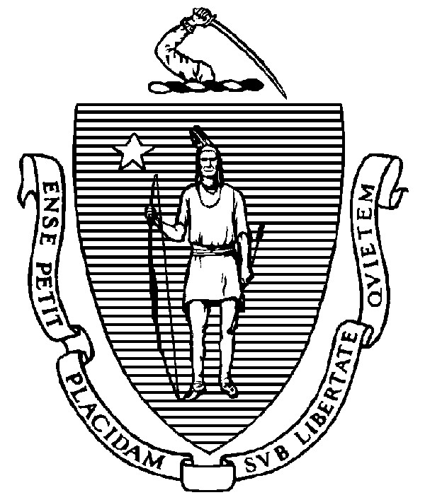
THE COMMONWEALTH OF MASSACHUSETTS TEL:FAX: (617) 727(617) 727--20402779

EXECUTIVE OFFICE FOR www.mass.gov/eoaf
ADMINISTRATION AND FINANCE STATE HOUSE ▪ ROOM 373 BOSTON, MA 02133

NOTICE OF PUBLIC MEETING

Capital Debt Affordability Committee

Friday, December 13, 2024 1:00 p.m.
In accordance with Section 20 of Chapter 20 of the Acts of 2021, as extended by Chapter 107 of the Acts of 2022, this meeting will be conducted, and open to the public, via Zoom and Teleconference.
Zoom URL: https://us02web.zoom.us/j/87068462500?pwd=kc4ALhYxAhk2xm0Voab35HYQxQ342L.1 Meeting ID: 870 6846 2500; Passcode: 411955
Teleconference line: 1-646-558-8656; Passcode: 411955#

AGENDA

- Administrative Matters
• Adoption of meeting minutes from December 6, 2024 (Vote)

- Debt Affordability Modeling & Discussion
- Debt Affordability Committee FY26 Bond Cap Recommendation (Vote)
- Other DAC Business
- Adjournment

