The Commonwealth of Massachusetts

Executive Office of Health and Human Services Department of Public Health

250 Washington Street, Boston, MA 02108-4619

CHARLES D. BAKER
Governor
KARYN E. POLITO
Lieutenant Governor
MARYLOU SUDDERS
Secretary
MARGRET COOKE
Acting Commissioner

Tel: 617-624-6000
www.mass.gov/dph

December 15, 2021

Steven T. James House Clerk

State House Room 145 Boston, MA 02133

Michael D. Hurley Senate Clerk

State House Room 335 Boston, MA 02133

Dear Mr. Clerk,

Pursuant to Chapter 384 of the Acts of 2020, please find enclosed a report from the Department of Public Health entitled “Report on Safe Patient Access to Emergency Departments.”

Sincerely,

Margret Cooke Acting Commissioner

Department of Public Health

(This page has intentionally been left blank)

3
1. Background
a. Legislative Language

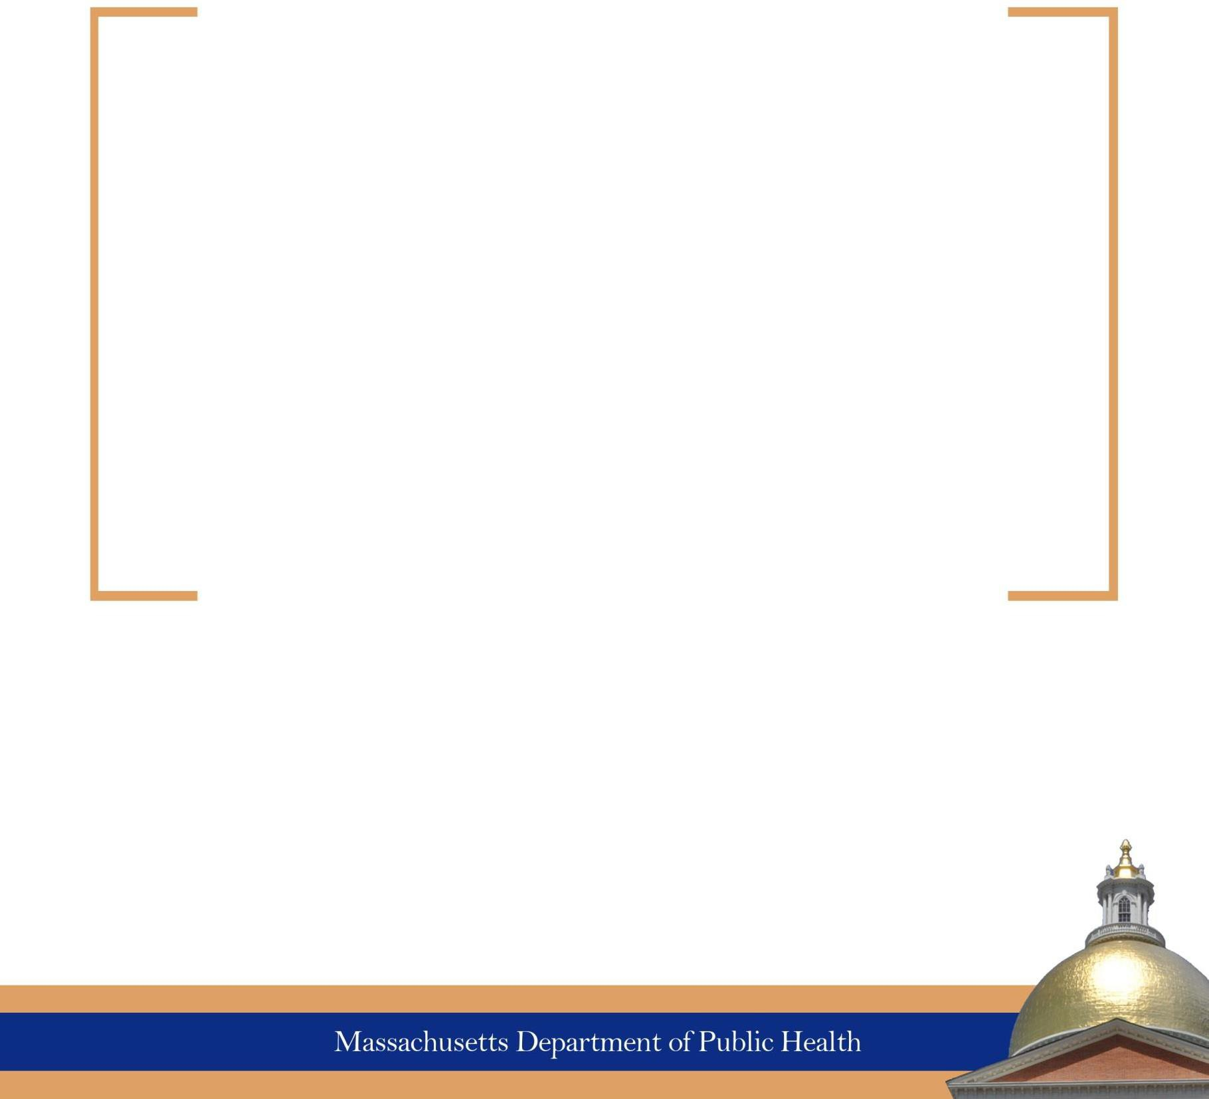
Report on Safe Patient Access to Emergency Departments

December 15, 2021

Table of Contents
Commission Members 5
Overview and Summary 6
Areas of Study by the Workgroup 6
Additional Considerations Discussed by the Commission 11

Commission Members

Department of Public Health | Elizabeth Kelley, Chair | Director, Bureau of Health Care Safety & Quality
Massachusetts Hospital Association | Nancy Hanright | Boston Medical Center, Senior Director, Real Estate & Space Planning
Massachusetts College of Emergency Physicians | Joseph Tennyson, MD, FACEP | UMass Health Alliance, Chair of Emergency Medicine
Massachusetts Commission for the Blind | Shandra Gardiner | Chief Financial Officer
Massachusetts Commission for the Deaf | Sharon Harrison | Chief of Staff
Alzheimer's Association | Julie McMurray | Senior Manager
Boston Society of Architecture | Josh Safdie, AIA, NCARB | KMA Architecture and Accessibility
Cambridge Health Alliance | Assaad Sayah, MD, FACEP | Chief Medical Officer
MetroWest Center for Independent Living | David Correia | Advocacy Director
Massachusetts General Hospital | Bonnie Michelman | Executive Director of Police, Security and Outside Services
Facility Guideline Institute, 2022 Healthcare Group Review Committee | Edward Browne, CHFM, CHPA | International Association for Healthcare Security and Safety member
Patient Advocate | Peter DeMarco
Massachusetts Association for Mental Health | Jennifer Honig | Co-Director of Public Policy and Government Relations
Wayfinding Expert | Polly Welch

Overview and Summary
The Safe Patient Access to Emergency Departments Workgroup (the Workgroup) was established pursuant to Chapter 384 of the Acts of 2020¹. The statutory charge of the Workgroup is to report on and make recommendations to inform the Department of Public Health (DPH or the Department) regulations on patient access to hospital emergency rooms or departments (ED). The Workgroup was charged with providing recommendations relative to signage, lighting, wayfinding, and security specific to access to hospital EDs.

The Workgroup met four times, from August 2021 through December 2021. The first meeting included an overview of the Facilities Guidelines Institute (FGI) recommendations on hospital wayfinding and signage process. At the second meeting, several members of the Workgroup presented on various topics related to patient access to hospital EDs.²

The presentations of this information and the discussions that followed in the final two meetings ultimately informed the final Workgroup recommendations on patient access to hospital EDs.

The impetus for the enabling legislation and the creation of the Workgroup was the 2016 death of Ms. Laura Levis, who died from an asthma attack steps from an emergency department due to numerous safety failures. Her death, and the lessons learned from it, compelled the
Legislature to pass “An Act Ensuring Safe Patient Access to Emergency Care”.³

Areas of Study by the Workgroup

Background: Facility Guidelines Institute Guidelines on Design & Construction of Hospitals

The Facility Guidelines Institute (FGI) provides health care planning, design and construction recommendations. The FGI Guidelines outline minimum program, space, risk assessment, infection prevention, architectural detail, surface, and built-in furnishing requirements for health care facilities. Licensed hospitals in Massachusetts are required, through the hospital licensure regulations, to follow DPH’s standards for review and approval of architectural plans for new construction or alterations or additions. The Department’s standards for review and approval are based on the FGI Guidelines applicable to design and construction of hospitals and outpatient healthcare facilities. The Department currently follows the 2018 Edition of the FGI Guidelines.

The FGI Guidelines provide requirements relative to hospital site access, ED access, wayfinding and security risk assessment as well as advisory recommendations for these topics. The recently adopted 2022 Edition of the FGI Guidelines includes new requirements around exterior wayfinding, video

1 Session Law - Acts of 2020 Chapter 384 (malegislature.gov)
2 All presentations and materials from the Workgroup can be found at the following website: https://www.mass.gov/orgs/patient-access-to-emergency-care-lauras-law-workgroup
3 For more information on Ms. Levis’ tragic death, please read this Boston Globe article by her husband, Peter DeMarco: https://www.bostonglobe.com/magazine/2018/11/03/losing- laura/VRPsuaoXZUduH0WGViIAwL/story.html. Please also see the Workgroup presentation by Peter DeMarco at this website: https://www.mass.gov/orgs/patient-access-to-emergency-care-lauras-law-workgroup

surveillance systems and duress alarm systems based upon the ED access efforts in Massachusetts since Ms. Levis’ death. The Workgroup used the FGI Guidelines as a basis for discussion and to support the formulation of recommendations.

Hospital Programs on Wayfinding, Security and Lighting for Emergency Departments

Several members of the Workgroup noted the importance of comprehensive programs for safe patient access to EDs. A comprehensive hospital and emergency room wayfinding program starts before a patient enters the hospital. It is important for hospitals to keep website information up to date and to leverage electronics, such as cloud sourced navigation tools and digital road maps, whenever possible. Hospitals should also use multiple forms of communication to communicate with the community it serves, such as patient reminder letters in the languages of the patients served by the hospital, and keeping staff informed of any changes to hospital entrances and security procedures. When necessary, hospitals should also engage with consultants with wayfinding expertise. For signage, consistent use of terminology and symbols is important.

Recommended Framework for Patient Access to Emergency Departments

The Workgroup reached consensus on a proposed framework for informing DPH regulations on patient access to EDs focusing on four key categories: signage, wayfinding, security, and lighting. Building from the presentations and discussions of the first two meetings, the Workgroup recommends to DPH the framework below to inform its regulations on patient access to EDs.⁴ Please note that some recommendations may be appropriate in multiple categories. For the purposes of this report, recommendations that cross multiple categories are placed in the category that is most reflective of the intent.

Signage
The Workgroup reached consensus on the following recommendations relative to interior and exterior signage:
- The Emergency Department should be clearly marked from both external and internal approaches. Signs identifying the ED should read “EMERGENCY” in all caps in red on a white background or white on red background.
- All hospital perimeter doors, including but not limited to, doors that are locked at night, main entrance doors, ED entrance doors, ambulance entrances, and any door a patient may typically use to enter the hospital, should be well lit and include directions to the ED.
- Hospital entry points should be clearly identified from all major exterior circulation routes used by pedestrians and vehicles with clearly visible signs, and understandable signage, icons, universal symbols and visual landmarks for cues and orientation.
- ED wayfinding signage should be accurate, useful, well lit (externally or internally illuminated), non-reflective, consistent, and legible from appropriate viewing distances.
- Text color should contrast with the background color of signs (see American with Disabilities Act Section 703) and colors should be distinguishable for those who are color-blind.
- A cross icon should be used on all new emergency signage.

4 While recommending the framework, the Workgroup acknowledged that some of the recommendations may be limited in practice and/or scope for hospitals due to jurisdictional concerns, such as local zoning ordinances and local signage and lighting codes and requirements.

- Signs should use wording that is accurate, consistent (including facility nomenclature) and understandable to most patients and companions, and generally written at a sixth-grade reading level.
- A sign listing communication accessibility features and services available at the ED should be posted at the ED and prominent hospital door entrances for prospective patients and family members to identify their communicative needs immediately.
- When EMERGENCY is included on a directional sign with other destinations, it should be at the top of the list.

Lighting
The Workgroup reached consensus on the following recommendations relative to lighting:
- Lighting should be designed, installed, and maintained to be compliant with Illuminating Engineers Society (IES) standards and/or other applicable industry guidelines.
- Emergency Department identification and directional signs should be sufficiently lit to allow drivers and pedestrians to see signs after dark and during inclement weather.
- ED patient drop-off and entry areas should be well lit in order for such areas to stand out from a distance and be at least as brightly lighted as other entrances.
- All hospital perimeter doors should be well lit, including but not limited to, doors that are locked at night, main entrance doors, ED entrance doors, ambulance entrances, and any door a patient may typically use to enter the hospital.
- Emergency duress button stations should be well lit.

Wayfinding⁵
The Workgroup reached consensus on the following recommendations relative to wayfinding (which includes both interior and exterior wayfinding) and patient access to EDs:
- Exterior wayfinding considerations should include vehicular and pedestrian access routes, starting from public transportation stops and the surrounding roadways and walkways at the perimeter of the grounds of the hospital, and continuing to ED parking and ED entry doors.
- Directional signs at streets should be located and sized so that drivers can read them when traveling from all directions at the posted speed limit.
- Exterior and interior approaches to wayfinding should be coordinated.
- Consistency should be used in the nomenclature of buildings.
- Directions should be clear to all users.
- A well-designed and located set of interior signs and clearly labeled directional maps should be located near the entrances.
- Symbols used on directional signage may be used in orientation maps for consistency and to assist users in finding primary destinations.
- Where symbols are used, a single symbol should be used to represent a single primary destination.
- Signs should be appropriately placed to direct people to and from the ED, parking and public transportation.

5 Wayfinding is defined as creating effective routes to EDs under all conditions (daylight, darkness, inclement weather, changes in terrain, walking vs. driving, etc.) by coordinating design elements such as signage and lighting; operational elements such as nomenclature and technology; and user behavior such as the likelihood of following signs and noticing landmarks. JANET CARPMAN & MYRON GRANT, “DESIGN THAT CARES: PLANNING HEALTH FACILITIES FOR PATIENTS AND VISITORS,” JOSSEY BASS, THIRD EDITION 2016

- Signs providing directions on the grounds of the hospital should be placed at major decision points (places where people have to decide to turn or keep going straight) with additional consideration of terrain and potential obstructions, including the following: major intersections; major destinations; and changes in buildings.
- To ensure visual continuity, hospitals should place successive directional signs including, but not limited to, reinforcement signs at regular intervals on the exterior on the grounds of the hospital such that the next sign along the path is visible and legible from the location of the previous sign.
- Where patient ED entrances and ambulance ED entrances are separate, each should be clearly identified and included in wayfinding signs. Signage at ambulance entrances directing people to walk-in emergency entrances should be visible prior to arriving at the ambulance entrance.
- Ensure that the physical address for the ED entrance is listed on the hospital website.
- Ensure that its ED has a unique address for GPS navigation purposes unless the ED shares the same patient access point as the hospital's existing GPS navigation address.

Security
The Workgroup reached consensus on the following recommendations relative to security:
- Lighted communications technology, such as two-way live intercom systems (video and audio) with duress alarm features should be used across the hospital facility, which should at minimum contain communication devices at main entrances, ED entrance, ambulance entrances, and any exterior door a patient may typically use, and around hospital grounds as needed to communicate with on-duty personnel. Such technology should be accessible to people with low vision, hearing loss, difficulties with speech and cognitive processing.
  - Such system should have Braille and feature a visual “door is now open” green light and
tactile alert.
  - Such system should also include emergency duress button stations that are well marked, not dependent solely on audio.
  - Hospital parking areas should be equipped with emergency call boxes that connect to on- duty personnel for 24/7 assistance.
- Exterior wayfinding and access policies should include vehicular and pedestrian entries to the hospital site, circulation to and from ED parking, information signage, and wayfinding-related lighting.
- Hospitals should consider means to differentiate between call duress buttons and intercom systems.
- Hospitals must have a policy to ensure that patients on hospital grounds seeking emergency
medical care who cannot independently access the ED are immediately located and attended to by the hospital organization.

Comprehensive Annual Review
The Workgroup reached consensus on the following recommendations relative to an annual review by the hospital of security, wayfinding, signage and lighting:

Hospitals must conduct an annual comprehensive review of the effectiveness of their security, exterior wayfinding, signage, and lighting and maintain and update policies and procedures, design

features and technology based upon the review understanding the uniqueness of each hospital
organization and facility. Significant physical changes to a facility’s exterior, entrance doors or access routes should trigger similar reviews. Policies and procedures should be reviewed annually and made available to DPH upon request.

Annual reviews:
  - Should be conducted during daylight and after dark.
  - May consider reviews submitted through the hospital’s ED patient survey, or the Patient and Family Advisory Council regarding physical access to the ED.
  - May include reviewers soliciting patient and family input about needed wayfinding and other improvements to ED exterior access.
  - Should include facility maintenance staff to ensure footpaths, lighting and signs are maintained and kept clear of debris and are not obscured by vegetation or snow or other physical obstructions, with reasonable allowances when weather conditions are extreme.
  - Should be multi-departmental, and include security, facilities, risk management and ED personnel at minimum.
  - Security reviews shall also cover policies related to security/surveillance monitoring, foot patrols, and staffing, including at ED and main entrances to the hospital.

- Policies and procedures should be reviewed annually and made available to DPH upon request and include but not be limited to:
  - The monitoring of site exterior access points and ED patient drop-off and walk-in areas by the hospital using effective security technology and include the ability to record and play back recordings for at least 24 hours and maintain recordings for at least 14 days.
  - ED patient drop-off and walk-in areas and main patient entry points, which should be sufficiently lighted for camera surveillance during all times of the day and night and in all types of weather.
  - Staffing at hospital security desks, ED front desks, and other official-looking entry areas, which should include 24/7 staffing or the availability of a phone number that can connect patients with a staff member who can provide immediate assistance.
  - Security staff training, which should include training about disability and disability access at the ED, including persons with physical disabilities, developmental and intellectual disabilities, behavioral health disabilities, and persons who are Deaf/Hard of Hearing/Late Deafened/Deaf Blind, and how to communicate with and provide support for such individuals.
  - Hospital and security staff should be trained on responsibilities when patients or families have difficulty finding or entering the ED, the requirements of EMTALA as it pertains to patient access, and other relevant concerns regarding exterior access to EDs.
  - Hospitals should document policies and procedures relating to security, lighting, wayfinding, and signage in case of a temporary or permanent re-location or closure of a known ED entrance.

Additional Considerations Discussed by the Commission

In developing a final recommended framework to inform DPH regulations, individual Workgroup members raised additional proposals and potential best practices that are important for consideration in patient access to EDs.

For wayfinding, lighting, and signage:

- Work with major navigation companies to make sure offsite and onsite drivers and pedestrians can use navigation apps to find the hospital ED.
- Work with appropriate local and/or state officials to determine locations for offsite hospital
“trailblazer” signs on public property.

For security and accessibility:

- Establish communication protocols between emergency medical services and EDs, to ensure that the ED is prepared to provide services for incoming patients, including someone who is identified as deaf/hard of hearing/late-deafened/deaf blind (ASL/CDI/Assistive Listening Device/CART should be made available upon arrival.)
- Review and improve protocols for access by persons with disabilities (in accordance with the ADA) including:
- Protocol for Emergency Transport informing EDs when transporting someone who is identified as deaf/hard of hearing/late-deafened/deaf blind or speech impaired, so that the ED can request ASL, CDI, Assistance Listening Device, or CART so it is available upon arrival.
- Permitting a companion to accompany a person with disability to communicate with hospital staff.
- Accommodating a service animal or emotional support animal in the ED.

For new or renovated EDs:
- Vehicular and pedestrian circulation routes and pathways should be clear and well signed from the site entrance to the ED patient drop-off and walk-in entrance.
- Ambulance circulation should be separate from patient vehicular circulation.
- Ambulance entrances should be separate from patient drop-off and walk-entrances.
- DPH should be notified prior to any changes and allowed to review all changes before completion.

