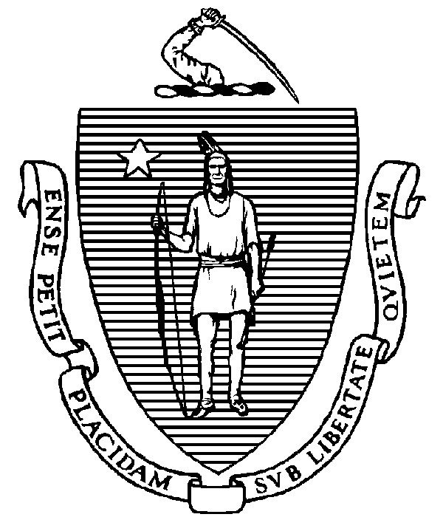
THE COMMONWEALTH OF MASSACHUSETTS
EXECUTIVE OFFICE FOR ADMINISTRATION AND FINANCE
STATE HOUSE ▪ ROOM 373
BOSTON, MA 02133
TEL: (617) 727-2040
FAX: (617) 727-2779
www.mass.gov/eoaf

NOTICE OF PUBLIC MEETING

Capital Debt Affordability Committee

Friday, December 15, 2023 1:00 p.m.
In accordance with Section 20 of Chapter 20 of the Acts of 2021, as extended by Chapter 107 of the Acts of 2022, this meeting will be conducted, and open to the public, via Zoom and Teleconference.
Zoom URL: https://zoom.us/j/92193750886?pwd=UGVqYjJ1Z09xWHBwcndNM3MwcHpQQT09
Meeting ID: 921 9375 0886; Passcode: 250112
Teleconference line: 1-646-931-3860; Passcode: 250112

AGENDA

- Administrative Matters
• Adoption of meeting minutes from December 13, 2023 (Vote)

- Debt Affordability Modeling & Discussion (cont).
- Debt Affordability FY25 Bond Cap Recommendation (Vote)
- Adjournment

