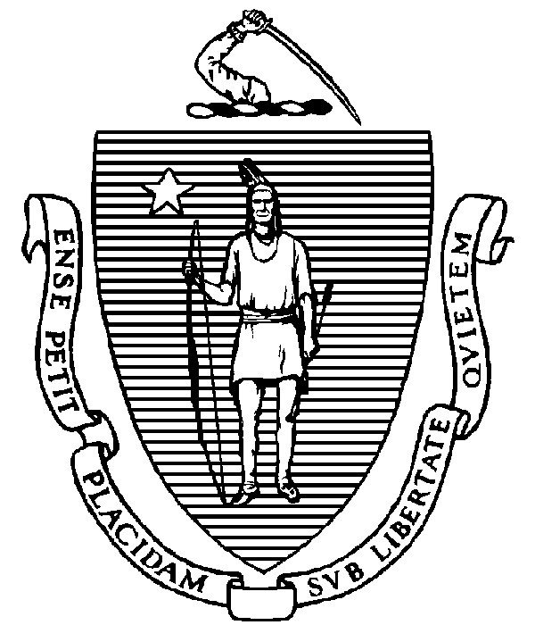
THE COMMONWEALTH OF MASSACHUSETTS
EXECUTIVE OFFICE FOR ADMINISTRATION AND FINANCE
STATE HOUSE ▪ ROOM 373
BOSTON, MA 02133
TEL: (617) 727-2040
FAX: (617) 727-2779
www.mass.gov/eoaf

NOTICE OF PUBLIC MEETING

Capital Debt Affordability Committee

Friday, December 2, 2022 1:00 p.m.
In accordance with Section 20 of Chapter 20 of the Acts of 2021, as extended by Chapter 107 of the Acts of 2022, this meeting will be conducted, and open to the public, via Zoom and Teleconference. Zoom URL: https://mass-gov-anf.zoom.us/j/83166166805?pwd=b2xyWnE0bnVKT2pmVVRnMGFuampRUT09 Zoom Password: 120222
Teleconference line: 713-353-7024; Conference code: 319738

AGENDA

- Administrative Matters
• Adoption of meeting minutes from November 18, 2022 (Vote)

- DAC Fiscal Year 2023-24 Bond Cap Recommendation (Vote)

- DAC New Reporting Requirement Section Review

4. Adjournment

