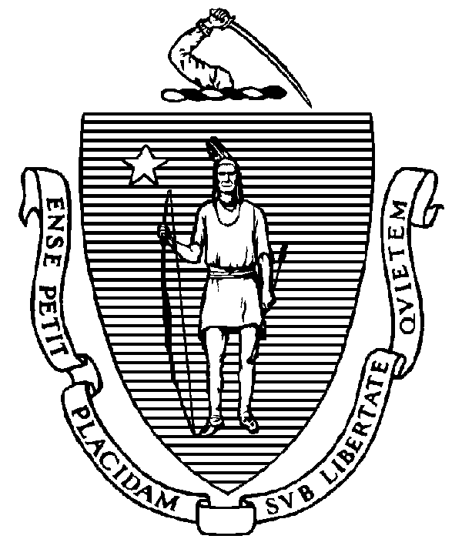Meeting Minutes
The Commonwealth of Massachusetts
Executive Office for
Administration and Finance
STATE HOUSE ▪ ROOM 373
BOSTON, MA 02133
TEL: (617) 727-2040
FAX: (617) 727-2779
www.mass.gov/eoaf

Debt Affordability Committee
December 4, 2018
2:00 pm
Executive Office for Administration and Finance
State House, Room 373

A meeting of the Debt Affordability Committee was held on Tuesday, December 4, 2018 in the Executive Office for Administration and Finance, State House, Room 373, Boston, Massachusetts, pursuant to notice duly given.

Meeting was called to order at 2:05 pm.

Board members comprising a physical quorum:

Bill McNamara, Executive Office for Administration & Finance
Howard Merkowitz, Office of the Comptroller
Michelle Ho, Massachusetts Department of Transportation
Catherine Walsh, Governor’s Appointee, Northeastern University
Michael Butler, Treasurer’s Appointee

Others in attendance:

Maya Jonas-Silver, Executive Office for Administration & Finance
Andrew Strumfels, House Committee on Bonding, Capital Expenditures and State Assets
Chris Marino, Senate Committee on Ways & Means
Abby Kim, Office of Senator Keenan
Supreo Ghosh, Office of the Treasurer
Kathy Bramlage, Office of the Treasurer

Minutes:

Note: The slide deck referenced in the minutes will also be made available and should be reviewed as well.

Mr. McNamara called the meeting to order.

The committee then began its review of the presentation prepared by the Executive Office for Administration & Finance (A&F). The committee noted the following:

Mr. McNamara explained that interest rates can change day-to-day, but looking at past state bond deals can provide guidelines for future expectations. He explained that the interest rates increase more quickly on bonds with 10- to 20-year terms, and increase more slowly from 20-year to 30-year terms.

Ms. Jonas-Silver, Mr. Ghosh, and Ms. Bramlage discussed the issuance of Commonwealth debt, and confirmed that the committee’s assumptions on the method of debt financing was appropriately reflected in the model.

Mr. McNamara explained that the yield outlook is drawn from 3rd party sources. He explained that the Commonwealth usually trades around the average of 20-year Moody’s estimates, and that the model had made conservative interest rate assumptions.

Mr. Ghosh noted that higher interest rates generally are tied to higher rates of inflation, which also drive faster revenue growth. The committee noted the importance of considering the interrelationship in those factors.

Mr. McNamara explained that the consensus revenue hearing was going to occur on Wednesday, December 5. At that hearing, the Joint Committee on Ways and Means and the Secretary of Administration and Finance would hear testimony on FY20 revenue estimates.

Mr. Merkowitz noted that revenue growth assumptions of 3.0% - 3.3% would imply inflation around 2% and real GDP growth around 1%. He noted that the CBO is anticipating 2% GDP growth.

The committee explored the need to stress test. The committee examined the charting of 6% of state revenues against expected debt service. The committee requested three scenarios: a conservative scenario with very little growth, a middle scenario that tracks expectations, and an optimistic scenario with higher revenue growth.

The committee discussed the negative correlation between revenue growth and interest rates.

Mr. Merkowitz requested an analysis using Moody’s analytics as well as the IHS Market.

Mr. Merkowitz suggested a midpoint where the state would maintain purchasing power. Mr. Butler and Mr. Merkowitz discussed using the government purchasing power index, as well as considering the cost of construction supplies like lumber and steel.

The committee noted a historical precedent of a maximum increase of $125 M.

On a motion made by Ms. Walsh and seconded by Mr. Butler, the committee adjourned at 3:10 p.m.

