THE COMMONWEALTH OF MASSACHUSETTS
EXECUTIVE OFFICE FOR
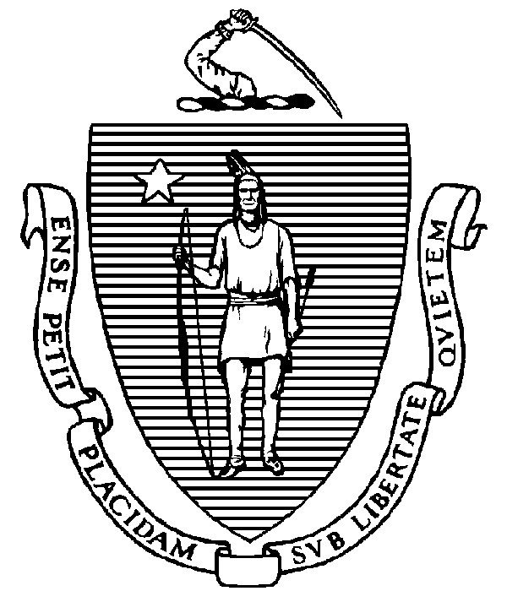
ADMINISTRATION AND FINANCE

STATE HOUSE ▪ ROOM 373 BOSTON, MA 02133 TEL: (617) 727-2040
FAX: (617) 727-2779 www.mass.gov/eoaf

NOTICE OF PUBLIC MEETING

Capital Debt Affordability Committee

Friday, December 8, 2023 1:00 p.m.
In accordance with Section 20 of Chapter 20 of the Acts of 2021, as extended by Chapter 107 of the Acts of 2022, this meeting will be conducted, and open to the public, via Zoom and Teleconference.
Zoom URL: https://zoom.us/j/98050603586?pwd=aEhrazRNYmdzeGtidmFYa25tWGRpdz09 Meeting ID: 980 5060 3586 ; Passcode: 073240
Teleconference line: 1-646-931-3860; Passcode: 073240

AGENDA

- Administrative Matters
  - Adoption of meeting minutes from November 20, 2023 (Vote)
  - Adoption of meeting minutes from December 1, 2023 (Vote)

- Debt Affordability Modeling & Discussion (cont).
- Adjournment

