The Commonwealth of Massachusetts
Executive Office of Health and Human Services
Department of Public Health
250 Washington Street, Boston, MA 02108-4619

CHARLES D. BAKER
Governor

KARYN E. POLITO
Lieutenant Governor

MARYLOU SUDDERS
Secretary

MARGRET R. COOKE
Commissioner

Tel: 617-624-6000
www.mass.gov/dph

May 11, 2022

Via Email - Andrew.Levine@huschblackwell.com

Andrew​​ Levine
Partner
Husch Blackwell LLP
One Beacon Street,
Suite 1320
Boston, MA 02108

RE: Notice of Final Action DoN # MGB-20121716-HE

Dear Mr. Levine,
At their meeting of May 4, 2022, the Commissioner and the Public Health Council, acting
together as the Department, voted pursuant to M.G.L. c.111, §25(c) and the regulations adopted
thereunder, to approve the Determination of Need application filed by Mass General Brigham,
Inc. for a Proposed Project at Brigham and Women’s Faulkner Hospital to construct a five-story addition to the existing facility that will contain the following:
- 78 additional medical/surgical inpatient beds;
- An 8-bed observation unit;
- Relocated and expanded endoscopy services, including one additional procedure room for advanced endoscopic procedures with capability for fluoroscopy (e.g., endoscopic retrograde cholangiopancreatography (ERCP) and endoscopic ultrasound (EUS) procedures);
- Expanded magnetic resonance imaging (MRI) capacity with a 3T MRI unit and renovated and expanded Radiology Department by adding an angiographic interventional radiology program, additional pre- and post-procedure recovery space, and additional support space; and
- Shell space for future build-out for anticipated expanded clinical services.

This Notice of Final Action incorporates by reference the Staff Report, and the Public Health Council proceedings concerning this application, all of which are incorporated herein by reference.

This Determination of Need Application was reviewed pursuant to M.G.L. c. 111, § 25(c), and the regulatory provisions of 105 CMR 100.000 et seq. Based upon a review of the materials, the Department found that the Applicant has met each DoN factor with conditions and approves this Determination of Need application for a substantial capital expenditure for the Proposed Project of $150,098,582.00 (January, 2021 dollars). The total required Community Health Initiative (CHI) contribution is $7,504,929.10.

In compliance with the provisions of 105 CMR 100.310(A)(2) and (11) the Holder shall submit an acknowledgment of receipt to the Department (attached) and include a written attestation of participation or intent to participate in MassHealth.

In compliance with 105 CMR 100.310(A)(12), which requires a report to the Department, at a minimum on an annual basis, including the measures related to achievement of the DoN factors for a period of five years from completion of the Proposed Project, the Holder shall address its assertions with respect to all the factors.

Other Conditions to the DoN

Condition 1 – CHI Contribution
- Of the total required CHI contribution of $7,504,929.10
  - $1,838,707.63 will be directed to the CHI Statewide Initiative
  - $5,516,122.89 will be dedicated to local approaches to the DoN Health Priorities
  - $150,098.58 will be designated as the administrative allowance
- To comply with the Holder’s obligation to contribute to the Statewide CHI Initiative, the Holder must submit a check for $1,838,707.63 to Health Resources in Action (the fiscal agent for the CHI Statewide Initiative).
    - The Holder must submit the funds to HRiA within 30 days from the date of the Notice of Approval.
    - The Holder must promptly notify DPH (CHI contact staff) when the payment has been made.

Payment should be sent to:
Health Resources in Action, Inc., (HRiA)
2 Boylston Street, 4th Floor
Boston, MA 02116
Attn: Ms. Bora Toro

Condition 2 – The Holder shall, on an annual basis, commencing with the approval of this DoN, and continuing for a period of five years after the Proposed Project is complete, provide the following information as part of the annual report required by 105 CMR 100.310(A)(12):
- Transfer of patients from BWH to BWFH inpatient care
- The number of patients who transfer from BWH to BWFH.
- The number and percent of patients clinically eligible to transfer from BWH who do transfer to BWFH (measured by # of patients who transfer from BWH to BWFH/total # of patients clinically eligible for transfer).
- The acuity level by case mix index of the transferred patients.
- The acuity level by case mix index for medical/surgical (M/S) patients at BWH.
- The acuity level by case mix index for medical/surgical (M/S) patients at BWFH.
- The number of patients transferred from BWFH to BWH including the acuity level of these patients.
- Separately for the BWH and BWFH EDs:
    - the number of ED boarders awaiting a med/surg bed (with boarding defined as 2 hours from the request for a bed).
    - Total hours of med/surg boarding and the average hours of boarding per patient.
- Percentage (with numerator and denominator) of BWFH inpatients who were part of MGB’s Patient Panel prior to the BWFH admission.
The number of BWFH inpatients who were part of MGB’s Patient Panel prior to the BWFH admission
Total patients admitted

- Provide data included in this table MGB provided in responses to DoN questions (https://www.mass.gov/doc/mass-general-brigham-incorporated-bwfh-responses-to-don-questions-1/download) Question 5e.
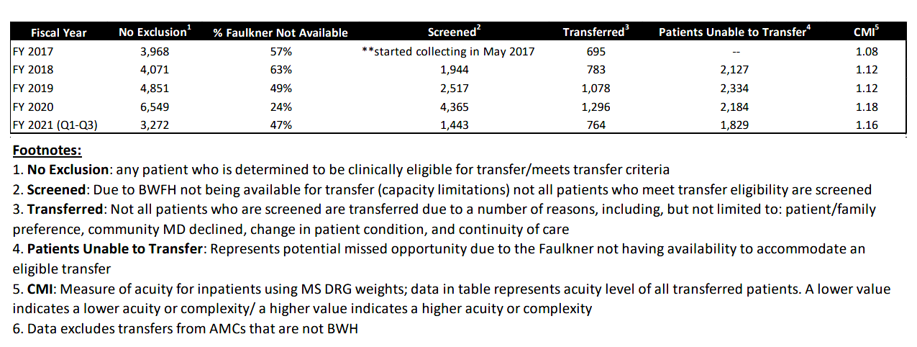

- Endoscopy
- The total number of advanced endoscopy procedures performed at BWFH (advanced endoscopy procedures defined as Endoscopic Retrograde Cholangiopancreatography (ERCP) and Endoscopic ultrasound (EUS)).
- The number of patients transferred to BWH from BWFH for advanced endoscopy procedures and top reasons for transfer.

- Observation Units
- The total of post-procedure patients receiving services in the observation unit.
- The occupancy rates of these observation beds at BWFH (occupancy rates calculated as number of patients observed over a given period of time to the total number of beds available for that same period of time).

- Imaging
- Upon implementation of the MRI, provide baseline data on capacity (scan volume) and inpatient and outpatient wait times (for the proposed measures in Attachment 1).
- The MRI utilization
    - for ED
    - inpatient
    - outpatient
- wait times (average and median)
    - for ED
    - inpatient
    - outpatient

Any of the following will be Referral Indicators related to Condition 2:
- A material increase in 1f, 1g, 2b, 4c
- A material decrease in 1a, 1b, 1c, 1d, 1e, 1h, 2a, 3a, 3b

If the DoN Program finds any one or more of the Referral Indicators, the matter shall be referred to the Public Health Council (PHC) for review to determine whether MGB is in violation of one or more of the conditions and thus out of compliance with the terms of this Notice of DoN.

Upon referral to the PHC based upon any one or more of the Referral Indicators, MGB shall have an opportunity to show cause why the PHC shall not find one or more of the Referral Indicators.

Ongoing compliance with the conditions and all terms of the DoN is, pursuant to the Regulation, a precondition to the filing of any future DoN by the Holder.

Sincerely,

[signature on file]

Elizabeth D. Kelley
Director, Bureau of Health Care Safety and Quality

cc:
Stephen Davis, Director, Division of Health Care Facility Licensure and Certification
Rebecca Rodman, General Counsel
Daniel Gent, Health Care Facility Licensure and Certification
Samuel Louis, Office of Health Equity
Jennica Allen, Division of Community Health Planning and Engagement
Elizabeth Maffei, Division of Community Health Planning and Engagement
Elizabeth Almanzor, Center for Health Information Analysis
Katherine Mills, Health Policy Commission
Eric Gold, Office of the Attorney General

