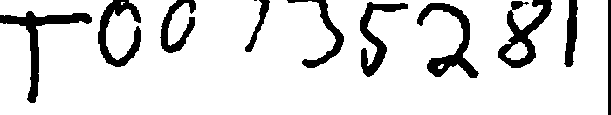 Received Jun 04 2003 Secretary of the Commonwealth Corporations Division

**BOSTON EYE SURGERY AND LASER CENTER TRUST AMENDED AND RESTATED DECLARATION OF TRUST**

AMENDED AND RESTATED DECLARATION OF TRUST, made as of

April 22, 2003, by and among the individuals listed as Shareholders and Trustees on the

signature page hereof.

WHEREAS, Trexler M. Topping, M.D., in his capacity as initial Trustee of the Trust, established a so-called Massachusetts business trust by declaring that all money and property contributed to the Trust shall be held and managed in trust under the declaration of trust filed as of December 28, 2000 ("Declaration of Trust");

WHEREAS, the Shareholders and Trustees have approved this Amended and Restated Declaration of Trust by vote held at a meeting the Trust on April 22, 2003, and the Trustees have directed that Trexler M. Topping, M.D. submit this Amended and Restated Declaration of Trust to the Secretary of State of the Commonwealth of Massachusetts;

NOW THEREFORE. the Trustees hereby amend and restate the Declaration of Trust -as set forth below. ·

### ARTICLE I

**NAME AND** DEFINITIONS

Section 1. This Trust shall be known as "Boston Eye Surgery and Laser Center

Trust".

### DEFINITIONS

Section 2. Wherever used herein, unless otherwise required by the context or specifically provided:

1. The "Trust" refers to "Boston Eye Surgery and Laser Center Trust";
2. “Shareholder" means a ·record owner of Shares of the Trust;
3. “Shares" means the equal proportionate transferable units of interest

into which the beneficial interest of the Trust shall be divided from time to time; and

1. The "Trustees" refer to the individual trustee or trustees in his or their capacity as trustees hereunder of the Trust and his or their successor or successors for the time being in office as such trustee or trustees.

# ARTICLE II

### PURPOSE OF TRUST

The purpose of this Trust is to engage in a medical practice specializing in ambulatory ophthalmic surgery, and to render any and all services, incidental or ancillary thereto, and, in general, to have and to exercise all powers and privileges now or hereafter granted for which business trusts may be organized under the Massachusetts Business Trust Law.

ARTICLE III

### BENEFICIAL INTEREST SHARES OF BENEFICIAL INTEREST

Section 1. The beneficial interest in the Trust shall be divided into such transferable Shares as the Trustees shall from tune to time create and establish. The number of Shares is unlimited and each Share shall be without par value and shall be fully paid and nonassessable. The Trustees shall have full power and authority, in their sole discretion and without obtaining any prior authorization or vote of the Shareholders of the Trust to create and establish (and to change in any manner) Shares with such preferences, voting powers, rights and privileges as the Trustees may from time to time determine, to divide or combine the Shares into a greater or lesser number, and to take such other action with respect to the Shares as the Trustees may deem desirable.

### OWNERSHIP OF SHARES; QUALIFIED PERSONS

Section 2. The Trust shall issue Shares only to "Qualified Persons" as that term is defined in the Trust's By-Laws, as amended from time to time. The Shares are subject to restrictions on transfer imposed by applicable requirements of the Board of Registration in Medicine of the Commonwealth of Massachusetts and the By-Laws of the Trust, as they may be amended from time to time. The ownership of Shares shall be recorded in the books of the Trust. The Trustees may make such rules as they consider appropriate for the transfer of Shares and similar matters. The record books of the Trust shall be conclusive as to who are the holders of Shares and as to the number of Shares held from time to time by each Shareholder.

### INVESTMENT IN THE TRUST

Section 3. The Trustees shall accept investments in the Trust from such Qualified Persons and on such terms as they may from time to time authorize. Such investments may be in the form of cash, securities or other property. After the date of the initial contribution of capital, the number of Shares to represent the initial contribution may in the Trustee's discretion be considered as outstanding and the amount received by the Trustee on account of the contribution shall be treated as an asset of the Trust.

Subsequent investments in the Trust shall be credited to each Shareholder's account in the form of Shares.

## LIMITATION OF PERSONAL LIABILITY

Section 4. The Trustees shall have no power to bind any Shareholder personally or to call upon any shareholder for the payment of any sum of money or assessment whatsoever other than such as the Shareholder may at any time personally agree to pay by way of subscription for any Shares or otherwise. Every note, bond, contract or other undertaking issued by or on behalf of the Trust or the Trustees relating to the Trust shall include a recitation limiting the obligation represented thereby to the Trust and its assets (but the omission of such a recitation shall not operate to bind any Shareholder).

## ARTICLE IV

THE TRUSTEES

## MANAGEMENT OF TIIE TRUST

Section 1. The business and affairs of the Trust shall be managed by the Trustees, and they shall have all powers necessary and desirable to carry out that responsibility in accordance with the By-Laws of the Trust in effect from time to time.

# OWNERSHIP OF ASSETS OF THE TRUST

Section 2. The assets of the Trust shall be held by the Trustees separate and apart from any assets now or hereafter held by them in any capacity other than as Trustees hereunder. All of the assets of the Trust shall at all times be considered as vested in the Trustees. No Shareholder shall be deemed to have a severable ownership in any individual asset of the Trust or any right of partition or possession thereof, but each Shareholder shall have a proportionate undivided beneficial interest in the Trust.

ARTICLE V

## SHAREHOLDERS' VOTING POWERS AND MEETINGS

VOTING POWERS

Section 1. The Shareholders shall have power to vote (i) with respect to the amendment of this Declaration of Trust as provided in Article VII, Section 6 and (ii) with respect to such additional matters relating to the Trust as may be required or authorized by law, by this Amended and Restated Declaration of Trust, or the Bylaws of the Trust. Each whole Share shall be entitled to one vote as to any matter on which it is entitled to vote, and each fractional Share shall be entitled to a proportionate fractional vote. Shares may be voted in person or by proxy provided that a Shareholder may only give such proxy to a Qualified Person.

ARTICLE VI

## LIMITATION OF LIABILITY

Section 1. Provided they have exercised reasonable care and have acted under the reasonable belief that their actions are in the best interest of the Trust, the Trustees shall

not be responsible for or liable in any event for neglect or wrongdoing of them or any officer, agent, employee adviser of the Trust, but nothing contained herein shall protect any Trustee against any liability to which he would otherwise be subject by reason of willful misfeasance, bad faith, gross negligence or reckless disregard of the duties involved in the conduct of his office.

INDEMNIFICATION

Section 2.

1. Subject to the exceptions and limitations contained in Section (b)

below:

* 1. every person who is, or has been, a Trustee or officer of the

Trust (hereinafter referred to as "Covered Person'') shall be indemnified by the Trust to the fullest extent permitted by law against liability and against all expenses reasonably incurred or paid by him in connection with any claim, action, suit or proceeding in which he becomes involve4 as a party or otherwise by virtue of his being or having been a Trustee or officer and against amounts paid or incurred by him in the settlement thereof;

* 1. the words “claim," "action,” "suit," or ''proceeding" shall apply to all claims, actions, suits or proceedings (civil, criminal or other, including appeals), actual or threatened while in office or thereafter, and the words ''liability'' and "expenses" shall include, without limitation, attorneys' fees, costs, judgments, amounts paid in settlement, fines, penalties and other liabilities.

1. No indemnification shall be provided hereunder to a Covered Person:
   1. who shall have been adjudicated by a court or body before which the proceeding was brought (A) to be liable to the Trust or its Shareholders by reason of willful misfeasance, bad faith, gross negligence or reckless disregard of the duties involved in the conduct of his office or (B) not to have acted in good faith in the reasonable belief that his action was in the best interest of the Trust; or
   2. in the event of a settlement, unless there has been a determination that such Trustee or officer did not engage in willful misfeasance, bad faith, gross negligence or reckless disregard of the duties involved in the conduct of his office,
2. by the court or other body approving the settlement;
3. by written opinion of independent legal counsel based upon a review of readily available facts (as opposed to a full trial-type inquiry);

provided, however, that any Shareholder may, by appropriate legal proceedings, challenge any such determination by independent counsel.

1. The rights of indemnification herein provided may be insured against by policies maintained by the Trust, shall be severable, shall not be exclusive of or affect any other rights to which any Covered Person may now or hereafter be entitled, shall continue as to a person who has ceased to be such Trustee or officer and shall inure to the benefit of the heirs, executors and administrators of such a person. Nothing contained herein shall affect any rights to indemnification to which Trust personnel, other than Trustees and officers, and other persons may be entitled by contract or otherwise under law.
2. Expenses in connection with the preparation and presentation of a

defense to any claim, action, suit or proceeding of the character described in paragraph

(a) of this Section 2 may be paid by the Trust from time to time prior to final disposition thereof upon receipt of an undertaking by or on behalf of such Covered Person that such amount will be paid over by him to the Trust if it is ultimately determined that he is not entitled to indemnification under this Section 2; provided, however, that either (a) such Covered Person shall have provided appropriate security for such undertaking, (b) the Trust is insured against losses arising out of any such advance payments or (c) either a majority of the Trustees who are neither interested persons of the Trust nor parties to the matter, or independent legal counsel in a written opinion, shall have determined, based upon a review of readily available facts (as opposed to a trial-type inquiry or full investigation), that there is reason to believe that such Covered Person will be found entitled to indemnification under this Section 2.

### SHAREHOLDERS

Section 3. In case any Shareholder or former Shareholder of the Trust shall be held to be personally liable solely by reason of his being or having been a Shareholder and not because of his acts or omissions or for some other reason, the Shareholder or former Shareholder (or his heirs, executors, administrators or other legal representatives or in the case of a corporation or other entity, its corporate or other general successor) shall be entitled out of the assets belonging to the Trust to be held harmless from and indemnified against all loss and expense arising from such liability. The Trust shall, upon request by the Shareholder, assume the defense of any claim made against the Shareholder for any act or obligation of the Trust and satisfy any judgment thereon.

ARTICLE VII

MISCELLANEOUS

### TRUST NOT A PARTNERSHIP

Section 1. It is hereby expressly declared that a trust and not a partnership is created hereby. No Trustee hereunder shall have any power to bind personally either the Trust's officers or any Shareholder. All persons extending credit to, contracting with or having any claim against the Trust or the Trustees shall look only to the assets of the Trust for payment under such credit, contract or claim; and neither the Shareholders nor the Trustees, nor any of their agents, whether past, present or future, shall be personally

original, may rely on a copy certified by an officer or Trustee of the Trust to be a copy of this instrument or of any such supplemental declaration of trust. In this instrument or in any such supplemental declaration of trust, references to this instrument and all expressions like "herein," ”hereof” and “hereunder,'' shall be deemed to refer to this instrument as amended or affected by any such supplemental declaration of trust Headings are placed herein for convenience of reference only and in case of any conflict, the text of this instrument, rather than the headings, shall control. This instrument may be executed in any number of counterparts each of which shall be deemed an original.

### APPLICABLE LAW

Section *5.* The trust set forth in this instrument is made in The Commonwealth of Massachusetts, and it is created under and is to be governed by and construed and administered according to the laws of said Commonwealth. The Trust shall be of the type commonly called a Massachusetts business trust, and without limiting the provisions hereof, the Trust may exercise all powers which are ordinarily exercised by such a trust.

### AMENDMENTS

Section 6. If authorized by sixty-seven percent (67%) of the Shares held by the Shareholders, the Shareholders who vote in favor of such amendment shall make a declaration of trust supplemental hereto, which thereafter shall form a part hereof.

Copies of the supplemental declaration of trust shall be filed as specified in Section 4 of this Article VII.

### FISCAL YEAR

Section 7. The fiscal year of the Trust shall end on a specified dale as set forth in the Bylaws, provided, however, that the Trust may, without Shareholder approval, change the fiscal year of the Trust.

Check#

MGL CHAPTER 182 **841460**

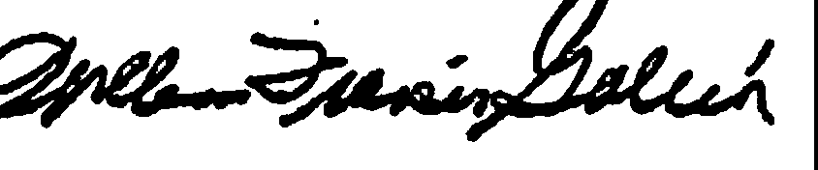

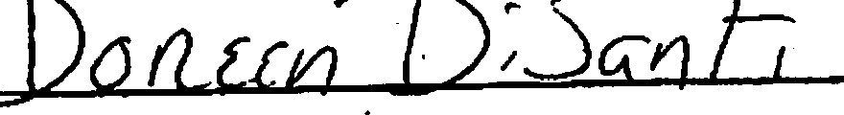

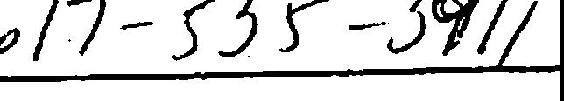

**Administrative marks - can ignore**