 | Massachusetts Department of Environmental Protection  Bureau of Resource Protection – Drinking Water Program  Declassification / Reclassification  Application |  |  |  | PWS ID
See Instructions  Important: When filling out forms on the computer, use only the tab key to move your cursor - do not use the return key.  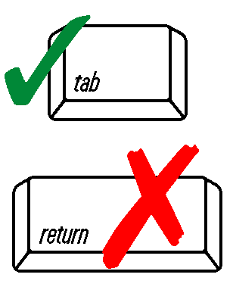 | A. Public Water Supply Information
 | PWS Name
PWS Mailing Address

City (bars 24)
PWS Location (if different)

Zip Code (bars 24)
 | Contact Person and Phone Number
 | email address
Present system classification (check one):
Community Non-Transient Non-Community Transient Non-Community
 | B. Declassification/Reclassification Information
 | Request for: Declassification or Reclassification to: Com NTNC TNC
 |  | Ownership Type: Private Municipal State Federal
Service area served by your water system:
Residential Academic Industrial Health Facility Commercial
Recreational Other (specify)

 |  | Population served or using the facility:
 |  | Is the facility used all year long or seasonal from through
 |  | Total number of days per year that 25 or more people use the facility: days per year
 |  | Total number of service connections:
 |  | Total number of sources (include active, inactive, emergency, and backup):
Source Type:
Ground water: sand/gravel well bedrock well
Surface water: spring river/reservoir
Purchase from: PWS name ____________________ PWS ID number ___________

 |  | Reason for this declassification or reclassification request: (Use additional sheet if necessary)
 |  | PWS Owner/Responsible Party Name: print
 |  | Signature: |  | Date:
 | C. Board of Health Use Only
Please note: Boards of Health must consider at least one year of written daily attendance logs when determining the population of a facility.

Acknowledgement of the declassification or reclassification of _____________________________
The Board of Health for the city/town of ______________________________________________
acknowledges that the petitioner of this request is no longer a public water system
or
be reclassified as a COM TNC NTNC according to the definitions in the Massachusetts drinking water regulations 310 CMR 22.00.

BoH Agent Name: (print) ___________________________________________________________

Signature: ______________________________________ Date: ________________________

 | D. MassDEP Use Only
 | Approved Denied
 | Reason this request being denied:
 | MassDEP Official Name: (print) ______________________________________________________
 | Signature: _______________________________________ Date: _______________________

Instructions:
This form should be used for any registered/active public water system (PWS) that feels it does not meet the definition of a PWS or its present assigned classification, as defined in the Massachusetts Drinking Water Regulations 310 CMR 22.00, and requests that its status be declassified or reclassified.

Please be advised that if declassification or reclassification is granted, subsequent requests to be reclassified as a PWS will require meeting all of the Department of Environmental Protection’s (MassDEP) standards in effect at the time the request for reclassification is made. For example, a grandfathered PWS which lacks the required protective radius around its well source, and whose request for declassification is granted, would have to comply with all MassDEP’s requirements before the water system could again be approved as a PWS.

Please note that if a water system requests its declassification as a PWS or its reclassification to a different class, but subsequently operates the water system without MassDEP’s prior approval or notification, that water system may be subject to enforcement action including monetary penalties.

