ISPE Poster_Aditi_Layout 1 8/17/15 11:18 AM Page 1

**Decrease in Diagnosed Abuse, Addiction, and Opioid Poisoning among Patients**

**Prescribed Opioids after Introduction of OxyContin with Abuse-Deterrent Characteristics**



Aditi Kadakia, Paul Coplan

Purdue Pharma L.P., Stamford, CT, 06901

INTRODUCTION



■ Abuse of prescription opioids is a serious public health problem

■ This study assessed the effect of reformulating OxyContin with abuse- deterrent characteristics in August 2010 on rates of diagnosed abuse, addiction/dependence and opioid overdose/poisoning rates among patients prescribed opioids

RESULTS (CONT.)

**Figure 1. Opioid overdose/poisoning diagnosis rate in patients dispensed one opi- oid, by type of opioid**

OBJECTIVES



■ To assess changes in rates of diagnosed opioid abuse, addiction or poisoning among patients dispensed OxyContin without concomitant opioids after introduction of reformulated OxyContin

■ To compare change in rates among patients dispensed OxyContin with changes among patients prescribed comparator opioid products consisting of two extended-release opioids and two immediate-release opioids

■ The time frame used a baseline pre-reformulation period one year before introduction of reformulation in August 2010 versus three years after its reformulation

METHODS



■ **Study Design:** retrospective cohort study

■ **Dataset:** Truven MarketScan commercial database, August 2009- October 2013

■ **Population:**

• patients 18-64 years of age

• incident or prevalent users of Oxycontin or 4 comparator opioids

– ER morphine, ER oxymorphone, IR hydromorphone, IR oxycodone single-entity (SE),

• separate cohorts were included for each opioid

■ **Study period:** divided in three time frames

• 1 year before reformulation of Oxycontin (August 2009 – July 2010)

• 3 months of transition period (August 2010 – October 2010)

• 3 years after reformulation period (November 2010 – October 2013)

■ **Opioid use:**

• Duration of continuous use defined by ≤15 days between prescriptions plus 15 days from the end of last prescription to account for an allowable gap and to capture events that might not be diagnosed during the prescription duration.

■ **Patient time of opioid use:**

• Patient time of opioid use started on the date of the initial dispensing of opioid and ended at the date that the dispensed opioid prescription ended or a diagnosed abuse, addiction or overdose event occurred, whichever came first.

■ **Diagnosed event of interest:**

• Based on ICD-9 CM diagnostic codes

– Abuse used 305.5x codes

– Addiction/dependence used 304.0x and 304.7x codes

– Poisoning/overdose used 965.00, 965.02 and 965.09 codes

• **Classification of cases:**

• Cases with event of interest were classified based on opioids used on the day of diagnosed event or within 29 days prior to the event

■ **Rates of diagnosed events:**

• Rates per 100 person years of opioid use were calculated among patients prescribed OxyContin and comparator opioids

• Change in rates one year before vs. three years after OxyContin reformulation assessed using Poisson regression

**Figure 2. Opioid addiction/dependence diagnosis rate among patients dispensed one opioid, by type of opioid**

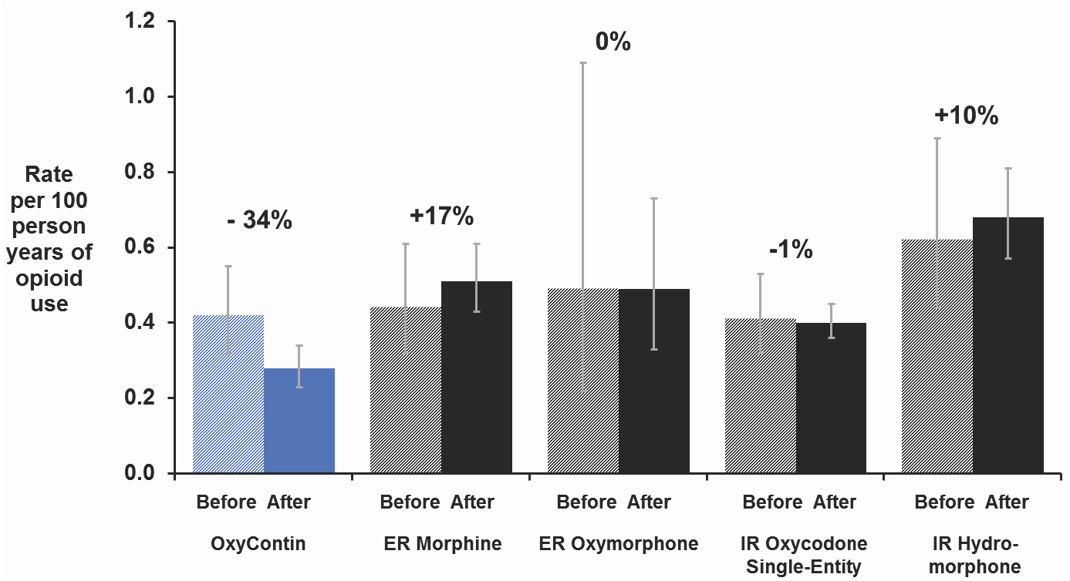

**Figure 3. Opioid abuse diagnosis rate among patients dispensed one opioid, by type of opioid**

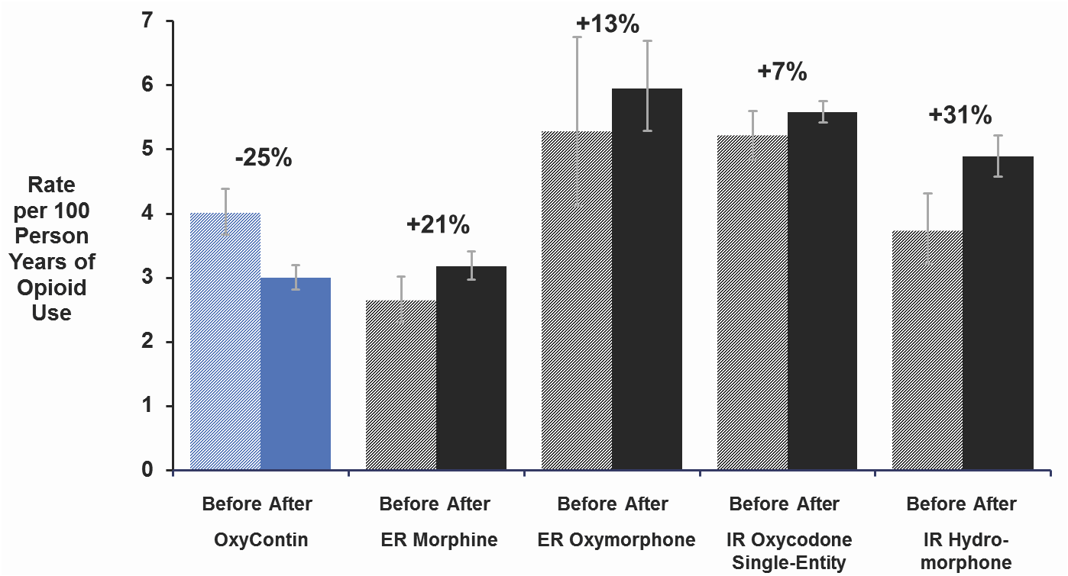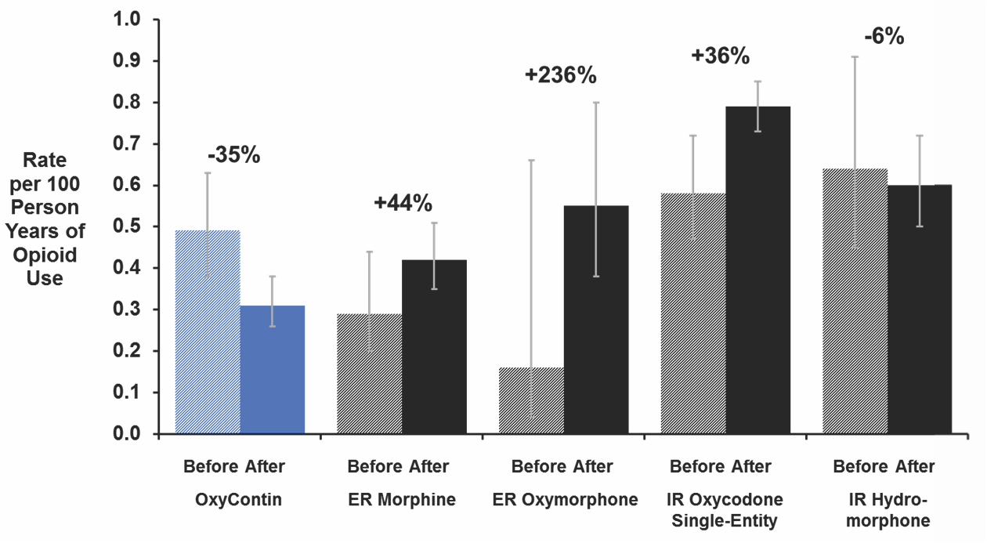

**Table 2. Changes in number of diagnosed cases, number of patients, and person time, by type of opioid**

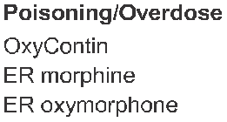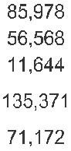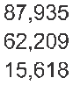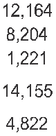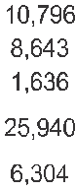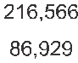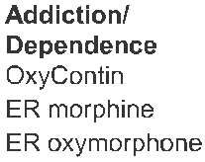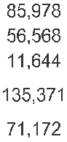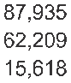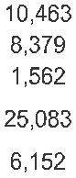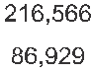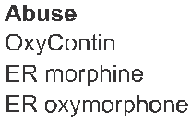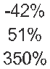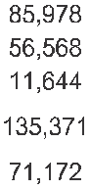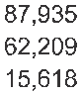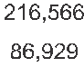

RESULTS



■ Among patients prescribed OxyContin without other concomitant opioids, changes in rates of diagnosed events were:

• A decrease in overdose/poisoning by 34% (95% CI -53%, -7%)

• A decrease in addiction/dependence by 25% (95% CI -33%, -16%)

• A decrease in abuse by 35% (95% CI -53%, -11%)

■ Change in rates of diagnosed opioid overdose/poisoning, opioid addiction/dependence and opioid abuse among patients dispensed primary opioid without concomitant opioids are shown in figure 1, 2, and 3 respectively.

■ Reduction in rates of opioid overdose/poisoning for were significantly different from the change from baseline for ER Morphine. (Table 1)

■ Decrease in rates of opioid addiction/dependence and opioid abuse was significantly different from the change from baseline for the 4 comparator opioids (Table 1).

■ The rate of opioid overdose/poisoning, opioid addiction/dependence and opioid abuse among patients dispensed OxyContin without concomitant opioids in the 3 years after reformulation was lesser than all the comparator opioids. (Table 1).

■ The number of diagnosed cases, patients prescribed opioids and person time exposure on opioids for 1 year before as well as mean of 3 years after is presented in table 2.

**Table 1. Difference in change from baseline for OxyContin vs. comparator opioids**

|  |  |  |  |  |  |  |  |
| --- | --- | --- | --- | --- | --- | --- | --- |
|  | **Opioid**  **Dispensed** | **Rate per 100**  **Person years**  **Aug 2009-**  **2010** | **Rate per 100**  **Person years Nov 2010- Oct 2013** | **% Change** | **95% CI** | **p-value for within opioid**  **pre-post change** | **p-value for between- opioid difference in change from**  **baseline** |
| **Poisoning/Overdose** | | | | | | |
| OxyContin | 0.42 | 0.28 | -34% | (-53%,-7%) | 0.019* | Reference |
| ER morphine | 0.44 | 0.51 | 17% | (-19%, 69%) | 0.406 | 0.027* |
| ER oxymorphone | 0.49 | 0.49 | 0% | (-59%, 143%) | 0.992 | 0.406 |
| IR oxycodone SE | 0.41 | 0.40 | -1% | (-25%, 31%) | 0.932 | 0.078 |
| IR hydromorphone | 0.62 | 0.68 | 10% | (-26%, 63%) | 0.650 | 0.060 |
| **Addiction/Dependence** | | | | | | |
| OxyContin | 4.01 | 3.00 | -25% | (-33%, -16%) | <.0001* | Ref |
| ER morphine | 2.64 | 3.18 | 21% | (4%, 40%) | 0.015* | <.0001* |
| ER oxymorphone | 5.27 | 5.95 | 13% | (-14%, 48%) | 0.386 | 0.006* |
| IR oxycodone SE | 5.21 | 5.58 | 7% | (-1%, 16%) | 0.083 | <.0001* |
| IR hydromorphone | 3.73 | 4.89 | 31% | (12%, 54%) | 0.009* | <.0001* |
| **Abuse** | | | | | | |
| OxyContin | 0.49 | 0.31 | -35% | (-53%,-11%) | 0.008* | Reference |
| ER morphine | 0.29 | 0.42 | 44% | (-8%, 123%) | 0.108 | 0.004* |
| ER oxymorphone | 0.16 | 0.55 | 236% | (-20%, 1,312%) | 0.098 | 0.027* |
| IR oxycodone SE | 0.58 | 0.79 | 36% | (8%, 71%) | 0.009* | 0.000* |
| IR hydromorphone | 0.64 | 0.60 | -6% | (-37%, 39%) | 0.705 | 0.158 |
|  | | | | | | | |

LIMITATIONS

■ Does not capture Medicare and Medicaid patients

• Preliminary analyses show similar trends in Medicaid-insured populations.

■ Not all diagnoses are accurate

• Diagnoses of opioid abuse, addiction and opioid overdose are measured by ICD-9-CM codes in administrative claims databases. ICD-

9 codes capture addiction and physical dependence with the same codes, as well as poisonings and overdose with the same codes. Analyses could not separate these out.

• Abuse, addiction or overdose may have been due to opioids other than the dispensed opioid; however heroin abuse, addiction or overdose is coded using different ICD-9-CM codes than prescription opioids.

■ Not all events are diagnosed

• This is applicable especially to fatal overdoses.

■ Does not capture route of abuse

• Route of abuse is captured in other studies like poison centers or substance abuse treatment centers.

■ In patients using multiple opioids one cannot identify which opioid associated with addiction, abuse or overdose

• We considered rates associated with single opioid use only for the primary analyses which provided greater assurance that OxyContin was associated with the event.

■ No analyses for changes in patient characteristics for pre- post Oxycontin reformulation were conducted for patients using Oxycontin or for comparing pre- post changes for OxyContin to comparator opioids

• Part of the impact of an abuse-deterrent formulation could be to change patient demographics because abusers stopped taking the medication after reformulation and adjustment for such changes could lead to over adjustment.

• Comparison of changes in rates of abuse, addiction or poisoning for oxycontin to those of comparator opioids compared the change within each opioid group so that any covariate difference between type of opioid was relatively consistent from pre to post period.



CONCLUSIONS



■ The rates of diagnosed overdose/poisoning, addiction/dependence and abuse per 100 person-years of one opioid use decreased among patients dispensed OxyContin in a commercially insured population after introduction of reformulated OxyContin

■ The change from baseline for OxyContin was different from that for comparator opioids

• Statistically significant for the more frequently diagnosed category of addiction/dependence

Disclosure Statement

Research funded by Purdue Pharma L.P.

A Kadakia and P Coplan are employees of Purdue Pharma L.P.

Presented at the International Society for Pharmacoepidemiology Annual Meeting, Boston, MA, August 23-26, 2015