**Municipal Vulnerability Preparedness Program Action Grant Case Study**

**Municipality:** *Town of Deerfield*

**Project Title:**  *Deerfield Green Infrastructure and Culvert Resiliency*

**Award Year (FY):** *FY19*

**Grant Award:** *$ 278,023*

**Match: *$****111,066*

**Match Source:** *Town of Deerfield general funds and in-kind contributions*

*•* Total Project Match: $111,066

• $78,056 cash (departmental available funds)

• $33,100 in-kind match, including:

$3,600 (in-kind match) Project Coordinator – Town Administrator (90 hours x $39.78/hour)

$5,000 (in-kind match) - Dept. of Public Works Superintendent, Kevin Scarborough

(123 hours x $40.58)

$2,650 (in-kind match) - Laurie McComb, Emergency Management Director (107 hours x $24.69)

$1,850 (in-kind match) - Volunteer Selectboard (5 members) (75 hours x $24.69)

$20,000 (in-kind contributions) - from Deerfield Academy, Eaglebrook School, Frontier High School, Franklin Land Trust

**One or Two Year Project:** *Two year project*

**Municipal Department Leading Project:**  *Town Administrator and Selectboard*

**Project Website URL:**

**Community Overview:**

* What is the population size of your community and where is it located?
* Do you have any [Environmental Justice](http://maps.massgis.state.ma.us/map_ol/ej.php) or other Climate Vulnerable communities? (Think about both those who live and work in your town.)
* Other unique traits of your municipality like who the top employers are, geography, history, etc.

*Incorporated in 1673, the Town of Deerfield is located in Franklin County, along the Connecticut River and Deerfield River Valleys in Western Massachusetts. Deerfield has a population of 5,125, and a Selectboard form of government. Deerfield was the first town in Massachusetts to be certified as an MVP community. Being a relatively small, rural community, Deerfield does not have any Environmental Justice or Climate Vulnerable communities. Deerfield is a river valley community, which is bounded by the Connecticut River on the east, and the Deerfield River on the north. The largest employer in Deerfield is Yankee Candle. The town includes Historic Deerfield, a museum dedicated to the heritage and preservation of Deerfield, Massachusetts, and history of the Connecticut River Valley. Its historic houses, museums, and programs provide visitors with an understanding of New England's historic villages and countryside.*

**Project Description and Goals:**

* Where was the project located?

*The construction component of the project was located in Old Deerfield village, where a culvert was replaced on Mill Village Road. Additional areas of focus for design and planning components were South Deerfield town center, including Kelleher Drive (where a culvert replacement was designed), Main and Elm Streets (where a series of tree box filters were designed), the Deerfield Elementary School (where two rain gardens and one tree box filter were designed), and the Deerfield River, (where a flood evacuation plan and floodplain conservation plan were focused).*

* What climate change impacts did the project address?

*Deerfield’s most important climate-related problem, and the one that this project is primarily designed to address, is flooding. Other related and priority threats are tropical storms and dam failures. Deerfield is a low-lying town located at the confluence of the Deerfield River and the Connecticut River. The Connecticut River is New England’s longest river, with a huge watershed. Deerfield is at the bottom of the watershed of the Deerfield River, a fast flowing river with headwaters in the Green Mountains of Vermont, that is susceptible to major floods as seen in 2011 with Tropical Storm Irene. Localized flooding, particularly on Bloody Brook in the town center, is also a frequent problem every year.*

*Areas in Deerfield that are highly vulnerable to flooding are Old Deerfield village on the Deerfield River and the town center on Bloody Brook. Old Deerfield, which has vulnerable student populations at Deerfield Academy, Bement School and Eaglebrook School, was heavily flooded during Tropical Storm Irene. Bloody Brook causes flood damages at least once a year in the town center, particularly along North Main Street. Bloody Brook has vulnerable student populations immediately adjacent to the brook at Frontier Regional High School and Deerfield Elementary School. In the areas subject to frequent flooding, Deerfield has tested mosquitoes positively for seven years for West Nile virus, making flooding a significant public health threat in town as well.*

* What were the specific goals and tasks of the project as stated in your application?
* Did your project meet the goals set forth in your application in terms of:
  + Employing nature-based solutions
  + Improving equitable outcomes for and fostering strong partnerships with EJ and other Climate Vulnerable Populations
  + Providing regional benefits
  + Implementing the public involvement and community engagement plan set forth in your application
  + Finishing the project on time

***Project Goals:***

*Deerfield’s most important climate-related problem, and the one that this project was primarily designed to address, is flooding. Other related and priority threats are tropical storms and dam failures. Deerfield is a low-lying town located at the confluence of the Deerfield River and the Connecticut River. The Connecticut River is New England’s longest river, with a huge watershed. Deerfield is at the bottom of the watershed of the Deerfield River, a fast flowing river with headwaters in the Green Mountains of Vermont, that is susceptible to major floods as seen in 2011 with Tropical Storm Irene. Localized flooding, particularly on Bloody Brook in the town center, is also a frequent problem every year. Areas in Deerfield that are highly vulnerable to flooding are Old Deerfield village on the Deerfield River and the town center on Bloody Brook. Old Deerfield, which is to vulnerable student populations at Deerfield Academy, Bement School and Eaglebrook School, was heavily flooded during Tropical Storm Irene. Bloody Brook causes flood damages at least once a year in the town center, particularly along North Main Street.*

*This project addressed flooding problems and climate change adaptation in a variety of ways. The project promoted nature based solutions and public awareness of climate resiliency issues through the design of green streets in the town center and rain gardens at two schools to help reduce town center flooding from Bloody Brook. The municipal Green Infrastructure Policy is an innovative approach to promoting the use of green infrastructure in all future municipal public works projects and developments. The townwide Climate Resiliency Forum attracted over 150 participants and greatly increased awareness in Deerfield residents and businesses about climate change impacts and needs for climate resiliency, including what people can do about these issues.*

*The project directly addressed flooding problems caused by damaged or highly vulnerable culverts, through the physical replacement of two priority culverts with open bottom culverts sized for climate change and designed for wildlife passage. The completed design plans for replacement of the Kelleher Drive culvert helps alleviate chronic flooding on Bloody Brook in the town center, and the replacement of the collapsed Mill Village Road culvert allowed that partially closed road to re-open.*

*This project succeeded in meeting our goals for community outreach and education. Public awareness of, and preparedness for, flooding vulnerabilities was enhanced through the development of an Evacuation Action Plan for Old Deerfield and other town neighborhoods vulnerable to major floods, and through an outreach campaign on awareness of the town’s new Rave Alert notification program. The Evacuation Action Plan engaged Deerfield’s private schools, Historic Deerfield officials and businesses in a task force to coordinate evacuation strategies.*

*Deerfield hosted a day-long townwide public forum, with the theme of “Climate Resiliency: Deerfield 2030”, attended by 150 participants. This forum had workshop sessions on a variety of topics related to climate resiliency needs, town actions to increase climate resiliency, and individual actions to reduce carbon footprints. This forum increased public awareness of climate issues and the MVP Plan, and broadly engaged town residents, farmers and businesses in climate action.*

*The green infrastructure improvements, including design of tree box filters and rain gardens, are nature-based solutions that will be located at highly visible locations in the town center and at Deerfield’s two public schools.*

*The townwide outreach to increase awareness of Deerfield’s new Rave emergency alert program was successful in broadly increasing participation of residents in the program.*

***Project Tasks:***

1. ***Construction of Replacement Culvert on Mill Village Road***

*The town, through its Selectboard, contracted with a contractor, Luciano’s Excavating Inc., to construct a new open bottom culvert to replace a partially collapsed and vulnerable culvert on Mill Village Road (near Old Main Street in Old Deerfield over an unnamed tributary to the Deerfield River). This culvert was constructed with an open bottom culvert to improve flow and fish/wildlife passage, reduce flooding and protect public safety.*

*The Mill Village Road culvert was listed as Deerfield’s top priority culvert for replacement in the approved Deerfield Municipal Vulnerability Plan, due to danger of further collapse of the existing culvert and roadway. Design, engineering and permitting for this project were completed by engineering consultants Tighe and Bond Inc., and funded under a previous MVP Implementation grant.*

*The selected contractor successfully installed the replacement culvert for Mill Village Road. This task included the following components:*

* *Install erosion and sedimentation controls*
* *Install temporary road*
* *Install cofferdam*
* *Excavate and remove existing failed culvert*
* *Install three sided precast culvert and restore stream channel*
* *Remove cofferdam*
* *Restore site and pave road.*
* *Remove and restore temporary road.*

*Tighe and Bond, the engineering consultant that prepared the engineering design plans for the Mill Village Road culvert, provided construction administration and oversight. The contractor provided the following bidding services: construction advertising; distribution of bidding documents; attend a pre-bid conference, respond to bidder questions, and prepare addenda to bidding documents; attend the public bid opening; review qualified bids received; and make a recommendation to the town on contract award.*

*Tighe and Bond also provided the following services during construction: conducted a pre-construction conference; provided support interpreting and clarifying contract documents and provisions as well as Requests for Information (RFI’s); review, reject/approve, and process shop drawings/submittals from the selected Contractor for Contract compliance; review and approve up to 2 pay requests from the Contractor; provide full time onsite construction services during active construction.*

1. ***Design and Permitting for Replacement Culvert on Kelleher Drive at Bloody Brook***

*The town, through its Selectboard, contracted with an engineering consultant, Tighe and Bond Inc., to prepare engineering design plans to replace an undersized and vulnerable culvert on Kelleher Drive (near North Main Street over Bloody Brook) with an open bottom culvert to improve flow and fish/wildlife passage, reduce flooding and protect public safety.*

*The Kelleher Drive culvert is listed as Deerfield’s second priority culvert for replacement in the approved Deerfield Municipal Vulnerability Plan, because it is a major contributor to the frequent flooding on Bloody Brook in Deerfield town center along North Main Street.*

*Based on a site visit with an engineer, the existing culvert is showing signs of imminent failure (sinkholes in the road indicating the ceiling of the pipe has perforations). The culvert also appears to be a significant restriction to upstream flow and is the cause of some significant localized flooding. The culvert needs immediate replacement and the Town has prioritized replacement of the culvert before it completely fails. This area has frequent flooding problems and the culvert size was evaluated.*

*Tighe and Bond prepared engineering design plans for an open-bottom replacement culvert and a traffic diversion plan for the culvert installation, including:*

* *Geotechnical Borings and Site Reconnaissance*
* *Site Survey.*
* *Hydrologic and Hydraulic Analysis*
* *Design Drawings and an Opinion of Probable Construction Cost*
* *Project Specifications and Contract Document*
* *Jurisdictional wetland delineation in the vicinity of the culvert replacement project*
* *Notice of Intent (NOI) in accordance with the MAWPA for submittal to the Deerfield Conservation Commission*
* *Pre-Construction Notification application under Section 404 of the Clean Water Act and Massachusetts General Permits (MA GP), and pre-application coordination under Section 106 of the National Historic Preservation Act.*

1. ***Design for Green Streets Infrastructure Improvements in Town Center***

*Deerfield undertook several green infrastructure improvements in the town center area to help reduce stormwater discharged from paved surfaces and consequently the town’s flooding vulnerability from Bloody Brook, including the design of tree box filters and rain gardens. Deerfield selected EBI Consulting to complete this design work.*

*EBI completed engineering design plans for tree box filter installations at 8 sites and rain gardens at two sites, all in and around the Deerfield town center. The designs for the 8 tree box filters were completed for these locations: two each on Sugarloaf Street, Elm Street, North Main Street, and South Main Street, all in the vicinity of the Town Common.*

*EBI completed engineering design plans for two rain gardens at Deerfield Elementary School. The two rain gardens are located at the school student pick-up circle and at the parking lot at Bloody Brook.*

1. ***Green Infrastructure Policy for Town***

*The town’s MVP consultant worked with the Town Administrator, Selectboard and DPW to draft and refine a new Green Infrastructure Policy for the Town of Deerfield. This policy promotes the use of green street facilities and green infrastructure in public and private development through regulation, capital investment, and management mechanisms as a cost-effective and sustainable practice for stormwater management in current and future projects when technically and economically feasible. This includes road development and reconstruction, bicycle and pedestrian projects, stormwater projects, and other development and redevelopment.*

*The policy was drafted with input from Deerfield’s MVP Core Group, and was recommended to the Selectboard for adoption by that group. The Selectboard formally adopted the policy on April 22, 2020. Deerfield has subsequently taken multiple steps to implement the new policy.*

1. ***Public Education and Outreach on Climate Resiliency***

*The Town of Deerfield hosted a very successful and well-attended townwide forum on “Climate Resiliency: Deerfield 2030” on Saturday, February 29, 2020 at the Frontier Regional High School, with over 150 participants.*

*The goal of this forum was to inform and motivate residents about actions that they can take that will make a difference on climate change and climate resiliency. The forum featured workshops on a wide variety of topics including:*

*• Understanding Climate Change and Its Impacts*

*• Homeowner Strategies for Reducing Carbon Footprint*

*• Forestland Management and Wildlife Impacts in a Changing Climate*

*• Moving Toward Net Zero or Zero Energy Buildings*

*• Student Activities to Address Climate Change*

*• Climate Resiliency for Farming Activity*

*• Green Infrastructure and Green Energy Strategies for Deerfield*

*• Design Charrette for Downtown Vision: Complete and Green Streets*

1. ***Public Education on New Rave Alert System***

*Deerfield is transitioning from a Code Red alert system to a upgraded new Rave alert system for notifying town residents of emergencies. The Deerfield Emergency Management Director and other town officials prepared and mailed written fact sheets to all town residents to make them aware of the new system and how to use it. They will prepared social media materials, press releases and information for the town website to inform the public of this new system. The materials developed also increased public understanding of climate change impacts within and beyond the community.*

1. ***Evacuation Action Plan for Great River Hydro Emergencies***

*Great River Hydro operates a series of hydropower dams on the Deerfield River system. This company recently completed a set of inundation maps showing downstream areas that would be flooded in the event of a catastrophic failure of any of its dams. They also completed an emergency action plan with notification flow chart and electronic notification procedures to be employed in the event of a dam failure. The Great River Hydro EAP for Harriman Dam in Vermont, for example, notes that in the event of a catastrophic failure, Old Deerfield village, with its multiple private schools and popular historic tourism destination, would have 1.5 hours to evacuate before being hit by a massive wall of water. The EAP, however, does not go far enough to adequately prepare the town for this type of disaster, and further work is needed. It does not provide any details about how evacuations would be carried out, how student and public notification would occur, consider evacuation drills or address route closures.*

*The town’s MVP consultant and other school and town officials worked together to develop the “Flood Evacuation Action Plan for Old Deerfield Village” with implementation details for the EAP, including convening a task force meeting that includes officials from public safety directors from Deerfield Academy and Bement School, Historic Deerfield and Pocumtuck Valley Memorial Association, town emergency management officials to develop EAP implementation details for:*

* *Detailed Plans and Exercises for Evacuations*
* *Notification and Educational Tools for Affected Schools (Deerfield Academy and Bement) and other large employers (Historic Deerfield, Pocumtuck Valley Memorial Association)*
* *Notification and Educational Tools for All Residents on Town Website*

*The resulting Evacuation Action Plan will be incorporated into the next revision of Deerfield’s MVP plan, and was widely disseminated to schools, and other involved groups.*

1. ***Land Conservation in Deerfield River Floodplain***

*The town’s MVP consultant developed a prioritization plan, the “Land Conservation Plan for the Deerfield River Floodplain”, for protecting key land parcels in the Deerfield River floodplain that contribute to the town’s resiliency to flood impacts. The plan used criteria such as floodplain and floodway boundaries, flood storage capacity, wildlife habitat, buffering of vulnerable neighborhoods and schools, and others, to determine the most important land parcels to protect in Deerfield. The plan includes land conservation funding strategies to finance acquisition of key parcels, including private fundraising, grants and other strategies.*

1. ***Rainwater Harvesting***

*Work on this task was initiated by consultants, Tighe and Bond. Tighe and Bond completed initial calculations of rainfall at the site to help in sizing the system. A kick-off meeting of stakeholders was held with stakeholders. Based on the initial calculations, the amount of rainfall that could be captured from the accessible area of the high school roof was not sufficient to provide enough water for watering the school playing fields. Consequently, school officials made the decision not to continue to full engineering design of a rooftop rainwater harvesting system. The remaining funds for this task were transferred to other tasks.*

**Results and Deliverables:**

* Describe, and quantify (where possible) project results (e.g. square footage of habitat restored or created, increase in tree canopy coverage, etc.).  Report out on the metrics outlined in your application.

*The success of this project is measured in the following ways:*

* *The participation in Deerfield’s townwide Climate Resiliency Forum was extraordinarily high, with over 150 participants, and attendees’ feedback was very positive about the value of the forum.*
* *The “Flood Evacuation Action Plan for Old Deerfield Village” and the “Land Conservation Plan for the Deerfield River Floodplain” were both successful because they were formally approved and adopted by vote of the Deerfield Selectboard, and engaged other schools and organizations.*
* *The townwide mailing to raise awareness of the Rave emergency alert system was a success, because it broadly increased participation in the alert system.*
* *The Mill Village Road replacement culvert was successfully installed and is functioning exactly as designed. Upstream water levels and flooding have decreased since the installation.*
* *The design plans for the Kelleher Drive culvert replacement and the designs for the tree box filters and rain gardens were successful because they were constructed under a subsequent MVP grant.*
* *The Green Infrastructure Policy was a success, because it was adopted by the Deerfield Selectboard, as the first of its kind in Massachusetts to our knowledge. It has since been actively implemented by the newly appointed town Green Infrastructure Committee.*
* Provide a brief summary of project deliverables with web links, if available.

*Project deliverables included:*

* *Completed installation of Mill Village Road replacement culvert with an open bottom culvert designed to accommodate increased flows and fish and wildlife passage;*
* *Completed engineering design plan for Kelleher Drive replacement culvert with an open bottom culvert designed to accommodate increased flows and fish and wildlife passage;*
* *Completed engineering design plans for 8 tree box filters in the town center, and two rain gardens at the Elementary School;*
* *Drafted and adopted a new Green Infrastructure Policy for the Town of Deerfield;*
* *Coordinated a very successful and well-attended townwide forum on “Climate Resiliency: Deerfield 2030” on February 29, 2020 at the Frontier Regional High School;*
* *Raised public awareness of the town’s new Rave alert system for notifying town residents of emergencies, by preparing and mailing written fact sheets to all town residents*
* *Prepared and adopted the “Flood Evacuation Action Plan for Old Deerfield Village” and other floodprone areas to promote public safety;*
* *Developed and adopted the “Land Conservation Plan for the Deerfield River Floodplain”, a prioritization plan for protecting key land parcels in the Deerfield River floodplain.*

*Copies of all deliverables will be submitted separately.*

**Lessons Learned:**

* What lessons were learned as a result of the project?  Focus on both the technical matter of the project and process-oriented lessons learned.

*Lessons learned from this project included:*

1. *The residents of Deerfield are very engaged and interested in learning what they can do, and the town can do, to address climate change and resiliency. Our townwide Climate Forum was attended by about 150 participants, who were eager to learn about climate issues, such as building energy efficient homes and no till agriculture. Residents came from surrounding towns and expressed that they hoped their towns would hold a similar forum, or that a regional forum could be held.*
2. *A town Green Infrastructure policy can be a highly effective tool for advancing green infrastructure throughout the town. Deerfield has used its policy to make green purchases, establish a system to review new projects for conformance with green development performance standards.*

* What is the best way for other communities to learn from your project/process?

*Community officials can learn from Deerfield’s project by viewing Deerfield’s webinar presentation on green development performance standards and green infrastructure policy on EOEEA’s website. They can also visit the green infrastructure installations in Deerfield’s town center. The town’s newly adopted Green Infrastructure Policy and new plans for flood evacuation and floodplain land conservation will be posted on the town’s website and EOEEA’s website.*

**Partners and Other Support:**

* Include a list of all project partners and describe their role in supporting/assisting in the project.

1. *Deerfield Academy, Eaglebrook School, Bement School, Pocumtuck Valley Memorial Association and Historic Deerfield – participated in a task force for creating an emergency evacuation action plan for major flood events, and the schools supported the Climate Resiliency Forum by providing lunch and breakfast for participants.*
2. *Frontier High School – hosted the townwide Climate Resiliency Forum.*
3. *Deerfield Elementary School – hosted two rain gardens.*
4. *Deerfield Department of Public Works – coordinated construction and maintenance of replacement culvert for Mill Village Road, and design issues for tree box filters and rain gardens.*
5. *Deerfield Emergency Management – coordinated work on notification mailing to town residents on Rave emergency alert program.*

**Project Photos:**

* In your electronic submission of this report, please attach (as .jpg or .png) a few high-resolution (at least 300 pixels per inch) representative photos of the project.  Photos should not show persons who can be easily identified, and avoid inclusion of any copyrighted, trademarked, or branded logos in the images.  MVP may use these images on its website or other promotional purposes, so please also let us know if there is someone who should receive credit for taking the photo.

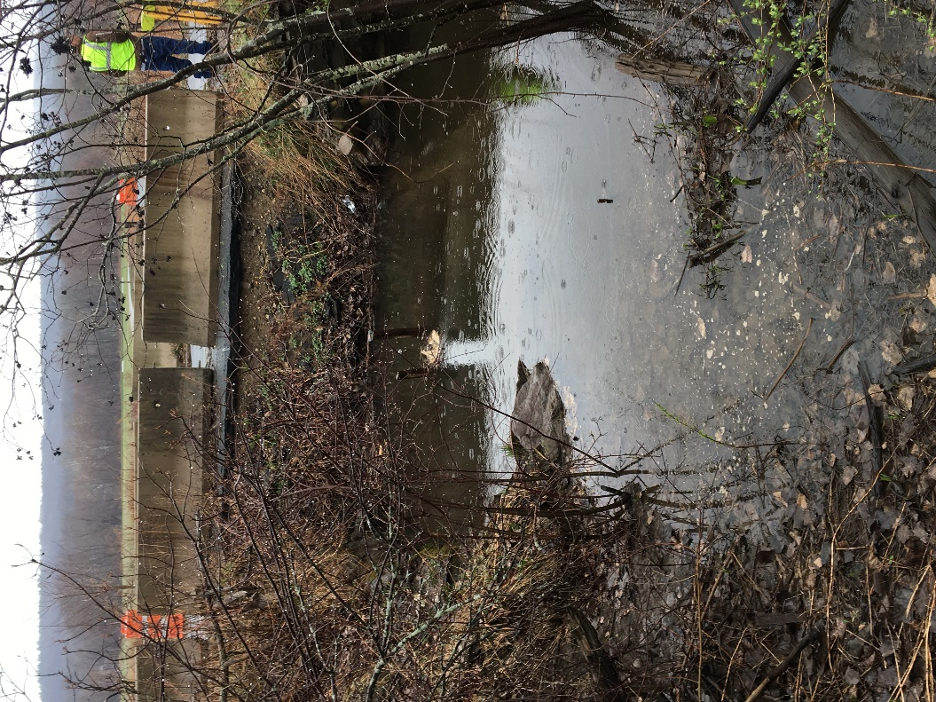

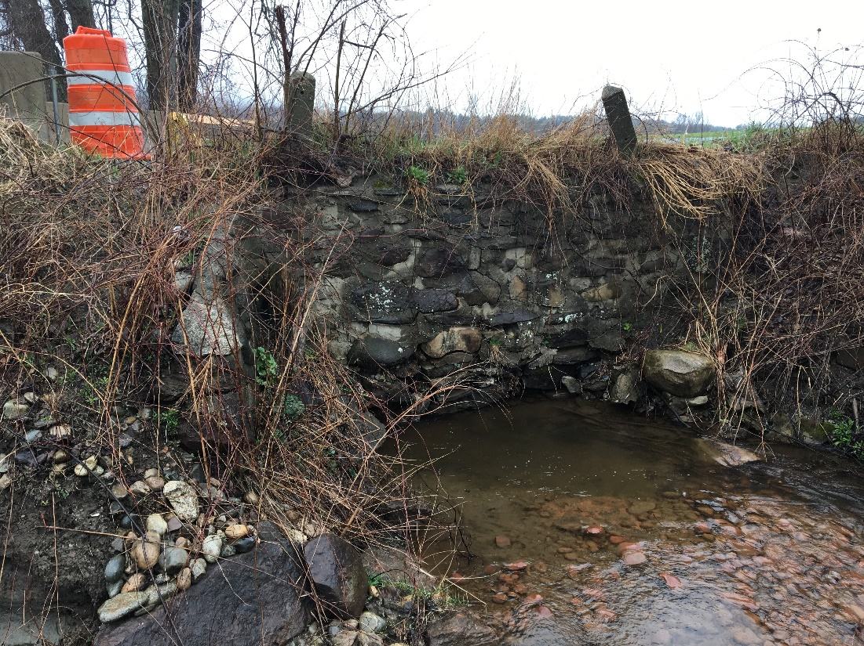

Flooding at Mill Village Road culvert before replacement

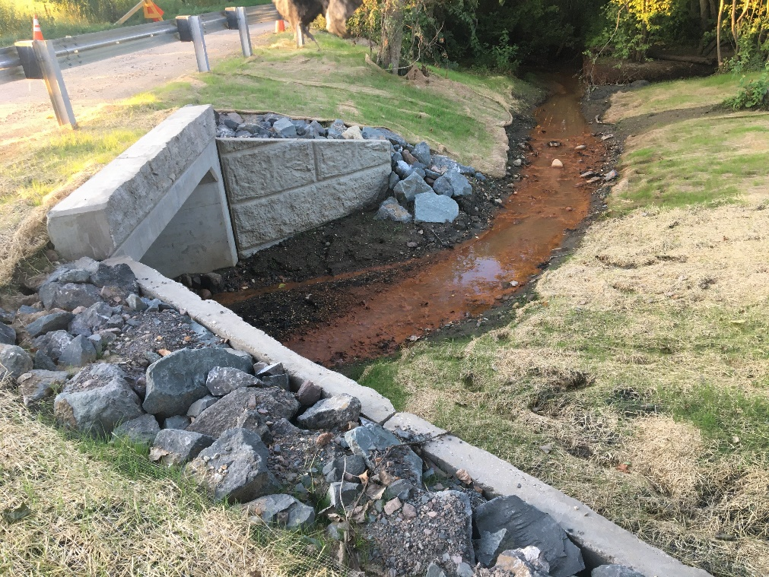

Mill Village Road culvert after replacement

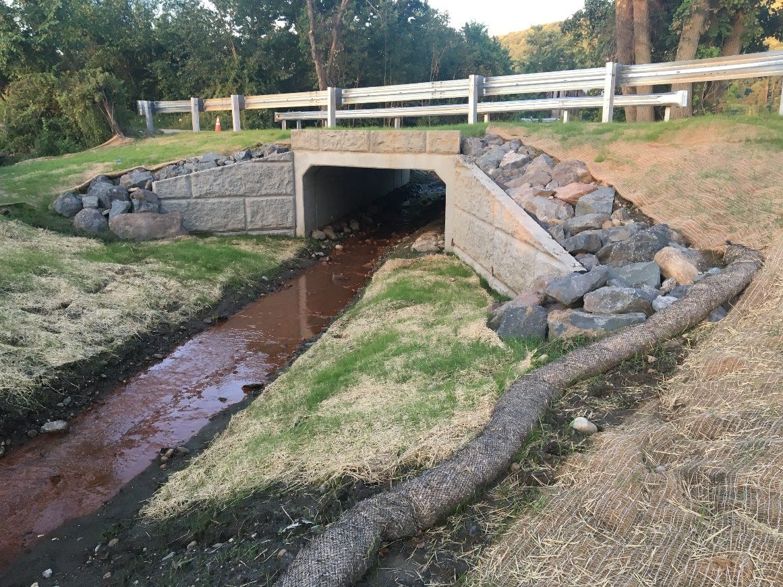

Mill Village Road culvert after replacement

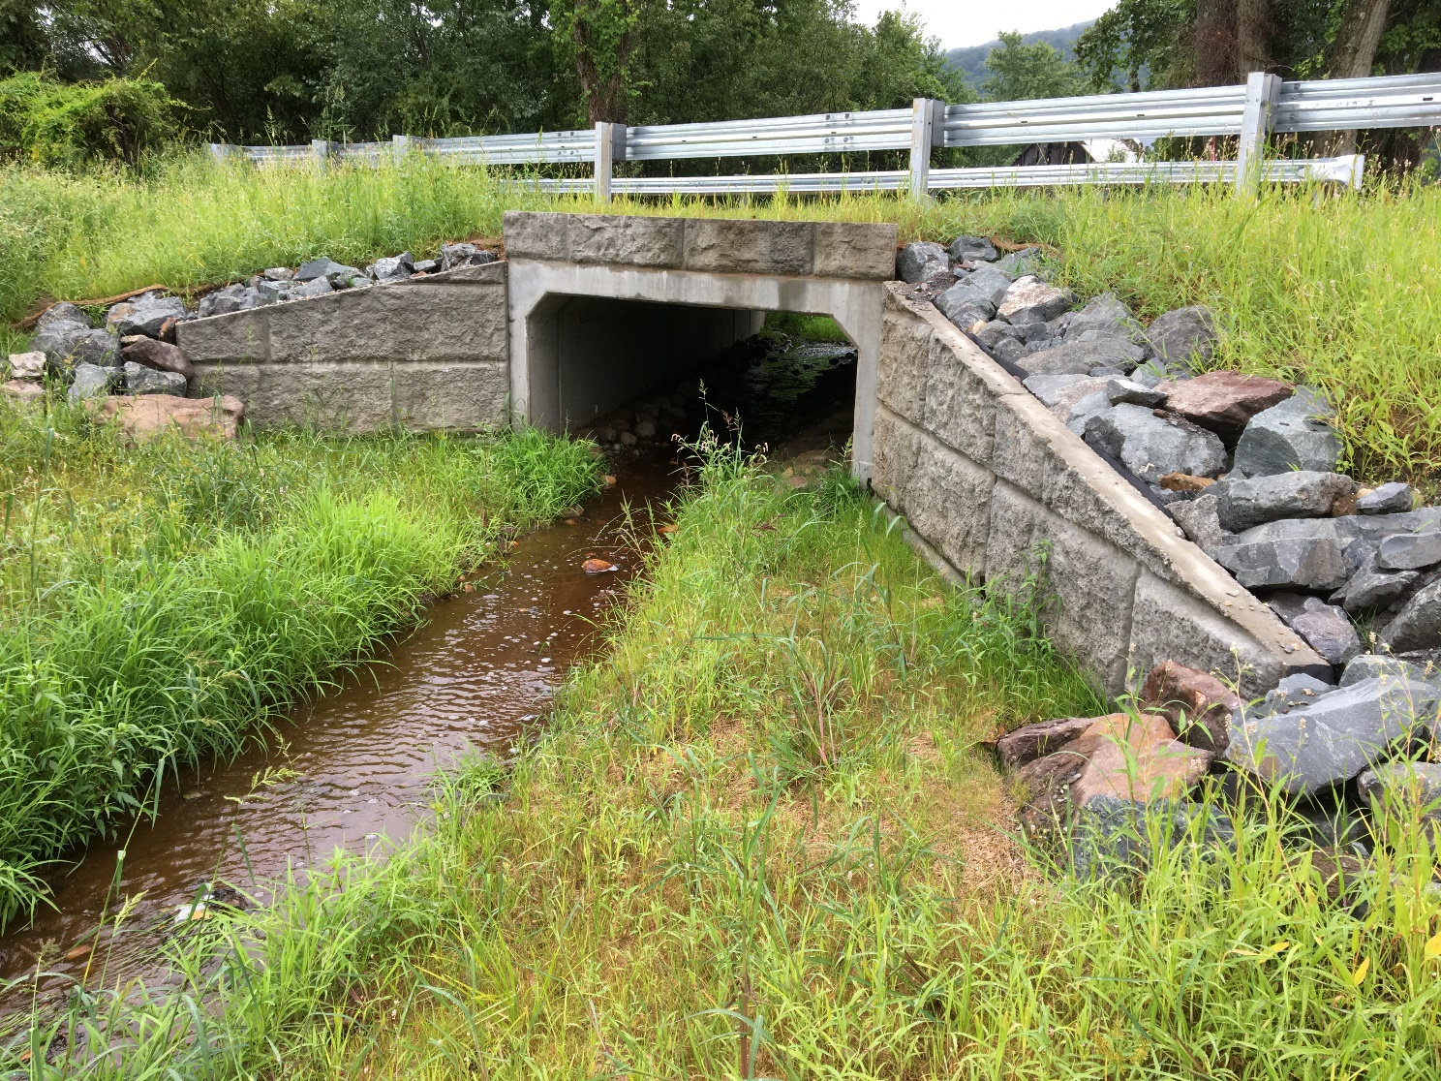

Mill Village Road culvert after replacement

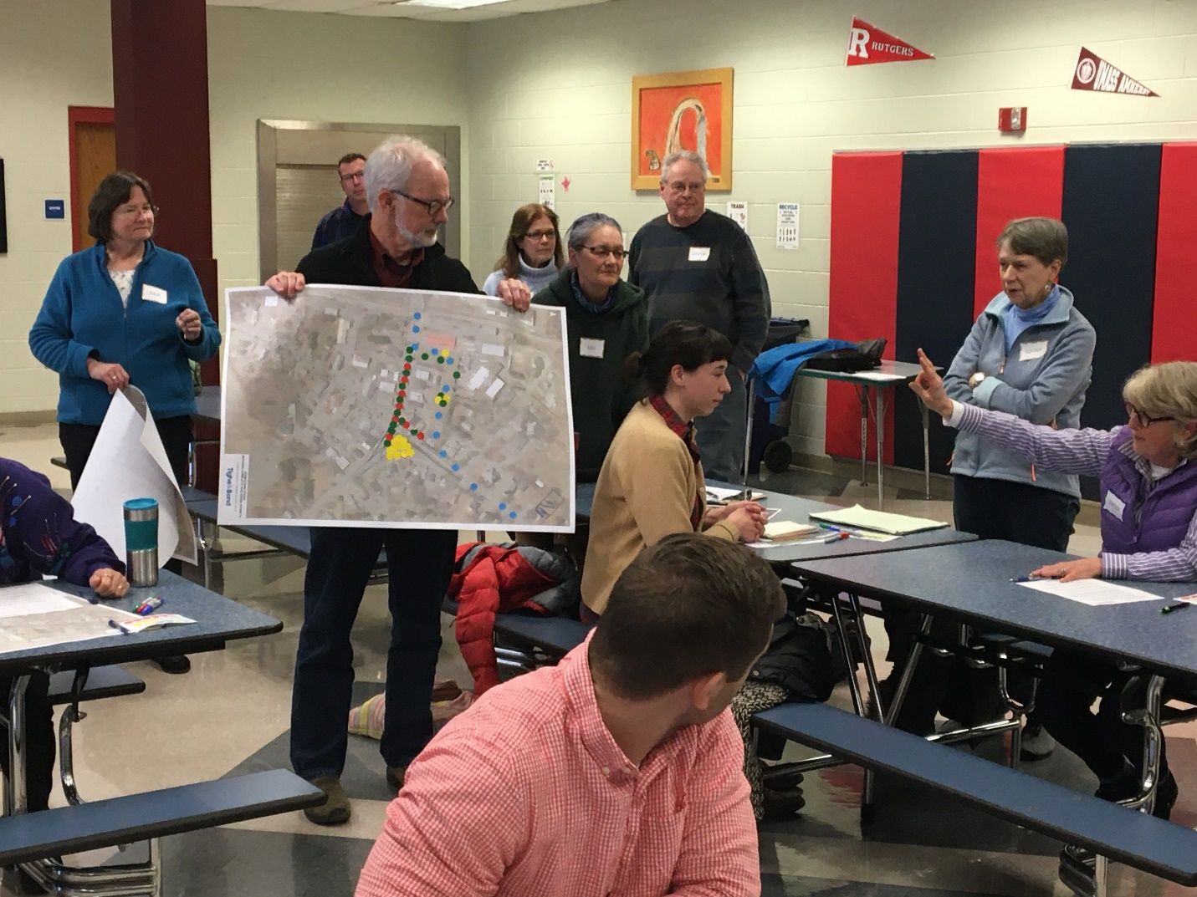

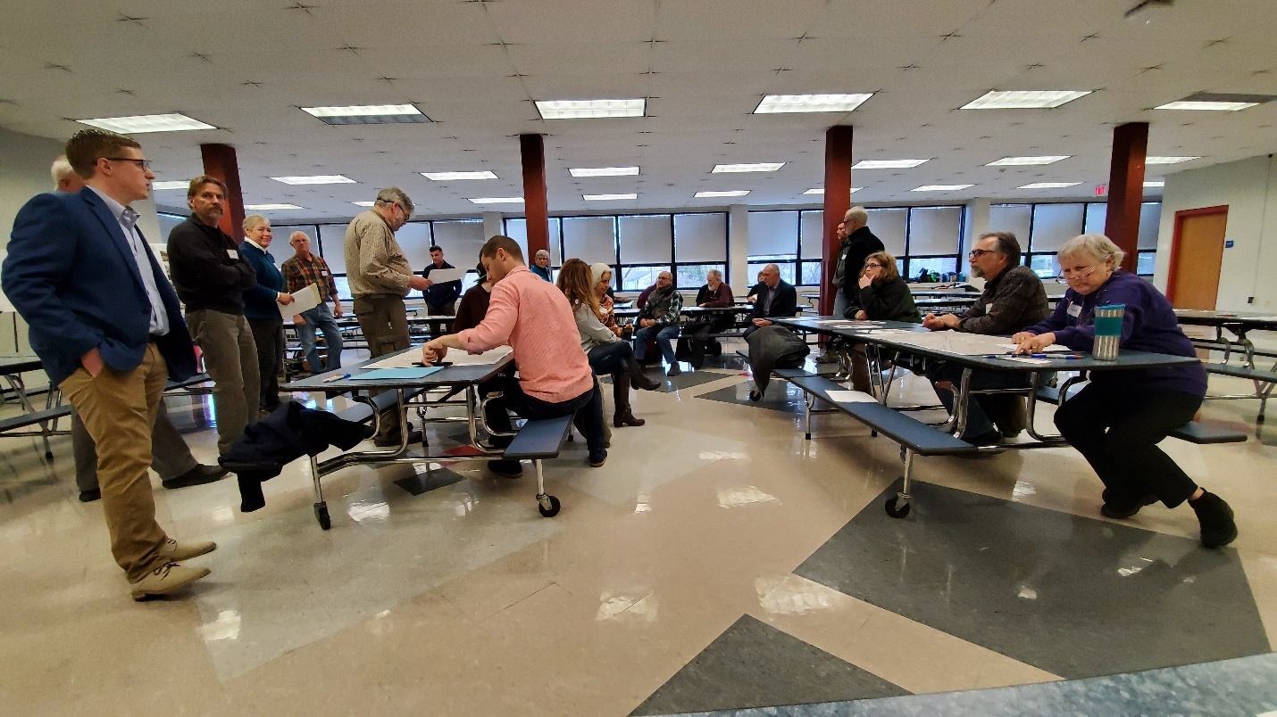

Design charrette at Deerfield’s Climate Resiliency Forum