**Municipal Vulnerability Preparedness Program Action Grant Case Study**

**Municipality:**  *Deerfield*

**Project Title:** *Healthy Soils, Green Infrastructure Policy and Climate Resiliency Public Engagement in Deerfield*

**Award Year (FY):** *FY22*

**Grant Award: $** *40,951*

**Match: $** *23,572*

**Match Source:** *Town cash and in-kind match, in-kind contributions from Atlantic Furniture, Deerfield Academy, Eaglebrook School, and Frontier Regional School*

**One or Two Year Project:**  *One year*

**Municipal Department Leading Project:**  *Selectboard*

**Project Website URL:** *https://www.deerfieldma.us/home/pages/climate-resiliency-and-mvp*

**Community Overview:**

*Incorporated in 1673, the Town of Deerfield is located in Franklin County, along the Connecticut River and Deerfield River Valleys in Western Massachusetts. Deerfield has a population of 5,125, and a Selectboard form of government. Deerfield was the first town in Massachusetts to be certified as an MVP community. Being a relatively small, rural community, Deerfield does not have any Environmental Justice or Climate Vulnerable communities. Deerfield is a river valley community, which is bounded by the Connecticut River on the east, and the Deerfield River on the north. The largest employer in Deerfield is Yankee Candle. The town includes Historic Deerfield, a museum dedicated to the heritage and preservation of Deerfield, Massachusetts, and history of the Connecticut River Valley. Its historic houses, museums, and programs provide visitors with an understanding of New England's historic villages and countryside.*

**Project Description and Goals:**

* Where was the project located?

*Areas of focus were the Deerfield Elementary School where two rain gardens were planted, and Frontier Regional School, where student engagement on climate issues took place, and a regional Climate Forum was held.*

* What climate change impacts did the project address?

*Deerfield has had excellent success over the past four years in advancing many of its recommended strategies in the town’s adopted MVP Plan. A key lesson learned from Deerfield’s MVP experience to date is that keeping the public, businesses, property owners and town officials engaged and involved is extremely important to the success of MVP initiatives. Our project proposed to do that in many ways. As Deerfield contemplates making more town expenditures for green infrastructure, climate resilient infrastructure, flood-proofing, electric vehicles and energy efficiency in municipal buildings, having better climate awareness among voters will be decisive when Town Meeting decisions are made on budgets.*

* What were the specific goals and tasks of the project as stated in your application?

*Deerfield has important MVP Plan goals to reduce the town’s carbon footprint and engage citizens in climate action and resiliency.*

Did your project meet the goals set forth in your application in terms of:

*All project goals were successfully met, including public involvement and engagement goals.*

* + Employing nature-based solutions

*This project was heavily focused on nature-based green infrastructure installations and designs through implementation of the town’s new Green Infrastructure and Climate Resiliency Policy. This policy promotes green, nature-based projects with all new town investments, public and private development projects, and in town zoning and building regulations.*

*Deerfield has experienced chronic flooding on Bloody Brook in the town center, and consequent serious public safety concerns with mosquitoes that have tested positive for bearing the West Nile virus for seven years. The town center has large areas of paved impervious surfaces that contribute to these flooding problems, and consequently Deerfield has selected green infrastructure as an appropriate and cost-effective nature-based solution to these problems.*

*Deerfield established a Green Infrastructure Policy Committee, comprised of officials from many town boards and departments, which met monthly throughout the project to implement the new policy with good success. The project resulted in successful implementation of green projects in many areas of town, and the development of a Green Infrastructure Policy Implementation Plan, listing prioritized projects, funding sources and lead entities.*

* + Improving equitable outcomes for and fostering strong partnerships with EJ and other Climate Vulnerable Populations

*Deerfield is a small town in western Massachusetts with no EJ population.*

* + Providing regional benefits

*Deerfield coordinated and hosted a highly successful regional Climate Forum, co-sponsored by Whately, Sunderland and Conway, and attended by about 120 participants. The forum featured over 30 speakers and workshops.*

*The implementation of a climate science curriculum and related student projects at Frontier Regional High School served the communities of Deerfield, Whately, Conway and Sunderland which share this regional facility, so it is by definition regional.*

*Deerfield implemented its new “Green Infrastructure and Climate Resiliency” town policy, which is the first of its kind in Massachusetts, and has benefits extending across the entire town, and in fact across Massachusetts as a ground-breaking initiative and model for other communities.*

*Finally, the Health Soils demonstration project is a unique opportunity to illustrate how the state’s new Healthy Soils initiative can be carried out in a community setting, providing again an effective model for other communities around Massachusetts.*

* + Implementing the public involvement and community engagement plan set forth in your application

• *Healthy Soils Initiative: Two public meetings and two Planning Board meetings were held, to gather community input and present findings, as part of Healthy Soils task.*

*• Green Infrastructure Policy: This task included regular monthly meetings of Deerfield MVP Core Group and of Green Infrastructure and Climate Resiliency Committee, coordinated to guide and implement the new town policy.*

*• Frontier Student Engagement: This task included the filming and editing of five class presentations on climate issues, for use in multiple Frontier High School and Middle School science classes, and coordination of a climate science curriculum with science teachers. This task also featured Involvement of high school students in the design, planting and maintenance of rain gardens.*

*• Climate Forum: Deerfield held a townwide and regional Climate Resiliency Forum with over 30 workshops on climate change impacts and climate resiliency strategies, including describing all Municipal Vulnerability Preparedness projects that have been completed in the town’s previous MVP grants. For each workshop, a powerpoint presentation and handouts were prepared to better inform the public. All of these presentations were videotaped and are available on the Town of Deerfield website at <https://www.deerfieldma.us/home/pages/climate-resiliency-and-mvp> and at the Franklin Community Access Television website at* [*https://www.youtube.com/user/FCATMedia/videos*](https://www.youtube.com/user/FCATMedia/videos)*.*

*• Website: Deerfield created a Climate Resiliency section on the town’s website to post descriptions and updates on all town MVP projects, including deliverables, design plans and powerpoint presentations.*

* + Finishing the project on time

*All tasks in the project were completed according to the scope and on time.*

**Results and Deliverables:**

* Describe, and quantify (where possible) project results (e.g. square footage of habitat restored or created, increase in tree canopy coverage, etc.).  Report out on the metrics outlined in your application.

• *The success of the new Deerfield “Green Infrastructure and Climate Resiliency” policy was tracked by the Deerfield MVP Core Group. They tracked the success by creating a Green Infrastructure Implementation Plan, and evaluating the components of the policy put into place (i.e. number of electric vehicles and EV charging stations purchased, LED streetlights installed, etc.), including regulations to promote green development, in Deerfield.*

*• The success of the Healthy Soils demonstration, the climate science class programming, and rain garden plantings is measured by the successful completion of the scopes of work. All of these tasks were completed successfully.*

*• The success of the townwide Climate Forum is measured by the number of workshops (32 in total), participants and attendees (120) at the forum.*

* Provide a brief summary of project deliverables with web links, if available.

*Task 1: Green Infrastructure Policy Implementation*

*Deliverables included: Coordination of monthly meetings of Green Infrastructure and Climate Resiliency Committee, Green Infrastructure Policy Implementation Action Plan, policy implementation activities.*

*The Deerfield Green Infrastructure Committee/ MVP Core Group met monthly throughout the entire grant period to work on creating a Green Infrastructure Policy Implementation Action Plan, developing policy implementation activities, and coordinating the overall work of the MVP grant. Committee members included:*

* *Carolyn Ness, Selectboard*
* *Tim Hilchey, Selectboard/ Conservation Commission*
* *Analee Wulfkuhle, Planning Board*
* *MA Swedlund, Energy Committee*
* *Kayce Warren, Town Adminstrator*
* *Laurie Boosahda, Energy Committee*
* *Kevin Scarborough, DPW*
* *Jennifer Gannett, Assistant Town Administrator*
* *Bob Walden, Building Inspector*
* *John Paciorek, Police Chief*

*Copies of all deliverables have been filed in the MVP dropbox.*

*Task 2: Frontier High School and Middle School Climate Science Class Programming and Student Engagement*

*Deliverables: Coordination of climate change and resiliency components in Environmental Science classes; Rain garden and signage plant installations at Deerfield Elementary.*

*The climate resiliency curriculum was adopted and used by four science teachers at Frontier Regional Middle School and High School. Due to Covid concerns, guest speakers videotaped their classroom presentations, and these presentations were used in classroom discussions. Student engagement at Frontier Regional School included a rain garden planting day at Deerfield Elementary School. Students studied and selected plants, then about 30 students participated in planting.*

*All of curriculum presentations were videotaped and are available on the Franklin Community Access Television website at https://www.youtube.com/user/FCATMedia/videos.*

*Task 3: Healthy Soils Pilot Demonstration Project*

*Deliverables: Healthy soils pilot demonstration final report and maps; Field Day for Frontier Regional School students*

*Regenerative Design with Conservation Works coordinated the development of a Healthy Soils initiative with a final report summarizing all findings. The report includes soil analysis and mapping to identify and locate the most important soils in Deerfield for carbon sequestration. It also included strategies and model bylaws for protecting the most healthy soils. Student engagement at Frontier Regional School included a healthy soils Field Day, where students visited sites on and off campus to learn about healthy soils.*

*Task 4: Public Participation and Community Engagement*

*Deliverables: Regional Climate Forum, town website on climate resiliency*

*Deerfield coordinated and hosted a highly successful regional Climate Forum, co-sponsored by Whately, Sunderland and Conway, and attended by about 120 participants. The forum featured over 30 speakers and workshops. For each workshop, a powerpoint presentation and handouts were prepared to better inform the public. All of these presentations were videotaped and are available on the Town of Deerfield website at <https://www.deerfieldma.us/home/pages/climate-resiliency-and-mvp> and at the Franklin Community Access Television website at* [*https://www.youtube.com/user/FCATMedia/videos*](https://www.youtube.com/user/FCATMedia/videos)*.*

**Lessons Learned:**

* What lessons were learned as a result of the project?  Focus on both the technical matter of the project and process-oriented lessons learned.

*We learned that is it possible to engage a broad cross-section of the community in climate change and climate resiliency issues through community-wide educational events and climate curriculum and student engagement events in the high school and middle school.*

* What is the best way for other communities to learn from your project/process?

*The Climate Forum featured over 30 speakers and workshops, and all of these presentations were videotaped and are available on the Town of Deerfield website at* [*https://www.deerfieldma.us/home/pages/climate-resiliency-and-mvp*](https://www.deerfieldma.us/home/pages/climate-resiliency-and-mvp) *and at the Franklin Community Access Television website at* [*https://www.youtube.com/user/FCATMedia/videos*](https://www.youtube.com/user/FCATMedia/videos)*. The presentations filmed and edited for the Frontier Regional School Climate Curriculum are also available for viewing at the FCAT website. The Healthy Soils Final Report and the Green Infrastrstucture implementation plan and policy will also be posted on the Town of Deerfield website.*

**Partners and Other Support:**

* Include a list of all project partners and describe their role in supporting/assisting in the project.

*This project was be co-managed by Deerfield’s Town Administrator, Kayce Warren, and the town’s certified MVP consultant, Christopher Curtis.*

*Project partners for this project included:*

* *Regenerative Design – coordinated the Healthy Soils project.*
* *Frontier Regional High School – hosted the Climate Change Forum 2022. Science teachers collaborated on utilizing the new climate curriculum. Students and teachers participated in rain garden planting day and healthy soils Field Day.*
* *Deerfield Elementary School – hosted planting day for two rain gardens and assisted in rain garden maintenance.*
* *Franklin Community Access Television – Filmed the entire Climate Forum and created Youtube videos for broad public viewing. Filmed climate curriculum presentations for Frontier Regional School class uses.*
* *Frontier students and Environmental Club – Students were actively engaged in rain garden plantings and design at Deerfield Elementary School.*
* *Deerfield Planning Board - collaborated in the review and drafting of new zoning regulations and other bylaws to protect healthy soil.*
* *Deerfield Academy – provided lunch for the Climate Forum.*
* *Eaglebrook School – provided refreshments for the Climate Forum.*
* *Atlantic Furniture – Provided cash donation for project support.*
* *Farmers in Deerfield – Provided access to farmland for the healthy soils initiative.*

**Project Photos:**

Field Day at Frontier Regional School, teaching students about healthy soils with Regenerative Design:

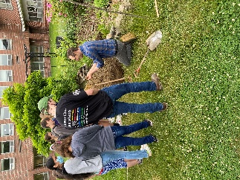

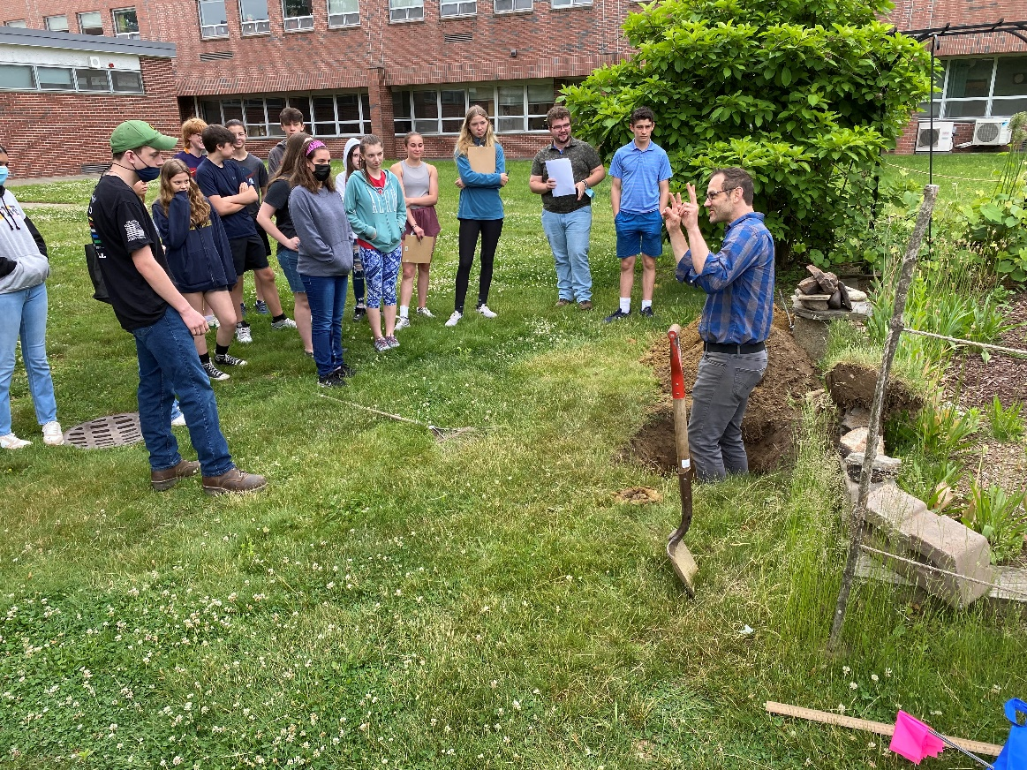

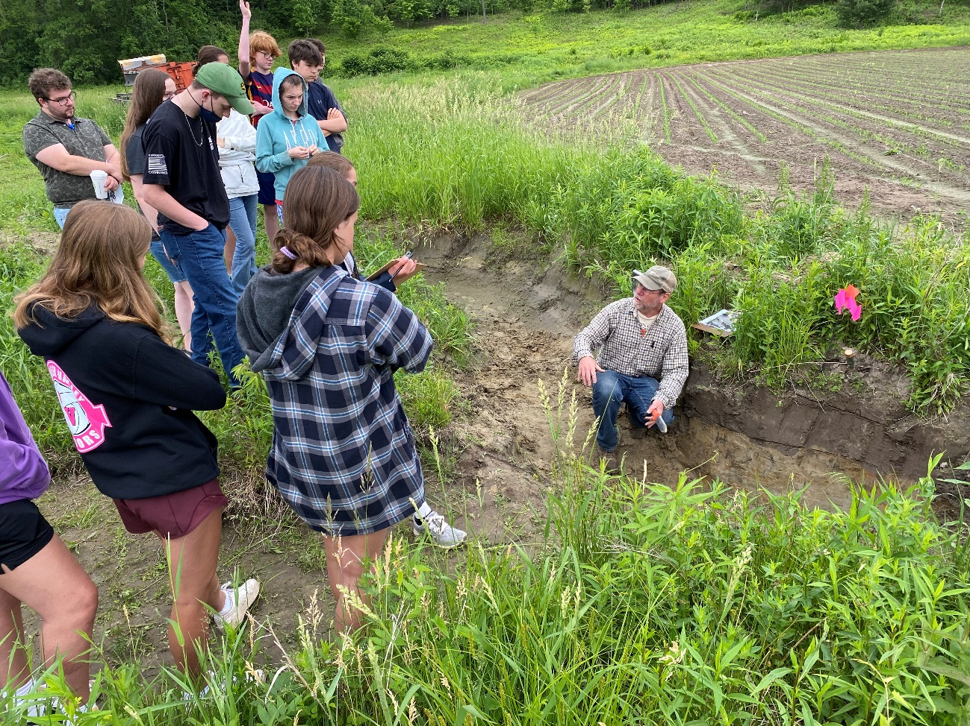

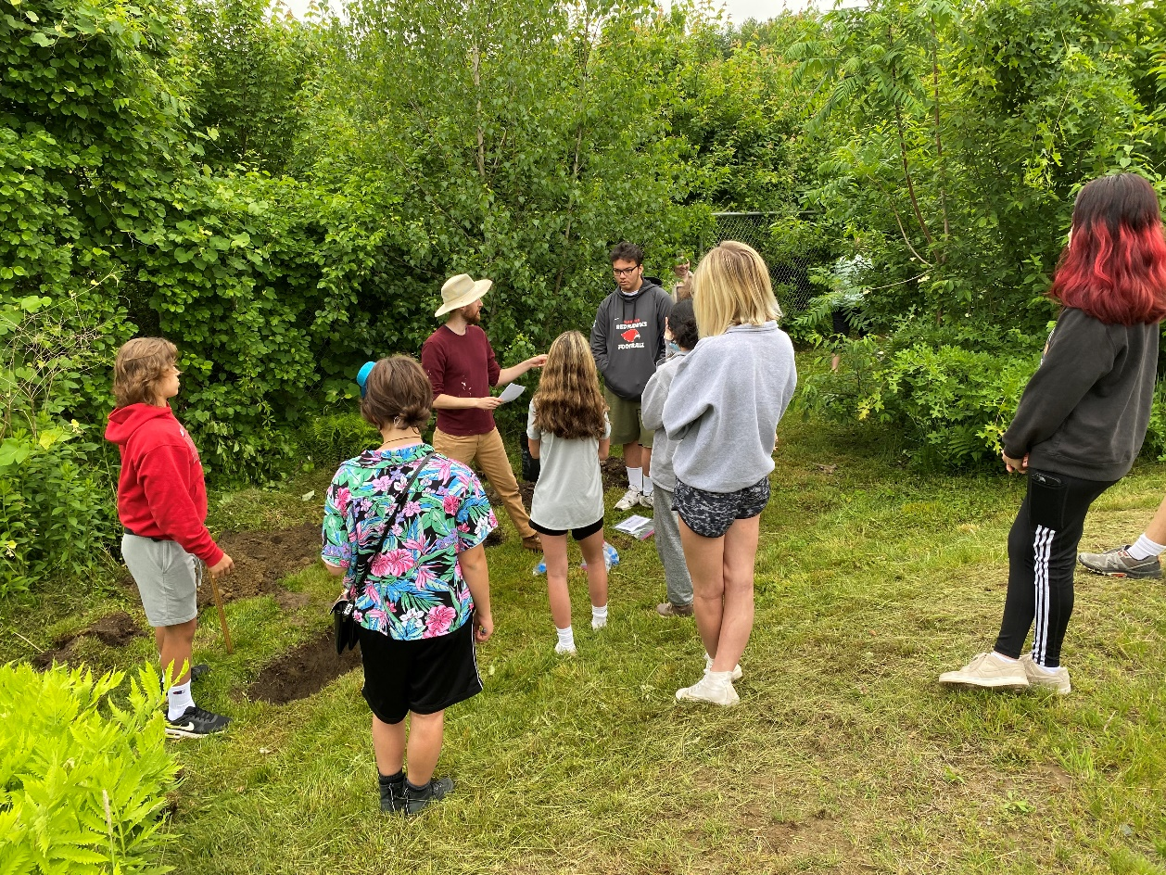

Students engaged in rain garden planting at Deerfield Elementary School:

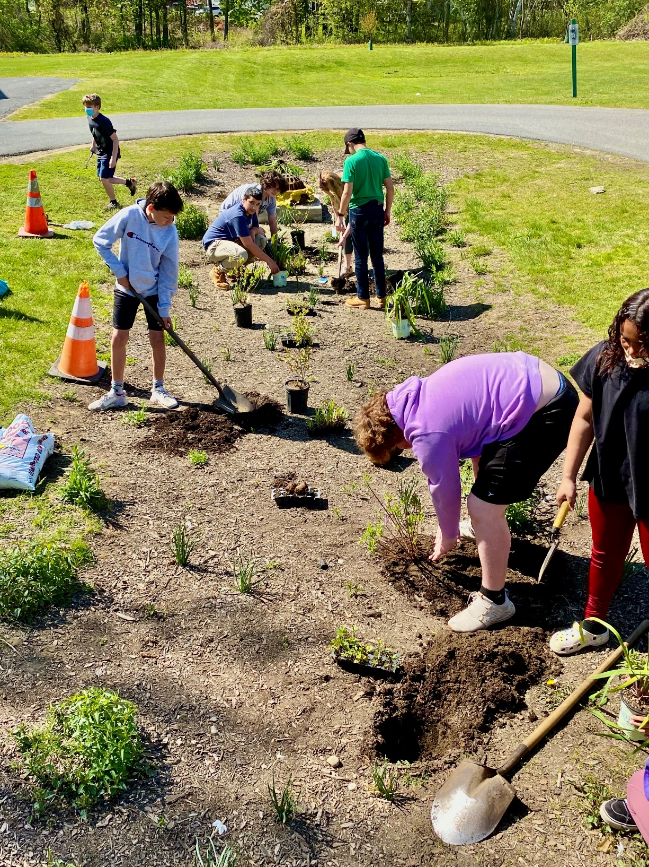

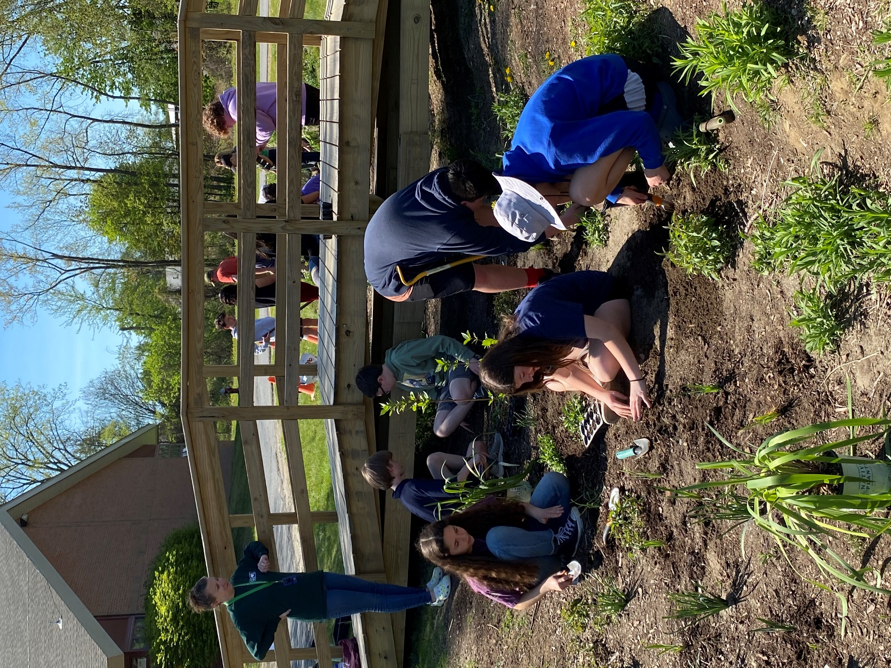

Climate Forum in Deerfield featuring keynote speakers, Senator Jo Comerford and Representative Natalie Blais:

