Deleting a MATRIS Run File

- Open MATRIS and create a “Run History” report.

- 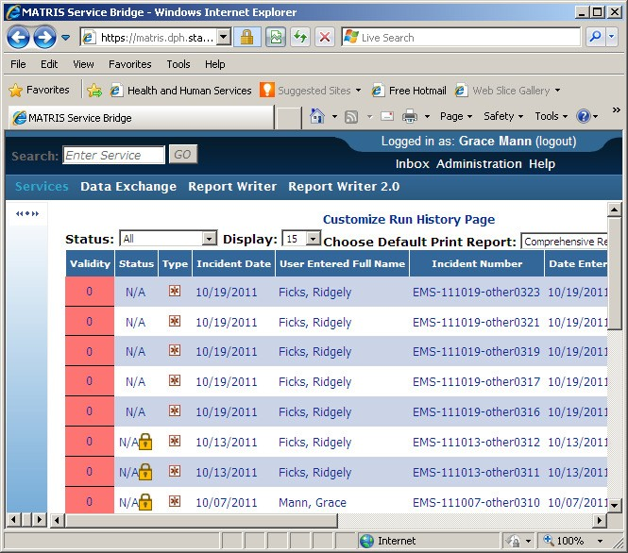Find the run you want to delete and click on the “Incident Number” in the Incident Number Column.

I am choosing EMS-111013-other0311

This screen will open.

- 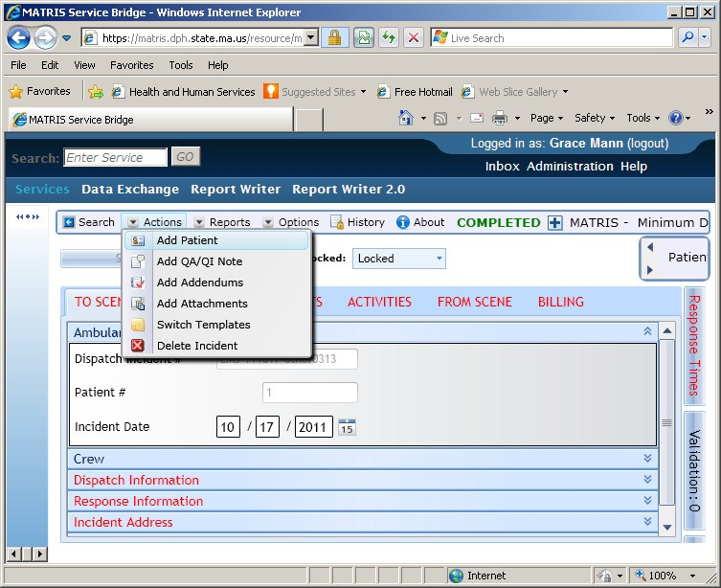Select “Actions”; second from the left at the top of this screen.

- Select “Delete Incident” from the drop down list.

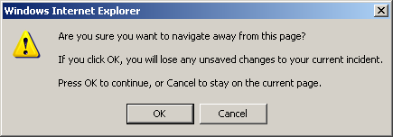

- This screen will appear; if you are sure you have selected the correct run, click on “OK”

This screen opens.
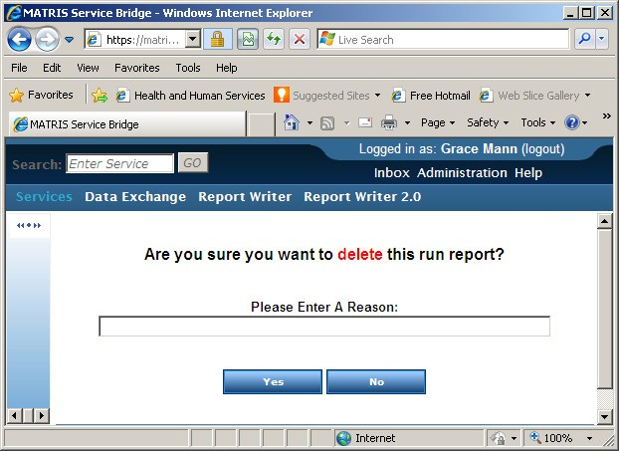
- You may or may not have to enter a reason, each service is setup according to their own preference.
If you don’t know check with the appropriate person in your organization.

- Select Yes if you want to proceed.

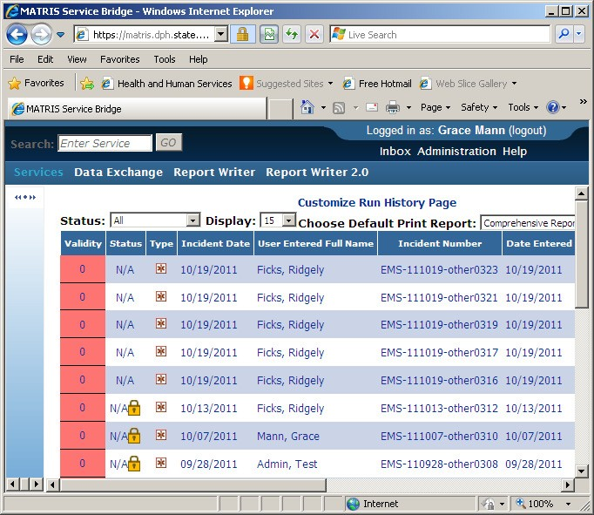This screen opens again – the selected run report has been deleted.

