|  |  |
| --- | --- |
|  | ***Commonwealth of Massachusetts***  ***Executive Office of Health and Human Services*** Office of Medicaid *www.mass.gov/masshealth* |

MassHealth

Transmittal Letter DEN-100

August 2018

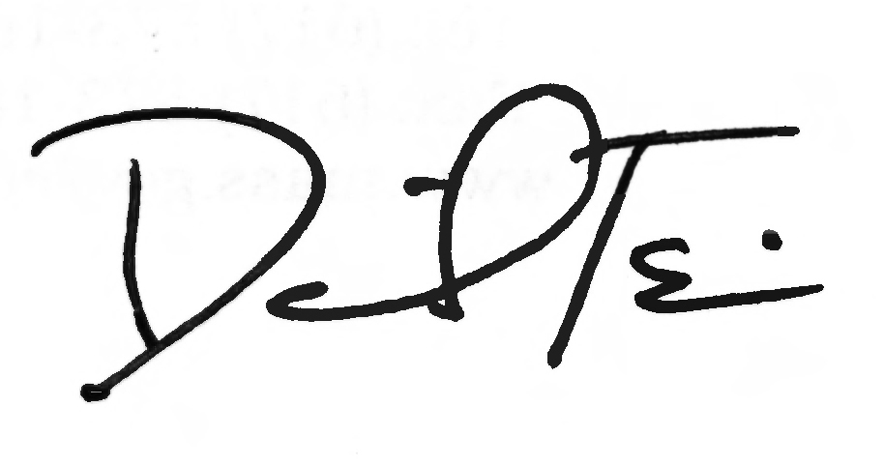

**TO:** Dental Providers Participating in MassHealth

**FROM:** Daniel Tsai, Assistant Secretary for MassHealth

**RE:** *Dental* *Manual* (Updates to 130 CMR 420.000: *Dental Services*)

This letter transmits updates to the MassHealth dental program regulation at 130 CMR 420.000: *Dental Services*. These updates are effective August 10, 2018.

Specifically, this letter transmits the final amendments to 130 CMR 420.000: *Dental Services* promulgated on an emergency basis on February 15, 2018, and transmitted under Transmittal Letter DEN-99, with further updates to the amendments. In particular, this letter transmits further updates to the billing rule for periodic orthodontic treatment visits described in DEN-99 and updates to the rule for retention visits.

The following is a summary of the changes. For additional information, please see the *Dental Manual* (available at [www.mass.gov/lists/masshealth-provider-manuals](http://www.mass.gov/lists/masshealth-provider-manuals)) and the *MassHealth Dental Program Office Reference Manual* (available at [www.masshealth-dental.net](http://www.masshealth-dental.net)).

**Periodic Orthodontic Treatment Visit Requirements**

Effective August 10, 2018, orthodontic treatment visits are paid on a quarterly (90-day) basis, with the first payment available 90 days after banding. Payment for each unit of service (D8670) includes all treatment visits provided to the member within the 90-day billing period. Providers are expected to see members every four to eight weeks, depending on the particular circumstances of the member’s treatment plan, but may bill a quarterly unit of service if at least one eligible treatment date occurred during the 90-day period by listing the billing date in the “Date of Service” field (Box 24) of the ADA claim form, the “Service Date” field when using the billing portal or on the HIPAA-compliant 837D, specifically 2300/DTP03. Providers MUST also note the actual treatment dates in the “Remarks” section (Box 35) on the ADA claim form, the “Notes” section when using the billing portal or the “Remarks” field on the HIPAA-compliant 837D, specifically 2300/NTE02.

If no service is provided in any given billing quarter, the next eligible treatment date should be used as the date of service on the claim. The next quarterly unit of service must then be billed at least 90 days from this date of service. Providers may not bill members for broken, repaired, or replacement brackets or wires, and may not charge members “appointment” or “retainer” fees to set appointments regardless of whether the fee is ultimately refunded to the member.

Claims for code D8670 submitted on or after August 10, 2018, will be monitored to ensure providers include the actual treatment dates in the “Remarks” section (Box 35) of the ADA claim form, the “Notes” field when using the billing portal or the “Remarks” field on the HIPAA-compliant 837D, specifically 2300/NTE02.

In the event the claim does not contain the actual treatment dates in the appropriate “Remarks” field, MassHealth may deny or recoup the payment and/or require a plan of correction.

For cases in progress before August 10, 2018, for which the provider has already claimed payment for one or more units of D8670 before August 10, 2018, providers must bill at least 180 days after the last quarterly payment was made. The following example illustrates how providers must bill for cases that are in progress before August 10, 2018.

***Example:*** The member was banded on May 1, 2018, and the first adjustment visit occurred on June 15, 2018. The member was subsequently seen on July 10, 2018, August 8, 2018, September 17, 2018, October 5, 2018, and November 12, 2018. The provider billed the first quarterly unit of code D8670 listing the June 15, 2018, date on the claim form. All visits that occurred in the 90-day period between June 15, 2018, and September 13, 2018, were included in the first quarterly payment.

The next 90-day period is from September 14, 2018, through December 13, 2018. As this quarter is after the August 10, 2018, update to the billing rule transmitted by this letter, the provider must now bill at the end of the 90-day period, which is December 13, 2018. Therefore, on December 13, 2018, the provider must review the member’s treatment records for the previous 90 days to ensure that there is at least one eligible treatment date. In this example, the patient was seen within the 90-day period on September 17, 2018, October 5, 2018, and November 12, 2018. The provider therefore bills the second quarterly unit of D8670 listing the December 13, 2018, billing date on the “Date of Service” field (Box 24) of the ADA claim form, the “Service Date” field when using the billing portal or on the HIPAA-compliant 837D, specifically 2300/DTP03, and also listing ALL of the actual treatment dates (9/17, 10/5, and 10/10) in the appropriate “Remarks” field of the claim form as noted above.

This timeline is illustrated in the following chart.

|  |  |
| --- | --- |
| **Date** | **Treatment/Procedure (Claim)** |
| 5/1/18 | Banding (Claim date for D8080) |
| 6/15/18 | Adjustment (Claim date for D8670) |
| 7/10/18 | Adjustment/repair |
| 8/8/18 | Adjustment |
| 9/17/18 | Adjustment/repair |
| 10/5/18 | Adjustment/repair |
| 11/12/18 | Adjustment |
| 12/13/18 | (Claim date for D8670) |

**Retention Visit Requirements**

Retention (code D8999) is paid separately and includes removal of appliances (debanding), construction and delivery of retainers, and follow-up visits. Effective August 10, 2018, the maximum number of payable retention visits (post-treatment stabilization) is five (5). Prior authorization is not required. If the patient loses or breaks his/her retainer(s), the provider must submit a prior authorization request and receive approval prior to billing for the repair and replacement of the retainer(s).

**MassHealth Website**

This transmittal letter and attached pages are available on the MassHealth website at [www.mass.gov/masshealth-transmittal-letters](http://www.mass.gov/masshealth-transmittal-letters).

To sign up to receive email alerts when MassHealth issues new transmittal letters and provider bulletins, send a blank email to [join-masshealth-provider-pubs@listserv.state.ma.us](mailto:join-masshealth-provider-pubs@listserv.state.ma.us). No text in the body or subject line is needed.

**Questions**

If you have any questions about the information in this transmittal letter, please contact the MassHealth Customer Services Center at (800) 841-2900, email your inquiry to [providersupport@mahealth.net](mailto:providersupport@mahealth.net), or fax your inquiry to (617) 988-8974.

NEW MATERIAL

(The pages listed here contain new or revised language.)

Dental Manual

Pages 4-21 and 4-22

OBSOLETE MATERIAL

(The pages listed here are no longer in effect.)

Dental Manual

Pages 4-21 and 4-22 — transmitted by Transmittal Letter DEN-99

|  |  |  |
| --- | --- | --- |
| **Commonwealth of Massachusetts**  **MassHealth**  **Provider Manual Series** | **Subchapter Number and Title**  4. Program Regulations  (130 CMR 420.000) | **Page**  4-21 |
| Dental Manual | **Transmittal Letter**  DEN-100 | **Date**  08/10/18 |

(B) Definitions.

(1) Pre-Orthodontic Treatment Examination. The pre-orthodontic treatment examination include the periodic observation of the member’s dentition at intervals established by the orthodontist to determine when orthodontic treatment should begin.

(2) Interceptive Orthodontic Treatment. Interceptive orthodontic treatment includes treatment of the primary and transitional dentition to prevent or minimize the development of a handicapping malocclusion and therefore, minimize or preclude the need for comprehensive orthodontic treatment.

(3) Comprehensive Orthodontic Treatment. Comprehensive orthodontic treatment includes a coordinated diagnosis and treatment leading to the improvement of a member’s craniofacial dysfunction and/or dentofacial deformity which may include anatomical and/or functional relationship. Treatment may utilize fixed and/or removable orthodontic appliances and may also include functional and/or orthopedic appliances. Comprehensive orthodontics may incorporate treatment phases including adjunctive procedures to facilitate care focusing on specific objectives at various stages of dentofacial development. Comprehensive orthodontic treatment includes the transitional and adult dentition.

(4) Orthodontic Treatment Visits. Orthodontic treatment visits are periodic visits which may include but are not limited to updating wiring, tightening ligatures or otherwise evaluating and updating care while undergoing comprehensive orthodontic treatment.

(C) Service Limitations and Requirements.

(1) Pre-Orthodontic Treatment Examination. The MassHealth agency pays for a pre-orthodontic treatment examination for members under the age of 21, once per six (6) months per member, and only for the purpose of determining whether orthodontic treatment is medically necessary, and can be initiated before the member’s twenty-first birthday. The MassHealth agency pays for a pre-orthodontic treatment examination as a separate procedure (see 130 CMR 420.413). The MassHealth agency does not pay for a pre-orthodontic treatment examination as a separate procedure in conjunction with pre-authorized ongoing or planned orthodontic treatment.

(2) Interceptive Orthodontics. The MassHealth agency pays for interceptive orthodontic treatment once per member per lifetime as an extension of preventative orthodontics that may include localized tooth movement. The MassHealth agency determines if the treatment will prevent or minimize the handicapping malocclusion based on the clinical standards described in Appendix F of the *Dental Manual*. Interceptive orthodontic treatment may occur in the primary or transitional dentition, may include such procedures as the redirection of ectopically erupting teeth and correction of dental crossbite or recovery of space loss where overall space is inadequate. When initiated during the incipient stages of a developing problem, interceptive orthodontics may reduce the severity of the malformation and mitigate it causes. Complicating factors such as skeletal disharmonies, overall space deficiency, or other conditions may require subsequent comprehensive orthodontic treatment.

(3) Comprehensive Orthodontics. The MassHealth agency pays for comprehensive orthodontic treatment, subject to prior authorization, once per member per lifetime under the age of 21 and only when the member has a handicapping malocclusion. The MassHealth agency determines whether a malocclusion is handicapping based on clinical standards for medical necessity as described in Appendix D of the *Dental Manual*. Upon the completion of orthodontic treatment, the provider must take post treatment photographic prints and maintain them in the member’s dental record.

|  |  |  |
| --- | --- | --- |
| **Commonwealth of Massachusetts**  **MassHealth**  **Provider Manual Series** | **Subchapter Number and Title**  4. Program Regulations  (130 CMR 420.000) | **Page**  4-22 |
| Dental Manual | **Transmittal Letter**  DEN-100 | **Date**  08/10/18 |

The MassHealth agency pays for the office visit, radiographs and a record fee of the pre-orthodontic treatment examination (alternative billing to a contract fee) when the MassHealth agency denies a request for prior authorization for comprehensive orthodontic treatment or when the member terminates the planned treatment. The payment for a pre-orthodontic treatment consultation as a separate procedure does not include models or photographic prints. The MassHealth agency may request additional consultation for any orthodontic procedure.

Payment for comprehensive orthodontic treatment is inclusive of initial placement, and insertion of the orthodontic fixed and removable appliances (for example: rapid palatal expansion (RPE) or head gear), and records. Comprehensive orthodontic treatment may occur in phases, with the anticipation that full banding must occur during the treatment period. The payment for comprehensive orthodontic treatment covers a maximum period of three (3) calendar years. The MassHealth agency pays for orthodontic treatment as long as the member remains eligible for MassHealth, if initial placement and insertion of fixed or removable orthodontic appliances begins before the member reaches age 21.

(4) Orthodontic Treatment Visits. The MassHealth agency pays for orthodontic treatment visits on a quarterly (90-days) basis for ongoing orthodontic maintenance and treatment beginning after the initial placement, and insertion of the orthodontic fixed and removable appliances. If a member becomes inactive for any period of time, prior authorization is not required to resume orthodontic treatment visits and subsequent billing, unless the prior authorization time limit has expired. The provider must document the number and dates of orthodontic treatment visits in the member’s orthodontic record.

(5) Orthodontic Case Completion. The MassHealth agency pays for orthodontic case completion for comprehensive orthodontic treatment which includes the removal of appliances, construction and placement of retainers and follow-up visits. The MassHealth agency pays for a maximum of five (5) visits for members under the age of 21. The MassHealth agency pays for the replacement of lost or broken retainers with prior authorization.

(6) Orthodontic Transfer Cases. The MassHealth agency pays for members who transfer from one orthodontic provider to another for orthodontic services subject to prior authorization to determine the number of treatment visits remaining. Payment for transfer cases is limited to the number of treatment visits approved. Providers must submit requests using the form specified by MassHealth.

(7) Orthodontic Terminations. The MassHealth agency requires providers to make all efforts to complete the active phase of treatment before requesting payment for removal of brackets and bands of a noncompliant member. If the provider determines that continued orthodontic treatment is not indicated because of lack of member’s cooperation and has obtained the member’s consent, the provider must submit a written treatment narrative on office letterhead with supporting documentation, including the case prior authorization number.

(8) Radiographs. Payment for Cephalometric and radiographs used in conjunction with orthodontic diagnosis is included in the payment for comprehensive orthodontic treatment (*see* 130 CMR 420.423(D)). The MassHealth agency pays for radiographs as a separate procedure for orthodontic diagnostic purposes only for members under age 21 if requested by the MassHealth agency.