|  |  |
| --- | --- |
|  | ***Commonwealth of Massachusetts***  ***Executive Office of Health and Human Services***  ***Office of Medicaid***  *www.mass.gov/masshealth* |

MassHealth

Transmittal Letter DEN-99

February 2018

**TO:** Dental Providers Participating in MassHealth

**FROM:** Daniel Tsai, Assistant Secretary for MassHealth 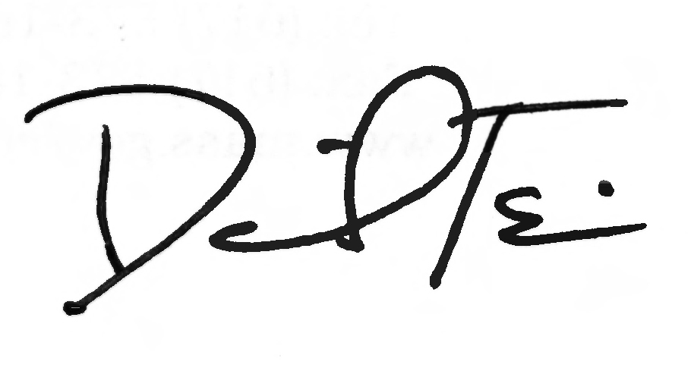

**RE:** *Dental* *Manual* (Orthodontic Treatment Visits)

This letter transmits emergency amendments, effective February 15, 2018, to 130 CMR 420.000: *Dental Services* codifying updates to the billing rule for periodic orthodontic treatment visits. Specifically, the amendments codify in regulation the policy set forth in Transmittal Letter DEN-98, which provided for payment for orthodontic treatment visits on a quarterly (90-day) basis. Providers may submit a claim for the first unit of service (service code D8670) beginning with the first actual orthodontic treatment visit provided to a member after the end of the calendar month in which the provider completes the initial placement of the appliance(s) for that member. Payment of that claim includes that first orthodontic treatment visit for the member and all subsequent treatment visits provided to the member over the next 90 days. Providers may submit a claim for the second unit of service on or after the first actual orthodontic treatment visit provided to the member after the 90th day of the initial billing period. Providers are expected to see members every four to eight weeks, depending on the particular circumstances of the member and the provider’s treatment plan.

*Example*: If the provider placed the appliance(s) for a member on March 15, 2018 and provided the first orthodontic treatment visit to that member on April 20, 2018, then the provider would submit a claim for one unit of D8670 using April 20, 2018 as the date of service. This date of service would begin the start of the first quarterly (90-day) billing period, and therefore any additional treatment visits provided to the member between April 20, 2018 and July 19, 2018 are included in the payment of that claim. The second 90-day billing and payment cycle would then begin with the first actual orthodontic treatment visit provided to the member on or after July 20, 2018. Thus, if the member’s first treatment visit after July 20, 2018 actually occurred on August 3, 2018, the provider would submit a claim for the second unit of D8670 using August 3, 2018 as the date of service, and the payment of that claim would cover any orthodontic treatment visits provided to the member during the second 90-day period (August 3, 2018 through November 1, 2018).

**MassHealth Website**

This transmittal letter and attached pages are available on the MassHealth website at [www.mass.gov/masshealth](http://www.mass.gov/masshealth).

**Questions**

If you have any questions about the information in this transmittal letter, please contact

the MassHealth Customer Service Center at 1-800-841-2900, e-mail your inquiry to [providersupport@mahealth.net](mailto:providersupport@mahealth.net), or fax your inquiry to 617-988-8974.

MassHealth

Transmittal Letter DEN-99

February 2018

Page 2

NEW MATERIAL

(The pages listed here contain new or revised language.)

Dental Manual

Pages 4-21 and 4-22

OBSOLETE MATERIAL

(The pages listed here are no longer in effect.)

Dental Manual

Pages 4-21 and 4-22 — transmitted by Transmittal Letter DEN-97

|  |  |  |
| --- | --- | --- |
| **Commonwealth of Massachusetts**  **MassHealth**  **Provider Manual Series** | **Subchapter Number and Title**  4. Program Regulations  (130 CMR 420.000) | **Page**  4-21 |
| Dental Manual | **Transmittal Letter**  DEN-99 | **Date**  02/15/2018 |

1. Definitions.
2. Pre-Orthodontic Treatment Examination. The pre-orthodontic treatment examination include the periodic observation of the member’s dentition at intervals established by the orthodontist to determine when orthodontic treatment should begin.
3. Interceptive Orthodontic Treatment. Interceptive orthodontic treatment includes treatment of the primary and transitional dentition to prevent or minimize the development of a handicapping malocclusion and therefore, minimize or preclude the need for comprehensive orthodontic treatment.
4. Comprehensive Orthodontic Treatment. Comprehensive orthodontic treatment includes a coordinated diagnosis and treatment leading to the improvement of a member’s craniofacial dysfunction and/or dentofacial deformity which may include anatomical and/or functional relationship. Treatment may utilize fixed and/or removable orthodontic appliances and may also include functional and/or orthopedic appliances. Comprehensive orthodontics may incorporate treatment phases including adjunctive procedures to facilitate care focusing on specific objectives at various stages of dentofacial development. Comprehensive orthodontic treatment includes the transitional and adult dentition.
5. Orthodontic Treatment Visits. Orthodontic treatment visits are periodic visits which may include but are not limited to updating wiring, tightening ligatures or otherwise evaluating and updating care while undergoing comprehensive orthodontic treatment.
6. Service Limitations and Requirements.
7. Pre-Orthodontic Treatment Examination. The MassHealth agency pays for a pre-orthodontic treatment examination for members under the age of 21, once per six (6) months per member, and only for the purpose of determining whether orthodontic treatment is medically necessary, and can be initiated before the member’s twenty-first birthday. The MassHealth agency pays for a pre-orthodontic treatment examination as a separate procedure (see 130 CMR 420.413). The MassHealth agency does not pay for a pre-orthodontic treatment examination as a separate procedure in conjunction with pre-authorized ongoing or planned orthodontic treatment.
8. Interceptive Orthodontics. The MassHealth agency pays for interceptive orthodontic treatment once per member per lifetime as an extension of preventative orthodontics that may include localized tooth movement. The MassHealth agency determines if the treatment will prevent or minimize the handicapping malocclusion based on the clinical standards described in Appendix F of the *Dental Manual*. Interceptive orthodontic treatment may occur in the primary or transitional dentition, may include such procedures as the redirection of ectopically erupting teeth and correction of dental crossbite or recovery of space loss where overall space is inadequate. When initiated during the incipient stages of a developing problem, interceptive orthodontics may reduce the severity of the malformation and mitigate it causes. Complicating factors such as skeletal disharmonies, overall space deficiency, or other conditions may require subsequent comprehensive orthodontic treatment.
9. Comprehensive Orthodontics. The MassHealth agency pays for comprehensive orthodontic treatment, subject to prior authorization, once per member per lifetime under the age of 21 and only when the member has a handicapping malocclusion. The MassHealth agency determines whether a malocclusion is handicapping based on clinical standards for medical necessity as described in Appendix D of the Dental Manual. Upon the completion of orthodontic treatment, the provider must take post treatment photographic prints and maintain them in the member’s dental record.

|  |  |  |
| --- | --- | --- |
| **Commonwealth of Massachusetts**  **MassHealth**  **Provider Manual Series** | **Subchapter Number and Title**  4. Program Regulations  (130 CMR 420.000) | **Page**  4-22 |
| Dental Manual | **Transmittal Letter**  DEN-99 | **Date**  02/15/2018 |

The MassHealth agency pays for the office visit, radiographs and a record fee of the pre-orthodontic treatment examination (alternative billing to a contract fee) when the MassHealth agency denies a request for prior authorization for comprehensive orthodontic treatment or when the member terminates the planned treatment. The payment for a pre-orthodontic treatment consultation as a separate procedure does not include models or photographic prints. The MassHealth agency may request additional consultation for any orthodontic procedure.

Payment for comprehensive orthodontic treatment is inclusive of initial placement, and insertion and any adjustments (treatment visits) occurring in the calendar month of insertion of the orthodontic fixed and removable appliances (for example: rapid palatal expansion (RPE) or head gear), and records. Comprehensive orthodontic treatment may occur in phases, with the anticipation that full banding must occur during the treatment period. The payment for comprehensive orthodontic treatment covers a maximum period of three (3) calendar years. The MassHealth agency pays for orthodontic treatment as long as the member remains eligible for MassHealth, if initial placement and insertion of fixed or removable orthodontic appliances begins before the member reaches age 21.

1. Orthodontic Treatment Visits. The MassHealth agency pays for orthodontic treatment visits on a quarterly (90-day) basis for ongoing orthodontic maintenance and treatment beginning the calendar month after the initial placement, and insertion of the orthodontic fixed and removable appliances. If a member becomes inactive for any period of time, prior authorization is not required to resume orthodontic treatment visits and subsequent billing, unless the prior authorization time limit has expired. The provider must document the number and dates of orthodontic treatment visits in the member’s orthodontic record.
2. Orthodontic Case Completion. The MassHealth agency pays for orthodontic case completion for comprehensive orthodontic treatment which includes the removal of appliances, construction and placement of retainers and follow-up visits. The MassHealth agency pays for a maximum of three (3) visits for members under the age of 21. The MassHealth agency pays for the replacement of lost or broken retainers with prior authorization.
3. Orthodontic Transfer Cases. The MassHealth agency pays for members who transfer from one orthodontic provider to another for orthodontic services subject to prior authorization to determine the number of treatment visits remaining. Payment for transfer cases is limited to the number of treatment visits approved. Providers must submit requests using the form specified by MassHealth.
4. Orthodontic Terminations. The MassHealth agency requires providers to make all efforts to complete the active phase of treatment before requesting payment for removal of brackets and bands of a noncompliant member. If the provider determines that continued orthodontic treatment is not indicated because of lack of member’s cooperation and has obtained the member’s consent, the provider must submit a written treatment narrative on office letterhead with supporting documentation, including the case prior authorization number.
5. Radiographs. Payment for Cephalometric and radiographs used in conjunction with orthodontic diagnosis is included in the payment for comprehensive orthodontic treatment (see 130 CMR 420.423(D)). The MassHealth agency pays for radiographs as a separate procedure for orthodontic diagnostic purposes only for members under age 21 if requested by the MassHealth agency.