Commonwealth of Massachusetts
Executive Office of Health and Human Services

Office of Medicaid
www.mass.gov/masshealth

MassHealth
Dental Bulletin 45
November 2016

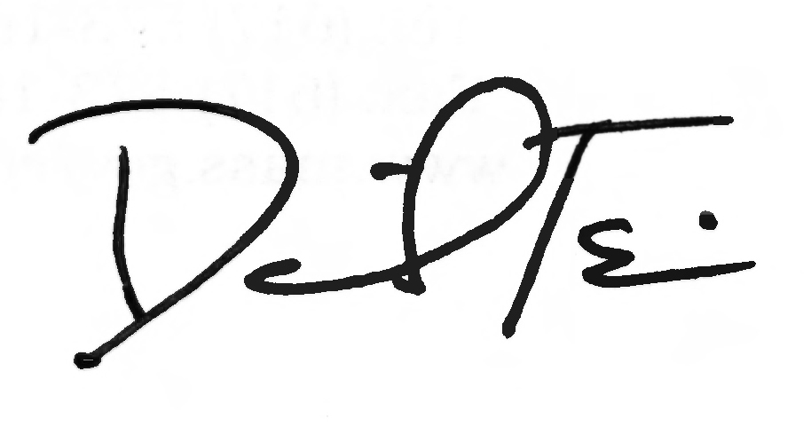

TO: Dental Providers Participating in MassHealth

FROM: Daniel Tsai, Assistant Secretary for MassHealth

RE: Start Date for Dental Third-Party Administrator for MassHealth and Health Safety Net Providers

Dental Third-Party Administrator

As communicated in Dental Bulletin 44, the Executive Office of Health and Human Services has contracted with Dental Service of Massachusetts, Inc. and its subcontractor DentaQuest to provide dental third-party administrator (TPA) services for MassHealth and the Health Safety Net (HSN). DentaQuest has an extensive experience as a dental TPA and has served as the TPA for the MassHealth dental program since 2007. This bulletin provides further detail of the TPA implementation processes and impact to providers.

MassHealth Providers

Claims processing, customer service, and other administrative functions for MassHealth-only dental providers (i.e., individual dentists, dental clinics, dental schools, public health dental hygienists, and dental hygiene schools) will remain largely the same. However, the TPA is implementing several enhancements to the MassHealth provider portal and a change in the timeframe in which dental providers receive claim remittance advices (RAs). Additional details on these changes are discussed below.

Provider Portal

The updated provider portal for participating MassHealth providers will go live on January 1, 2017. Providers will be notified to register for webinar training which will highlight the new portal functions. The following link lists the webinar dates for the portal trainings for providers: https://www.surveymonkey.com/r/MHrsvpform.

Claim Remittance Advice/835 File

Currently, MassHealth dental providers receive their RAs before receiving payments for claims. Beginning in January 2017, MassHealth dental providers will receive their RAs and 835 files on or near the same day of payment for claims. This will allow providers to more easily balance accounts receivable at the time of payment.

(continued on next page)

MassHealth

Dental Bulletin 45

November 2016

Page 2

MassHealth Providers (cont.)

MassHealth Office Reference Manual

On December 1, 2016, an updated MassHealth Office Reference Manual (ORM) will be available for download on the provider portal at www.masshealth-dental.net.

System Upgrade and Downtime for Member Eligibility and Claim Processing

On December 12, 2016, the TPA will be updating its eligibility system. As a result of the system migration, member eligibility information and claim and prior-authorization processing will be impacted from December 3, 2016, through December 11, 2016. Additional information on these impacts can be found below and on the provider portal at www.masshealth-dental.net.

During the period from December 3, 2016, through December 11, 2016, providers may experience the following impacts:

Member eligibility on the provider portal

The provider portal will be available to view member eligibility. However, the eligibility status may not be accurate during this time of transition to the new system. Providers should print the member detail screen on the provider portal to document that they checked eligibility on the date of service. This documentation may be needed in the event a claim is denied due to member ineligibility.

The provider portal will be available for claims and prior-authorization submission; however, any claims and prior-authorization requests will remain in a pending status in the system until December 12, 2016. After December 12, 2016, all claim and prior-authorization processing will resume, including the pending items submitted during the system update period.

Customer service

Customer Service may not be able to provide accurate member eligibility information during this time due to the transition to the new system. Additionally, providers may experience longer than usual wait time to speak to a customer service representative.

Claims and payment

All claims sent electronically via a clearing house/vendor will be held in a pending status until December 12, 2016. As a result, providers will not receive confirmation from clearing houses/vendors regarding acceptance of claims sent electronically December 3, 2016, through December 12, 2016.

(continued on next page)

MassHealth

Dental Bulletin 45

November 2016

Page 3

Claims and payment (cont.)

Providers should send in all claims for dates of service prior to December 3, 2016, as soon as possible prior to this planned transition. MassHealth strongly encourages providers not to “hold” claims.

After the system transition is complete, it may take up to two weeks for providers to begin receiving payment for claims.

The Health Safety Net and Health Safety Net Providers

In January 2017, DentaQuest will begin processing dental claims on behalf of the HSN and will provide customer service support for HSN dental providers.

The HSN only makes payments for dental services to community health centers, acute hospital outpatient departments, and hospital-licensed health centers; these providers are considered HSN dental providers. All HSN dental providers must also be MassHealth providers. As a reminder, not all MassHealth providers are HSN providers. For example other MassHealth dental providers such as individual dentists, dental clinics, dental laboratories, dental schools, public health dental hygienists, and dental hygiene schools are not HSN providers.

HSN Office Reference Manual

The HSN Provider Office Reference Manual (HSN ORM) will be available on December 1, 2016, for download on the provider portal at www.masshealth-dental.net. The HSN ORM contains a reference directory for customer services related to claims, qualifying patients, and electronic data interchange (EDI).

Claims

HSN dental providers must submit claims or adjustments with dates of service on or after January 1, 2017, to the TPA rather than the HSN.

All claims must be submitted electronically in the 837D format as outlined in the HSN 837D Companion Guide. The HSN 837D Companion Guide outlines transaction-specific information and the technical requirements to electronically interface with DentaQuest. To request a copy of the HSN 837D Companion Guides please contact the MassHealth Dental Customer Service Center at 1-800-207-5019.

Claims or adjustments to claims with dates of service prior to January 1, 2017, must be submitted to the HSN in the current 837D format.

Claim files may not include dates of service both before and after January 1, 2017. Submission of such claims will result in denial. HSN providers will need to send two separate files to HSN and the TPA, respectively, depending on the dates of service.

(continued on next page)

MassHealth

Dental Bulletin 45

November 2016

Page 5

Claims (cont.)

HSN providers are reminded to submit claims in a timely manner; failure to do so could result in delayed payments.

EDI Training

In October 2016, HSN providers receiving training on electronic data interchange requirements and changes. HSN providers may view the recorded EDI training and the FAQ document at www.masshealth-dental.net under the “Related Documents” link. Please contact the TPA with EDI questions at editeam@greatdentalplans.com or 1-800-207-5019.

Claim Remittance Advice/835 File

HSN providers will receive the 835 file from the TPA which will contain adjudicated claim amounts. However, actual payments to the HSN provider may differ from those reported in the 835 due to the shortfall allocation and other HSN-specific adjustments. HSN providers can use the 835 file information to resubmit denied claims, as appropriate. Additionally, the 835 will not contain a check number for re-association to EFT transactions. HSN providers will also receive an Excel file each month, as they currently do, that will contain actual paid claim amounts to be used to for monthly reconciliation.

HSN Provider Training

Multiple trainings were held for HSN providers in October 2016. The training addressed customer services, the HSN ORM, claims submission, and the provider portal. There will be refresh training in early December for those providers who had missed previous trainings or need refresher training. Additional information regarding the training dates will be forthcoming.

Customer Services

HSN dental providers should contact the TPA for claim and authorization questions. For all payment-related questions, HSN dental providers should continue to contact the HSN helpdesk. All customer services contact information is listed in the HSN ORM in the reference directory.

Questions

If you have any questions about the information in this bulletin, please contact the MassHealth Dental Customer Service Center at 1-800-207-5019, e-mail your inquiry to providersupport@mahealth.net, or fax your inquiry to 617-988-8974.

