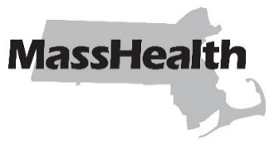
Dental Bulletin 56
Commonwealth of Massachusetts
Executive Office of Health and Human Services
Office of Medicaid
www.mass.gov/masshealth
DATE: January 2026
TO: Dental Providers Participating in MassHealth
FROM: Mike Levine, Undersecretary for MassHealth [signature of Mike Levine]
RE: Extension for Submitting Dental Claims

MassHealth is temporarily extending the time limitation for submitting dental claims. These extensions are due to ongoing dental claims-processing issues and temporarily replace the applicable aspects of 130 CMR 450.309 and 450.313 for timely filing.
The following time limitation extensions apply to dental claims submitted through March 31, 2026.
- Dental claims with dates of service (DOS) on or after December 15, 2024, will be considered timely if such claims are submitted within 345 days of the DOS.
- Dental claims with DOS on or after September 15, 2023, with any third-party-liability claims that are submitted with the required explanation of benefit documentation, will be considered timely.
All MassHealth rules and regulations that do not conflict with these time limitation extensions are still in effect. Unless MassHealth states otherwise, these time limitation extensions do not apply to dental claims submitted on or after April 1, 2026.

MassHealth Website
This bulletin is available on the MassHealth Provider Bulletins web page.
Sign up to receive email alerts when MassHealth issues new bulletins and transmittal letters.

Questions?
All questions about this bulletin should be directed to the third-party administrator of the MassHealth Dental Program at (844) 643-3685 (844-MH-DENTL).

MassHealth on Facebook MassHealth on LinkedIn MassHealth on X MassHealth on YouTube

