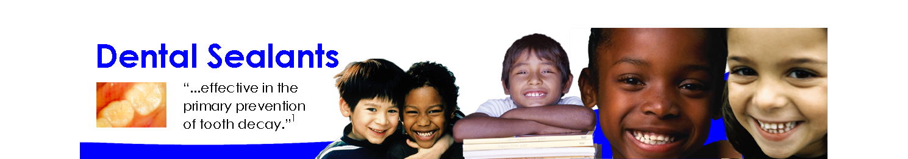

Oral Health in Massachusetts: A Fact Sheet

What is the public health issue?
In Massachusetts tooth decay has affected:
- 28% of Kindergarteners
- 41% of Third Graders
- 34% of Sixth Graders

Oral health is integral to general health.² Although preventable; tooth decay is a chronic disease affecting all age groups. In fact, it is the most common chronic disease of childhood.² The burden of disease is far worse for those who have restricted access to prevention and treatment services. Tooth decay, left untreated, can cause pain and tooth loss. Untreated tooth decay is associated
with difficulty in eating and with being underweight.³ Untreated decay and tooth loss can have negative effects on an individual’s self-esteem and employability.

What is the impact of dental sealants?
Dental sealants are a plastic material placed on the pits and fissures of the chewing surfaces of teeth; sealants cover up to 90 percent of the places where decay occurs in school children’s teeth.⁴ Sealants prevent tooth decay by creating a barrier between a tooth and decay-causing bacteria. Sealants also stop cavities from growing and can prevent the need for expensive fillings. Sealants are 100 percent effective if they are fully retained on the tooth.² According to the Surgeon General’s 2000 report on oral health, sealants have been shown to reduce decay by more than 70 percent.¹ The combination of sealants and fluoride has the potential to nearly eliminate tooth decay in school age children.⁵ Sealants are most cost-effective when provided to children who are at highest risk for tooth decay.⁶

Why are school-based dental sealant programs recommended?
Healthy People 2010 Objectives⁸

    - Fifty percent of 8 and 14 year-old children will have dental sealants on their molar teeth.
    - Forty-two percent of children under 9 years old will have experience of tooth decay

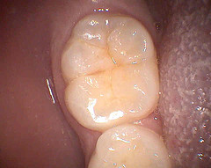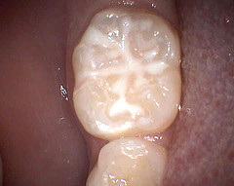

Molar tooth without a Molar tooth with a
dental sealant dental sealant
In 2002, the Task Force on Community Preventive Services strongly recommended school sealant programs as an effective strategy to prevent tooth decay.³ The Task Force is a national, independent, nonfederal, multidisciplinary task force appointed by the director of the Centers for Disease Control and Prevention (CDC). CDC estimates that if 50 percent of children at high risk participated in school sealant programs, over half of their tooth decay would be prevented and money would be saved on their treatment costs.⁴ School-based sealant programs reduce oral health disparities in children.⁷
How is Massachusetts doing?
A 2007 Statewide Oral Health Assessment⁹ in Massachusetts revealed that:
- 46 percent of third-graders (age 8 years) had at least one dental sealant
- 52 percent of sixth-graders (age 12 years) had at least one dental sealant

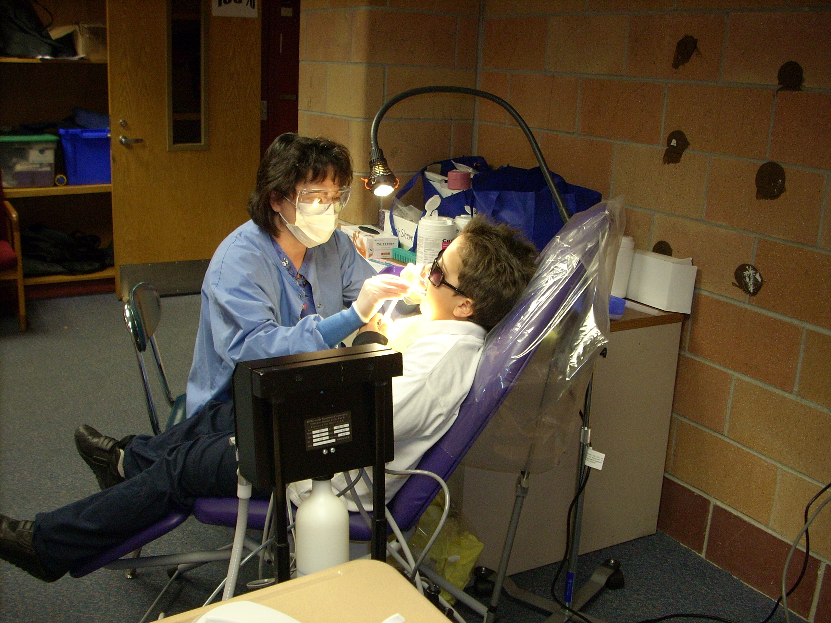
What is Massachusetts doing?
- In Massachusetts, 65% of the population is receiving fluoridated
water.
- In Massachusetts, 34% of high-need schools have a dental
sealant program.
- Massachusetts promotes the use of school-based dental sealant
programs following established evidence-based guidelines,
especially targeting children at high-risk for dental disease.

References
1. National Institutes of Health (NIH). Consensus Development Conference on Diagnosis and Management of Dental Caries Throughout Life. Bethesda, MD. March 26–28, 2001. Conference Papers. Journal of Dental Education 65 (2001): 935–1179.
2. U.S. Department of Health and Human Services. Oral Health in America: A Report of the Surgeon General. Rockville, MD: U.S. Department of Health and Human Services, National Institutes of Health, National Institute of Dental and Craniofacial Research, 2000.
3. Truman BI, Gooch BF, Sulemana I, et al., and the Task Force on Community Preventive Services. Reviews of evidence on interventions to reduce dental caries, oral and pharyngeal cancers, and sports-related craniofacial injury. American Journal of Preventive Medicine 23 (2002, 1S): 1–84.
4. U.S. Department of Health and Human Services, Centers for Disease Control and Prevention. Preventing Dental Caries. Atlanta, GA: U.S. Department of Health and Human Services, Centers for Disease Control and Prevention, 2002. http://www.cdc.gov/OralHealth/factsheets/dental_caries.htm.
5. Kim S, Lehman AM, Siegal MD, Lemeshow S. Statistical model for assessing the impact of targeted, school-based dental sealant programs on sealant prevalence among third graders in Ohio. Journal of Public Health Dentistry 63 (Summer 2003): 195–199.
6. Burt BA, Eklund SA. Dentistry, Dental Practice, and the Community (5th ed.). Philadelphia: W.B. Saunders, 1999.
7. Weintraub JA, Stearns SC, Burt BA, Beltran E, Eklund SA. A retrospective analysis of the cost-effectiveness of dental sealants in a children’s health center. Social Science & Medicine 36 (1993, 11): 1483–1493.
8. U.S. Department of Health and Human Services, Office of Disease Prevention and Health Promotion. Healthy People 2010. Washington DC: U.S. Department of Health and Human Services, Office of Disease Prevention and Health Promotion, 2000. http://www.health.gov/healthypeople.
9. Catalyst Institute, The Oral Health of Massachusetts’ Children, 2008.

For more information, contact:
Massachusetts Department of Public Health
Office of Oral Health
250 Washington Street
Boston, MA 02108-4619
Oral.Health@state.ma.us

