The Commonwealth of Massachusetts
Executive Office of Health and Human Services
Department of Public Health
250 Washington Street, Boston, MA 02108-4619
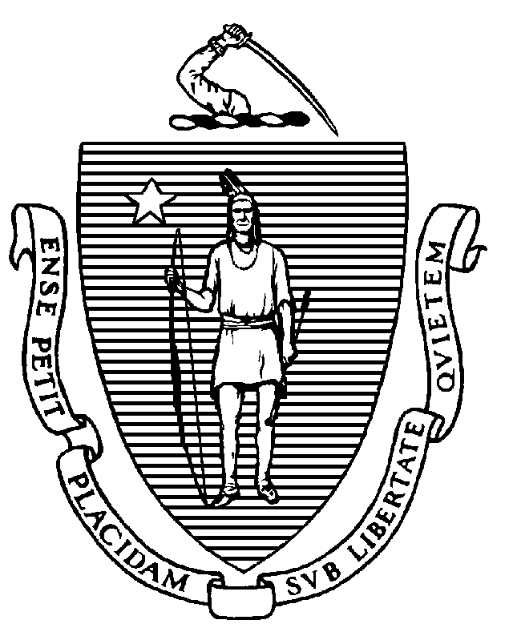

KATHLEEN E. WALSH
Secretary
ROBERT GOLDSTEIN, MD, PhD Commissioner

Tel: 617-624-6000
www.mass.gov/dph

MAURA T. HEALEY
Governor
KIMBERLEY DRISCOLL
Lieutenant Governor

IMPORTANT CHANGES TO THE MCSR RENEWAL PROCESS

Dear Dentist:

Section 9 of chapter 260 of the acts of 2020 requires the Department of Public Health’s (DPH) Drug Control Program (DCP) to synchronize the term and expiration date of your Massachusetts Controlled Substance Registration (MCSR) with your Board issued Dental License. For dentists this means the next time you renew your MCSR, it will now have a term of 2 years instead of 3 years and will be synchronized with the expiration date of your Dental License.

To implement this requirement, the next time you renew your MCSR it will have a term of at least 2 years and expire on the same day as your dental license.

As set forth in the Executive Office of Administration and Finance’s rate regulation, 801 CMR 4.02, the fee for MCSR registration and renewal is $150 annually. Therefore, the cost of a two-year MCSR will be $300.

If you have a limited faculty or limited intern license your MCSR will be synchronized with the expiration date of your limited dental license.

We are pleased to announce one stop shopping! You will now renew your MCSR on-line through the same portal and at the same time as your underlying Board of Dentistry License.

You will be receiving registration instructions and a link to the DPH eLicensing system via email.

