Background

INDOOR AIR QUALITY &
WATER DAMAGE ASSESSMENT

Department of Agricultural Resources
64 Century Way
West Springfield, MA

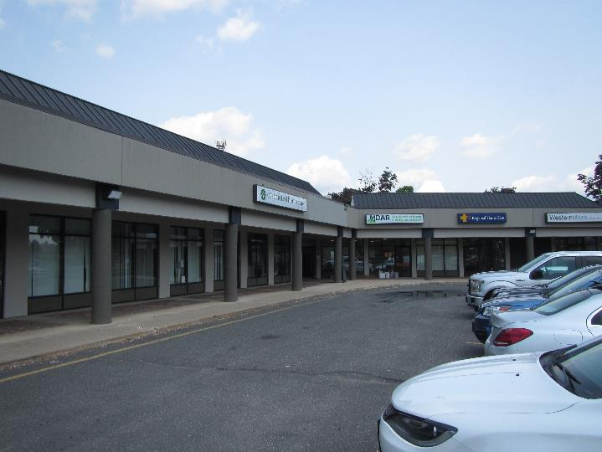

Prepared by:
Massachusetts Department of Public Health
Bureau of Environmental Health
Indoor Air Quality Program
December 2019

Building: | Department of Agricultural Resources (DAR)
Address: | 64 Century Way, West Springfield, MA
Dates of Assessment: | July 12, 2019 and  July 26, 2019
BEH/IAQ Staff Conducting Assessment: | Michael Feeney, Director, Indoor Air Quality (IAQ) Program
Project Manager: | Jamie Merrill Blood  Regional Planner/Project Manager, Division of Capital Asset Management and Maintenance (DCAMM)

Background/Introduction
Over the weekend of July 4, 2019, DCAMM reported that a water dispenser had leaked and wet floor and walls around restrooms, the breakroom, and adjacent cubicle spaces. A water damage contractor, Complete Restoration Solutions (CRS), was contacted to conduct remediation. To assess the extent of water damage, the MDPH IAQ Program visited the DAR office on July 12, 2019 to conduct an initial assessment while drying and other restoration efforts were taking place. It is important to note that the restoration was conducted during a hot, humid weather (outdoor temperature 91°F with relative humidity > 70%), which can negatively affect drying times for moistened materials. The MDPH IAQ Program returned on July 26, 2019 to assess whether restoration efforts were successful and to conduct follow-up indoor air testing when the restoration was mostly completed.
Reportedly, when building facility staff became aware of the water release, they began drying and other remediation measures. These included:
- Use of fans to accelerate drying of carpeting and gypsum wallboard (GW);
- Removal of water-damaged ceiling tiles;
- Removal of areas of GW, with holes drilled in some remaining wallboard to accelerate drying;
- Movement of objects from the floor such as cabinets and floor mats;
- Measurement of moisture content of GW and carpeting to identify areas needing additional treatment.

Methods
Please refer to the IAQ Manual and appendices for methods, sampling procedures, and interpretation of results (MDPH, 2015).

IAQ Testing Results
The following is a summary of indoor air testing results for July 12, 2019 (Table 1) and July 26, 2019 (Table 2):
- Carbon dioxide levels were below the MDPH guideline of 800 parts per million (ppm) in all areas, indicating adequate air exchange on July 12, 2019. On July 26, 2019, carbon dioxide levels were below the MDPH guideline of 800 parts per million (ppm) in all but one area.
- Temperature was within the MDPH recommended range of 70°F to 78°F on both days of the assessment, however many occupants expressed temperature complaints.
- Relative humidity was above the MDPH recommended range of 40 to 60% in all areas on July 12, 2019. After the heating, ventilation and air-conditioning (HVAC) system was readjusted and hot weather had eased, relative humidity was within the MDPH recommended range of 40 to 60% in all areas on July 26, 2019.
- Carbon monoxide levels were non-detectable (ND) in all areas tested on both days of testing.
- Fine particulate matter (PM2.5) concentrations measured were above the National Ambient Air Quality (NAAQS) limit of 35 μg/m³ in all areas tested on July 12, 2019 and reflective of outdoor conditions (68 μg/m³). Measurements were below the National Ambient Air Quality (NAAQS) limit of 35 μg/m³ in all areas tested on July 26, 2019.

Discussion

Ventilation
A heating, ventilating and air conditioning (HVAC) system has several functions. First it provides heating and, if equipped, cooling. Second, it is a source of fresh air. Finally, an HVAC system will dilute and remove normally-occurring indoor environmental pollutants by not only introducing fresh air, but by filtering the airstream and ejecting stale air to the outdoors via exhaust ventilation. Even if an HVAC system is operating as designed, point sources of respiratory irritation may exist and cause symptoms in sensitive individuals.
Fresh air is provided by ceiling-mounted fresh air diffusers. A mechanical exhaust vent system removes stale air.
To maximize air exchange, the MDPH recommends that both supply and exhaust ventilation operate continuously during periods of occupancy. In order to have proper ventilation with a mechanical supply and exhaust system, the systems must be balanced to provide an adequate amount of fresh air to the interior of a room while removing stale air from the room. It is recommended that HVAC systems be re-balanced every five years to ensure adequate air systems function (SMACNA, 1994). It is unknown when the last time this system was balanced.

Microbial/Moisture Concerns
As noted above, GW in the DAR office was moistened by a leak from a water dispenser. The following actions were taken by the remediation company, most of which are consistent with water damage remediation guidelines established by United States Environmental Protection Agency (US EPA):
- Many areas of water-damaged GW were removed.
- Fans and dehumidifiers were used to dry building materials (GW and carpeting).
- Coving was removed from the base of GW in some areas.
- Furniture and items including porous items (e.g., boxes) were observed remaining on the floor in the affected area. These items can prevent walls/floors from drying and can prevent access for cleaning and testing. Furthermore, porous items can become colonized with mold.
The US Environmental Protection Agency (US EPA) and the American Conference of Governmental Industrial Hygienists (ACGIH) recommends that porous materials (e.g., wallboard, carpeting) be dried with fans and heating within 24 to 48 hours of becoming wet (US EPA, 2008; ACGIH, 1989). If porous materials are not dried within this time frame, mold growth may occur.
With regard to the elevated relative humidity measured in the DAR offices on July 12, 2019, several conditions exist that may increase non-conditioned air penetrations into occupied space:
- A mailbox that is open to the outdoors exists in the conference room (Picture 1). This opening should be rendered air-tight and be properly insulated.
- The front and rear exterior doors have spaces beneath/around them.
- A significant length of the junction between the sidewalk and window panels is missing sealant (Picture 2).

Conclusions/Recommendations

Based on observations of these visits, the water damage was adequately repaired. Based on observations, the following recommendations are made.
- Reapply a sealant to the window/sidewalk junction.
- Install adequate weather-stripping and door sweeps to exterior doors.
- Consider permanently sealing the mailbox in the conference room.
- Move or remove any remaining items and furniture from the floor and away from walls in the affected areas to inspect underneath and behind them for additional water damage.
- Water-damaged porous materials such as boxes/papers may need to be discarded if they show signs of mold colonization such as musty odors.
- Increase cleaning in the affected areas to remove dust and debris from carpeting and flat surfaces. Clean carpeting and surfaces thoroughly once the rest of the remediation is completed.
- Consider adopting a balancing schedule of every 5 years for all mechanical ventilation systems, as recommended by ventilation industrial standards (SMACNA, 1994).
- Refer to resource manual and other related IAQ documents located on the MDPH’s website for further building-wide evaluations and advice on maintaining public buildings. These documents are available at: http://mass.gov/dph/iaq.

References
ACGIH. 1989. Guidelines for the Assessment of Bioaerosols in the Indoor Environment. American Conference of Governmental Industrial Hygienists, Cincinnati, OH.
MDPH. 2015. Massachusetts Department of Public Health. Indoor Air Quality Manual: Chapters I-III. Available at: http://www.mass.gov/eohhs/gov/departments/dph/programs/environmental-health/exposure-topics/iaq/iaq-manual/.
SMACNA. 1994. HVAC Systems Commissioning Manual. 1st ed. Sheet Metal and Air Conditioning Contractors’ National Association, Inc., Chantilly, VA.
US EPA. 2008. Mold Remediation in Schools and Commercial Buildings. US Environmental Protection Agency, Office of Air and Radiation, Indoor Environments Division, Washington, D.C. EPA 402-K-01-001. http://www.epa.gov/mold/mold-remediation-schools-and-commercial-buildings-guide.
Picture 1
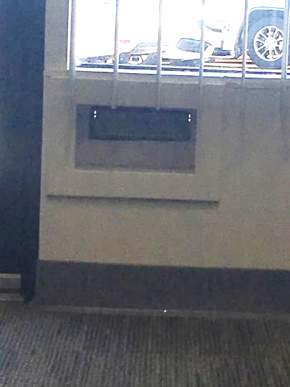
Mailbox in conference room
Picture 2
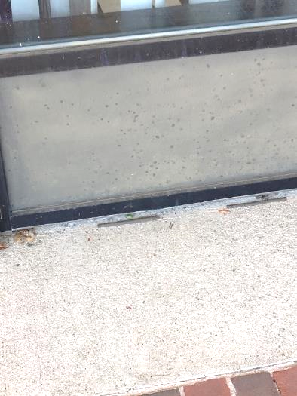
Missing sealant on sidewalk/window panel junction
(Arrow shows old/discontinuous sealant)
Location | Carbon  Dioxide  (ppm) | Carbon Monoxide  (ppm) | Temp  (°F) | Relative  Humidity  (%) | PM2.5  (µg/m³) | Occupants  in Room | Windows  Openable | Ventilation |  | Remarks
 |  |  |  |  |  |  |  | Supply | Exhaust
Background (outdoors) | 381 | ND | 91 | 47 | 68
Conference room | 445 | ND | 73 | 73 | 67 | 1 | N | Y | Y | Mail slot
Storeroom | 431 | ND | 71 | 73 | 61 | 0 | N | Y | Y
Laboratory | 428 | ND | 70 | 72 | 65 | 0 | N | Y | Y
Server room | 460 | ND | 70 | 73 | 66 | 0 | N | Y | Y
Rest room | 438 | ND | 70 | 75 | 66 |  | N | Y | Y
IT | 531 | ND | 71 | 76 | 66 | 2 | N | Y | Y
Reception | 459 | ND | 71 | 75 | 64 | 0 | N | Y | Y
Printer room | 425 | ND | 70 | 71 | 64 | 0 | N | Y | Y
Directors | 428 | ND | 70 | 70 | 65 | 0 | N | Y | Y
Staff cubicles | 455 | ND | 70 | 71 | 64 | 0 | N | Y | Y
Break room | 419 | ND | 70 | 73 | 64 | 0 | N | Y | Y
Men’s restroom | 432 | ND | 70 | 74 | 64 | - | N | Y | Y
Women’s restroom | 420 | ND | 70 | 75 | 64 | - | N | Y | Y

Location | Carbon  Dioxide  (ppm) | Carbon Monoxide  (ppm) | Temp  (°F) | Relative  Humidity  (%) | PM2.5  (µg/m³) | Occupants  in Room | Windows  Openable | Ventilation |  | Remarks
 |  |  |  |  |  |  |  | Supply | Exhaust
Background (outdoors) | 434 | ND | 77 | 59 | 14
Reception | 648 | ND | 74 | 44 | 8 | 0 | N | Y | Y
Storage | 634 | ND | 73 | 44 | 9 | 0 | N | Y | Y
Conference room | 619 | ND | 76 | 48 | 9 | 4 | N | Y | Y | Mail slot
Director office | 616 | ND | 74 | 45 | 5 | 0 | N | Y | Y
Printer room | 606 | ND | 75 | 44 | 4 | 0 | N | Y | Y
Cubicles | 612 | ND | 75 | 44 | 2 | 2 | N | Y | Y | Dehumidifier
Kitchen | 607 | ND | 76 | 41 | 3 | 0 | N | Y | Y | Dehumidifier
Laboratory | 603 | ND | 75 | 44 | 4 | 0 | N | Y | Y
IT | 820 | ND | 75 | 50 | 3 | 3 | N | Y | Y
Back hallway | 757 | ND | 76 | 51 | 3 | 0 | N | N | Y
Restroom | 710 | ND | 74 | 51 | 2 | 0 | N | N | Y
Foyer | 624 | ND | 74 | 52 | 5 | 0 | N | N | Y

