Indoor Air Quality Assessment

Department of Capital Asset Management & Maintenance
220 Old Common Road
Lancaster, MA

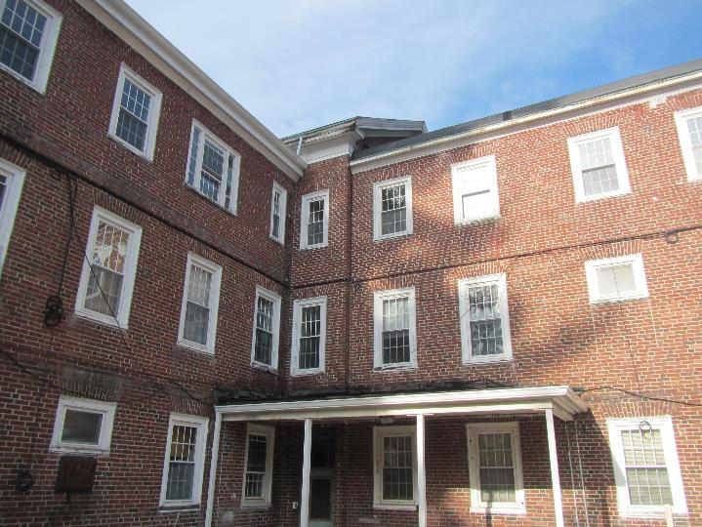

Prepared by:
Massachusetts Department of Public Health
Bureau of Environmental Health
Indoor Air Quality Program
January 2019

Background
Building: | Department of Capital Asset Management & Maintenance (DCAMM)
Address: | 220 Old Common Road Lancaster, MA
Assessment Requested by: | Jason Kruckas, DCAMM, Facility Manager
Reason for Request: | General Indoor Air Quality (IAQ) concerns by anonymous complaint
Date of Assessment: | December 14, 2018
Massachusetts Department of Public Health/Bureau of Environmental Health (MDPH/BEH) Staff Conducting Assessment: | Jason Dustin, Environmental Analyst, IAQ program
Building Description: | The occupied offices examined are primarily on the basement, first, and second floors of a three-story building. The building has a pitched slate roof and a small section with a flat rubber membrane roof. It was originally built between the late 1800’s and the early 1900’s. Renovations are ongoing.
Windows: | Some openable

Methods
Please refer to the IAQ Manual for methods, sampling procedures, and interpretation of results (MDPH, 2015).

IAQ Testing Results
The following is a summary of indoor air testing results (Table 1).
- Carbon dioxide levels were below the MDPH guideline of 800 parts per million (ppm) in all areas surveyed, indicating adequate air exchange. It should be noted that there was low building occupancy during the assessment which would decrease carbon dioxide readings.
- Temperature was within or below the MDPH recommended range of 70°F to 78°F in all areas tested.
- Relative humidity was below the MDPH recommended range of 40 to 60% in the areas tested which is typical during the heating season.
- Carbon monoxide levels were non-detectable (ND) in all areas tested except for the supply/tool room which is adjacent to the parking lot where a vehicle was noted to be idling at the time of this assessment.
- Fine particulate matter (PM2.5) concentrations measured were below the National Ambient Air Quality (NAAQS) limit of 35 μg/m³ in all areas tested except for one area on the second floor with active construction.
- Total Volatile Organic Compound (TVOC) levels were ND in all areas surveyed.

Ventilation
A heating, ventilating and air conditioning (HVAC) system has several functions. First it provides heating and, if equipped, cooling. Second, it is a source of fresh air. Finally, an HVAC system will dilute and remove normally-occurring indoor environmental pollutants by not only introducing fresh air, but by filtering the airstream and ejecting stale air to the outdoors via exhaust ventilation. Even if an HVAC system is operating as designed, point sources of respiratory irritation may exist and cause symptoms in sensitive individuals.
The DCAMM building does not appear to have any mechanical ventilation to introduce fresh air into occupied areas. The building has a newly upgraded oil boiler and hot water radiators for heating but there is no air handling unit (AHU) to distribute tempered fresh air. Some window air conditioner (AC) units were noted in the building which may be used in the “fan only” setting to supply a limited amount of fresh air during temperate weather. There are a number of local exhaust fans/vents throughout the building which eject air directly outside however these systems were inactive at the time of this assessment (Picture 1). Instead, this building relies on fresh air from openable windows. The MDPH IAQ program typically recommends supply/exhaust ventilation in each office area to more effectively dilute/remove commonly found indoor air pollutants.

Microbial/Moisture Concerns
BEH staff noted that the sink trap in the bathroom off of the tool/supply room is actively leaking. A plastic barrel was being used to catch the water but the barrel was also being used to discard paper trash (Picture 2). This leak should be repaired as soon as possible and any porous items (e.g., paper, cardboard) that were water-damaged should be discarded to prevent microbial colonization.
BEH staff noted some areas of historic water damage throughout the building (Pictures 3). It was reported by DCAMM staff that the building recently had a new rubber roof installed over the flat section of the building as well as extensive slate repairs to the main pitched roof. Most building materials in the DCAMM building appeared to be nonporous (e.g., tile, plaster, concrete) and therefore are not conducive to mold growth. However, dirt and debris accumulation on these materials can support microbial growth if exposed to chronic moisture. A few areas did have some water-damaged porous building materials (e.g., ceiling tiles, wall paper, gypsum wallboard, carpet, boxes) which may become colonized by microbial growth if exposed to chronic moisture (Picture 4).
The third floor/attic area had two large finished rooms. One of these areas had water damage due to leaks from two skylights (Picture 5). The attic area had an old carpet that also appeared to be water-damaged (Picture 6). The dirt/dust within this carpet could support microbial colonization following the sustained water damage and should be removed during the planned renovations.
In general, carpeting should be vacuumed daily using a high efficiency particulate arrestance (HEPA) equipped filter and cleaned at least annually in accordance with IICRC recommendations (IICRC, 2012). Carpeting in areas that may be subject to chronic moistening (e.g., basement areas, Picture 7) should be removed and replaced with non-porous flooring where possible to prevent microbial colonization due to condensation.
During an exterior assessment of the building, IAQ staff noted that there appeared to be several issues which may allow the infiltration of water through the building envelope. This would include missing flashing, rotted window sills/trim, clogged window well drainage, and missing mortar/damaged brickwork (Pictures 8 to 10). Some downspouts were noted draining in close proximity of the building and it was reported that some storm water collection pipes were scheduled to be repaired (Picture 11).

Other IAQ Evaluations
Low levels of carbon monoxide were measured in the basement tool/supply room which is adjacent to the parking lot. A vehicle was observed to be idling just outside this room. Anti-idling measures should be conducted to reduce the migration of vehicle combustion into occupied spaces which may present health concerns with chronic exposure. Note that M.G.L. c. 90:16A restricts idling of vehicles to no more than five minutes unless absolutely necessary (MGL, 1996).
Exposure to low levels of total volatile organic compounds (TVOCs) may produce eye, nose, throat, and/or respiratory irritation in some sensitive individuals. To determine if VOCs were present, BEH/IAQ staff examined rooms for products containing VOCs. BEH/IAQ staff noted cleaners, hand sanitizers, air fresheners and other products in use within the areas. All of these products have the potential to be irritants to the eyes, nose, throat, and respiratory system of sensitive individuals.
BEH staff noted a number of large holes/pathways in ceilings and walls of the building. These pathways allow for dust, moisture, odors, and unconditioned air to enter occupied areas. Many of these pathways are assumed to be sealed during the planned renovations (Pictures 12 to 14).
The relative humidity readings were below the MDPH recommended comfort range the day of the assessment. The MDPH recommends a comfort range of 40 to 60 percent for indoor air relative humidity. Relative humidity in the building would be expected to drop during the winter months due to heating. The sensation of dryness and irritation is common in a low relative humidity environment. “Extremely low (below 20%) relative humidity may be associated with eye irritation [and]…may affect the mucous membranes of individuals with bronchial constriction, rhinitis, or cold and influenza related symptoms” (Arundel et al., 1986). Low relative humidity is a common problem during the heating season in the northeast part of the United States.
Due to the ongoing renovations in an occupied building, there is potential for occupants to be exposed to construction related pollutants (e.g., dusts, odors, VOCs). Project managers should implement isolation techniques and depressurization during necessary work.

Conclusions/Recommendations
Based on observations at the time of assessment, the following is recommended:
- Remove any water-damaged porous items that were not dried properly within 24-48 hours. This would include the carpeting on the third floor/attic as well as any materials containing cellulose (e.g., ceiling tiles, wallpaper, gypsum wallboard, boxes, etc.).
- Make repairs to water-damaged plaster walls and ceilings.
- Seal all holes/pathways leading to wall cavities or other unconditioned areas.
- Follow the MDPH guideline “Construction and renovation generated pollutants in occupied buildings” to reduce occupant exposure during active renovations. Perform particularly dusty/odorous work while building is unoccupied whenever possible.
- Due to the age of the building, lead safe renovation practices should be observed.
- Repair leaking sink trap in restroom off of supply/tool area in basement.
- Make repairs to the building envelope to prevent the infiltration of water. This would include repairing flashing and rotted window sills/trim, repairing window well drainage, and repairing missing mortar/brickwork. Downspouts should direct water at least 5 feet away from the building or into a properly functioning drainage system.
- Continue to make repairs to the local exhaust systems in the building in order to properly remove odors and moisture from occupied spaces.
- Consider adding mechanical fresh air supply (AHU) to the DCAMM building. In the meanwhile, use the windows as needed to supplement fresh air.
- Regularly clean/maintain any window air conditioners and dehumidifiers. Refrain from opening windows while air conditioning is operating to avoid condensation.
- Consider replacing carpeting with nonporous flooring options for areas prone to condensation (e.g., basement areas).
- Ensure that a program of daily high efficiency particulate arrestance (HEPA) vacuuming and annual carpet cleaning in accordance with IICRC recommendations (IICRC, 2012) is maintained.
- Enforce anti-idling efforts in parking lot outside of tool/supply room. Post signs which discourage idling to eliminate migration of combustion products into building.
- Eliminate/reduce the use of hand sanitizers, air fresheners, harsh or scented cleaning products and dry erase materials in the office since all of these products have the potential to be irritants to the eyes, nose, throat, and respiratory system of sensitive individuals.
- For buildings in New England, periods of low relative humidity during the winter are often unavoidable. Therefore, scrupulous cleaning practices should be adopted to minimize common indoor air contaminants whose irritant effects can be enhanced when the relative humidity is low. To control for dusts, a high efficiency particulate arrestance (HEPA) filter equipped vacuum cleaner in conjunction with wet wiping of all surfaces is recommended. Avoid the use of feather dusters. Drinking water during the day can help ease some symptoms associated with a dry environment (throat and sinus irritations).
- Reduce the amount of items stored on flat surfaces to allow regular cleaning.
- Refer to resource manual and other related IAQ documents located on the MDPH’s website for further building-wide evaluations and advice on maintaining public buildings. These documents are available at: http://mass.gov/dph/iaq.

References
Arundel et al. 1986. Indirect Health Effects of Relative Humidity on Indoor Environments. Env. Health Perspectives 65:351-361.
IICRC. 2012. Institute of Inspection, Cleaning and Restoration Certification. Carpet Cleaning: FAQ.
MGL. 1996. Stopped motor vehicles; Operation of Engine; Time Limit; Penalty. Massachusetts General Laws. M.G.L. c. 90:16A.
MDPH. 2015. Massachusetts Department of Public Health. Indoor Air Quality Manual: Chapters I-III. Available at: http://www.mass.gov/eohhs/gov/departments/dph/programs/environmental-health/exposure-topics/iaq/iaq-manual/.
Picture 1
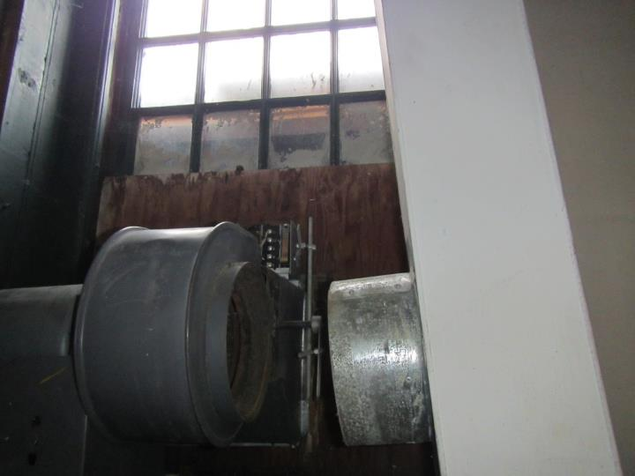
Exhaust ventilation inactive/disconnected
Picture 2
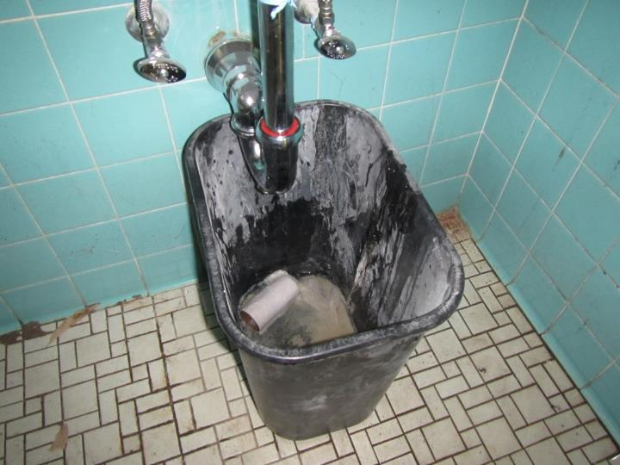
Barrel with porous trash catching water from leak in sink trap
Picture 3
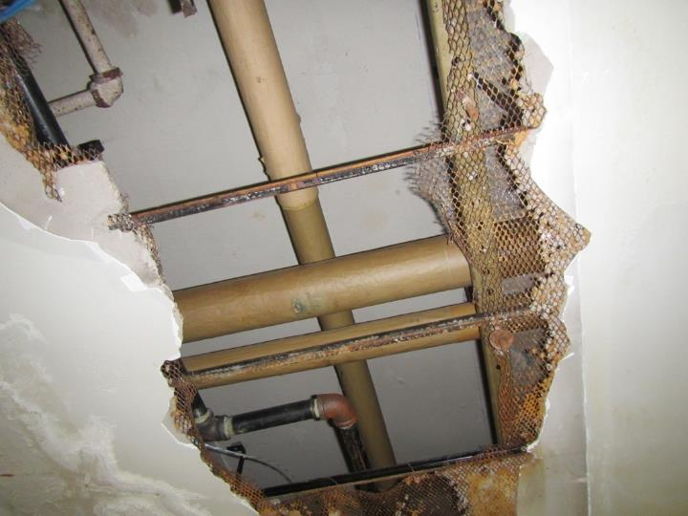
Historic water-damaged plaster ceiling with repairs being made
Picture 4
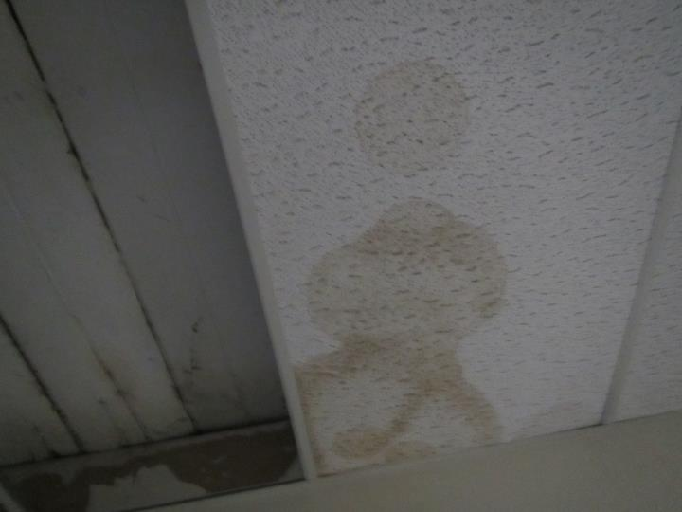
Historic water-damaged porous ceiling tiles
Picture 5
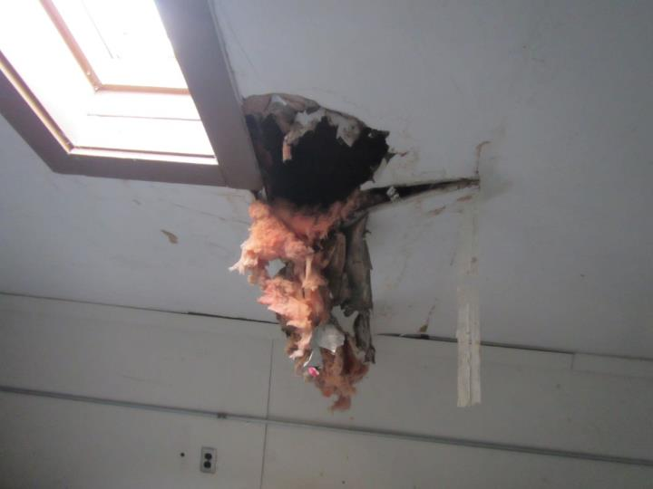
Water-damaged ceiling adjacent to skylight
Picture 6
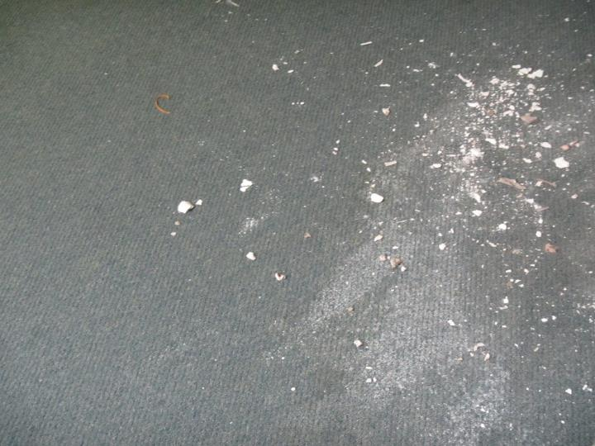
Water-damaged carpeting with ceiling debris in attic
Picture 7
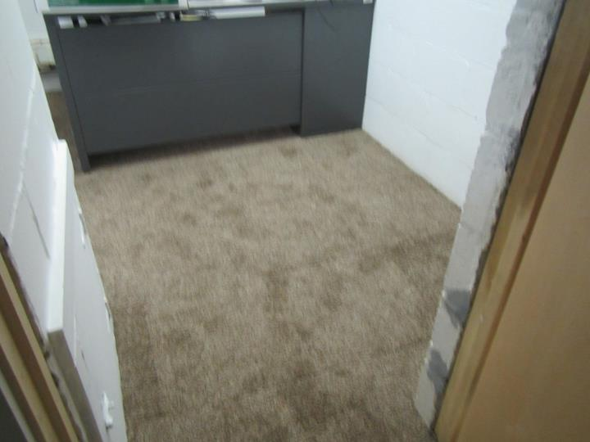
New carpeting in basement office area
Picture 8
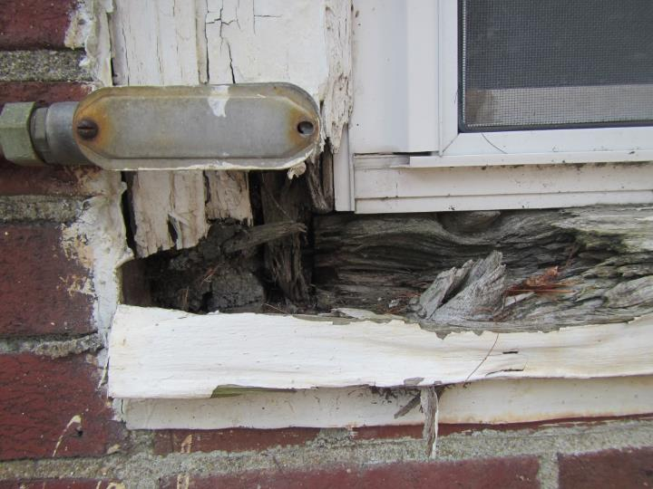
Rotted window sill and trim
Picture 9
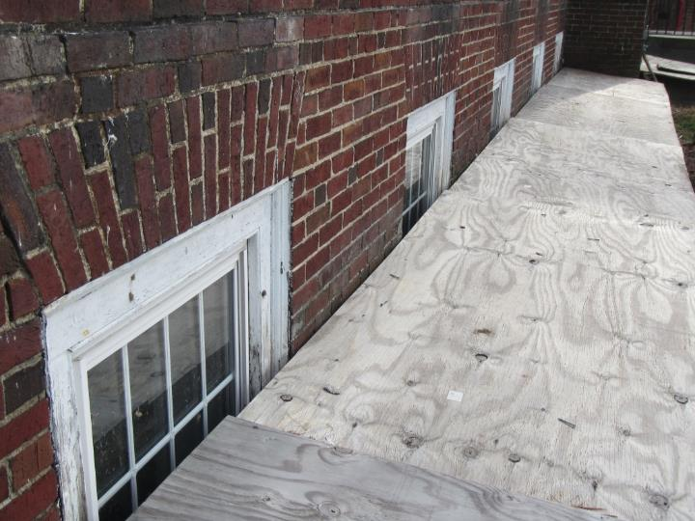
Makeshift window well cover due to clogged drainage below
Picture 10
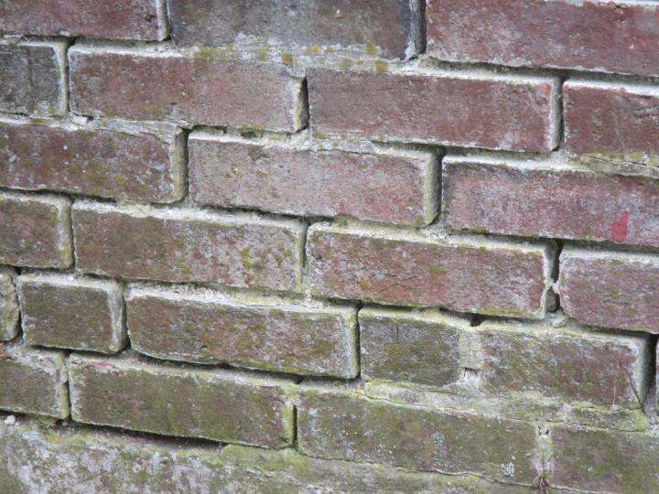
Brickwork showing missing mortar
Picture 11
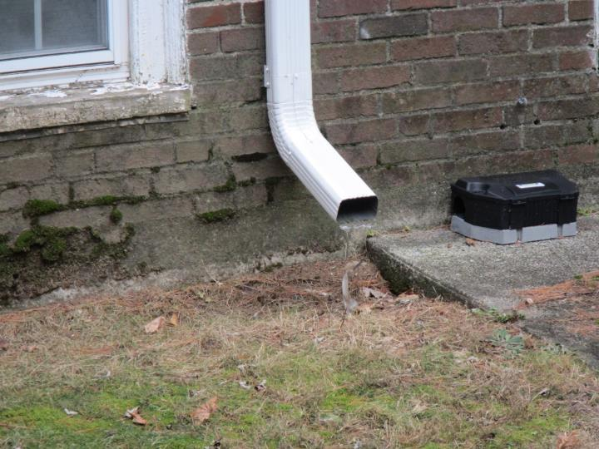
Downspout drains in close proximity to building
Picture 12
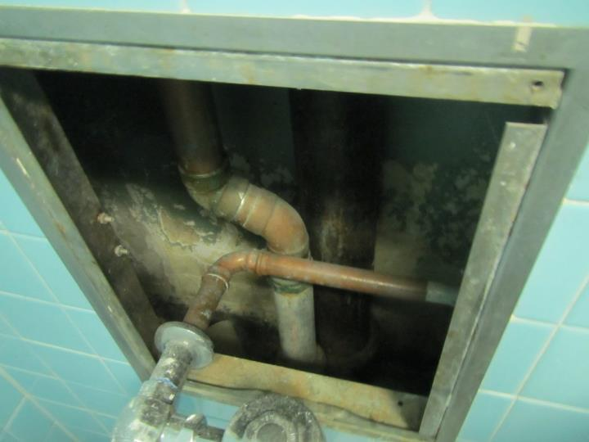
Plumbing access panel left open exposing wall cavity
Picture 13
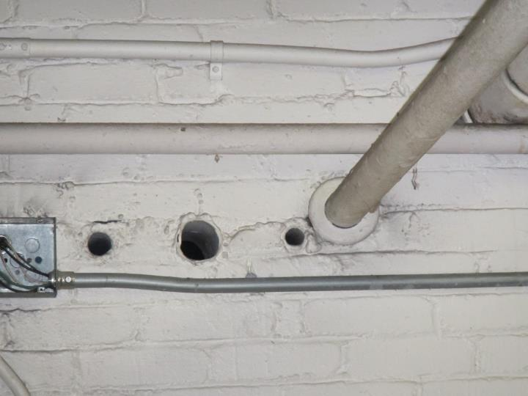
Holes in walls serve as pathways for pollutants to migrate
Picture 14
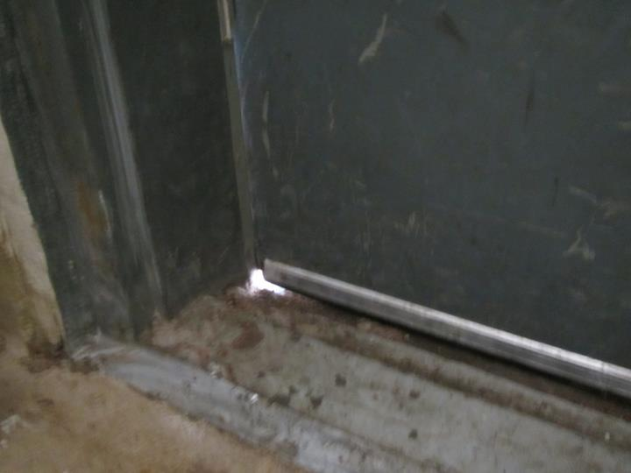
Gap in door serves as pathway for moisture, pests, and unconditioned air
Location | Carbon  Dioxide  (ppm) | Carbon Monoxide  (ppm) | Temp  (°F) | Relative  Humidity  (%) | PM2.5  (µg/m³) | TVOC  (ppm) | Occupants  in Room | Windows  Openable | Ventilation |  | Remarks
 |  |  |  |  |  |  |  |  | Supply | Exhaust
Background | 443 | ND | 44 | 53 | 16 | ND | - | - | - | -
Basement
Supply/tool room | 583 | 1.0 | 58 | 32 | 21 | ND | 1 | Y | N | Y off | WD plaster ceilings, WAC, tile floor, many pathways, vehicle idling near door
Bath | - | - | - | - | - | - | - | - | N | N | Leaking trap on sink, pathways, no exhaust
Main office | 581 | ND | 61 | 30 | 24 | ND | 1 | Y | N | N | WAC, boxes on floor, gap under door to tool room, pathways
Office 1 | 554 | ND | 66 | 26 | 21 | ND | 0 | Y | N | N | Carpet on slab, solvents (WD-40)
Office 2 | 497 | ND | 67 | 26 | 17 | ND | 0 | Y | N | N | Carpet on slab, boxes on floor
Office 3 | 501 | ND | 68 | 25 | 19 | ND | 0 | Y | N | N | Carpet on slab, AI, dry erase materials
Bath 2 | - | - | - | - | - | - | - | - | - | N | Not in use, steam leak, no window or exhaust
Plumbing storage | - | - | - | - | - | - | - | - | - | Y | Boxes on floor/slab
First floor
MEMA lab | 591 | ND | 72 | 23 | 15 | ND | 1 | Y | N | N | HS, solvents, instruments
MEMA storage | - | - | - | - | - | - | - | - | - | - | Historic WD, new rubber roof since, WD boxes removed while there
Conference room | 528 | ND | 73 | 22 | 11 | ND | 1 | Y | N | N | WAC
Break room | 541 | ND | 73 | 20 | 11 | ND | 0 | Y | N | Y | Renovations underway
Kim’s | 610 | ND | 74 | 20 | 8 | ND | 1 | Y | N | N | CPs, AF plugin
Yourenette | 622 | ND | 75 | 21 | 10 | ND | 1 | Y | N | N | WAC, AF plugin
Dan’s | 481 | ND | 74 | 19 | 7 | ND | 0 | Y | N | N
Copy/office | 540 | ND | 75 | 20 | 7 | ND | 0 | Y | N | N | Photocopier
Second Floor
Jason’s | 465 | ND | 73 | 22 | 23 | ND | 0 | Y | N | N | AI, boxes, etc.
Hotel space | 612 | ND | 72 | 26 | 46 | ND | 1 | Y | N | N | Active construction
Tram’s | 442 | ND | 70 | 24 | 11 | ND | 0 | Y | N | N
Old Bath | - | - | - | - | - | - | - | - | - | - | Unoccupied, capped plumbing, renovations being made, pathways to wall cavities, etc.
Third Floor/Attic
Large finished space | - | - | - | - | - | - | - | - | N | N | Unoccupied, historic WD from leaking skylights, WD ceilings/walls, WD carpet, bird droppings?

