INDOOR AIR QUALITY ASSESSMENT

Department of Career Services
Executive Office of Labor and Workforce Development
19 Staniford Street 1st floor
Boston MA 02114

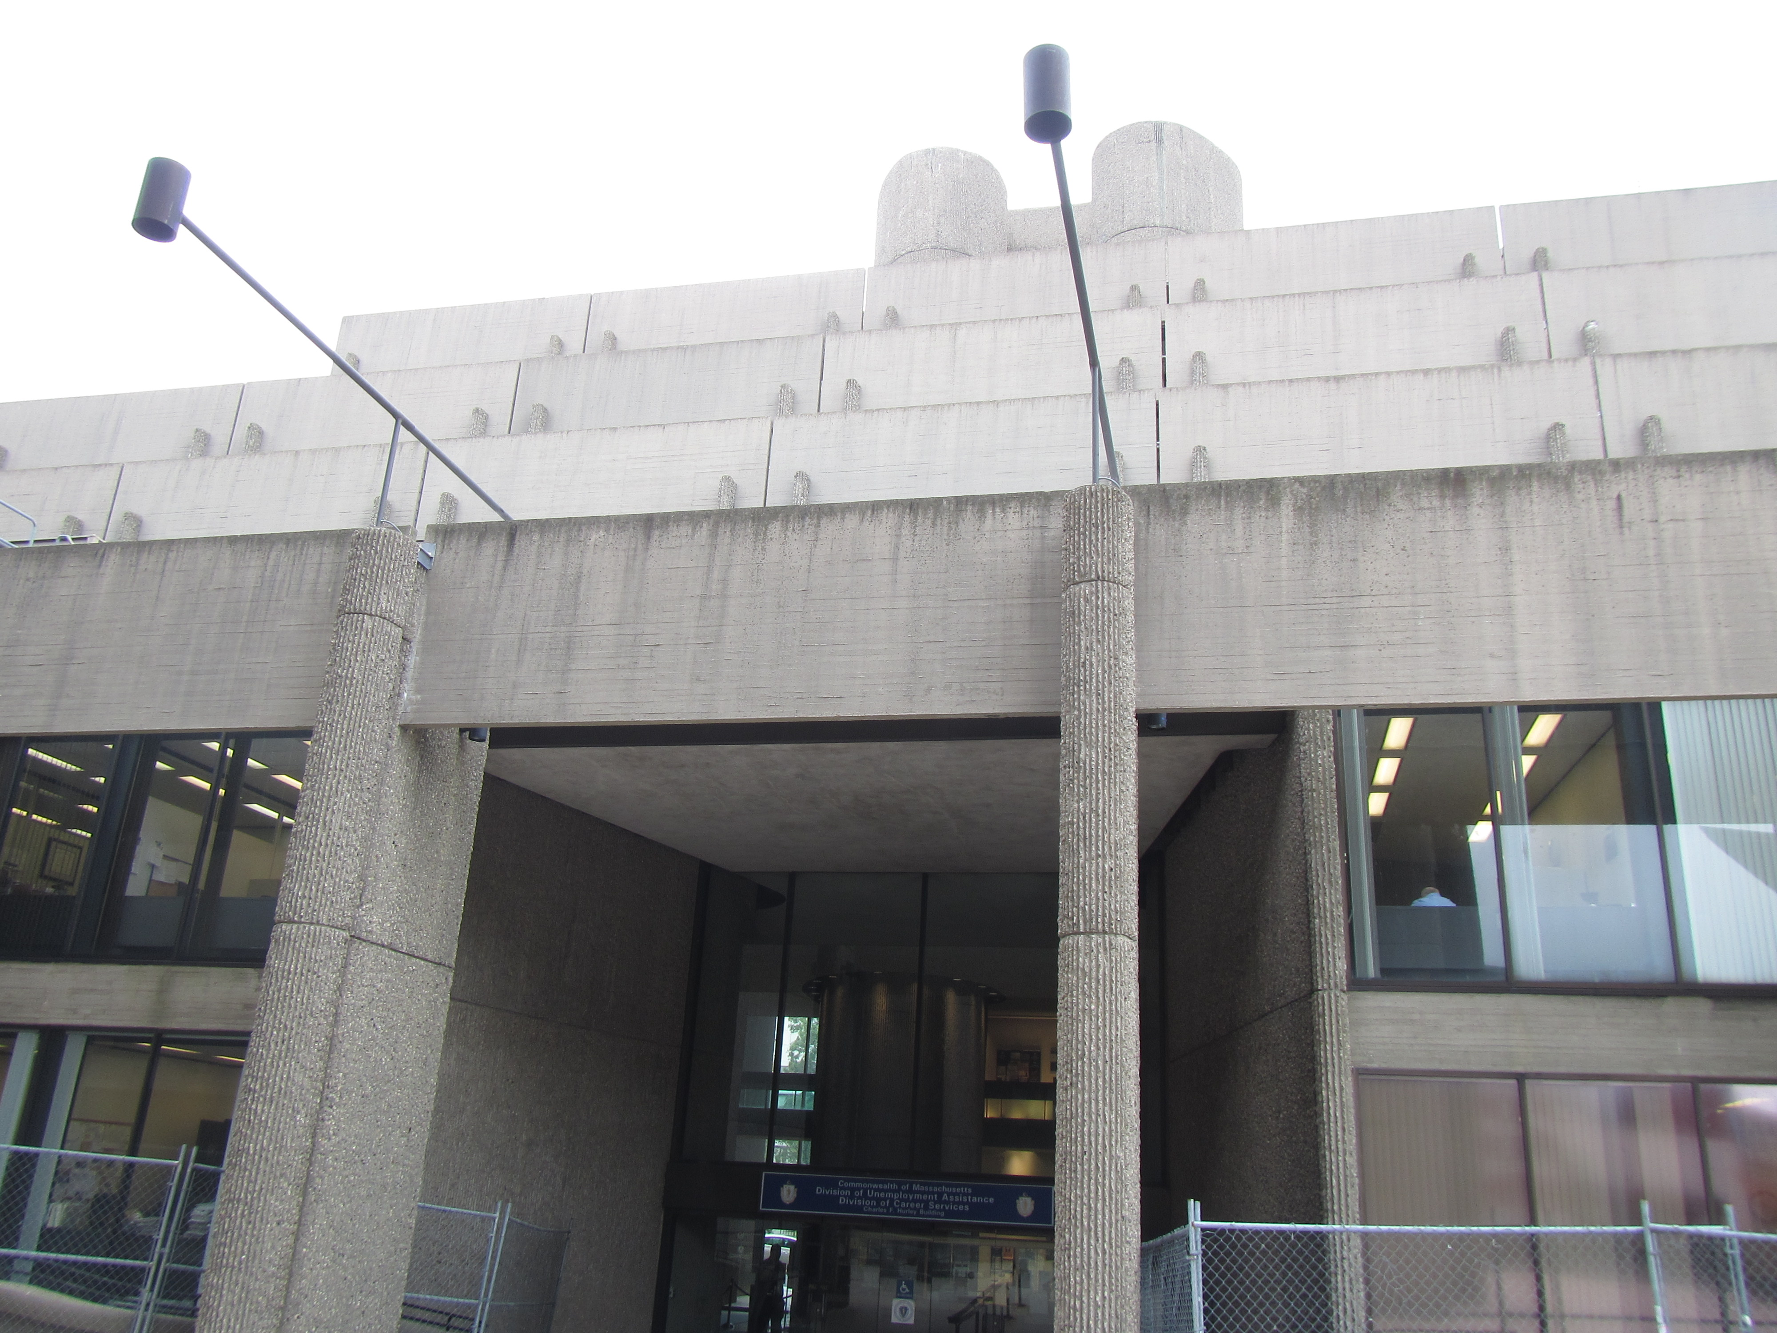

Prepared by:
Massachusetts Department of Public Health
Bureau of Environmental Health
Indoor Air Quality Program
December 2017

Background
Building: | Hurley Building, Department of Career Services (DCS), Executive Office of Labor and Workforce Development (EOLWD)
Address: | 19 Staniford Street, 1st floor, Boston MA
Assessment Requested by: | Karen Haynes-Clifton, Deputy Director of Diversity, EOLWD
Reason for Request: | General Indoor Air Quality (IAQ) concerns. Note that this space was previously assessed by the MDPH/IAQ Program in October of 2015
Date of Assessment: | December 7, 2017
Massachusetts Department of Public Health/Bureau of Environmental Health (MDPH/BEH) Staff Conducting Assessment: | Ruth Alfasso, Environmental Engineer, indoor air quality (IAQ) Program
Building Description: | The area assessed is on the first floor of Hurley Building, a Brutalist concrete building constructed in the 1960s.
Windows: | Not openable

Methods
Please refer to the IAQ Manual for methods, sampling procedures, and interpretation of results (MDPH, 2015).

IAQ Testing Results
The following is a summary of indoor air testing results (Table 1).
- Carbon dioxide levels were below 800 parts per million (ppm) in all areas surveyed, indicating adequate air exchange.
- Temperature was within the recommended range of 70°F to 78°F in all areas tested.
- Relative humidity was below the recommended range of 40 to 60% in the areas tested which is typical during the heating season.
- Carbon monoxide levels were non-detectable (ND) in all areas tested.
- Fine particulate matter (PM2.5) concentrations measured were below the National Ambient Air Quality (NAAQS) limit of 35 μg/m³ in all areas tested.

Ventilation
A heating, ventilating and air conditioning (HVAC) system has several functions. First it provides heating and, if equipped, cooling. Second, it is a source of fresh air. Finally, an HVAC system will dilute and remove normally-occurring indoor environmental pollutants by not only introducing fresh air, but by filtering the airstream and ejecting stale air to the outdoors via exhaust ventilation. Even if an HVAC system is operating as designed, point sources of respiratory irritation may exist and cause symptoms in sensitive individuals.
Fresh air is provided by air handling units (AHUs). Ducts carry air from the AHUs to offices and distribute tempered air via supply vents located around some light fixtures in the main areas. Fresh air and heating/cooling/circulation for offices is provided by induction units located adjacent to windows (Picture 1). Return air is drawn into ceiling-mounted vents located around other light fixtures and brought back to AHUs.
The assessment results indicate that the ventilation system is providing adequate fresh air for the current occupancy. It is recommended that HVAC systems be re-balanced every five years to ensure adequate air systems function (SMACNA, 1994). It was reported that the HVAC system was balanced in April of 2017.

Microbial/Moisture Concerns
In a few offices by the windows there were water collection containers (Pictures 2 and 3), one with collected standing water. These containers are used to collect condensation and/or leaks from the induction units, typically when operating in cooling mode. A water-damaged cardboard box was also observed in one area (Picture 4), but no water-damaged building materials were noted during the inspection. Leaks from HVAC equipment should be reported to building management when they occur. Containers used to collect condensate or leaks should be emptied daily or more frequently to prevent spills and odors. Items should not be stored in areas that may become moistened from condensation.
Plants were observed in some offices (Picture 5). Some of these plants were in located on the ventilation equipment or on porous surfaces. Plants should be well maintained, not overwatered and kept away from the airstream of ventilation equipment to prevent odors, water damage, and pests.

Other IAQ Evaluations
Exposure to low levels of total volatile organic compounds (TVOCs) may produce eye, nose, throat, and/or respiratory irritation in some sensitive individuals. To determine if VOCs were present, BEH/IAQ staff examined rooms for products containing VOCs. BEH/IAQ staff noted cleaners, hand sanitizers, air fresheners and other products in use within the building (Table 1). All of these products have the potential to be irritants to the eyes, nose, throat, and respiratory system of sensitive individuals.
Cooking equipment, including toasters, microwave ovens, and coffee machines, were located in various parts of the office space (Table 1; Picture 6). Food areas and cooking equipment need to be kept clean to prevent odors and pests.
In some areas, stored materials and accumulated items make it more difficult for custodial staff to clean (Table 1; Pictures 7 and 8). Items should be stored neatly and moved periodically to allow for wet-wiping and vacuuming of surfaces. Items should also not be stored on top of radiators or in the airstream of ventilation equipment as heating and moving air can cause items to release dusts and odors. Also note that the design of the building with ventilation equipment set away from the windows leaves a gap behind the equipment that is difficult to reach in order to clean. In many areas, items were observed in this space (Pictures 3 and 4). The base of the windows also have trays which, in many rooms, contained a buildup of debris (Picture 9). If moistened, the debris may be a source of odors and a medium for mold growth.
Thorough cleaning of ventilation equipment surface should be conducted during the year. Personal fans also had settled dust, which can be reaerosolized when the fan is activated.
Rodent traps were observed in some areas. Rodent infestation can result in indoor air quality related symptoms due to materials in their wastes. Mouse urine contains a protein that is a known sensitizer (US EPA, 1992). A sensitizer is a material that can produce symptoms (e.g., running nose or skin rashes) in sensitive individuals after repeated exposure. To eliminate exposure to allergens, rodents must be removed from the building. Please note that removal, even after cleaning, may not provide immediate relief since allergens can exist in the interior for several months after rodents are eliminated (Burge, 1995). Once the infestation is eliminated, a combination of cleaning and increased ventilation and filtration should serve to reduce allergens associated with rodents.
Most offices were carpeted. Carpets and area rugs should be vacuumed regularly with a HEPA-filter-equipped vacuum cleaner and cleaned annually (or semi-annually in soiled/high traffic areas) in accordance with Institute of Inspection, Cleaning and Restoration Certification (IICRC) recommendations, (IICRC, 2012).

Conclusions/Recommendations
Based on observations at the time of assessment, the following is recommended:
- Operate supply and exhaust ventilation continuously in all areas during occupied periods. Ensure all HVAC equipment is cleaned/maintained in accordance with manufacturer’s instructions including filter changes. Avoid placing items, especially plants, on top of radiators.
- Have the HVAC system balanced every 5 years in accordance with SMACNA recommendations (SMACNA, 1994).
- For buildings in New England, periods of low relative humidity during the winter are often unavoidable. Therefore, scrupulous cleaning practices should be adopted to minimize common indoor air contaminants whose irritant effects can be enhanced when the relative humidity is low. To control for dusts a HEPA-filter-equipped vacuum cleaner in conjunction with wet wiping of all surfaces is recommended. Avoid the use of feather dusters. Drinking water during the day can help ease some symptoms associated with a dry environment (throat and sinus irritations).
- Repair HVAC leaks or adjust system to reduce condensation in induction units.
- Avoid storing anything in areas where leaks or condensation are likely to occur.
- Ensure that any container used to collect water is emptied at least daily or more frequently as needed and kept clean to avoid odors.
- Remediate any water-damaged building materials in accordance with the EPA guideline “Mold Remediation in Schools and Commercial Buildings” (USEPA, 2008). Clean non-porous water-stained surfaces, including walls and floors and remove any debris. Discard water-damaged boxes.
- Keep plants in good condition, avoid overwatering, and remove from the airstream of heating and ventilation equipment.
- Consider the use of waterproof mats underneath all water dispensers and refrigerators to protect carpet. Keep refrigerators clean.
- Reduce the use of cleaning products, sanitizers, and other items that contain VOCs. Minimize the use of scented products.
- Use the principles of Integrated Pest Management (IPM) and the services of a licensed pest control operator to remove rodents and reduce the potential for pest infestation. Ensure that any area where rodents may have been is thoroughly cleaned to remove allergens.
- Ensure that all cooking equipment is kept clean.
- Clean dust and debris from ventilation equipment, including supply and exhaust vents, radiators and the blades of personal fans to prevent aerosolization of dust.
- Reduce the amount of accumulated items on surfaces to allow for regular cleaning.
- Clean carpeting annually or more frequently per the recommendations of the Institute of Inspection, Cleaning and Restoration Certification (IICRC).
- Refer to resource manual and other related IAQ documents located on the MDPH’s website for further building-wide evaluations and advice on maintaining public buildings. These documents are available at: http://www.mass.gov/dph/iaq.

References
Burge, H.A. 1995. Bioaerosols. Lewis Publishing Company, Boca Raton, FL.
IICRC. 2012. Institute of Inspection, Cleaning and Restoration Certification. Carpet Cleaning: FAQ. Retrieved from http://www.iicrc.org/consumers/care/carpet-cleaning.
MDPH. 2015. Massachusetts Department of Public Health. Indoor Air Quality Manual: Chapters I-III. Available at: http://www.mass.gov/eohhs/gov/departments/dph/programs/environmental-health/exposure-topics/iaq/iaq-manual/.
SMACNA. 1994. HVAC Systems Commissioning Manual. 1st ed. Sheet Metal and Air Conditioning Contractors’ National Association, Inc., Chantilly, VA.
US EPA. 1992. Indoor Biological Pollutants. US Environmental Protection Agency, Environmental Criteria and Assessment Office, Office of Health and Environmental Assessment, research Triangle Park, NC. EPA 600/8-91/202. January 1992.
US EPA. 2008. “Mold Remediation in Schools and Commercial Buildings”. Office of Air and Radiation, Indoor Environments Division, Washington, DC. EPA 402-K-01-001. September 2008. Available at: http://www.epa.gov/mold/mold-remediation-schools-and-commercial-buildings-guide.

Picture 1
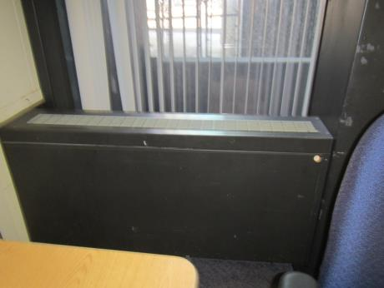
Induction unit
Picture 2
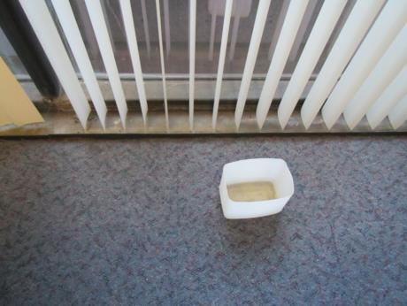
Water collection vessel near windows, contains water
Picture 3
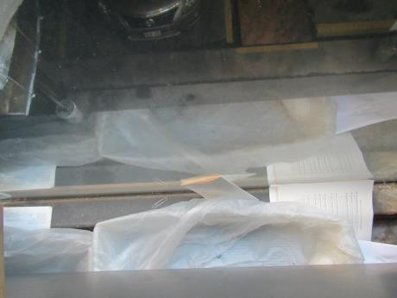
Water collection vessel near windows; also note papers, dust and debris in this area
Picture 4
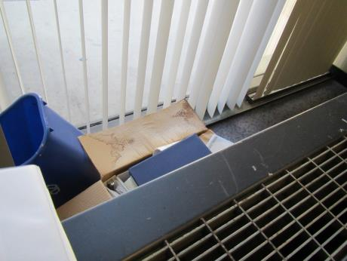
Water-damaged box and other items stored under/behind ventilation equipment
Picture 5
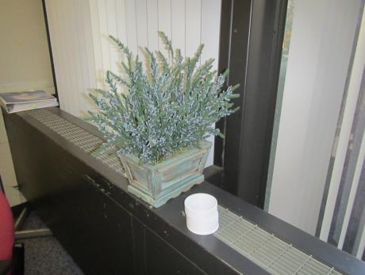
Plant on ventilation equipment
Picture 6
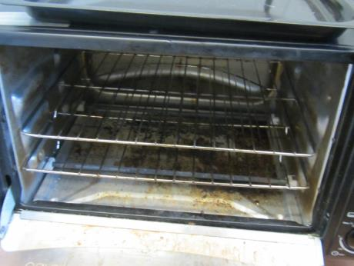
Toaster with crumbs
Picture 7
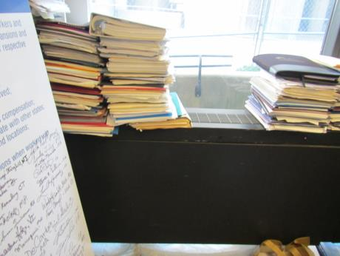
Items stacked on ventilation equipment
Picture 8
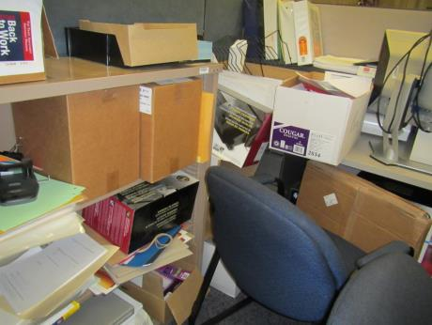
Accumulated items
Picture 9
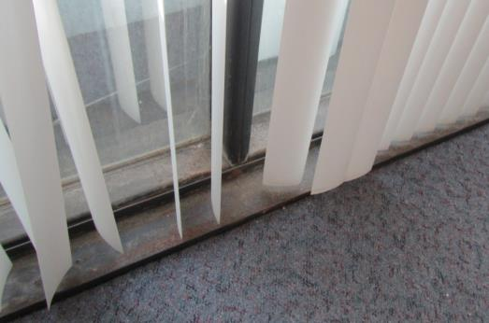
Debris accumulated in window tray

Location | Carbon  Dioxide  (ppm) | Carbon Monoxide  (ppm) | Temp  (°F) | Relative  Humidity  (%) | PM2.5  (µg/m³) | Occupants  in Room | Windows  Openable | Ventilation |  | Remarks
 |  |  |  |  |  |  |  | Supply | Exhaust
Background | 395 | ND | 52 | 21 | 9 |  |  |  |  | Sunny, windy
Quality Assessment office | 748 | ND | 72 | 20 | 4 | 3 | N | Y | Y | Space behind heater next to windows has dust/debris, PF
Costa cubes | 637 | ND | 73 | 17 | 4 | 0 | N | Y | Y
167A | 542 | ND | 74 | 15 | 4 | 0 | N | Y | Y | Fridge on stained carpet, toaster, microwave
US DOL Vet | 614 | ND | 75 | 16 | 4 | 1 | N | Y | Y | ½ wall office, CP
US DOL Vet | 652 | ND | 76 | 16 | 4 | 0 | N | Y | Y | ½ wall office
156A | 690 | ND | 75 | 15 | 5 | 0 | N | Y | Y | PF, plants on vent, HS, DEM
Stadthard cubes | 698 | ND | 75 | 16 | 4 | 2 | N | Y | Y | Plants
Lamarca office | 619 | ND | 74 | 15 | 5 | 1 | N | Y | Y | DEM, AI, CP
Manny office | 648 | ND | 75 | 16 | 4 | 2 | N | Y | Y | DEM, PF
Taintor cubes | 599 | ND | 75 | 15 | 4 | 1 | N | Y | Y | DEM
Sweeney office | 574 | ND | 75 | 15 | 4 | 0 | N | Y | Y | HS, water collection dish behind heater next to window (has water in), fridge and microwave
Small conference room | 522 | ND | 75 | 14 | 5 | 0 | N | Y | Y | DEM
Cambridge conference room | 562 | ND | 75 | 14 | 5 | 0 | N | Y | Y | Dust on window ledges, DEM
Boucher, cubes | 569 | ND | 75 | 15 | 4 | 4 | N | Y | Y
Zhang cubes | 588 | ND | 75 | 15 | 4 | 3 | N | Y | Y | HS
Berke cubes | 596 | ND | 76 | 15 | 4 | 3 | N | Y | Y | AI – paper
Empty cubes | 571 | ND | 75 | 15 | 4 | 0 | N | Y | Y | AI, old books
MOSES area | 577 | ND | 75 | 14 | 4 | 0 | N | Y | Y | ½ wall, PF
Ruiz cubes | 540 | ND | 75 | 14 | 5 | 2 | N | Y | Y | PF, plants, near elevator
Director of Miltilingual services | 552 | ND | 74 | 15 | 4 | 1 | N | Y | Y | PF, DEM
Lopes Cubes | 608 | ND | 75 | 15 | 4 | 2 | N | Y | Y | Food
Office | 594 | ND | 74 | 15 | 4 | 1 | N | Y | Y | AI, DEM, PF, CP
Glasser office | 669 | ND | 75 | 15 | 5 | 0 | N | Y | Y | Fridge on floor, items on vent, CP, food
Pinkham office | 561 | ND | 74 | 14 | 6 | 1 | N | Y | Y | CP, cardboard
Koeranga office | 524 | ND | 75 | 15 | 6 | 0 | N | Y | Y | ½ wall
Burke cube | 531 | ND | 75 | 14 | 6 | 2 | N | Y | Y | PFs
Reception | 563 | ND | 75 | 15 | 4 | 0 | N | Y | Y
Goguen office | 599 | ND | 74 | 14 | 5 | 0 | N | Y | Y | DEM
Bower cube | 605 | ND | 77 | 15 | 6 | 2 | N | Y | Y | AI
Nwabinwe cubes | 593 | ND | 77 | 14 | 5 | 2 | N | Y | Y
Tate office | 626 | ND | 76 | 21 | 7 | 1 | N | Y | Y
Ledonne office | 594 | ND | 76 | 14 | 6 | 1 | N | Y | Y | CP, DEM
Thompson cubes | 586 | ND | 77 | 15 | 5 | 2 | N | Y | Y | One cube has coffee machine, boxes, HS
Lally cubes | 715 | ND | 77 | 15 | 6 | 0 | N | Y | Y | AI, food
Cubes | 575 | ND | 77 | 14 | 7 | 1 | N | Y | Y | AI, DEM
Bartkeiwicz office | 548 | ND | 76 | 13 | 8 | 0 | N | Y | Y | PF- dusty, DEM, WD box behind heater
Alexander office | 556 | ND | 76 | 14 | 7 | 0 | N | Y | Y | plants
Filkins cubes | 602 | ND | 76 | 15 | 7 | 1 | N | Y | Y
Kasle cubes | 587 | ND | 76 | 15 | 6 | 1 | N | Y | Y | CP, items, HS
Messing office | 537 | ND | 77 | 14 | 7 | 0 | N | Y | Y | Water-catch bins behind heater, DEM, paper on vents
Laterzo iffice | 517 | ND | 78 | 13 | 8 | 0 | N | Y | Y | DEM, CP, HS
Staff training | 509 | ND | 77 | 13 | 7 | 0 | N | Y | Y | PF, vent covered in paper, DEM, food
Mazza office | 524 | ND | 75 | 13 | 9 | 0 | N | Y | Y | Items including on vents, dust/debris under heaters

