Background/Introduction

INDOOR AIR QUALITY ASSESSMENT

Commonwealth of Massachusetts
Department of Children and Families
140 High Street
Springfield, Massachusetts

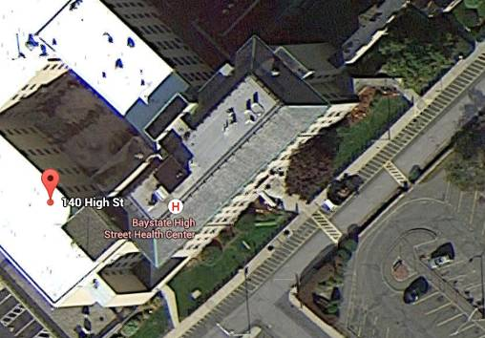

Prepared by:
Massachusetts Department of Public Health
Bureau of Environmental Health
Indoor Air Quality Program
April 2015

In response to a request by occupants, the Massachusetts Department of Public Health (MDPH), Bureau of Environmental Health (BEH) provided assistance and consultation regarding indoor air quality (IAQ) at the Department of Children and Families (DCF) located at 140 High Street in Springfield, Massachusetts. The request was prompted by general IAQ concerns and was coordinated through Gerry Covino, Project Manager, Office of Leasing and State Office Planning (OLSOP), Department of Capital Asset Management and Maintenance (DCAMM). On March 30, 2015 the DCF was visited by Ruth Alfasso, Environmental Engineer/Inspector to conduct an IAQ assessment.
The DCF occupies the fourth floor as well as part of the fifth floor of a former hospital originally constructed in the early 1900s. A west wing addition was built in 1968. The DCF has occupied the space since July, 2008. Floors in the majority of areas are carpeted. Windows are not openable in the building. Other Executive Office of Health and Human Services (EOHHS) offices occupy adjacent space in the building.
The BEH/IAQ program visited this space in 2012 as a part of a general effort to assess the IAQ of leased office space for EOHHS agencies. A report was issued at that time with recommendations. Appendix A provides a list of recommendations made in that report and observations relative to the improvements/actions taken on those recommendations.

Methods
Air tests for carbon monoxide, carbon dioxide, temperature and relative humidity were conducted with the TSI, Q-Trak, IAQ Monitor, Model 7565. Air tests for airborne particle matter with a diameter less than 2.5 micrometers were taken with the TSI, DUSTTRAK™ Aerosol Monitor Model 8520. BEH/IAQ staff also performed a visual inspection of building materials for water damage and/or microbial growth.

Results
Approximately 200 employees work in the DCF-occupied areas of the building, which is visited by clients/members of the public daily. The tests were taken during normal operations and appear in Table 1.

Discussion

Ventilation
It can be seen from Table 1 that carbon dioxide levels were below 800 parts per million (ppm) in 79 of 92 areas tested, indicating optimal air exchange in most areas on the day of the assessment. Note that many areas were vacant or sparsely populated, which would tend to decrease carbon dioxide levels. Carbon dioxide levels would be expected to rise with greater occupancy.
Fresh air is provided by air handling units (AHUs) ducted to ceiling-mounted supply diffusers (Pictures 1 and 2). Return air is drawn back into ceiling vents (Picture 3) and returned to AHUs. Note that in a few areas, supply vents were diverted or blocked off (e.g., Picture 4), which reduces the ability of the system to supply fresh air to that space.
Additional ventilation in restrooms is provided by exhausts vented directly to fans on the roof. Note that during the assessment, restroom exhaust ventilation was found to be off/nonfunctional in most areas. Lack of exhaust ventilation in restrooms can lead to a build-up of odors and moisture, which can then migrate to adjacent areas.
Fan coil units (FCUs) are located along the base of walls under windows (Picture 5) and provide supplemental heating or cooling to perimeter areas. FCUs do not introduce outside air; these units are limited to recirculating air. In some areas, FCUs were blocked/obstructed by furniture (Picture 6). Others had books, papers, plants and other items on top, which blocks airflow and may also distribute dust, pollen and other irritants into the space. In order for FCUs to facilitate airflow as designed, they must remain free of obstructions. FCUs appear to be original to the building, which would make them approximately 50 years old. According to the American Society of Heating, Refrigeration and Air-Conditioning Engineering (ASHRAE), the service life for a unit heater, hot water or steam is 20 years, assuming routine maintenance of the equipment (ASHRAE, 1991). Despite attempts to maintain the equipment, the optimal operational lifespan of this equipment has been exceeded.
To maximize air exchange, the MDPH recommends that both supply and exhaust ventilation operate continuously during periods of occupancy. In order to have proper ventilation with a mechanical supply and exhaust system, the systems must be balanced to provide an adequate amount of fresh air to the interior of a room while removing stale air from the room. It is recommended that HVAC systems be re-balanced every five years to ensure adequate air systems function (SMACNA, 1994).
Minimum design ventilation rates are mandated by the Massachusetts State Building Code (MSBC). Until 2011, the minimum ventilation rate in Massachusetts was higher for both occupied office spaces and general classrooms, with similar requirements for other occupied spaces (BOCA, 1993). The current version of the MSBC, promulgated in 2011 by the State Board of Building Regulations and Standards (SBBRS), adopted the 2009 International Mechanical Code (IMC) to set minimum ventilation rates. Please note that the MSBC is a minimum standard that is not health-based. At lower rates of cubic feet per minute (cfm) per occupant of fresh air, carbon dioxide levels would be expected to rise significantly. A ventilation rate of 20 cfm per occupant of fresh air provides optimal air exchange resulting in carbon dioxide levels at or below 800 ppm in the indoor environment in each area measured. MDPH recommends that carbon dioxide levels be maintained at 800 ppm or below. This is because most environmental and occupational health scientists involved with research on IAQ and health effects have documented significant increases in indoor air quality complaints and/or health effects when carbon dioxide levels rise above the MDPH guidelines of 800 ppm for schools, office buildings and other occupied spaces (Sundell et al., 2011). The ventilation must be on at all times that the room is occupied. Providing adequate fresh air ventilation with open windows and maintaining the temperature in the comfort range during the cold weather season is impractical. Mechanical ventilation is usually required to provide adequate fresh air ventilation.
Carbon dioxide is not a problem in and of itself. It is used as an indicator of the adequacy of the fresh air ventilation. As carbon dioxide levels rise, it indicates that the ventilating system is malfunctioning or the design occupancy of the room is being exceeded. When this happens, a buildup of common indoor air pollutants can occur, leading to discomfort or health complaints. The Occupational Safety and Health Administration (OSHA) standard for carbon dioxide is 5,000 parts per million parts of air (ppm). Workers may be exposed to this level for 40 hours/week, based on a time-weighted average (OSHA, 1997).
The MDPH uses a guideline of 800 ppm for publicly occupied buildings. A guideline of 600 ppm or less is preferred in schools due to the fact that the majority of occupants are young and considered to be a more sensitive population in the evaluation of environmental health status. Inadequate ventilation and/or elevated temperatures are major causes of complaints such as respiratory, eye, nose and throat irritation, lethargy and headaches. For more information concerning carbon dioxide, please see Appendix B.
Temperature readings during the assessment ranged from 69ºF to 76ºF (Table 1), all but one of which were within the MDPH recommended comfort guidelines. The MDPH recommends that indoor air temperatures be maintained in a range of 70ºF to 78ºF in order to provide for the comfort of building occupants. In many cases concerning indoor air quality, fluctuations of temperature in occupied spaces are typically experienced, even in a building with an adequate fresh air supply. Temperature complaints were expressed at the time of the assessment; several employees were using supplemental heaters in offices (Table 1). Heaters can be a source of odors if they are placed on or near items such as plastic, which can off-gas when heated. In addition, due to fire risk, heaters must be shut off at the end of every day.
The relative humidity measured during the assessment ranged from 18 to 26 percent, which was below the MDPH recommended comfort range. The MDPH recommends a comfort range of 40 to 60 percent for indoor air relative humidity. Relative humidity levels in the building would be expected to drop during the winter months due to heating. The sensation of dryness and irritation is common in a low relative humidity environment. Low relative humidity is a very common problem during the heating season in the northeast part of the United States.

Microbial/Moisture Concerns
A few water-damaged ceiling tiles were observed (Picture 7, Table 1). These appeared to be from historic or periodic roof leaks. Water-damaged ceiling tiles can provide a source of mold and should be replaced after a water leak is discovered and repaired. The location of the stained tiles near windows/exterior walls suggest leakage may be associated with heavy rains and wind in a specific direction. The roof, flashing or masonry in this area may need repairs.
Plants were observed in several areas (Table 1). Plants can be a source of pollen and mold, which can be respiratory irritants to some individuals. Plants should be properly maintained, over-watering of plants should be avoided and drip pans should be inspected periodically for mold growth.
Water coolers and refrigerators were observed on carpet (Picture 8). Spills or leaks from these appliances can moisten carpeting. They should be located in a non-carpeted area or on waterproof mats. Several water fountains not in current use were observed in the office (Picture 9). The drains in these units may become dry if they are not used or maintained, and may allow sewer gases to penetrate occupied space. In addition, broken plumbing fixtures can be a source of leaks. These fountains should either be repaired and brought back into service, or removed with plumbing properly cut/capped.
Many rooms on the fourth floor were equipped with ductless air conditioning (AC) units to maintain temperature control during the cooling season (Picture 10). These units have condensation drains that are typically pumped to the outside of the building. The ACs should be regularly inspected to ensure that condensation drains and pumps are working properly and are not clogged or leaking. The water-damaged ceiling tile shown in Picture 10 may indicate a leak from the condensation drain system or another source of water that should be repaired.

Other IAQ Evaluations
Indoor air quality can be negatively influenced by the presence of respiratory irritants, such as products of combustion. The process of combustion produces a number of pollutants. Common combustion emissions include carbon monoxide, carbon dioxide, water vapor, and smoke (fine airborne particle material). Of these materials, exposure to carbon monoxide and particulate matter with a diameter of 2.5 micrometers (μm) or less (PM2.5) can produce immediate, acute health effects upon exposure. To determine whether combustion products were present in the indoor environment, BEH/IAQ staff obtained measurements for carbon monoxide and PM2.5.

Carbon Monoxide
Carbon monoxide is a by-product of incomplete combustion of organic matter (e.g., gasoline, wood and tobacco). Exposure to carbon monoxide can produce immediate and acute health effects. Several air quality standards have been established to address carbon monoxide and prevent symptoms from exposure to these substances. The MDPH established a corrective action level concerning carbon monoxide in ice skating rinks that use fossil-fueled ice resurfacing equipment. If an operator of an indoor ice rink measures a carbon monoxide level over 30 ppm, taken 20 minutes after resurfacing within a rink, that operator must take actions to reduce carbon monoxide levels (MDPH, 1997).
The American Society of Heating Refrigeration and Air-Conditioning Engineers (ASHRAE) has adopted the National Ambient Air Quality Standards (NAAQS) as one set of criteria for assessing indoor air quality and monitoring of fresh air introduced by HVAC systems (ASHRAE, 1989). The NAAQS are standards established by the US EPA to protect the public health from six criteria pollutants, including carbon monoxide and particulate matter (US EPA, 2006). As recommended by ASHRAE, pollutant levels of fresh air introduced to a building should not exceed the NAAQS levels (ASHRAE, 1989). The NAAQS were adopted by reference in the Building Officials & Code Administrators (BOCA) National Mechanical Code of 1993 (BOCA, 1993), which is now an HVAC standard included in the Massachusetts State Building Code (SBBRS, 2011). According to the NAAQS, carbon monoxide levels in outdoor air should not exceed 9 ppm in an eight-hour average (US EPA, 2006).
Carbon monoxide should not be present in a typical, indoor environment. If it is present, indoor carbon monoxide levels should be less than or equal to outdoor levels. During the visit outdoor carbon monoxide concentrations were measured at 4 ppm, likely due to traffic/parking outside the building. Indoor levels were all non-detect (ND) (Table 1).

Particulate Matter
The US EPA has established NAAQS limits for exposure to particulate matter. Particulate matter includes airborne solids that can be irritating to the eyes, nose and throat. The NAAQS originally established exposure limits to PM with a diameter of 10 μm or less (PM10). In 1997, US EPA established a more protective standard for fine airborne particulate matter with a diameter of 2.5 μm or less (PM2.5). This more stringent PM2.5 standard requires outdoor air particle levels be maintained below 35 μg/m³ over a 24-hour average (US EPA, 2006). Although both the ASHRAE standard and BOCA Code adopted the PM10 standard for evaluating air quality, MDPH uses the more protective PM2.5 standard for evaluating airborne PM concentrations in the indoor environment.
Outdoor PM2.5 concentrations were measured at 31 μg/m³ (Table 1). PM2.5 levels indoors ranged from ND to 39 μg/m³. All but two readings were below the NAAQS PM2.5 level of 35 μg/m³ (Table 1); these elevations are most likely due to cooking/cleaning activities in the area near the time of testing. Frequently, indoor air levels of particulate matter (including PM2.5) can be at higher levels than those measured outdoors. A number of activities that occur indoors and/or mechanical devices can generate particulate matter during normal operations. Sources of indoor airborne particulate matter may include but are not limited to particles generated during the operation of fan belts in the HVAC system, use of stoves and/or microwave ovens in kitchen areas; use of photocopiers, fax machines and computer printing devices; operation of an ordinary vacuum cleaner and heavy foot traffic indoors.

Volatile Organic Compounds
Indoor air concentrations can be greatly impacted by the use of products containing volatile organic compounds (VOCs). VOCs are carbon-containing substances that have the ability to evaporate at room temperature. Total volatile organic compounds (TVOCs) can result in eye and respiratory irritation if exposure occurs. For example chemicals evaporating from a paint can stored at room temperature would most likely contain VOCs.
Of note is the presence of copy machines within office areas with no dedicated exhaust ventilation (Table 1). Photocopiers can be sources of pollutants such as VOCs, ozone, heat and odors, particularly if the equipment is older and in frequent use. Both VOCs and ozone are respiratory irritants (Schmidt Etkin, 1992). Photocopiers should be kept in well-ventilated rooms/areas and should be located near windows or exhaust vents.
Additional sources of TVOCs in office areas include dry erase boards and related materials (Table 1). Materials such as dry erase markers and dry erase board cleaners may contain VOCs, such as methyl isobutyl ketone, n-butyl acetate and butyl-cellusolve (Sanford, 1999), which can be irritating to the eyes, nose and throat.
Hand sanitizer was also observed in several areas (Table 1); these products may contain ethyl alcohol and/or isopropyl alcohol, which are highly volatile and may be irritating to the eyes and nose. Sanitizing products may also contain fragrances to which some people may be sensitive.
Cleaning products, air freshening sprays and scented products were also found in the office (Table 1). Plug-in air fresheners and other air deodorizers contain chemicals that can be irritating to the eyes, nose and throat of sensitive individuals. Many air fresheners contain 1,4-dichlorobenzene, a VOC which may cause reductions in lung function (NIH, 2006). Furthermore, deodorizing agents do not remove materials causing odors, but rather mask odors that may be present in the area. Many cleaning products contain chemicals that can be irritating to the eyes, nose and throat of sensitive individuals. Cleaning products should be properly labeled and stored in an appropriate area. In addition, a Material Safety Data Sheet (MSDS) should be available at a central location for each product in the event of an emergency.

Other Conditions
Other conditions that can affect IAQ were observed during the assessment. In some areas, accumulations of items were seen on floors, windowsills, tabletops, counters, bookcases and desks, which provide a source for dusts to accumulate (Picture 11). These items (e.g., papers, folders, boxes) make it difficult for custodial staff to clean. Items should be relocated and/or be cleaned periodically to avoid excessive dust build up.
The DCF also has a large number of items stored for clients, including clothing and luggage (Picture 12). Some of these items were observed to be in open bins or on floors in storage rooms, where they can become dusty, dirty or damaged or can serve as harborage for pests.
Personal fans, supply and exhaust vents were found to be dusty in some areas (Picture 3, Table 1). Regular cleaning of supply diffusers, exhaust vents and personal fans will reduce aerosolization of any accumulated particulate matter on these surfaces. In some areas, items were observed to be hanging from the ceiling (Picture 13). These items can be a source for dusts to accumulate as well as disturbing the ceiling tile system, which can allow dust and debris from the ceiling tile system/plenum to enter occupied space.
Food and food preparation equipment was seen in some areas, and crumbs/food debris was observed in appliances (Picture 14). Food should be kept in tightly-sealed bags/containers to prevent attracting pests. Food preparation equipment should also be kept clean and free of debris.
Most areas of the office space were carpeted. The Institute of Inspection, Cleaning and Restoration Certification (IICRC) recommends that carpeting be cleaned annually (or semi-annually in soiled high traffic areas) (IICRC, 2012). Regular cleaning with a high efficiency particulate arrestance (HEPA) filtered vacuum in combination with an annual cleaning will help to reduce accumulation and potential aerosolization of materials from carpeting.

Conclusions/Recommendations
In view of the findings at the time of the visit, the following recommendations are made:
- Refer to Appendix A for recommendations made previously.
- Operate all ventilation systems throughout the building continuously during periods of occupancy to maximize air exchange. This would include leaving thermostat fan settings in the “on” mode (not auto) for continuous airflow.
- Inspect and activate motors for restroom exhaust vents, make repairs as needed.
- Remove obstructions from in front of FCUs and avoid placing items on top of them which obstruct/impact airflow.
- Avoid placing heaters on or near items which may off-gas and ensure all heaters are turned off at the end of the day.
- Consider adopting a balancing schedule of every 5 years for all mechanical ventilation systems, as recommended by ventilation industrial standards (SMACNA, 1994).
- For buildings in New England, periods of low relative humidity during the winter are often unavoidable. Therefore, scrupulous cleaning practices should be adopted to minimize common indoor air contaminants whose irritant effects can be enhanced when the relative humidity is low. To control for dusts, a high efficiency particulate arrestance (HEPA) filter equipped vacuum cleaner in conjunction with wet wiping of all surfaces is recommended. Avoid the use of feather dusters. Drinking water during the day can help ease some symptoms associated with a dry environment (throat and sinus irritations).
- Examine areas of leakage and ensure any water-damaged ceiling tiles are repaired and/or replaced. Examine the area above ceiling tiles for mold growth. Disinfect areas of water leaks with an appropriate antimicrobial, as needed.
- Indoor plants should be properly maintained and equipped with drip pans to prevent water damage to porous building materials and be located away from ventilation sources to prevent the aerosolization of dirt, pollen or mold.
- Place water coolers/dispensers in areas without carpeting or place on a waterproof mat.
- Repair or properly abandon/cut/cap unused water fountains.
- Consider moving refrigerators to areas without carpeting.
- Consider using fewer small refrigerators in the office space to reduce the potential for leaks, spills and odors. Ensure that all refrigerators are kept clean.
- Regularly inspect ductless air conditioning units for proper condensation drainage.
- Consider installing local exhaust vents near photocopiers or relocating them to areas with local exhaust ventilation and away from occupants.
- Use dry erase markers only in well-ventilated areas. Clean dry erase boards and trays to prevent accumulation of materials.
- Reduce the use of hand sanitizing products especially those containing fragrances.
- Avoid the use of air freshener sprays, solids and diffuser reeds to avoid exposure to VOCs and fragrance compounds.
- Ensure that stored items are enclosed to protect from dust and are in plastic containers or on shelves off the floor to prevent condensation.
- Consider reducing the amount of items stored in offices and other areas, particularly paper/boxes.
- Regularly clean supply diffusers, exhaust vents and personal fans to avoid re-aerosolizing any accumulated debris.
- Avoid hanging items from the ceiling tile system.
- Vacuum carpet with a high efficiency particulate arrestance (HEPA) filtered vacuum in combination with an annual cleaning to help to reduce accumulation and potential aerosolization of materials from the carpeting.
- Refer to resource manuals and other related indoor air quality documents for further building-wide evaluations and advice on maintaining public buildings. Copies of these materials are located on the MDPH’s website: http://mass.gov/dph/iaq.

References
ASHRAE. 1989. Ventilation for Acceptable Indoor Air Quality. American Society of Heating, Refrigeration and Air Conditioning Engineers. ANSI/ASHRAE 62-1989.
BOCA. 1993. The BOCA National Mechanical Code/1993. 8th ed. Building Officials & Code Administrators International, Inc., Country Club Hills, IL.
IICRC. 2012. Carpet Cleaning FAQ 4 Institute of Inspection, Cleaning and Restoration Certification. Institute of Inspection Cleaning and Restoration, Vancouver, WA.
MDPH. 1997. Requirements to Maintain Air Quality in Indoor Skating Rinks (State Sanitary Code, Chapter XI). 105 CMR 675.000. Massachusetts Department of Public Health, Boston, MA.
NIH. 2006. Chemical in Many Air Fresheners May Reduce Lung Function. NIH News. National Institute of Health. July 27, 2006. http://www.nih.gov/news/pr/jul2006/niehs-27.htm
OSHA. 1997. Limits for Air Contaminants. Occupational Safety and Health Administration. Code of Federal Regulations. 29 C.F.R 1910.1000 Table Z-1-A.
Sanford. 1999. Material Safety Data Sheet (MSDS No: 198-17). Expo® Dry Erase Markers Bullet, Chisel, and Ultra Fine Tip. Sanford Corporation. Bellwood, IL.
SBBRS. 2011. Mechanical Ventilation. State Board of Building Regulations and Standards. Code of Massachusetts Regulations, 8th edition. 780 CMR 1209.0.
Schmidt Etkin, D. 1992. Office Furnishings/Equipment & IAQ Health Impacts, Prevention & Mitigation. Cutter Information Corporation, Indoor Air Quality Update, Arlington, MA.
SMACNA. 1994. HVAC Systems Commissioning Manual. 1st ed. Sheet Metal and Air Conditioning Contractors’ National Association, Inc., Chantilly, VA.
Sundell. 2011. Sundell, J., H. Levin, W. W. Nazaroff, W. S. Cain, W. J. Fisk, D. T. Grimsrud, F. Gyntelberg, Y. Li, A. K. Persily, A. C. Pickering, J. M. Samet, J. D. Spengler, S. T. Taylor, and C. J. Weschler. Ventilation rates and health: multidisciplinary review of the scientific literature. Indoor Air, Volume 21: pp 191–204.
US EPA. 2006. National Ambient Air Quality Standards (NAAQS). US Environmental Protection Agency, Office of Air Quality Planning and Standards, Washington, DC. http://www.epa.gov/air/criteria.html.
Picture 1
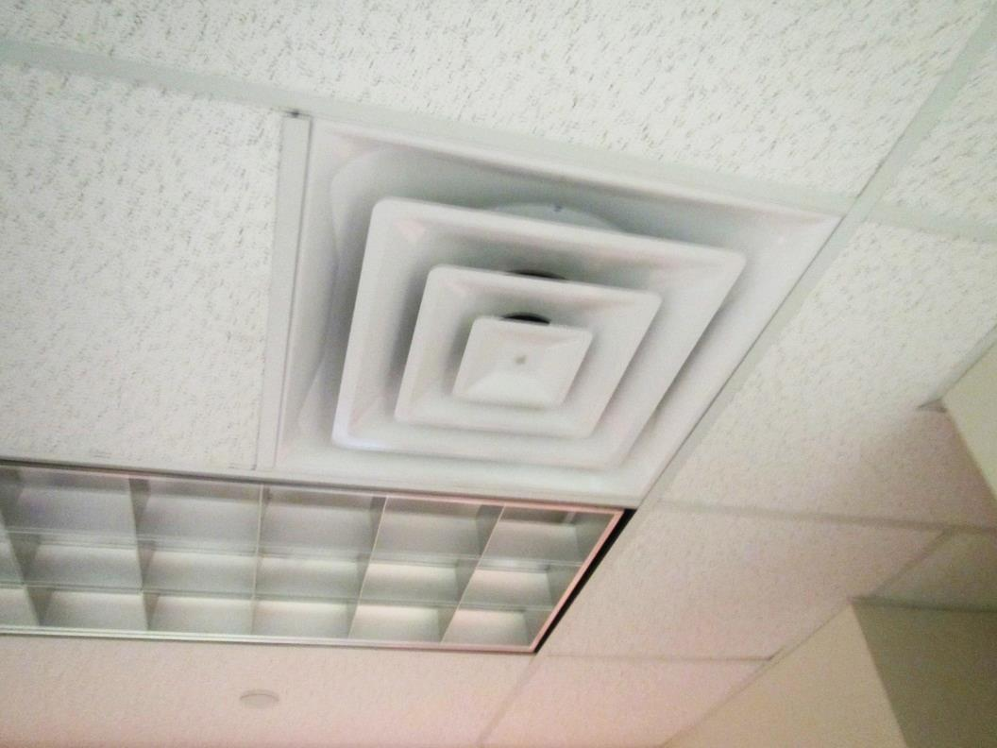
Full-sized supply vent
Picture 2
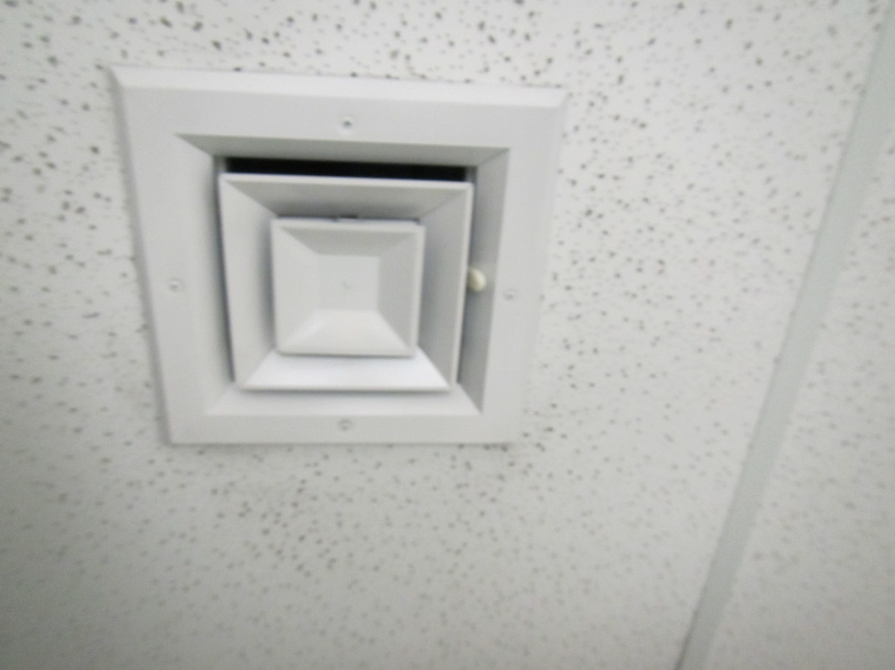
Smaller-sized supply vent
Picture 3
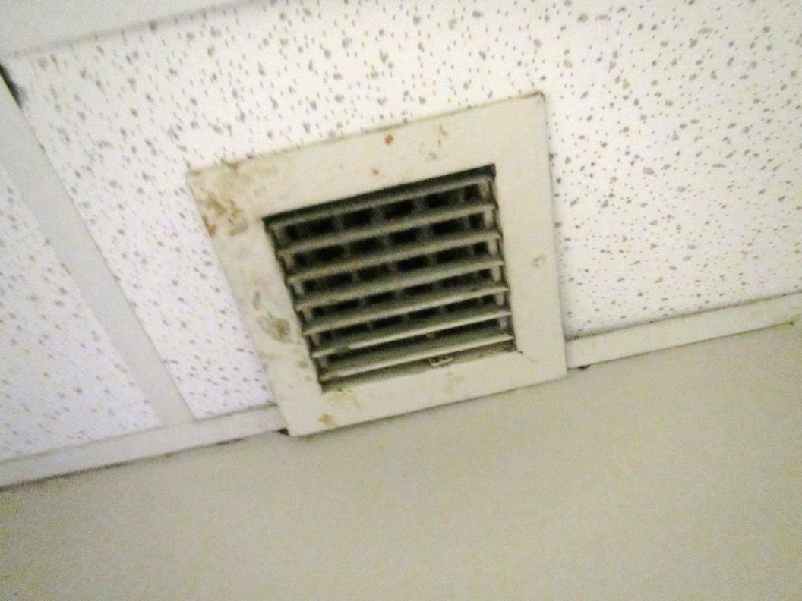
Typical exhaust vent, note dust/debris
Picture 4
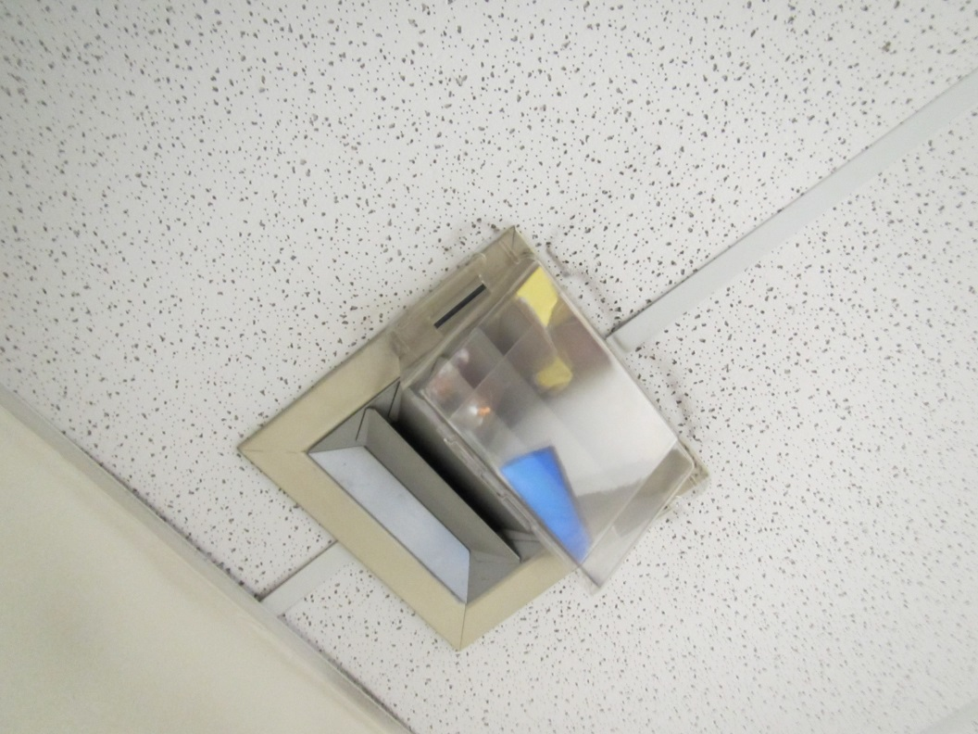
Diverted/blocked supply vent
Picture 5
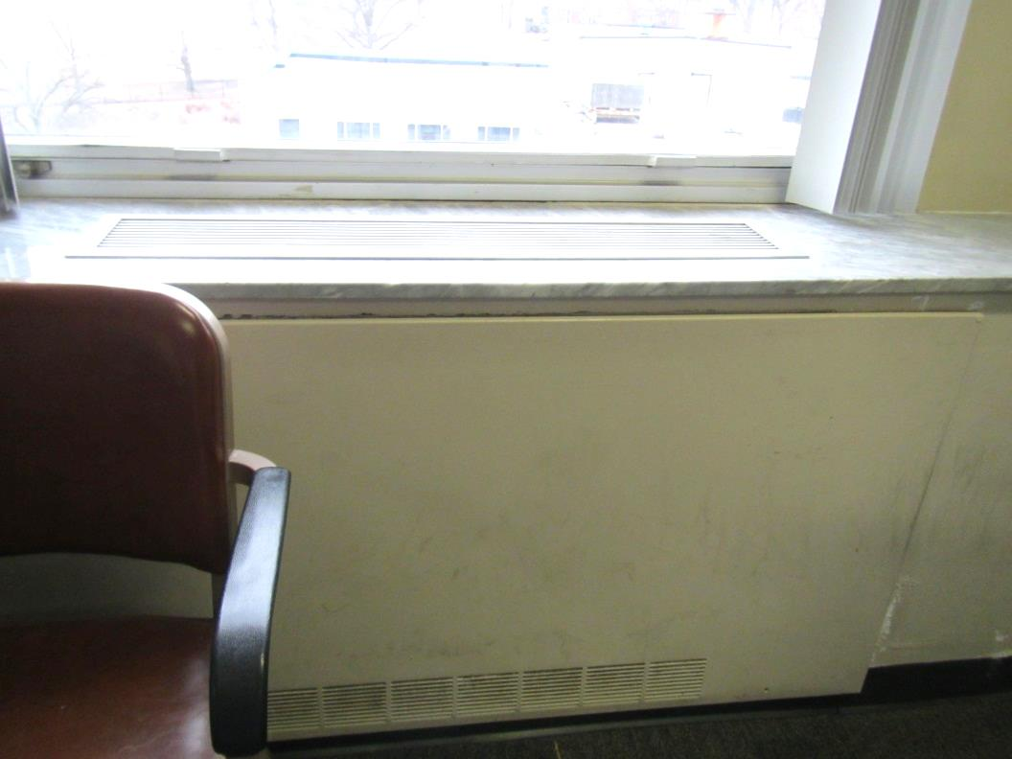
Fan coil unit
Picture 6
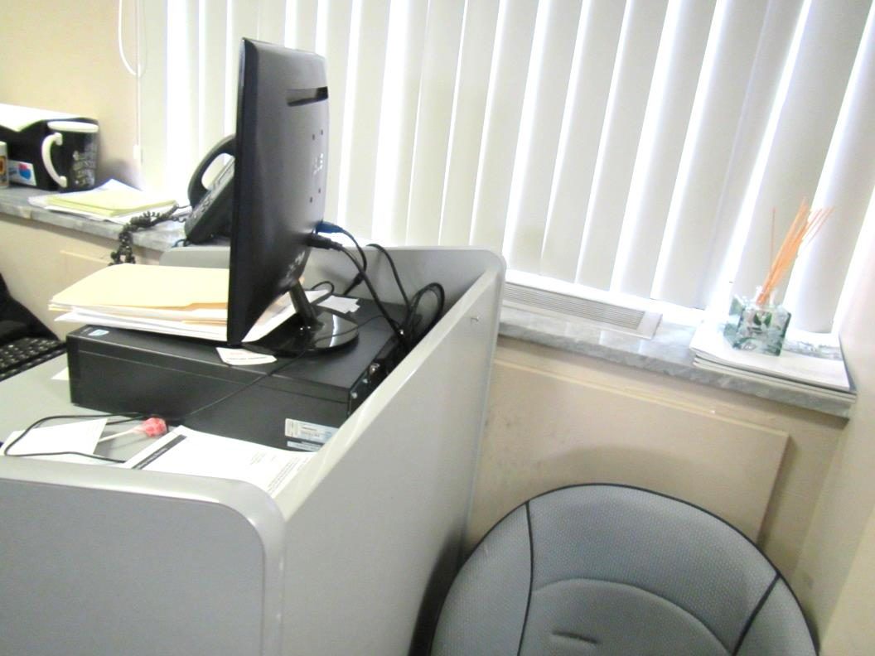
Obstructed fan coil unit
Picture 7
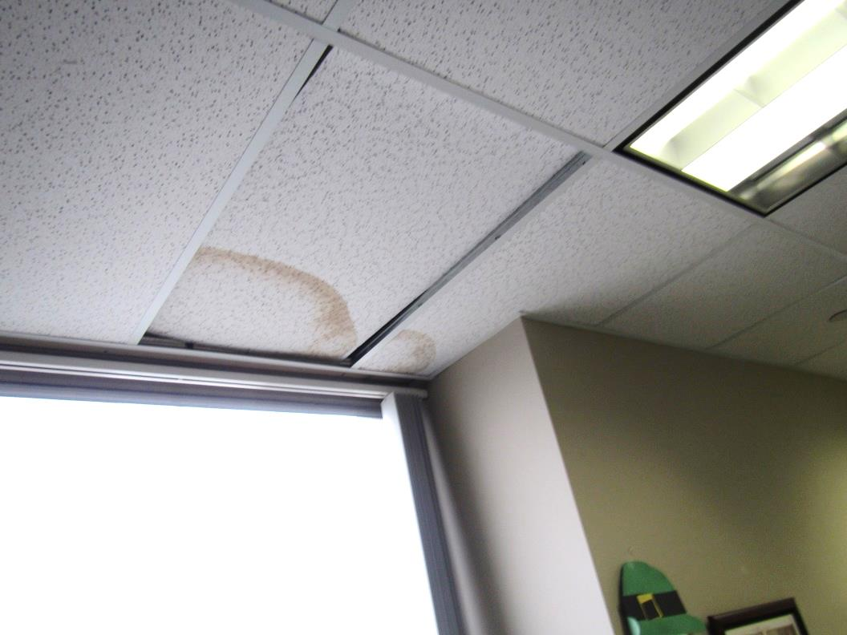
Water-damaged ceiling tiles
Picture 8
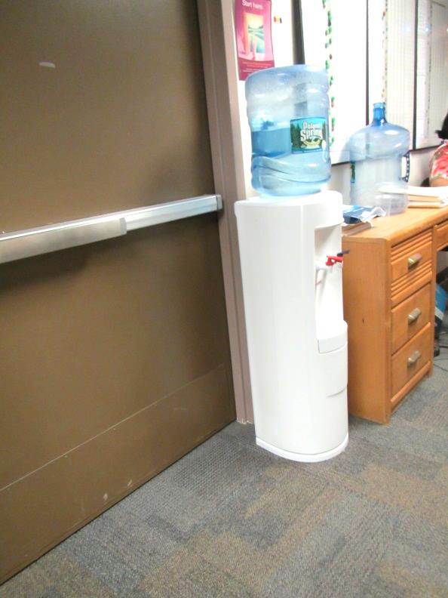
Water dispenser on carpet
Picture 9
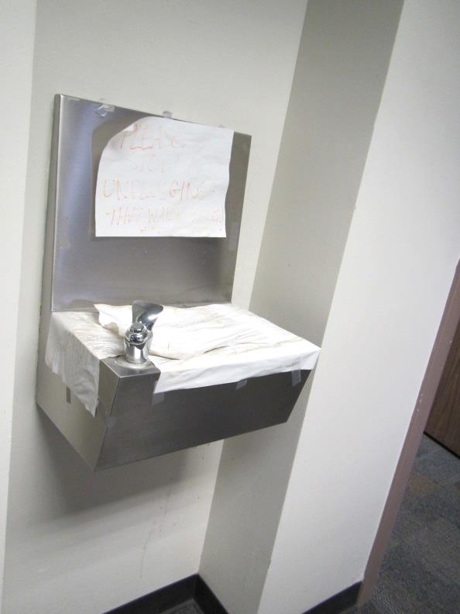
Blocked off water fountain
Picture 10
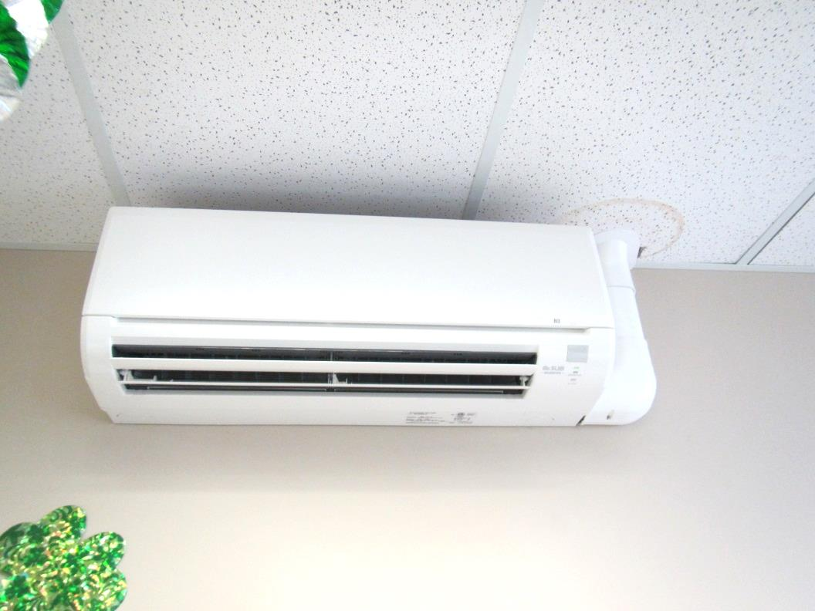
Ductless air conditioning unit, note water-damaged ceiling tile next to drain pipe
Picture 11
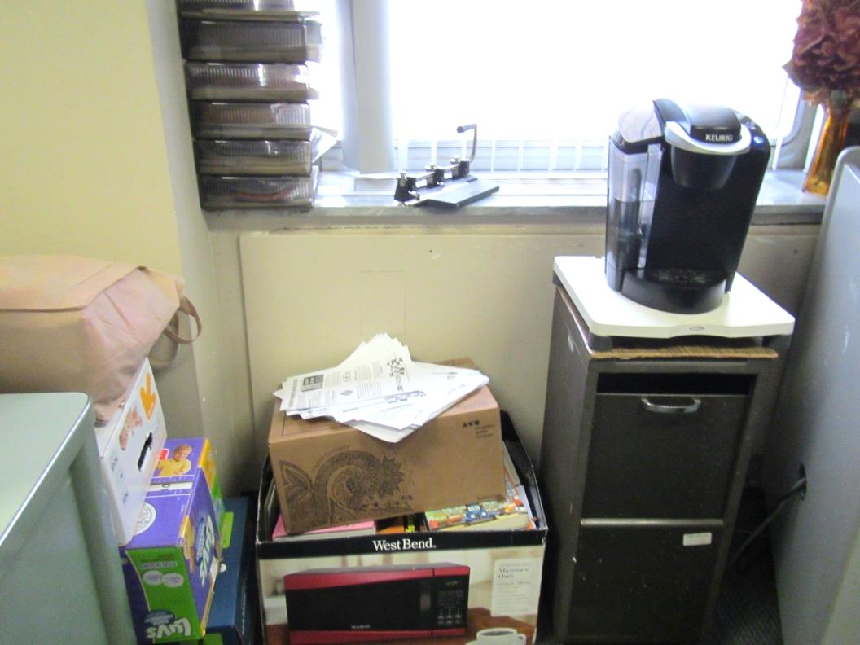
Items in an office, including food preparation equipment and boxes on the floor
Picture 12
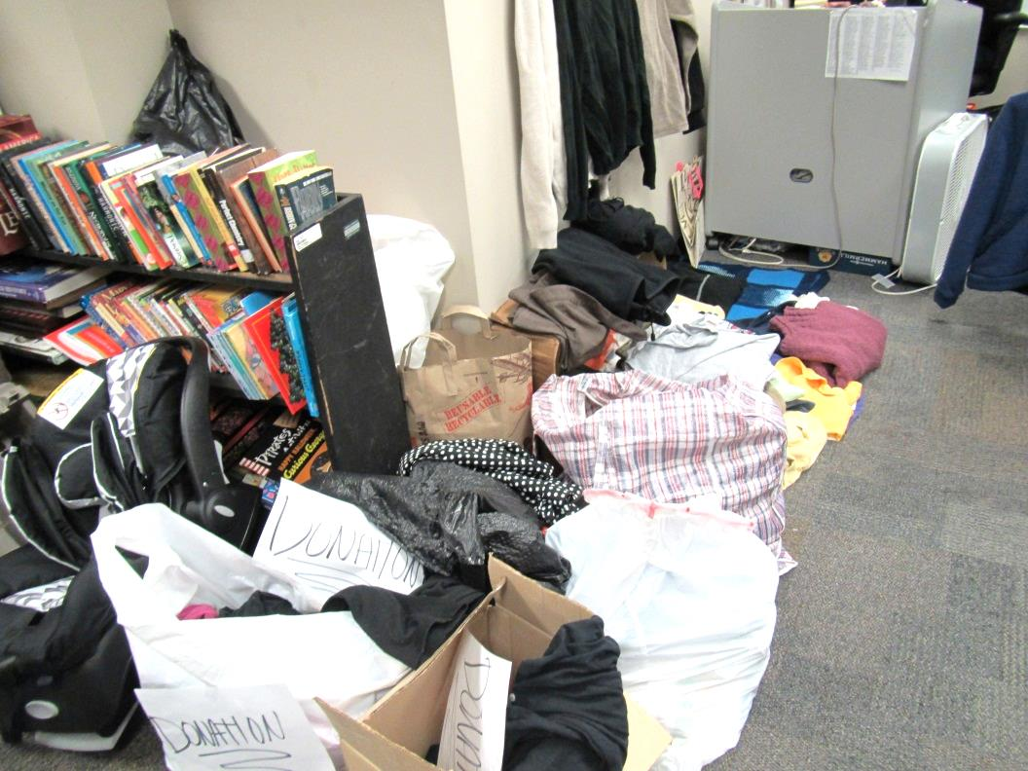
Stored items on the floor
Picture 13
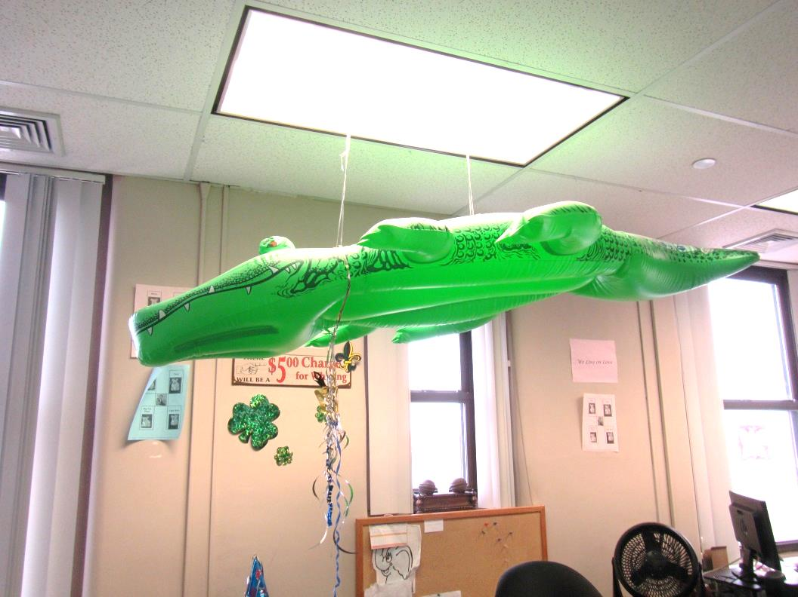
Items hanging from the ceiling tile system
Picture 14
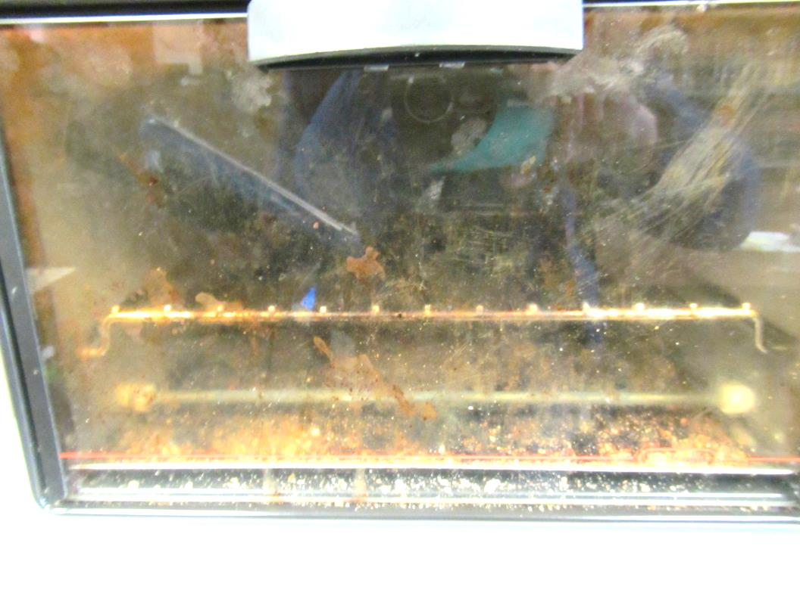
Toaster oven with crumbs
Location | Carbon  Dioxide  (ppm) | Carbon Monoxide  (ppm) | Temp  (°F) | Relative  Humidity  (%) | PM2.5  (µg/m³) | Occupants  in Room | Windows  Openable | Ventilation |  |  | Remarks
 |  |  |  |  |  |  |  | Intake | Exhaust
Background | 400 | 4 | 50 | 29 | 31
4th floor
Kitchen | 635 | ND | 69 | 25 | 12 | 0 | N | Y |  | N | WD CT (2), NC, vending and kitchen appliances
Reception | 727 | ND | 71 | 26 | 29 | 2 | N | Y |  | Y | Water cooler on carpet, DEM
Support services | 714 | ND | 72 | 26 | 13 | 2 | N | Y |  | Y | Plants
Area manager Collins | 665 | ND | 72 | 25 | 12-39 | 1 | N | Y |  | Y | PF, HS
Collins unit | 679 | ND | 73 | 25 | 20 | 3 | N | Y |  |  | Candles, DEM
Adolescent unit D | 649 | ND | 72 | 24 | 23 | 4-5 | N | Y |  | Y | Boxes on floor
Conference | 505 | ND | 72 | 22 | 9 | 0 | N | Y |  | Y | Supply and exhaust look the same
Open records room |  |  |  |  |  |  | N | Y |  | N | NC, process of cleaning
4th floor restroom |  |  |  |  |  |  | N | N |  | Y, not on
Chief’s office | 651 | ND | 72 | 22 | 14 | 3 | N | Y |  | Y | Fridges on carpet
Sterns unit | 756 | ND | 73 | 22 | 14 | 4 | N | Y dusty |  | Y dusty | DEM, plant
Sterns office | 651 | ND | 73 | 21 | 12 | 0 | N | Y |  | Y | 2 PF, fridge, boxes on floor
Bri office | 639 | ND | 73 | 21 | 12 | 0 | N | Y |  | Y | PF, DO
Lee Johnson | 645 | ND | 73 | 22 | 12 | 1 | N | Y |  | Y dusty | DO
Albert Jack | 674 | ND | 73 | 22 | 12 | 0 | N | Y |  | Y | DO
Jack’s unit | 670 | ND | 73 | 23 | 14 | 4 | N | Y |  | Y | DO
Johnson’s unit | 708 | ND | 73 | 22 | 23 | 5 | N | Y |  | Y | PF, plants, items on floor, fridge and microwave
Marin office | 748 | ND | 73 | 22 | 14 | 1 | N | Y |  | N | UF, DO
DeVane | 634 | ND | 73 | 22 | 10 | 0 | N | Y |  | Y
Ryan unit | 617 | ND | 73 | 21 | 15 | 1 | N | Y |  | ?
Kyle office | 759 | ND | 73 | 23 | 10 | 1 | N | Y |  | Y | DEM, AI
Dawkins | 646 | ND | 73 | 20 | 11 | 0 | N | Y |  | Y
Santana unit | 627 | ND | 73 | 22 | 11 | 2 | N | y |  | Y | Plants, PF on, fridge, DEM, microwave
Santana office | 637 | ND | 74 | 22 | 10 | 1 | N | Y |  | N | Plug-in, WD CT, food
DeSousa unit | 653 | ND | 75 | 21 | 8 | 2 | N | Y |  | N | Fridge and microwave, DEM
M. Johnson unit | 657 | ND | 75 | 21 | 10 | 2 | N | Y |  | N | Fridge and microwave, damaged wall, not water damage
Quiles | 641 | ND | 74 | 21 | 10 | 2 | N | Y |  | Y | PF on, fridge
M. Johnson office | 991 | ND | 75 | 22 | 27 | 2 | N | Y |  | Y | Scent/AF, turned off supply
Harris | 653 | ND | 74 | 20 | 11 | 0 | N | Y |  | Y | DEM
Empty office | 591 | ND | 74 | 20 | 10 | 0 | N | Y |  | Y | DEM
Gresh | 652 | ND | 74 | 21 | 9 | 0 | N | Y |  | Y | Plants
Diana unit | 633 | ND | 73 | 22 | 10 | 5 | N | Y |  |  | DO
Office next to unit A | 597 | ND | 74 | 22 | 12 | 0 | N | Y |  |  | Heater and fan, fridge, microwave, DEM
Unit A | 631 | ND | 74 | 22 | 14 | 3 | N | Y |  |  | Fridge and microwave, reports of sneezing/couching
Santana unit | 730 | ND | 74 | 21 | 9 | 5 | N | Y |  |  | Fridge and microwave
Marin’s unit | 739 | ND | 75 | 22 | 16 | 3 | N | Y |  |  | Toaster, microwave, fridge
Unit E left | 773 | ND | 73 | 22 | 8 | 3 | N | Y |  |  | Fridge and food, microwave, toaster
Unit E right | 800 | ND | 74 | 22 | 9 | 3 | N | Y |  |  | Plants, food, microwave
Office next to unit E | 851 | ND | 74 | 22 | 11 | 3 | N | Y |  | Y | Fridge on carpet
Office next to unit E | 824 | ND | 74 | 22 | 7 | 1 | N | y |  | Y | DO, DEM, PF
Harris office | 528 | ND | 72 | 20 | 15 | 0 | N | Y |  | Y | Microwave
Jones office | 684 | ND | 72 | 21 | 9 | 0 | N | Y |  | Y | DEM, fridge, microwave
Mia’s unit | 688 | ND | 73 | 23 | 18 | 2 | N | Y |  | N | AI, food
Office next to Mia’s unit | 766 | ND | 74 | 23 | 18 | 0 | N | Y |  | N | Food, AI
Judy | 700 | ND | 74 | 22 | 10 | 6 | N | Y |  | N | WD CT
Office next to unit C | 779 | ND | 75 | 21 | 3 | 3 | N | Y |  | N
Unit C | 816 | ND | 75 | 21 | 1 | 1 | N | Y |  | N | PF, items
C supervisor’s office | 853 | ND | 75 | 19 | 2 | 1 | N | Y |  | Y | PF, ductless AC
Alice | 815 | ND | 75 | 18 | 1 | 1 | N | Y |  | N | Items, fridge
Cofoni | 820 | ND | 75 | 18 | 1 | 1 | N | Y |  | N | Ductless AC
Copy |  |  |  |  |  |  | N | Y |  | N | NC, PCs
Kristin’s unit | 881 | ND | 75 | 19 | 2 | 2 | N | Y |  | Y | Plant, fridges
Kristin’s office | 900 | ND | 76 | 20 | 2 | 4 | N | Y |  |  | Ductless AC, PF, fridge on carpet
M office | 837 | ND | 76 | 20 | 1 | 1 | N | Y |  | N | Heater
F | 853 | ND | 76 | 19 | 1 | 2 | N | y |  | y | Fridge on carpet
Grant | 841 | ND | 75 | 18 | ND | 1 | N | Y |  | Y | Ductless AC, fridge on carpet
Office across from grant | 803 | ND | 75 | 19 | ND | 2 | N | Y |  | N | Ductless AC, PF
Waiting | 600 | ND | 75 | 20 | 11 | 2 | N | Y |  | N | NC
Interview rooms |  |  |  |  |  |  | N | Y |  | Y | Rooms locked, could not be measured, WD CT in several, NC
5th floor
Reception | 655 | ND | 74 | 21 | 7 | 1 | N | Y
Conference | 604 | ND | 73 | 20 | 7 | 0 | N | Y |  | Y
Small conference | 568 | ND | 73 | 20 | 7 | 0 | N | Y |  | Y | Plants
Office next to conference room | 555 | ND | 72 | 20 | 10 | 0 | N | Y |  | Y | Heater, plants, microwave, PF
Law office | 532 | ND | 72 | 21 | 12 | 0 | N | Y |  | Y | Plants, PF
Horvath | 555 | ND | 72 | 21 | 10 | 0 | N | Y |  | Y | Plants, AI
Kelleher | 550 | ND | 72 | 21 | 19 | 1 | N | Y |  | Y | Plants, AI
Support staff | 556 | ND | 73 | 21 | 7 | 3 | N | Y |  | y | PF, plant, WD CT and WD plaster
Admin to Cameron | 611 | ND | 74 | 21 | 17 | 1 | N | Y |  |  | Plants, food
Cameron | 585 | ND | 74 | 20 | 11 | 0 | N | Y |  |  | Plants
Law library/lounge | 559 | ND | 74 | 21 | 7 | 2 | N | Y |  | Y | Fridge on carpet, microwave, toaster
Scibak | 541 | ND | 75 | 20 | 7 | 1 | N | Y |  | Y weak | Plants, boxes on floor
Krusas | 590 | ND | 73 | 20 | 12 | 0 | N | Y |  | Y | WD CT, area rug on carpet, AI, boxes
Paloma | 542 | ND | 73 | 20 | 7 | 0 | N | Y |  |  | WD CT
Lebrun | 483 | ND | 72 | 22 | 14 | 0 | N | Y |  | Y
Deran | 618 | ND | 75 | 23 | 15 | 1 | N | Y |  | Y | DEM
Ward | 493 | ND | 75 | 20 | 11 | 0 | N | Y |  | Y | UF, plug in
John Dahl | 513 | ND | 74 | 20 | 12 | 1 | N | Y |  | Y | UF, WD CT – mold?
McMillan | 491 | ND | 74 | 20 | 7 | 0 | N | Y |  |  | Stained CT (not WD)
Lounge | 494-560 | ND | 75 | 20 | 9 | 0 | N | Y |  | Y | Fridge on carpet, food
Office | 538 | ND | 75 | 21 | 13 | 0 | N | Y |  | N
Zamorski | 532 | ND | 75 | 20 | 39 | 2 | N | Y |  | N
Cubby off hallway, room | 525 | ND | 74 | 24 | 10 | 0 | N | Y
Restroom |  |  |  |  |  |  | N |  |  | Y, not working | CP/scents
Office across from restroom | 504 | ND | 76 | 20 | 8 | 1 | N | Y |  | N
Cubby room off hallway | 509 | ND | 75 | 20 | 9 | 1 | N |  |  | N
Office | 485 | ND | 75 | 20 | 9 | 0 | N | Y |  | Y
Office | 558 | ND | 76 | 20 | 13 | 0 | N | Y |  | Y | WD CT
Menard | 494 | ND | 76 | 19 | 17 | 0 | N | Y |  | N | DO
Office | 473 | ND | 76 | 19 | 12 | 0 | N
Hallway room | 471 | ND | 76 | 19 | 10 | 1 | N | Y |  | N
Reyes | 485 | ND | 75 | 20 | 9 | 0 | N | Y |  |  | DEM
Meeting room | 465 | ND | 75 | 20 | 10 | 0 | N | Y dusty |  |  | DEM
Room next to stairwell C | 464 | ND | 74 | 20 | 11 | 1 | N | Y
Paul | 455 | ND | 73 | 21 | 9 | 0 | N | Y |  | Y | Boxes on floor
ADLU unit | 513 | ND | 74 | 22 | 9 | 2 | N | Y |  |  | Garlic odor
ADLU supervisor | 527 | ND | 74 | 22 | 24 | 1 | N | Y |  |  | Plants
Across from ADLU | 514 | ND | 74 | 21 | 8 | 0 | N | Y |  |  | Plants

Actions on MDPH Recommendations at
Springfield DCF (140 High Street)

The following is a status report of action(s) taken on MDPH recommendations (specific short-term recommendations only) made following the December 2012 MDPH report (in bold) based on reports from facilities staff and MDPH observations taken during the March 30, 2015 assessment.
- Remove materials and obstructions from air supply, exhaust vents and FCU intakes and diffusers.
- Action: Some HVAC components were obstructed. A few were intentional (to reduce temperature complaints).
- Consider adopting a balancing schedule of every 5 years for all mechanical ventilation systems, as recommended by ventilation industrial standards (SMACNA, 1994).
- Action: It could not be determined when the system was last balanced.
- For buildings in New England, periods of low relative humidity during the winter are often unavoidable. Therefore, scrupulous cleaning practices should be adopted to minimize common indoor air contaminants whose irritant effects can be enhanced when the relative humidity is low. To control for dusts, a high efficiency particulate arrestance (HEPA) filter equipped vacuum cleaner in conjunction with wet wiping of all surfaces is recommended. Avoid the use of feather dusters. Drinking water during the day can help ease some symptoms associated with a dry environment (throat and sinus irritations).
- Action: It could not be determined if cleaning processes use HEPA vacuums.
- Remove water-damaged ceiling tiles and examine for source of water. Monitor for future leaks.
- Action: Water-damaged ceiling tiles are reportedly removed and replaced, but some were observed during the assessment.
- Consider moving water dispensing equipment to areas with tiled floors instead of carpeting, or installing waterproof mats to prevent leaks from damaging carpet.
- Action: Water dispensers were located on carpeting.
- Avoid overwatering of plants. Ensure flat surfaces around plants are free of potting soil and other plant debris. Examine drip pans periodically for mold growth and disinfect with an appropriate antimicrobial where necessary. Do not place plants on porous materials (e.g., paper/cardboard).
- Action: Plants appeared to be in good condition in most areas.
- Refrain from having scented candles or using air fresheners/deodorizers to prevent exposure to VOCs.
- Action: Scented items/air fresheners were observed in some offices.
- Replace missing ceiling tiles. Ensure all ceiling tiles are flush to prevent movement of materials from the plenum.
- Action: Ceiling tile systems were in-tact.
- Relocate or consider reducing the amount of materials stored in offices and common areas to allow for more thorough cleaning.
- Action: Storage of items, including both files and client items such as clothing continues to be an issue in some areas.
- Clean FCUs, air vents and personal fans periodically of accumulated dust.
- Action: Some HVAC components and fans had visible dust/debris.

The service life is the median time during which a particular system or component of …[an HVAC]… system remains in its original service application and then is replaced. Replacement may occur for any reason, including, but not limited to, failure, general obsolescence, reduced reliability, excessive maintenance cost, and changed system requirements due to such influences as building characteristics or energy prices (ASHRAE, 1991).

