INDOOR AIR QUALITY ASSESSMENT

Department of Children and Families
80 Everett Ave.
Chelsea, Massachusetts

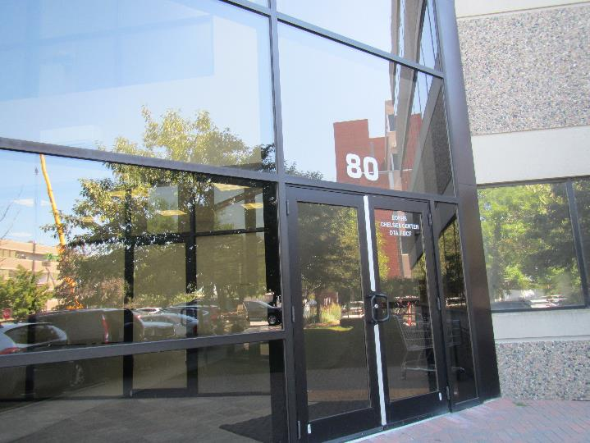

Prepared by:
Massachusetts Department of Public Health
Bureau of Environmental Health
Indoor Air Quality Program
August 2019

Background
Building: | Department of Children and Families (DCF)
Address: | 80 Everett Ave, Chelsea
Assessment Requested by: | Pedro Batista, Facilities Resource Coordinator, Executive Office of Health and Human Services (EOHHS)
Reason for Request: | Concerns about indoor air quality (IAQ)
Date of Assessment: | August 20, 2019
Massachusetts Department of Public Health/Bureau of Environmental Health (MDPH/BEH) Staff Conducting Assessment: | Ruth Alfasso, Environmental Engineer, IAQ Program
Building Description: | This DCF office occupies the first and second floor of a three-story building in an office park in Chelsea. The building has a flat roof and textured siding.
Windows: | Not openable

Methods
Please refer to the IAQ Manual for methods, sampling procedures, and interpretation of results (MDPH, 2015). Note that these offices were visited in 2014 for a post-occupancy assessment; that report is available at https://www.mass.gov/info-details/indoor-air-quality-reports-cities-and-towns-c#chelsea-.

IAQ Testing Results
The following is a summary of indoor air testing results (Table 1).
- Carbon dioxide levels were below the MDPH guideline of 800 parts per million (ppm) in all but one of the areas surveyed, indicating adequate air exchange for the population in the building at the time of the assessment.
- Temperature was within the MDPH recommended range of 70°F to 78°F in all areas tested.
- Relative humidity was within the MDPH recommended range of 40 to 60%.
- Carbon monoxide levels were non-detectable (ND) in all areas tested.
- Fine particulate matter (PM2.5) concentrations measured were below the National Ambient Air Quality Standard (NAAQS) limit of 35 μg/m³ in all areas tested.

Ventilation
A heating, ventilating, and air conditioning (HVAC) system has several functions. First it provides heating and, if equipped, cooling. Second, it is a source of fresh air. Finally, an HVAC system will dilute and remove normally-occurring indoor environmental pollutants by not only introducing fresh air, but by filtering the airstream and ejecting stale air to the outdoors via exhaust ventilation. Even if an HVAC system is operating as designed, point sources of respiratory irritation may exist and cause symptoms in sensitive individuals.
HVAC system consists of air handling units (AHUs) located on the roof, which draw in outside air and heat/cool it. Fresh air is delivered to spaces via ceiling-mounted supply vents (Picture 1). Return air is drawn into an above-ceiling plenum via ceiling grates (Picture 2) and and ducted back to AHUs. Supplemental cooling in some areas is provided by wall-mounted ductless air-conditioning (AC) units.
The HVAC system is controlled by digital thermostats. Thermostats examined were in “occupied” mode (Picture 3). It could not be determined if the “occupied” mode provided for continual air circulation during occupied hours or if this was just used to determine the temperature settings for the building. When the system fans are continually on, as recommended during occupied hours, the system provides a continuous source of air circulation and filtration. An “automatic” setting would instead activate the HVAC system based on pre-set temperature and only supply fresh/filtered air when heating or cooling was called for in the space.
Exhaust ventilation in restrooms is provided by dedicated exhaust vents, which are reportedly connected to fans on the roof. Occupants had concerns about the adequacy of ventilation in the women’s restroom on the 2nd floor. The exhaust vent in this room was checked and was strongly drawing air. Without an operating exhaust system, moisture and odors can build up in restrooms, so the operation of the fans should be checked periodically.
In order to have proper ventilation with a mechanical ventilation system, the systems must be balanced after installation to provide an adequate amount of fresh air to the interior of a room while removing stale air from the room. It is recommended that HVAC systems be re-balanced every five years to ensure adequate air systems function (SMACNA, 1994). It is not known when the systems were last balanced.

Microbial/Moisture Concerns
Light water stains were noted in the 2nd floor women’s restroom (Picture 4; Table 1). This likely is the result of a leak/condensation in the plumbing or sprinkler system. The area above this ceiling tile should be examined for the source of the leak and for any additional water-damaged materials. Once the leak is repaired, the affected ceiling tiles should be replaced. Water-damaged plaster and other materials were noted along the exterior wall in a few places. The most prominent plaster damage was found in the entrance vestibule (Pictures 5 and 6). This appears to be due to gaps between the main building and the vestibule, which may to have been a later addition to the building (Picture 7). Materials with water damage in this area appear to be plaster, which is resistant to mold growth; however the source of the damage (e.g., missing/damaged flashing) and any damaged areas should be repaired. Another area with damaged plaster was noted near windows on that same side of the building.
There were also reported leaks from ductless air conditioning units (Picture 8). Condensation drains from these units can develop clogs which can lead to leaks. The units and drains/piping/pumps should be examined periodically and cleaned or repaired if clogs develop.
Plants were noted in many areas (Picture 9; Table 1). Plants should be properly maintained and equipped with drip pans and should be located away from airflow to prevent the aerosolization of dirt, pollen, and mold. Aquariums were also found in several offices, including one that had murky water (Picture 10; Table 1). Aquariums should be kept clean so they don’t become a source of odors.
Refrigerators and water dispensers were located on carpet (Picture 11). Refrigerators and water dispensing equipment should be located in a non-carpeted area or on a waterproof mat to prevent damage to carpet and subsequent odors. Many individual offices and groups of cubicles had small refrigerators. If these are not kept clean and in good repair, they may become a source of odors and microbial growth. Consider limiting the number of refrigerators on the floor and consider developing a system to ensure that refrigerators are cleaned on a regular basis, including when office occupants are on vacation.
The exterior of the building was also examined. Trees were overhanging the building and trees and bushes were touching the sides. This can lead to debris clogging roof drains and damage to the building exterior. Trees and plants should be trimmed away from the building.

Other Concerns
Exposure to low levels of total volatile organic compounds (TVOCs) may produce eye, nose, throat, and/or respiratory irritation in some sensitive individuals. BEH/IAQ examined spaces for products containing VOCs. BEH/IAQ staff noted hand sanitizers, cleaners, and dry erase materials in the office space (Picture 12; Table 1). All of these products have the potential to be irritants to the eyes, nose, throat, and respiratory system of sensitive individuals.
Food and food preparation equipment, including microwaves, toasters, and coffee pots were observed in many offices and common areas. Food should be kept tightly sealed to prevent pest access and food preparation equipment should be kept clean to prevent smoke, odors and pests. Pest issues have been reported in this building in the past. Removal of sources of food, including crumbs and residues, is very important to prevent pest issues in the future.
Items were observed on flat surfaces, such as windowsills, tabletops, counters, bookcases, and desks (Table 1). Items stored in offices provide a source for dusts to accumulate. These items also make it difficult for custodial staff to clean. Items should be relocated and/or be cleaned periodically to avoid excessive dust build up. Because of the large amount of items, including clothing, car seats, and toys, handled by this office, consideration should be given to creating flexible storage that allows items to be stored neatly, off the floor, and protected from dust and pests.
Most of the offices are carpeted. Carpets should be cleaned annually (or semi-annually in soiled/high traffic areas) in accordance with Institute of Inspection, Cleaning and Restoration Certification (IICRC) recommendations, (IICRC, 2012).

Conclusions/Recommendations
Based on observations at the time of assessment, the following is recommended:
- Operate supply and exhaust ventilation continuously in all areas during occupied periods. Ensure all HVAC equipment is cleaned/maintained in accordance with manufacturer’s instructions.
- Change filters for HVAC equipment 2-4 times a year. If possible in current equipment, use pleated filters of MERV 8 (or higher), which are adequate in filtering out pollen and mold spores (ASHRAE, 2012).
- Regularly clean supply and return vents.
- Periodically check the function of restroom exhaust vents and repair as needed.
- Balance the HVAC system every 5 years in accordance with Sheet Metal and Air Conditioning Contractors’ National Association (SMACNA) recommendations (SMACNA, 1994).
- Replace water-damaged ceiling tiles and repair damaged plaster. Examine spaces above/behind areas of water damage to determine if any hidden damage or odors have occurred.
- Have the flashing and roof membrane between the brick vestibule and the rest of the building checked for gaps and repair as needed.
- Keep plants and flowers in good condition, avoid overwatering, and remove from the airstream of heating and ventilation equipment.
- Keep aquariums in good condition.
- Consider a regular inspection program for ductless air conditioning condensation systems to prevent clogs and leaks. Dry, repair or replace any plaster, wallboard or carpeting moistened by leaks from ductless air conditioners as needed.
- Consider placing refrigerators and water dispensers in areas without carpeting, or use a waterproof mat to protect carpeting.
- Trim trees and plants away from the building to at least five feet.
- For buildings in New England, periods of low relative humidity during the winter are often unavoidable. Therefore, scrupulous cleaning practices should be adopted to minimize common indoor air contaminants whose irritant effects can be enhanced when the relative humidity is low. To control for dusts, a high efficiency particulate arrestance (HEPA) filter equipped vacuum cleaner in conjunction with wet wiping of all surfaces is recommended. Avoid the use of feather dusters. Drinking water during the day can help ease some symptoms associated with a dry environment (throat and sinus irritations).
- Reduce the use of cleaning products, sanitizers, and other items that contain VOCs.
- Keep food preparation equipment clean, and clean out refrigerators, including the gaskets, regularly. Because of the large number of small refrigerators, consider developing a tracking program to ensure all refrigerators are cleaned out periodically.
- Use the services of a licensed pest contractor to control pests as needed. Increase cleaning in areas where pests were present to remove allergens.
- Consider storage solutions for items such as clothing, car seats and, toys (e.g., hooks, shelving, totes) to keep items organized, off the floor, and protected from dust and pests.
- Clean carpeting in accordance with IICRC recommendations (IICRC, 2012).
- Refer to resource manual and other related IAQ documents located on the MDPH’s website for further building-wide evaluations and advice on maintaining public buildings. These documents are available at: http://mass.gov/dph/iaq.

References
ASHRAE. 2012. American Society of Heating, Refrigeration and Air Conditioning Engineers (ASHRAE) Standard 52.2-2012 -- Method of Testing General Ventilation Air-Cleaning Devices for Removal Efficiency by Particle Size (ANSI Approved). 2012.
IICRC. 2012. Institute of Inspection, Cleaning and Restoration Certification. Carpet Cleaning: FAQ.
MDPH. 2015. Massachusetts Department of Public Health. Indoor Air Quality Manual: Chapters I-III. Available at: http://www.mass.gov/eohhs/gov/departments/dph/programs/environmental-health/exposure-topics/iaq/iaq-manual/.
SMACNA. 1994. HVAC Systems Commissioning Manual. 1st ed. Sheet Metal and Air Conditioning Contractors’ National Association, Inc., Chantilly, VA.
Picture 1
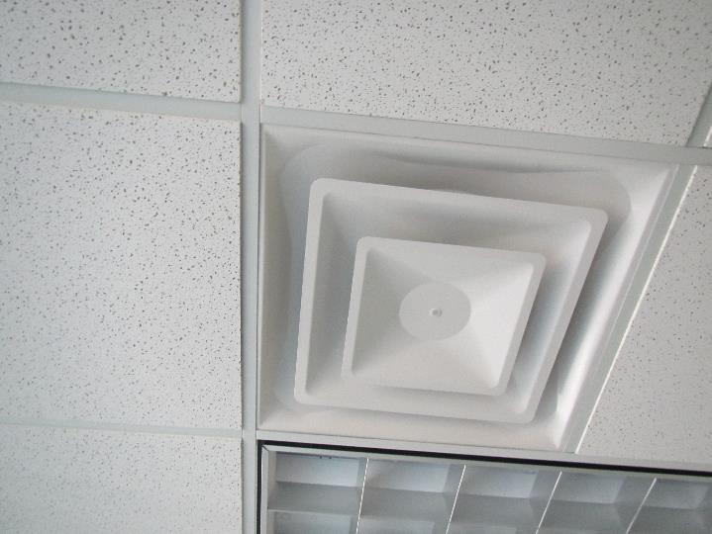
Supply vent
Picture 2
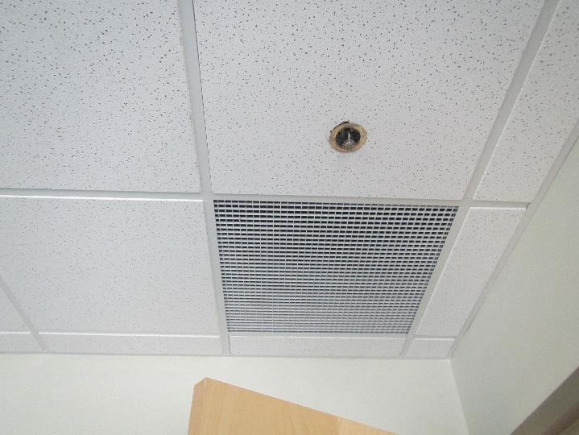
Return grate
Picture 3
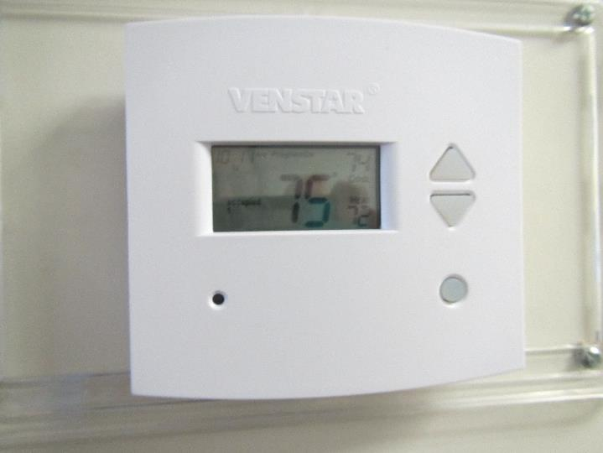
Thermostat set to “occupied”
Picture 4
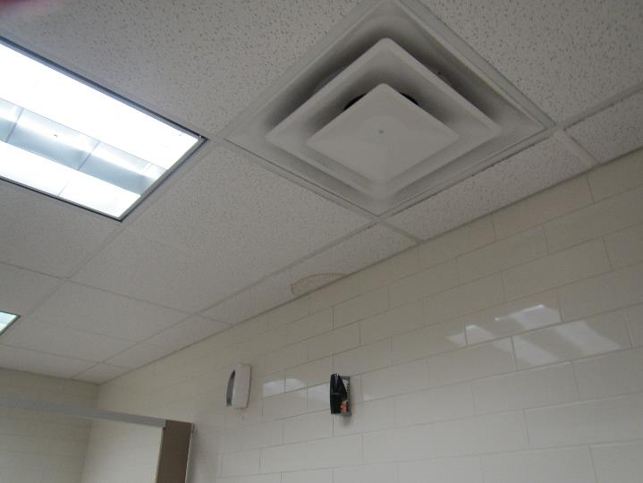
Water stain on ceiling tile in women’s restroom
Picture 5
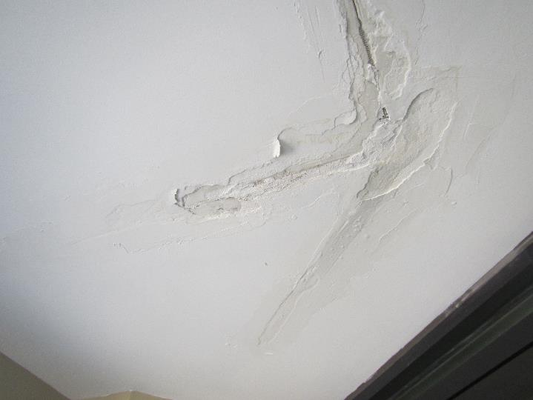
Damaged plaster in vestibule
Picture 6
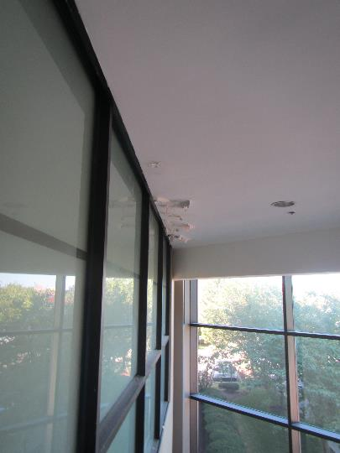
Damaged plaster in vestibule
Picture 7
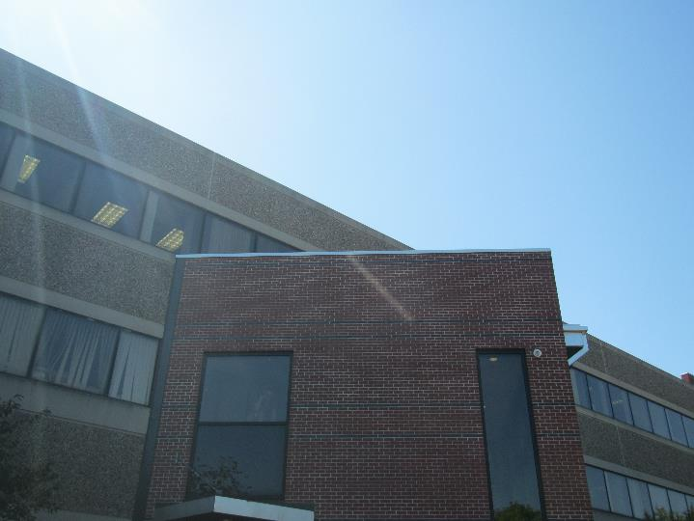
Vestibule shown in Pictures 5 and 6, likely an addition to the building
Picture 8
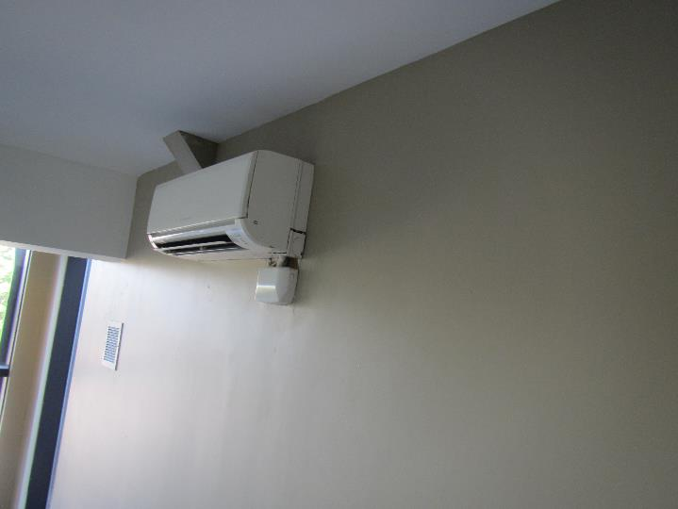
Ductless air conditioning unit with signs of leaks
Picture 9
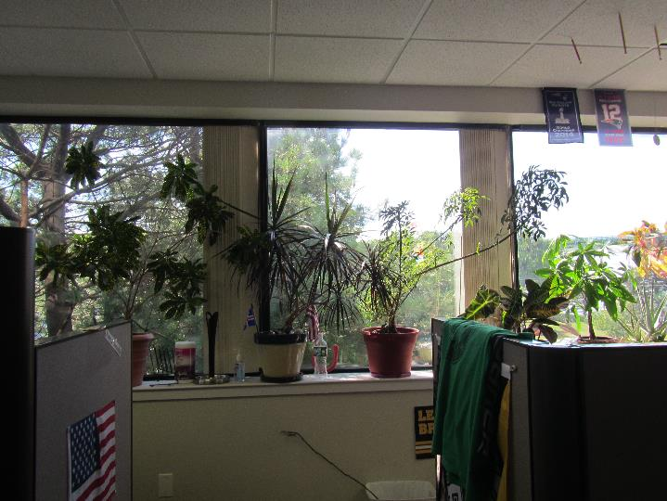
Plants in the office
Picture 10
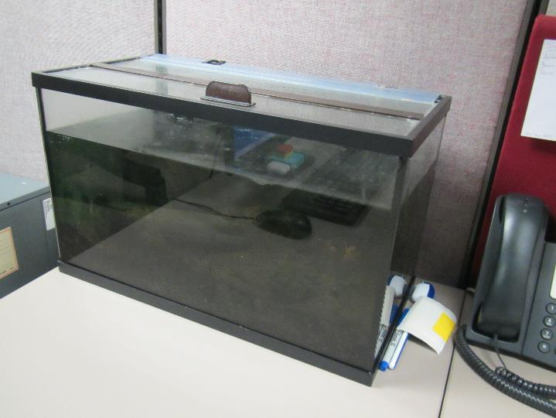
Murky water in an aquarium
Picture 11
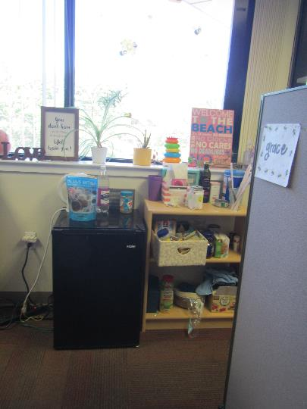
Small refrigerator on carpet
Picture 12
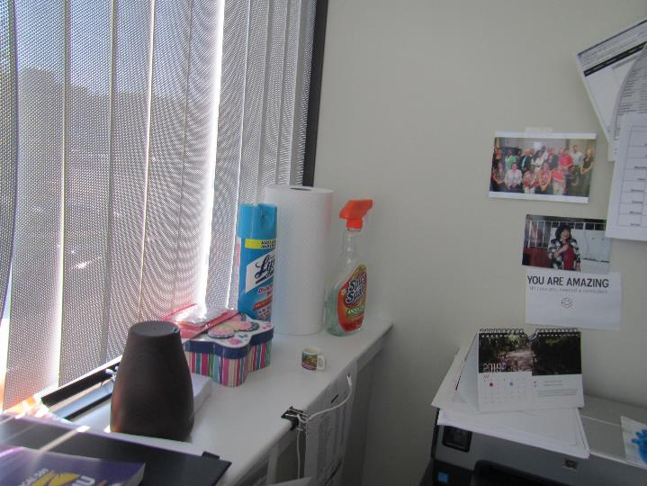
Cleaning products
Location | Carbon  Dioxide  (ppm) | Carbon Monoxide  (ppm) | Temp  (°F) | Relative  Humidity  (%) | PM2.5  (µg/m³) | Occupants  in Room | Windows  Openable | Ventilation |  | Remarks
 |  |  |  |  |  |  |  | Supply | Exhaust
Background | 392 | ND | 79 | 57 | 11 | - | - | - | - | Sunny and pleasant
Second floor
Cesar office | 636 | ND | 77 | 49 | 5 | 0 | N | Y | Y | Mat on floor, DEM
Ratliffe-Hocine cube area | 608 | ND | 77 | 49 | 6 | 1 | N | Y | Y | Heater, plant
Okunbor cube area | 580 | ND | 77 | 49 | 5 | 0 | N | Y | Y | Fridge on carpet, DEM
Storage cube area | 642 | ND | 76 | 47 | 5 | 0 | N | Y | Y
Horta | 1202 | ND | 76 | 49 | 6 | 2 | N | Y | Y | Aquarium, fridge, plants, area rug
Mena | 612 | ND | 76 | 47 | 5 | 0 | N | Y | Y | Items on floor, DEM
Brito cube area | 561 | ND | 75 | 47 | 5 | 2 | N | Y | Y | Plant, fridge
Tejada cube aera | 555 | ND | 75 | 47 | 6 | 0 | N | Y | Y | AI, fridge
Oliva cube area | 552 | ND | 75 | 47 | 6 | 1 | N | Y | Y | AI, UF
Lopez office | 540 | ND | 75 | 48 | 6 | 0 | N | Y | Y | DEM, UF
Horrigan office | 560 | ND | 74 | 46 | 5 | 0 | N | Y | Y | Food, plants, DEM, fridge
Burrel cube area | 505 | ND | 75 | 46 | 6 | 0 | N | Y | Y | Items on windowsill, plants
McGuiness office | 579 | ND | 74 | 44 | 5 | 0 | N | Y | N | DEM
Ly cube area | 513 | ND | 73 | 45 | 6 | 1 | N | Y | Y | Plants, DEM, fan, items on floor
Sanchez cube area | 538 | ND | 74 | 47 | 5 | 1 | N | Y | Y | Plant
Unit E | 546 | D | 74 | 49 | 6 | 1 | N | Y | Y | Fridge, microwave, backpacks
Link office | 550 | NDN | 74 | 48 | 6 | 0 | N | Y | Y | UF
Grasso cube area | 560 | ND | 74 | 47 | 6 | 1 | N | Y | Y | Sunlight, food
Kindness cube area | 557 | ND | 75 | 46 | 5 | 2 | N | Y | Y
Marquez cube area | 507 | ND | 75 | 45 | 6 | 2 | N | Y | Y | Fridge, PF
Donation room | 572 | ND | 74 | 44 | 6 | 0 | N | Y | Y
Tejada office | 606 | ND | 74 | 44 | 5 | 0 | N | Y | Y | Microwave, toaster, fridge
Diaz cube area | 626 | ND | 74 | 44 | 6 | 3 | N | Y | Y | Plant
Conference | 622 | ND | 74 | 43 | 5 | 1 | N | Y | N | Plant, UF
Donnelly office | 679 | ND | 74 | 45 | 5 | 3 | N | Y | Y | HS, many plants, PF
Marquez | 659 | ND | 74 | 44 | 5 | 2 | N | Y | Y | DEM, area rug
Ladies restroom | 707 | ND | 74 | - | - | - | N | Y | Y ON | 1 water-damaged ceiling tile, plant, reports of odors
Cardona office | 615 | ND | 72 | 49 | 5 | 0 | N | Y | Y
5-person office | 610 | ND | 71 | 42 | 6 | 1 | N | Y | Y
Vacant office | 639 | ND | 72 | 44 | 5 | 0 | N | Y | Y
Pereyra office | 595 | ND | 71 | 43 | 5 | 0 | N | Y | Y | Aquarium, microwave and fridge, DEM
Vernaza | 692 | ND | 71 | 44 | 5 | 0 | N | Y | Y | Plant including along wall, UF, fridge
Break room | 582 | ND | 71 | 45 | 5 | 0 | N | Y | Y | Microwave and fridge, no sink
Gojkovic office | 586 | ND | 72 | 47 | 6 | 0 | N | Y | Y | Fridge
Totten office | 647 | ND | 73 | 50 | 5 | 0 | N | Y | Y | Fridge and microwave. PF
Quinn office | 609 | ND | 73 | 47 | 5 | 1 | N | Y | Y | UF
Conference | 613 | ND | 73 | 47 | 6 | 0 | N | Y
Fernandez | 622 | ND | 75 | 48 | 6 | 0 | N | Y | Y | CP, fridge and microwave, solar heating
Palomares cube area | 689 | ND | 76 | 44 | 9 | 0 | N | Y | Y | WD plaster – historic
First Floor
Rehbain cubes | 658 | ND | 74 | 42 | 7 | 3 | N | Y | Y
Family meeting open area | 719 | ND | 75 | 43 | 7 | 1 | N | Y | Y | ½ wall office
Education | 660 | ND | 74 | 42 | 7 | 3 | N | Y | Y | Old fridge
Gordon office | 608 | ND | 74 | 41 | 7 | 0 | N | Y | Y | Plant
Jones cube area | 637 | ND | 74 | 43 | 7 | 5 | N | Y | Y | Sunlight
St. Cloud cube area | 638 | ND | 73 | 42 | 7 | 1 | N | Y | Y | CP, items
Parnell | 655 | ND | 73 | 43 | 8 | 0 | N | Y | Y | ½ wall office, aquarium
Lunch | 661 | ND | 74 | 43 | 7 | 5 | N | Y | Y | NC
158 | 684 | ND | 74 | 44 | 7 | 0 | N | Y | Y
1st floor open area | 626 | ND | 75 | 49 | 9 | 0 | N | Y | Y
Haupt office | 695 | ND | 75 | 49 | 6 | 1 | N | Y | Y | Plants, DEM
Orellana open area | 660 | ND | 75 | 48 | 5 | 3 | N | Y | Y | DEM, PF
Family resource office | 667 | ND | 76 | 47 | 13 | 1 | N | Y | Y | Area rug
Reception | 682 | ND | 76 | 48 | 7 | 1 | N | Y | Y | HS, plant
Waiting | 690 | ND | 76 | 48 | 7 | 6 | N | Y | Y | NC
104 infant hearing room | 673 | ND | 75 | 47 | 6 | 0 | N | Y | Y | Toys
107 | 671 | ND | 75 | 47 | 6 | 0 | N | Y | Y
105 | 639 | ND | 75 | 46 | 6 | 0 | N | Y | Y

