INDOOR AIR QUALITY ASSESSMENT

Commonwealth of Massachusetts
Department of Children and Families
Massachusetts Rehabilitation Commission
110 Mulberry Street
Brockton, MA

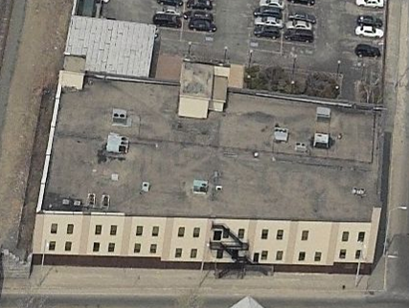

Prepared by:
Massachusetts Department of Public Health
Bureau of Environmental Health
Indoor Air Quality Program
May 2014

Background/Introduction
In response to a request from Dave Devine, Project Manager, Division of Capital Asset Management and Maintenance (DCAMM), the Massachusetts Department of Public Health (MDPH), Bureau of Environmental Health (BEH) conducted a post-occupancy indoor air quality (IAQ) assessment at the Department of Children and Families (DCF) and Massachusetts Rehabilitation Commission (MCR) Brockton area offices, located at 110 Mulberry Street, Brockton, Massachusetts. This evaluation was conducted as part of enhanced efforts to ensure acceptable IAQ of office space leased by Massachusetts state agencies. On April 7, 2014, a visit to conduct an IAQ assessment was made by Cory Holmes, Environmental Analyst/Inspector and Ruth Alfasso, Environmental Engineer/Inspector, from BEH’s IAQ Program.
The Department of Transitional Assistance (DTA) had previously occupied space on the first floor of the building. In January of 2013, tenants were relocated and the building was significantly remodeled, including updates to the heating, ventilating and air conditioning (HVAC) systems, new office layouts, new carpeting and furnishings. In September 2013, the DCF legal department took occupancy of the second floor and the first floor was occupied, by MRC and DCF staff, in November 2013.
The building has two-stories with a flat rubber roof originally built as offices for a telecom company. The current layout includes offices, open work areas (cubicles), conference and hearing rooms, storage, and kitchen/utility areas. The flooring in most areas of the building is covered with carpet tiles. Windows in the building were originally openable but have been rendered unopenable.

Methods
Air tests for carbon dioxide, carbon monoxide, temperature, and relative humidity were taken with the TSI, Q-Trak, IAQ Monitor 7565. Air tests for airborne particle matter with a diameter less than 2.5 micrometers were taken with the TSI, DUSTTRAK™ Aerosol Monitor Model 8520. Testing for Total Volatile Organic Compounds (TVOCs) was conducted using a MiniRAE 2000 photoionization detector. BEH/IAQ staff also performed a visual inspection of building materials for water damage and/or microbial growth.

Results
The combined employee population of the DTA and MRC offices is approximately 100 and up to 25 visitors may access the space daily. Test results appear in Table 1 and are listed by numerical designation for offices and one of the numerical designations in a group of cubicles.

Discussion

Ventilation
It can be seen from Table 1 that carbon dioxide levels were above 800 parts per million (ppm) in 58 out of 101 areas tested, indicating limited air exchange in more than half the areas surveyed at the time of assessment. Most of the areas on the first floor had levels below 800 ppm, while most areas on the second floor had levels above 800 ppm (Table 1).
Fresh air is provided by rooftop air-handling units (AHUs; Picture 1). Fresh air is drawn into the AHUs through a bank of air filters, heated or cooled and delivered to occupied areas via ducted air diffusers (Picture 2). Return air is drawn into ceiling -mounted vents (Picture 3) or vents around light fixtures (Picture 2) and ducted back to rooftop AHUs.
The HVAC system is controlled by digital thermostats. Thermostats examined had a fan switch with two settings, on and auto (Picture 4). When the fan is set to on, the system provides a continuous source of air circulation and filtration. The automatic setting on the thermostat activates the HVAC system at a pre-set temperature. Once the pre-set temperature is reached, the HVAC system is deactivated. Therefore, no mechanical ventilation is provided until the thermostat re-activates the system. At the time of assessment, all thermostat fan setting were in the “auto” position. As mentioned, this thermostat setting can limit airflow. The MDPH typically recommends that thermostats be set to the fan on setting during occupied hours to provide continuous air circulation.
Occupancy levels on both floors of the building were similar, which suggests that thermostat settings on the second floor or the AHUs serving that floor may need adjustment to supply additional fresh air to those areas with levels of carbon dioxide above 800 ppm.
To maximize air exchange, the MDPH recommends that both supply and exhaust ventilation operate continuously during periods of occupancy. In order to have proper ventilation with a mechanical supply and exhaust system, the systems must be balanced to provide an adequate amount of fresh air to the interior of a room while removing stale air from the room. It is recommended that HVAC systems be re-balanced every five years to ensure adequate air systems function (SMACNA, 1994). Reportedly, the HVAC system was balanced following the renovation.
Minimum design ventilation rates are mandated by the Massachusetts State Building Code (MSBC). Until 2011, the minimum ventilation rate in Massachusetts was higher for both occupied office spaces and general classrooms, with similar requirements for other occupied spaces (BOCA, 1993). The current version of the MSBC, promulgated in 2011 by the State Board of Building Regulations and Standards (SBBRS), adopted the 2009 International Mechanical Code (IMC) to set minimum ventilation rates. Please note that the MSBC is a minimum standard that is not health-based. At lower rates of cubic feet per minute (cfm) per occupant of fresh air, carbon dioxide levels would be expected to rise significantly. A ventilation rate of 20 cfm per occupant of fresh air provides optimal air exchange resulting in carbon dioxide levels at or below 800 ppm in the indoor environment in each area measured. MDPH recommends that carbon dioxide levels be maintained at 800 ppm or below. This is because most environmental and occupational health scientists involved with research on IAQ and health effects have documented significant increases in indoor air quality complaints and/or health effects when carbon dioxide levels rise above the MDPH guidelines of 800 ppm for schools, office buildings and other occupied spaces (Sundell et al., 2011). The ventilation must be on at all times that the room is occupied. Providing adequate fresh air ventilation with open windows and maintaining the temperature in the comfort range during the cold weather season is impractical. Mechanical ventilation is usually required to provide adequate fresh air ventilation.
Carbon dioxide is not a problem in and of itself. It is used as an indicator of the adequacy of the fresh air ventilation. As carbon dioxide levels rise, it indicates that the ventilating system is malfunctioning or the design occupancy of the room is being exceeded. When this happens, a buildup of common indoor air pollutants can occur, leading to discomfort or health complaints. The Occupational Safety and Health Administration (OSHA) standard for carbon dioxide is 5,000 parts per million parts of air (ppm). Workers may be exposed to this level for 40 hours/week, based on a time-weighted average (OSHA, 1997).
The MDPH uses a guideline of 800 ppm for publicly occupied buildings. A guideline of 600 ppm or less is preferred in schools due to the fact that the majority of occupants are young and considered to be a more sensitive population in the evaluation of environmental health status. Inadequate ventilation and/or elevated temperatures are major causes of complaints such as respiratory, eye, nose and throat irritation, lethargy and headaches. For more information concerning carbon dioxide, please see Appendix A.
Indoor temperature measurements at the time of assessment ranged from 71° F to 77° F (Table 1), which were within the MDPH recommended comfort range. The MDPH recommends that indoor air temperatures be maintained in a range of 70° F to 78° F in order to provide for the comfort of building occupants. In many cases concerning indoor air quality, fluctuations of temperature in occupied spaces are typically experienced, even in a building with an adequate fresh air supply. In a few areas, direct sunlight was streaming through windows (solar gain, Table 1), which can contribute to fluctuations in temperature and feelings of thermal discomfort. Shades should be used in these areas to moderate the impact of direct sunlight.
Indoor relative humidity measurements at the time of assessment ranged from 19 to 29 percent (Table 1), which were below the MDPH recommended comfort range. The MDPH recommends a comfort range of 40 to 60 percent for indoor air relative humidity. The sensation of dryness and irritation is common in a low relative humidity environment. Low relative humidity is a very common problem during the heating season in the northeast part of the United States.

Microbial/Moisture Concerns
In order for building materials to support mold growth, a source of water exposure is necessary. Water-damaged ceiling tiles were observed in a few areas (Table 1; Picture 5). According to building occupants in one area of the second floor, there had been a significant leak reportedly from the HVAC system above and that the ceiling tiles had been recently changed. Water-damaged ceiling tiles can provide a source of mold and should be replaced after a water leak is discovered and repaired. If leaks from the HVAC system continue to occur, an HVAC technician should be consulted about repairs to the system or condensate drainage.
The US Environmental Protection Agency (US EPA) and the American Conference of Governmental Industrial Hygienists (ACGIH) recommend that porous materials (e.g., carpeting, gypsum wallboard) be dried with fans and heating within 24 to 48 hours of becoming wet (US EPA, 2001; ACGIH, 1989). If not dried within this time frame, mold growth may occur. Once mold has colonized porous materials, they are difficult to clean and should be removed/discarded.
Plants were noted in some areas (Table 1). Plants can be a source of pollen and mold, which can be respiratory irritants to some individuals. Plants should be properly maintained and equipped with drip pans.
Water dispensing equipment and small refrigerators were observed in carpeted areas (Table 1; Picture 6). Spills or leaks from this equipment can moisten carpet and lead to microbial growth and carpet degradation. In addition, gaskets in one of the kitchen refrigerators was found to be colonized with mold (Picture 7), which can result in odors and exposure to mold spores. All refrigerators should be cleaned regularly and if gaskets and other components cannot be adequately cleaned with an anti-microbial agent, they should be replaced.
A ductless air conditioning unit was observed in one conference room (Picture 8). These units typically have a condensation drain to remove accumulated moisture. The drain should be inspected regularly to ensure that it is not leaking into the wall cavity or becoming stagnant where it can create odors.

Other IAQ Evaluations
Indoor air quality can be negatively influenced by the presence of respiratory irritants, such as products of combustion. The process of combustion produces a number of pollutants. Common combustion emissions include carbon monoxide, carbon dioxide, water vapor, and smoke (fine airborne particle material). Of these materials, exposure to carbon monoxide and particulate matter with a diameter of 2.5 micrometers (μm) or less (PM2.5) can produce immediate, acute health effects upon exposure. To determine whether combustion products were present in the indoor environment, BEH/IAQ staff obtained measurements for carbon monoxide and PM2.5.

Carbon Monoxide
Carbon monoxide is a by-product of incomplete combustion of organic matter (e.g., gasoline, wood and tobacco). Exposure to carbon monoxide can produce immediate and acute health effects. Several air quality standards have been established to address carbon monoxide and prevent symptoms from exposure to these substances. The MDPH established a corrective action level concerning carbon monoxide in ice skating rinks that use fossil-fueled ice resurfacing equipment. If an operator of an indoor ice rink measures a carbon monoxide level over 30 ppm, taken 20 minutes after resurfacing within a rink, that operator must take actions to reduce carbon monoxide levels (MDPH, 1997).
The American Society of Heating Refrigeration and Air-Conditioning Engineers (ASHRAE) has adopted the National Ambient Air Quality Standards (NAAQS) as one set of criteria for assessing indoor air quality and monitoring of fresh air introduced by HVAC systems (ASHRAE, 1989). The NAAQS are standards established by the US EPA to protect the public health from six criteria pollutants, including carbon monoxide and particulate matter (US EPA, 2006). As recommended by ASHRAE, pollutant levels of fresh air introduced to a building should not exceed the NAAQS levels (ASHRAE, 1989). The NAAQS were adopted by reference in the Building Officials & Code Administrators (BOCA) National Mechanical Code of 1993 (BOCA, 1993), which is now an HVAC standard included in the Massachusetts State Building Code (SBBRS, 2011). According to the NAAQS, carbon monoxide levels in outdoor air should not exceed 9 ppm in an eight-hour average (US EPA, 2006).
Carbon monoxide should not be present in a typical, indoor environment. If it is present, indoor carbon monoxide levels should be less than or equal to outdoor levels. Outdoor carbon monoxide concentrations were 1.6 ppm the day of assessment (Table 1). No measureable levels of carbon monoxide were detected in the building during the assessment (Table 1).

Particulate Matter
The US EPA has established NAAQS limits for exposure to particulate matter. Particulate matter includes airborne solids, which can result in eye and respiratory irritation if exposure occurs. The NAAQS originally established exposure limits to particulate matter with a diameter of 10 μm or less (PM10). According to the NAAQS, PM10 levels should not exceed 150 micrograms per cubic meter (μg/m³) in a 24-hour average (US EPA, 2006). These standards were adopted by both ASHRAE and BOCA. Since the issuance of the ASHRAE standard and BOCA Code, US EPA established a more protective standard for fine airborne particles. This more stringent PM2.5 standard requires outdoor air particle levels be maintained below 35 μg/m³ over a 24-hour average (US EPA, 2006). Although both the ASHRAE standard and BOCA Code adopted the PM10 standard for evaluating air quality, MDPH uses the more protective PM2.5 standard for evaluating airborne particulate matter concentrations in the indoor environment.
Outdoor PM2.5 was measured at 9 μg/m³ (Table 1). PM2.5 levels measured indoors ranged from 6 to 11 μg/m³ (Table 1), which were below the NAAQS PM2.5 level of 35 μg/m³. Frequently, indoor air levels of particulates (including PM2.5) can be at higher levels than those measured outdoors. A number of mechanical devices and/or activities that occur in buildings can generate particulate matter during normal operations. Sources of indoor airborne particulates may include but are not limited to particles generated during the operation of fan belts in the HVAC system, use of stoves and/or microwave ovens in kitchen areas; use of photocopiers, fax machines and computer printing devices; operation of an ordinary vacuum cleaner and heavy foot traffic indoors.

Volatile Organic Compounds
Indoor air concentrations can be greatly impacted by the use of products containing volatile organic compounds (VOCs). VOCs are carbon-containing substances that have the ability to evaporate at room temperature. Total volatile organic compounds (TVOCs) can result in eye and respiratory irritation if exposure occurs. For example, chemicals evaporating from a paint can stored at room temperature would most likely contain VOCs. In an effort to determine whether VOCs were present in the building, air monitoring for TVOCs was conducted.
Outdoor air samples were taken for comparison. Outdoor TVOC concentrations were measured at 1.0 ppm (Table 1). Indoor measurements of TVOCs ranged from non-detect (ND) to 1.3 ppm (Table 1). These low levels of TVOCs are likely associated with outdoor/background concentrations combined with the relatively new office furnishings and use of products containing VOCs in the office (see below).
Hand sanitizer was found in many offices and common areas (Table 1). Hand sanitizer products may contain ethyl alcohol and/or isopropyl alcohol, which are highly volatile and may be irritating to the eyes and nose and may contain fragrances to which some people may be sensitive.
Photocopiers were located in several areas. VOCs and ozone can be produced by photocopiers, particularly if the equipment is older and in frequent use. Ozone is a respiratory irritant (Schmidt Etkin, 1992). It was noted that most copiers were located in areas not directly adjacent to occupied areas, which is recommended. However, no dedicated exhaust ventilation was observed near copiers. One copier was observed to have a supply vent directly above it (Picture 9), which may push/distribute odors and particulates from the use of the photocopier to other areas of the office.
Cleaning products were found in a number of areas throughout the building (Table 1). Cleaning products contain chemicals that can be irritating to the eyes, nose and throat of sensitive individuals. These products should be properly labeled. Consideration should be given to working with building management to provide staff with cleaning products and supplies consistent with lease agreements to prevent any potential for adverse chemical interactions.

Other Conditions
Other conditions that can affect indoor air quality were observed during the assessment. Filters in AHUs located on the roof were examined and some were found to be the wrong size for the units (Picture 10). Filter should be correctly sized to fit into AHU filter racks without gaps that can allow unfiltered air to bypass.
Heaters, personal fans and air purifying units were observed in some offices. These items should be kept clean and free of debris. Personal air purifying units should be maintained in accordance with manufacturer’s instructions to prevent them becoming a source of particulates and odors.
In some offices, a large number of items were on flat surfaces (e.g., floors, windowsills, tabletops), which provide a source for dusts to accumulate (Picture 11). These items (e.g., papers, folders, boxes) make it difficult for areas to be cleaned. Items should be relocated and/or be cleaned periodically to avoid excessive dust build up. In addition, dust and debris can accumulate on flat surfaces (e.g., desktops, shelving and carpets) in occupied areas and subsequently be re-aerosolized causing further irritation. Storage areas, including those for clothing and car seats, were examined and appeared well-designed for the items stored, although some items were found on floors in storerooms and many of the plastic totes were open with items spilling out of them (Picture 12). Keeping items off the floor and totes sealed will protect the stored items from dust and moisture.
Food and food preparation equipment was observed in many offices and common areas. Food should be kept in tightly-sealed containers to prevent attracting pests and food preparation equipment should be kept clean and free of debris that can cause odors, smoke when heated or attract pests.
Most areas in the offices are carpeted; the Institute of Inspection, Cleaning and Restoration Certification (IICRC), recommends that carpeting be cleaned annually (or semi-annually in soiled high traffic areas) (IICRC, 2005).

Conclusions/Recommendations
In view of the findings at the time of the visit, the following recommendations are made:
- Set thermostats to the fan “on” position to provide continuous air circulation/filtration during business hours. Consult with an HVAC technician to increase fresh air intake/delivery, particularly on the second floor.
- Consider adopting a balancing schedule of every 5 years for all mechanical ventilation systems, as recommended by ventilation industrial standards (SMACNA, 1994).
- For buildings in New England, periods of low relative humidity during the winter are often unavoidable. Therefore, scrupulous cleaning practices should be adopted to minimize common indoor air contaminants whose irritant effects can be enhanced when the relative humidity is low. To control for dusts, a high efficiency particulate arrestance (HEPA) filter equipped vacuum cleaner in conjunction with wet wiping of all surfaces is recommended. Avoid the use of feather dusters. Drinking water during the day can help ease some symptoms associated with a dry environment (throat and sinus irritations).
- Replace water-damaged ceiling tiles when a leak is discovered and repaired. If chronic HVAC leaks occur, consult with an HVAC engineer to repair systems. Staff should be encouraged to report building leaks to management for prompt remediation.
- Avoid overwatering of plants. Ensure flat surfaces around plants are free of potting soil and other plant debris. Examine drip pans periodically for mold growth and disinfect with an appropriate antimicrobial where necessary.
- Place refrigerators and water dispensing equipment in non-carpeted areas or consider using a waterproof mat to contain spills or leaks.
- Ensure refrigerators are cleaned out regularly. Clean moldy gaskets with a mild detergent or antimicrobial agent, if cannot be adequately cleaned consider replacing. Consider reducing the number of refrigerators in use in the office.
- Monitor the condensation drain from ductless air conditioners for leaks and stagnant water.
- When possible, move photocopiers to areas with exhaust ventilation; consider removing the supply vent over the photocopier shown in Picture 9.
- Use properly sized filters in rooftop AHUs and change in accordance with manufacturer’s recommendations.
- Clean/maintain heaters, personal fans and air purifiers regularly to prevent aerosolization of dust and debris.
- Relocate or consider reducing the amount of stored materials in offices to allow for more thorough cleaning. Move items from floors when possible. Clean items regularly with a wet cloth or sponge to prevent excessive dust build-up.
- Continue to use shelving and totes/bins in storerooms and keep bins closed when not in use.
- Ensure that food is kept tightly sealed and food preparation equipment is cleaned regularly to prevent smoke, odors and attracting of pests.
- Clean carpeting annually or semi-annually in soiled high traffic areas as per the recommendations of the Institute of Inspection, Cleaning and Restoration Certification (IICRC). Copies of the IICRC fact sheet can be downloaded at: http://1.cleancareseminars.net/?page_id=185 (IICRC, 2005).
- Refer to resource manual and other related indoor air quality documents located on the MDPH’s website for further building-wide evaluations and advice on maintaining public buildings. These documents are available at http://mass.gov/dph/iaq.

References
ACGIH. 1989. Guidelines for the Assessment of Bioaerosols in the Indoor Environment. American Conference of Governmental Industrial Hygienists, Cincinnati, OH.
ASHRAE. 1989. Ventilation for Acceptable Indoor Air Quality. American Society of Heating, Refrigeration, and Air Conditioning Engineers. ANSI/ASHRAE 62-1989.
BOCA. 1993. The BOCA National Mechanical Code/1993. 8th ed. Building Officials and Code Administrators International, Inc., Country Club Hill, IL.
IICRC. 2005. Carpet Cleaning FAQ 4 Institute of Inspection, Cleaning and Restoration Certification. Institute of Inspection Cleaning and Restoration, Vancouver, WA.
MDPH. 1997. Requirements to Maintain Air Quality in Indoor Skating Rinks (State Sanitary Code, Chapter XI). 105 CMR 675.000. Massachusetts Department of Public Health, Boston, MA.
OSHA. 1997. Limits for Air Contaminants. Occupational Safety and Health Administration. Code of Federal Regulations. 29 C.F.R 1910.1000 Table Z-1-A
SBBRS. 2011. Mechanical Ventilation. State Board of Building Regulations and Standards. Code of Massachusetts Regulations, 8th edition. 780 CMR 1209.0
Schmidt Etkin, D. 1992. Office Furnishings/Equipment & IAQ Health Impacts, Prevention & Mitigation. Cutter Information Corporation, Indoor Air Quality Update, Arlington, MA.
SMACNA. 1994. HVAC Systems Commissioning Manual. 1st ed. Sheet Metal and Air Conditioning Contractors’ National Association, Inc., Chantilly, VA.
Sundell. 2011. Sundell, J., H. Levin, W. W. Nazaroff, W. S. Cain, W. J. Fisk, D. T. Grimsrud, F. Gyntelberg, Y. Li, A. K. Persily, A. C. Pickering, J. M. Samet, J. D. Spengler, S. T. Taylor, and C. J. Weschler. 2011. Ventilation rates and health: multidisciplinary review of the scientific literature. Indoor Air, Volume 21: pp 191–204.
US EPA. 2001. “Mold Remediation in Schools and Commercial Buildings”. Office of Air and Radiation, Indoor Environments Division, Washington, DC. EPA 402-K-01-001. March 2001. Available at: http://www.epa.gov/mold/mold_remediation.html.
US EPA. 2006. National Ambient Air Quality Standards (NAAQS). US Environmental Protection Agency, Office of Air Quality Planning and Standards, Washington, DC. http://www.epa.gov/air/criteria.html.
Picture 1
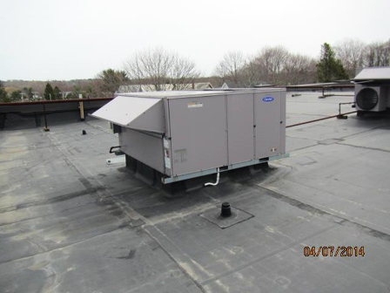
Air handling unit (AHU) on the roof
Picture 2
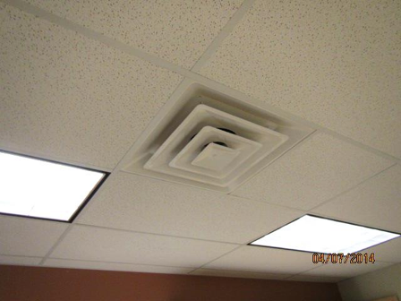
Typical supply diffuser

Picture 3
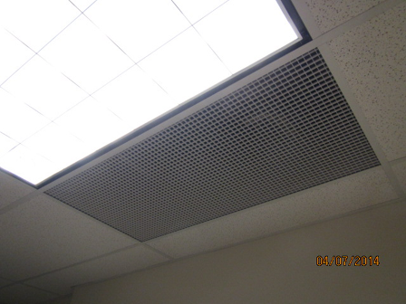
Typical exhaust grate
Picture 4
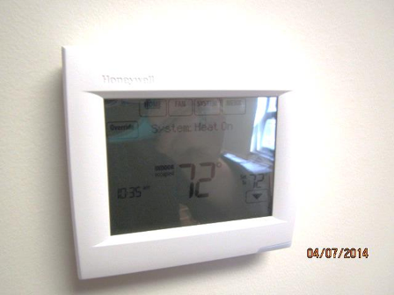
Thermostat in the office

Picture 5
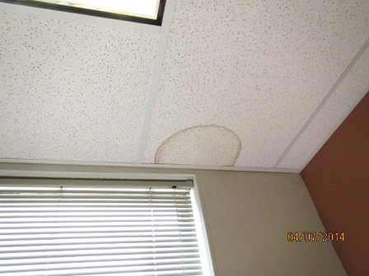
Water-damaged ceiling tile
Picture 6
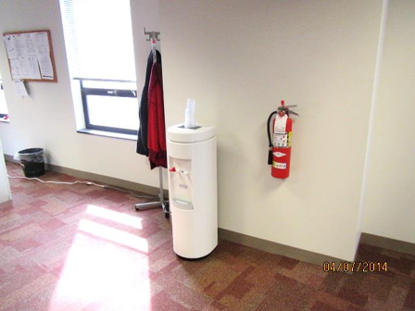
Water dispenser on carpet

Picture 7
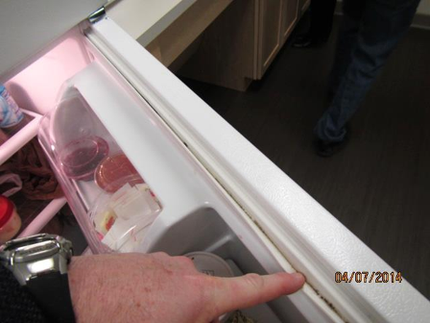
Mold-colonization (dark staining) on refrigerator gasket
Picture 8
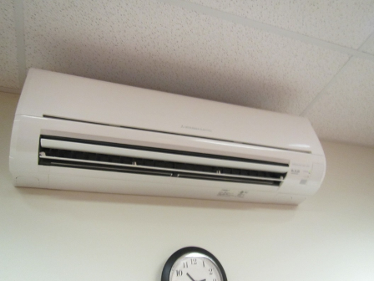
Ductless air conditioning unit

Picture 9
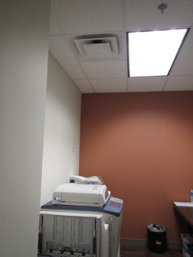
Photocopier directly below supply vent
Picture 10
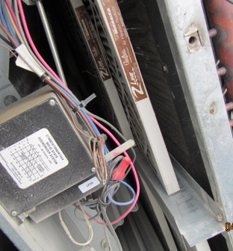
Opened rooftop AHU showing wrong-sized filter

Picture 11
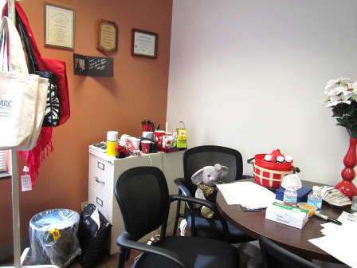
Items in an office
Picture 12
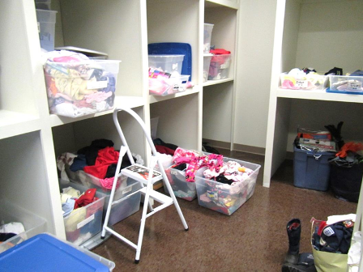
Stored items in open totes
Location | Carbon  Dioxide  (ppm) | Temp  (°F) | Relative  Humidity  (%) | Carbon  Monoxide  (ppm) | PM2.5  (µg/m³) | TVOC  (ppm) | Occupants  in Room | Windows  Openable | Ventilation  Supply Exhaust |  | Comments
Background | 387 | 60 | 17 | 1.6 | 9 | 1.0 |  |  |  |  | Sunny, hazy, parking lot
1017 mail | 720 | 74 | 21 | ND | 6 | 1 | 0 | N | Y | Y
1020 | 839 | 75 | 21 | ND | 8 | 1 | 0 | N | Y | N | HS, AP, DO
1021 | 810 | 75 | 23 | ND | 7 | 1 | 0 | N | Y | N | DO, WD CT, food, HS, CP
1022 office | 815 | 75 | 21 | ND | 7 | 1 | 0 | N | Y | N | DO, water dispenser on carpet in hall
1025 cube | 807 | 75 | 22 | ND | 7 | 1 | 1 | N | Y | Y
1030 cube | 802 | 75 | 22 | ND | 7 | 1 | 1 | N | Y | Y | Food, plants
1032 cube | 859 | 75 | 23 | ND | 7 | 1 | 2 | N | Y | Y | Door to outside (tight)
1037 cube | 811 | 75 | 22 | ND | 7 | 1 | 2 | N | Y | Y | Items, food
1040 half-wall | 798 | 75 | 21 | ND | 7 | 1 | 0 | N | Y | Y | Items, HS, CP
1041 | 790 | 75 | 21 | ND | 6 | 1 | 0 | N | Y | Y | HS, plant
1051 office | 747 | 74 | 21 | ND | 7 | 1 | 0 | N | Y | N | DO, food
1052 office | 713 | 74 | 21 | ND | 7 | 1 | 0 | N | Y | N | DO, CP
1053 cubes | 722 | 74 | 21 | ND | 8 | 1 | 2 | N | Y | Y | Printer/copier nearby
1055 cubes | 690 | 74 | 21 | ND | 7 | 0.9 | 0 | N | Y | Y | NC
1056 | 724 | 74 | 21 | ND | 7 | 1 | 2 | N | Y | N | DO, food
1057 cubes | 782 | 74 | 21 | ND | 7 | 1 | 1 | N | Y | Y | Food
1060 cubes | 810 | 74 | 21 | ND | 7 | 1 | 1 | N | Y | Y
1070 office | 683 | 76 | 19 | ND | 6 | 1 | 0 | N | Y | Y | DO
1071 office | 708 | 75 | 20 | ND | 7 | 0.9 | 0 | N | Y | Y | DO, plush chair
1072 office | 730 | 75 | 21 | ND | 6 | 0.9 | 0 | N | Y | Y | DO
1075 office | 678 | 75 | 20 | ND | 7 | 0.9 | 1 | N | Y | Y | Plant, items on floor, CP
1076 office | 725 | 75 | 20 | ND | 7 | 1 | 1 | N | Y | Y | Plant
1077 office | 730 | 75 | 20 | ND | 7 | 1 | 1 | N | Y | Y | DO, papers on floor
1078 office | 735 | 76 | 20 | ND | 7 | 1 | 0 | N | Y | Y | DO
1080 conference | 781 | 75 | 20 | ND | 7 | 1 | 3 | N | Y | N | Electric wall-mounted AC
1081 office | 761 | 77 | 19 | ND | 7 | 1 | 0 | N | Y | N | DO
1082 office | 869 | 77 | 21 | ND | 7 | 1 | 1 | N | Y | N | Plants on carpet, solar gain, DO
1083 office | 741 | 77 | 20 | ND | 7 | 1 | 1 | N | Y | N | DO, potpourri, plants
1089 | 733 | 77 | 20 | ND | 6 | 0.9 | 1 | N | Y | Y | Items
1089 cubes | 758 | 76 | 21 | ND | 7 | 1 | 0 | N | Y | Y | Printer
1092 cubes | 731 | 76 | 21 | ND | 7 | 0.9 | 0 | N | Y | Y | Plant
1095 cubes | 785 | 72 | 21 | ND | 7 | 0.9 | 2 | N | Y | Y
1097 cubes | 766 | 76 | 21 | ND | 7 | 0.9 | 0 | N | Y | Y | Water dispenser on carpet, solar gain
1111 | 703 | 76 | 22 | ND | 6 | 0.9 | 1 | N | Y | Y | Vacant area
1113 storage | 773 | 76 | 21 | ND | 7 | 0.9 | 0 | N | Y | Y | NC, boxes on floor
1114 office | 766 | 76 | 22 | ND | 7 | 0.9 | 1 | N | Y | N | DO
1115 office | 729 | 75 | 21 | ND | 7 | 0.9 | 0 | N | Y | N | DO, boxes on floor
1118 office | 713 | 75 | 20 | ND | 7 | 0.9 | 0 | N | Y | N | DO, heater, items on floor, food
1119 office | 707 | 76 | 21 | ND | 7 | 0.9 | 0 | N | Y | N | DO, fridge on carpet, items
1122 cube | 706 | 75 | 20 | ND | 7 | 0.9 | 0 | N | Y | Y
1124 office | 704 | 76 | 21 | ND | 7 | 0.9 | 0 | N | Y | N | DO
1125 office | 749 | 76 | 21 | ND | 7 | 0.9 | 0 | N | Y | N | DO, slight fruit/cleaner odor
1127 cube | 718 | 76 | 21 | ND | 7 | 0.9 | 1 | N | Y | Y
1129 office | 776 | 76 | 22 | ND | 7 | 0.9 | 1 | N | Y | N | DO, fridge on carpet, box on floor
1131 office | 793 | 76 | 20 | ND | 7 | 0.9 | 1 | N | Y | N | DO
1132 cubes | 799 | 76 | 21 | ND | 6 | 0.9 | 2 | N | Y | Y | Items
1133 | 815 | 76 | 21 | ND | 7 | 0.9 | 0 | N | Y | N | DO, PF, solar gain
1st floor kitchen | 661 | 74 | 23 | ND | 7 | 0.9 | 1 | N | Y | Y | 2 refrigerators, microwave, toasters, sink, NC
1st floor law library | 726 | 74 | 21 | ND | 7 | 1 | 0 | N | Y | N | DO, books
1st floor staff ladies room |  |  |  |  |  |  |  | N | Y | Y | New wallboard near sink
1st floor waiting area | 700 | 72 | 23 | ND | 7 | 0.9 | 0 | N | Y | Y
1st main floor reception | 759 | 75 | 21 | ND | 6 | 1 | 2 | N | Y | Y | Printer, mailing equipment, perfume odor
2001 office | 831 | 72 | 23 | ND | 11 | 1.0 | 0 | N | Y | Y
2003 office | 886 | 72 | 25 | ND | 8 | 1.1 | 0 | N | Y | Y | DO, 1 WD CT
2006 cube | 1160 | 74 | 27 | ND | 10 | 1.2 | 0 | N | Y | Y | DO
2007 cubes | 1200 | 75 | 26 | ND | 9 | 1.2 | 1 | N | y | Y
2012 cube | 1063 | 74 | 25 | ND | 8 | 1.1 | 1 | N | Y | Y
2013 | 1035 | 74 | 25 | ND | 9 | 1.1 | 0 | N | Y | Y | DO
2014 | 1030 | 74 | 25 | ND | 9 | 1.1 | 0 | N | Y | Y | DO
2015 office | 1142 | 75 | 26 | ND | 8 | 1.1 | 0 | N | Y | Y | DO, heater
2016 office | 1532 | 75 | 28 | ND | 10 | 1 | 1 | N | Y | Y | Perfume odor
2017 office | 1168 | 75 | 25 | ND | 10 | 1 | 1 | N | Y | Y | Fridge
2018 | 1143 | 75 | 26 | ND | 9 | 1.2 | 0 | N | Y | Y | DO
2019 | 1142 | 75 | 26 | ND | 9 | 1.1 | 1 | N | Y | Y
2021 | 1182 | 75 | 25 | ND | 9 | 1.2 | 2 | N | Y | Y | DO
2022 office | 1132 | 75 | 26 | ND | 9 | 1.1 | 2 | N | Y | Y | PF
2028 cubes | 1084 | 75 | 24 | ND | 10 | 1.2 | 2 | N | Y | Y
2029 office | 1057 | 75 | 23 | ND | 10 | 1.1 | 0 | N | Y | Y | Fridge on carpet
2030 office | 1144 | 75 | 25 | ND | 10 | 1.2 | 0 | N | Y | Y | Fridge, area rug, DO
2031 office | 1064 | 75 | 23 | ND | 10 | 1.2 | 0 | N | Y | Y | Food, CP, HS
2032 cubes | 1070 | 75 | 24 | ND | 10 | 1.2 | 2 | N | Y | Y | PF
2041 cubes | 1040 | 75 | 23 | ND | 10 | 1.2 | 2 | N | Y | Y
2046 records |  |  |  |  |  |  |  | N |  |  | NC
2047 office | 1043 | 76 | 23 | ND | 11 | 1.2 | 0 | N | Y | Y | DEM, fridge, DO
2048 kitchen | 1060 | 76 | 23 | ND | 8 | 1.2 | 0 | N | Y | Y | NC, fridge, toasters, microwave
2053 cubes | 1025 | 75 | 22 | ND | 10 | 1.2 | 4 | N | Y | Y | Items, food
2055 office | 1048 | 75 | 23 | ND | 8 | 1.2 | 2 | N | Y | Y | Heater, 2 refrigerators, DO
2058 cube | 1087 | 75 | 25 | ND | 9 | 1.2 | 0 | N | Y | Y | Items
2064 conference | 1066 | 76 | 22 | ND | 9 | 1.2 | 0 | N | Y | Y | DO, DEM
2065 office | 1076 | 76 | 23 | ND | 9 | 1.2 | 0 | N | Y | Y | DO
2066 office | 1140 | 76 | 23 | ND | 9 | 1.2 | 1 | N | Y | Y | Plant, fridge, fabric chair, DO
2067 office | 1333 | 76 |  | ND | 10 | 1.2 | 2 | N | Y | Y | Items, bike, fridge
2068 office | 1138 | 75 | 24 | ND | 10 | 1.2 | 1 | N | Y | Y | DO, fridge on carpet
2074 cube | 1091 | 75 | 24 | ND | 9 | 1.2 | 4 | N | Y | Y | Items on floor
2074 office | 698 | 75 | 21 | ND | 8 | 0.9 | 1 | N | Y | N | DO, thermostat
2075 office | 1117 | 75 | 24 | ND | 9 | 1.1 | 0 | N | Y | Y | Heater, fridge
2076 cubes | 1110 | 74 | 24 | ND | 9 | 1.3 | 1 | N | Y | Y | Printer
2079 office | 1104 | 74 | 25 | ND | 9 | 1.3 | 1 | N | Y | Y | Fridge
2080 office | 1117 | 74 | 24 | ND | 9 | 1 | 1 | N | Y | Y | DO, fridge
2086 cubes | 1107 | 74 | 24 | ND | 9 | 1 | 1 | N | Y | Y | WD CT, items
2092 cubes | 1114 | 74 | 24 | ND | 9 | 1 | 2 | N | Y | Y
2098 cubes | 1095 | 74 | 24 | ND | 9 | 1 | 1 | N | Y | Y | Plants, boxes on floor
2099 cubes | 1101 | 74 | 24 | ND | 9 | 1 | 1 | N | Y | Y
2109 cubes | 1100 | 74 | 24 | ND | 8 | 1 | 3 | N | Y | Y | Plants, items, recycling
2111 office | 1133 | 74 | 25 | ND | 10 | 1 | 2 | N | Y | Y | Fridge, food, DEM, DO
2112 office | 1096 | 74 | 25 | ND | 8 | 1 | 1 | N | Y | N | DO, fridge on carpet
2113 office | 1330 | 73 | 26 | ND | 8 | 1 | 2 | N | Y | N | DO, fridge on carpet, cut flowers
2114 office | 1390 | 72 |  | ND | 9 | 1 | 2 | N | Y |  | Plants, cut flowers, fridge on carpet
2120 cubes | 1104 | 74 | 25 | ND | 9 | 1 | 4 | N | Y | Y | CT reportedly recently changed, reported AC leak, one WD CT
2121 storage | 782 | 71 | 22 | ND | 10 | 1 | 0 | N | Y | N | Stored items in bins, some items not enclosed
2123 cube | 1022 | 73 | 26 | ND | 9 | 1 | 4 | N | Y | Y | Food, HS
2128 cube | 1030 | 72 | 25 | ND | 9 | 1 | 2 | N | Y | N | plants
2135 cube | 1161 | 75 | 29 | ND | 9 | 1.2 | 3 | N | Y | Y | Items, hanging items from ceiling
2nd floor car seat storage |  |  |  |  |  |  |  | N |  |  | Boxes on floor, NC
2nd floor storage |  |  |  |  |  |  |  | N

