INDOOR AIR QUALITY ASSESSMENT

Department of Children and Families Office
810 Memorial Drive
Cambridge, MA

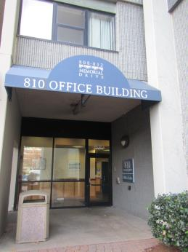

Prepared by:
Massachusetts Department of Public Health
Bureau of Environmental Health
Indoor Air Quality Program
December 2016

Background
Building: | Department of Children and Families (DCF)
Address: | 810 Memorial Drive,w Cambridge, MA
Assessment Requested by: | Erin R. McCabe, Executive Office of Health and Human Services (EHHS)
Reason for Request: | General IAQ concerns including water damage and pests
Date of Assessment: | November 21, 2016
Massachusetts Department of Public Health/Bureau of Environmental Health (MDPH/BEH) Staff Conducting Assessment: | Ruth Alfasso, Environmental Engineer/Inspector, IAQ Program
Building Description: | Mixed use high-rise building with three floors of office space below multiple floors of residential space.
Building Population: | Approximately 60 employees on the second floor.
Windows: | Not openable

Methods
Please refer to the IAQ Manual for methods, sampling procedures, and interpretation of results (MDPH, 2015).

IAQ Testing Results
The following is a summary of indoor air testing results (Table 1).
- Carbon dioxide levels were below 800 parts per million (ppm) in all areas assessed, indicating adequate fresh air in the space.
- Temperature was within the recommended range of 70°F to 78°F in all areas assessed except the IT/computer room.
- Relative humidity was below the recommended range of 40% to 60% in all areas assessed.
- Carbon monoxide levels were non-detectable in all indoor areas assessed.
- Fine particulate matter (PM2.5) concentrations measured were below the National Ambient Air Quality Standard (NAAQS) level of 35 μg/m³ in all areas assessed.

Ventilation
A heating, ventilating, and air conditioning (HVAC) system has several functions. First, it provides heating and, if equipped, cooling. Second, it is a source of fresh air. Finally, an HVAC system will dilute and remove normally occurring indoor environmental pollutants by not only introducing fresh air, but also filtering the airstream and ejecting stale air to the outdoors via exhaust ventilation. Even if an HVAC system is operating as designed, point sources of respiratory irritation may exist and cause symptoms in sensitive individuals. The following analysis examines and identifies components of the HVAC system and likely sources of respiratory irritant/allergen exposure due to water damage, aerosolized dust, and/or chemicals found in the indoor environment.
Fresh air is provided by air handling units (AHUs), at least one of which is located in a closet on this floor (Picture 1). Air from the AHUs is filtered, heated/cooled, and delivered to rooms via ducted supply vents (Pictures 2 and 3). Air is returned/exhausted through vents in the walls or ceiling.
The assessment results indicate that the ventilation system is providing adequate fresh air for the occupancy in the building. In some areas assessed, the thermostats were observed to be set to the “fan auto” setting (Picture 4), which does not provide a continuous source of fresh air; the “fan on” setting is preferred in occupied areas.
Temperature control was expressed as an issue in some locations. One thermostat near the Legal office was observed to be set to heating, with a set temperature of 60 degrees, but on the thermostat and with BEH/IAQ equipment it was measured at 76 degrees in this space, which, given the cold outdoor temperatures, indicated that additional heat was being supplied. In a nearby storeroom, the thermostat was set to cooling. A comprehensive investigation of thermostat settings and function should be conducted to ensure that the thermostats are operating properly, that settings for occupied periods include having the fan on for circulation, and that night/weekend unoccupied times and settings are harmonized over the entire suite.
Note that the thermostats examined were covered by plastic boxes to prevent unauthorized use. The box covering the thermostat in the Legal area described above was opaque, which prevents the operating conditions from being monitored. It is recommended that this opaque box be replaced with a clear one (e.g., Picture 4).
It is recommended that HVAC systems be re-balanced every five years to ensure adequate air systems function (SMACNA, 1994). It is unknown when the last time this system was balanced.

Microbial/Moisture Concerns
One of the issues that this visit was requested to address was water damage. Note that above the offices on the DCF floor are many floors of residential units. Periodic floods from plumbing malfunctions on the floors above have caused water to leak into DCF spaces in the past. At the time of the visit, water-damaged ceiling tiles (Picture 5), water-stained walls (Picture 6) and rusted fittings (Picture 7) indicating past water exposure, were observed in many locations, particularly along interior partition walls. It was reported that many stained tiles had been removed recently subsequent to the most recent water damage incident, as well as some carpet squares that had gotten wet.
No damp or mold-colonized materials were observed, however in one conference room, a large whiteboard was attached to a wall that had significant water streaks (Picture 6) and it is possible that moisture had gotten behind this and not sufficiently dried. The whiteboard should be removed during an unoccupied period to check behind it for water damage and remediate as necessary.
The ceiling above the tile system was observed in a few locations. There is a significant gap between the tile system and the upper ceiling, which appeared to be concrete, a material that does not support mold growth. This will facilitate the rapid drying of any water-stained tiles and help prevent microbial growth.
Plants were observed in office areas (Table 1; Pictures 8 and 9). Plants can be a source of pollen and mold, which can be respiratory irritants to some individuals. Plants should be properly maintained and equipped with drip pans to prevent water damage to porous materials. Plants should also be located away from air diffusers to prevent the aerosolization of dirt, pollen, and mold. Some of the plants were in poor condition (e.g., dead) and should be removed.
Small refrigerators and water dispensers were observed in carpeted areas (Table 1; Picture 10). These appliances may spill or leak and lead to carpet damage and microbial growth. It is recommended that these appliances be located in areas without carpeting or on waterproof mats. Carpet squares could also be replaced with tile in areas where water dispensers and refrigerators are located. Refrigerators should be kept clean to prevent odors and microbial growth.
A ductless air conditioning unit was observed in the IT room (Picture 11). The condensate pump and piping that connect this unit with a drain should be inspected periodically for clogs and leaks to prevent water damage to nearby building materials. Note that the curve of the piping has trapped some water inside, which can become stagnant during colder weather when the unit does not need to operate consistently; if possible this pipe should be sloped to drain completely. A chilling unit was seen in a maintenance closet (Picture 12) which also had a condensate pump.

Other IAQ Evaluations
Exposure to low levels of total volatile organic compounds (TVOCs) may produce eye, nose, throat, and/or respiratory irritation in some sensitive individuals. To determine if VOCs were present, BEH/IAQ staff examined rooms for products containing VOCs. BEH/IAQ staff noted hand sanitizers, cleaners, scented candles, pesticides and dry erase materials in use within the building (Table 1; Pictures 10 and 13). All of these products have the potential to be irritants to the eyes, nose, throat, and respiratory system of sensitive individuals.
Issues with pests were reported in this office. The residential portion of the building is equipped with a trash chute that passes through a room behind a storage area (Pictures 14 and 15). Roaches and odors were reported emanating from this trash chute area into occupied spaces. Reportedly, the building management had the chute cleaned and sanitized in response to this issue, as well as using the services of a pest control company. However, as shown in Picture 15, roaches are still present in this area. Pest control should be continued, as well as both the building management and occupants following the other principles of integrated pest management (IPM). Note that IPM includes “exclusion” such as ensuring the walls of this room are free of holes and gaps (e.g., Picture 16) and the installation of tight weather-stripping at the base of the door between the trash room and the storage area (Picture 17).
IPM also includes removal of sources of food, water and harborage for pests. Cooking equipment, including toasters, microwave ovens and coffee machines were located in various parts of the office space (Table 1; Picture 10). The presence of so many different pieces of cooking equipment near workstations and without direct exhaust ventilation also increases the chance of food odors permeating office areas. Food areas and cooking equipment need to be kept clean to prevent odors and pests. Carpeting in these areas may trap crumbs and spills as well. Consider consolidating cooking areas into unoccupied and uncarpeted areas or protect the carpeting in these areas with a mat. Food was observed stored in the open (Picture 18); all food should be stored in pest-proof containers.
The door to the closet with the chilling unit shown in Picture 12 had a coating of dust (Picture 19) that indicates that air is being drawn into this closet. The function of this unit should be investigated, as no obvious air intakes/returns were observed. If it requires a source of make-up air, a vent should be cut into this door to supply a free flow of air. If no air should be drawn into this unit, any gaps or leaks should be repaired. There were also holes in the wall and missing ceiling tiles in this room. The dust shown in Picture 19 should be cleaned to prevent reaerosolization.
In some areas, stored materials and accumulated items make it more difficult for custodial staff to clean. Items should be stored neatly and moved periodically to allow for wet wiping and vacuuming of surfaces. This office has a number of storerooms, containing items such as clothing, car seats and bicycles. These storerooms should be kept clean and well organized and items should be stored so that they do not become dusty or create harborage for pests.
Personal fans were observed in a number of areas. Fan blades to some of these units had settled dust, which can be reaerosolized when the fan is activated. Some supply and exhaust vents were also dusty. Debris was observed in the trays of whiteboards. This material should be cleaned regularly so that it does not become aerosolized.
The offices were mostly carpeted. Carpets should be cleaned annually (or semi-annually in soiled/high traffic areas) in accordance with Institute of Inspection, Cleaning and Restoration Certification (IICRC) recommendations, (IICRC, 2012).
Upholstered furniture was observed in several offices and visitation rooms (Picture 20). Upholstered furniture, pillows and cushions are covered with fabric that comes in contact with human skin. This type of contact can leave oils, perspiration, hair and skin cells. Dust mites feed upon human skin cells and excrete waste products that contain allergens. In addition, if relative humidity levels increase above 60 percent, dust mites tend to proliferate (US EPA, 1992). In order to remove dust mites and other pollutants, frequent vacuuming of upholstered furniture is recommended (Berry, M.A., 1994). It is also recommended that upholstered furniture be professionally cleaned on an annual basis or more frequently if needed.

Conclusions/Recommendations
Based on observations at the time of assessment, the following is recommended:
- Operate supply and exhaust ventilation in all areas during occupied periods.
- Have the thermostat in the open area near the Legal office and related control systems investigated and repaired so that set temperatures can be accurately met. Have all thermostat and control systems set systematically to provide comfortable temperatures and constant air flow during occupied periods and reasonable setback temperatures when the offices are unoccupied.
- Replace the opaque plastic box over the thermostat near the Legal office with a clear plastic box such as that shown in Picture 4.
- Have the HVAC system balanced every 5 years in accordance with SMACNA recommendations (SMACNA, 1994).
- For buildings in New England, periods of low relative humidity during the winter are often unavoidable. Therefore, scrupulous cleaning practices should be adopted to minimize common indoor air contaminants whose irritant effects can be enhanced when the relative humidity is low. To control for dusts, a high efficiency particulate arrestance (HEPA) filter equipped vacuum cleaner in conjunction with wet wiping of all surfaces is recommended. Avoid the use of feather dusters. Drinking water during the day can help ease some symptoms associated with a dry environment (throat and sinus irritations).
- Regularly monitor the offices for leaks and ensure a system is in place to enable occupants to promptly report leaks. When leaks are detected, initiate drying with fans and removal of damaged materials as soon as possible.
- Replace all stained ceiling tiles, and wash water-stained walls. This will also make detecting leaks easier.
- During an unoccupied period, have the whiteboard located in Conference room 2 removed from the wall and check the back of the whiteboard and the wall for dampness, mold colonization and moldy odors. If any such conditions exist, discard the whiteboard and remediate damaged wallboard.
- Given that leaks may occur again, avoid storing materials on the floors or up against walls to avoid water damage.
- Keep indoor plants in good condition, avoid overwatering, and avoid placing them on porous items such as carpets or paper. Also, keep plants out of the air stream of supply vents.
- Consider moving refrigerators and water dispensers to areas without carpeting or place them on a waterproof mat.
- Clean refrigerators out regularly to avoid odors and microbial growth.
- Inspect condensate pumps and piping for ductless air-conditioning and other chilling units regularly for clogs and leaks.
- Continue to work with a pest control contractor to control roaches in the trash chute room.
- Ensure that a regular, scheduled cleaning/sanitizing of the trash chute occurs.
- Have all gaps in the walls in the trash chute room sealed with an appropriate sealant. Have stiff, tightly fitted weather-stripping installed underneath the door between the trash chute room and the storage area and monitor for visible light underneath.
- Ensure cooking areas/equipment are kept clean to prevent odors and pests. Consider reducing the number of areas where food is stored and locating them away from occupied areas. Store all food in pest-proof containers.
- Use other principles of Integrated Pest Management (IPM) to help control pests in the office. Refer to the “Integrated Pest Management Kit for Building Managers” (MDFW, 1996) for more information; it can be access here: http://pestweb.com/assets/files/schoolipm/IPM_kit_booklet.pdf.
- Investigate the function of the chilling unit shown in Picture 12. If it requires a source of make-up air to function, have the door to this room undercut or install a vent in it. If it should not be drawing air, have it repaired. Seal all holes in walls and maintain an intact ceiling in this room.
- Clean the dust from the door edges in the chiller room.
- Store items in storerooms neatly to allow for thorough cleaning and to prevent creating harborage for pests,
- Change filters on AHUs on a regular schedule at least twice a year. Repair AHU filter racks so that filters fit tightly without need for tape.
- Clean carpeting in accordance with IICRC recommendations (IICRC, 2012).
- Reduce accumulated materials on flat surfaces and store in an organized manner to allow for thorough cleaning.
- Clean the blades of personal fans, supply, and exhaust vents periodically to avoid aerosolizing dusts.
- Clean upholstered furniture, cloth curtains, stuffed animals, and pillows on a regular schedule. If not possible/practical, consider removing them from rooms.
- Refer to resource manual and other related IAQ documents located on the MDPH’s website for further building-wide evaluations and advice on maintaining public buildings. These documents are available at: http://mass.gov/dph/iaq.

References

Berry, M.A. 1994. Protecting the Built Environment: Cleaning for Health, Michael A. Berry, Chapel Hill, NC.
IICRC. 2012. Institute of Inspection, Cleaning and Restoration Certification. Carpet Cleaning: FAQ. Retrieved from http://www.iicrc.org/consumers/care/carpet-cleaning.
MDFA. 1996. Integrated Pest Management Kit for Building Managers. Massachusetts Department of Food and Agriculture, Pesticide Bureau, Boston, MA.
MDPH. 2015. Massachusetts Department of Public Health. Indoor Air Quality Manual: Chapters I-III. Available at: http://www.mass.gov/eohhs/gov/departments/dph/programs/environmental-health/exposure-topics/iaq/iaq-manual/.
SMACNA. 1994. HVAC Systems Commissioning Manual. 1st ed. Sheet Metal and Air Conditioning Contractors’ National Association, Inc., Chantilly, VA.
US EPA. 1992. Indoor Biological Pollutants. US Environmental Protection Agency, Environmental Criteria and Assessment Office, Office of Health and Environmental Assessment, research Triangle Park, NC. EPA 600/8-91/202. January 1992.

Picture 1
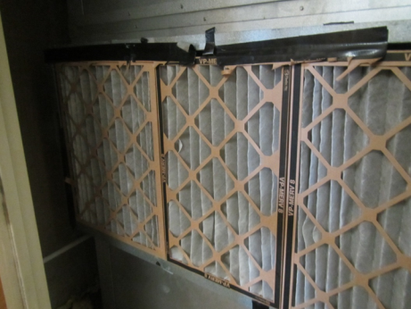
Air handling unit in a closet; note MERV 8 filters sealed on with tape
Picture 2
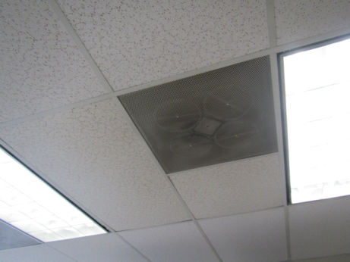
One style of supply vent
Picture 3
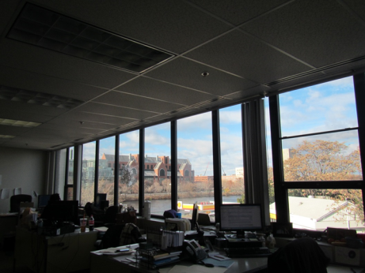
Supply vents along windows
Picture 4
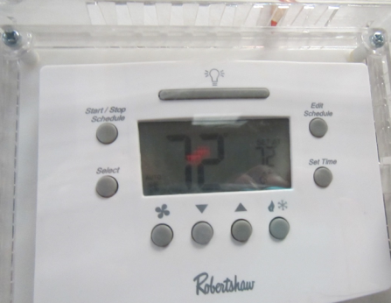
Thermostat in clear plastic case with fan set to “auto” (arrow)
Picture 5
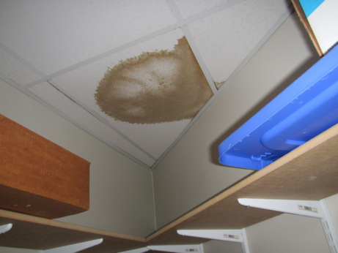
Water-damaged ceiling tile
Picture 6
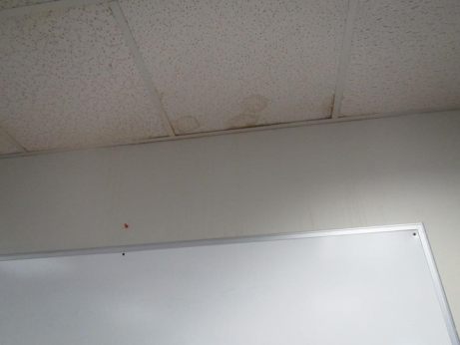
Water-stained ceiling tiles and streaks on wall, note whiteboard attached to wall
Picture 7
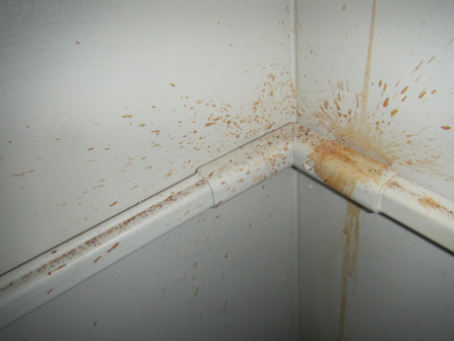
Water and rust stains on wall and fittings
Picture 8
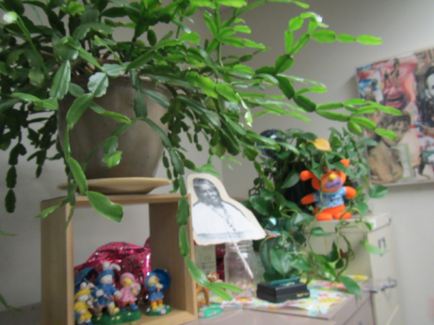
Plants on an office shelf
Picture 9
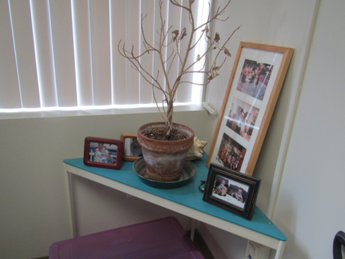
Dead plant
Picture 10
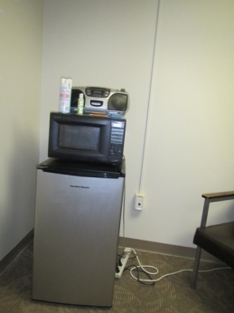
Refrigerator on carpet, note microwave and cleaning products
Picture 11
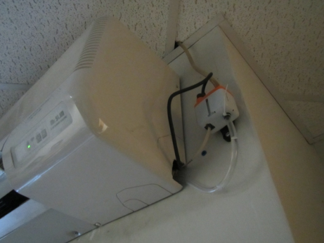
Ductless air conditioner in IT room; note water in drainage tube
Picture 12
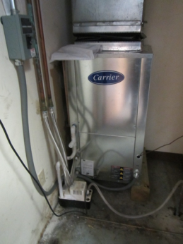
Chilling unit with condensate pump
Picture 13
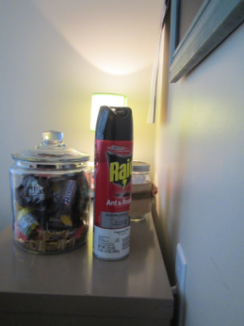
Can of pesticide and jar of food
Picture 14
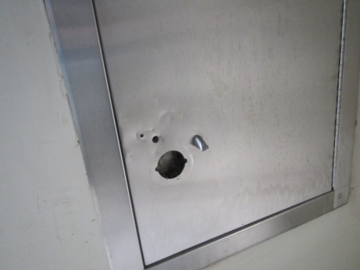
Door to trash chute (not openable on this level)
Picture 15
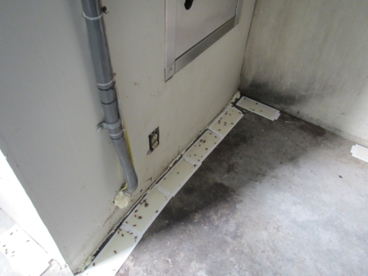
Glue traps with roaches next to trash chute door
Picture 16
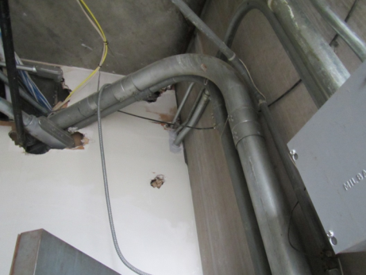
Holes in wall in trash chute room
Picture 17
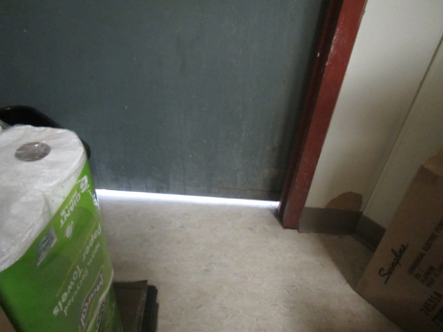
Door to trash chute room as seen from storage room, note large gap under door
Picture 18
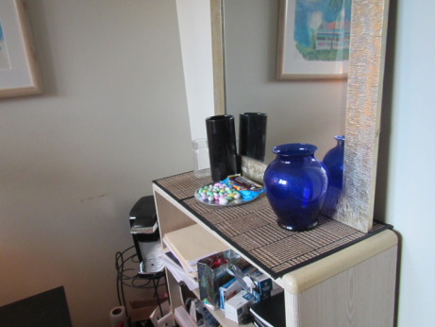
Food left out in the open
Picture 19
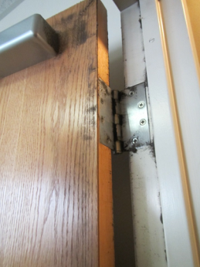
Dust along edges of door to chiller room
Picture 20
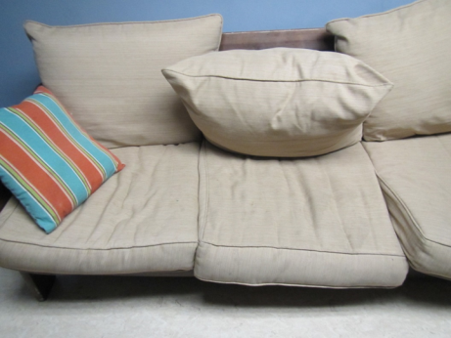
Upholstered furniture
Location | Carbon  Dioxide  (ppm) | Carbon Monoxide  (ppm) | Temp  (°F) | Relative  Humidity  (%) | PM2.5  (µg/m³) | Occupants  in Room | Windows  Openable | Ventilation |  | Remarks
 |  |  |  |  |  |  |  | Supply | Exhaust
Background | 336 | 1.3 | 46 | 23 | 3 |  |  |  |  | Cold and windy
Kitchen | 733 | ND | 73 | 22 | 3 | 4 | Y | Y | Y | Fridge, stove with hood (recirculating), microwave, toaster, vending machines, NC
Reception Desk | 730 | ND | 75 | 19 | 5 | 1 | Y | Y | Y | Heater
Conference 1 | 740 | ND | 74 | 20 | 3 | 3 | Y | Y | Y
Conference 2 | 778 | ND | 73 | 21 | 3 | 9 | Y | Y | Y | WD wall and WD CT, carpet removal supposedly occurred
IT room | 578 | ND | 68 | 18 | 3 | 0 | Y | Y | Y | Ductless AC (drain has standing water)
Storage and trash chute area |  | ND |  |  |  |  | N | N | N | Holes in walls, ceiling in trash room; needs weather-stripping on door between storage and trash room, traps with pests caught.
Unit E | 583 | ND | 74 | 19 | 5 | 5 | Y | Y | Y | Plants, fridge on carpet, DEM
Adoption and family resources | 601 | ND | 76 | 17 | 4 | 4 | Y | Y | Y | DEM, plants
Adolescent unit | 589 | ND | 76 | 16 | 6 | 2 | Y | Y | Y | Plant (dead), fridge on carpet, CP
Office “Dreams” | 665 | ND | 76 | 17 | 5 | 1 | Y | Y | N | DEM
Office “Love” | 640 | ND | 77 | 17 | 4 | 1 | Y | Y | N | DO, CP, food
Office “Believe” | 696 | ND | 77 | 17 | 4 | 1 | Y | Y | N | DO
Legal | 663 | ND | 76 | 17 | 5 | 0 | Y | Y | Y | WD wall (see pictures)
Open area for legal, nearby | 710 | ND | 76 | 17 | 5 | 0 | N | Y | Y | Thermostat (in opaque box) problems with temperature control
Car seat/bike storage | 609 | ND | 76 | 15 | 5 | 0 | N | Y | Y | Thermostat set for cooling and fan “auto”; car seats and boxes on floor
Files | 583 | ND | 74 | 17 | 5 | 0 | Y | Y | Y | Water-stained walls
Conference | 562 | ND | 74 | 17 | 4 | 0 | Y | Y | Y | Dusty vents
Files | 640 | ND | 74 | 18 | 5 | 0 | N | Y | Y
Office next to copy machine | 673 | ND | 74 | 19 | 5 | 0 | N | N | N | Low walls open to main room
Office | 635 | ND | 75 | 18 | 6 | 2 | Y | Y | Y | Plants, microwave, fridge on carpet
Office | 615 | ND | 74 | 18 | 5 | 0 | Y | Y | N | DO, plants
Office | 619 | ND | 75 | 18 | 5 | 1 | Y | Y | Y | Food, fridge and area rug
Open area -- intake | 668 | ND | 75 | 19 | 5 | 3 | Y | Y | Y | Fridge and microwave, big windows (solar gain/drafts)
Manager reception | 690 | ND | 74 | 18 | 4 | 1 | N | Y | Y | Fridge and microwave
APM office | 750 | ND | 74 | 19 | 5 | 1 | Y | Y | Y | DEM, upholstered chair
Area director office | 731 | ND | 75 | 20 | 5 | 1 | Y | Y | N | Draft from window
3 | 659 | ND | 74 | 19 | 4 | 0 | Y | Y | N | Plant, heater/fan, WD CT, DO
4 | 695 | ND | 75 | 19 | 4 | 1 | Y | Y | N | DO, plant, baseboard heater broke, dusty
5 | 730 | ND | 75 | 20 | 5 | 1 | Y | Y | N | Food, upholstered chair, plants
6 | 680 | ND | 74 | 19 | 5 | 0 | Y | Y | N
Open area | 657 | ND | 74 | 19 | 5 | 1 | Y | Y | Y
Storage (clothes) | 577 | ND | 73 | 22 | 5 | 0 | N | N | Y | Items, WD CT in interior area
Linton | 627 | ND | 73 | 22 | 4 | 1 | N | Y | Y | Plants
Unit C | 630 | ND | 73 | 20 | 5 | 0 | N | Y | Y
Wellness room | 631 | ND | 75 | 19 | 4 | 0 | N | Y | N | Upholstered items and pillows
Virginia’s office | 675 | ND | 75 | 19 | 5 | 0 | Y | Y | N | DO, plants, upholstered chair
Unit B | 675 | ND | 75 | 19 | 4 | 1 | Y | Y | Y | Plants, items hanging on ceiling, toaster and fridge
Encounter | 637 | ND | 75 | 19 | 5 | 0 | N | Y | N | PF –dusty, 1 WD CT, food
Family networks | 701 | ND | 76 | 19 | 5 | 4 | Y | Y | N | Fridge, and microwave, PF, DEM
Chiller closet |  |  |  |  |  |  | N | N | N | Holes in ceiling/walls, dust along edges (need makeup vent?)
11 | 712 | ND | 76 | 17 | 5 | 1 | Y | Y | N | Area rug, plants
12 | 708 | ND | 76 | 17 | 5 | 0 | Y | Y | N | Plants, odor in this room (spoiled food?)
17 | 669 | ND | 75 | 15 | 4 | 0 | Y | Y | N | DEM, fridge
Unit F | 602 | ND | 75 | 17 | 4 | 2 | Y | Y | N | DEM, fridge and microwave, AI, HS
Visiting room 4 | 587 | ND | 75 | 16 | 4 | 0 | N | Y | Y | NC, couch (broken, upholstered), toys, fan/AP
Visiting room 3 | 577 | ND | 76 | 15 | 5 | 0 | N | Y | Y | Area rug
Visiting room 2 | 574 | ND | 76 | 18 | 5 | 0 | N | Y | N | Powder odor/diaper changing area, NC
Visiting room 1 | 609 | ND | 76 | 18 | 4 | 0 | N | Y | N | PF, DEM, toys
Waiting | 563 | ND | 76 | 16 | 5 | 0 | N | Y | Y
Woman’s restroom | 555 | ND | 74 | 17 | 5 | 0 | N | Y | Y

