INDOOR AIR QUALITY ASSESSMENT

Department of Children and Families
30 Mystic Street
Arlington, MA

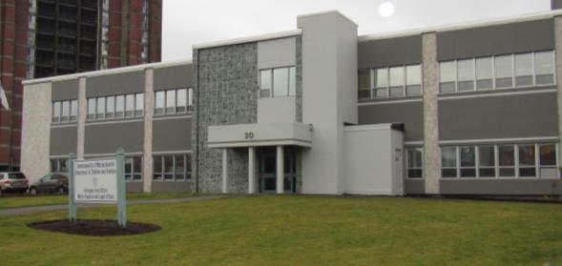

Prepared by:
Massachusetts Department of Public Health
Bureau of Environmental Health
Indoor Air Quality Program
December 2018

Background
Building: | Department of Children and Families (DCF) Arlington Area Office
Address: | 30 Mystic Street, Arlington, MA
Assessment Requested by: | Erin McCabe, EHS Facilities Deputy Director for Finance and Operations
Reason for Request: | Concerns about indoor air quality (IAQ) and health
Date of Assessment: | December 17, 2018
Massachusetts Department of Public Health/Bureau of Environmental Health (MDPH/BEH) Staff Conducting Assessment: | Ruth Alfasso, Environmental Engineer/Inspector, IAQ Program
Building Description: | Two-story brick building with a flat roof originally built in the late 1950s. The DCF office has occupied this building for approximately 10 years.
Building Population: | Approximately 100 employees of DCF. Members of the public visit daily.
Windows: | Openable

Methods
Please refer to the IAQ Manual for methods, sampling procedures, and interpretation of results (MDPH, 2015).

IAQ Testing Results
The following is a summary of indoor air testing results (Table 1).
- Carbon dioxide levels were below the MDPH guideline of 800 parts per million (ppm) in all but one area assessed, indicating adequate fresh air for the space.
- Temperature was within the recommended range of 70°F to 78°F.
- Relative humidity was below the recommended range of 40% to 60% in all areas assessed the day of the assessment.
- Carbon monoxide levels were non-detectable (ND) in all indoor areas assessed.
- Fine particulate matter (PM2.5) concentrations measured were below the National Ambient Air Quality Standard (NAAQS) level of 35 μg/m³ in all areas assessed.
- Total Volatile Organic Compounds (TVOC) were ND in the areas assessed.

Ventilation
A heating, ventilating, and air conditioning (HVAC) system has several functions. First it provides heating and, if equipped, cooling. Second, it is a source of fresh air. Finally, an HVAC system will dilute and remove normally occurring indoor environmental pollutants not only by introducing fresh air, but also by filtering the airstream and ejecting stale air to the outdoors via exhaust ventilation. Even if an HVAC system is operating as designed, point sources of respiratory irritation may exist and cause symptoms in sensitive individuals. The following analysis examines and identifies components of the HVAC system and likely sources of respiratory irritant/allergen exposure from water damage, aerosolized dust, and/or chemicals found in the indoor environment.
Fresh air is provided by air-handling units (AHUs) located on the roof. Operation of the building’s HVAC system is controlled by an automated computer system. Air from the AHUs is filtered, heated/cooled, and delivered to rooms via ducted supply vents (Picture 1). Air is returned/exhausted through return vents (Picture 2). It is recommended that HVAC systems be re-balanced every five years to ensure adequate air systems function (SMACNA, 1994). It was reported that exhaust vents in the restrooms and kitchen areas vent directly outside. Direct-vented exhaust is recommended in areas where moisture and odors may be generated.
In a few areas, supply vents were blocked with plastic or cardboard (Pictures 3 and 4). Vents should remain unobstructed for proper airflow once the system has been balanced. If there are concerns regarding drafts or noise, building maintenance staff should be contacted for adjustments of the system.

Microbial/Moisture Concerns
Water-damaged ceiling tiles were found in several offices and other areas (Pictures 5 and 6). Some of the water-damaged tiles were near the edge of the building and may be related to leaks through the building envelope. Other water-damaged tiles originate with leaks from the plumbing or HVAC system. Water-damaged tiles should be replaced when the leaks are repaired. The area above/around the water-damaged tiles should be examined for moisture and odors and remediated as necessary.
Several water coolers and refrigerators were located in carpeted areas (Picture 7). Spills or leaks from these appliances can moisten the carpet, leading to odors and microbial growth. Refrigerators should be kept clean and free of spills and spoiled food that can lead to odors. The large number of small refrigerators presents a challenge in keeping all of them clean (Picture 8).
Plants were present in some areas (Pictures 9 and 10; Table 1). Some of the plants were in poor condition. Plants can be a source of pollen and mold, which can be respiratory irritants to some individuals. Plants should be properly maintained and equipped with drip pans to prevent water damage to porous materials. Plants should also be located away from air diffusers to prevent the aerosolization of dirt, pollen, and mold.
A few trees and plants are located close to the building. Plants can hold moisture against the exterior and prevent drying. Plant roots can also damage the building foundation.

Other IAQ Evaluations
Exposure to low levels of total volatile organic compounds (TVOCs) may produce eye, nose, throat, and/or respiratory irritation in some sensitive individuals. To determine if VOCs were present, BEH/IAQ staff took measurements for TVOCS and examined rooms for products containing VOCs. While no TVOCs above background were detected, BEH/IAQ staff noted dry erase markers, cleaning products, air freshening products and hand sanitizers in use within the building (Picture 11; Table 1). All of these products have the potential to be irritants to the eyes, nose, throat, and respiratory system of sensitive individuals.
Several office areas contained food (Picture 12; Table 1). Food should be stored in tightly-sealed containers to prevent odors and pests, particularly since rodents had been observed in the building. Kitchen equipment such as toasters and microwaves should also be cleaned regularly.
In a few areas, boxes and other items were stored on the floor. Stored items should be placed on shelving to prevent damage from condensation on floors and for ease of cleaning. Note that this assessment was conducted during the agency holiday gift event, and numerous items were being brought into and out of the building as well as stored there to be transported to clients before the holidays, so many of the stored items were temporary during this period.
In many areas, supply and return vents were dusty (Picture 1; Table 1). Personal fans also had dust build-up. These should be cleaned periodically to remove dust which can be reaerosolized and cause irritation. Note that the vent shown in Picture 3 had been covered due to occupant concerns with dust/debris in the office that was attributed to the vent. While no debris was present during the assessment, the occupant reported that dust/debris continues to occur with the vent covered. The occupant should report this dust/debris when it occurs to facility maintenance staff to assist in determining the source, such as disturbed ceiling tiles, plenum pressurization or other issues.
Many offices are carpeted. Carpets should be cleaned annually (or semi-annually in soiled/high traffic areas) in accordance with Institute of Inspection, Cleaning, and Restoration Certification (IICRC) recommendations (IICRC, 2012).

Conclusions/Recommendations
Based on observations at the time of assessment, the following is recommended:
- Operate supply and return ventilation continuously (“fan on”) during occupied periods.
- Remove obstructions (paper, plastic) from vents. If drafts, noise or other issues are of concern, work with building maintenance staff to resolve.
- Have occupants report concerns with reoccurring dust/debris to facility maintenance staff to assist in determining the source and resolving the issue. Ensure AHU cabinets are vacuumed out during regular filter changes and ensure no loose/damaged insulation/materials inside unit.
- Have the HVAC system balanced every 5 years in accordance with SMACNA recommendations (SMACNA, 1994).
- Change filters for HVAC equipment 2-4 times a year. Use pleated filters of MERV 8 (or higher), which are adequate in filtering out pollen and mold spores (ASHRAE, 2012), if these can be used with current equipment.
- For buildings in New England, periods of low relative humidity during the winter are often unavoidable. Therefore, scrupulous cleaning practices should be adopted to minimize common indoor air contaminants whose irritant effects can be enhanced when the relative humidity is low. To control for dusts, a high efficiency particulate arrestance (HEPA) filter equipped vacuum cleaner in conjunction with wet wiping of all surfaces is recommended. Avoid the use of feather dusters. Drinking water during the day can help ease some symptoms associated with a dry environment (throat and sinus irritations).
- Replace water-damaged ceiling tiles. Inspect area above the water-damaged tiles for other water damage or odors and clean or repair as necessary. If water damage continues to occur, identify and repair the leaks.
- Avoid placing porous items (cloth, boxes) in areas with potential water leaks such as windowsills.
- Place refrigerators and water dispensing equipment in areas without carpeting or use a waterproof mat underneath them.
- Ensure all refrigerators are cleaned regularly to remove spoiled food and spills.
- Keep plants in good condition, avoid overwatering, and avoid placing them on porous materials.
- Trim back trees and plants adjacent to the building.
- Reduce use of cleaning products, sanitizers, and scented products.
- Keep food in tightly sealed containers and keep kitchen equipment clean.
- Use the principles of Integrated Pest Management (IPM) and the services of a licensed pest control operator to remove rodents and reduce the potential for pest infestation. Ensure that any area where rodents may have been is thoroughly cleaned to remove allergens.
- Store items in an organized manner and off the floor. Move items periodically to allow for cleaning, including vacuuming and wet wiping of surfaces to remove dust.
- Clean carpeting in accordance with IICRC recommendations (IICRC, 2012).
- Clean supply and exhaust vents, personal fans, and heaters regularly to prevent aerosolization of debris.
- Refer to resource manual and other related IAQ documents located on the MDPH’s website for further building-wide evaluations and advice on maintaining public buildings. These documents are available at: http://mass.gov/dph/iaq.

References
ASHRAE. 2012. American Society of Heating, Refrigeration and Air Conditioning Engineers (ASHRAE) Standard 52.2-2012 -- Method of Testing General Ventilation Air-Cleaning Devices for Removal Efficiency by Particle Size (ANSI Approved). 2012.
IICRC. 2012. Institute of Inspection, Cleaning and Restoration Certification. Carpet Cleaning: FAQ.
MDPH. 2015. Massachusetts Department of Public Health. Indoor Air Quality Manual: Chapters I-III. Available at: http://www.mass.gov/eohhs/gov/departments/dph/programs/environmental-health/exposure-topics/iaq/iaq-manual/.
SMACNA. 1994. HVAC Systems Commissioning Manual. 1st ed. Sheet Metal and Air Conditioning Contractors’ National Association, Inc., Chantilly, VA.
Picture 1
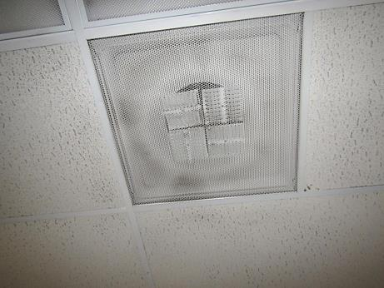
Typical supply vent, note dust on vent
Picture 2
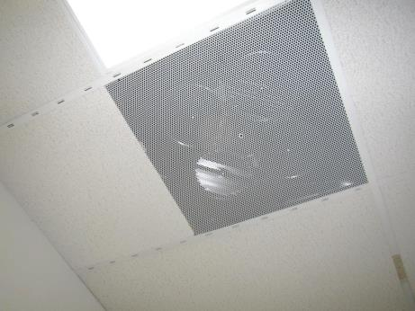
Return vent
Picture 3
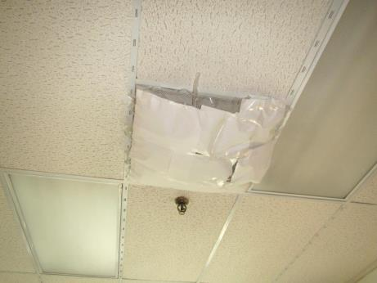
Vent blocked with plastic
Picture 4
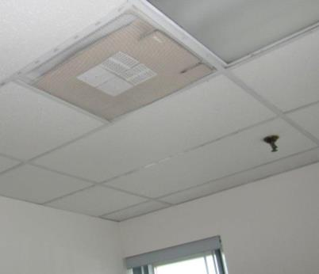
Vent blocked with cardboard
Picture 5
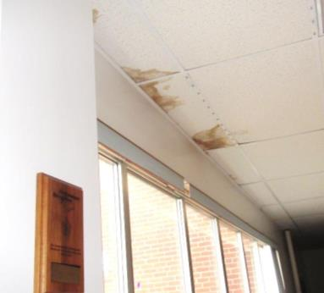
Water-damaged ceiling tiles next to windows
Picture 6
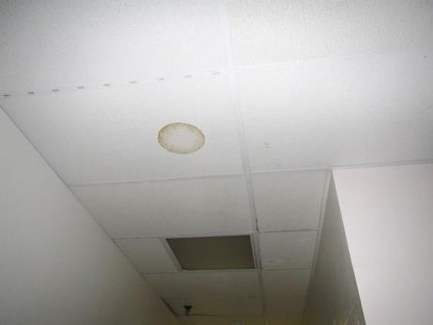
Water-damaged ceiling tile
Picture 7
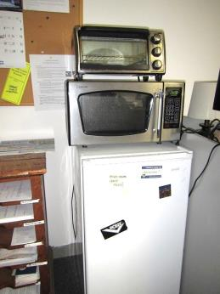
Refrigerator on carpet
Picture 8
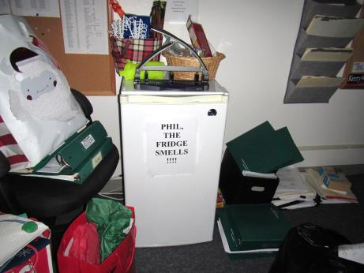
Refrigerator sign, note items on floor
Picture 9
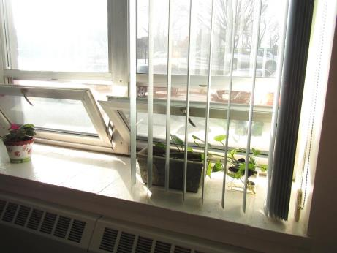
Plants on windowsill
Picture 10
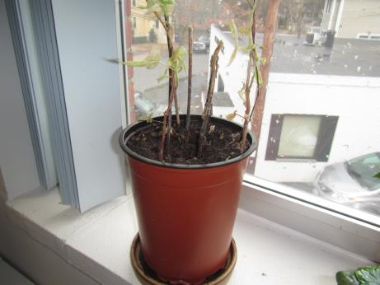
Plant in poor condition in an office
Picture 11
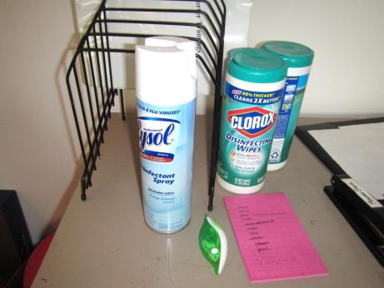
Cleaners/sanitizers in an office
Picture 12
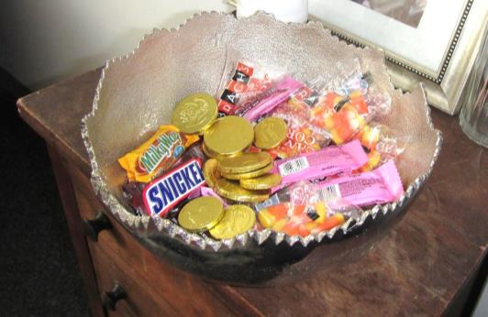
Food in an office
Location | Carbon  Dioxide  (ppm) | Carbon Monoxide  (ppm) | Temp  (°F) | Relative  Humidity  (%) | PM2.5  (µg/m³) | TVOCs  (ppm) | Occupants  in Room | Windows  Openable | Ventilation |  | Remarks
 |  |  |  |  |  |  |  |  | Supply | Exhaust
Background | 439 | ND | ~32 | 49 | 2 | ND |  |  |  |  | Light wintry mix
First floor
Mark T. | 814 | ND | 70 | 36 | ND | ND | 3 | Y | Y | Y
Marc S. | 590 | ND | 71 | 29 | ND | ND | 0 | Y | Y | Y | Refrigerator, toaster, DO
Kitchen | 520 | ND | 72 | 28 | ND | ND | 1 | Y | Y | Y | 2 refrigerators, plants
Case Records | 599 | ND | 73 | 27 | ND | ND | 0 | N | Y | Y | Boxes on floor, debris on carpet
Laura A. | 554 | ND | 74 | 27 | ND | ND | 0 | Y | Y | Y
Sheila H. | 406 | ND | 74 | 25 | ND | ND | 0 | Y | Y | Y | Boxes on floor
Reception | 530 | ND | 75 | 25 | ND | ND | 1 | Y | Y | Y | NC, mailing equipment
Erin B. | 514 | ND | 75 | 24 | 1 | ND | 0 | Y | Y | Y | Food, HS, area rug
Anne Marie | 524 | ND | 74 | 24 | ND | ND | 0 | Y | Y | Y | AT, wall hanging
Dee D. | 518 | ND | 75 | 24 | ND | ND | 1 | Y | Y | Y | UF, plants, scented product, food
Kate B. | 623 | ND | 75 | 25 | ND | ND | 1 | Y | Y | Y | Area rug, plants
Kim K. | 549 | ND | 76 | 23 | ND | ND | 0 | Y 1 open | Y | Y | Plants, HS, items on floor, DEM
Conference | 531 | ND | 76 | 22 | 12 | ND | 2 | Y open | Y | Y | DEM, toys on floor
Elizabeth | 541 | ND | 77 | 23 | ND | ND | 2 | Y | Y | Y
Judith E. | 630 | ND | 77 | 23 | 1 | ND | 0 | Y | Y | Y | Plants
Patricia A. | 538 | ND | 76 | 23 | 3 | ND | 2 | Y 2 open | Y | Y | Plants, vent covered, reports of dust on surfaces each morning, vent reportedly loud, very tiny WD on CT
Laura R. | 552 | ND | 76 | 22 | 2 | ND | 0 | Y 1 open | Y | Y | Items on windowsill, DEM, HS
Cheryl B. | 569 | ND | 75 | 21 | 1 | ND | 0 | Y | Y | Y | HS, toys, plants, DEM
Adriana Z. | 577 | ND | 75 | 21 | ND | ND | 0 | Y | Y | Y
Unit outside Mark T. | 501 | ND | 75 | 22 | 1 | ND | 2 | N | Y | Y | Refrigerator on carpet
Unit | 657 | ND | 75 | 22 | 1 | ND | 1 | N | Y | Y | Refrigerator on carpet
LEAD unit | 567 | ND | 75 | 24 | 3 | ND | 3 | N | Y | Y | Many boxes/toys, DEM
Admin unit | 584 | ND | 76 | 24 | ND | ND | 1 | N | Y | Y | Small area of WD CT
Unit C ongoing | 555 | ND | 75 | 22 | ND | ND | 0 | N | Y | Y
Family Network | 611 | ND | 75 | 23 | 1 | ND | 3 | N | Y | Y | DEM, HS
Unit A ongoing | 621 | ND | 76 | 23 | 2 | ND | 4 | Y | Y | Y | Refrigerator on carpet, microwave, PF
Response | 550 | ND | 75 | 22 | 1 | ND | 4 | Y | Y | Y | WD CT by windows, plants, refrigerator on carpet
Intake B | 560 | ND | 75 | 24 | 1 | ND | 2 | N | Y | Y | DEM, refrigerator, HS
Intake A | 565 | ND | 75 | 23 | 1 | ND | 3 | Y | Y | Y | DEM, refrigerator, toaster
Liz | 575 | ND | 75 | 24 | 2 | ND | 1 | Y 1 open | Y | Y | UF, WD CT – windows, area rug
2nd floor
Prom dress storage | 614 | ND | 71 | 26 | ND | ND | 0 | Y | Y | Y | Prom dresses on hanger racks, slight fabric odor
Legal conference | 641 | ND | 72 | 25 | ND | ND | 0 | N | Y | Y | WD CT, boxes of records
Debbie (Legal) | 760 | ND | 73 | 25 | ND | ND | 1 | Y | Y | Y | Heater on, HS, candle
Furniture storage | 599 | ND | 73 | 24 | 1 | ND | 0 | N | Y | Y | Old furniture in piles
Shen K. | 577 | ND | 73 | 24 | ND | ND | 1 | Y | Y | Y
Lekeisha | 650 | ND | 73 | 24 | ND | ND | 0 | Y | Y | Y | Plants, WD table
Donna/Bill | 552 | ND | 74 | 24 | ND | ND | 0 | Y | Y | Y | Paper on floor, plants
Paralegal | 558 | ND | 74 | 24 | ND | ND | 0 | Y |  |  | Dead plant, refrigerator
Records room | 589 | ND | 74 | 23 | ND | ND | 0 | N | Y | Y | 1 WD CT, boxes on floor
Tom (legal) | 539 | ND | 75 | 23 | ND | ND | 1 | Y | Y | Y
Marton and Brook | 554 | ND | 76 | 24 | 1 | ND | 2 | Y | Y | Y | 1 WD CT cardboard on vent in hallway alcove
Hennigan et. al office | 558 | ND | 75 | 22 | ND | ND | 1 | Y | Y | Y | Boxes on floor
Files and storage | 557 | ND | 74 | 24 | ND | ND | 0 | N | Y | Y | Boxes on floor
Bannender et. al. | 554 | ND | 74 | 23 | ND | ND | 2 | Y | Y | Y | Plants, items on floor, dust/debris on vents
Conference | 509 | ND | 74 | 23 | 1 | ND | 0 | N | Y | N | WD CT (a few small areas), NC, AT, all vents appear to be supply vents
Unit J ongoing | 523 | ND | 74 | 23 | 2 | ND | 1 | N | Y | Y | Area rug, refrigerator, microwave
Gail H. | 522 | ND | 73 | 23 | 1 | ND | 0 | Y | Y | Y | Plants, UF
Michelle E. | 507 | ND | 73 | 23 | ND | ND | 0 | Y | Y | Y | DEM, cloth on windowsill
Unit A Ongoing | 527 | ND | 73 | 23 | 4 | ND | 1 | N | Y | Y | Bean bag chair
Upstairs kitchen | 495 | ND | 73 | 23 | 1 | ND | 0 | Y | Y | Y | Also conference room, NC
File room | 532 | ND | 73 | 23 | 1 | ND | 0 | N | Y | Y | Boxes on floor, AT
Wellness room | 512 | ND | 73 | 23 | 1 | ND | 0 | Y | Y | Y | Wellness room
Case records | 491 | ND | 72 | 23 | 1 | ND | 0 | Y | Y | Y
Intern | 551 | ND | 71 | 24 | 1 | ND | 1 | N | Y | Y
Dennis | 553 | ND | 71 | 25 | 1 | ND | 1 | Y | Y | Y | Refrigerator
File room #3 | 536 | ND | 70 | 24 | 1 | ND | 0 | Y | Y | Y | Boxes on floor
No name room | 540 | ND | 71 | 25 | 1 | ND | 0 | Y | Y | Y
Unit G ongoing | 573 | ND | 71 | 26 | 1 | ND | 2 | N | Y | Y | Refrigerator, HS, items
Redacting room | 567 | ND | 74 | 26 | 1 | ND | 0 | Y | Y | Y | UF
Allison | 557 | ND | 74 | 26 | 1 | ND | 1 | Y | Y | Y | AF – plug in, DEM, plants
Unit I ongoing | 571 | ND | 74 | 26 | 1 | ND | 2 | N | Y | Y | Refrigerator
Unit D ongoing | 584 | ND | 73 | 25 | 1 | ND | 2 | Y | Y | Y | Refrigerator and microwave
Carol B. | 547 | ND | 73 | 25 | 1 | ND | 0 | N | Y | Y
Doublas | 569 | ND | 73 | 24 | ND | ND | 2 | Y | Y | Y | DEM
Alyse | 553 | ND | 72 | 25 | 1 | ND | 2 | Y | Y | Y | DEM
Waiting | 554 | ND | 73 | 26 | 3 | ND | 0 | door | Y | Y
Visit 1 | 650 | ND | 73 | 26 | 1 | ND | 0 | N | Y | Y | Area rug, WD CT, UF
Visit 2 | 582 | ND | 74 | 25 | 1 | ND | 0 | N | Y | Y | Area rug
Waiting/  conference | 575 | ND | 75 | 24 | 2 | ND | 0 | Y | Y | Y
Visit 3 | 673 | ND | 75 | 25 | 2 | ND | 1 | N | Y | Y

