**INDOOR AIR QUALITY ASSESSMENT**

**Department of Children and Families**

**200 Front Street**

**Holyoke**

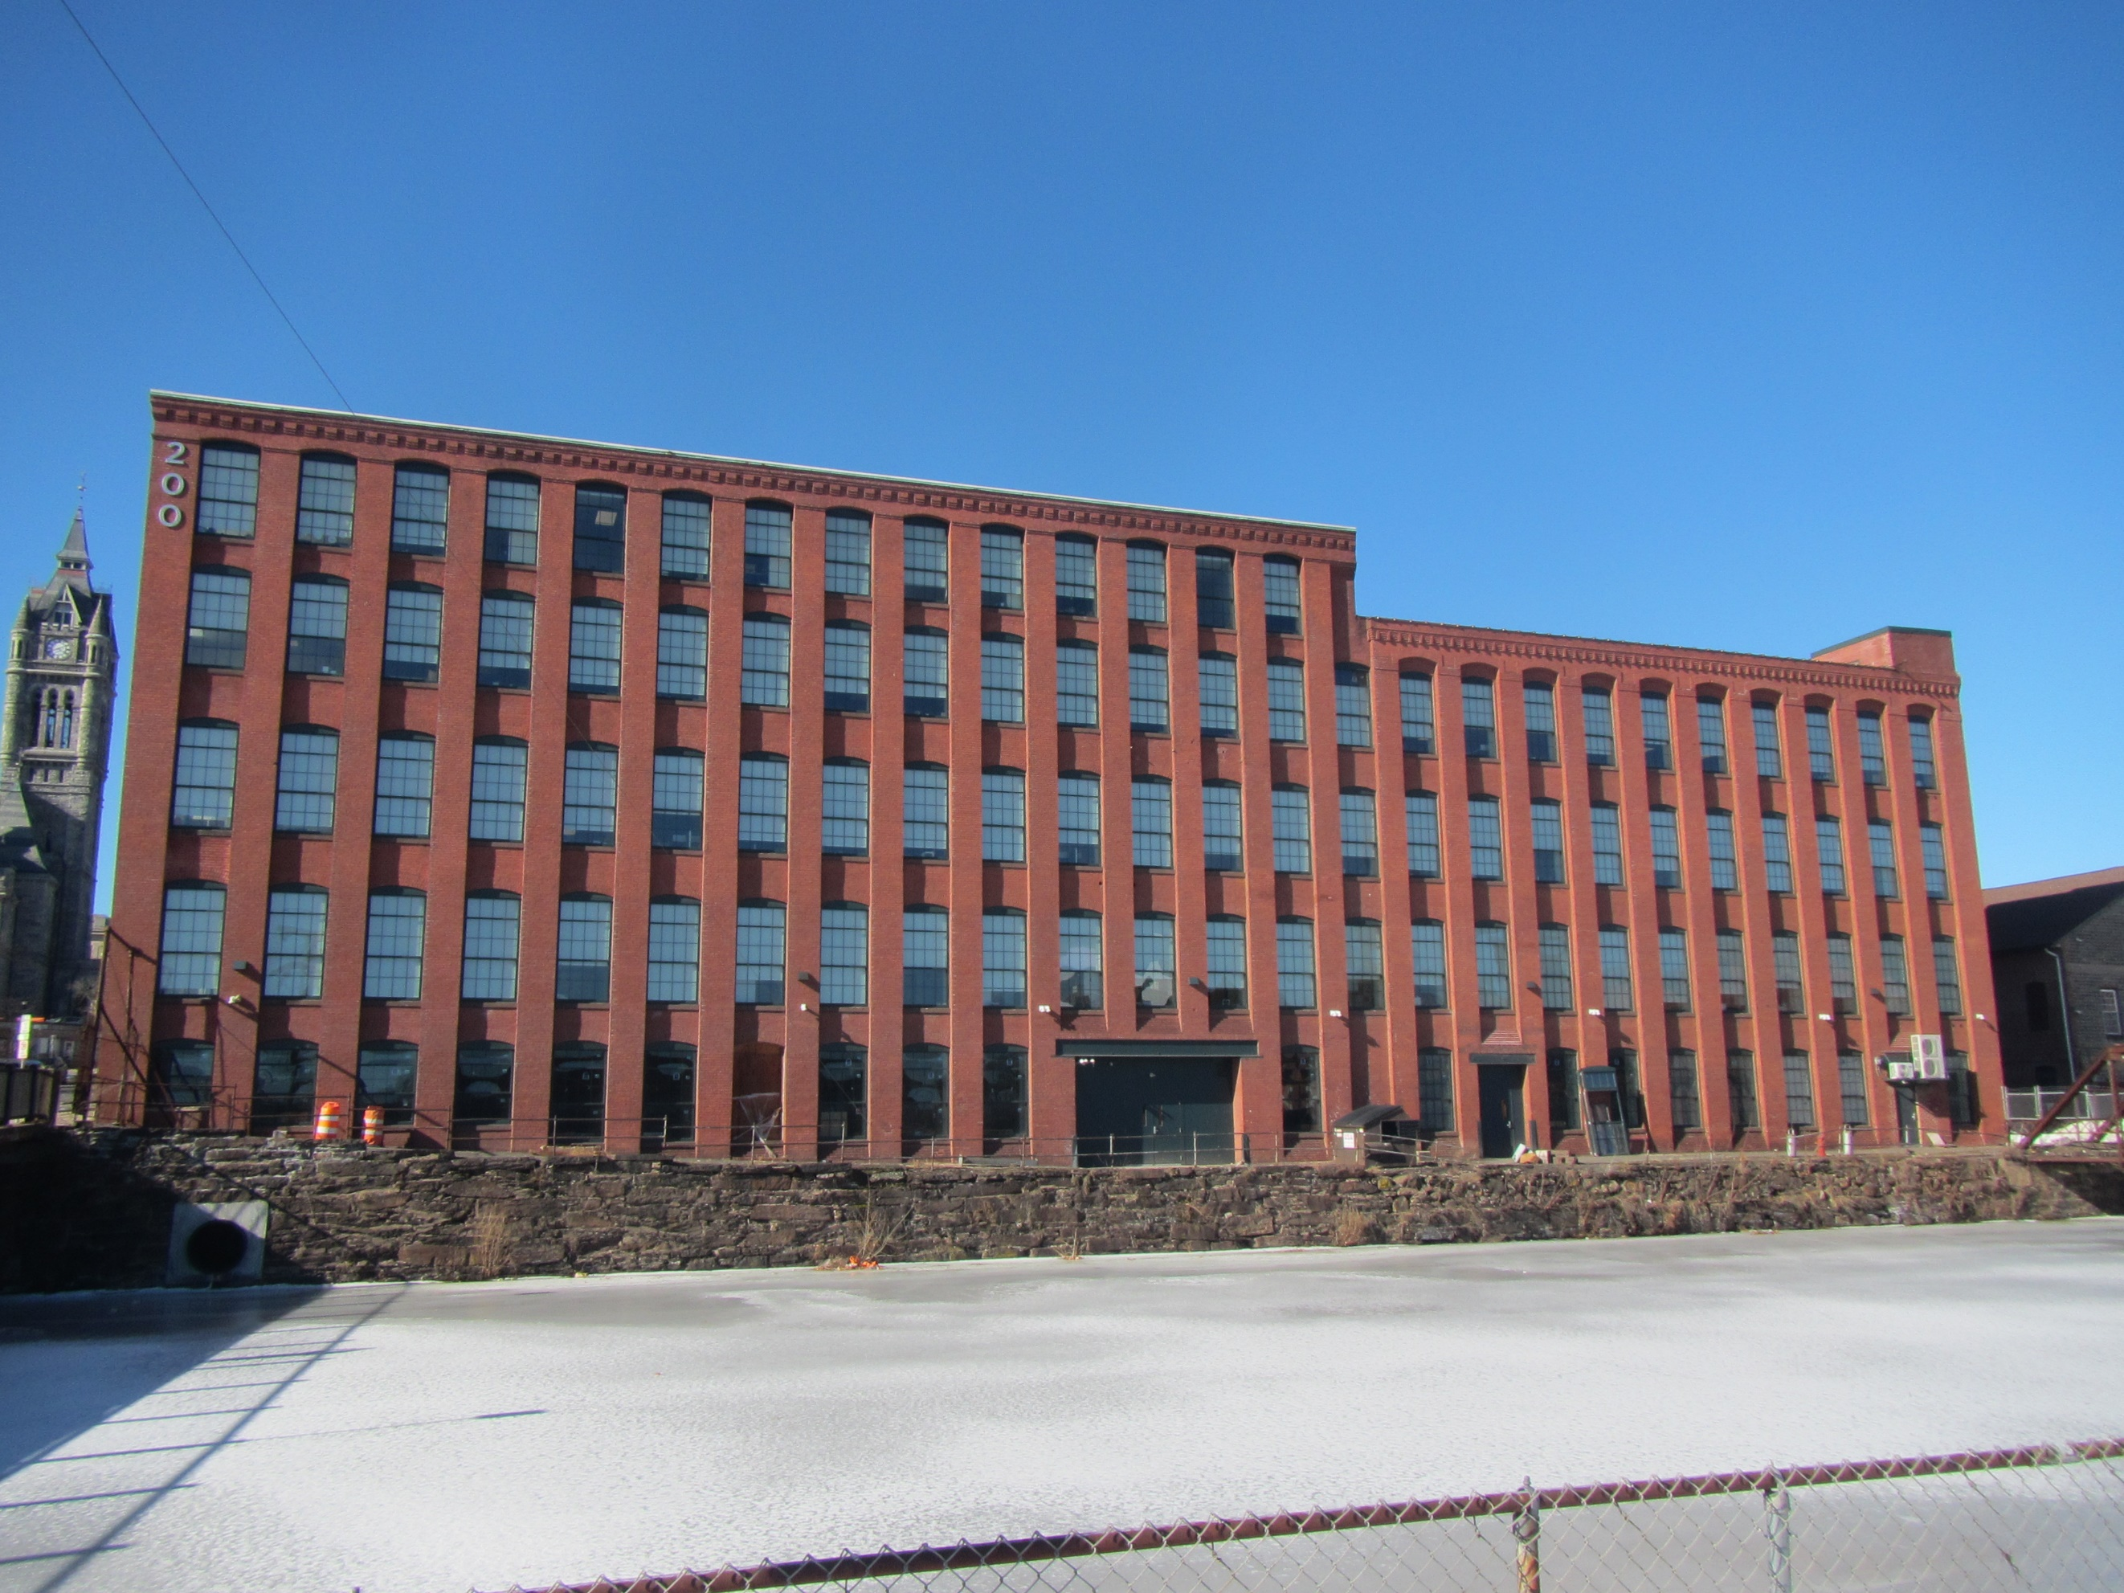

Prepared by:

Massachusetts Department of Public Health

Bureau of Climate and Environmental Health

Division of Environmental Health Regulations and Standards

February 2025

# BACKGROUND

|  |  |
| --- | --- |
| Building: | Department of Children and Families (DCF) |
| Address: | 200 Front Street, Holyoke |
| Assessment Requested by: | Pedro Batista, Project Coordinator, Executive Office of Health and Human Services (EOHHS) |
| Reason for Request: | EOHHS staff received a complaint from DCF staff about health concerns and general indoor air quality (IAQ). |
| Date of Assessment: | February 5, 2024 |
| Massachusetts Department of Public Health/Bureau of Climate and Environmental Health (MDPH/BCEH) Staff Conducting Assessment: | Thomas Murphy, Environmental Analyst, Division of Environmental Health Regulations and Standards (EHRS) |
| Building Description: | The DCF office is located on the first floor of a former brick mill building. It was most likely built in the mid to late 1800s, similar to a neighboring former mill building built in the 1860s where a Department of Transitional Assistance office is located. It is located directly next to the First Level Canal. The office space includes a lobby, rooms for visitors and staff to meet, offices, and cubicles. |
| Windows: | Windows are not openable. |

# METHODS

Please refer to the IAQ Manual for methods, sampling procedures, and interpretation of results (MDPH, 2015).

# RESULTS AND DISCUSSION

The following is a summary of indoor air testing results (Table 1).

* ***Carbon dioxide*** measurements were below the MDPH guideline of 800 parts per million (ppm) in all areas indicating adequate air exchange at the time of assessment. However, the space was minimally occupied at the time of testing. Carbon dioxide levels would be expected to be higher with increased occupancy.
* ***Temperature*** was within the recommended range of 70°F to 78°F in all areas.
* ***Relative humidity*** was below the recommended range of 40% to 60% in all areas examined, which is typical during heating season in New England.
* ***Carbon monoxide*** levels were non-detectable (ND) in all indoor areas tested.
* ***Fine particulate matter (PM2.5)*** concentrations were below the National Ambient Air Quality Standard (NAAQS) level of 35 μg/m3 in all areas tested.
* ***Total Volatile Organic Compounds (TVOC)*** were ND in all areas except for the women’s restroom which was 2.1 ppm. This level may be due to products used in the space. This is discussed further below.

## Ventilation

A heating, ventilating, and air conditioning (HVAC) system has several functions. First, it provides heating and, if equipped, cooling. Second, it is a source of fresh air. Finally, an HVAC system will dilute and remove normally occurring indoor environmental pollutants by not only introducing fresh air, but also filtering the airstream and ejecting stale air to the outdoors via exhaust ventilation. Even if an HVAC system is operating as designed, point sources of respiratory irritation may exist and affect symptoms in sensitive individuals.

The HVAC system consists of air handling units (AHUs) which draw in outside air. Air from the AHUs is filtered, heated/cooled, and delivered to rooms via ducted supply vents (Picture 1). Air is drawn through exhaust vents (Picture 2) to return to the AHU. Due to the layout of the DCF, some cubicles are not located close to an exhaust vent (Picture 3). Consideration should be given to add more exhaust vents to filter potential odors and stale air.

The AHUs for this building were not assessed during this visit. The MDPH/BCEH recommends that AHU filters be changed 2-4 times a year (or per the manufacturer’s recommendations) and be at least a minimum efficiency reporting value (MERV) 8, or higher if the equipment can handle them without a degradation in airflow, as these are adequate to filter out pollen, mold, and similar particulates (ASHRAE, 2012). EOHHS staff reported the filters are at least a MERV 8.

Restrooms are equipped with ceiling mounted exhaust vents. These should be on during all occupied periods to remove odors and moisture from the restrooms.

According to DCF and EOHHS staff, employees do have the ability to control thermostats, although they are difficult to use due to their configuration (Picture 4). Consideration should be given to upgrade them to a digital readout system for easier usage. To maximize air exchange, the MDPH recommends that both supply and exhaust ventilation operate continuously during periods of occupancy. To have proper ventilation with a mechanical supply and exhaust system, the systems must be balanced to provide an adequate amount of fresh air to the interior of a room while removing stale air from the room. It is recommended that HVAC systems be re-balanced every five years and whenever significant changes are made to the layout of the building to ensure adequate air systems function (SMACNA, 1994). According to EOHHS staff, the HVAC system has not yet been re-balanced.

## Rodent/Moisture Concerns

During the assessment, mouse droppings were observed on desks (Pictures 5 and 6; Table 1). Rodent infestation can result in symptoms due to materials in their waste. Mouse urine contains a protein that is a known sensitizer (US EPA, 1992). A sensitizer is a material that can produce symptoms (e.g., running nose or skin rashes) in sensitive individuals after repeated exposure. A three-step approach is necessary to eliminate rodent infestation:

* Removal of the rodents
* Cleaning of waste products from the interior of the building; and
* Reduction/elimination of pathways/food sources that are attracting rodents.

Please note that removal, even after cleaning, may not provide immediate relief since allergens can exist in the interior for several months after rodents are eliminated (Burge, 1995). Once the infestation is eliminated, a combination of cleaning and increased ventilation and filtration should serve to reduce allergens associated with rodents. According to EOHHS staff, the property owner does have an integrated pest management (IPM).

Candy, sugar packets, tea packets, crumbs, and other food items were noted in several different areas including a kitchenette, offices, cubicles, and rooms for staff to meet with the public (Pictures 7 through 10; Table 1). To reduce the potential for rodent activity, all food and food items should be stored in closed, rodent-proof containers at all times other than active use. Food waste and crumbs should be cleaned up promptly and garbage cans emptied every night. Rodents also seek out sources of water and shelter (harborage) so any water leaks/spills should be cleaned up and items should be stored neatly and up off the floor wherever possible. The staff kitchenette has appliances including a refrigerator, a microwave, toaster, and other equipment. After opening the microwave, an odor was immediately detected. Food/liquid stains were observed in the refrigerator (Picture 11) and crumbs were found on the toaster (Picture 12). Food preparation equipment should be kept clean to prevent odors, water damage, and pests.

Cardboard boxes and other items were observed including on floors, desks, and other surfaces (Pictures 13 and 14; Table 1). Too many items can make it difficult for custodial staff to clean and may become attractive to pests as harborage. Items should be stored neatly, off the floor, and be moved periodically for cleaning. Items that have been in long term storage or that are brought from home should be inspected to ensure they do not carry dust, pet hair, or odors.

## Other IAQ Concerns

Personal products, particularly those with volatile organic compounds (VOCs) including scents, can also be a source of respiratory irritation**.** VOCs are carbon-containing substances that can evaporate at room temperature. Exposure to low levels of total-VOCs (TVOCs) may produce eye, nose, throat, and/or respiratory irritation in some sensitive individuals. Products noted in the DCF were cleaning sprays/wipes, sanitizers, dry erase materials, and scented products such as a candle and an odor neutralizing room spray (Pictures 15 through 20). A scented air freshener, hairspray, and hand sanitizer were also observed in the women’s restroom which was the only room with detectable levels of TVOCs (Picture 21). These types of heavily scented products can be irritants to the respiratory system, and only cover up odors, not remove them. They should not be used, as many people can be sensitive to fragrances. Consult “[Clean Air Is Odor Free](https://www.mass.gov/doc/clean-air-is-odor-free-removing-fragrances-to-improve-indoor-air-quality-in-schools-and-offices-0/download)” for more information on fragrances in buildings.

Roughly half of the DCF has wall to wall carpeting and the other half has non-carpeted flooring with area rugs. Carpets should be cleaned annually (or semi-annually in soiled/high traffic areas) in accordance with Institute of Inspection, Cleaning and Restoration Certification (IICRC) recommendations, (IICRC, 2012). All carpeting should be routinely vacuumed and cleaned to ensure proper removal of dirt, dust, and debris. Regular cleaning with a high efficiency particulate air (HEPA) filtered vacuum in combination with an annual cleaning will help to reduce accumulation and potential aerosolization of materials from carpeting. Dirt, dust, and debris were observed on several non-carpeted floor areas including under chairs, behind doors and in corners of rooms (Pictures 22 through 24). All non-carpeted flooring should be routinely mopped, wet-wiped, and cleaned to ensure proper removal of dirt, dust, and debris. In addition, consideration should be given to install walk-off mats at all outside doors to minimize dirt, dust, and debris. All area rugs should be cleaned consistently and disposed of when worn out. Upholstered furniture was also noted in rooms for DCF staff to meet with the public. These should be cleaned regularly to remove dust and debris.

Some personal fans had accumulated dust and debris (Pictures 25 and 26). This dust/debris can be re-aerosolized when fans are activated and be a source of eye and respiratory irritation. Fans should be checked and cleaned periodically.

Efflorescence was observed on the exterior of the building envelope (Picture 27).Efflorescence results when rainwater penetrates into brick and mortar. A suspension of water and salts forms in the brick and mortar, which then travels to the wall surface. As the water evaporates, a white, powdery material is formed (efflorescence). While efflorescence is a sign of water exposure to brick, and water intrusion, it is not mold growth.

# CONCLUSIONS/RECOMMENDATIONS

In view of the findings at the time of the visit, the following recommendations are made:

## Short-term Recommendations

### Ventilation recommendations

1. Consult a ventilation engineer (or similar) to determine if adding additional exhaust vents to the DCF would improve airflow and reduce the potential for odors and stale air to be drawn into employee spaces.
2. Air handling units should be equipped with MERV 8-rated filters (or higher), which are adequate to filter out pollen and mold spores. Filters should be changed 2-4 times a year, or as per the manufactures’ recommendations.
3. Ensure that all restroom exhaust vents are on and operating during occupied hours.
4. Consider upgrading thermostats which will allow them to be set and operational, including system time, and scheduled temperature setbacks for occupied and unoccupied periods.
5. Operate the HVAC system (supply/exhaust) to provide for *continuous* fresh air ventilation during occupied hours.
6. Balance the mechanical ventilation system every five years, as recommended by ventilation industry standards (SMACNA, 1994).

### Rodent/Moisture recommendations

1. Use Integrated Pest Management (IPM) to remove mice/pests from the building. A copy of the IPM recommendations can be downloaded from: <https://massnrc.org/ipm/docs/ipmkitforbuildingmanagers.pdf>. Activities that can be used to eliminate pest infestation may include the following:
   * Consult a licensed pesticide applicator on the most appropriate method to end infestation.
   * Reduce/eliminate pathways (e.g., spaces under doors)/food sources that are attracting pests.
   * Reduce harborages (cardboard boxes and other items) where pests may reside.
2. Ensure all food and food packets are stored in pest-proof containers and clean up food waste and crumbs promptly to deter rodents.
3. Clean and remove all potential sources of odors such as food/liquid stains from all microwaves, refrigerators, and other food storage/preparation equipment.
4. Ensure cardboard boxes and other items are stored off the floor and in appropriate locations as soon as possible, to make thorough cleaning easier.

### Other recommendations

1. Use VOC-containing products in areas with good ventilation and keep tightly closed when not in use. Avoid products with strong scents and avoid mixing incompatible products.
2. Remove air fresheners and hairsprays being used in the restrooms.
3. Refer to “[Clean Air Is Odor Free](https://www.mass.gov/doc/clean-air-is-odor-free-removing-fragrances-to-improve-indoor-air-quality-in-schools-and-offices-0/download)” for more information on fragrances in buildings.
4. Consistently clean carpeting with a HEPA-equipped vacuum cleaner to prevent the aerosolization of dust and debris on the floor.
5. Clean carpeting in accordance with IICRC recommendations (IICRC, 2012) annually (or semi-annually in soiled/high traffic areas).
6. Ensure the entirety of non-carpeted floor surfaces including underneath furniture, behind doors, and hard to reach corners are being mopped, wet-wiped, and cleaned on a routine basis.
7. Consider installing walk-off mats at all outside doors to minimize dirt, dust, and debris.
8. Clean area rugs on a consistent basis and dispose of when worn out.
9. Clean upholstered furniture regularly.
10. For buildings in New England, periods of low relative humidity during the winter are often unavoidable. Therefore, scrupulous cleaning practices should be adopted to minimize common indoor air contaminants whose irritant effects can be enhanced when the relative humidity is low. To control dust, HEPA filter equipped vacuum cleaner in conjunction with wet wiping of all surfaces is recommended. Avoid the use of feather dusters. Drinking water during the day can help ease some symptoms associated with a dry environment (throat and sinus irritations).
11. Clean dust/debris off personal fans and periodically check them.
12. Clean/scrape efflorescence off the exterior of the building envelope.
13. Refer to resource manual and other related IAQ documents located on the MDPH’s website for further building-wide evaluations and advice on maintaining public buildings. These documents are available at: <http://mass.gov/dph/iaq>.

# REFERENCES

ACGIH.1989. Guidelines for the Assessment of Bioaerosols in the Indoor Environment. American Conference of Governmental Industrial Hygienists, Cincinnati, OH.

ASHRAE. 2012. American Society of Heating, Refrigeration and Air Conditioning Engineers (ASHRAE) Standard 52.2-2012 -- Method of Testing General Ventilation Air-Cleaning Devices for Removal Efficiency by Particle Size (ANSI Approved).

Burge, H.A. 1995. Bioaerosols. Lewis Publishing Company, Boca Raton, FL.

IICRC. 2012. Institute of Inspection, Cleaning and Restoration Certification. Carpet Cleaning: FAQ.

MDPH. 2015. Massachusetts Department of Public Health. Indoor Air Quality Manual: Chapters I-III. Available at: <https://www.mass.gov/lists/indoor-air-quality-manual-and-appendices>.

SMACNA. 1994. HVAC Systems Commissioning Manual. 1st ed. Sheet Metal and Air Conditioning Contractors’ National Association, Inc., Chantilly, VA.

US EPA. 1992. Indoor Biological Pollutants. US Environmental Protection Agency, Environmental Criteria and Assessment Office, Office of Health and Environmental Assessment, research Triangle Park, NC. EPA 600/8-91/202. January 1992.

**Picture 1**

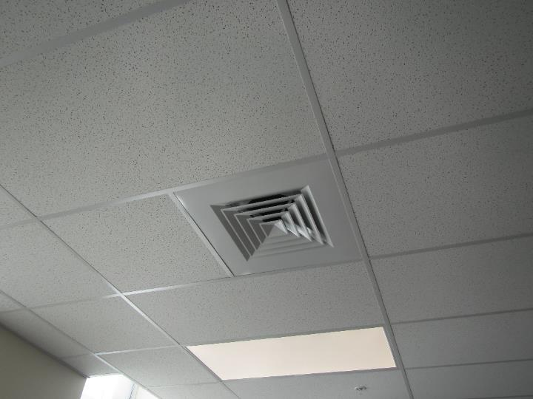

**Ceiling-mounted supply vent**

**Picture 2**

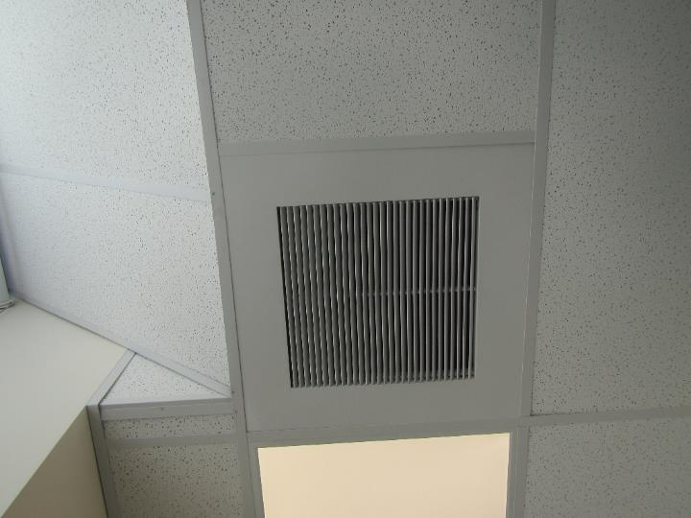

**Ceiling-mounted return vent**

**Picture 3**

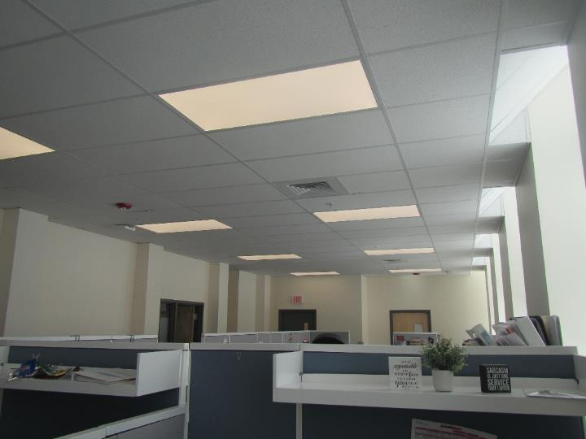

**Layout of cubicles displaying lack of exhaust vents**

**Picture 4**

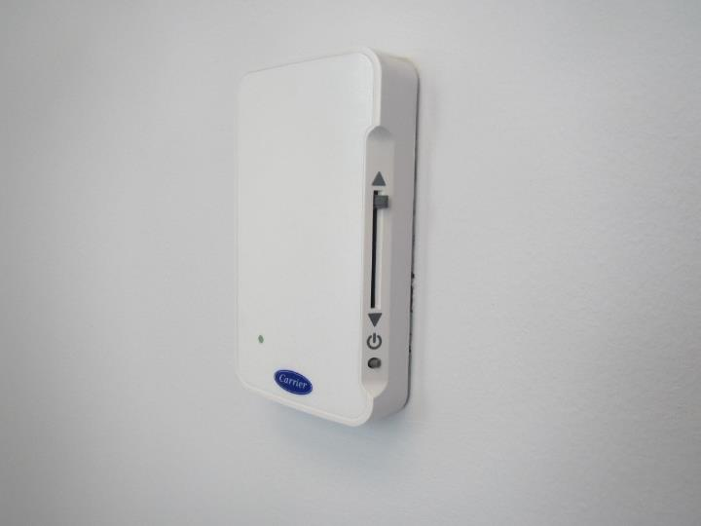

**Thermostat on office wall, note lack of digital readout system**

**Picture 5**

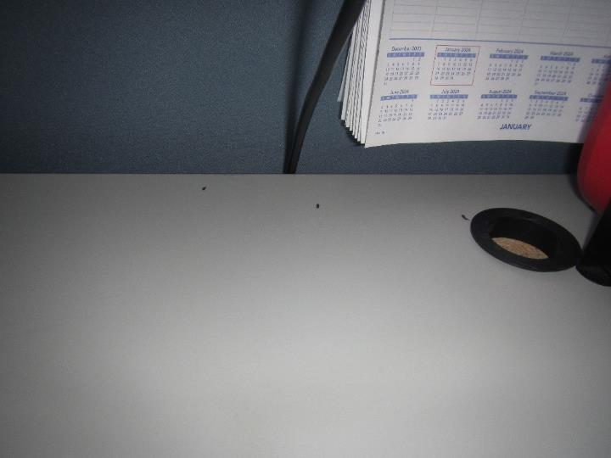

**Mouse droppings on a desk**

**Picture 6**

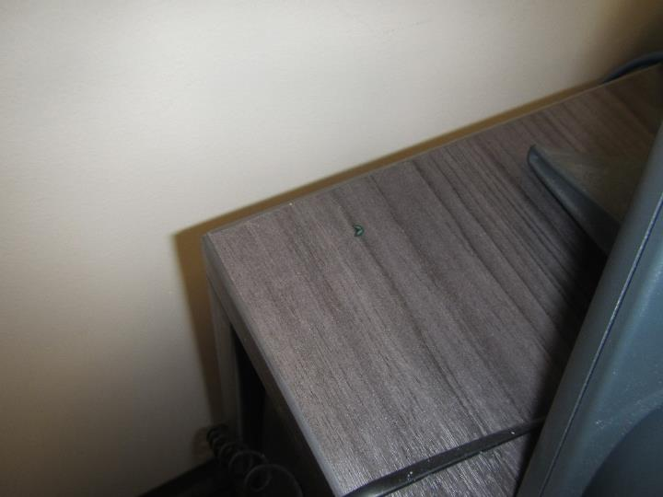

**Mouse droppings on another desk**

**Picture 7**

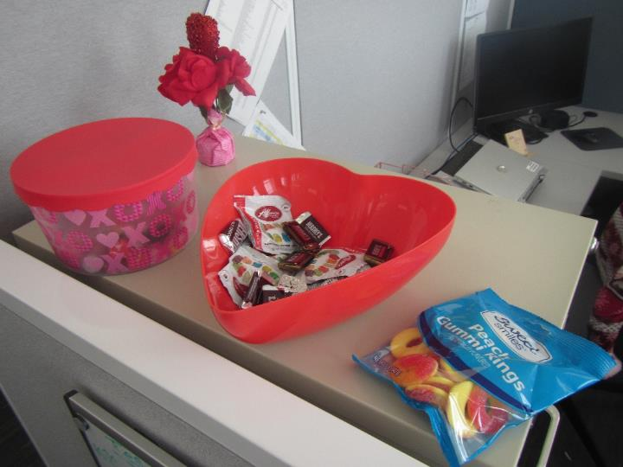

**Open candy dish and a candy bag on a cabinet**

**Picture 8**

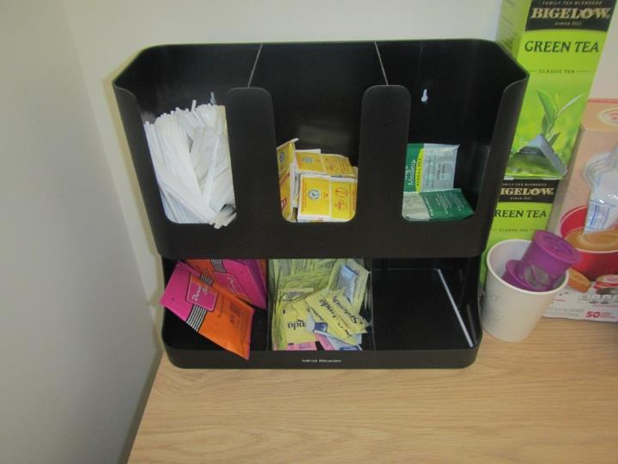

**Sugar packets and tea packets on a table**

**Picture 9**

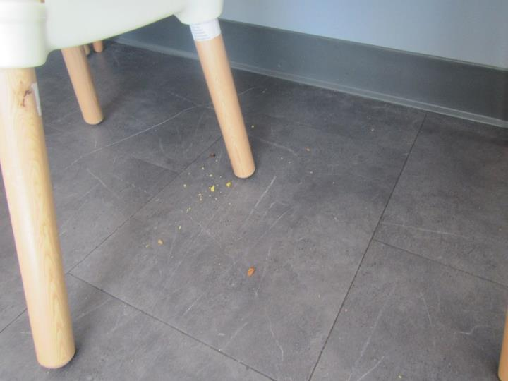

**Food crumbs on the floor in a room where visitors and staff meet**

**Picture 10**

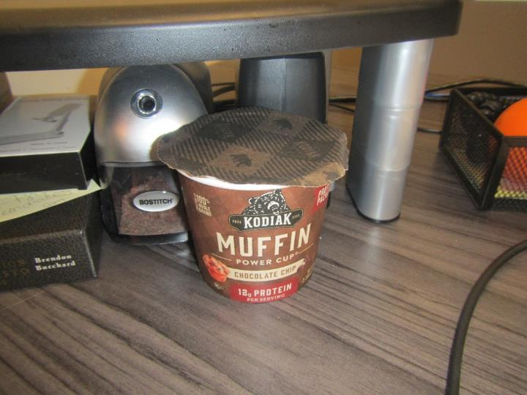

**Food on a desk which also had mouse droppings on it in Picture 6**

**Picture 11**

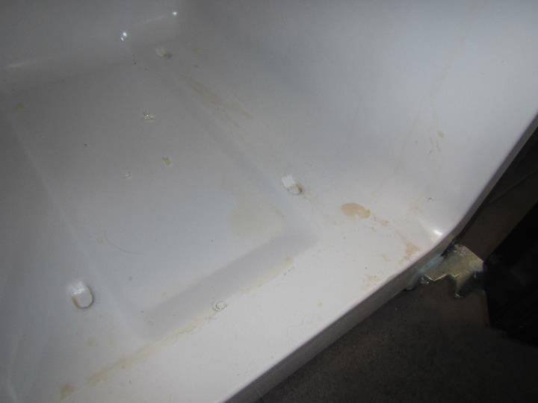

**Food/liquid stains inside a refrigerator**

**Picture 12**

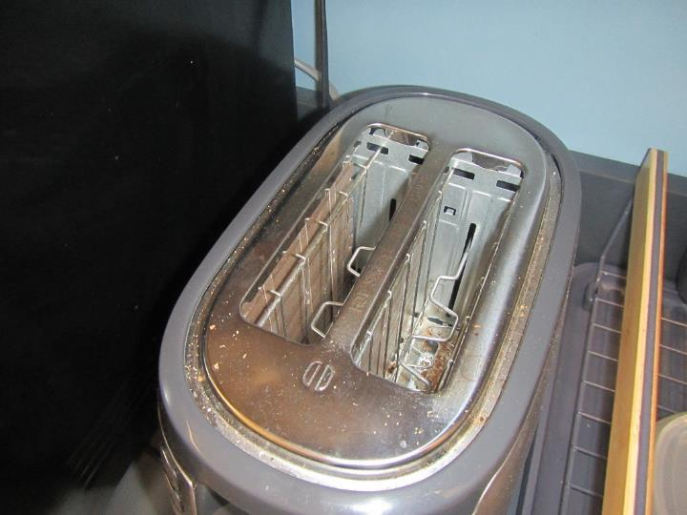

**Food crumbs on a toaster**

**Picture 13**

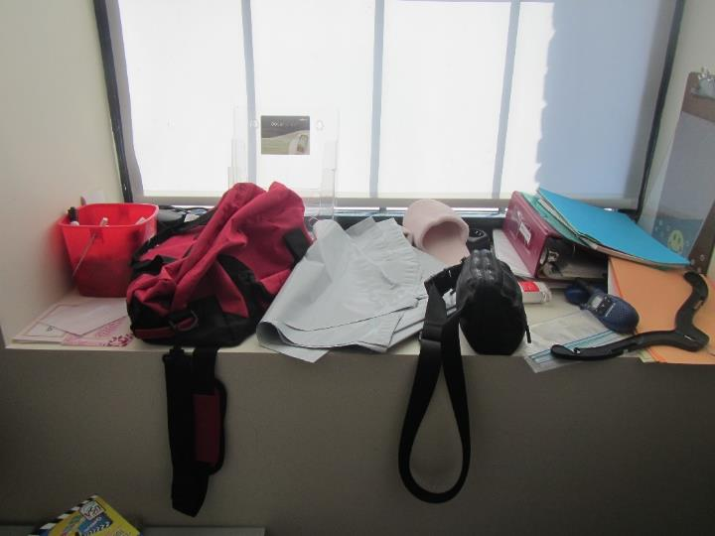

**Items stored near a cubicle**

**Picture 14**

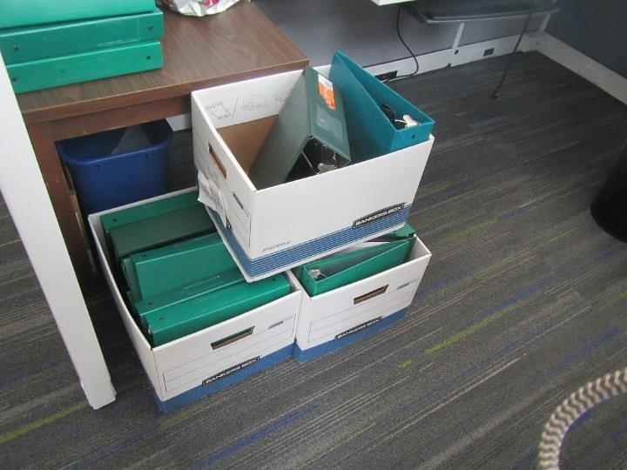

**Cardboard boxes stored on floor**

**Picture 15**

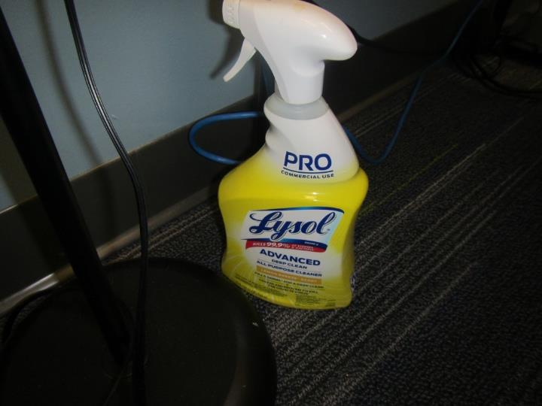

**All-purpose cleaning spray**

**Picture 16**

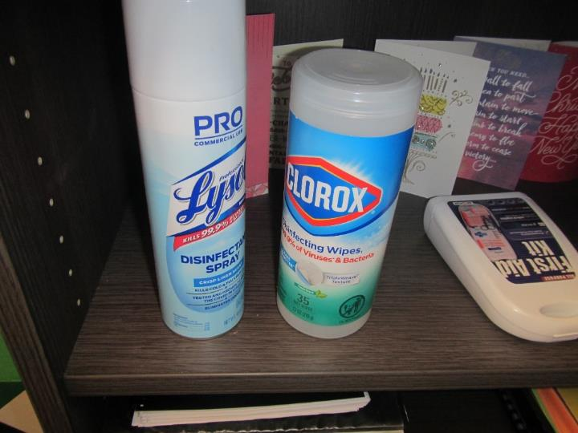

**Disinfectant spray and disinfecting wipes**

**Picture 17**

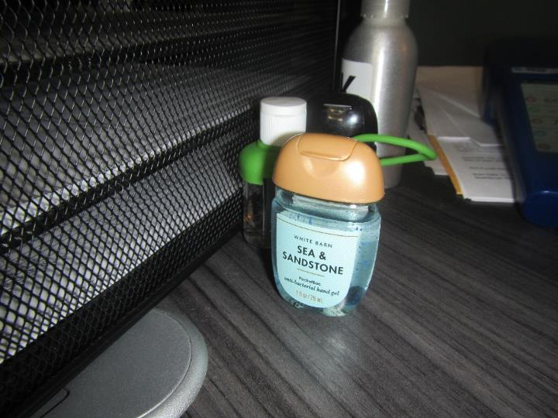

**Anti-bacterial hand gel (hand sanitizer) on a desk which had a strong odor when used**

**Picture 18**

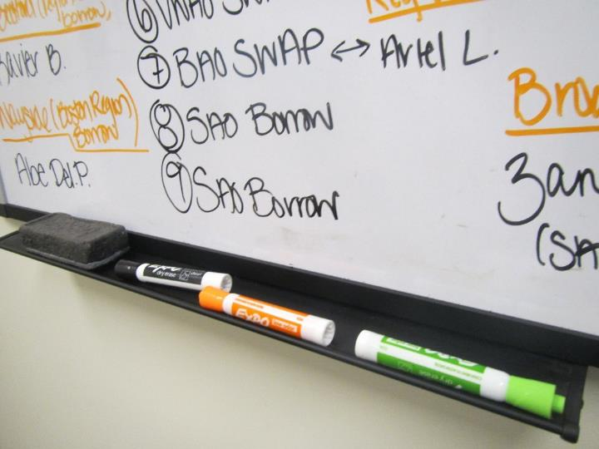

**Dry erase markers in an office**

**Picture 19**

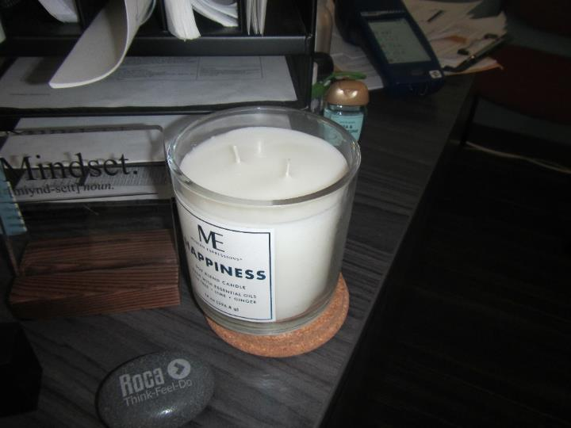

**Scented candle on a desk**

**Picture 20**

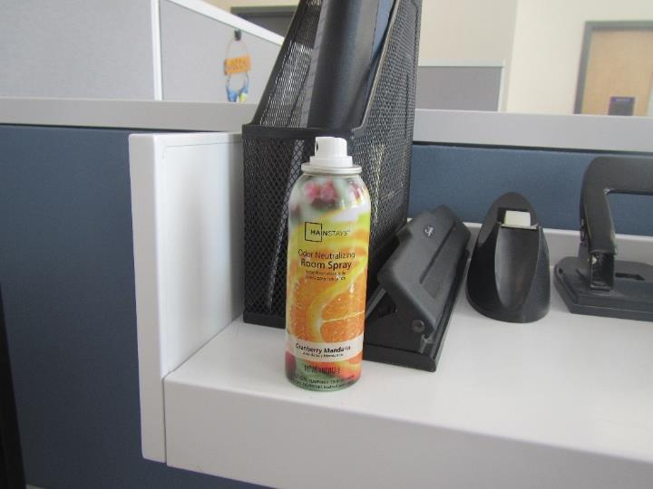

**Odor neutralizing room spray on a desk**

**Picture 21**

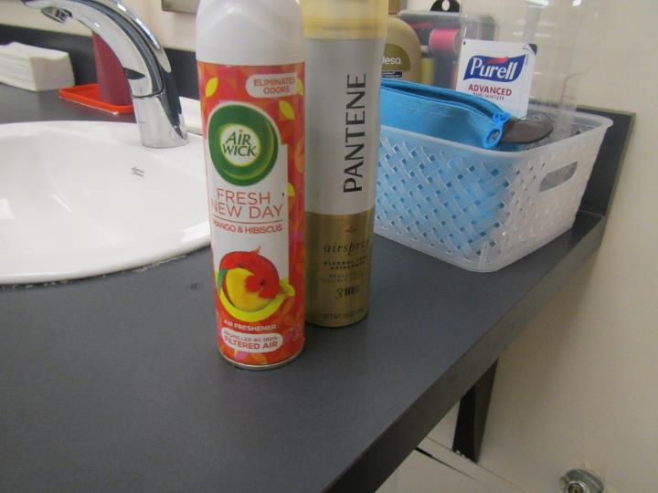

**Air freshener, hairspray, and hand sanitizer in women’s restroom**

**Picture 22**

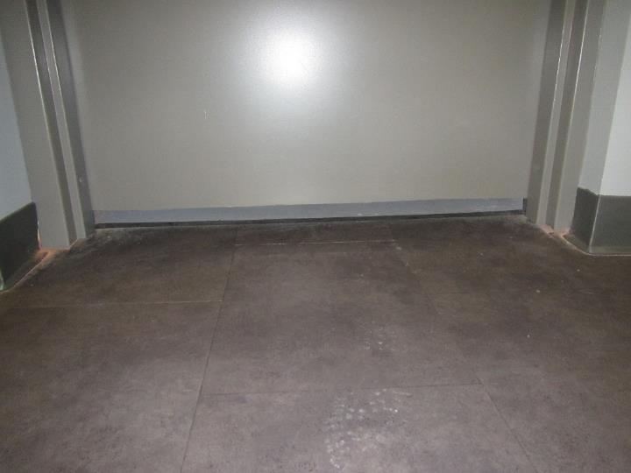

**Dirt, dust, and debris on floor**

**Picture 23**

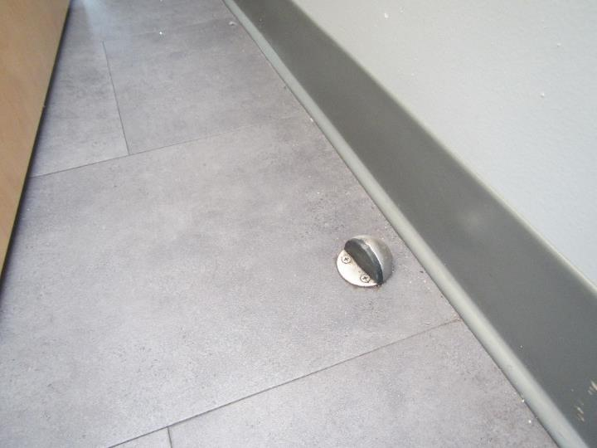

**Dirt, dust, and debris on floor behind a door**

**Picture 24**

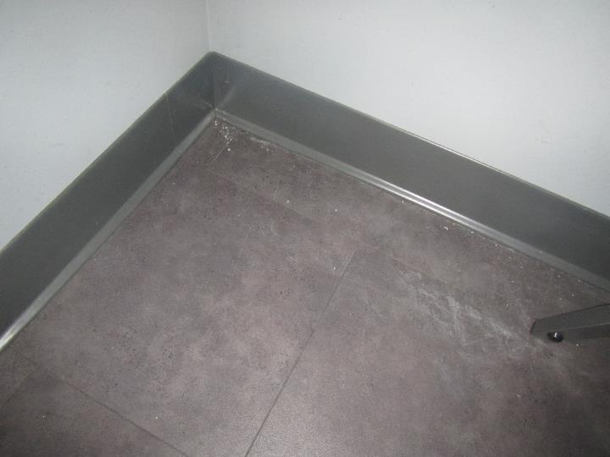

**Dirt, dust, and debris on floor in the corner of lobby underneath chairs**

**Picture 25**

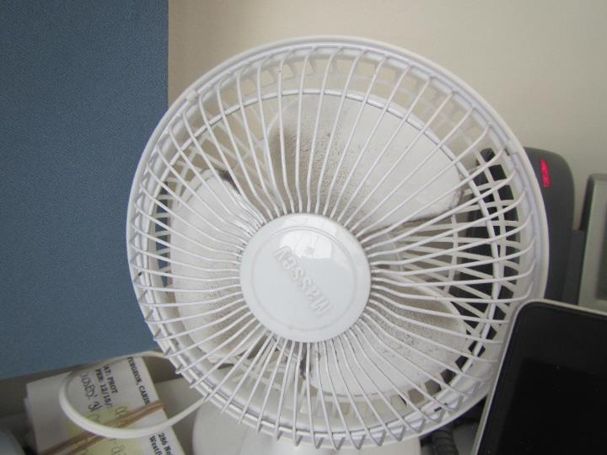

**Dusty personal fan**

**Picture 26**

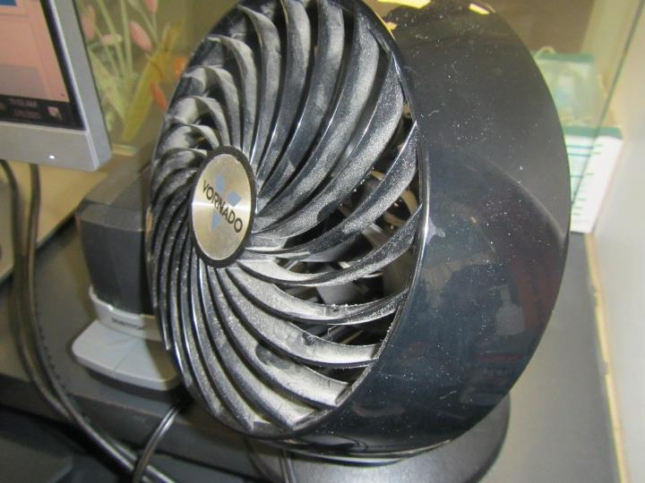

**Dusty personal fan**

**Picture 27**



**Efflorescence on the exterior of the building**

| **Location** | **Carbon**  **Dioxide**  **(ppm)** | **Carbon Monoxide**  **(ppm)** | **Temp**  **(°F)** | **Relative**  **Humidity**  **(%)** | **PM2.5**  **(µg/m3)** | **TVOC (ppm)** | **Occupants**  **in Room** | **Windows**  **Openable** | **Ventilation** | | **Remarks** |
| --- | --- | --- | --- | --- | --- | --- | --- | --- | --- | --- | --- |
| **Supply** | **Exhaust** |
| Background (outside) | 491 | 2 | 27 | 21 | ND | ND |  |  |  |  | Vehicles idling, sunny, frozen canal behind building |
| Visitor Area | | | | | | | | | | | |
| Lobby | 622 | ND | 72 | 20 | ND | ND | 0 | N | Y | Y | HS, NC, AC, dust/debris on floor |
| Children’s Room 103 | 610 | ND | 72 | 20 | ND | ND | 0 | N | Y | Y | NC, AC, furniture |
| Meeting Room 104 | 639 | ND | 72 | 19 | ND | ND | 0 | N | Y | Y | NC, dust/debris on floor |
| Children’s Room 107 | 606 | ND | 72 | 19 | ND | ND | 0 | N | Y | N | NC, food crumbs on floor |
| Children’s Room 108 | 621 | ND | 73 | 18 | ND | ND | 0 | N | Y | Y | NC, food crumbs on floor, furniture, dust/debris on floor |
| Children’s Room 109 | 584 | ND | 72 | 18 | ND | ND | 0 | N | Y | N | NC, AC, furniture, dirt on floor |
| Children’s Room 112 | 640 | ND | 72 | 20 | ND | ND | 0 | N | Y | N | NC, AC, furniture |
| Non-Visitor Area | | | | | | | | | | | |
| Cubicles 117 & 118 | 740 | ND | 74 | 20 | ND | ND | 0 | N | Y | N | Cardboard boxes on floor, dusty personal fan |
| Cubicles 119 & 120 | 708 | ND | 74 | 20 | ND | ND | 0 | N | Y | N | Cardboard boxes on floor |
| Cubicles 121 & 122 | 753 | ND | 74 | 20 | ND | ND | 0 | N | Y | N | Cardboard boxes on floor |
| Cubicles 123 & 124 | 734 | ND | 74 | 20 | ND | ND | 1 | N | Y | N | Cardboard boxes on floor, air freshener, candy/food |
| Cubicles 125 & 126 | 755 | ND | 74 | 20 | ND | ND | 2 | N | Y | N |  |
| Cubicles 127 & 128 | 782 | ND | 73 | 19 | ND | ND | 0 | N | Y | Y | Water cooler on tray |
| Office 129 | 795 | ND | 73 | 22 | ND | ND | 0 | N | Y | Y | Personal fan, disinfectant wipes, cardboard boxes on floor, dry erase markers |
| Office 130 | 681 | ND | 72 | 20 | ND | ND | 0 | N | Y | N | Candle, HS, dry erase markers, cardboard boxes on floor |
| Office 131 | 728 | ND | 73 | 21 | ND | ND | 0 | N | Y | Y | Mouse droppings, food on desk, dry erase marker |
| Office 132 | 784 | ND | 74 | 22 | ND | ND | 2 | N | Y | Y |  |
| Office 133 | 771 | ND | 73 | 19 | ND | ND | 1 | N | Y | N | NC. cardboard boxes on floor |
| Cubicles 135 & 136 | 723 | ND | 72 | 21 | ND | ND | 0 | N | Y | N |  |
| Office 137 | 630 | ND | 73 | 20 | ND | ND | 0 | N | Y | N | Cleaning spray, candy in jar |
| Office 138 | 629 | ND | 73 | 20 | ND | ND | 0 | N | Y | N | Personal fan, air freshener |
| Cubicles 139 & 140 | 614 | ND | 73 | 20 | ND | ND | 0 | N | Y | N | Personal fan, disinfectant wipes |
| Cubicles 141 & 142 | 650 | ND | 73 | 20 | ND | ND | 0 | N | Y | N |  |
| Cubicles 143 & 144 | 703 | ND | 73 | 20 | ND | ND | 0 | N | Y | Y | Personal fan, cardboard boxes on floor, |
| Cubicles 145 & 146 | 677 | ND | 73 | 20 | ND | ND | 0 | N | Y | Y | HS, mouse droppings |
| Copy/Mail Room | 622 | ND | 73 | 17 | ND | ND | 0 | N | Y | Y | Copy machine |
| Kitchenette | 738 | ND | 73 | 24 | ND | ND | 0 | N | Y | Y | Sugar/tea packets, dirty refrigerator, odor from microwave, crumbs on toaster |
| Reception Area | 659 | ND | 72 | 19 | ND | ND | 3 | N | Y | Y | HS, reported mice activity area, dusty personal fan |
| Men’s Restroom | 651 | ND | 70 | 23 | ND | ND | 0 | N | Y | Y | Air fresheners |
| Women’s Restroom | 649 | ND | 70 | 23 | ND | 2.1 | 0 | N | Y | Y | HS, air freshener, hairspray |