INDOOR AIR QUALITY ASSESSMENT

Department of Children and Families
140 High Street
5th Floor
Springfield, Massachusetts

Prepared by:
Massachusetts Department of Public Health
Bureau of Environmental Health
Indoor Air Quality Program
July 2019

Background
Building: | Department of Children and Families (DCF)
Address: | 140 High Street, 5th Floor  Springfield, Massachusetts
Assessment Requested by: | Executive Office of Health and Human Services (EOHHS) Facilities Department
Reason for Request: | Odor and Indoor Air Quality (IAQ) concerns
Date of Assessment: | April 26, 2019
Massachusetts Department of Public Health/Bureau of Environmental Health (MDPH/BEH) Staff Conducting Assessment: | Mike Feeney, Director, IAQ Program
Building Description: | The building was originally a hospital constructed in the early 1900s. A west wing addition was built in 1968. DCF has occupied the space since July of 2008. Other EOHHS offices occupy adjacent space in the building.
Windows: | Not openable

Introduction
Prior to this assessment, the building complex reportedly lost heating for a period of time. After heating was restored, employees on the 5th floor complained of IAQ related issues.
Note that this space was visited by the MDPH IAQ program several times, including a full assessment in 2012 and a follow-up assessment in 2015. The 2015 report is available on the MDPH IAQ website at: https://www.mass.gov/info-details/indoor-air-quality-reports-cities-and-towns-s.

Methods
Please refer to the IAQ Manual for methods, sampling procedures, and interpretation of results (MDPH, 2015).

IAQ Testing Results
The following is a summary of indoor air testing results (Table 1).
- Carbon dioxide levels were below the MDPH guideline of 800 parts per million (ppm) in all areas surveyed, indicating adequate air exchange at the time of assessment.
- Temperature was within or close to the lower end of the MDPH recommended range of 70°F to 78°F in all areas tested. Temperature complaints in this building are common.
- Relative humidity was within the MDPH recommended range of 40 to 60% in all areas tested.
- Carbon monoxide levels were non-detectable (ND) in all indoor areas tested.
- Fine particulate matter (PM2.5) concentrations measured were below the National Ambient Air Quality (NAAQS) limit of 35 μg/m³ in the areas tested.
- Total Volatile Organic Compounds (TVOCS) were ND in all areas tested.

Ventilation
A heating, ventilating and air conditioning (HVAC) system has several functions. First it provides heating and, if equipped, cooling. Second, it is a source of fresh air. Finally, an HVAC system will dilute and remove normally-occurring indoor environmental pollutants by not only introducing fresh air, but by filtering the airstream and ejecting stale air to the outdoors via exhaust ventilation. Even if an HVAC system is operating as designed, point sources of respiratory irritation may exist and cause symptoms in sensitive individuals.
Fresh air is provided by ceiling-mounted fresh air diffusers. A mechanical exhaust vent system removes stale air. Fan coil units (FCU) were installed along exterior walls within the building. The FCUs are designed to provide both heat and cooling. Depending on the setting, heated or chilled water is pumped through a finned tube (i.e., a coil) that is connected to the furnace/chiller by copper pipes that are installed in the pipe chase. Water runs through supply pipes into the coils, which heat/cool the air forced through the coils by the FCU fans. It is important to note that FCUs are designed to provide either heating or cooling, but do not have a fresh air supply. FCU units can only recirculate air.
To maximize air exchange, the MDPH recommends that both supply and exhaust ventilation operate continuously during periods of occupancy. In order to have proper ventilation with a mechanical supply and exhaust system, the systems must be balanced to provide an adequate amount of fresh air to the interior of a room while removing stale air from the room. It is recommended that HVAC systems be re-balanced every five years to ensure adequate air systems function (SMACNA, 1994). It is unknown when the last time this system was balanced.
While relative humidity was within comfort range the day of this assessment, measurements taken in other sections of the building complex during winter months have had relative humidity readings below the MDPH recommended comfort range of 40 to 60 percent for indoor air relative humidity. Relative humidity in the building would be expected to drop during the winter months due to heating. The sensation of dryness and irritation is common in a low relative humidity environment. “Extremely low (below 20%) relative humidity may be associated with eye irritation [and]…may affect the mucous membranes of individuals with bronchial constriction, rhinitis, or cold and influenza related symptoms” (Arundel et al., 1986). Low relative humidity is a common problem during the heating season in the northeast part of the United States.
Of note is the type of air filters used in the FCUs. Instead of manufactured filters with cardboard frames, each unit has a wire frame device with filter material that is cut by hand (Picture 1). These filters provide minimal filtration. The dust spot efficiency is the ability of a filter to remove particulate matter of a certain diameter from air passing through the filter. ASHRAE indicates that filters with a dust spot efficiency of a minimum of 40 percent would be sufficient to reduce many airborne particulates (Thornburg, 2000; MEHRC, 1997; ASHRAE, 1992). Pleated filters with a minimum efficiency reporting value (MERV) dust-spot efficiency of 8 or higher are recommended to filter out pollen and mold spores. Consideration should be given to installing pleated filters. Note that increasing filtration may require evaluation and adjustments to the FCUs to manage increased flow resistance created from using higher MERV value filters.
The FCU cabinets also have openings above the filter system (Picture 2). These opening allow unfiltered air from wall cavities to be drawn into the unit to become aerosolized.

Microbial/Moisture Concerns
Substantial amounts of accumulated dirt and debris were noted in the interior of FCUs. Towels used to absorb water from a pipe leak were found in one unit (Picture 3). These can become colonized with mold when chronically moistened and be attractive to pests.
Plaster walls in the office have water damage that appears to be due to leaks from heat system pipes, as shown by:
- location of damage, including beneath access panels (Picture 4);
- pattern of damage (straight lines) in walls not beneath windows (Picture 5); or
- damage in corners where pipe elbow joints likely exist (Picture 6).
Evidence of water spaying the interior of the wall cavity was noted (Picture 7). Water from heating pipes can have a metallic odor that can be irritating to the eyes, nose and throat. Despite this, no visible mold growth or associated odors were observed. Additionally, a number of areas had water-damaged ceiling tiles (Table 1).
The US Environmental Protection Agency (US EPA) and the American Conference of Governmental Industrial Hygienists (ACGIH) recommends that porous materials (e.g., wallboard, carpeting) be dried with fans and heating within 24 to 48 hours of becoming wet (US EPA, 2008; ACGIH, 1989). If porous materials are not dried within this time frame, mold growth may occur. It is important to have a system to inspect, identify and report leaks and other problems so that drying can begin promptly.

Other IAQ Evaluations
Exposure to low levels of total volatile organic compounds (TVOCs) may produce eye, nose, throat, and/or respiratory irritation in some sensitive individuals. To determine if VOCs were present, IAQ staff took measurements for TVOCs and examined rooms for products containing VOCs. While no TVOCs were detected, several offices and hallways had obvious fragrance odors. The source of this odor appears to be the use of fragrance oil diffuser devices (Table 1). The use of oil diffusers is not recommended since these products can cause eye, nose and respiratory system irritation as detailed in the guideline Clean Air is Odor-free: Removing fragrances to improve indoor air quality in schools and offices, which is included as Appendix A.
Carpets and area rugs should be vacuumed regularly with a high efficiency particulate arrestance (HEPA)-filter-equipped vacuum cleaner and cleaned annually (or semi-annually in soiled/high traffic areas) in accordance with Institute of Inspection, Cleaning and Restoration Certification (IICRC) recommendations, (IICRC, 2012). It was reported that carpets had not been cleaned for several years prior to the BEH/IAQ site visit but that cleaning had been scheduled for the following week.
One area had a freestanding air purifier which was labelled as an “ionizer”. Some areas had personal fans and air purifiers which should be cleaned and maintained according to manufacturer recommendations. Certain air purifiers (electrostatic precipitators or ionizers) should be avoided since they may produce ozone, which is a known lung irritant (US EPA, 2003).
Upholstered furniture was observed. These items are covered with fabrics that may be exposed to human skin. This type of contact can leave oils, perspiration, hair and skin cells. Dust mites feed upon human skin cells and excrete waste products that contain allergens. In addition, if relative humidity levels increase above 60 percent, dust mites tend to proliferate (US EPA, 1992). In order to remove dust mites and other pollutants, frequent vacuuming of upholstered furniture is recommended (Berry, 1994). It is also recommended that upholstered furniture be professionally cleaned on an annual basis. Where an excessively dusty environment exists due to outdoor conditions or indoor activities (e.g., renovations), cleaning frequency should be increased (every six months) (IICRC, 2000).

Conclusions/Recommendations
The conditions in the DCF office are complicated due to the likely presence of leaks from the heating system piping, valves and joints. Remediation of leaks may require removal of plaster walls. While plaster is resistant to mold growth accumulated dust, dirt and other debris may serve as a mold growth media if repeated moistened. In addition, water/steam leaks can be irritating to the eyes, nose and respiratory system, particularly if drawn into the FCUs adjacent to employee workstations.
Therefore, these recommendations are split into two parts. The first is short-term recommendations that can be done quickly to improve IAQ immediately, while the second is long-term recommendations that require planning to minimize the impact of remediation on the DCF office. In views of the findings at the time of the visit, the following recommendations are made:

Short Term Recommendations
- Do not use free-standing air purifier in the (ionizing) setting.
- Replace hand-cut filters with cardboard framed filters of the correct size.
- Replace filters at least twice a year.
- Seal all spaces/holes in FCU cabinets above the filter rack with aluminum refrigerator tape.
- Have the interior of all FCUs cleaned by an HVAC service company.
- Remove all debris and items (e.g., towels) used to absorb leaking water.
- For buildings in New England, periods of low relative humidity during the winter are often unavoidable. Therefore, scrupulous cleaning practices should be adopted to minimize common indoor air contaminants whose irritant effects can be enhanced when the relative humidity is low. To control for dusts, a high efficiency particulate arrestance (HEPA) filter equipped vacuum cleaner in conjunction with wet wiping of all surfaces is recommended. Drinking water during the day can help ease some symptoms associated with a dry environment (throat and sinus irritations).
- Operate supply and exhaust ventilation continuously in all areas during occupied periods. Ensure all HVAC equipment is maintained and supply and return vents are cleaned periodically to prevent dust re-aerosolization.
- Repair all leaking pipe valves for the HVAC system that do not require the demolition of plaster walls.
- Discontinue the use of fragrance diffusers.
- Identify the source of water moistening ceiling tiles and repair. Once the water source is eliminated, remove water-damaged ceiling tiles in a manner in accordance with the EPA guideline “Mold Remediation in Schools and Commercial Buildings” (US EPA, 2008).
- Refer to resource manual and other related IAQ documents located on the MDPH’s website for further building-wide evaluations and advice on maintaining public buildings. These documents are available at: http://mass.gov/dph/iaq.

Long Term Recommendations
- Have the existing ventilation/heating system evaluated by an engineer with experience in this type of HVAC system to determine the cause of water-damaged plaster walls. Such an individual should consider the feasibility of such repair as well as the ability of the existing HVAC system to operate in a manner to maintain occupant comfort.
- In order to examine and repair the water leaks, it is likely that portions of plaster walls would have to be removed. In order to prevent impact on building occupants, it is highly recommended that any evaluation be done in a manner in accordance with the EPA guideline “Mold Remediation in Schools and Commercial Buildings” (US EPA, 2008).
- Prior to any demolition of plaster walls, it is highly recommended that the wall material be tested for the presence of asbestos in a manner consistent with federal and Massachusetts statutes and regulations.

References
ACGIH. 1989. Guidelines for the Assessment of Bioaerosols in the Indoor Environment. American Conference of Governmental Industrial Hygienists, Cincinnati, OH.
Arundel et al. 1986. Indirect Health Effects of Relative Humidity on Indoor Environments. Env. Health Perspectives 65:351-361.
ASHRAE. 1992. Gravimetric and Dust-Spot Procedures for Testing Air-Cleaning Devices Used in General Ventilation for Removing Particulate Matter. American Society of Heating, Refrigeration and Air Conditioning Engineers. ANSI/ASHRAE 52.1-1992.
Berry, M.A. 1994. Protecting the Built Environment: Cleaning for Health. Michael A. Berry, Chapel Hill, NC.IICRC. 2012. Institute of Inspection, Cleaning and Restoration Certification. Carpet Cleaning: FAQ.
IICRC. 2000. IICRC S001. Reference Guideline for Professional On-Location Cleaning of Textile Floor Covering Materials. Institute of Inspection, Cleaning and Restoration Certification. Institute of Inspection Cleaning and Restoration, Vancouver, WA.
MDPH. 2015. Massachusetts Department of Public Health. Indoor Air Quality Manual: Chapters I-III. Available at: http://www.mass.gov/eohhs/gov/departments/dph/programs/environmental-health/exposure-topics/iaq/iaq-manual/.
MEHRC. 1997. Indoor Air Quality for HVAC Operators & Contractors Workbook. MidAtlantic Environmental Hygiene Resource Center, Philadelphia, PA.
SMACNA. 1994. HVAC Systems Commissioning Manual. 1st ed. Sheet Metal and Air Conditioning Contractors’ National Association, Inc., Chantilly, VA.
Thornburg, D. 2000. Filter Selection: a Standard Solution. Engineering Systems 17:6 pp. 74-80.
US EPA. 1992. Indoor Biological Pollutants. US Environmental Protection Agency, Environmental Criteria and Assessment Office, Office of Health and Environmental Assessment, research Triangle Park, NC. EPA 600/8-91/202. January 1992.
US EPA. 2003. “Ozone Generators that are Sold as Air Cleaners: An Assessment of Effectiveness and Health Consequences”. US Environmental Protection Agency, Office of Air and Radiation, Indoor Environments Division, Washington, D.C. https://www.epa.gov/indoor-air-quality-iaq/ozone-generators-are-sold-air-cleaners.
US EPA. 2008. “Mold Remediation in Schools and Commercial Buildings”. Office of Air and Radiation, Indoor Environments Division, Washington, DC. EPA 402-K-01-001. September 2008. Available at: http://www.epa.gov/mold/mold-remediation-schools-and-commercial-buildings-guide.
Picture 1
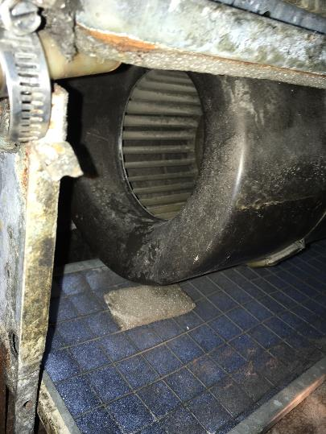
Hand-cut filters in wire rack
Picture 2
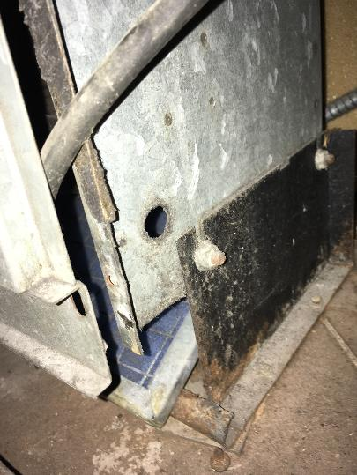
Hole in FCU cabinet above filter that allows particles to by-pass filtrations
Picture 3
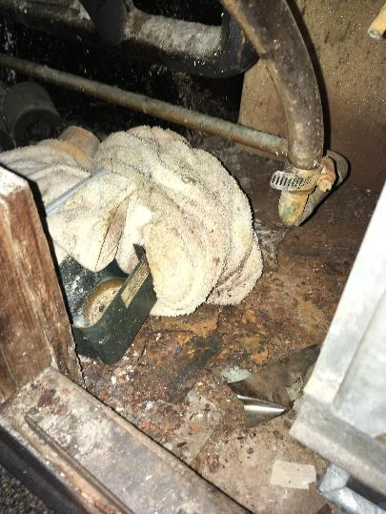
Towel inside wall cavity (note signs of water leakage and corrosion)
Picture 4
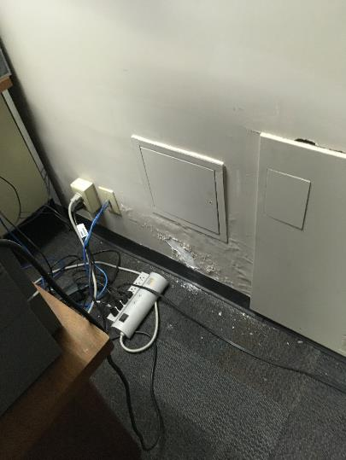
Water damaged plaster beneath inspection door
Picture 5
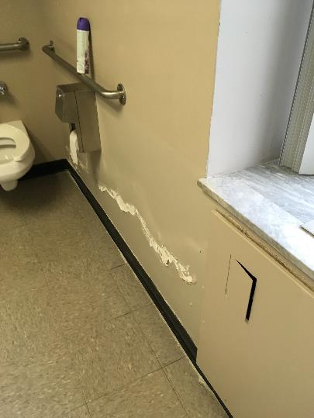
Damaged plaster in a straight line on a wall not directly beneath a window
Picture 6
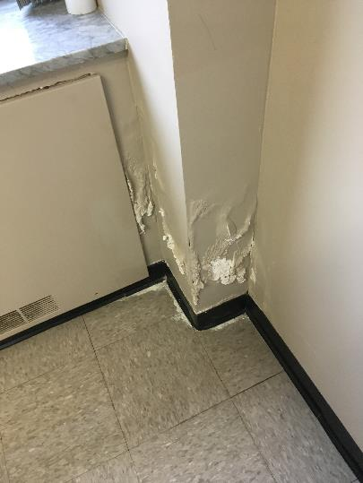
Damage at a corner where heating system pipe elbow joints likely exist
Picture 7
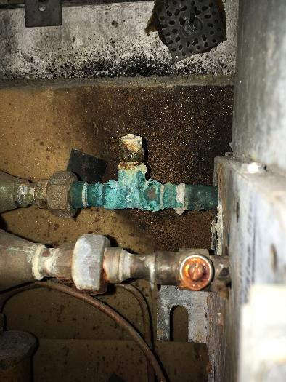
Evidence of water spraying the interior of the wall cavity
(Note corrosion and water bead on valve as well as wall discoloration behind valve)

Location | Carbon  Dioxide  (ppm) | Carbon Monoxide  (ppm) | Temp  (°F) | Relative  Humidity  (%) | PM2.5  (µg/m³) | TVOC  (ppm) | Occupants  in Room | Windows  Openable | Ventilation |  | Remarks
 |  |  |  |  |  |  |  |  | Supply | Exhaust
501 | 465 | ND | 70 | 50 | 4 | ND | 0 | N | Y | Y
502 | 789 | ND | 71 | 48 | 3 | ND | 6 | N | Y | Y | Refrigerator and microwave
504 | 471 | ND | 72 | 44 | 3 | ND | 0 | N | Y | Y
505 | 566 | ND | 73 | 44 | 3 | ND | 7 | N | Y | Y
508 | 471 | ND | 73 | 43 | 4 | ND | 0 | N | Y | Y | Upholstered furniture, soda cans
507 | 494 | ND | 72 | 44 | 4 | ND | 1 | N | Y | Y | Hole in closet ceiling
510 | 428 | ND | 71 | 44 | 4 | ND | 0 | N | Y | Y
Library | 417 | ND | 71 | 44 | 5 | ND | 0 | N | Y | Y
535 | 746 | ND | 72 | 46 | 4 | ND | 12 | N | Y | Y | 1 WD CT, WD plaster
514 | 461 | ND | 71 | 45 | 4 | ND | 2 | N | Y | Y
516 | 434 | ND | 71 | 44 | 4 | ND | 0 | N | Y | Y | 1 WD CT
517 | 478 | ND | 71 | 46 | 6 | ND | 3 | N | Y | Y | WD plaster
518 | 382 | ND | 71 | 46 | 6 | ND | 0 | N | Y | Y
521 | 373 | ND | 70 | 47 | 5 | ND | 1 | N | Y | Y | 1 WD CT
520 | 426 | ND | 71 | 44 | 4 | ND | 0 | N | Y | Y | 1 WD CT
522 | 412 | ND | 70 | 46 | 5 | ND | 1 | N | Y | Y
521 | 411 | ND | 71 | 46 | 5 | ND | 1 | N | Y | Y
524 | 385 | ND | 71 | 45 | 5 | ND | 1 | N | Y | Y
525 | 347 | ND | 71 | 45 | 4 | ND | 0 | N | Y | Y
Break room | 420 | ND | 71 | 48 | 5 | ND | 1 | N | Y | Y
512 | 500 | ND | 71 | 46 | 5 | ND | 1 | N | Y | Y
529 | 370 | ND | 70 | 47 | 9 | ND | 1 | N | Y | N | Diffuser
531 | 343 | ND | 69 | 47 | 5 | ND | 0 | N | Y | Y
536 | 313 | ND | 68 | 49 | 5 | ND | 0 | N | Y | Y
537 | 330 | ND | 68 | 49 | 6 | ND | 0 | N | Y | Y | 3 WD CT
539 | 305 | ND | 68 | 49 | 5 | ND | 0 | N | N | Y
538 | 336 | ND | 68 | 50 | 5 | ND | 0 | N | Y | Y | Diffuser
541 | 347 | ND | 69 | 50 | 5 | ND | 1 | N | Y | Y | 1 WD CT, diffuser

