INDOOR AIR QUALITY ASSESSMENT

Massachusetts Department of Children and Families
261 High Street
Holyoke, Massachusetts



Prepared by:
Massachusetts Department of Public Health
Bureau of Environmental Health
Indoor Air Quality Program
December 2012

Background/Introduction
In response to a request from Carol Root, Administrative Manager of the Massachusetts Department of Children and Families (DCF) Franklin/Hampshire Area, the Massachusetts Department of Public Health (MDPH), Bureau of Environmental Health (BEH), provided assistance and consultation regarding indoor air quality (IAQ) concerns at the Holyoke DCF offices located at 261 High Street, Holyoke, Massachusetts. The request was prompted by concerns related to water damage and possible mold growth in the basement of the building and general IAQ. On October 17, 2012, a visit to conduct an IAQ assessment was made by Ruth Alfasso, Environmental Engineer/Inspector, and Kathleen Gilmore, Environmental Analyst/Regional Inspector within BEH’s IAQ Program. They were accompanied by Chris Goncalves of the Holyoke DCF office, and Rick LaValle and Andy Urbanowicz, representing the building owners.
The DCF office occupies the second and third floors of a four-story building originally constructed in the late 1800s as a department store. The building has been renovated several times, most recently in 1994 shortly before the DCF took occupancy. The basement and fourth floor are unoccupied and portions of those areas serve as storage space for the DCF. The building originally had openable windows, but they have since been sealed over with Plexiglas. Portions of the first floor are occupied by the Holyoke Health Center.

Methods
Air tests for carbon monoxide, carbon dioxide, temperature and relative humidity were conducted with the TSI, Q-Trak, IAQ Monitor, Model 7565. Air tests for airborne particle matter with a diameter less than 2.5 micrometers were taken with the TSI, DUSTTRAK™ Aerosol Monitor Model 8520. BEH/IAQ staff also performed visual inspection of building materials for water damage and/or microbial growth.

Results
This DCF office has an employee population of approximately 110 staff and is visited by up to fifty people daily. The tests were taken during normal operations. Test results appear in Table 1.

Discussion

Ventilation
It can be seen from Table 1 that carbon dioxide levels were above 800 parts per million (ppm) in 4 of 47 areas, indicating adequate air exchange in most of the building at the time of the assessment. It is important to note that a number of areas were sparsely populated or unoccupied at the time measurements were taken, which may result in reduced carbon dioxide levels. Carbon dioxide levels would be expected to be higher with full occupancy.
Mechanical ventilation is provided by rooftop air-handling units (AHUs) (Picture 1). Fresh air is drawn into the AHUs and delivered to occupied areas via ceiling-mounted air diffusers (Picture 2). Return air is drawn through ceiling-mounted exhaust grills and directed back into the AHU (Picture 3).
It was noted that in many offices, the exhaust vents were located near the doors, most of which were open. This may reduce the effectiveness of the exhaust vents to remove air from the inside of the room, since air from the hallways outside may preferentially be drawn into the room.
Air circulation is controlled by wall-mounted thermostats and connected sensors (Pictures 4 and 5). Reportedly they are set to circulate air only when heating or cooling is called for rather than operating continuously during occupied hours. When the AHUs on the roof were examined, the fans on many of them were not operating, indicating either the zones to which they were connected were not calling for air circulation, or that they were in need of maintenance. Weak or nonexistent air flow was detected in many locations from both the supply and exhaust vents (Table 1).
Restroom exhaust ventilation is provided by ceiling-mounted vents connected directly to exhaust vents on the roof. The exhausts are activated by the light switch. It is recommended that exhaust ventilation in bathrooms be continuous during occupied hours rather than in response to a light switch.
To maximize air exchange, the MDPH recommends that both supply and exhaust ventilation operate continuously during periods of occupancy. In order to have proper ventilation with a mechanical supply and exhaust system, the systems must be balanced to provide an adequate amount of fresh air to the interior of a room while removing stale air from the room. It is recommended that HVAC systems be re-balanced every five years to ensure adequate air systems function (SMACNA, 1994). The date of the last balancing of these systems was not available at the time of the assessment.
Minimum design ventilation rates are mandated by the Massachusetts State Building Code (MSBC). Until 2011, the minimum ventilation rate in Massachusetts was higher for both occupied office spaces and general classrooms, with similar requirements for other occupied spaces (BOCA, 1993). The current version of the MSBC, promulgated in 2011 by the State Board of Building Regulations and Standards (SBBRS), adopted the 2009 International Mechanical Code (IMC) to set minimum ventilation rates. Please note that the MSBC is a minimum standard that is not health-based. At lower rates of cubic feet per minute (cfm) per occupant of fresh air, carbon dioxide levels would be expected to rise significantly. A ventilation rate of 20 cfm per occupant of fresh air provides optimal air exchange resulting in carbon dioxide levels at or below 800 ppm in the indoor environment in each area measured. MDPH recommends that carbon dioxide levels be maintained at 800 ppm or below. This is because most environmental and occupational health scientists have documented significant increases in indoor air quality complaints and/or health effects when carbon dioxide levels rise above the MDPH guidelines of 800 ppm for schools, office buildings and other occupied spaces (Sundell et al., 2011). The ventilation must be on at all times that the room is occupied. Providing adequate fresh air ventilation with open windows and maintaining the temperature in the comfort range during the cold weather season is impractical. Mechanical ventilation is usually required to provide adequate fresh air ventilation.
Carbon dioxide is not a problem in and of itself. It is used as an indicator of the adequacy of the fresh air ventilation. As carbon dioxide levels rise, it indicates that the ventilating system is malfunctioning or the design occupancy of the room is being exceeded. When this happens, a buildup of common indoor air pollutants can occur, leading to discomfort or health complaints. The Occupational Safety and Health Administration (OSHA) standard for carbon dioxide is 5,000 parts per million parts of air (ppm). Workers may be exposed to this level for 40 hours/week, based on a time-weighted average (OSHA, 1997).
The MDPH uses a guideline of 800 ppm for publicly occupied buildings. A guideline of 600 ppm or less is preferred in schools due to the fact that the majority of occupants are young and considered to be a more sensitive population in the evaluation of environmental health status. Inadequate ventilation and/or elevated temperatures are major causes of complaints such as respiratory, eye, nose and throat irritation, lethargy and headaches. For more information concerning carbon dioxide, please consult Appendix A.
Temperature readings ranged from 70 °F to 75 °F in occupied areas during the assessment, which were within the MDPH recommended comfort guidelines; the unheated fourth floor attic space had a temperature of 66 °F (Table 1). The MDPH recommends that indoor air temperatures be maintained in a range of 70 °F to 78 °F in order to provide for the comfort of building occupants. In many cases concerning indoor air quality, fluctuations of temperature in occupied spaces are typically experienced, even in a building with an adequate fresh air supply.
Although temperature readings were within recommended levels, building occupants reported that temperatures were uncomfortable in the building, which is likely related to the location of cubicles/office space adjacent to windows. The windows are composed of a single pane in metallic frames, most covered with Plexiglas, which may subject portions of office space to solar gain in direct sunlight and chilling in cold weather. This phenomenon was confirmed by building occupants reports of warm temperatures and thermal discomfort in the south-facing portion of the building during the late morning through the early afternoon during sunny weather. With this build-up of heated air, return ventilation is needed to create airflow and increase the comfort of building occupants. Although most windows were equipped with vertical shades, BEH/IAQ staff observed that many were open or pulled aside to allow light into the office on the day of the assessment (Picture 6). The adjustment of shades to modulate solar heat gain in the office is recommended to reduce this effect.
The relative humidity measured during the assessment ranged from 31 to 46 percent, which was below or close to the lower end of the MDPH recommended comfort level in areas surveyed on the day of the assessment (Table 1). The MDPH recommends a comfort range of 40 to 60 percent for indoor air relative humidity. Relative humidity levels in the building would be expected to drop during the winter months due to heating. The sensation of dryness and irritation is common in a low relative humidity environment. Low relative humidity is a very common problem during the heating season in the northeast part of the United States.

Microbial/Moisture Concerns
The basement of the building is unoccupied, however portions of the space is used as storage space for DCF files and other items (Picture 7). Upon entering the basement, a musty odor was detected. There had reportedly been a significant flood from a water main break approximately two months prior to the BEH/IAQ visit, which had reportedly resulted in water to a depth of several inches on the floor. The floor is composed of a combination of cement in some areas, and dirt covered with wooden flooring over it in others. The flooring was not moist at the time of the BEH/IAQ assessment. Items that had been water-damaged from the flood had reportedly been discarded and the area had been dried out with fans. Although the wooden flooring was water-damaged (Picture 8), it did not appear to be colonized with mold. Most of the water had reportedly drained rapidly into a sub-basement area; an access door to this area was open (Picture 9) and a musty odor was detected from within it. It is recommended that this door remain closed at all times and that it be modified to be air tight to prevent odors from migrating from the sub-basement into the basement. According to the building management employees, the subbasement is still being cleaned/repaired from the flooding.
Although most DCF cardboard boxes, paper files and other porous items were stored on metal shelving or in file cabinets, BEH/IAQ staff observed boxes on the floor (Picture 10). The DCF storage space was not directly adjacent to the flood areas and did not appear to have been water-damaged or colonized with mold. It should be noted that the basement has no mechanical ventilation and is subject to moisture infiltration during hot, humid weather which may result in moistening of stored materials and potential mold colonization.
In order to become colonized with mold, a material must be exposed to water and remain moist. If sufficiently moistened, porous materials such as books, paper, insulation covering, and carpeting can support mold growth (US EPA, 2001). The US EPA and the American Conference of Governmental Industrial Hygienists (ACGIH) recommend that porous materials be dried with fans and heating within 24 to 48 hours of becoming wet (US EPA, 2001; ACGIH, 1989). If porous materials are not dried within this time frame, mold growth may occur. Once mold has colonized porous materials, they are difficult to clean and should be removed and discarded.
Repeated roof leaks were also reported, particularly in one corner area on the third floor. Following these incidents, items that had been water-damaged had reportedly been removed or dried. On the day of the assessment, BEH/IAQ staff observed ceiling tiles with some staining but the carpet was dry. Reportedly, the root cause of the leaks, a poorly-fitting collar on a roof drain, had been repaired. The space directly under where the roof leak entered the third floor is currently unoccupied.
Water-damaged ceiling tiles were observed in some other areas (Picture 11). Water-damaged ceiling tiles can stem from roof leaks, leaks in the plumbing system and/or leaks and condensation from air-conditioning systems. Water-damaged ceiling tiles can provide a source of mold. These tiles should be replaced after a water leak is discovered and repaired.
Musty odors were also detected in the area near the elevator lobby and inside the elevators, possibly due to the piston effect of the elevators drawing air from the basement, or due to soiled carpeting in the elevators themselves.
Plants were observed in many cubicles/offices (Picture 12). Plants can be a source of pollen and mold, which can serve as respiratory irritants for some sensitive individuals. Plants should be properly maintained and equipped with drip pans to prevent water damage to porous building materials. Plants should also be located away from ventilation sources (e.g., air diffusers, portable fans) to prevent the aerosolization of dirt, pollen or mold.
A water dispenser was located in a carpeted area (Picture 13). BEH/IAQ staff also noted that refrigerators, microwaves and coffee machines were located in many areas of the office (Table 1), often on carpet. Water dispensers, refrigerators and cooking equipment can be a source of condensation and spills, which can moisten carpeting and may lead to microbial growth. Refrigerators that are not maintained can also become contaminated with mold, and be a source of odors. BEH/IAQ recommends that sources of moisture and spills not be located on carpeting, and that any spills be cleaned up promptly.

Other IAQ Evaluations
Indoor air quality can be negatively influenced by the presence of respiratory irritants, such as products of combustion. The process of combustion produces a number of pollutants. Common combustion emissions include carbon monoxide, carbon dioxide, water vapor, and smoke (fine airborne particle material). Of these materials, exposure to carbon monoxide and particulate matter with a diameter of 2.5 micrometers (μm) or less (PM2.5) can produce immediate, acute health effects upon exposure. To determine whether combustion products were present in the indoor environment, BEH/IAQ staff obtained measurements for carbon monoxide and PM2.5.

Carbon Monoxide
Carbon monoxide is a by-product of incomplete combustion of organic matter (e.g., gasoline, wood and tobacco). Exposure to carbon monoxide can produce immediate and acute health effects. Several air quality standards have been established to address carbon monoxide and prevent symptoms from exposure to these substances. The MDPH established a corrective action level concerning carbon monoxide in ice skating rinks that use fossil-fueled ice resurfacing equipment. If an operator of an indoor ice rink measures a carbon monoxide level over 30 ppm, taken 20 minutes after resurfacing within a rink, that operator must take actions to reduce carbon monoxide levels (MDPH, 1997).
The American Society of Heating Refrigeration and Air-Conditioning Engineers (ASHRAE) has adopted the National Ambient Air Quality Standards (NAAQS) as one set of criteria for assessing indoor air quality and monitoring of fresh air introduced by HVAC systems (ASHRAE, 1989). The NAAQS are standards established by the US EPA to protect the public health from six criteria pollutants, including carbon monoxide and particulate matter (US EPA, 2006). As recommended by ASHRAE, pollutant levels of fresh air introduced to a building should not exceed the NAAQS levels (ASHRAE, 1989). The NAAQS were adopted by reference in the Building Officials & Code Administrators (BOCA) National Mechanical Code of 1993 (BOCA, 1993), which is now an HVAC standard included in the Massachusetts State Building Code (SBBRS, 2011). According to the NAAQS, carbon monoxide levels in outdoor air should not exceed 9 ppm in an eight-hour average (US EPA, 2006).
Carbon monoxide should not be present in a typical, indoor environment. If it is present, indoor carbon monoxide levels should be less than or equal to outdoor levels. Outdoor carbon monoxide concentrations were non-detect (ND) at the time of the assessment (Table 1). On the day of the assessment, no measureable levels of carbon monoxide were detected in the building (Table 1).

Particulate Matter
The US EPA has established NAAQS limits for exposure to particulate matter. Particulate matter is airborne solids that can be irritating to the eyes, nose and throat. The NAAQS originally established exposure limits to particulate matter with a diameter of 10 μm or less (PM10). According to the NAAQS, PM10 levels should not exceed 150 micrograms per cubic meter (μg/m³) in a 24-hour average (US EPA, 2006). These standards were adopted by both ASHRAE and BOCA. Since the issuance of the ASHRAE standard and BOCA Code, US EPA established a more protective standard for fine airborne particles. This more stringent PM2.5 standard requires outdoor air particle levels be maintained below 35 μg/m³ over a 24-hour average (US EPA, 2006). Although both the ASHRAE standard and BOCA Code adopted the PM10 standard for evaluating air quality, MDPH uses the more protective PM2.5 standard for evaluating airborne particulate matter concentrations in the indoor environment.
Outdoor PM2.5 concentration was measured at 25 μg/m³ (Table 1). PM2.5 levels measured indoors ranged from 5 to 8 μg/m³ (Table 1), which were below the NAAQS PM2.5 level of 35 μg/m³. Frequently, indoor air levels of particulates (including PM2.5) can be at higher levels than those measured outdoors. A number of activities that occur indoors and/or mechanical devices can generate particulates during normal operations. Sources of indoor airborne particulates may include but are not limited to particles generated during the operation of fan belts in the HVAC system, use of stoves and/or microwave ovens in kitchen areas; use of photocopiers, fax machines and computer printing devices; operation of an ordinary vacuum cleaner and heavy foot traffic indoors.
Volatile Organic Compounds
Indoor air can be greatly impacted by the use of products containing volatile organic compounds (VOCs). VOCs are carbon-containing substances that have the ability to evaporate at room temperature. Frequently, exposure to low levels of total VOCs (TVOCs) may produce eye, nose, throat and/or respiratory irritation in some sensitive individuals. For example, chemicals evaporating from a paint can stored at room temperature would most likely contain VOCs. In an effort to identify materials that can potentially increase indoor VOC concentrations, BEH/IAQ staff examined the office space for products containing respiratory irritants.
Photocopiers and lamination machines were located in hallways and administrative areas of the building. Lamination machines melt plastic and give off odors and VOCs. VOCs and ozone can be produced by photocopiers, particularly if the equipment is older and in frequent use. Ozone is a respiratory irritant (Schmidt Etkin, 1992).
Scented candles (Picture 14) were noted in an administrative office. Scented candles contain chemicals that can be irritating to the eyes, nose and throat of sensitive individuals. Scented products were also noted in restrooms. Deodorizing agents do not remove materials causing odors, but rather mask odors that may be present in the area.
Several rooms contained dry erase boards and related materials (Table 1). Materials such as dry erase markers and dry erase board cleaners may contain VOCs, such as methyl isobutyl ketone, n-butyl acetate and butyl-cellusolve (Sanford, 1999), which can be irritating to the eyes, nose and throat.

Other Concerns
Other conditions that can affect indoor air quality were observed during the assessment. The majority of floor surfaces are covered by wall-to-wall carpeting, some of which appears to be original to the building. In many areas, the carpeting appeared to be soiled and worn. The Institute of Inspection, Cleaning and Restoration Certification (IICRC), recommends that carpeting be cleaned annually (or semi-annually in soiled high traffic areas) (IICRC, 2005). If the carpeting is beyond its service life, consideration should be given towards replacement.
A number of exhaust vents and personal fans had accumulated dust/debris (Pictures 15 and 16). Vents and fans should be cleaned periodically in order to prevent them from serving as a source of aerosolized particulates.
In many offices, items were observed on the floors, windowsills, tabletops, counters, bookcases and desks (Picture 17). These items included holiday decorations which were hanging from the ceiling, draped over desks and on other surfaces. Stored and decorative items provide a source for dusts to accumulate. These items (e.g., papers, folders, boxes) make it difficult for custodial staff to clean. Items should be relocated and/or be cleaned periodically to avoid excessive dust build up. In addition, dust can accumulate on flat surfaces (e.g., desktops, shelving and carpets) in occupied areas and subsequently be re-aerosolized causing further irritation.
The fourth floor area is unoccupied storage space for DCF items including files, clothing and toys to be distributed to children. The fourth floor is not heated, apart from heat rising from the floors below, and does not have electric lighting. The floor is unfinished wood and the space used by DCF is an open area. BEH/IAQ staff observed peeling paint in the space (Picture 18) and there was some accumulation of dust and debris, which may include flakes of paint dust. It is not known if the paint dust contains lead.
The area was reportedly cleaned out recently and appeared relatively neat and organized. However, items including toys, were stored on the floor on top of a tarp (Picture 19). Given the lack of climate control in this area, and the potential for paint flakes and other dust, a more enclosed method of storing items, particularly unwrapped plush toys is recommended. Dust can be irritating and allergenic to both the staff handling the toys and to the children to whom the toys are given. Additional structured storage, such as shelving, and/or enclosed bins or drawers would improve the organization and protection of stored materials from dust.
In the basement, an old heating/water heating component with exposed insulation material was marked with an “A” (Picture 20). Due to the potential for these materials to contain asbestos, testing to should be done by a licensed contractor. If asbestos is present, it should be remediated in conformance with all applicable Massachusetts asbestos abatement and hazardous materials disposal laws.

Conclusions/Recommendations
In view of the findings at the time of the visit, the following recommendations are made:
- To maximize air exchange, set thermostats to the fan “on” position to operate the ventilation system continuously during business hours.
- Ensure that thermostats are operable and are placed in a location to readily measure room temperature. The areas around and beneath thermostats should be clear of obstructions, and heat-producing office equipment should not be located in close proximity.
- To reduce the potential for temperature fluctuations due to solar gain, adjust window blinds as needed.
- For buildings in New England, periods of low relative humidity during the winter are often unavoidable. Therefore, scrupulous cleaning practices should be adopted to minimize common indoor air contaminants whose irritant effects can be enhanced when the relative humidity is low. To control for dusts, a high efficiency particulate arrestance (HEPA) filter equipped vacuum cleaner in conjunction with wet wiping of all surfaces is recommended. Avoid the use of feather dusters. Drinking water during the day can help ease some symptoms associated with a dry environment (throat and sinus irritations).
- Consider adopting a balancing schedule of every 5 years for all mechanical ventilation.
- Remove water-damaged ceiling tiles and examine for source of water. Monitor for future leaks.
- Store all paper and porous materials in basement on shelving, in file cabinets and/or in plastic bins to reduce potential exposure to moisture and potential mold colonization/growth.
- Keep door to the sub-basement closed and install weather-stripping to limit air penetration through the doorframe. Check for air-tightness by monitoring for light and/or drafts around door. Monitor repairs to sub-basement.
- Ensure all plants are equipped with drip pans. Examine drip pans for mold growth and disinfect areas of water leaks with an appropriate antimicrobial where necessary.
- Consider moving water dispensing and cooking equipment to areas with tiled floors instead of carpeting, or installing waterproof mats to prevent leaks from damaging carpet. Clean refrigerators and cooking equipment regularly.
- Store materials such as plush toys in the attic in an enclosed form of storage to protect items from dust, dirt and moisture. Consider having the peeling paint tested for lead to eliminate a source of hazardous materials.
- Refrain from having scented candles or using air fresheners/deodorizers to prevent exposure to VOCs.
- Ascertain whether insulation on the heating unit shown in Picture 20 contains asbestos and encapsulate or remove in conformance with Massachusetts law. Other areas of the basement should also be inspected, including pipe insulation and floor tile. Consult with a licensed asbestos inspector for the most appropriate course of action concerning remediation.
- Relocate or consider reducing the amount of materials stored in offices and common areas to allow for more thorough cleaning.
- Clean AHU air intake, air diffusers, return vents and personal fans periodically of accumulated dust/debris.
- Clean carpeting annually (or semi-annually in soiled high traffic areas) as per the recommendations of the Institute of Inspection, Cleaning and Restoration Certification (IICRC). Consider a schedule for replacing worn carpeting that is beyond its service life.
- Refer to resource manuals and other related indoor air quality documents for further building-wide evaluations and advice on maintaining public buildings. Copies of these materials are located on the MDPH’s website: http://mass.gov/dph/iaq.

References
ACGIH. 1989. Guidelines for the Assessment of Bioaerosols in the Indoor Environment. American Conference of Governmental Industrial Hygienists, Cincinnati, OH.
ASHRAE. 1989. ASHRAE Standard: Ventilation for Acceptable Indoor Air Quality. Sections 5.11, 5.12. American Society of Heating, Refrigerating and Air-Conditioning Engineers, Inc. Atlanta, GA.
BOCA. 1993. The BOCA National Mechanical Code/1993. 8th ed. Building Officials and Code Administrators International, Inc., Country Club Hill, IL. Section M-308.1.1.
IICRC. 2005. Carpet Cleaning FAQ 4 Institute of Inspection, Cleaning and Restoration Certification. Institute of Inspection Cleaning and Restoration, Vancouver, WA.
IMC, 2009. 2009 International Mechanical Code. International Code Council Inc., Country Club Hills, IL.
MDPH. 1997. Requirements to Maintain Air Quality in Indoor Skating Rinks (State Sanitary Code, Chapter XI). 105 CMR 675.000. Massachusetts Department of Public Health, Boston, MA.
OSHA. 1997. Limits for Air Contaminants. Occupational Safety and Health Administration. Code of Federal Regulations. 29 C.F.R 1910.1000 Table Z-1-A.
Sanford. 1999. Material Safety Data Sheet (MSDS No: 198-17). Expo® Dry Erase Markers Bullet, Chisel, and Ultra Fine Tip. Sanford Corporation, Bellwood, IL.
SBBRS. 2011. Mechanical Ventilation. State Board of Building Regulations and Standards. Code of Massachusetts Regulations, 8th edition. 780 CMR 1209.0.
Schmidt Etkin, D. 1992. Office Furnishings/Equipment & IAQ Health Impacts, Prevention & Mitigation. Cutter Information Corporation, Indoor Air Quality Update, Arlington, MA.
SMACNA. 1994. HVAC Systems Commissioning Manual. 1st ed. Sheet Metal and Air Conditioning Contractors’ National Association, Inc., Chantilly, VA.
Sundell, J., H. Levin, W. W. Nazaroff, W. S. Cain, W. J. Fisk, D. T. Grimsrud, F. Gyntelberg, Y. Li, A. K. Persily, A. C. Pickering, J. M. Samet, J. D. Spengler, S. T. Taylor, and C. J. Weschler. 2011. Ventilation rates and health: multidisciplinary review of the scientific literature. Indoor Air, Volume 21: pp 191–204.
US EPA. 2001. Mold Remediation in Schools and Commercial Buildings. US Environmental Protection Agency, Office of Air and Radiation, Indoor Environments Division, Washington, DC. EPA 402-K-01-001. March 2001.
US EPA. 2006. National Ambient Air Quality Standards (NAAQS). US Environmental Protection Agency, Office of Air Quality Planning and Standards, Washington, DC. http://www.epa.gov/air/criteria.html.
Picture 1

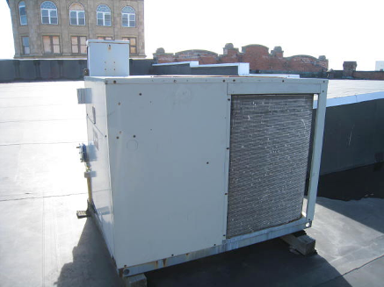

Roof-top AHU

Picture 2

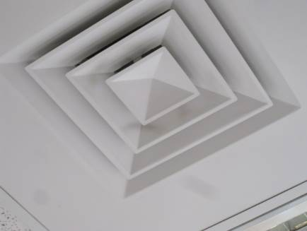

Fresh Air Supply Vent

Picture 3

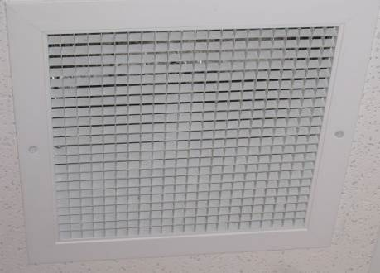

Return Air Exhaust Vent

Picture 4

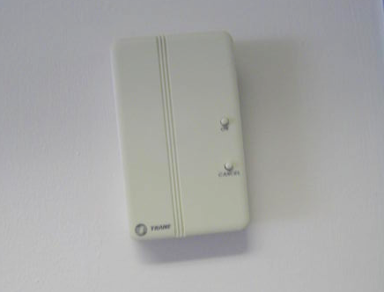

Wall-mounted Thermostat

Picture 5

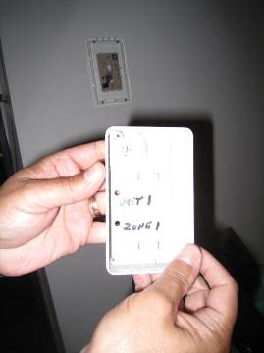

Thermostat Showing Zone Setting

Picture 6

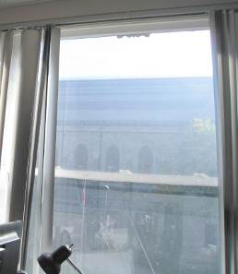

Window Shades Open on South Side of Building

Picture 7

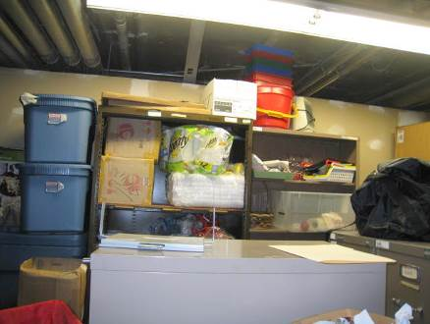

Storage Space in Basement

Picture 8

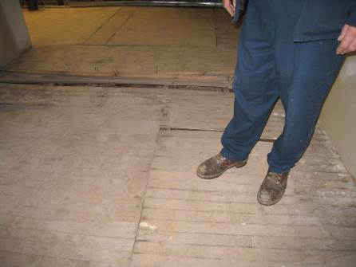

Water-damaged Wooden Floor in Basement

Picture 9

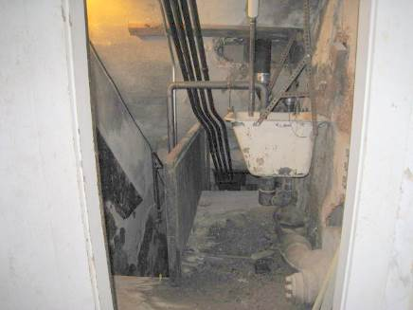

Open Door to Subbasement: Note Stairway

Picture 10

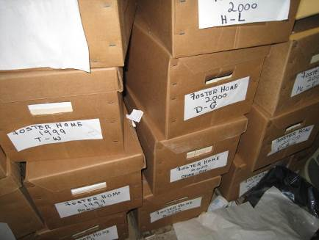

Boxes Stored on Basement Floor

Picture 11

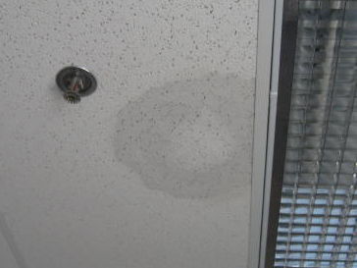

Water-damaged Ceiling Tile

Picture 12

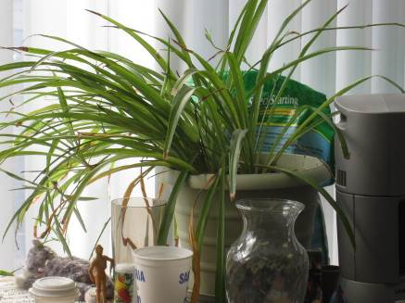

Plant Located in Office Space

Picture 13

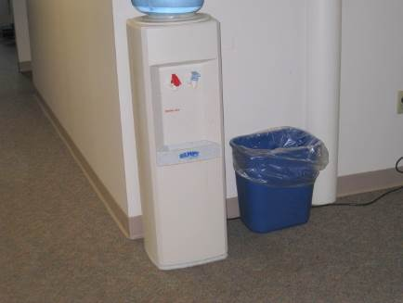

Water Cooler Located on Carpet

Picture 14



Scented Candles in Office Space

Picture 15

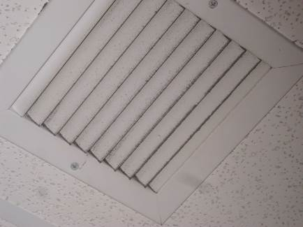

Exhaust Vent Showing Dirt/Debris

Picture 16

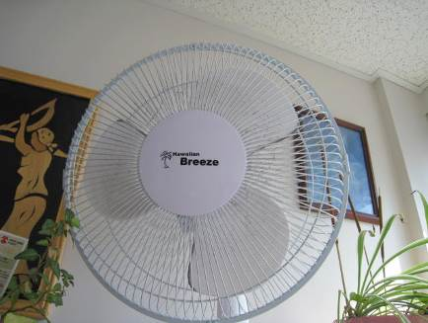

Personal Fan with Dirt/Debris

Picture 17

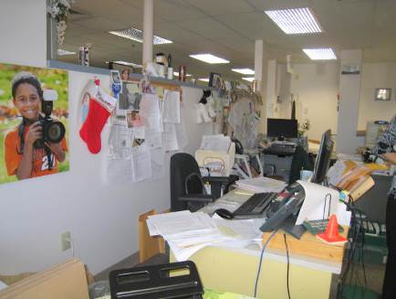

Clutter in Third Floor Office Space

Picture 18

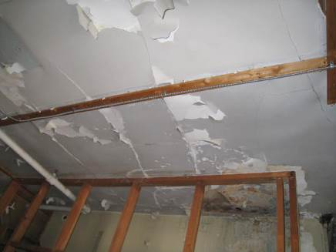

Peeling Paint on Fourth Floor

Picture 19

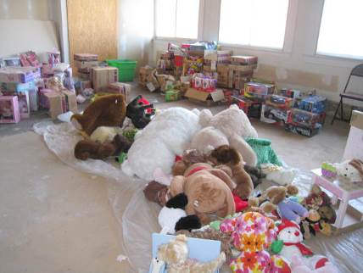

Toys and Items Stored in the Fourth Floor Storage Space

Picture 20

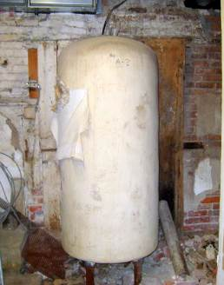

Heating Component with Exposed Insulation
Location/ Room | Carbon Dioxide  (ppm) | Carbon Monoxide  (ppm) | Temp  (°F) | Relative Humidity (%) | PM2.5  (µg/m³) | Occupants in Room | Windows  Openable | Ventilation |  | Remarks
 |  |  |  |  |  |  |  | Supply | Exhaust | Remarks
Background | 416 | ND | 50 | 45 | 25 |  |  |  |  | Sunny and breezy, traffic in front of building
Open work space (213-219) | 661 | ND | 73 | 34 | 7 | 4 | N | Y | Y | Plants, toaster, microwave, plush toys
2nd floor supply room | 678 | ND | 74 | 33 | 7 | 9 | N | Y | Y | Boxes on floor, file cabinets
2nd floor copy room | 702 | ND | 75 | 36 | 7 | 0 | N | Y | Y | Supply and exhaust vents dirty
2nd floor client bathroom | 833 | ND | 75 | 35 | 7 | 0 | N | N | Y (off) | Exhaust vent dirty
2nd floor women’s rest room | 637 | ND | 73 | 35 | 7 | 0 | N | N | Y (off) | 1 WD-CT, water stains on door
2nd floor men’s rest room | 865 | ND | 73 | 39 | 7 | 0 | N | N | Y (off) | 1 WD-CT
206 | 652 | ND | 73 | 34 | 6 | 0 | N | Y (off) | Y (off) | Exhaust vent dirty, DO, plants, microwave
222 | 602 | ND | 74 | 34 | 6 | 0 | N | Y | Y | Plush items, leather furniture, solar gain
226 | 594 | ND | 74 | 31 | 7 | 0 | N | Y | Y | Plants, tile floor, area carpet, fridge
230 | 757 | ND | 73 | 35 | 5 | 0 | N | Y (off) | N | Candles, PF, microwave
232 | 600 | ND | 73 | 33 | 6 | 0 | N | Y | Y | DO, PF, leather furniture
237 | 620 | ND | 73 | 34 | 6 | 0 | N | Y | Y
237 | 710 | ND | 71 | 37 | 5 | 0 | N | Y | Y (off) | DO, plants
239 | 808 | ND | 70 | 40 | 6 | 4 | N | Y | Y
240 | 766 | ND | 72 | 36 | 6 | 0 | N | Y | Y | PF, DO, plants, microwave and fridge
241 | 626 | ND | 74 | 37 | 5 | 0 | N | Y | Y (off)
Nikki Brak area | 631 | ND | 75 | 34 | 6 | 4 | N | Y | Y | PF, plants, microwave, fax, fridge, toaster, dusty PF, DEM, solar gain
Training room | 783 | ND | 74 | 37 | 6 | 18 | N | Y | Y | DO, plants
Justin Lak Area | 601 | ND | 73 | 34 | 6 | 2 | N | Y (off) | Y (off) | Solar gain from windows, clutter, kitchenette area, plants, DEM
Stairwell |  | ND |  |  |  |  | N |  |  | Musty odor, peeling paint
Renate Riley office area | 602 | ND | 71 | 42 | 6 | 2 | N | Y | Y | DEM, microwave, fridge, items, plants
Corner of office where leak had been reported |  | ND |  |  |  |  | N |  |  | No desk or important items stored here anymore, 2 WD-CT
Allison Zolotor Langone office | 645 | ND | 71 | 34 | 6 | 1 | N | Y | Y | Feels chilly, DO, fan
Area adjacent to Allison Zolotor office | 612 | ND | 71 | 34 | 6 | 4 | N | Y | Y | Refrigerator, and microwave
Adolescent Unit | 638 | ND | 71 | 34 | 6 | 3 | N | Y | Y | Light or ventilation system noisy, microwave, fridge
Supervisor office (vacant) | 632 | ND | 71 | 34 | 6 | 0 | N | Y | Y
Kirsten Andrew area | 626 | ND | 72 | 34 | 6 | 4 | N | Y | N | Plants, DEM, refrigerator, microwave, coffee maker
Mechelle Bolden area | 642 | ND | 73 | 33 | 6 | 3-4 | N | Y | Y | Refrigerator, microwave, toaster, PF, reported temperature issues
Eileen Beal area | 648 | ND | 74 | 31 | 5 | 1 | N | Y | Y | items, fridge, plants
3rd floor open work space | 731 | ND | 72 | 45 | 6 | 4 | N | Y | Y | Candles, PFs, FC, clutter
3rd floor women’s rest room | 801 | ND | 72 | 44 | 7 | 0 | N | N | Y (off) | Exhaust dirty, air freshener
3rd floor men’s rest room | 799 | ND | 72 | 43 | 7 | 0 | N | N | Y (off) | Exhaust dirty
3rd floor supply room | 654 | ND | 73 | 43 | 6 | 0 | N | Y | Y | Water cooler on carpet, car seats, toys, clutter
3rd floor office next to stairwell | 682 | ND | 70 | 40 | 8 | 0 | N | Y | Y | Low ceiling, carpet, microwave
301 | 702 | ND | 74 | 45 | 6 | 0 | N | Y | Y (off)
302 | 745 | ND | 74 | 46 | 6 | 1 | N | Y | Y (off)
307 | 688 | ND | 74 | 45 | 5 | 1 | N | N | Y (off) | PF, microwave
308 | 670 | ND | 74 | 35 | 6 | 0 | N | Y | Y (off)
309 | 675 | ND | 73 | 35 | 5 | 0 | N | Y | N
311 | 650 | ND | 73 | 36 | 5 | 1 | N | Y | Y (off) | DO, exhaust dirty
312 | 656 | ND | 72 | 37 | 6 | 0 | N | Y | N | Plants
315 | 679 | ND | 71 | 40 | 5 | 0 | N | Y | Y | DO, plants
317 | 682 | ND | 72 | 42 | 6 | 0 | N | Y | Y (off) | Microwave, printer
320 | 601 | ND | 71 | 34 | 6 | 1 | N | Y | Y | WD-CT, dusty PF
323 (files) | 633 | ND | 74 | 35 | 6 | 0 | N | Y | Y | items stored directly on floor, DO
327 | 618 | ND | 74 | 32 | 6 | 0 | N | Y (off) | Y | DO, plants, food
Office adjacent to 327 | 653 | ND | 74 | 32 | 5 | 0 | N | Y | Y | PF, WD-CT
333 | 644 | ND | 75 | 33 | 6 | 0 | N | Y off | Y off | Many plants, solar gain, fridge, dusty PF, DO
4th floor (storage area) | 570 | ND | 66 | 46 | 6 | 0 | N |  |  | Files, toys, peeling paint (see photos)

