INDOOR AIR QUALITY ASSESSMENT

Massachusetts Department of Children and Families
121 Providence Street
Worcester, Massachusetts

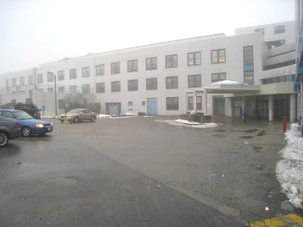

Prepared by:
Massachusetts Department of Public Health
Bureau of Environmental Health
Indoor Air Quality Program
July 2013

Background/Introduction
At the request of Deborah Coleman, Facilities Director, Executive Office of Health and Human Services, the Massachusetts Department of Public Health (MDPH), Bureau of Environmental Health (BEH) provided assistance and consultation regarding indoor air quality (IAQ) concerns at the Department of Children and Families (DCF) office located at 121 Providence Street, Worcester, MA. Concerns regarding temperature and water damage prompted the request. On June 17, 2013, a visit to conduct a general IAQ assessment was made to the DCF by Michael Feeney, Director of BEH’s IAQ Program.
The DCF occupies the second and third floors of a former teaching hospital that was constructed in the early 1950s. The building has a flat roof. Currently DCF is the sole remaining tenant in the building. The heating, ventilating and air-conditioning (HVAC) system for the vacant floors was reportedly deactivated, which resulted in a section of the second floor HVAC system becoming deactivated. In order to increase thermal comfort for building occupants, the landlord has installed portable air conditioning (AC) units in the affected areas (Picture 1). The occupied space consists of private offices, open work areas (cubicles), conference rooms and storage areas. Floors are carpeted. Windows in the DCF space are openable.
This report details the findings of the general IAQ assessment. To specifically address concerns regarding water damage to ceiling and walls of the lobby after severe rainstorms, BEH issued a letter dated June 21, 2013, included as Appendix A of this report, detailing water infiltration remediation recommendations.
In addition, BEH/IAQ staff had previously visited the building in 2012 and issued a report discussing conditions observed at that time. A summary of actions in response to recommendations in the 2012 report are included as Appendix B.

Methods
Tests for carbon monoxide, carbon dioxide, temperature and relative humidity were conducted with a TSI, Q-Trak, IAQ Monitor, Model 7565. Air tests for airborne particulate matter with a diameter less than 2.5 micrometers were taken with the TSI, DUSTTRAK™ Aerosol Monitor Model 8520. BEH/IAQ staff also performed visual inspection of building materials for water damage and/or microbial growth.

Results
The DCF has an employee population of approximately 200 and can be visited by up to 50 individuals daily. Tests were taken during normal operations. Results appear in Table 1.

Discussion

Ventilation
It can be seen from Table 1 that carbon dioxide levels were above 800 parts per million (ppm) in 31 of 42 areas surveyed, indicating inadequate air exchange in the majority of areas during the assessment. Mechanical ventilation is provided by air-handling units (AHUs). Fresh air is drawn into the AHUs and delivered to occupied areas via ceiling-mounted air diffusers and induction units (IUs). According to DCF officials, IUs for a third of the office space were deactivated when HVAC systems for unoccupied floors were deactivated. These actions would serve to reduce the amount of fresh air supplied to the second floor. Note that the third floor HVAC system is not affected.
Some ceiling-mounted air diffusers were observed to be blocked with tape or cardboard and were therefore not operating as designed. Exhaust ventilation for the offices is provided by a ceiling plenum system. Air is drawn into the ceiling plenum via “egg crate” vents installed in the suspended ceiling and returned to the AHUs.
The IUs (Figure 1), located along the base of walls, provide heating and/or cooling to perimeter areas beneath windows. In a number of areas, IUs were blocked/obstructed by several items including cardboard boxes, books and other stored materials. In order for IUs to facilitate airflow as designed, air diffusers and return vents must remain free of obstructions. IUs appear to be original to the building, which would make them approximately 50-60 years old. Ventilation equipment of this age is difficult to maintain because replacement parts are often unavailable.
To maximize air exchange, the MDPH recommends that both supply and exhaust ventilation operate continuously during periods of occupancy. In order to have proper ventilation with a mechanical supply and exhaust system, the systems must be balanced to provide an adequate amount of fresh air to the interior of a room while removing stale air from the room. It is recommended that HVAC systems be re-balanced every five years to ensure adequate air systems function (SMACNA, 1994). The date of the last balancing was not available at the time of the assessment.
Minimum design ventilation rates are mandated by the Massachusetts State Building Code (MSBC). Until 2011, the minimum ventilation rate in Massachusetts was higher for both occupied office spaces and general classrooms, with similar requirements for other occupied spaces (BOCA, 1993). The current version of the MSBC, promulgated in 2011 by the State Board of Building Regulations and Standards (SBBRS), adopted the 2009 International Mechanical Code (IMC) to set minimum ventilation rates. Please note that the MSBC is a minimum standard that is not health-based. At lower rates of cubic feet per minute (cfm) per occupant of fresh air, carbon dioxide levels would be expected to rise significantly. A ventilation rate of 20 cfm per occupant of fresh air provides optimal air exchange resulting in carbon dioxide levels at or below 800 ppm in the indoor environment in each area measured. MDPH recommends that carbon dioxide levels be maintained at 800 ppm or below. This is because most environmental and occupational health scientists involved with research on IAQ and health effects have documented significant increases in indoor air quality complaints and/or health effects when carbon dioxide levels rise above the MDPH guidelines of 800 ppm for schools, office buildings and other occupied spaces (Sundell et al., 2011). The ventilation must be on at all times that the room is occupied. Providing adequate fresh air ventilation with open windows and maintaining the temperature in the comfort range during the cold weather season is impractical. Mechanical ventilation is usually required to provide adequate fresh air ventilation.
Carbon dioxide is not a problem in and of itself. It is used as an indicator of the adequacy of the fresh air ventilation. As carbon dioxide levels rise, it indicates that the ventilating system is malfunctioning or the design occupancy of the room is being exceeded. When this happens, a buildup of common indoor air pollutants can occur, leading to discomfort or health complaints. The Occupational Safety and Health Administration (OSHA) standard for carbon dioxide is 5,000 parts per million parts of air (ppm). Workers may be exposed to this level for 40 hours/week, based on a time-weighted average (OSHA, 1997).
The MDPH uses a guideline of 800 ppm for publicly occupied buildings. A guideline of 600 ppm or less is preferred in schools due to the fact that the majority of occupants are young and considered to be a more sensitive population in the evaluation of environmental health status. Inadequate ventilation and/or elevated temperatures are major causes of complaints such as respiratory, eye, nose and throat irritation, lethargy and headaches. For more information concerning carbon dioxide, please see Appendix C.
Temperature readings (Table 1) were within the MDPH recommended comfort guidelines in all areas measured with the exception of the waiting room (81 ºF). The MDPH recommends that indoor air temperatures be maintained in a range of 70 ºF to 78 ºF in order to provide for the comfort of building occupants. In many cases concerning indoor air quality, fluctuations of temperature in occupied spaces are typically experienced, even in a building with an adequate fresh air supply.
As mentioned previously, portable AC units were installed on the second floor where the IUs were deactivated. As noted in the 2012 MDPH assessment, building occupants reported temperature extremes in the building, which is likely related to two specific building features. First, the windows are single pane in metallic frames, which would be subject to solar gain in direct sunlight. This phenomenon was confirmed by building occupants reports of warm temperatures in the eastern portion of the office in the morning and in the western portion of the office in the afternoon during sunny weather. With this build-up of heated air, return ventilation is needed to create airflow and increase the comfort of building occupants. Lack of air circulation can be attributed to the location of return vents (Figure 2), which is the other factor contributing to temperature extremes. Return vents are located in an irregular pattern over corridor space in the core of the building. The use of floor dividers to create private office space has separated open cubicle space from return vents. In this configuration, pollutants such as excessive waste heat can build up and are not removed from the occupied environment, which can lead to reports of thermal discomfort.
The portable AC units are equipped with flexible ducts. In their current configuration, the portable AC unit draws and directs air into the hallways instead of into employee-occupied cubicles. In addition, one portable unit is located direct below an exhaust vent, which would draw chilled air into the general HVAC system instead of into occupied space. The portable AC unit located in the waiting room was deactivated during this assessment. Airflow of these portable AC units should be redirected to provide chilled air for building occupants.
The relative humidity measured in the building ranged from 40 to 58 percent, which was within the MDPH recommended comfort range in all areas the day of assessment (Table 1). The MDPH recommends a comfort range of 40 to 60 percent for indoor air relative humidity. Relative humidity levels in the building would be expected to drop during the winter months due to heating. The sensation of dryness and irritation is common in a low relative humidity environment. Low relative humidity is a common problem during the heating season in the northeast part of the United States.

Microbial/Moisture Concerns
BEH/IAQ staff noted water damage around IU #48 on the third floor (Picture 2). It is possible that water has moistened the adjacent carpet tile. An odor was noted in the law library; newspapers were observed to be on top of the IU diffuser in direct sunlight (Picture 3). Newsprint, if moistened and/overheated, can be a source of irritating odors.
Other potential sources of water damage/infiltration were observed in the building. Several rooms in the building had water-damaged ceiling tiles, which stem from roof leaks, plumbing leaks and/or leaks and condensation from AC components (Table 1). Water-damaged ceiling tiles can provide a source of mold and should be replaced after a water leak is discovered and repaired.
A few areas had water coolers installed over carpeting in hallways. Overflow/spills from water coolers/water fountains can moisten carpeting. It is also important that the catch basin of water coolers be cleaned regularly as stagnant water can be a source of odors.
The US Environmental Protection Agency (US EPA) and the American Conference of Governmental Industrial Hygienists (ACGIH) recommend that porous materials be dried with fans and heating within 24 to 48 hours of becoming wet (US EPA, 2001; ACGIH, 1989). If not dried within this time frame, mold growth may occur. Once mold has colonized porous materials, they are difficult to clean and should be removed/discarded.
Plants were observed in several areas (Table 1). Plants should be properly maintained and equipped with drip pans. Plants should be located away from ventilation sources (e.g., IUs) to prevent aerosolization of dirt, pollen or mold. Plants should not be placed on porous materials, since water damage to porous materials may lead to microbial growth.

Other IAQ Evaluations
Indoor air quality can be negatively influenced by the presence of respiratory irritants, such as products of combustion. The process of combustion produces a number of pollutants. Common combustion emissions include carbon monoxide, carbon dioxide, water vapor and smoke (fine airborne particle material). Of these materials, exposure to carbon monoxide can produce immediate, acute health effects upon exposure. To determine whether combustion products were present in the indoor environment, BEH/IAQ staff obtained measurements for carbon monoxide and PM2.5.

Carbon Monoxide
Carbon monoxide is a by-product of incomplete combustion of organic matter (e.g., gasoline, wood and tobacco). Exposure to carbon monoxide can produce immediate and acute health effects. Several air quality standards have been established to address carbon monoxide and prevent symptoms from exposure to these substances. The MDPH established a corrective action level concerning carbon monoxide in ice skating rinks that use fossil-fueled ice resurfacing equipment. If an operator of an indoor ice rink measures a carbon monoxide level over 30 ppm, taken 20 minutes after resurfacing within a rink, that operator must take actions to reduce carbon monoxide levels (MDPH, 1997).
The American Society of Heating, Refrigerating and Air-Conditioning Engineers (ASHRAE) has adopted the National Ambient Air Quality Standards (NAAQS) as one set of criteria for assessing indoor air quality and monitoring of fresh air introduced by HVAC systems (ASHRAE, 1989). The NAAQS are standards established by the US EPA to protect the public health from six criteria pollutants, including carbon monoxide and particulate matter (US EPA, 2006). As recommended by ASHRAE, pollutant levels of fresh air introduced to a building should not exceed the NAAQS levels (ASHRAE, 1989). The NAAQS were adopted by reference in the Building Officials & Code Administrators (BOCA) National Mechanical Code of 1993 (BOCA, 1993), which is now an HVAC standard included in the Massachusetts State Building Code (SBBRS, 2011). According to the NAAQS, carbon monoxide levels in outdoor air should not exceed 9 ppm in an eight-hour average (US EPA, 2006).
Carbon monoxide should not be present in a typical, indoor environment. If it is present, indoor carbon monoxide levels should be less than or equal to outdoor levels (Table 1). No measureable levels of carbon monoxide were detected inside the building during the assessment (Table 1).

Particulate Matter
The US EPA has established NAAQS limits for exposure to particulate matter. Particulate matter (PM) is airborne solids that can be irritating to the eyes, nose and throat. The NAAQS originally established exposure limits to PM with a diameter of 10 μm or less (PM10). In 1997, US EPA established a more protective standard for fine airborne particulate matter with a diameter of 2.5 μm or less (PM2.5). The NAAQS has subsequently been revised, and PM2.5 levels were reduced. This more stringent PM2.5 standard requires outdoor air particle levels be maintained below 35 μg/m³ over a 24-hour average (US EPA, 2006). Although both the ASHRAE standard and BOCA Code adopted the PM10 standard for evaluating air quality, MDPH uses the more protective PM2.5 standard for evaluating airborne PM concentrations in the indoor environment.
Outdoor PM2.5 was measured at 11 μg/m³. Indoor PM2.5 levels ranged from 5 to 16 μg/m³ (Table 1). At the time of testing, both indoor and outdoor levels were below the NAAQS PM2.5 level of 35 μg/m³. Frequently, indoor air levels of particulates (including PM2.5) can be at higher levels than those measured outdoors. A number of mechanical devices and/or activities that occur indoors can generate particulate during normal operations. Sources of indoor airborne particulates may include but are not limited to particles generated during the operation of fan belts in the HVAC system, use of stoves and/or microwave ovens in kitchen areas; use of photocopiers, fax machines and computer printing devices; operation of an ordinary vacuum cleaner; and heavy foot traffic indoors.

Other Conditions
Other conditions that can affect indoor air quality were observed during the assessment.
Of note is the number of locations that contain significant amounts of cardboard (Pictures 4 through 6). Cardboard is manufactured from a variety of chemicals which can off-gas and be a source of odors and irritation to the eyes, nose and respiratory system. Having a large amount of cardboard stored/shelved in occupied space can result in respiratory irritation to occupants.
Areas on the second floor remain cluttered with items on IUs, floors, windowsills, tabletops, counters, bookcases and desks. The large number of items stored in the workplace provides a source for dusts to accumulate. These items (e.g., papers, folders, boxes, books) make it difficult for custodial staff to clean. Items should be relocated and/or be cleaned periodically to avoid excessive dust build up. In addition, these materials can accumulate on flat surfaces (e.g., desktops, shelving and carpets) in occupied areas and subsequently be re-aerosolized causing further irritation.
Many of the floor surfaces are covered by wall-to-wall carpeting. It was not known if the building had a carpet cleaning program in place. The Institute of Inspection, Cleaning and Restoration Certification (IICRC), recommends that carpeting be cleaned annually (or semi-annually in soiled high traffic areas) (IICRC, 2005).

Conclusions/Recommendations
In view of the findings at the time of the visit, the following recommendations are made:
- Implement the recommendations concerning water-damaged gypsum wallboard in the lobby (Appendix A)
- Implement the recommendations in the previous IAQ report (Appendix B).
- Reconfigure portable AC units to provide heat relief to staff in low cubicles. Increasing the number of portable AC units on the second floor may be necessary.
- Remove coving and carpet tiles around IU #48 (Picture 2) and replace after repairing source of water infiltration.
- Reduce the amount of cardboard in the occupied space.
- Relocate or consider reducing the amount of materials stored in offices and common areas to allow for more thorough cleaning.
- Remove newspapers and other items from IUs.

References
ACGIH. 1989. Guidelines for the Assessment of Bioaerosols in the Indoor Environment. American Conference of Governmental Industrial Hygienists, Cincinnati, OH.
ASHRAE. 1989. Ventilation for Acceptable Indoor Air Quality. American Society of Heating, Refrigeration and Air Conditioning Engineers. ANSI/ASHRAE 62-1989.
BOCA. 1993. The BOCA National Mechanical Code-1993. 8th ed. Building Officials & Code Administrators International, Inc., Country Club Hills, IL.
IICRC. 2005. Carpet Cleaning FAQ 4 Institute of Inspection, Cleaning and Restoration Certification. Institute of Inspection Cleaning and Restoration, Vancouver, WA.
IMC. 2009. 2009 International Mechanical Code. International Code Council Inc., Country Club Hills, IL.
MDPH. 1997. Requirements to Maintain Air Quality in Indoor Skating Rinks (State Sanitary Code, Chapter XI). 105 CMR 675.000. Massachusetts Department of Public Health, Boston, MA.
OSHA. 1997. Limits for Air Contaminants. Occupational Safety and Health Administration. Code of Federal Regulations. 29 C.F.R 1910.1000 Table Z-1-A.
SBBRS. 2011. Mechanical Ventilation. State Board of Building Regulations and Standards. Code of Massachusetts Regulations, 8th edition. 780 CMR 1209.0.
SMACNA. 1994. HVAC Systems Commissioning Manual. 1st ed. Sheet Metal and Air Conditioning Contractors’ National Association, Inc., Chantilly, VA.
Sundell. 2011. Sundell, J., H. Levin, W. W. Nazaroff, W. S. Cain, W. J. Fisk, D. T. Grimsrud, F. Gyntelberg, Y. Li, A. K. Persily, A. C. Pickering, J. M. Samet, J. D. Spengler, S. T. Taylor, and C. J. Weschler. Ventilation rates and health: multidisciplinary review of the scientific literature. Indoor Air, Volume 21: pp 191–204.
US EPA. 2001. Mold Remediation in Schools and Commercial Buildings. US Environmental Protection Agency, Office of Air and Radiation, Indoor Environments Division, Washington, D.C. EPA 402-K-01-001. March 2001.
US EPA. 2006. National Ambient Air Quality Standards (NAAQS). US Environmental Protection Agency, Office of Air Quality Planning and Standards, Washington, DC. http://www.epa.gov/air/criteria.html

Air Diffuser

Coil

Air Stream

Room Air

Drip Pan

Air Jet

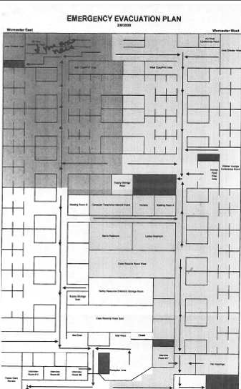
Picture 1

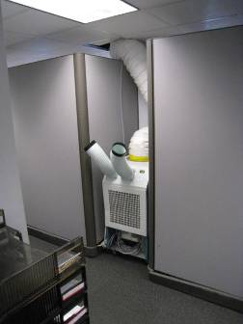

Portable AC unit on opposite side of divider from staff cubicles

Picture 2

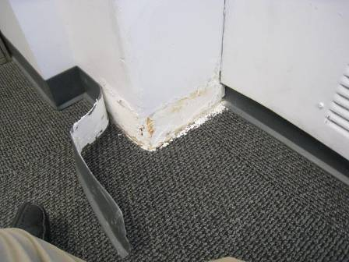

Water damage around IU #48

Picture 3

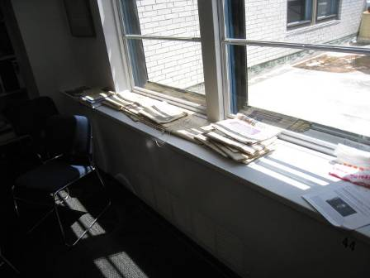

Newspapers on IU in sunlight

Picture 4

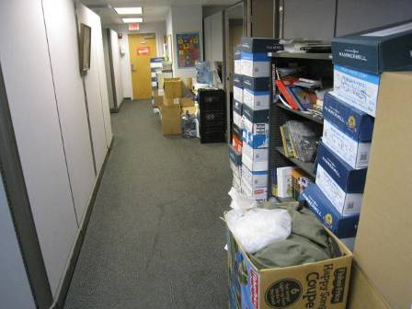

Cardboard in occupied space

Picture 5

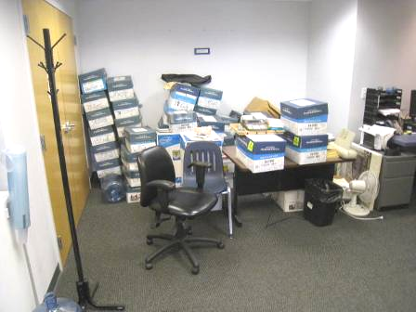

Cardboard in occupied space

Picture 6

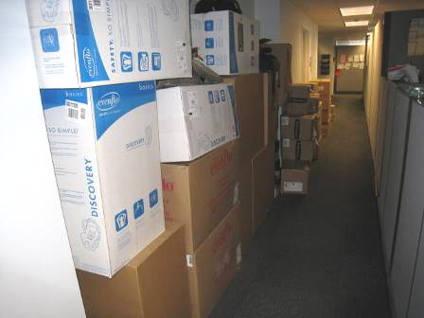

Cardboard in occupied space
Location/Room | Carbon  Dioxide  (ppm) | Carbon Monoxide  (ppm) | Temp  (°F) | Relative  Humidity  (%) | PM2.5  (µg/m³) | Occupants  in Room | Windows  Openable | Ventilation |  | Remarks
 |  |  |  |  |  |  |  | Supply | Exhaust | Remarks
Background (outdoors) | 357 | ND | 82 | 56 | 11
Waiting room | 1226 | ND | 81 | 40 | 5 | 3 | N | Y | Y
1 | 923 | ND | 77 | 48 | 11 | 5 | N | Y | Y
2 | 939 | ND | 76 | 48 | 9 | 3 | N | Y | Y
4 | 1110 | ND | 76 | 50 | 8 | 7 | N | Y | Y
6 | 1077 | ND | 75 | 51 | 8 | 6 | N | Y | Y | Floor fan operating
8 | 976 | ND | 75 | 51 | 7 | 5 | N | Y | Y
10 | 950 | ND | 74 | 50 | 7 | 5 | N | Y | Y
12 | 926 | ND | 74 | 48 | 6 | 4 | N | Y | Y
13 | 950 | ND | 75 | 49 | 6 | 2 | N | Y | Y
15 | 960 | ND | 74 | 48 | 8 | 1 | N | Y | Y
16 | 976 | ND | 75 | 47 | 6 | 2 | N | Y | Y
17 | 1106 | ND | 76 | 48 | 7 | 6 | N | Y | Y
18 | 1030 | ND | 75 | 48 | 6 | 5 | N | Y | Y
19 | 652 | ND | 75 | 43 | 7 | 0 | N | Y | Y | Water damage plaster, coving off wall at Induction Unit #48
20 | 1207 | ND | 76 | 48 | 7 | 3 | N | Y | Y | Boxes
21 | 1085 | ND | 74 | 52 | 7 | 5 | N | Y | Y | Plants
23 | 1082 | ND | 74 | 50 | 6 | 4 | N | Y | Y | Plants
25 | 1109 | ND | 76 | 51 | 8 | 7 | N | Y | Y | Boxes, induction unit
27 | 1223 | ND | 76 | 51 | 8 | 5 | N | Y | Y | Plants
29 | 1224 | ND | 77 | 50 | 8 | 9 | N | Y | Y | Boxes, portable air conditioning unit - noise
31 | 1220 | ND | 77 | 49 | 9 | 6 | N | Y | Y | Floor fan operating
33 | 1212 | ND | 77 | 48 | 9 | 1 | N | Y | Y
34 | 1248 | ND | 77 | 48 | 9 | 0 | N | Y | Y
44 | 1004 | ND | 74 | 52 | 6 | 0 | N | Y | Y | Boxes
48 | 1114 | ND | 73 | 53 | 5 | 4 | N | Y | Y
55 | 945 | ND | 78 | 47 | 11 | 2 | N | Y | Y | Boxes
66 | 619 | ND | 73 | 43 | 7 | 2 | N | Y | Y
70 | 632 | ND | 73 | 43 | 6 | 0 | N | Y | Y
79 | 618 | ND | 75 | 44 | 6 | 0 | N | Y | Y
81 | 629 | ND | 75 | 44 | 6 | 2 | N | Y | Y
134 | 1057 | ND | 75 | 50 | 6 | 1 | N | Y | Y | 1 water-damaged ceiling tile
304 | 1002 | ND | 74 | 52 | 6 | 1 | N | Y | Y | Photocopier, plants, boxes
305 | 1012 | ND | 74 | 51 | 5 | 2 | N | Y | Y | Photocopier, boxes
Rest room hall | 1056 | ND | 76 | 48 | 8 | 0 | N | Y | Y
FCR | 927 | ND | 77 | 49 | 11 | 0 | N | Y | Y | Portable air conditioning unit - off
Case file room | 874 | ND | 77 | 48 | 9 | 0 | N | Y | Y
Conference | 620 | ND | 74 | 45 | 6 | 0 | N | Y | Y | Floor fan
Mail | 646 | ND | 75 | 44 | 6 | 0 | N | Y | Y | Photocopier
File room | 645 | ND | 75 | 44 | 6 | 0 | N | Y | Y | Door open
Conference B | 609 | ND | 74 | 44 | 6 | 0 | N | Y | Y
Law library | 627 | ND | 76 | 47 | 7 | 0 | N | Y | Y | Newsprint odor
Lobby | 492 | ND | 70 | 58 | 16 | 0 | N | Y | Y | 5 water-damaged ceiling tiles, water-damaged gypsum wallboard


DEVAL L. PATRICK
GOVERNOR
JOHN W. POLANOWICZ
SECRETARY
CHERYL BARTLETT
COMMISSIONER

The Commonwealth of Massachusetts
Executive Office of Health and Human Services
Department of Public Health
Bureau of Environmental Health
250 Washington Street, Boston, MA 02108-4619
Phone: 617-624-5757 Fax: 617-624-5777
TTY: 617-624-5286
June 21, 2013

Mark Waterbury, Chief Operating Officer
Executive Office of Health and Human Services
One Ashburton Place, 11th Floor
Boston, MA 02108

Dear Mr. Waterbury:
On June 17, 2013, the Massachusetts Department of Public Health (MDPH), Bureau of Environmental Health’s (BEH) Indoor Air Quality (IAQ) Program conducted an assessment at the Department of Children and Families (DCF) office, 126 Providence Street, Worcester, Massachusetts. The IAQ assessment was in response to a request from Deborah Coleman, Facilities Director, Executive Office of Health and Human Services (EOHHS) and was prompted by occupant concerns related to IAQ conditions at this location.
As part of the assessment, BEH/IAQ staff examined for a variety of indoor environmental conditions including the ventilation system and sources of respiratory irritants (e.g., moisture intrusion/microbial growth). Details of the full IAQ evaluation will be discussed in a report to follow. The purpose of this letter is to address water-damaged/mold-colonized building materials in the foyer and lobby of the building.
In order for building materials to support mold growth, a source of water exposure is necessary. It was reported to BEH/IAQ staff that water infiltration occurred in this area after a severe weather event on June 12, 2013. At the time of the BEH/IAQ assessment, the gypsum wallboard (GW) and carpeting remained wet. BEH/IAQ staff removed chipping paint and noted visible mold growth behind the paint layer (Pictures 1 through 3); paint acts as a water impermeable barrier that prevents drying. At the time of the assessment, the GW walls were saturated with moisture. DCF staff reported that these areas were not dried using fans and/or other means subsequent to the weather event previously mentioned.
The US Environmental Protection Agency (US EPA) and the American Conference of Governmental Industrial Hygienists (ACGIH) recommends that porous materials be dried with fans and heating within 24 to 48 hours of becoming wet (US EPA, 2001; ACGIH, 1989). If porous materials (e.g., carpeting and GW) are not dried within this time frame, mold growth may occur. Cleaning cannot adequately remove mold growth from water-damaged porous materials. The application of a mildewcide to mold-contaminated porous materials is not recommended. Due to the extent of water damage and mold contamination, a professional flooding restoration/mold remediation firm should be contacted to conduct remediation.
In view of the findings at the time of this visit, we suggest the following recommendations be implemented as soon as possible:
- Remove water-damaged/mold-colonized GW and carpeting as well as any wet insulation in wall cavities in the foyer and lobby.
- Remediation efforts would best be conducted after work hours.
- Seal off/contain remediation areas and place under negative pressure to draw particulates/odors away from occupied areas. Containment procedures should be consistent with the IAQ Guidelines for Occupied Buildings Under Construction published by the Sheet Metal and Air Conditioning Contractors National Association, Inc. (SMACNA, 1995).
- Dry and sanitize all non-porous surfaces once remediation efforts are complete.
- Refer to “Mold Remediation in Schools and Commercial Buildings” published by the US Environmental Protection Agency (US EPA, 2001) for additional information regarding removal and remediation of water-damaged materials. This document can be downloaded from the US EPA website at: http://www.epa.gov/mold/mold_remediation.html.
- Refer to Attachment A, Methods Used to Reduce/Prevent Exposure to Construction/Renovation Generated Pollutants in Occupied Buildings, prepared by the MDPH as additional guidance to prevent/reduce the migration of renovation-generated pollutants into occupied areas.
Please feel free to contact us at (617) 624-5757 if you are in need of further information or technical assistance regarding this issue.
Sincerely,

Suzanne K. Condon, Associate Commissioner
Director, Bureau of Environmental Health

cc: Mike Feeney, Director, Indoor Air Quality Program, BEH
Kelly Prendergast, Director of Worcester Areas, DCF
Deborah Coleman, Facilities Director. EOHHS
Mary Farrell, Office for Leasing and State Owned Properties, EOHHS
Pamela Jackson, Human Resource Director, EOHHS

Enclosure(s)
References

ACGIH. 1989. Guidelines for the Assessment of Bioaerosols in the Indoor Environment. American Conference of Governmental Industrial Hygienists, Cincinnati, OH.
SMACNA. 1995. IAQ Guidelines for Occupied Buildings Under Construction. 1st ed. Sheet Metal and Air Conditioning Contractors' National Association, Inc., Chantilly, VA.
US EPA. 2001. Mold Remediation in Schools and Commercial Buildings. US Environmental Protection Agency, Office of Air and Radiation, Indoor Environments Division, Washington, DC. EPA 402-K-01-001. March 2001.
Picture 1

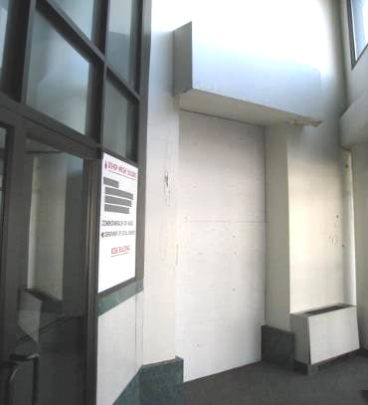

Water-damaged GW and wet carpeting in foyer

Picture 2
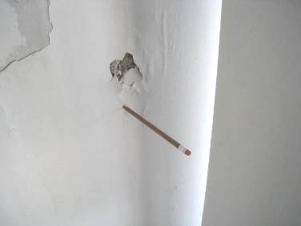

Close-up of water damage in Picture 1
(Note chipped paint reveals mold colonization behind paint layer, and the saturated GW allows a pencil to be easily inserted)

Picture 3

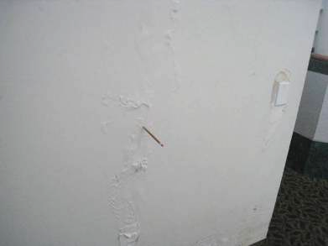

Water-damaged/mold-colonized gypsum wallboard in the lobby above
wet wall-to-wall carpeting

Actions on Previous MDPH Recommendations at
Department of Children and Families offices at
121 Providence St., Worcester MA

The following is a status report of action(s) taken on MDPH recommendations made in the 2012 MDPH report (in bold) based on a follow-up site visit, photographs and BEH/IAQ staff observations.
  - Ensure missing/damaged ceiling tiles are replaced to maintain integrity of the return plenum.
  - Action: Some ceiling tiles were replaced.
  - Unblock vents that are currently blocked with tape and/or cardboard and remove obstructions from IUs.
  - Action: Vents in some locations remain blocked.
  - Consider relocating suspended ceiling return vents from the hallway to locations over the low wall cubicles to enhance removal of waste heat to improve comfort of building occupants.
  - Action: Exhaust vents were not moved.
  - To control for dusts, a high efficiency particulate arrestance (HEPA) filter equipped vacuum cleaner in conjunction with wet wiping of all surfaces is recommended.
  - Action: Vacuum cleaner was not replaced.
  - Ensure all plants are equipped with drip pans. Examine drip pans for mold growth and disinfect areas of water leaks with an appropriate antimicrobial where necessary.
  - Action: Some plants were removed.
  - Consider moving water dispensing equipment to areas with tiled floors instead of carpeting, or installing waterproof mats to prevent leaks from damaging carpet.
  - Action: Water coolers were not moved.
  - Relocate or consider reducing the amount of materials stored in offices and common areas to allow for more thorough cleaning.
  - Action: A large number of cardboard boxes remained in occupied areas.
  - Clean air diffusers and personal fans periodically of accumulated dust.
  - Action: IU vents appeared to be clean.

An induction unit uses a series of nozzles that are connected to the building AHU to produce a jet of air. The jet of air induces (draws) air from the room into the unit through a heating/cooling coil. The room air is cooled and/or heated to control the room temperature. Room air mixes with the air jet and is discharged into the room.
The ceiling plenum is the space located between a roof/floor decking and a suspended ceiling system.

