INDOOR AIR QUALITY ASSESSMENT

Massachusetts Department of Children and Families
121 Providence Street
Worcester, Massachusetts

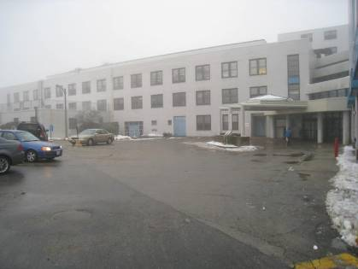

Prepared by:
Massachusetts Department of Public Health
Bureau of Environmental Health
Indoor Air Quality Program
June 2012

Background/Introduction
At the request of Mr. Dave Morin, Area Administrative Manager for the Worcester area of the Massachusetts Department of Children and Families (DCF), the Massachusetts Department of Public Health (MDPH), Bureau of Environmental Health (BEH) provided assistance and consultation regarding indoor air quality (IAQ) concerns at the Worcester DCF office located at 121 Providence Street. Concerns of microbial growth around induction units (IUs) and water-damaged materials prompted the request. On January 13, 2012, a visit to conduct a general IAQ assessment was made to the DCF by Michael Feeney, Director of BEH’s Indoor Air Quality Program. Mr. Feeney was accompanied by Kathleen Gilmore, Regional Inspector for BEH’s IAQ Program.
The DCF occupies the second and third floors of a former teaching hospital with a flat roof that was constructed in the early 1950s. The space was renovated in 2006 prior to occupancy by DCF. The occupied space consists of private offices, open work areas (cubicles), conference rooms and storage areas. Floors are carpeted. Windows in the DCF space are openable.

Methods
Tests for carbon monoxide, carbon dioxide, temperature and relative humidity were conducted with a TSI, Q-Trak, IAQ Monitor, Model 7565. Air tests for airborne particulate matter with a diameter less than 2.5 micrometers were taken with the TSI, DUSTTRAK™ Aerosol Monitor Model 8520. BEH staff also performed visual inspection of building materials for water damage and/or microbial growth.

Results
The DCF has an employee population of approximately 200 and can be visited by up to 50 individuals daily. Tests were taken during normal operations. Results appear in Table 1.

Discussion

Ventilation
It can be seen from Table 1 that carbon dioxide levels were below 800 parts per million (ppm) in all areas surveyed, indicating adequate air exchange during the assessment. Mechanical ventilation is provided by air-handling units (AHUs). Fresh air is drawn into the AHUs and delivered to occupied areas via ceiling-mounted air diffusers and IUs and drawn into the ceiling plenum via ceiling-mounted return grates and subsequently ducted back to AHUs. Of note was a number of ceiling-mounted air diffusers blocked with tape or cardboard, hence they were not operating as designed (Picture 2). Exhaust ventilation for the offices is provided by a ceiling plenum system. Air is drawn into the ceiling plenum via “egg crate” vents installed in the suspended ceiling.
The IUs (Figure 1; Picture 1), located along the base of walls, provide heating and/or cooling to perimeter areas beneath windows. The IUs were operating in all of the areas surveyed during the assessment. In a number of areas, IUs were blocked/obstructed by several items including cardboard boxes, books and other stored materials. In order for IUs to facilitate airflow as designed, air diffusers and return vents must remain free of obstructions. IUs appear to be original to the building, which would make them approximately 50-60 years old. Ventilation equipment of this age is difficult to maintain because replacement parts are often unavailable.
To maximize air exchange, the MDPH recommends that both supply and exhaust ventilation operate continuously during periods of occupancy. In order to have proper ventilation with a mechanical supply and exhaust system, the systems must be balanced to provide an adequate amount of fresh air to the interior of a room while removing stale air from the room. It is recommended that HVAC systems be re-balanced every five years to ensure adequate air systems function (SMACNA, 1994). The date of the last balancing was not available at the time of the assessment.
The Massachusetts Building Code requires a minimum ventilation rate of 20 cubic feet per minute (cfm) per occupant of fresh outside air or have openable windows in each room (SBBRS, 1997; BOCA, 1993). The ventilation must be on at all times that the room is occupied. Providing adequate fresh air ventilation with open windows and maintaining the temperature in the comfort range during the cold weather season is impractical. Mechanical ventilation is usually required to provide adequate fresh air ventilation.
Carbon dioxide is not a problem in and of itself. It is used as an indicator of the adequacy of the fresh air ventilation. As carbon dioxide levels rise, it indicates that the ventilating system is malfunctioning or the design occupancy of the room is being exceeded. When this happens, a buildup of common indoor air pollutants can occur, leading to discomfort or health complaints. The Occupational Safety and Health Administration (OSHA) standard for carbon dioxide is 5,000 parts per million parts of air (ppm). Workers may be exposed to this level for 40 hours/week, based on a time-weighted average (OSHA, 1997).
The MDPH uses a guideline of 800 ppm for publicly occupied buildings. A guideline of 600 ppm or less is preferred in schools due to the fact that the majority of occupants are young and considered to be a more sensitive population in the evaluation of environmental health status. Inadequate ventilation and/or elevated temperatures are major causes of complaints such as respiratory, eye, nose and throat irritation, lethargy and headaches. For more information concerning carbon dioxide, please see Appendix A.
Temperature readings ranged from 71 ºF to 76 ºF, which were within the MDPH recommended comfort guidelines in all areas surveyed during the assessment (Table 1). The MDPH recommends that indoor air temperatures be maintained in a range of 70 ºF to 78 ºF in order to provide for the comfort of building occupants. In many cases concerning indoor air quality, fluctuations of temperature in occupied spaces are typically experienced, even in a building with an adequate fresh air supply.
Building occupants reported temperature extremes in the building, which is likely related to two specific building features. First, the windows are single pane in metallic frames, which would be subject to solar gain in direct sunlight and chilling in cold weather. This phenomenon was confirmed by building occupants reports of warm temperature in the eastern portion of the office in the morning and in the western portion of the office in the afternoon during sunny weather. With this build-up of heated air, return ventilation is needed to create airflow and increase the comfort of building occupants. Lack of air circulation can be attributed to the location of return vents (Figure 2) which is the other factor impacting temperature extremes. Return vents are located in an irregular pattern over corridor space in the core area of the building. The use of floor dividers to create private office space has separated open cubicle space from return vents. In this configuration, pollutants such as excessive waste heat can build up and are not removed from the occupied environment, which can then lead to reports of thermal discomfort.
The relative humidity measured in the building ranged from 22 to 28 percent, which was below the MDPH recommended comfort range in all areas on the day of the assessment (Table 1). The MDPH recommends a comfort range of 40 to 60 percent for indoor air relative humidity. Relative humidity levels in the building would be expected to drop during the winter months due to heating. The sensation of dryness and irritation is common in a low relative humidity environment. Low relative humidity is a very common problem during the heating season in the northeast part of the United States. Therefore, scrupulous cleaning practices should be adopted to minimize common indoor air contaminants whose irritant effects can be enhanced when the relative humidity is low.

Microbial/Moisture Concerns
During the assessment, BEH staff were informed about mold concerns, particularly regarding accumulation of dust/debris and possible mold growth on the outer surface of IUs. The likely cause of this dust becoming moistened is hot, moist air entering the workspace from opened windows in summer months. Windows in an air-conditioned building should remain closed, particularly during hot, humid weather to prevent water damage within the building. If windows are opened and hot moist air enters the building, it can result in condensation moistening building components, including IU cabinets, creating opportunities for mold growth. The substrate for mold on IU cabinets would be moistened accumulated dust around air intakes, so increased cleaning of surfaces is recommended.
Other potential sources of water damage/infiltration were observed in the building. Several rooms in the building had water-damaged ceiling tiles, which stem from roof leaks, plumbing leaks and/or leaks and condensation from air conditioning components (Picture 3). Water-damaged ceiling tiles can provide a source of mold and should be replaced after a water leak is discovered and repaired.
A few areas had water coolers installed over carpeting in the hallways (Picture 4). Overflow of water coolers/water fountains or spills that often occur can moisten carpeting. It is also important that the catch basin of water coolers be cleaned regularly as stagnant water can be a source of odors.
The US Environmental Protection Agency (US EPA) and the American Conference of Governmental Industrial Hygienists (ACGIH) recommend that porous materials be dried with fans and heating within 24 to 48 hours of becoming wet (US EPA, 2001; ACGIH, 1989). If not dried within this time frame, mold growth may occur. Once mold has colonized porous materials, they are difficult to clean and should be removed/discarded.
Plants were observed in several areas (Picture 5). Plants should be properly maintained and equipped with drip pans. Plants should be located away from ventilation sources (e.g., IUs) to prevent aerosolization of dirt, pollen or mold. Plants should not be placed on porous materials, since water damage to porous materials may lead to microbial growth.

Other IAQ Evaluations
Indoor air quality can be negatively influenced by the presence of respiratory irritants, such as products of combustion. The process of combustion produces a number of pollutants. Common combustion emissions include carbon monoxide, carbon dioxide, water vapor and smoke (fine airborne particle material). Of these materials, exposure to carbon monoxide and particulate matter with a diameter of 2.5 micrometers (μm) or less (PM2.5) can produce immediate, acute health effects upon exposure. To determine whether combustion products were present in the indoor environment, BEH staff obtained measurements for carbon monoxide and PM2.5.

Carbon Monoxide
Carbon monoxide is a by-product of incomplete combustion of organic matter (e.g., gasoline, wood and tobacco). Exposure to carbon monoxide can produce immediate and acute health effects. Several air quality standards have been established to address carbon monoxide and prevent symptoms from exposure to these substances. The MDPH established a corrective action level concerning carbon monoxide in ice skating rinks that use fossil-fueled ice resurfacing equipment. If an operator of an indoor ice rink measures a carbon monoxide level over 30 ppm, taken 20 minutes after resurfacing within a rink, that operator must take actions to reduce carbon monoxide levels (MDPH, 1997).
The American Society of Heating, Refrigerating and Air-Conditioning Engineers (ASHRAE) has adopted the National Ambient Air Quality Standards (NAAQS) as one set of criteria for assessing indoor air quality and monitoring of fresh air introduced by HVAC systems (ASHRAE, 1989). The NAAQS are standards established by the US EPA to protect the public health from six criteria pollutants, including carbon monoxide and particulate matter (US EPA, 2006). As recommended by ASHRAE, pollutant levels of fresh air introduced to a building should not exceed the NAAQS levels (ASHRAE, 1989). The NAAQS were adopted by reference in the Building Officials & Code Administrators (BOCA) National Mechanical Code of 1993 (BOCA, 1993), which is now an HVAC standard included in the Massachusetts State Building Code (SBBRS, 1997). According to the NAAQS, carbon monoxide levels in outdoor air should not exceed 9 ppm in an eight-hour average (US EPA, 2006).
Carbon monoxide should not be present in a typical, indoor environment. If it is present, indoor carbon monoxide levels should be less than or equal to outdoor levels. On the day of the assessment, outdoor carbon monoxide concentrations were non-detect (ND). No measureable levels of carbon monoxide were detected inside the building during the assessment (Table 1).

Particulate Matter
The US EPA has established NAAQS limits for exposure to particulate matter. Particulate matter is airborne solids that can be irritating to the eyes, nose and throat. The NAAQS originally established exposure limits to particulate matter with a diameter of 10 μm or less (PM10). According to the NAAQS, PM10 levels should not exceed 150 micrograms per cubic meter (μg/m³) in a 24-hour average (US EPA, 2006). These standards were adopted by both ASHRAE and BOCA. Since the issuance of the ASHRAE standard and BOCA Code, US EPA established a more protective standard for fine airborne particles. This more stringent PM2.5 standard requires outdoor air particle levels be maintained below 35 μg/m³ over a 24-hour average (US EPA, 2006). Although both the ASHRAE standard and BOCA Code adopted the PM10 standard for evaluating air quality, MDPH uses the more protective PM2.5 standard for evaluating airborne particulate matter concentrations in the indoor environment.
Outdoor PM2.5 was measured at 1 μg/m^{3,} which is below the NAAQS PM2.5 level of 35 μg/m³. Indoor PM2.5 levels ranged from 3 to 9 μg/m³ (Table 1), which were also below the NAAQS PM2.5 level of 35 μg/m³. Frequently, indoor air levels of particulates (including PM2.5) can be at higher levels than those measured outdoors. A number of mechanical devices and/or activities that occur indoors can generate particulate during normal operations. Sources of indoor airborne particulates may include but are not limited to particles generated during the operation of fan belts in the HVAC system, use of stoves and/or microwave ovens in kitchen areas; use of photocopiers, fax machines and computer printing devices; operation of an ordinary vacuum cleaner and heavy foot traffic indoors.

Other Conditions
Other conditions that can affect indoor air quality were observed during the assessment. Areas on the second floor were cluttered with items on IUs, floors, windowsills, tabletops, counters, bookcases and desks (Pictures 6 and 7). The large number of items stored in the workplace provides a source for dusts to accumulate. These items (e.g., papers, folders, boxes, books) make it difficult for custodial staff to clean. Items should be relocated and/or be cleaned periodically to avoid excessive dust build up. In addition, these materials can accumulate on flat surfaces (e.g., desktops, shelving and carpets) in occupied areas and subsequently be re-aerosolized causing further irritation.
Accumulated dust/debris was also observed on the surface of air diffusers, exhaust grills and personal fans. Dust can become aerosolized from vents and personal fans when activated. Dusts can be irritating to the eyes, nose and respiratory tract. These diffusers, vents and fans should be cleaned periodically in order to prevent dust/debris from being aerosolized and redistributed throughout the room.
Many of the floor surfaces are covered by wall-to-wall carpeting. It was not known if the building had a carpet cleaning program in place. The Institute of Inspection, Cleaning and Restoration Certification (IICRC), recommends that carpeting be cleaned annually (or semi-annually in soiled high traffic areas) (IICRC, 2005).

Conclusions/Recommendations
In view of the findings at the time of the visit, the following recommendations are made:
- Ensure missing/damaged ceiling tiles are replaced to maintain integrity of the return plenum.
- Unblock vents that are currently blocked with tape and/or cardboard and remove obstructions from IUs.
- Consider relocating suspended ceiling return vents from the hallway to locations over the low wall cubicles to enhance removal of waste heat to improve comfort of building occupants.
- Once the suspended ceiling return vents are moved, consider balancing mechanical ventilation systems every 5 years, as recommended by ventilation industrial standards (SMACNA, 1994).
- Increase cleaning IU surfaces, particularly air intakes.
- For buildings in New England, periods of low relative humidity during the winter are often unavoidable. Therefore, scrupulous cleaning practices should be adopted to minimize common indoor air contaminants whose irritant effects can be enhanced when the relative humidity is low. To control for dusts, a high efficiency particulate arrestance (HEPA) filter equipped vacuum cleaner in conjunction with wet wiping of all surfaces is recommended. Avoid the use of feather dusters. Drinking water during the day can help ease some symptoms associated with a dry environment (throat and sinus irritations).
- Ensure all plants are equipped with drip pans. Examine drip pans for mold growth and disinfect areas of water leaks with an appropriate antimicrobial where necessary.
- Consider moving water dispensing equipment to areas with tiled floors instead of carpeting, or installing waterproof mats to prevent leaks from damaging carpet.
- Relocate or consider reducing the amount of materials stored in offices and common areas to allow for more thorough cleaning.
- Clean air diffusers and personal fans periodically of accumulated dust.
- Clean carpeting annually (or semi-annually in soiled high traffic areas) as per the recommendations of the Institute of Inspection, Cleaning and Restoration Certification (IICRC).
- For further building-wide evaluations, advice on maintaining public buildings and other related indoor air quality documents, see the MDPH’s website at: http://www.mass.gov/dph/iaq.

References
ACGIH. 1989. Guidelines for the Assessment of Bioaerosols in the Indoor Environment. American Conference of Governmental Industrial Hygienists, Cincinnati, OH.
ASHRAE. 1989. ASHRAE Standard: Ventilation for Acceptable Indoor Air Quality. Sections 5.11, 5.12. American Society of Heating, Refrigerating and Air-Conditioning Engineers, Inc. Atlanta, GA.
BOCA. 1993. The BOCA National Mechanical Code/1993. 8th ed. Building Officials and Code Administrators International, Inc., Country Club Hill, IL. Section M-308.1.1.
IICRC. 2005. Carpet Cleaning FAQ 4 Institute of Inspection, Cleaning and Restoration Certification. Institute of Inspection Cleaning and Restoration, Vancouver, WA.
MDPH. 1997. Requirements to Maintain Air Quality in Indoor Skating Rinks (State Sanitary Code, Chapter XI). 105 CMR 675.000. Massachusetts Department of Public Health, Boston, MA.
OSHA. 1997. Limits for Air Contaminants. Occupational Safety and Health Administration. Code of Federal Regulations. 29 C.F.R 1910.1000 Table Z-1-A.
SBBRS. 1997. Mechanical Ventilation. State Board of Building Regulations and Standards. Code of Massachusetts Regulations. 780 CMR 1209.0
SMACNA. 1994. HVAC Systems Commissioning Manual. 1st ed. Sheet Metal and Air Conditioning Contractors’ National Association, Inc., Chantilly, VA.
US EPA. 2001. Mold Remediation in Schools and Commercial Buildings. US Environmental Protection Agency, Office of Air and Radiation, Indoor Environments Division, Washington, DC. EPA 402-K-01-001. March 2001.
US EPA. 2006. National Ambient Air Quality Standards (NAAQS). US Environmental Protection Agency, Office of Air Quality Planning and Standards, Washington, DC. http://www.epa.gov/air/criteria.html.

Air Diffuser

Coil

Air Stream

Room Air

Drip Pan

Air Jet

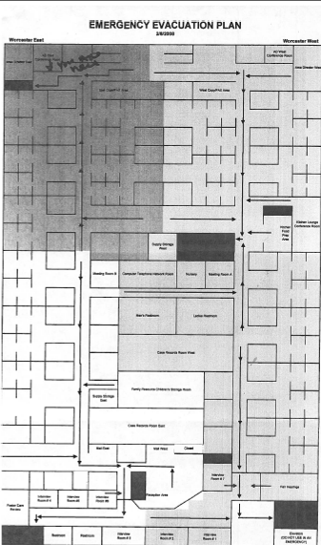
Picture 1

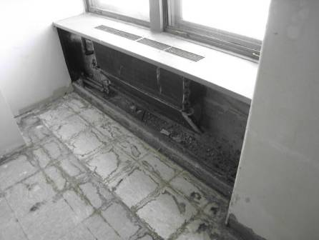

Dismantled Induction Unit

Picture 2

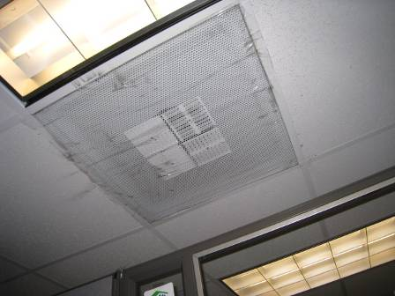

Supply Vent blocked with Tape

Picture 3

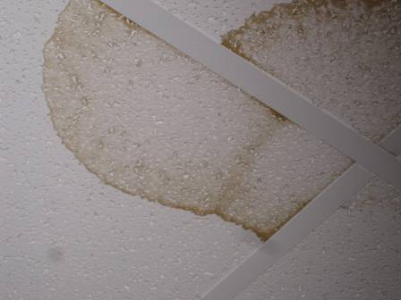

Water-damaged Ceiling Tiles

Picture 4

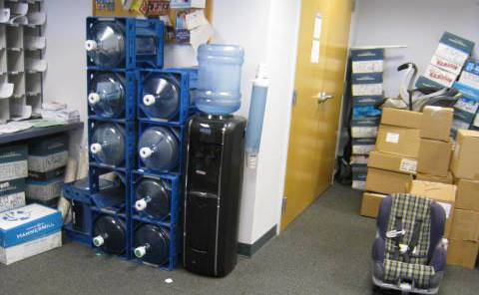

Water Cooler in Hallway

Picture 5

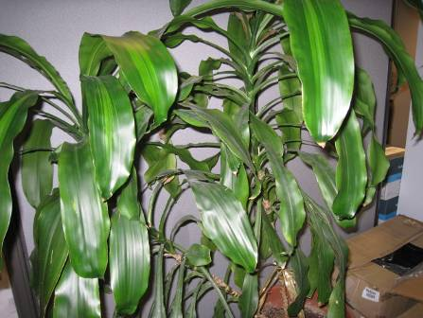

Plants Located in Work Area

Picture 6

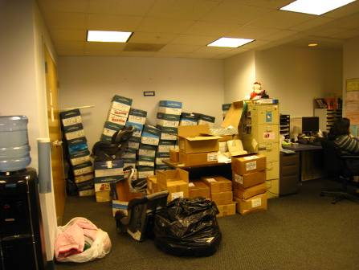

Clutter in Work Area

Picture 7

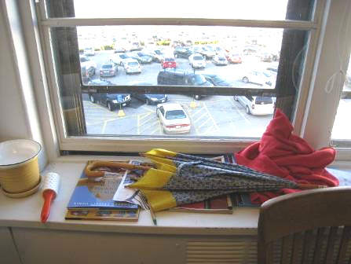

Materials on Induction Unit
Location/ Room | Occupants  in Room | Temp  (°F) | Relative  Humidity  (%) | Carbon  Dioxide  (ppm) | Carbon Monoxide  (ppm) | PM2.5  (µg/m³) | Windows  Openable | Ventilation |  | Remarks
 |  |  |  |  |  |  |  | Supply | Exhaust | Remarks
Background |  | 42 | 21 | 392 | ND | 1 |  |  |  | Cloudy, windy
Second Floor
Lounge Room | 0 | 76 | 24 | 646 | ND | 5 | Y | Y | N | Induction unit with plants
Hallway | 0 | 75 | 26 | 678 | ND | 5 | N | N | N | Clutter, cardboard, boxes, PC
004 | 0 | 75 | 25 | 724 | ND | 5 | N | N | Y | Induction unit blocked with items, clutter
005 | 0 | 75 | 26 | 642 | ND | 8 | N | N | Y | Exhaust vent dirty
006 | 2 | 76 | 25 | 724 | ND | 4 | Y | Y | N | Plants, clutter
008 | 5 | 75 | 25 | 781 | ND | 5 | Y | Y | N
012 | 3 | 74 | 26 | 605 | ND | 8 | Y | Y | N | Induction unit, PF on and dirty
014 | 2 | 76 | 24 | 745 | ND | 5 | Y | Y | N | WD CT, plants
015 | 1 | 76 | 24 | 727 | ND | 6 | N | Y | N
017 | 3 | 74 | 26 | 677 | ND | 9 | N | Y | Y | WD CT (3), PF dirty
024 | 0 | 73 | 26 | 598 | ND | 5 | Y | Y | Y | WDCT, induction unit blocked, PF dirty, clutter
025 | 0 | 73 | 26 | 649 | ND | 7 | N | Y | Y | Clutter, induction unit blocked with items
028 | 2 | 72 | 25 | 617 | ND | 6 | N | Y | N | Plants, clutter
029 | 0 | 71 | 23 | 546 | ND | 5 | N | Y | N | Clutter
031 | 2 | 71 | 26 | 777 | ND | 5 | Y | Y | Y | Induction unit, clutter
032 | 2 | 71 | 24 | 586 | ND | 5 | N | N | N
038 | 0 | 71 | 28 | 584 | ND | 8 | N | Y | Y | WD CT, PC, plants, clutter
040 | 1 | 71 | 27 | 490 | ND | 7 | N | Y | N | WD CT, PF, PC, plants on Induction unit
041 | 0 | 71 | 26 | 543 | ND | 7 | N | Y | N | Supply vent blocked with tape, induction unit blocked with items, clutter
226 | 5 | 75 | 25 | 603 | ND | 7 | N | Y | N | Induction unit, clutter, PF
229 | 0 | 71 | 23 | 546 | ND | 7 | N | Y | N
230 | 0 | 73 | 26 | 543 | ND | 6 | N | Y | N | DO
244 | 0 | 73 | 26 | 590 | ND | 5 | Y | Y | N | Induction unit, window open
245 | 0 | 73 | 26 | 650 | ND | 5 | Y | Y | N | Clutter
248 | 2 | 76 | 23 | 696 | ND | 6 | N | Y | N | WD CT
254 | 1 | 73 | 23 | 526 | ND | 8 | N | Y | N
266 | 0 | 74 | 24 | 659 | ND | 6 | N | Y | Y | WD CT, clutter, PF dirty
291 | 0 | 74 | 24 | 686 | ND | 4 | N | Y | N | WD CT (2)
293 | 6 | 73 | 26 | 725 | ND | 5 | Y | Y | N | Clutter
295 | 6 | 74 | 24 | 636 | ND | 6 | Y | Y | N | Supply vent dirty
298 | 0 | 74 | 27 | 613 | ND | 9 | N | Y | Y | Supply vent blocked
303 | 5 | 75 | 25 | 742 | ND | 6 | N | Y | Y | Induction unit, clutter
308 | 4 | 75 | 24 | 714 | ND | 5 | Y | Y | Y | Induction unit, clutter
309 | 1 | 76 | 24 | 763 | ND | 5 | N | Y | N
311 | 3 | 76 | 23 | 616 | ND | 7 | N | Y | N | Clutter
312 | 4 | 76 | 24 | 616 | ND | 7 | Y | Y | N | Induction unit blocked with items, plants
313 | 5 | 74 | 26 | 616 | ND | 8 | N | Y | N | Clutter
314 | 5 | 75 | 26 | 616 | ND | 9 | N | Y | N | Exhaust vent blocked with cardboard
316 | 3 | 76 | 25 | 525 | ND | 9 | N | Y | Y
317 | 3 | 76 | 25 | 471 | ND | 8 | N | Y | N
321 | 1 | 73 | 23 | 526 | ND | 9 | N | Y | N
322 | 3 | 75 | 23 | 594 | ND | 8 | N | Y | N
324 | 3 | 75 | 22 | 606 | ND | 8 | N | Y | N
326 | 1 | 76 | 23 | 566 | ND | 8 | N | Y | N
327 | 3 | 75 | 23 | 557 | ND | 9 | Y | Y | N | Induction unit
330 | 3 | 74 | 23 | 551 | ND | 6 | Y | Y | Y
Third Floor
Conference Room A | 0 | 73 | 26 | 402 | ND | 5 | N | Y | Y | DO
Conference Room B | 0 | 74 | 25 | 482 | ND | 5 | N | Y | Y | DO
Conference Room C | 0 | 71 | 26 | 419 | ND | 3 | N | Y | Y | DO, PF dirty
File Room | 0 | 71 | 26 | 374 | ND | 3 | N | Y | Y | DO
Hallway | 0 | 71 | 26 | 443 | ND | 3 | N | Y | Y | PC
Kitchen | 0 | 73 | 26 | 393 | ND | 4 | N | Y | Y | DO
300 | 0 | 74 | 25 | 444 | ND | 5 | N | Y | Y
305 | 1 | 71 | 27 | 443 | ND | 4 | Y | N | Y
305 | 1 | 74 | 26 | 417 | ND | 4 | N | Y | Y | DO
306 | 1 | 73 | 25 | 423 | ND | 5 | Y | N | N | DO
307 | 1 | 73 | 24 | 455 | ND | 5 | N | Y | Y | DO
309 | 0 | 72 | 25 | 370 | ND | 3 | N | Y | Y | Plants
310 | 0 | 72 | 25 | 379 | ND | 4 | N | Y | Y | DO
318 | 0 | 72 | 24 | 399 | ND | 5 | Y | Y | Y | Induction unit
323 | 1 | 72 | 24 | 425 | ND | 5 | Y | Y | Y | Induction unit
328 | 1 | 72 | 26 | 469 | ND | 4 | Y | Y | Y | Induction unit
331  Storage | 0 | 75 | 26 | 522 | ND | 5 | N | N | N | DO
333 | 2 | 73 | 25 | 402 | ND | 5 | N | N | Y | DO
335 | 1 | 74 | 26 | 574 | ND | 5 | N | N | N | DO
337 | 0 | 74 | 25 | 502 | ND | 6 | N | Y | N | DO
338 | 1 | 75 | 24 | 495 | ND | 4 | Y | N | N | Induction unit, DO
342 | 1 | 74 | 26 | 452 | ND | 6 | Y | Y | N
343 | 1 | 73 | 24 | 591 | ND | 6 | N | N | N | DO
350 | 0 | 74 | 25 | 488 | ND | 4 | Y | Y | Y | Induction unit

The ceiling plenum is the space located between a roof/floor decking and a suspended ceiling system.
An induction unit uses a series of nozzles that are connected to the building AHU to produce a jet of air. The jet of air induces (draws) air from the room into the unit through a heating/cooling coil. The room air is cooled and/or heated to control the room temperature. Room air mixes with the air jet, mixed, and is discharged into the room.

