BACKGROUND

INDOOR AIR QUALITY
PRE-OCCUPANCY ASSESSMENT

Department of Children and Families
110 Haverhill Road
Amesbury, MA

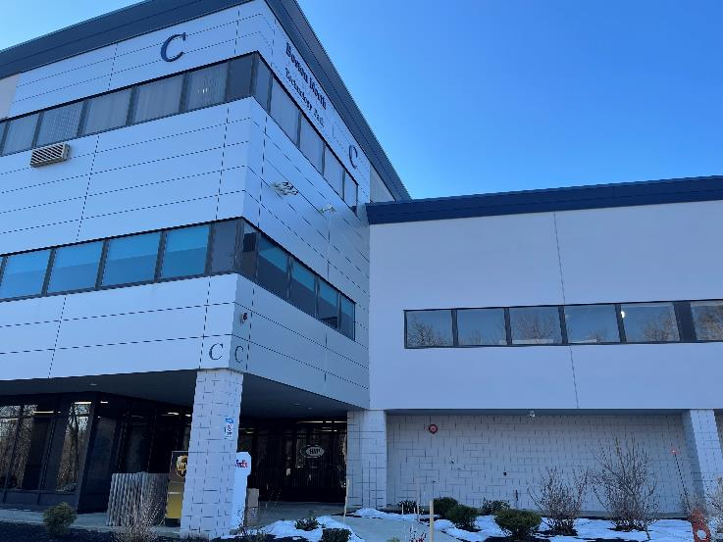

Prepared by:
Massachusetts Department of Public Health
Bureau of Environmental Health
Indoor Air Quality Program
May 2023
Building: | Department of Children and Families (DCF)
Address: | 110 Haverhill Road, Amesbury, MA
Assessment Requested by: | Jamie Blood, Regional Planner/Project Manager, Division of Capital Asset Management and Maintenance (DCAMM)
Reason for Request: | Pre-occupancy air testing prior to opening
Date of Assessment: | January 27, 2023
Massachusetts Department of Public Health/Bureau of Environmental Health (MDPH/BEH) Staff Conducting Assessment: | Michael Feeney, Director, and Jennifer Lajoie, Environmental Analyst, Indoor Air Quality (IAQ) Program
Building Description: | This office is located on Route 110 in a small office park surrounded by a mixed use of residential and commercial properties. DCF office space is located in Building C on the second floor.

At the time of inspection, personnel were moving office equipment in and setting up offices. Business was not yet in operation. Heating, ventilation, and air-conditioning (HVAC) systems were operational.

History:
The property at 110 Haverhill Road was formerly the site of the Brazonics and Antenna & Microwave Divisions of Adams-Russell Electronics Company, Inc. (Brazonics). The Brazionics site is listed as Closed under the Massachusetts Contingency Plan (MCP).
The adjacent property at 104-106 Haverhill Avenue is the former Microfab site, which closed in 1987. This site was tracked by the Massachusetts Department of Environmental Protection (MDEP) under the MCP from 1988, including a number of remedial activities. The site was subsequently listed by the EPA Superfund Program in 2017. Site assessment and remediation activities are ongoing. According to the EPA Fact Sheet on the site, “VOCs detected in groundwater include trichloroethylene (TCE), cis-1,2-dichloroethylene (cis-1,2-DCE), tetrachloroethene (PCE), and vinyl chloride. Metals (including copper, hexavalent chromium, arsenic, lead and nickel), mercury, cyanide, and TCE were detected in soil and sediment.” (USEPA, 2022).
Based on information in the Final Conceptual Site Model Technical Memorandum, elevated levels of VOCs were found in soil gas beneath the existing structure on the Microfab site, but “the known groundwater VOC plume does not underly other existing structures” which would include those on adjacent properties. Maps included with the Conceptual Site Model support this (USEPA 2019).
Note that EPA did not conduct an indoor air study in the commercial building 2 years ago when they first began site investigation because they were not permitted to access the building due to COVID. Instead, they collected data from groundwater monitoring wells and soil gas probes near the building to serve as screening for whether to conduct an indoor air study in the future. VOC levels in groundwater and soil gas have been non-detectable or very low near the building. The groundwater plume appears to skirt the edge of the building; there is no evidence of migration toward the building. Based on data thus far from groundwater monitoring wells and soil gas probes near the building, EPA and MDEP report that they see no indication that the plume is under the building, however they included the caveat that they did not sample directly below the slab. Monitoring of groundwater and soil gas along the edge of the building is ongoing. If future data indicate otherwise, they intend to conduct an indoor air study, which would include sub-slab sampling (LaPointe, 2023).

METHODS
Air tests for carbon monoxide, temperature, relative humidity, and airborne particle matter with a diameter less than 2.5 micrometers were taken with the TSI Q-Trak XP Indoor Air Quality Monitor Model 7585. Screening for volatile organic compounds (VOCs) was conducted using a MiniRAE Lite Photo Ionization Detector. BEH/IAQ staff also performed a visual inspection of building materials for water damage and/or microbial growth and examined the space for the presence of odors or other environmental concerns.
Please refer to the IAQ Manual for additional information on methods, sampling procedures, and interpretation of results (MDPH, 2015).

RESULTS AND DISUSSION
Media sampled |  | MDPH Guideline/  Comparison Value |  | Measured Range |  |  | Comments
 |  |  |  | Outdoors/  Background |  | Indoors
Carbon Dioxide (CO₂) |  | < 800 parts per million (ppm) is preferred |  | 400 |  | 474-710 | Unoccupied apart from a few people performing punch list activities
Carbon Monoxide (CO) |  | Non-detectable (ND) or equal to or below background level measured |  | ND |  | ND
Temperature |  | 70 to 78ºF |  | 48 |  | 65-69
Relative Humidity (RH) |  | 40% to 60% |  | 33 |  | 29-33
Particulate Matter 2.5 (PM2.5) |  | US EPA National Ambient Air Quality Standards (NAAQS) 35 μg/m³ or less |  | ND |  | ND | Construction in lobby outside office
Total Volatile Organic Compounds (TVOCs) |  | Equal to or below background level measured |  | 0.8 |  | 0.6-1.5* | *1.5 measured in lobby directly outside the DCF offices where painting/ spackling/drywall installation activities was currently occurring at the time of the assessment.
ppm = parts per million | µg/m³ = microgram per cubic meter |  | ND = non-detectable

At the time of the assessment, activities related to punch-list items were being conducted. The space had a slight odor of paint from the active construction area just outside the open DCF door. No evidence of water leaks or other moisture concerns were observed or reported.
Tests were taken with the mechanical ventilation system installed. Overall, conditions in the building after renovations appeared to be adequate in terms of mechanical ventilation components. Restrooms include supply and exhaust ventilation.

RECOMMENDATIONS
Based on observations and measurements at the time of the visit, the following recommendations are made:
- Consistent with previously established protocol, once the space has been occupied for a minimum of two weeks, contact the IAQ Program to conduct a post-occupancy assessment of the space. Note that a follow-up visit was conducted on March 10, 2023.
- It is recommended that building management/owners monitor and track any activities regarding hazardous waste remediation at the adjacent Superfund site and track measures if any dust/dirt/debris-generating activity is planned that may impact the building. If such activities occur, it is recommended that building management work with DCAMM and DDS on-site staff to limit any impact that such Superfund site mitigation activities might have on building occupants.
- Refer to the resource manual and other related indoor air quality documents located on the MDPH’s website for further building-wide evaluations and advice on maintaining public buildings. These documents are available at http://mass.gov/dph/iaq.

REFERENCES
LaPointe. 2023. Email from Dalene LaPointe, DPH, Bureau of Environmental Health, Environmental Epidemiology Program (2023), to Michael Feeney, DPH, Bureau of Environmental Health IAQ Program, April 7, 2023.

MDPH. 2015. Massachusetts Department of Public Health. “Indoor Air Quality Manual: Chapters I-III”. Available at: Indoor air quality - manual and appendices | Mass.gov
USEPA. 2022. Former Microfab, Inc. Superfund Site Amesbury, MA https://semspub.epa.gov/work/01/100020313.pdf)

USEPA. 2019. Final Conceptual Site Model Technical Memorandum Microfab, Inc. (Former) Superfund Site Amesbury, Massachusettshttps://semspub.epa.gov/work/01/100016572.pdf)

