INDOOR AIR QUALITY ASSESSMENT

Department of Children and Families
140 High Street,
5th Floor
Springfield, Massachusetts

Prepared by:
Massachusetts Department of Public Health
Bureau of Environmental Health
Indoor Air Quality Program
November 2021

Background
Building: | Department of Children and Families (DCF)
Address: | 140 High Street, 5th Floor  Springfield, Massachusetts
Assessment Requested by: | Executive Office of Health and Human  Services (EOHHS) Facilities  Department
Reason for Request: | Odor and Indoor Air Quality (IAQ) concerns
Date of Assessment: | October 1, 2021
Massachusetts Department of Public Health/Bureau of Environmental Health (MDPH/BEH) Staff Conducting Assessment: | Mike Feeney, Director, IAQ Program
Building Description: | This building was constructed as a  hospital in the early 1900s. A west  wing addition was built in 1968. DCF  has occupied the space since July of  2008. Other EOHHS offices occupy  adjacent space in the building.
Windows: | Not openable

Introduction
This space was visited by the MDPH IAQ program several times, including assessments in 2012, 2015 and 2021. The 2015 report is available on the MDPH IAQ website at: https://www.mass.gov/info-details/indoor-air-quality-reports-cities-and-towns-s. Prior to the current assessment, the building complex reportedly lost heating for a period of time. After heating was restored, employees on the 5th floor complained of odors and other IAQ related issues.

Methods
Please refer to the IAQ Manual for methods, sampling procedures, and interpretation of results (MDPH, 2015). Fan coil units (FCU) in areas with reported odors were opened and examined.

Results and Discussion

Ventilation
A heating, ventilating and air conditioning (HVAC) system has several functions. First it provides heating and, if equipped, cooling. Second, it provides a source of fresh air. Finally, an HVAC system dilutes and removes normally occurring indoor environmental pollutants by not only introducing fresh air, but by filtering the airstream and ejecting stale air to the outdoors via exhaust ventilation. Even if an HVAC system is operating as designed, point sources of respiratory irritation may exist and cause symptoms in sensitive individuals.
Fresh air is provided by ceiling-mounted fresh air diffusers and a mechanical exhaust vent system removes stale air. FCUs designed to provide both heating and cooling are installed along exterior walls within the building. Depending on the setting, heated or chilled water is pumped through a finned tube (i.e., a coil) that is connected to the furnace/chiller by copper pipes that are installed in the pipe chase. Water runs through supply pipes into the coils, which heat/cool the air forced through the coils by the FCU fans. It is important to note that FCUs do not have a fresh air supply, as they only recirculate air.
To maximize air exchange, the MDPH recommends that both supply and exhaust ventilation operate continuously during periods of occupancy. In order to have proper ventilation with a mechanical supply and exhaust system, the systems must be balanced to provide an adequate amount of fresh air to the interior of a room while removing stale air from the room. It is recommended that HVAC systems be re-balanced every five years to ensure adequate air systems function (SMACNA, 1994). It is unknown when the last time this system was balanced.
Of note, is the type of air filter used in the FCUs. Instead of single manufactured filters with cardboard frames, some units appear to have two filters taped together (Picture 1). Filters were also found ajar in the filter frame. Properly sized and fitted filters will prevent the accumulation of debris in the FCUs. This is necessary to prevent odors when such debris becomes moistened by condensation during the cooling season. In previous reports, it was noted that FCUs had metal frame filters which provide minimal filtration.
The dust spot efficiency is the ability of a filter to remove particulate matter of a certain diameter from air passing through the filter. ASHRAE indicates that filters with a dust spot efficiency of a minimum of 40 percent would be sufficient to reduce many airborne particulates (Thornburg, 2000; MEHRC, 1997; ASHRAE, 1992). Pleated filters with a minimum efficiency reporting value (MERV) dust-spot efficiency of 8 or higher are recommended to filter out pollen and mold spores.

Microbial/Moisture Concerns
It is important to note that Massachusetts has experienced extended periods of relative humidity during the summer of 2021. This July was the wettest ever recorded in Massachusetts, and the three-month period from June through August, known as the meteorological summer, was the fourth-wettest on record, according to the National Oceanic and Atmospheric Administration’s Centers for Environmental Information. The three-month period also was the third-warmest ever in the state and was tied for the warmest on record across the United States. (HG, 2021, NOAA, 2021).
In this weather, FCUs would produce significant amounts of condensation, and the condensed water would accumulate in the drip pan beneath the coils to then be drained from the unit. Substantial amounts of accumulated debris were noted in the drip pans in FCUs (Picture 2). Given the weather conditions of the summer 2021, it is likely that FCUs were accumulating condensation from several weeks to months which was chronically moistening the debris in coils and drip pans, which can then produce odors.
The conditions in the DCF office are complicated due to the likely presence of leaks from the heating system piping, valves, and joints. Remediation of leaks may require removal of plaster walls. While plaster is resistant to mold growth, accumulated dust, dirt and other debris may serve as a mold growth media if repeatedly moistened. In addition, steam leaks can be irritating to the eyes, nose, and respiratory system, particularly if drawn into the FCUs adjacent to employee workstations.

Conclusions/Recommendations
In views of the findings at the time of the visit, the following recommendations are made:

- Implement recommendation made in previous IAQ assessments (https://www.mass.gov/info-details/indoor-air-quality-reports-cities-and-towns-s).
- Ensure that properly sized filters are installed in FCUs and that filters fit flush with the filter holder. Use filters of a MERV rating of at least 8.
- Inspect FCUs for debris accumulation and clean scale and debris from all FCU drip pans.
- Consider having the interior of all FCUs cleaned by an HVAC service company that has experience cleaning FCUs of this age. Such work should be done when offices/locations serviced by the FCUs are not occupied by workers.
- After initial cleaning, implement regular inspections of each FCU when filters are changed for accumulation of debris in coils and the drip pan and clean as needed.

References
ASHRAE. 1992. Gravimetric and Dust-Spot Procedures for Testing Air-Cleaning Devices Used in General Ventilation for Removing Particulate Matter. American Society of Heating, Refrigeration and Air Conditioning Engineers. ANSI/ASHRAE 52.1-1992.
HG. 2021. Mold keeps South Hadley High School shuttered. Hampshire Gazette. https://www.gazettenet.com/South-Hadley-High-School-still-closed-amid-mold-remediation-42413519.
MDPH. 2015. Massachusetts Department of Public Health. Indoor Air Quality Manual: Chapters I-III. Available at: https://www.mass.gov/lists/indoor-air-quality-manual-and-appendices
MEHRC. 1997. Indoor Air Quality for HVAC Operators & Contractors Workbook. MidAtlantic Environmental Hygiene Resource Center, Philadelphia, PA.
NOAA. 2021. Summer 2021 neck and neck with Dust Bowl summer for hottest on record. National Oceanic and Atmospheric Administration, 1401 Constitution Avenue NW, Room 5128, Washington, DC 20230: https://www.noaa.gov/news/summer-2021-neck-and-neck-with-dust-bowl-summer-for-hottest-on-record
SMACNA. 1994. HVAC Systems Commissioning Manual. 1st ed. Sheet Metal and Air Conditioning Contractors’ National Association, Inc., Chantilly, VA.
Thornburg, D. 2000. Filter Selection: a Standard Solution. Engineering Systems 17:6 pp. 74-80.

Picture 1
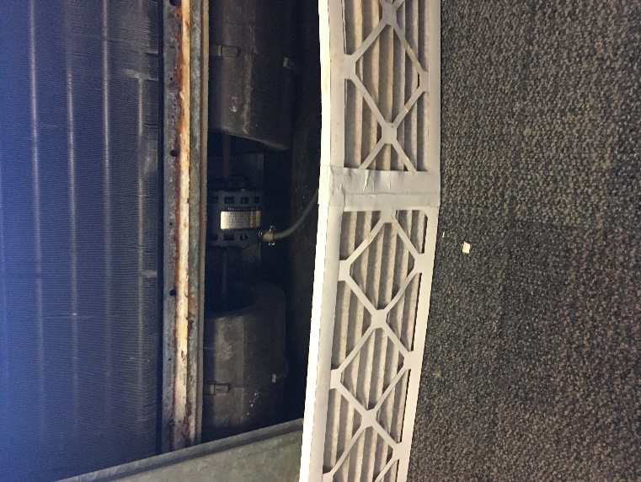
Filters taped together

Picture 2
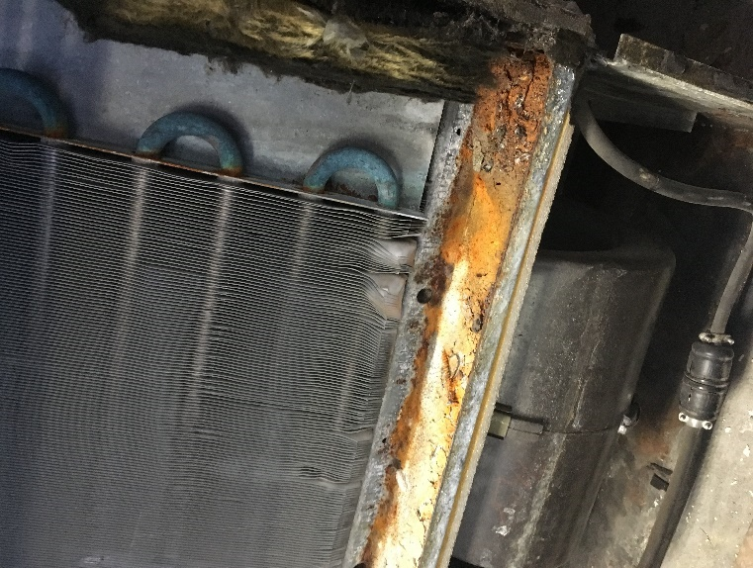
Debris in drip pan

