INDOOR AIR QUALITY ASSESSMENT
MOLD INVESTIGATION

Department Of Children and Family
810 Memorial Drive
Cambridge, Massachusetts

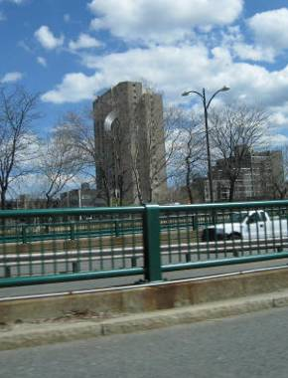

Prepared by:
Massachusetts Department of Public Health
Bureau of Environmental Health
Indoor Air Quality Program
February 2011

Background/Introduction
At the request of Doug Shatkin, Human Resources Director for the Massachusetts Executive Office of Health and Human Services’ (EOHHS) Department of Children and Families (DCF), the Massachusetts Department of Public Health (MDPH), Bureau of Environmental Health (BEH) provided assistance and consultation regarding water damage and mold concerns at the DCF’s Cambridge/Somerville Area Office located at 810 Memorial Drive, Cambridge, Massachusetts. The DCF is located on the third and second floor of a multi-story high-rise apartment complex building. On April 8, 2010, a fire in an apartment above the DCF offices reportedly activated the fire suppression system, causing water damage to areas on lower stories. The third floor of the DCF offices is divided into 9 areas (Figure 1). Areas 5 and 8 were water-damaged from the sprinkler activation.
On April 15, 2010, a visit to conduct an assessment was made by Michael Feeney, Director of BEH’s Indoor Air Quality (IAQ) Program and Sharon Lee, an Environmental Analyst/Inspector within BEH’s IAQ Program.

Methods
BEH staff performed a visual inspection of building materials for water damage and mold growth. Moisture content of porous building materials [e.g., carpeting, gypsum wallboard (GW)] was measured with a Delmhorst, BD-2000 Model, Moisture Detector equipped with a Delmhorst Standard Probe and a Tramex Moisture Encounter Plus Non-Destructive Moisture Detector.

Results
The DCF has a staff population of 50, with up to 100 people visiting the building daily. Visual observation/evaluation+ and moisture testing were taken under normal operating conditions.

Discussion

Microbial/Moisture Concerns
A section of offices and hallways on the second and third floors (Figure 1) were damaged by the water resulting from the fire mentioned previously. At the time of the MDPH assessment, restoration efforts were underway in DCF space. GW and carpeting had been removed, and fans/dehumidifiers were operating to aid the drying of building materials. BEH staff conducted moisture sampling of GW in areas under renovation and found no measureable levels of moisture. In areas adjacent to the renovation areas, moist GW was found behind plastic wall coving (Figure 1, Pictures 1 and 2). MDPH/IAQ staff recommended to DCF staff that coving in these areas be removed and dried in a manner similar to other areas where remediation was underway.
Of note is the route of water entry to the DCF space. Floor decking above the water-damaged area appeared free of water staining (Picture 3). A pipe (the function of which was unknown) was observed above the area where DCF staff identified the point of water entry. This pipe had two openings. The interior of the pipe appeared corroded, indicating the pipe is likely used for water drainage from upper stories. These pipe openings are the most likely source of water that caused the damage observed on the third floor. Water that pooled on the third floor likely passed through spaces in the floor/decking, resulting in damage to the second floor.
In order for building materials to support mold growth, a source of water exposure is necessary. Identification and elimination of the source of water moistening building materials is necessary to control mold growth. The US Environmental Protection Agency (US EPA) and the American Conference of Governmental Industrial Hygienists (ACGIH) recommends that porous materials be dried with fans and heating within 24 to 48 hours of becoming wet (US EPA, 2001; ACGIH, 1989). If porous materials are not dried within this time frame, mold growth may occur. Cleaning cannot adequately remove mold growth from water-damaged porous materials. The application of a mildewcide to mold contaminated, porous materials is not recommended.
In Area 3 (Figure 1), an office appeared to have significant water staining. This damage is likely related to a series of drain pipes located above the suspended ceiling (Picture 4). Two conditions noted likely play a role in pipe leakage. First, the pipes are held together using screw clamps with a rubber gasket (Picture 5). Secondly, Pipe 1 appears to be “draining upward” into the main drain pipe (Pipe 5). The direction water is flowing from Pipe 1 to Pipe 5 suggests that a device is pumping water into this drain system, thereby pressurizing the pipes. The use of rubber screw clamps in a pressurized drain system like this can lead to spaces between the gasket and pipe joint, since the pipes are not coupled and sealed in a manner to render the joints airtight. Once gaps are created, repeated water leakage will occur, resulting in water damage to ceiling tiles, GW and carpeting, all of which can support mold growth.
Some ceiling tiles in offices along exterior windows were found water-damaged. It is likely that the window frame sealant has eroded over time (Picture 6). Efflorescence was observed above window frames near the aforementioned damaged ceiling tiles, indicating water is concentrating at the wall/window frame seam. Window frames should be re-caulked when water damage is apparent around sill and adjacent ceiling tiles.

Other Conditions
Office staff report that the reception area in Area 8 experiences pungent odors (Figure 1). A pair of restrooms is located in this general area. Each restroom has functioning exhaust ventilation. A custodial closet adjacent to the restrooms has a sink and various drain pipes (Picture 7). The custodial closet does not have a mechanical exhaust vent. Of note are pipes that empty into the mop sink. These pipes are the most likely sources of reported odors. When the restroom exhaust vents are operating, odors are drawn out of the custodial closet into the waiting room.
Another issue of concern is the condition of mechanical rooms. Of note is an AHU that has a filter held in place by a heating coil (Picture 8), which is installed over the air intake for the unit. The filter does not completely cover the air intake opening, which can result in airborne dirt, dust, odors and particulates being drawn into the HVAC system and distributed to occupied areas. The filter is in contact with a radiant heat source, which poses a fire hazard. Disposable filters are not designed to be in contact with HVAC system heating coils.

Conclusions/Recommendations
A number of significant steps to remediate water-damaged building materials were in the progress at the time of the assessment. however, conditions unrelated to the sprinkler activation were also observed in the office space. At the time of the assessment, BEH staff advised DCF staff of the conditions present in the building. Based on these observations, the following recommendations were made:
- Install appropriate filter in air intake in mechanical room. Remove filter that is in contact with heating coils.
- Continue to remediate water damaged areas, including those identified by BEH staff.
- Fix plumbing leaks in ceiling noted in Pictures 4 and 5.
- Examine gaskets/caulking around windows where stained ceiling tiles exist.
- Reconfigure the filter on the AHU in Picture 8 so that it is not held in place by the heating coil.
- Refer to resource manuals and other related indoor air quality documents for additional building-wide evaluations and advice on maintaining public buildings. These materials are located on the MDPH’s website: http://mass.gov/dph/iaq.

References
ACGIH. 1989. Guidelines for the Assessment of Bioaerosols in the Indoor Environment. American Conference of Governmental Industrial Hygienists, Cincinnati, OH.
ASHRAE. 1989. Ventilation for Acceptable Indoor Air Quality. American Society of Heating, Refrigeration and Air Conditioning Engineers. ANSI/ASHRAE 62-1989
US EPA. 2001. “Mold Remediation in Schools and Commercial Buildings”. Office of Air and Radiation, Indoor Environments Division, Washington, DC. EPA 402-K-01-001. March 2001. Available at: http://www.epa.gov/iaq/molds/mold_remediation.html

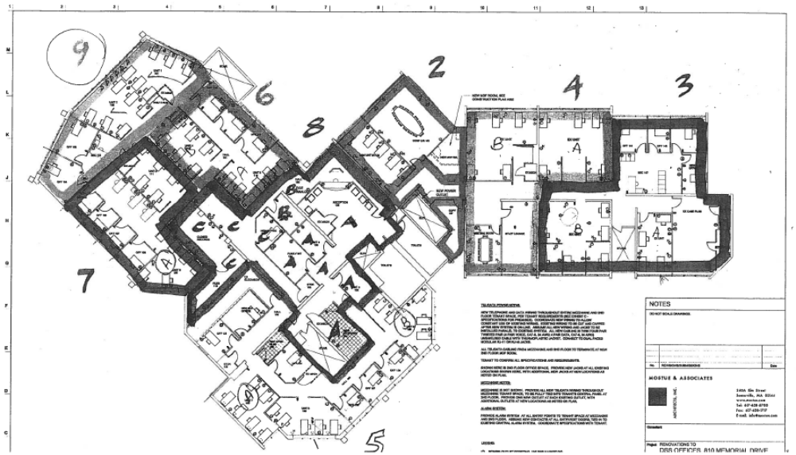

Area Damaged by Sprinkler Release

Location of Musty Odors

Area of Water Damage Unrelated to
Sprinkler Release

Area of Remain Moistened GW

Picture 1

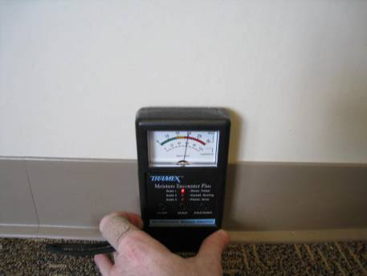

Wet GW behind Coving next to Mechanical Room in Area 5
(Note indicator needle in red zone, indicating moisture)

Picture 2

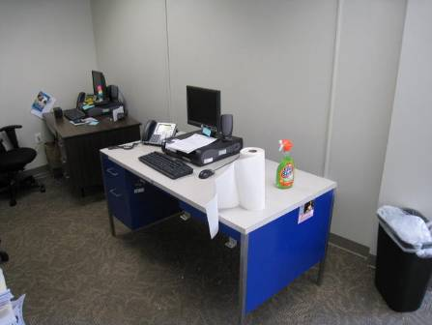

Moistened GW behind Desk in Area 5A
Picture 3

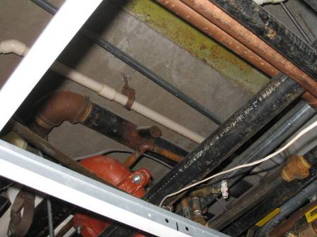

Open Drain Pipe in Ceiling Plenum

Picture 4

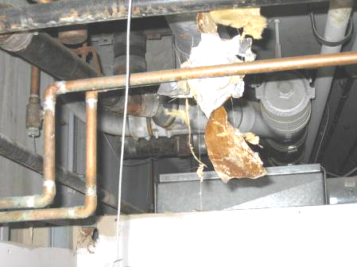

3
2

4
5

Drain Pipes above Water Damage in Area 3
(Note Pipes (Numbered 1-5), all feed into Pipe 5)

Picture 5

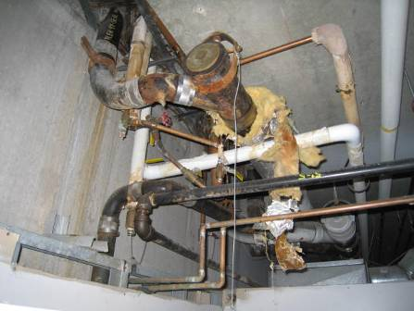

3

2
1
5

Clamp and Gasket holding pipe together. Note Drain Pipe #1 is “Draining” Upwards, Which Likely Indicates Pressurization of the Main Drain Pipe)

Picture 6

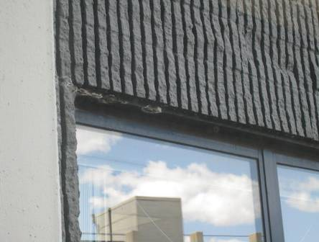

Possible Eroded Gaskets in Location of Water Damaged Ceiling Tiles

Picture 7

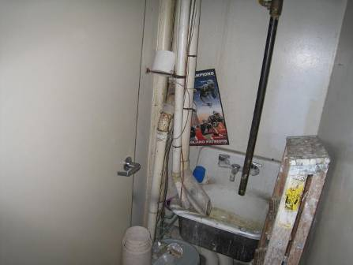

Sink and Pipes in Custodial Closet

Picture 8

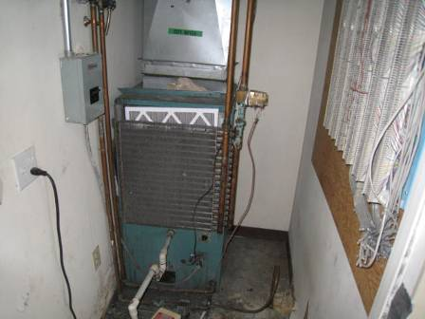

Filter Held in place by Heating Coil

