INDOOR AIR QUALITY ASSESSMENT

Department of Children and Families Office
151 West Boylston Drive
Worcester, MA

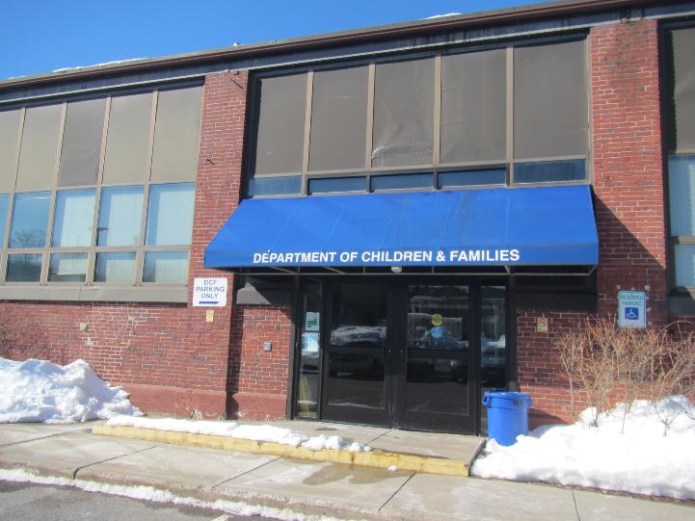

Prepared by:
Massachusetts Department of Public Health
Bureau of Climate and Environmental Health
Division of Environmental Health Regulations and Standards
March 2026

BACKGROUND
Building: | Department of Children and Families Office (DCF)
Address: | 151 West Boylston Drive, Worcester, MA
Assessment Requested by: | Pedro Batista, EOHHS Facilities
Reason for Request: | General indoor air quality (IAQ) and water damage issues
Date of Assessment: | February 27, 2026
Massachusetts Department of Public Health/Bureau of Climate and Environmental Health/Division of Environmental Health Regulations and Standards (MDPH/BCEH/EHRS) Staff Conducting Assessment: | Ruth Alfasso, Environmental  Engineer, EHRS
Building Description: | The DCF office is located in a single-story brick building that may be about 100 years old. The roof is partly flat and part slightly pitched. Another current tenant in the building is a medical supply company.
Windows: | Windows are not openable in this building.

METHODS
Please refer to the IAQ Manual for methods, sampling procedures, and interpretation of results (MDPH, 2015).

RESULTS AND DISCUSSION
The following is a summary of indoor air testing results (Table 1).
- Carbon dioxide levels were below the MDPH guideline of 800 parts per million (ppm) in all areas assessed, indicating work areas had adequate ventilation for the occupancy at the time of the visit.
- Temperature was within the recommended range of 70°F to 78°F in most areas assessed.
- Relative humidity was below the MDPH recommended range of 40 to 60% in all areas assessed. This is reflective of outdoor conditions. Low relative humidity is common indoors during the heating season. Note that low relative humidity can lead to common symptoms such as: dry skin, lips, and scalp; dry/scratchy throats and noses (nose bleeds); exacerbation of asthma, eczema, or allergies; dry/irritated eyes; and irritation of respiratory tract.
- Carbon monoxide was not detected (ND) in all areas tested. Carbon monoxide should not be present in a typical, indoor environment. If it is present, indoor carbon monoxide levels should be less than or equal to outdoor levels.
- Fine particulate matter (PM2.5) concentrations measured were below the National Ambient Air Quality Standard (NAAQS) level of 35 μg/m³ in all areas assessed.

Ventilation
A heating, ventilating, and air conditioning (HVAC) system has several functions. First, it provides heating and, if equipped, cooling. Second, it is a source of fresh air. Finally, an HVAC system will dilute and remove normally occurring indoor environmental pollutants by introducing fresh air, filtering the airstream and ejecting stale air to the outdoors via exhaust ventilation. Even if an HVAC system is operating as designed, point sources of respiratory irritation may exist and lead to symptoms in sensitive individuals.
Fresh air is provided by rooftop air-handling units (AHUs; Picture 1). Two or three units serve the DCF spaces in the building. Fresh air is drawn into the AHUs through a bank of filters, heated or cooled, and delivered to occupied areas via ducted supply diffusers (Picture 2). Return air is drawn into ceiling-mounted vents (Picture 2) and ducted back to the rooftop AHUs.
To have proper ventilation with a mechanical supply and exhaust system, the systems must be balanced to provide an adequate amount of fresh air to the interior of a room while removing stale air from the room. It is recommended that HVAC systems be re-balanced every five years to ensure adequate air systems function (SMACNA, 1994). It is not known when the system was last balanced.
The ventilation system should be on and operational to supply fresh air continuously during occupied periods. Without adequate fresh air supply and removal of stale air, common indoor air pollutants can build up and cause irritation. Thermostats in the building (Picture 3) show that the system in a “fan on” mode, which is likely the setting that allows for continuous air circulation whether or not the system is calling for heating or cooling as recommended by the EHRS. Note that one thermostat (Picture 4) showed a problem with a sensor. Temperature control issues had previously been a concern in this building, but have not been reported recently and most temperatures measured were within the EHRS guidance.
A carbon dioxide sensor was noted in the larger conference room (Picture 5). The display of this unit agreed well with the EHRS measurement in the same area. Carbon dioxide sensors are useful in rooms where occupancy can vary from empty to highly occupied to make sure the ventilation system is activated when carbon dioxide increases due to occupancy.
Building staff reported that filters of a MERV 8 (Minimum Efficiency Rating Value of 8) rating are currently in use in the building and are changed at least 2 times a year. Higher MERV-rated filters had reportedly been installed to supply additional protection during return-to-work after COVID-19 pandemic lockdowns, but this caused stress on the equipment. The EHRS recommends that filters should be at least MERV 8 which is sufficient to remove pollen and other airborne particles (ASHRAE, 2012), and that filters be changed at least 2 times a year.

Water damage issues
A few water-damaged ceiling tiles were noted in the building (Table 1; Pictures 6 and 7). These water-damaged tiles appear to be from the roof or building envelope. None of the water-damaged tiles had dark staining indicating mold. Some of the cloth coverings on lights also had water stains. Water-damaged ceiling tiles should be replaced once an issue has been identified and repaired. A water-damaged ceiling tile and water damage to a wall were noted in one exterior office (Pictures 8 and 9). This pattern of water damage suggests that the exterior of the building or roof edge/gutter in this area needs repair.
A ductless air conditioning unit was noted on the wall of the MDF room for temperature control of computer equipment. Water stains were noted on the wall below the unit (Picture 10) where the condensation drain tube and the condensation pump are located. In addition, a box underneath the unit had water stains (Picture 11). The condensation drainage for ductless units needs to be checked periodically for clogs or breaks that can let water leak indoors. Porous items should not be stored below these units.
Small refrigerators (Table 1; Picture 12) and water dispensers were located in carpeted areas. Leaks or spills from these appliances can damage carpeting. A large refrigerator was in the Staff Support room. This refrigerator was full and somewhat disorganized (Pictures 13 and 14). One of the small refrigerators had evidence of past spills inside (Picture 15). All refrigerators in use need to be kept clean to prevent odors. Note that while refrigerators in this office building are not covered by the food code, it is good practice to have a thermometer in each refrigerator that is visible to ensure refrigerated food temperatures are kept at 5ºC (41ºF) or less (US FDA, 2022).
Food, food preparation equipment, and related items were found in many offices and common areas (Pictures 16 through 18). Food needs to be kept in tightly-sealed pest-proof containers when not in use. All crumbs and other food debris need to be removed from surfaces and appliances such as toasters and microwaves to avoid attracting pests.
The exterior of the building was examined for issues that may compromise IAQ. Not all of the building could be examined due to recent heavy snow, including the roof. It is known that the roof sometimes leaks, leading to stained ceiling tiles. A small amount of ice damming was also noted along the roof edge. This can lead to water infiltration into the building if significant precipitation falls, or snow melts, before the ice at the roof’s edge can melt away. Given weather conditions in the week following the visit, ice dam impacts are not likely to be significant at this time.
This building has apparently been changed over time. Brickwork on the front appears to have been filled in in different styles, potentially showing where doors had been in the past (Picture 19). Areas where different types/ages of materials meet may be more likely to leak. Other areas of brick appeared to be slightly deteriorated and may need repointing. On the day of the site visit, snow was noted piled up against the sides of the building. As this melts, care should be taken that meltwater is not being held against the building by piles of snow.
There is an attached portion of building along one edge of the DCF space (Picture 20) that contains electrical equipment used by the building owner. This building, though attached to the main building, is not part of the DCF space, and is not accessible to DCF staff. DCF staff also had concerns about a warehouse in the building that is not a part of DCF space, including concerns about water damage and mold in this space. The side door used for some DCF access and egress is not far from roll-up doors to this warehouse space (Picture 21). This space was not accessible during the visit, but information and pictures have been requested from the landlord. These spaces should be separated by firewalls, and there should be no impact on the occupants of the DCF space. Note, however, that a dumpster is near the door (Picture 21). If the dumpster is not kept closed and leak-free, this may lead to odors entering the building. Servicing of the dumpster may also lead to truck exhaust fumes entering the space when the door is opened. The door itself appeared to close tightly, with no light visible around it from the inside.

Other IAQ issues
Significant amounts of materials are stored in this office, including papers, boxes, clothing, car seats, and other materials useful in DCF work. Many of the storage areas were overfilled and disorganized (Pictures 22 and 23). Offices for DCF that have been planned more recently have storage areas that better suit the needs of the agency, however there appears to be sufficient space available for the items in the building. Storage areas need to be kept clean and organized. With items kept on floors, janitorial staff are less effective at surface cleaning. Items in piles can also become harborage for pests. Furthermore, items that are on floors may become moistened by condensation if the floors are cooler than the air in the summer.
Most areas in the building are carpeted. Carpeting needs to be cleaned regularly using a HEPA-equipped vacuum, and deep cleaned once or twice a year. Waiting areas and some high-traffic areas are not carpeted, however some high-traffic areas still have carpeting which can be difficult to keep clean. Some supply vents were noted to be dusty. These should be cleaned periodically.
Some lights were covered with fabric (Picture 7). This material may not be allowed per the fire code. Any material that is allowed should be cleaned periodically to remove dust and odors. Some of the cloth covers showed signs of water damage. These should be carefully laundered or replaced.
While VOC testing was not conducted, products were in use in the office that can increase VOCs in the air. Items including hand sanitizers, cleaners, and scented products were noted (Picture 24). Products with strong scents, including scent sprays and essential oils should not be used in a shared office space as many people are sensitive to fragrance compounds.

CONCLUSIONS/RECOMMENDATIONS
In view of the findings at the time of the visit, the following recommendations are made:

Ventilation recommendations
- Continue to operate supply and exhaust ventilation in all areas continuously during occupied periods.
- Have the HVAC system balanced every 5 years in accordance with SMACNA recommendations (SMACNA, 1994).
- Continue to change filters for HVAC units at least two to four times a year or as per the manufacturers’ recommendations using filters with a Minimum Efficiency Rating Value (MERV) of 8 or better. Ensure HVAC cabinets are cleaned of debris during filter changes.
- Ensure the thermostat showing a sensor fault is repaired or reconnected.
- Have the carbon dioxide sensor in the conference room calibrated or replaced when recommended by the manufacturer.
- For buildings in New England, periods of low relative humidity during the winter are often unavoidable. Therefore, scrupulous cleaning practices should be adopted to minimize common indoor air contaminants whose irritant effects can be enhanced when the relative humidity is low. To control dust, a high efficiency particulate arrestance (HEPA) filter equipped vacuum cleaner in conjunction with wet wiping of all surfaces is recommended. Avoid the use of feather dusters. Drinking water during the day can help ease some symptoms associated with a dry environment (throat and sinus irritations).

Water damage recommendations
- Replace water-damaged ceiling tiles. During replacement, check above the suspended ceiling system for additional damage to porous materials or obvious gaps in the building envelope and clean/repair as needed.
- Repair water damage to the wall shown in Picture 9.
- Inspect the roof edge and gutters for damage including damage due to ice dams and repair.
- Check the tubing and pump for the ductless air conditioning unit in the MDF room for clogs and leaks and clean/repair. Clean the water stains from the wall. Check periodically during the cooling season for issues with condensation from this unit.
- Do not store items underneath the ductless air conditioner.
- Consider moving refrigerators and water dispensers to areas without carpeting or use a waterproof mat underneath.
- Routinely clean food/liquid stains from refrigerators and keep items inside organized. Ensure there is a process for refrigerators to be cleaned out regularly to avoid spoiled food.
- Consider consolidating to use fewer small refrigerators in the office.
- It is good practice to have a visible thermometer in each refrigerator to ensure they are kept at an appropriate temperature, 5ºC (41ºF) or less (US FDA, 2022).
- Ensure all microwaves, toasters, coffee makers, or any other appliances used to prepare or heat food are kept clean
- Keep all food in pest-proof containers that are closed at all times, and avoid using food items for decoration.
- Have the building exterior including brickwork examined by a building envelope contractor to determine if repointing or other work is needed to increase water-tightness.
- Remove accumulations of snow against the exterior of the building.
- Request information from the landlord on the condition of the warehouse space to eliminate any cause of concern about mold in this area.
- Inspect above ceiling tiles in the area abutting the warehouse space for any light or other potential penetrations and seal them.
- Ensure the dumpster shown in Picture 21 is in good condition and kept closed and leak-free. Keep the door to DCF space tightly closed when the dumpster is being serviced.

Other recommendations
- Reduce clutter and ensure items have a location for proper storage. Items may need to be thoroughly sorted to discard unneeded/outdated items to make space for necessary items. Items should be organized and stored off the floor to allow for thorough cleaning.
- Consider if cloth used to cover lights is acceptable under the fire code. If allowable, ensure these items are laundered periodically to remove dust and odors.
- Have the carpets vacuumed regularly and deep cleaned once or twice a year.
- Use VOC-containing products with good ventilation. Avoid products with strong scents or products the purpose of which is to impart a scent (e.g., essential oils, fragrance sprays, or scented candles).
- Periodically clean dust from supply and return vents and fans.
- Refer to resource manual and other related IAQ documents located on the MDPH’s website for further building-wide evaluations and advice on maintaining public buildings. These documents are available at: http://mass.gov/dph/iaq.

REFERENCES
ASHRAE. 2012. American Society of Heating, Refrigeration and Air Conditioning Engineers (ASHRAE) Standard 52.2-2012 -- Method of Testing General Ventilation Air-Cleaning Devices for Removal Efficiency by Particle Size (ANSI Approved).
MDPH. 2015. Massachusetts Department of Public Health. Indoor Air Quality Manual: Chapters I-III. Available at: https://www.mass.gov/lists/indoor-air-quality-manual-and-appendices.
SMACNA. 1994. HVAC Systems Commissioning Manual. 1st ed. Sheet Metal and Air Conditioning Contractors’ National Association, Inc., Chantilly, VA.
US EPA. 2025. National Ambient Air Quality Standards (NAAQS). US Environmental Protection Agency, Office of Air Quality Planning and Standards, Washington, DC. Last updated on November 4, 2025
US FDA. 2022. 2022 Food Code. U.S. Department of Health and Human Services. U.S. Food and Drug Administration. College Park, MD January 18, 2023 Version. https://www.fda.gov/media/164194/download

Picture 1
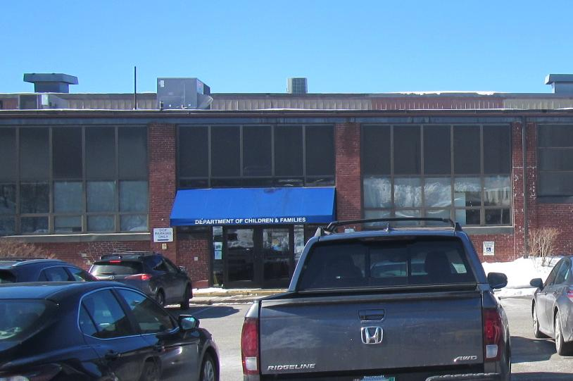
Air handling unit on the roof of the building (arrow)
Picture 2
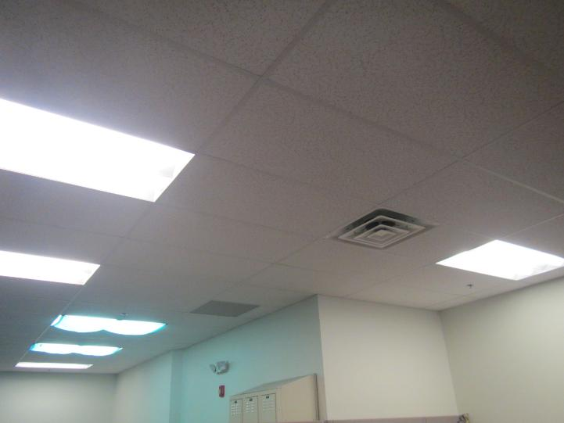
Supply (front right) and return (center rear) vent in ceiling, also note cloth coverings

Picture 3
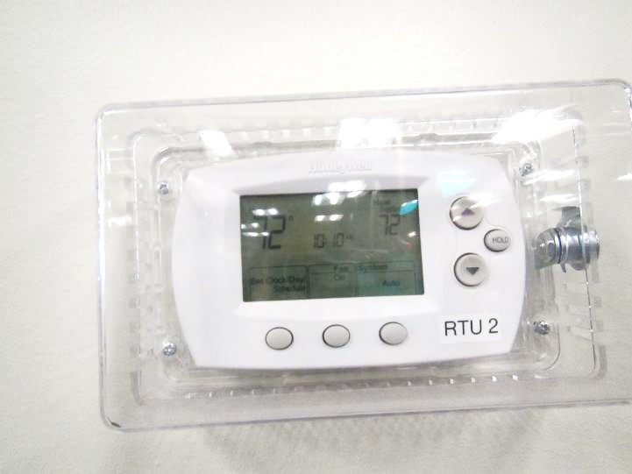
Thermostat showing fan on mode
Picture 4
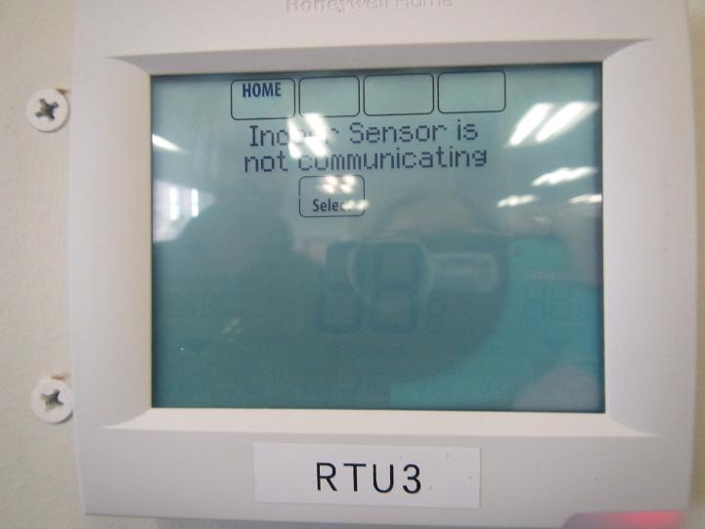
Thermostat showing an issue with a sensor

Picture 5
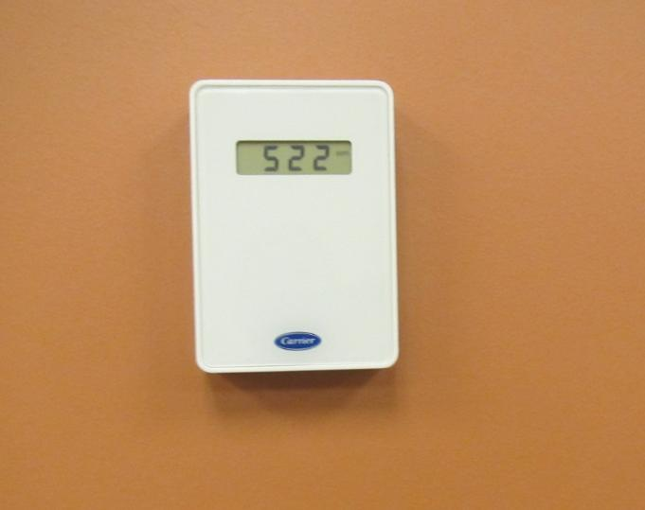
Carbon dioxide sensor in a large conference room agreed well with EHRS equipment
Picture 6
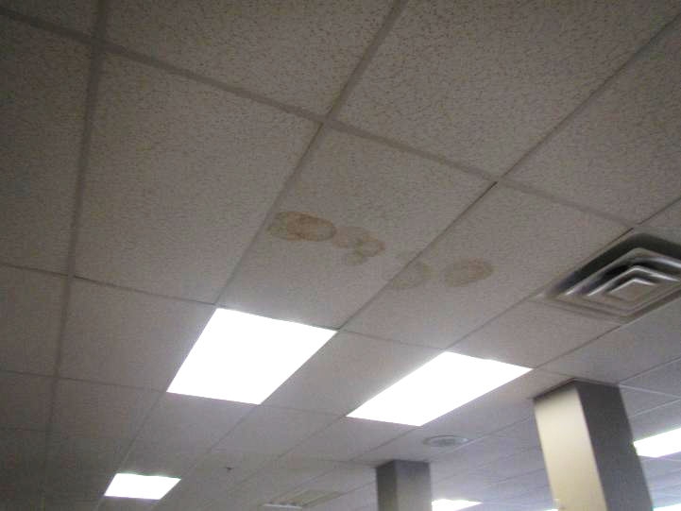
Water-damaged ceiling tiles

Picture 7
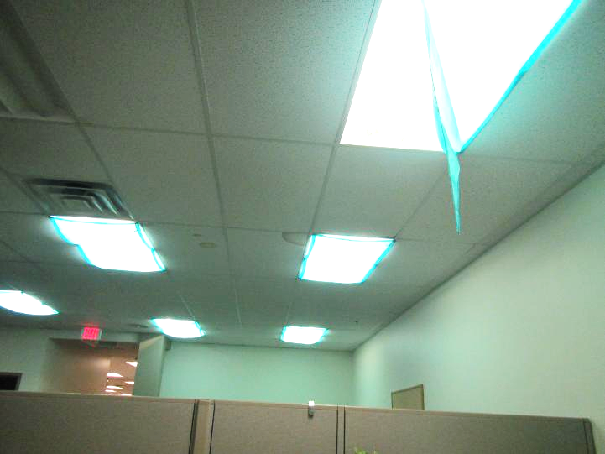
Water-damaged ceiling tiles; one of the light coverings has water damage as well
Picture 8
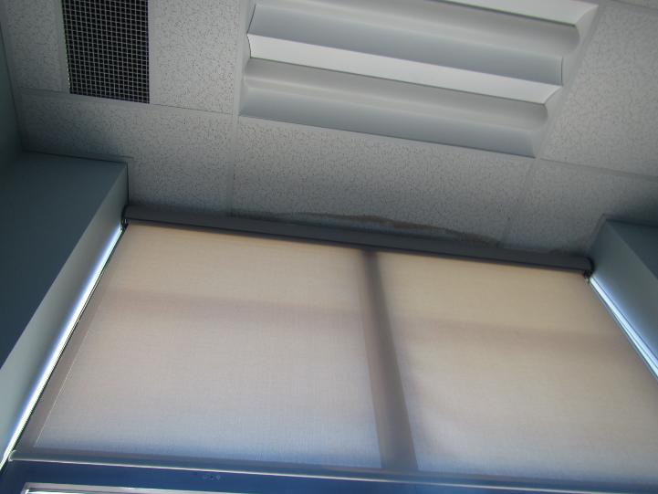
Water-damaged ceiling tile above window in an exterior office

Picture 9
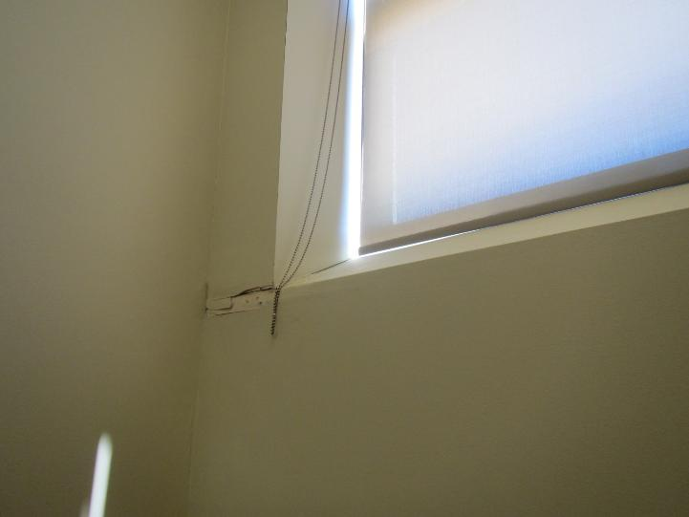
Water-damaged wall under window shown in Picture 8
Picture 10
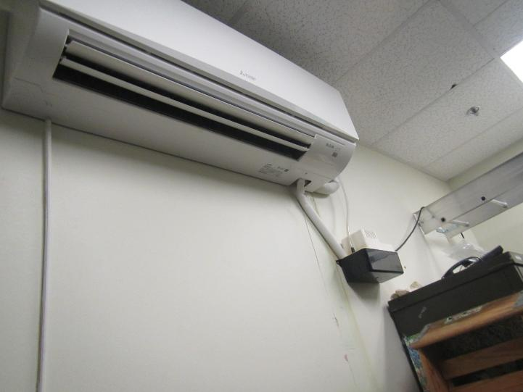
Water stain below condensation drain and pump for ductless air conditioner

Picture 11
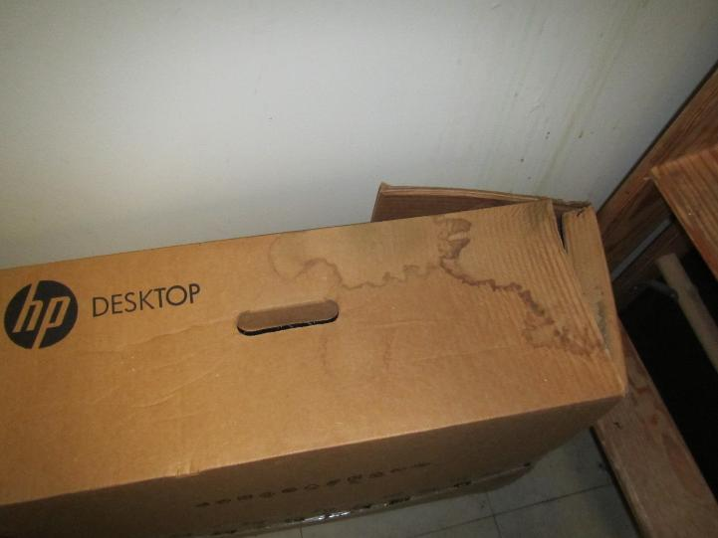
Water-damaged wall and box under a ductless air conditioner
Picture 12
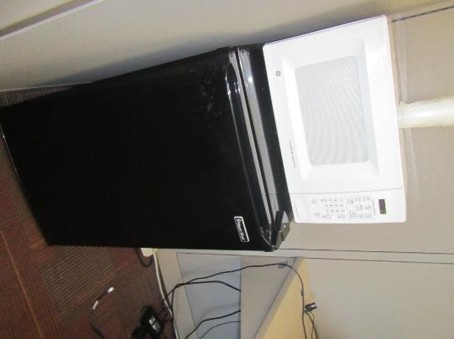
Refrigerator and microwave in an office

Picture 13
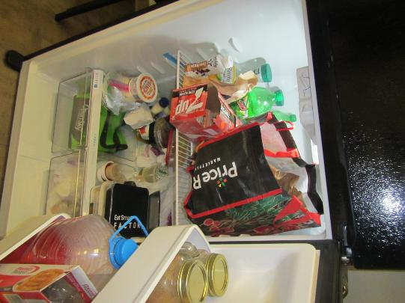
Full refrigerator in staff support room
Picture 14
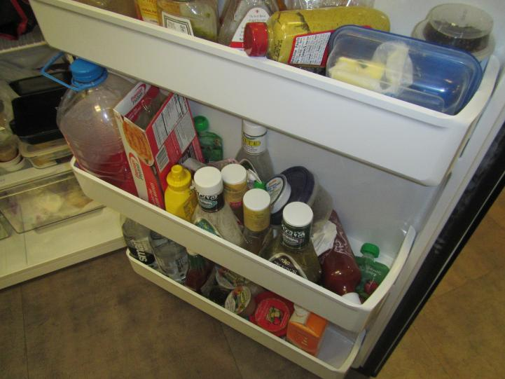
Very full refrigerator door in staff support room

Picture 15
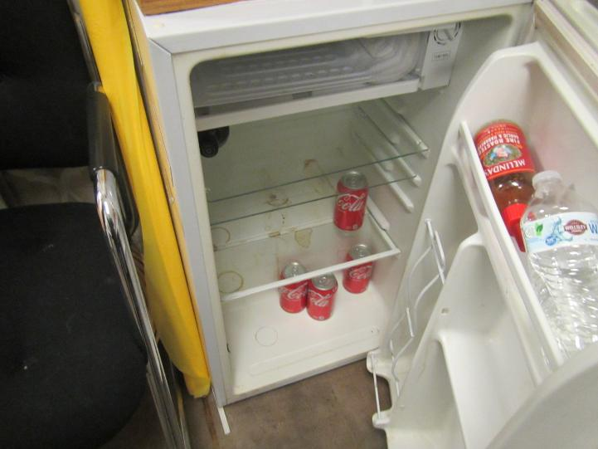
Evidence of spill inside small refrigerator
Picture 16
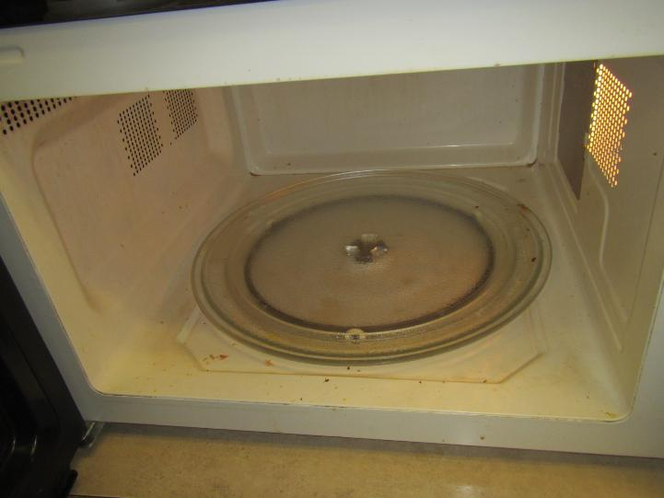
Microwave in Staff Support room in need of cleaning

Picture 17
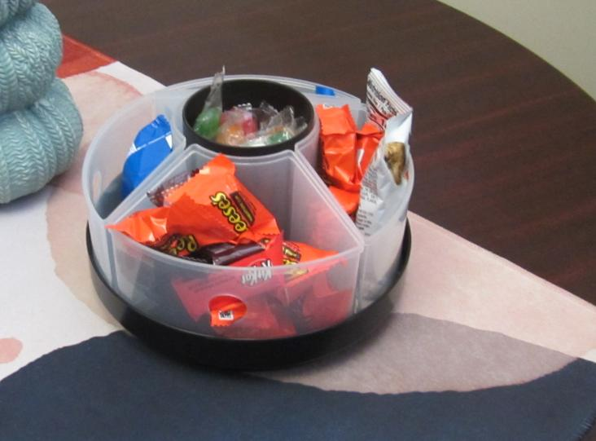
Uncovered candy container in an office
Picture 18
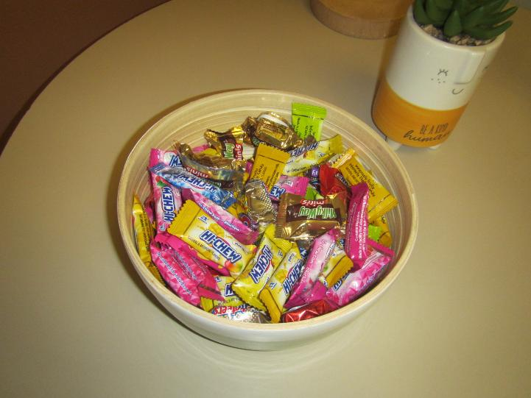
Candy dish in an office

Picture 19
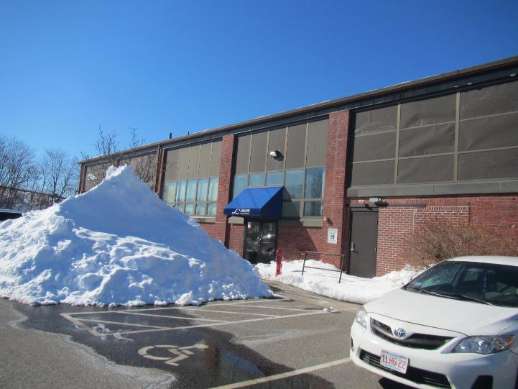
Change in brick style and long lintel showing where a larger door may have originally been
Picture 20
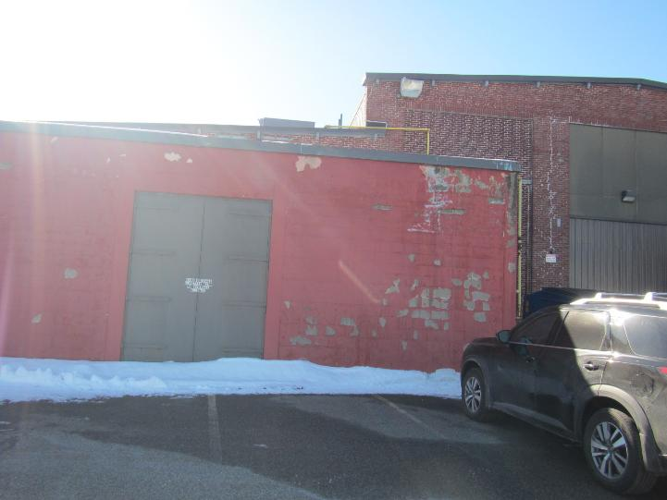
Electric building as an attached annex to the DCF space

Picture 21
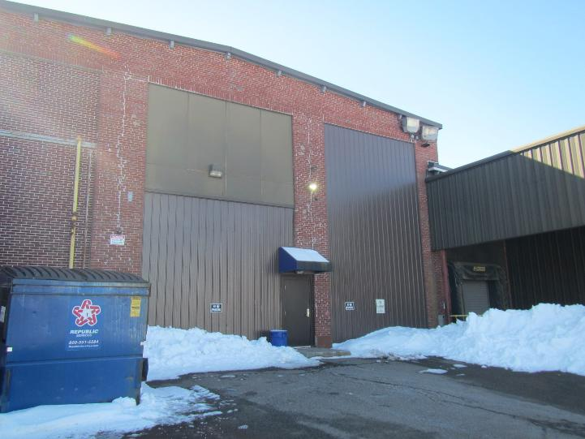
Side door used by DCF with warehouse access to the right and dumpster to the left
Picture 22
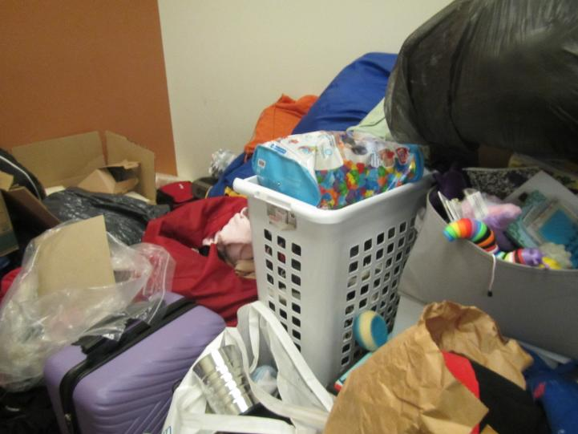
Clothing, toys, and suitcases in a storage area

Picture 23
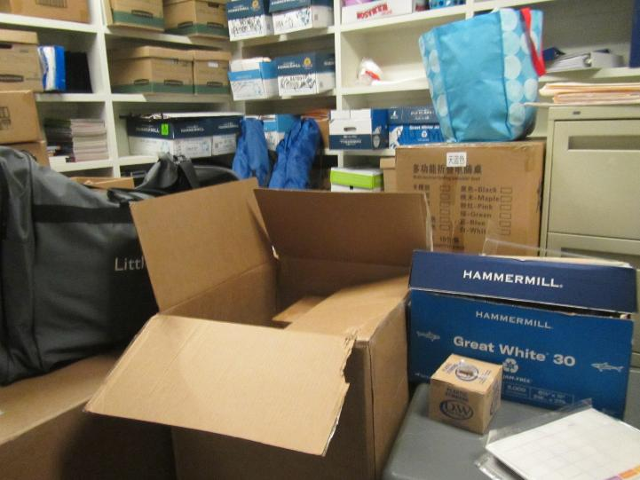
Boxes in a storage room, including opened on the floor
Picture 24
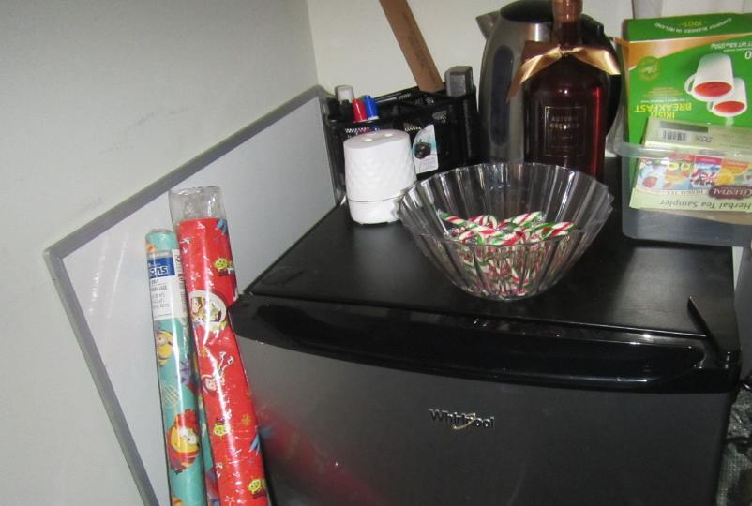
Scent diffuser (arrow) in an office

Location | Carbon  Dioxide  (ppm) | Carbon Monoxide  (ppm) | Temp  (°F) | Relative  Humidity  (%) | PM2.5  (µg/m³) | Occupants  in Room | Windows  Openable | Ventilation |  | Remarks
 |  |  |  |  |  |  |  | Supply | Exhaust | Remarks
Background | 416 | ND | 39 | 27 | 4
Cubes near 1805 | 600 | ND | 73 | 13 | ND | 2 | N | Y | Y | 2 WD CT, hanging items and cloth over lights
“low lights” area | 569 | ND | 73 | 12 | ND | 0 | N | Y | Y | WD CT and WD cloth over light
1805 | 610 | ND | 73 | 12 | ND | 2 | N | Y | Y | Fridge on carpet, DEM
Cubes in front of 1803 | 580 | ND | 73 | 12 | ND | 1 | N | Y | Y | PF, items
Cubes in front of 1607 | 543 | ND | 73 | 12 | ND | 0 | N | Y | Y | Door to outside next to electric annex
1608 | 535 | ND |  | 16 | ND | 0 | N | Y | Y | Car seat storage, NC
1607 | 540 | ND | 68 | 14 | ND | 0 | N | Y | Y | Storage, carpeted
1606 | 564 | ND | 69 | 14 | ND | 0 | N | Y | Y | Items on floor
Cubes near 1606 | 550 | ND | 70 | 14 | ND | 0 | N | Y | Y | HS, food
Cubes near 1603 | 542 | ND | 72 | 12 | ND | 0 | N | Y | Y | Fridge on carpet, PF, items on floor
1602 | 538 | ND | 71 | 13 | ND | 0 | N | Y | Y | PF, empty cups, food
Cubes outside 1601 | 552 | ND | 72 | 13 | ND | 0 | N | Y | Y | Food, HS
Cubes outside 1401 | 537 | ND | 72 | 13 | ND | 0 | N | Y | Y
1404 | 550 | ND | 72 | 13 | ND | 0 | N | Y | Y | Coffee, lotion, flowers (cloth/plastic)
Cubes outside 1404 | 549 | ND | 72 | 12 | ND | 0 | N | Y | Y | WD CT
1601 | 554 | ND | 72 | 13 | ND | 1 | N | Y | Y | Printer
1405 | 573 | ND | 73 | 12 | ND | 0 | N | Y | Y | Food, fragrance diffuser, fridge on carpet, CP
1403 | 577 | ND | 73 | 12 | ND | 0 | N | Y | Y | Food, PF
Cubes near 1403 | 611 | ND | 73 | 12 | ND | 5 | N | Y | Y
Cubes near 1405 | 617 | ND | 74 | 12 | ND | 0 | N | Y | Y | Microwave, CP
1202 | 542 | ND | 74 | 12 | ND | 1 | N | Y | Y
Cubes near 1201 | 613 | ND | 74 | 12 | ND | 0 | N | Y | Y | Microwave and fridge
Mail area | 613 | ND | 74 | 12 | ND | 0 | N | Y | Y
Reception (inside) | 600 | ND | 74 | 12 | ND | 1 | N | Y | Y | Salt lamp
Cubes near 1204 | 586 | ND | 74 | 12 | ND | 1 | N | Y | Y
Cubes near 1802 | 561 | ND | 74 | 11 | ND | 0 | N | Y | Y | PF, HS, items
Cubes near 1101 | 573 | ND | 73 | 12 | ND | 0 | N | Y | Y | Cloth flowers
1101 | 574 | ND | 74 | 12 | ND | 0 | N | Y | Y | Fridge on carpet, food
1102 | 577 | ND | 74 | 11 | ND | 1 | N | Y | Y | Food, microwave
1103 | 563 | ND | 74 | 11 | ND | 0 | N | Y | Y | Food, coffee, fridge on carpet
Cubes near 1103 | 553 | ND | 74 | 11 | ND | 1 | N | Y | Y | Fridge
Cubes near 1804 | 554 | ND | 74 | 11 | ND | 1 | N | Y | Y | Fridge
1804 | 614 | ND | 74 | 12 | ND | 0 | N | Y | Y | DEM, PF
1902 | 618 | ND | 74 | 12 | ND | 2 | N | Y | Y | Perfume odor, fridge, WD CT
1901 | 593 | ND | 73 | 12 | ND | 0 | N | Y | Y
1903 conference | 560 | ND | 73 | 12 | ND | 0 | N | Y | Y | 3 WD CT
Cubes near 1904 | 566 | ND | 73 | 12 | ND | 0 | N | Y | Y
1905 | 589 | ND | 73 | 12 | ND | 0 | N | Y | Y | Food, fridge, PF, WD CT, dusty supply vent
1906 | 555 | ND | 73 | 12 | ND | 0 | N | Y | Y | Stored items
Cubes near 1906 | 550 | ND | 73 | 12 | ND | 1 | N | Y | Y
1907 | 554 | ND | 73 | 12 | ND | 0 | N | Y | Y | Fridge, microwave, HS
1908 | 556 | ND | 73 | 13 | ND | 0 | N | Y | Y | Storage, cluttered/disorganized
1910 | 528 | ND | 73 | 13 | ND | 0 | N | Y | Y | Open records room, NC, WD CT
Cubes near 1104 | 593 | ND | 72 | 13 | ND | 0 | N | Y | Y | Piles on floor
MDF |  |  |  |  |  |  |  |  |  | Ductless air conditioner, WD wall, NC
Ladies’ restroom |  |  |  |  |  |  |  | Y | Y
Staff support (kitchen) | 543 | ND | 73 | 12 | ND | 0 | N | Y | Y | Fridge (full), food, NC, toaster (dirty), microwave (dirty)
1020 conference | 523 | ND | 74 | 11 | 0 | 0 | N | Y | Y | Carbon dioxide instrument next to thermostat (numbers agree), dirty PFs
1909 |  |  |  |  |  |  | N | Y | Y | Storage area, bowed CT, personal protective equipment and CP stored, slight ammonia odor
1021 |  |  |  |  |  |  | N | Y | Y | Office used for storage, WD CT, ND
1110 |  |  |  |  |  |  | N | Y | Y | Storage, too cluttered
1111 |  |  |  |  |  |  | N | Y | Y | Storage, NC
1108 |  |  |  |  |  |  | N | Y | Y | NC, car seat storage
1017 | 609 | ND | 71 | 13 | ND | 0 | N | Y | Y | NC, heater, fridge (dirty), microwave
1402 | 558 | ND | 72 | 12 | ND | 0 | N | Y | Y | Food, WD wall (exterior)
1604 | 579 | ND | 72 | 12 | ND | 1 | N | Y | Y | Food
1201 | 594 | ND | 73 | 12 | ND | 1 | N | Y | Y | Food, fan, fridge, ND, CP
1001 interview | 560 | ND | 71 | 12 | ND | 0 | N | Y | Y | ND
1003 interview | 558 | ND | 70 | 13 | ND | 0 | N | Y | Y | WD CT, NC
1011 | 565 | ND | 69 | 14 | ND | 0 | N | Y | Y | NC

