**POST-OCCUPANCY**

**INDOOR AIR QUALITY ASSESSMENT**

**Department of Children and Families Office**

**640 North Main Street**

**Leominster, MA**

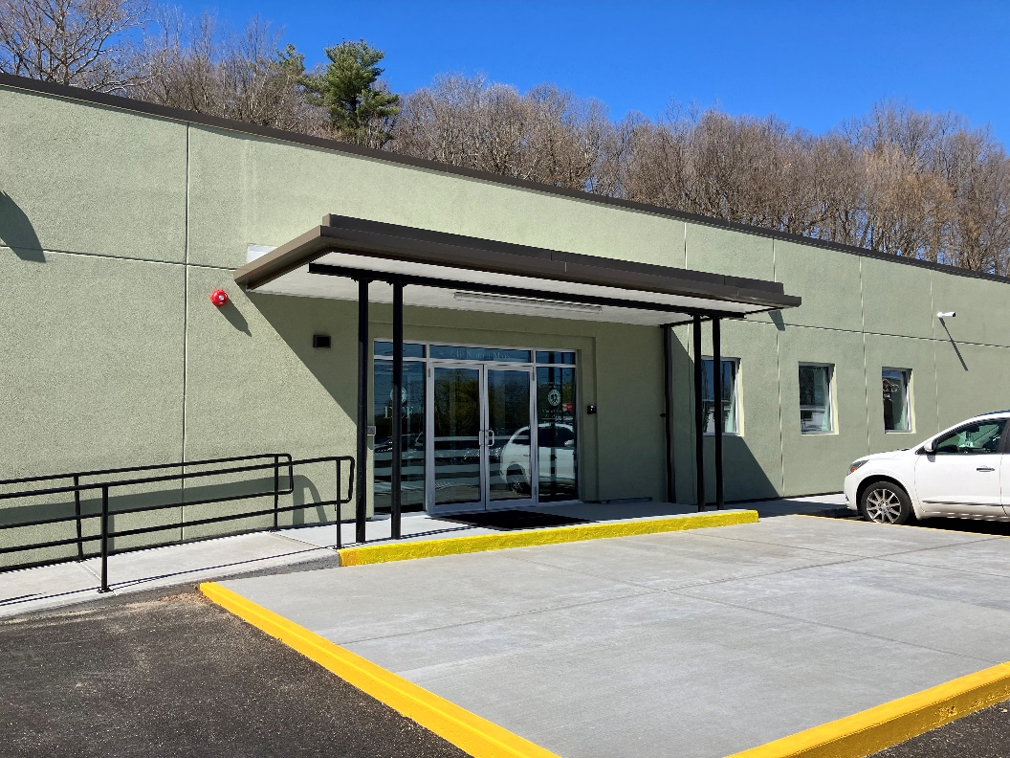

Prepared by:

Massachusetts Department of Public Health

Bureau of Climate and Environmental Health

Indoor Air Quality Program

May 2024

# BACKGROUND

|  |  |
| --- | --- |
| Building: | Department of Children and Families (DCF), North Central Area Office |
| Address: | 640 North Main Street, Leominster, MA |
| Assessment Requested by: | Jamie Merrill Blood, Regional Planner, Senior Project Manager, Division of Capital Asset Management & Maintenance (DCAMM)  Office of Leasing and State Office  Planning |
| Reason for Request: | Post-occupancy indoor air quality (IAQ) assessment of leased space |
| Date of Assessment: | April 26, 2024 |
| Massachusetts Department of Public Health/Bureau of Climate and Environmental Health (MDPH/BCEH) Staff Conducting Assessment: | Ruth Alfasso, Environmental  Engineer/Inspector, IAQ Program |
| Building Description: | The building at 640 North Main Street was built in the 1960s as a bowling alley. A complete renovation has occurred, including an addition to one side of the building. It is a single-story building with a flat roof. |
| Windows: | Windows in the space are not openable |

# METHODS

Please refer to the IAQ Manual for methods, sampling procedures, and interpretation of results (MDPH, 2015).

# RESULTS AND DISCUSSION

The following is a summary of indoor air testing results (Table 1).

* ***Carbon dioxide*** measurements were below the MDPH guideline of 800 parts per million (ppm) in all areas assessed.
* ***Temperature*** was within the recommended range of 70°F to 78°F in many areas, but there were portions of the office that were slightly colder and slightly warmer than that range. It should be noted that controls for the heating, ventilating, and air conditioning system were being worked on at the time of the visit.
* ***Relative humidity*** was below the recommended range of 40% to 60% in all areas tested. This is reflective of outdoor conditions.
* ***Carbon monoxide*** levels were non-detectable (ND) in all areas tested.
* ***Fine particulate matter (PM2.5)*** concentrations were ND and therefore below the National Ambient Air Quality Standard (NAAQS) level of 35 μg/m3 in all indoor areas tested. Outside levels were elevated above the NAAQS limit. This appeared to be localized and possibly due to landscaping activities or the operation of trucks immediately outside the building.
* ***Total Volatile Organic Compounds (TVOC)*** ranged from 0.3 ppm to 0.7 ppm inside the building, while they were ND outside. These low levels may be due to post-construction off-gassing or products used in the space. This is discussed further below.

## Ventilation

A heating, ventilating, and air conditioning (HVAC) system has several functions. First, it provides heating and, if equipped, cooling. Second, it is a source of fresh air. Finally, an HVAC system will dilute and remove normally occurring indoor environmental pollutants by not only introducing fresh air, but also filtering the airstream and ejecting stale air to the outdoors via exhaust ventilation. Even if an HVAC system is operating as designed, point sources of respiratory irritation may exist and affect symptoms in sensitive individuals.

The HVAC system uses air handling units (AHU) on the roof. Fresh air is drawn into the units, conditioned, and delivered to offices and other areas through ceiling-mounted supply vents (Picture 1). Return air is drawn into other vents and returned to the AHU/exhausted from the building (Picture 2). Every office and other room examined had at least one supply and return vent.

Thermostat units were located in various offices and common areas (Picture 3). As noted above, work on HVAC controls was occurring during the assessment. Occupants have expressed concerns regarding temperature control, and temperatures that were both warmer and cooler than MDPH guidance were noted in the space. Occupants should continue to work with facility staff until these temperature issues are resolved. Thermostats can be adjusted a few degrees by occupants to account for personal temperature preferences. Thermostats did not have an obvious indication if they also controlled the fan/fresh air ventilation. It is recommended that HVAC systems be set so that fresh air ventilation is provided at all times to occupied spaces even when temperatures are within setpoint ranges. The HVAC units and filters for this building were not inspected by the IAQ program. The IAQ Program recommends that filters be replaced at least two times a year and that filters should have a Minimum Efficiency Rating Value (MERV rating) of at least 8, or higher if the equipment can operate with more restrictive filters.

It is recommended that HVAC systems be re-balanced every five years to ensure adequate air systems function (SMACNA, 1994). The system was likely balanced during the remodeling prior to occupancy.

## Microbial/Moisture Concerns

No water-damaged ceiling tiles or other materials were noted during the post-occupancy assessment. New ceiling tiles were part of the renovation.

As noted in the pre-occupancy assessment, some of the doors to the outside have worn-out weatherstripping as shown by visible light underneath the door (Picture 4). Lack of weatherstripping on doors can be one pathway for pests to enter the building, as well as allowing unconditioned outside air and moisture into the building. Building occupants have reported issues with rodents. Ensuring all exterior doors are tightly fitted is one measure that will help exclude rodents from the building.

Food was noted in several offices and common areas (Pictures 5 and 6). To reduce the potential for rodent activity, all food should be in closed, rodent-proof containers at all times other than active use. Food waste and crumbs should be cleaned up promptly and garbage cans emptied every night. Rodents also seek out sources of water and shelter (harborage) so any plumbing leaks should be fixed promptly, and items should be stored neatly and up off the floor wherever possible. The staff break room has appliances including refrigerators, a microwave, and other equipment. One of the refrigerators was empty and marked as out of order due to damage during moving. Food preparation equipment should be kept clean to prevent odors, water damage, and pests.

Rodent infestation can result in symptoms due to materials in their waste. Mouse urine contains a protein that is a known sensitizer (US EPA, 1992). A sensitizer is a material that can produce symptoms (e.g., running nose or skin rashes) in sensitive individuals after repeated exposure. To eliminate exposure to allergens, rodents must be removed from the building. Please note that removal, even after cleaning, may not provide immediate relief since allergens can exist in the interior for several months after rodents are eliminated (Burge, 1995). Once the infestation is eliminated, a combination of cleaning and increased ventilation and filtration should serve to reduce allergens associated with rodents.

An electrical/data room is equipped with a ductless air conditioning unit on the wall (Picture 7). These units have a condensation drain and pump to remove the collected condensation and transport it to an appropriate drain or outside. Over time, the pumps may malfunction, or the hoses become clogged, which can lead to leaks. This equipment should be checked periodically to ensure good condition and repaired/cleaned when necessary.

One room in the DCF office is equipped with a shower and laundry appliances. If the shower is not used regularly, water should be poured down the drain at least once a week to ensure the drain traps remain wet. If drain traps dry out, this removes the seal that prevents sewer gas and odors from entering into occupied space. The washer and dryer had not been fully set up yet, but no vent for the dryer was noted. Unless they are specifically condensing dryers, a clothes dryer needs to be vented to the outdoors. A dryer that is not vented will allow the odors and moisture from the dryer operation into the room.

## Other IAQ Concerns

Sampling for total volatile organic compounds (TVOC) was conducted in the space and levels ranged from 0.3 to 0.7. TVOC readings of 0.4 to 0.9 ppm were measured during the pre-occupancy visit. Continued low levels of TVOCs may have several causes:

* Continued off-gassing of new paint, furnishings, or HVAC equipment. To reduce these odors and VOCs, increase ventilation in the space during unoccupied hours until all levels have dissipated.
* The use of personal products such as sanitizers and scented products. Some rooms had a perfume or air freshener scent (Table 1). Items such as essential oils were noted in offices as well (Picture 8).

DCF offices have a need to store significant amounts of files, as well as items such as clothing, toys, and car seats. Dedicated storage rooms for items have been provided in this office. Most storage was in good condition, with items on shelves or in plastic totes, but some items have not yet been put away, and were found on floors in several rooms (Picture 9). Storage of items in piles on the floor, and other clutter, can make thorough cleaning difficult.

This office is equipped with lockers for storage of items by staff. Lockers should be cleaned out periodically to prevent odors and pest attraction.

Some areas in this office are carpeted. Carpets should be cleaned regularly in accordance with Institute of Inspection, Cleaning and Restoration Certification (IICRC) recommendations (IICRC, 2012). Upholstered furniture was also noted in some rooms. These should also be cleaned regularly to remove dust and debris.

# RECOMMENDATIONS

The following are recommendations made to maintain IAQ. Some of these are reiterated from the pre-occupancy assessment as well:

## Ventilation recommendations

1. Operate supply and exhaust ventilation in all areas during occupied periods.
2. Ensure thermostats are set and operational, including system time, and scheduled temperature setbacks for occupied and unoccupied periods.
3. Ensure filters are replaced on HVAC units at least twice a year. Use filters with a minimum efficiency rating value (MERV) of 8 or better.
4. It is recommended that HVAC systems be re-balanced every five years to ensure adequate air systems function (SMACNA, 1994).

## Water damage and pest recommendations

1. Repair or replace worn out weatherstripping on exterior doors.
2. Ensure all food is stored in pest-proof containers and clean up food waste and crumbs promptly to deter rodents.
3. Work with a licensed pest contractor to exclude and remove rodents. Once rodents have been removed, thoroughly clean any areas where rodents had been found to remove traces of waste and dander.
4. Keep refrigerators and other food-preparation appliances clean.
5. Periodically check ductless air conditioning condensation drains and pumps to prevent leaks.
6. Ensure that the trap for the shower drain is kept moist by pouring water down it at least once a week when it has not been used.
7. Vent the dryer to the outside of the building using sturdy components that will not sag or gap/break. Clean dryer vents periodically to remove lint that will reduce effectiveness of the dryer and potentially be a fire hazard.
8. If certain exterior doors are to be regularly used, consider adding a walk-off mat or non-porous flooring near the door to prevent water damage to carpeting.
9. Complete the drainage system and landscaping around the building to keep water away from the base of the building.
10. Monitor the condition of EIFS siding and ensure that the surface is not impacted by vehicles.
11. Have the hillside to the rear of the building inspected and maintained periodically to prevent trees from falling on the building. Trim branches that overhang the roof to reduce debris accumulation.

## Other recommendations

1. Increase ventilation during unoccupied periods for a week or more to reduce lingering construction VOCs and odors.
2. Use VOC-containing products in areas with good ventilation and keep tightly closed when not in use. Avoid products with strong scents and avoid mixing incompatible products.
3. Store items in designated rooms and on shelving or in waterproof totes to make for easier cleaning and prevent water or pest damage.
4. Consider a program to clean lockers periodically to remove items which may lead to odors or attract pests.
5. Clean carpeting in accordance with IICRC recommendations (IICRC, 2012). Clean upholstered furniture regularly as well.
6. For buildings in New England, periods of low relative humidity during the winter are often unavoidable. Therefore, scrupulous cleaning practices should be adopted to minimize common indoor air contaminants whose irritant effects can be enhanced when the relative humidity is low. To control dust, a high efficiency particulate arrestance (HEPA) filter equipped vacuum cleaner in conjunction with wet wiping of all surfaces is recommended. Avoid the use of feather dusters. Drinking water during the day can help ease some symptoms associated with a dry environment (throat and sinus irritations).
7. Refer to resource manual and other related IAQ documents located on the MDPH’s website for further building-wide evaluations and advice on maintaining public buildings. These documents are available at: <http://mass.gov/dph/iaq>.

# REFERENCES

Burge, H.A. 1995. *Bioaerosols*. Lewis Publishing Company, Boca Raton, FL.

IICRC. 2012. Carpet Cleaning FAQ 4 Institute of Inspection, Cleaning and Restoration Certification. Institute of Inspection Cleaning and Restoration, Vancouver, WA.

MDPH. 2015. Massachusetts Department of Public Health. Indoor Air Quality Manual: Chapters I-III. Available at: <https://www.mass.gov/lists/indoor-air-quality-manual-and-appendices>.

SMACNA. 1994. HVAC Systems Commissioning Manual. 1st ed. Sheet Metal and Air Conditioning Contractors’ National Association, Inc., Chantilly, VA.

MDPH. 2015. Massachusetts Department of Public Health. Indoor Air Quality Manual: Chapters I-III. Available at: <https://www.mass.gov/lists/indoor-air-quality-manual-and-appendices>

US EPA. 1992. Indoor Biological Pollutants. US Environmental Protection Agency, Environmental Criteria and Assessment Office, Office of Health and Environmental Assessment, research Triangle Park, NC. EPA 600/8-91/202. January 1992.

**Picture 1**

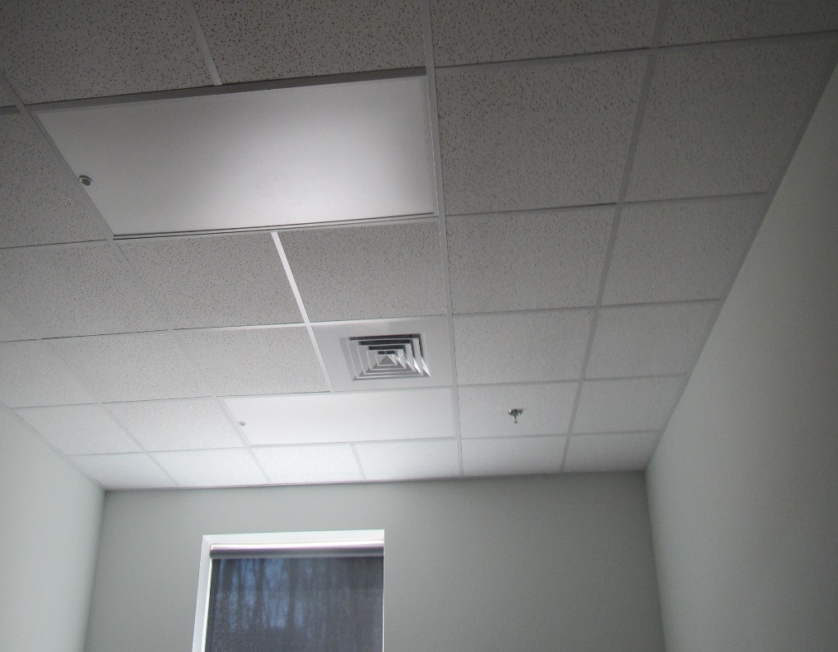

**Typical supply vent**

**Picture 2**

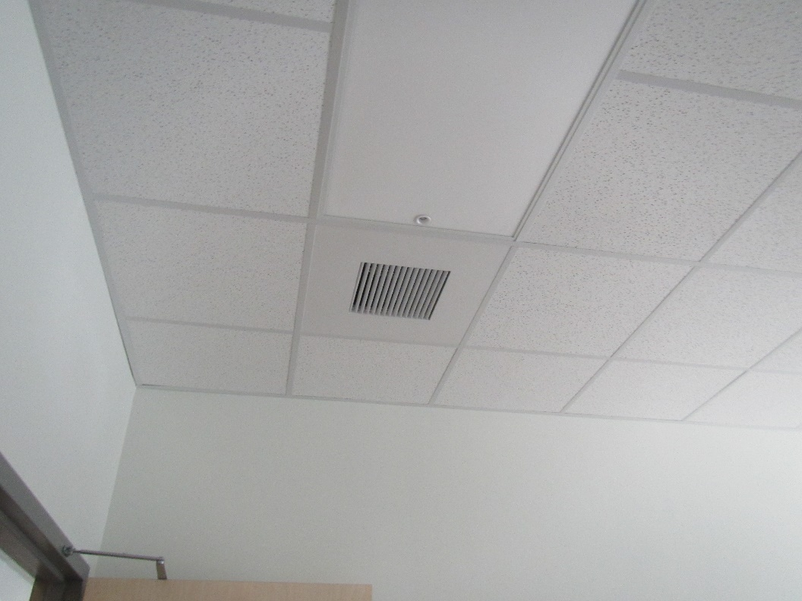

**Typical return vent**

**Picture 3**

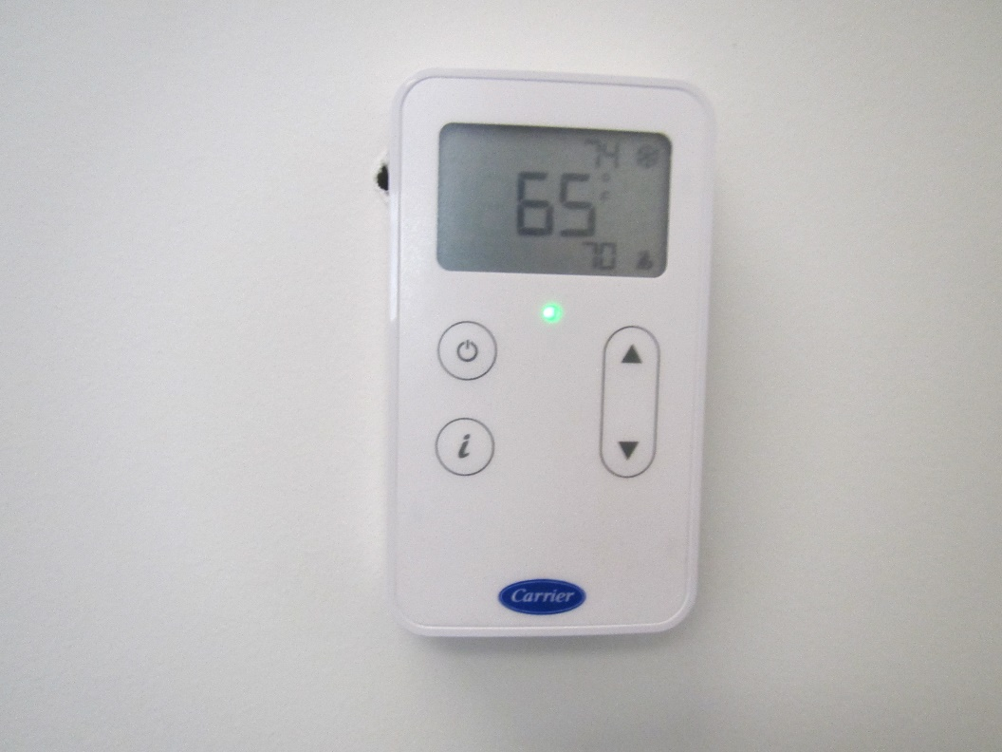

**Thermostat**

**Picture 4**

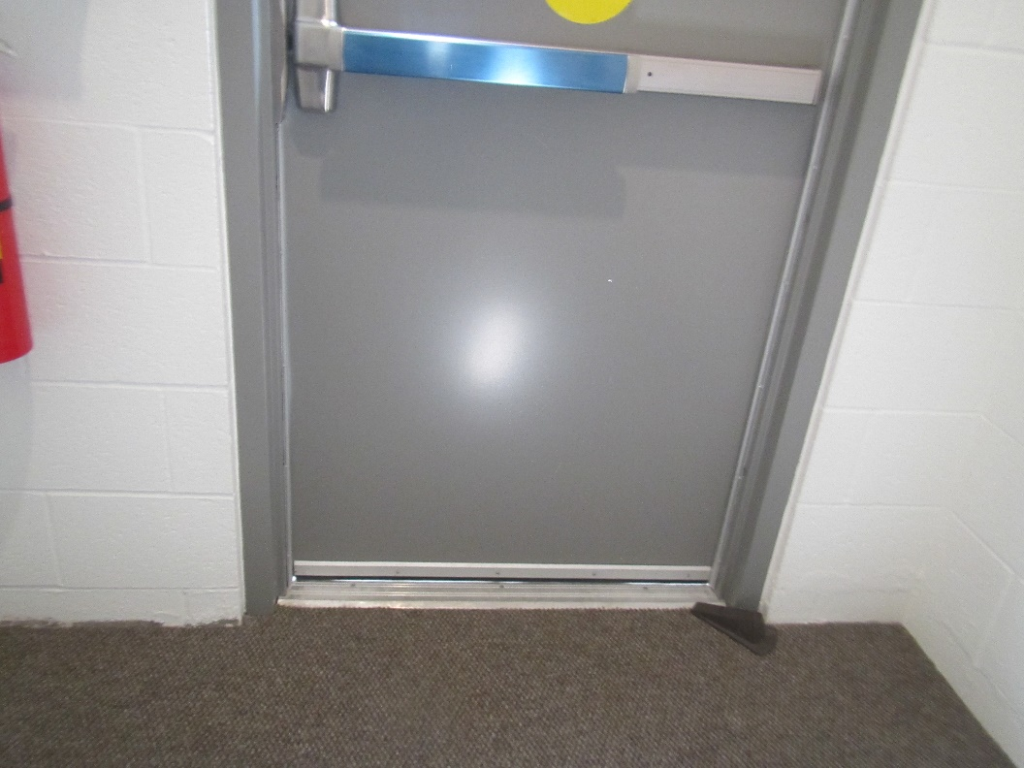

**Worn weatherstripping on exterior door as shown by light underneath the door**

**Picture 5**

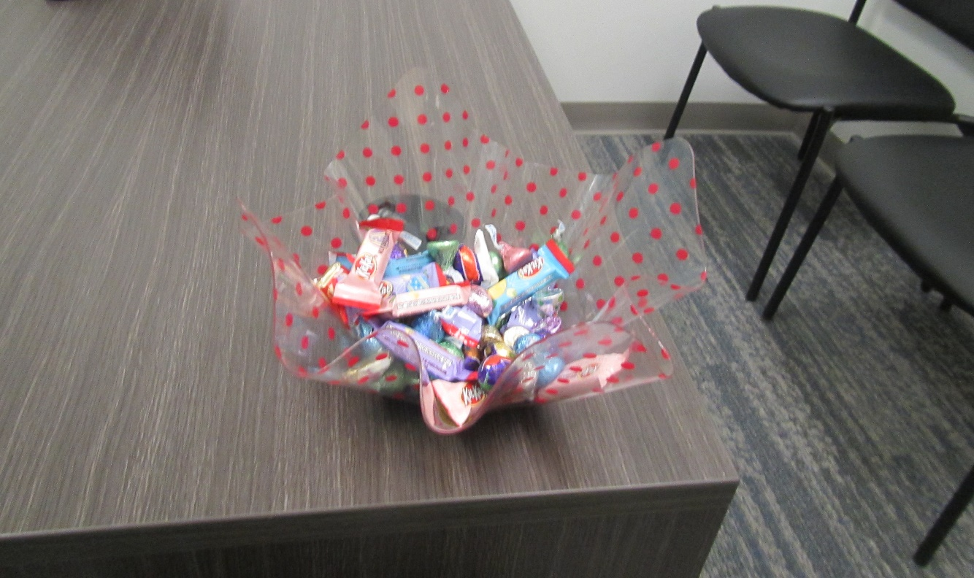

**Open candy dish on a desk**

**Picture 6**

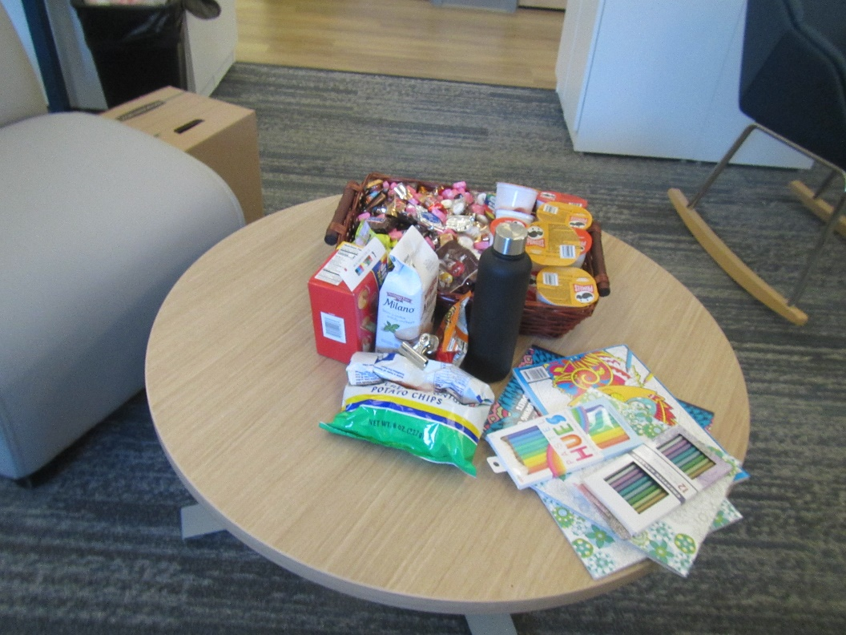

**Food in an open work area**

**Picture 7**

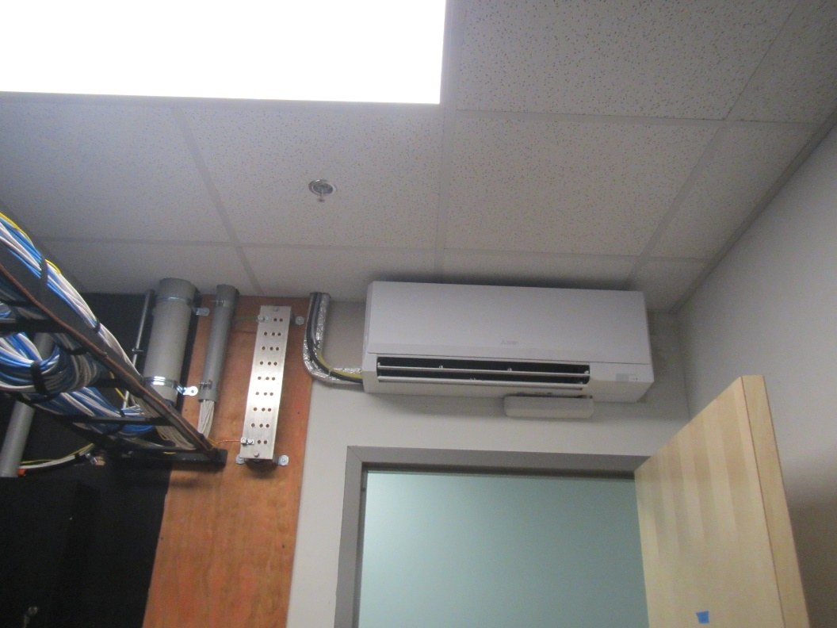

**Ductless air conditioner**

**Picture 8**

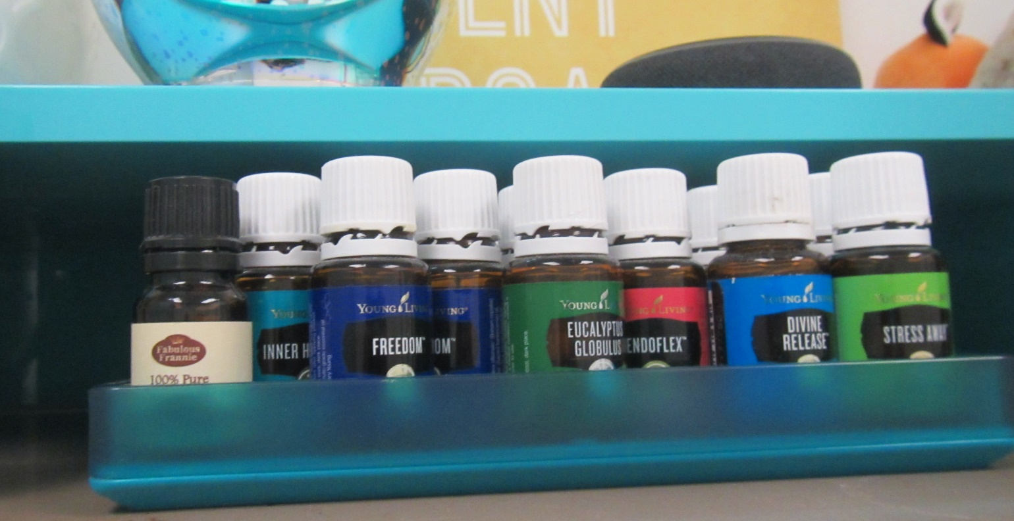

**Essential oils in an office**

**Picture 9**

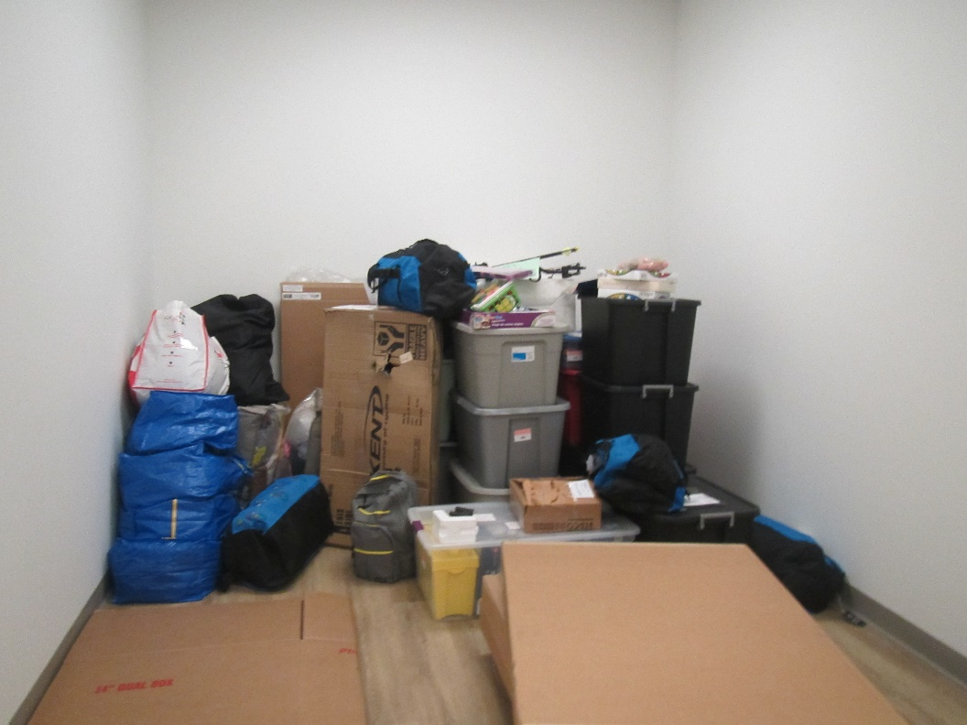

**Items on floor needing to be put in storage area**

| **Location** | **Carbon**  **Dioxide**  **(ppm)** | **Carbon Monoxide**  **(ppm)** | **Temp**  **(°F)** | **Relative**  **Humidity**  **(%)** | **PM2.5**  **(µg/m3)** | **TVOC**  **(ppm)** | **Occupants**  **in Room** | **Windows**  **Openable** | **Ventilation** | | **Remarks** |
| --- | --- | --- | --- | --- | --- | --- | --- | --- | --- | --- | --- |
| **Supply** | **Exhaust** |
| Background | 379 | ND | 61 | 21 | 246 | ND |  |  |  |  | Parking lot next to busy road, mostly sunny |
| Reception (inside) | 715 | ND | 71 | 26 | ND | ND | 2 | N | Y | Y | Carpet, photocopier |
| 118 | 681 | ND | 71 | 26 | ND | ND | 0 | N | Y | Y | NC |
| 117 | 638 | ND | 71 | 27 | ND | 0.2 | 0 | N | Y | Y | Storage |
| 115 | 586 | ND | 71 | 26 | ND | 0.3 | 0 | N | Y | Y | NC, storage |
| Open area | 597 | ND | 73 | 24 | ND | 0.3 | 3 | N | Y | Y | Sunlight, carpet, lockers |
| 159 | 579 | ND | 74 | 22 | ND | 0.3 | 0 | N | Y | Y | Food, air freshener odor |
| 157 conference | 616 | ND | 74 | 24 | ND | 0.3 | 0 | N | Y | Y | Carpet |
| 168 | 582 | ND | 73 | 23 | ND | 0.3 | 0 | N | Y | Y | Carpet |
| 173 | 530 | ND | 73 | 24 | ND | 0.3 | 0 | N | Y | Y | Carpet |
| 172 | 655 | ND | 73 | 24 | ND | 0.3 | 0 | N | Y | Y | Carpet |
| 171 conference | 631 | ND | 72 | 24 | ND | 0.2 | 0 | N | Y | Y |  |
| Open area | 622 | ND | 71 | 25 | ND | 0.3 | 8 | N | Y | Y | Carpet |
| Open area | 655 | ND | 71 | 25 | ND | 0.2 | 3 | N | Y | Y | Carpet. HS |
| 188 | 627 | ND | 71 | 25 | ND | 0.2 | 0 | N | Y | Y | PF, carpet |
| 189 | 598 | ND | 71 | 25 | ND | 0.2 | 0 | N | Y | Y |  |
| 190 | 589 | ND | 70 | 26 | ND | 0.3 | 0 | N | Y | Y | Food, carpet |
| 191 | 724 | ND | 80 | 25 | ND | 0.3 | 0 | N | Y | Y | Carpet |
| 186 conference | 605 | ND | 80 | 25 | ND | 0.3 | 0 | N | Y | Y | Carpet |
| 198 conference | 634 | ND | 80 | 24 | ND | 0.3 | 0 | N | Y | Y | Carpet |
| 203 | 622 | ND | 69 | 26 | ND | 0.3 | 0 | N | Y | Y |  |
| 201 | 578 | ND | 69 | 27 | ND | 0.3 | 0 | N | Y | Y | Carpet |
| Open area | 729 | ND | 69 |  | ND | 0.5 | 5 | N | Y | Y | Food |
| 200 | 683 | ND | 69 | 26 | ND | 0.3 | 0 | N | Y | Y | Food |
| 153 | 589 | ND | 69 | 27 | ND | 0.3 | 0 | N | Y | Y | Records room, NC |
| 151 | 532 | ND | 69 | 27 | ND | 0.3 | 0 | N | Y | Y | Records room, NC |
| 150 | 574 | ND | 69 | 26 | ND | 0.3 | 0 | N | Y | Y |  |
| 130 | 703 | ND | 75 | 24 | ND | 0.4 | 2 | N | Y | Y | Carpet |
| 131 | 721 | ND | 76 | 25 | ND | 0.4 | 0 | N | Y | Y | Carpet |
| 132 | 685 | ND | 76 | 24 | ND | 0.4 | 0 | N | Y | Y | Carpet |
| 133 | 660 | ND | 75 | 25 | ND | 0.6 | 0 | N | Y | Y | Storage |
| 214 cube area | 671 | ND | 75 | 24 | ND | 0.4 | 2 | N | Y | Y | Carpet, artificial plant |
| 134 conference | 640 | ND | 75 | 24 | ND | 0.4 | 0 | N | Y | Y |  |
| 135 | 622 | ND | 74 | 24 | ND | 0.4 | 0 | N | Y | Y | Carpet |
| Mother’s room | 598 | ND | 74 | 25 | ND | 0.4 | 0 | N | Y | Y | Part carpeted, sink, fridge, upholstered furniture |
| 109 | 570 | ND | 72 | 23 | ND | 0.4 | 0 | N | Y | Y | NC |
| 114 | 550 | ND | 72 | 24 | ND | 0.5 | 0 | N | Y | Y | NC |
| 119 supplies | 600 | ND | 71 | 26 | ND | 0.5 | 0 | N | Y | Y |  |
| 121 | 660 | ND | 71 | 25 | ND | 0.4 | 0 | N | Y | Y | Carpet |
| 124 | 680 | ND | 71 | 25 | ND | 0.4 | 0 | N | Y | Y | HS/wipes, carpet |
| Records | 527 | ND | 71 | 27 | ND | 0.4 | 0 | N | Y | Y | NC, boxes |
| 126 | 627 | ND | 72 | 25 | ND | 0.4 | 0 | N | Y | Y | Wellness room, items, upholstered furniture |
| 138 conference | 704 | ND | 73 | 25 | ND | 0.5 | 0 | N | Y | Y | Carpet |
| Open area | 742 | ND | 73 | 25 | ND | 0.4 | 7 | N | Y | Y | Carpet, lockers |
| 141 conference | 607 | ND | 74 | 23 | ND | 0.4 | 0 | N | Y | Y |  |
| 142 | 676 | ND | 74 | 25 | ND | 0.5 | 0 | N | Y | Y | Sunlight, artificial plant, and dried plants, carpet |
| 140 | 717 | ND | 74 | 25 | ND | 0.4 | 1 | N | Y | Y | Carpet, food |
| Kitchen | 646 | ND | 74 | 24 | ND | 0.4 | 1 | N | Y | Y | NC, fridges (1 broken), microwave, toaster |
| 128 | 651 | ND | 74 | 24 | ND | 0.4 | 0 | N | Y | Y | Food, carpet |
| 110 | 524 | ND | 72 | 23 | ND | 0.3 | 0 | N | Y | Y | NC |
| 111 | 527 | ND | 72 | 24 | ND | 0.4 | 0 | N | Y | Y | NC |
| 113 | 547 | ND | 72 | 23 | ND | 0.4 | 0 | N | Y | Y | NC |
| 112 | 550 | ND | 71 | 23 | ND | 0.4 | 0 | N | Y | Y | NC |
| 103 | 578 | ND | 71 | 23 | ND | 0.4 | 0 | N | Y | Y |  |
| 102 | 583 | ND | 71 | 23 | ND | 0.4 | 0 | N | Y | Y |  |
| 106 | 645 | ND | 72 | 24 | ND |  | 0 | N | Y | Y | NC |
| 107 | 764 | ND | 72 | 31 | ND | 0.7 | 1 | N | Y | Y | Odors of cleaner or perfume |
| 105 | 700 | ND | 72 | 25 | ND | 0.5 | 0 | N | Y | Y | Odor of cleaner or perfume |