INDOOR AIR QUALITY ASSESSMENT

Department of Children & Families
2 Omni Way
Chelmsford, Massachusetts

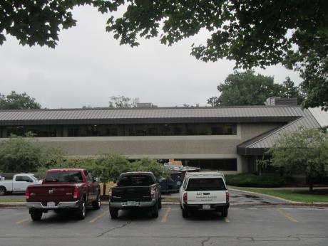

Prepared by:
Massachusetts Department of Public Health
Bureau of Environmental Health
Indoor Air Quality Program
October 2018

Background
Building: | Department of Children & Families (DCF)
Address: | 2 Omni Way Chelmsford, MA
DCAMM Project Manager: | Paul Burke, Senior Project Manager, Division of Capital Asset Management and Maintenance (DCAMM)
Reason for Request: | Post-occupancy assessment
Date of Assessment: | September 13, 2018
Massachusetts Department of Public Health/Bureau of Environmental Health (MDPH/BEH) Staff Conducting Assessment: | Jason Dustin, Environmental Analyst/Inspector, Indoor Air Quality (IAQ) Program
Building Description: | The DCF space is located on the second floor of a two-story office building that was constructed in 1984. The space is composed of private offices, open work areas and conference rooms. Most areas have carpet tile and dropped ceiling tiles.
Windows: | Windows are not openable.

Methods
Please refer to the IAQ Manual for methods, sampling procedures, and interpretation of results (MDPH, 2015).

Results
The following is a summary of indoor air testing results (Table 1).
- Carbon dioxide levels were below the MDPH guideline of 800 parts per million (ppm) in most areas assessed. Some areas were slightly elevated as explained below.
- Temperature was within the MDPH recommended range of 70°F to 78°F in all areas.
- Relative humidity was slightly above the MDPH recommended range of 40% to 60% in some areas.
- Carbon monoxide levels were non-detectable (ND) in all indoor areas assessed.
- Fine particulate matter (PM2.5) concentrations measured were below the National Ambient Air Quality Standard (NAAQS) level of 35 micrograms per cubic meter (μg/m³) in all occupied areas.

Discussion

Ventilation
A heating, ventilating, and air conditioning (HVAC) system has several functions. First it provides heating and, if equipped, cooling. Second, it is a source of fresh air. Finally, an HVAC system will dilute and remove normally occurring indoor environmental pollutants by not only introducing fresh air, but by filtering the airstream and ejecting stale air to the outdoors via exhaust ventilation. Even if an HVAC system is operating as designed, point sources of respiratory irritation may exist and cause symptoms in sensitive individuals.
The HVAC system in this space consists of large rooftop air handling units (AHUs) that draw in fresh air from intakes on the roof. Supply air is ducted to ceiling-mounted supply diffusers throughout the space (Picture 1). Return air is brought back to the AHUs through return vents (Picture 2).
To maximize air exchange, the MDPH recommends that both supply and exhaust ventilation operate continuously during periods of occupancy. In order to have proper ventilation with a mechanical supply and exhaust system, the systems must be balanced to provide an adequate amount of fresh air to the interior of a room while removing stale air from the room. It is recommended that HVAC systems be re-balanced every five years to ensure adequate air systems function (SMACNA, 1994). The HVAC system balancing was completed prior to this assessment.
BEH staff noted that one area had slightly elevated carbon dioxide readings (areas 2184 to 2198). This condition indicates that the AHU fresh air intake louvres may need to be adjusted to allow more fresh air into the unit serving this area. The thermostat fan settings for the AHUs should also be inspected to ensure they are set to “Fan On” rather than “Auto”. This is especially important during temperate weather (e.g., spring and fall) in spring and fall where heating or cooling may not be called for frequently. Intermittent fresh air supply will likely increase occupant complaints regarding IAQ.
Relative humidity readings in the DCF space were on the higher end of the MDPH guideline (Table 1) which reflects outdoor conditions on the day of the assessment. Higher humidity can increase the perception of poor IAQ. The HVAC settings should be reviewed to ensure that the units are adequately removing moisture from the air especially during humid weather.

Microbial/Moisture Concerns
Water-damaged ceiling tiles were noted in an open cubicle area near 2109 (Picture 3). It was not clear whether a leak is ongoing. Porous items such as ceiling tiles can be a source of microbial growth if exposed to chronic moisture. The ceiling tiles should be discarded and replaced and any necessary repairs should be made if the leak is active.
Some restrooms were out of order due to problems with the plumbing. Plumbing problems can be a source of sewage backups and odors and should be addressed as soon as possible. DCF staff reported that property management/contractors have been actively working to repair this condition.

Other Conditions
Hand sanitizers and scented cleaning products were noted in some areas of the office space. These products can cause irritation of the eyes, nose and respiratory system of some people.
Most flooring is covered with carpet tile. The Institute of Inspection, Cleaning and Restoration Certification (IICRC), recommends that carpeting be cleaned annually (or semi-annually in soiled high traffic areas) (IICRC, 2012).
Some occupants expressed concerns with discomfort since their desks are located in the path of the supply air stream. This condition can lead to temperature complaints as well as dryness/irritation of the eyes.

Conclusions/Recommendations
Based on the observations made during the visit, the following is recommended:
- Operate the HVAC system to provide for continuous fresh air ventilation during occupied hours. Inspect all thermostats to ensure that they are set for “fan on” instead of the “auto” setting.
- Inspect fresh air intake louvres in the AHU unit serving area 2168-2198. Adjust if necessary to allow increased fresh air to this space.
- Inspect humidity set points for the HVAC system to adequately remove moisture from the air especially during humid weather.
- Continue to make necessary repairs on the plumbing system to restore the functionality of the restrooms rendered out of order and to prevent any future sewage backups.
- Remove any water-damaged ceiling tiles (Table 1) and replace. Monitor the area for any new leaking and make any necessary repairs.
- Reduce or eliminate the use of scented cleaners, hand sanitizers, and personal air fresheners.
- Regularly vacuum carpeting with a HEPA-filtered vacuum cleaner. Clean carpeting at least once per year according to IICRC recommendations (IICRC 2012).
- Implement a method of diverting/deflecting the supply air flow from diffusers so as to avoid it directly impacting occupants currently in the air stream (e.g., cubicle #2162).
- Continue to change filters for HVAC equipment 2-4 times a year. Continue to use pleated filters of MERV 8 (or higher), which are adequate in filtering out pollen and mold spores (ASHRAE, 2012), if these can be used with current equipment.
- Consider adopting a balancing schedule of every 5 years for all mechanical ventilation systems, as recommended by ventilation industrial standards (SMACNA, 1994).
- Refer to resource manuals and other related IAQ documents for further building-wide evaluations and advice on maintaining public buildings. Copies of these materials are located on the MDPH’s website: http://mass.gov/dph/iaq.

References
ASHRAE. 2012. American Society of Heating, Refrigeration and Air Conditioning Engineers (ASHRAE) Standard 52.2-2012 -- Method of Testing General Ventilation Air-Cleaning Devices for Removal Efficiency by Particle Size (ANSI Approved).
IICRC. 2012. Institute of Inspection Cleaning and Restoration Certification. Institute of Inspection, Cleaning and Restoration Certification. Carpet Cleaning: FAQ. Retrieved from https://www.iicrc.org/general/custom.asp?page=SANSIIICRCS100.
MDPH. 2015. Massachusetts Department of Public Health. “Indoor Air Quality Manual: Chapters I-III”. Available at: http://www.mass.gov/eohhs/gov/departments/dph/programs/environmental-health/exposure-topics/iaq/iaq-manual/.
SMACNA. 1994. HVAC Systems Commissioning Manual. 1st ed. Sheet Metal and Air Conditioning Contractors’ National Association, Inc., Chantilly, VA.
Picture 1
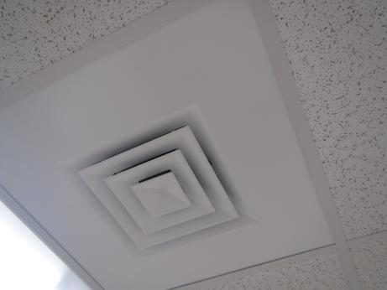
Ceiling-mounted supply air diffuser
Picture 2
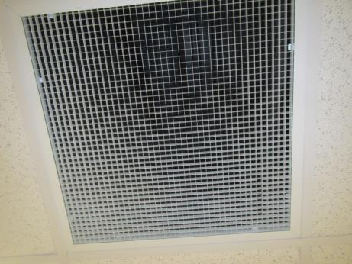
Return air vent
Picture 3
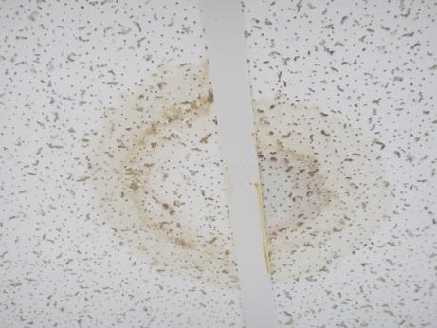
Water-damaged ceiling tiles near cubicle #2109

Location | Carbon  Dioxide  (ppm) | Carbon Monoxide  (ppm) | Temp  (°F) | Relative  Humidity  (%) | PM2.5  (µg/m³) | Occupants  in Room | Windows  Openable | Ventilation |  |  | Remarks
 |  |  |  |  |  |  |  | Intake | Exhaust
Background (outside) | 478 | ND | 73 | 78 | 18 | - | - | - |  | - | Overcast, humid
Reception –public side | 724 | ND | 72 | 62 | 14 | 7 | N | Y |  | Y
Reception – inner | 608 | ND | 72 | 60 | 12 | 4 | N | Y |  | Y | CPs
Open cubes- front near 2018 | 591 | ND | 72 | 61 | 13 | 5 | N | Y |  | Y | Carpet tile
Open cubes rear | 583 | ND | 72 | 62 | 13 | 3 | N | Y |  | Y | Plants, HS
2043 | 586 | ND | 72 | 62 | 12 | 0 | N | Y |  | Y | DEM, UF
2044 | 600 | ND | 71 | 62 | 13 | 0 | N | Y |  | Y
2045 | 615 | ND | 71 | 63 | 13 | 0 | N | Y |  | Y | AI
Open cubes near 2059 | 620 | ND | 72 | 63 | 14 | 3 | N | Y |  | Y | Dem, HS
2052 | 598 | ND | 71 | 63 | 13 | 0 | N | Y |  | Y
2051 | 603 | ND | 71 | 63 | 13 | 0 | N | Y |  | Y | Area rug
2050 | 587 | ND | 71 | 63 | 12 | 0 | N | Y |  | Y
2017 | 585 | ND | 71 | 64 | 13 | 4 | N | Y |  | Y | Stored items
2053 | 633 | ND | 71 | 64 | 12 | 0 | N | Y |  | Y
Storage | 616 | ND | 71 | 62 | 12 | 1 | N | Y |  | Y | Stored items
2085 | 715 | ND | 72 | 60 | 13 | 0 | N | Y |  | Y
2088 | 752 | ND | 73 | 60 | 13 | 1 | N | Y |  | Y
2089 | 771 | ND | 73 | 58 | 12 | 1 | N | Y |  | Y | UF
Open area Front near 2094 | 749 | ND | 73 | 57 | 12 | 3 | N | Y |  | Y
2096 | 737 | ND | 73 | 57 | 13 | 0 | N | Y |  | Y
Open area near 2101 | 796 | ND | 73 | 57 | 13 | 3 | N | Y |  | Y | CPs
2103 | 745 | ND | 73 | 57 | 12 | 1 | N | Y |  | Y
2109 | 743 | ND | 73 | 57 | 12 | 4 | N | Y |  | Y | WD CT, AI
Open area near 2116 | 739 | ND | 73 | 57 | 12 | 3 | N | Y |  | Y | DEM, HS
2118 | 731 | ND | 73 | 57 | 12 | 0 | N | Y |  | Y
2119 | 736 | ND | 73 | 58 | 12 | 1 | N | Y |  | Y
2126 | 733 | ND | 72 | 57 | 12 | 0 | N | Y |  | Y | HS, candle
Open area near 2124 | 730 | ND | 72 | 57 | 11 | 3 | N | Y |  | Y | DEM
Open area near middle | 735 | ND | 72 | 57 | 12 | 3 | N | Y |  | Y | CPs, HS
Open area near 2138 | 740 | ND | 73 | 57 | 12 | 4 | N | Y |  | Y
Open area near 2141 | 756 | ND | 72 | 57 | 12 | 4 | N | Y |  | Y | HS, fragrances
Open area near 2151 | 726 | ND | 72 | 60 | 12 | 5 | N | Y |  | Y
Open area near 2157 | 717 | ND | 72 | 59 | 12 | 5 | N | Y |  | Y | HS, CP
Open area near 2160 | 715 | ND | 72 | 59 | 12 | 3 | N | Y |  | Y
Cubicle 2162 | 699 | ND | 71 | 62 | 12 | 5 | N | Y |  | Y | Supply diffuser air stream impacting this cubicle
2201 | 790 | ND | 72 | 61 | 11 | 1 | N | Y |  | Y | PF
2208 | 773 | ND | 72 | 60 | 12 | 0 | N | Y |  | Y
2206 | 758 | ND | 73 | 60 | 11 | 8 | N | Y |  | Y
Open area near 2213 | 754 | ND | 73 | 59 | 12 | 5 | N | Y |  | Y
2215 | 769 | ND | 73 | 59 | 12 | 0 | N | Y |  | Y
2216 | 773 | ND | 74 | 59 | 12 | 1 | N | Y |  | Y
Open area near 2221 | 744 | ND | 73 | 58 | 11 | 4 | N | Y |  | Y | PF
Open area near 2228 | 776 | ND | 74 | 58 | 12 | 4 | N | Y |  | Y | DEM
Open area near 2232 | 790 | ND | 73 | 58 | 11 | 6 | N | Y |  | Y | HS, fragrances
2237 | 720 | ND | 74 | 58 | 11 | 0 | N | Y |  | Y
2238 | 777 | ND | 74 | 59 | 11 | 1 | N | Y |  | Y
Open 2240 | 776 | ND | 74 | 58 | 11 | 4 | N | Y |  | Y
2245 | 773 | ND | 74 | 59 | 12 | 2 | N | Y |  | Y
2247 | 759 | ND | 73 | 59 | 14 | 0 | N | Y |  | Y
Large conference | 657 | ND | 72 | 58 | 11 | 0 | N | Y |  | Y
2069 | 678 | ND | 72 | 58 | 10 | 2 | N | Y |  | Y
2070 | 680 | ND | 72 | 60 | 11 | 1 | N | Y |  | Y
2071 | 661 | ND | 72 | 60 | 12 | 0 | N | Y |  | Y
2072 | 728 | ND | 72 | 59 | 11 | 1 | N | Y |  | Y | Vinyl tile
2073 | 648 | ND | 72 | 60 | 10 | 1 | N | Y |  | Y | HS
2074 | 637 | ND | 72 | 59 | 10 | 1 | N | Y |  | Y | CP, HS, AI
2075 conference | 634 | ND | 72 | 60 | 11 | 0 | N | Y |  | Y
2076 | 637 | ND | 72 | 61 | 11 | 0 | N | Y |  | Y | DEM
2079 | 645 | ND | 71 | 62 | 11 | 1 | N | Y |  | Y | HS
2080 | 658 | ND | 71 | 62 | 11 | 1 | N | Y |  | Y
2081 | 630 | ND | 71 | 63 | 10 | 0 | N | Y |  | Y
2082 | 624 | ND | 70 | 64 | 11 | 0 | N | Y |  | Y
2170 | 816 | ND | 72 | 59 | 10 | 0 | N | Y |  | Y
Open area near 2184 | 862 | ND | 73 | 60 | 12 | 5 | N | Y |  | Y
Open area near 2180 | 802 | ND | 73 | 60 | 11 | 2 | N | Y |  | Y
2200 | 788 | ND | 73 | 58 | 10 | 0 | N | Y |  | Y | CPs
Open area near 2189 | 808 | ND | 73 | 57 | 10 | 4 | N | Y |  | Y | CPs
2168 | 851 | ND | 73 | 58 | 10 | 0 | N | Y |  | Y
2169 | 935 | ND | 72 | 58 | 11 | 3 | N | Y |  | Y
2171 | 835 | ND | 72 | 57 | 10 | 0 | N | Y |  | Y | PF
2199 | 860 | ND | 73 | 58 | 10 | 2 | N | Y |  | Y | AI
Open 2196 | 797 | ND | 73 | 57 | 10 | 3 | N | Y |  | Y
2166 | 848 | ND | 73 | 57 | 10 | 3 | N | Y |  | Y
2167 | 840 | ND | 72 | 57 | 11 | 0 | N | Y |  | Y
2165 | 836 | ND | 72 | 58 | 10 | 0 | N | Y |  | Y | HS
2197 | 801 | ND | 73 | 58 | 10 | 0 | N | Y |  | Y | HS
2198 | 832 | ND | 73 | 58 | 10 | 0 | N | Y |  | Y | PF, AI

