Background/Introduction

INDOOR AIR QUALITY ASSESSMENT

Commonwealth of Massachusetts
Department of Children and Families
100 North Front Street
New Bedford, Massachusetts

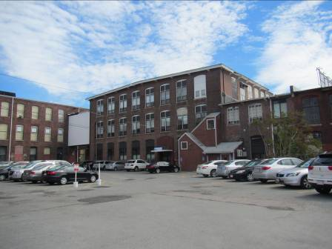

Prepared by:
Massachusetts Department of Public Health
Bureau of Environmental Health
Indoor Air Quality Program
June 2015

In response to a request from Dave Devine, Project Manager, Division of Capital Asset Management and Maintenance (DCAMM), the Massachusetts Department of Public Health (MDPH), Bureau of Environmental Health (BEH) conducted an indoor air quality (IAQ) assessment at the Department of Children and Families (DCF), located at 100 North Front Street, New Bedford, Massachusetts. This evaluation was conducted as part of enhanced efforts to ensure acceptable IAQ in office space leased by Massachusetts state agencies. On May 21, 2015, a visit to conduct an IAQ assessment was made by Cory Holmes, Environmental Analyst/Inspector and Ruth Alfasso, Environmental Engineer/Inspector, from BEH’s IAQ Program.
The DCF occupies the first and second floors of a red brick building located near the New Bedford waterfront. It was reported that DCF has occupied the space for close to 20 years. The space contains offices, open workstations, reception/waiting room, interview rooms, conference rooms, storage areas and kitchen/lounge areas. Ceilings consist of suspended ceiling tiles. Floors consist of wall to wall carpeting in the majority of areas. Windows are not openable on the first floor of the building.

Methods
Air tests for carbon monoxide, carbon dioxide, temperature and relative humidity were conducted with the TSI, Q-Trak, IAQ Monitor, Model 7565. Air tests for airborne particle matter with a diameter less than 2.5 micrometers were taken with the TSI, DUSTTRAK™ Aerosol Monitor Model 8520. BEH/IAQ staff also performed a visual inspection of building materials for water damage and/or microbial growth. Moisture content of building materials in select areas was measured using a Delmhorst BD-2100 moisture meter.

Results
The employee population of the DCF office is approximately 145, which is visited by clients/members of the public daily. The tests were taken during normal operations and appear in Table 1.

Discussion

Ventilation
It can be seen from Table 1 that carbon dioxide levels were below 800 parts per million (ppm) in 55 out of 62 areas tested, indicating adequate air exchange in most areas tested on the day of the assessment. Fresh air for the first floor is provided by two large air handling units (AHUs) located on the exterior of the building (Picture 1). Fresh air for the second floor is provided by four rooftop AHUs (Picture 2). Outside air is drawn through 2-inch thick pleated filters (Picture 3) and ducted to ceiling-mounted supply diffusers (Picture 4). Return air is drawn back into ceiling vents (Pictures 5 and 6) and returned to the AHUs. On the second floor, offices are equipped with supply vents and doors are undercut to allow air to be drawn to return vents in corridors when doors are shut. Return vents on the second floor are also equipped with additional filters installed in the vents (Picture 6).
Ventilation in restrooms is provided by exhausts vented directly to fans on the roof or exterior wall. At the time of the assessment some restroom exhaust vents were found to be off or drawing weakly. Lack of exhaust ventilation in restrooms can lead to odors and moisture migrating to adjacent areas.
It is important to note that AHUs are reported to be at least 20 years old. Efficient function of such aged equipment is difficult, since compatible replacement parts are often unavailable or difficult to obtain. According to the American Society of Heating, Refrigeration and Air-Conditioning Engineering (ASHRAE), the service life for a unit heater, hot water or steam is 20 years, assuming routine maintenance of the equipment (ASHRAE, 1991). Despite attempts to maintain the equipment, it is nearing its operational lifespan.
To maximize air exchange, the MDPH recommends that both supply and exhaust ventilation operate continuously during periods of occupancy. In order to have proper ventilation with a mechanical supply and exhaust system, the systems must be balanced to provide an adequate amount of fresh air to the interior of a room while removing stale air from the room. It is recommended that HVAC systems be re-balanced every five years to ensure adequate air systems function (SMACNA, 1994).
Minimum design ventilation rates are mandated by the Massachusetts State Building Code (MSBC). Until 2011, the minimum ventilation rate in Massachusetts was higher for both occupied office spaces and general classrooms, with similar requirements for other occupied spaces (BOCA, 1993). The current version of the MSBC, promulgated in 2011 by the State Board of Building Regulations and Standards (SBBRS), adopted the 2009 International Mechanical Code (IMC) to set minimum ventilation rates. Please note that the MSBC is a minimum standard that is not health-based. At lower rates of cubic feet per minute (cfm) per occupant of fresh air, carbon dioxide levels would be expected to rise significantly. A ventilation rate of 20 cfm per occupant of fresh air provides optimal air exchange resulting in carbon dioxide levels at or below 800 ppm in the indoor environment in each area measured. MDPH recommends that carbon dioxide levels be maintained at 800 ppm or below. This is because most environmental and occupational health scientists involved with research on IAQ and health effects have documented significant increases in indoor air quality complaints and/or health effects when carbon dioxide levels rise above the MDPH guidelines of 800 ppm for schools, office buildings and other occupied spaces (Sundell et al., 2011). The ventilation must be on at all times that the room is occupied. Providing adequate fresh air ventilation with open windows and maintaining the temperature in the comfort range during the cold weather season is impractical. Mechanical ventilation is usually required to provide adequate fresh air ventilation.
Carbon dioxide is not a problem in and of itself. It is used as an indicator of the adequacy of the fresh air ventilation. As carbon dioxide levels rise, it indicates that the ventilating system is malfunctioning or the design occupancy of the room is being exceeded. When this happens, a buildup of common indoor air pollutants can occur, leading to discomfort or health complaints. The Occupational Safety and Health Administration (OSHA) standard for carbon dioxide is 5,000 parts per million parts of air (ppm). Workers may be exposed to this level for 40 hours/week, based on a time-weighted average (OSHA, 1997).
The MDPH uses a guideline of 800 ppm for publicly occupied buildings. A guideline of 600 ppm or less is preferred in schools due to the fact that the majority of occupants are young and considered to be a more sensitive population in the evaluation of environmental health status. Inadequate ventilation and/or elevated temperatures are major causes of complaints such as respiratory, eye, nose and throat irritation, lethargy and headaches. For more information concerning carbon dioxide, please see Appendix A.
Temperature readings during the assessment ranged from 70ºF to 74ºF (Table 1), which were within the MDPH recommended comfort guidelines. The MDPH recommends that indoor air temperatures be maintained in a range of 70ºF to 78ºF in order to provide for the comfort of building occupants. In many cases concerning indoor air quality, fluctuations of temperature in occupied spaces are typically experienced, even in a building with an adequate fresh air supply. Several temperate control complaints were reported by occupants during the assessment. As stated, the HVAC equipment is over 20 years old, at the end of their lifecycle and will become difficult to maintain as it continues to age. BEH/IAQ staff also examined units on the roof and noted that the insulation on ductwork had become damaged (Pictures 7 and 8), exposing the ductwork to the elements, which can reduce efficiency and effect temperature control.
The relative humidity measured during the assessment ranged from 26 to 41 percent, which was below the MDPH recommended comfort range in the majority of areas. The MDPH recommends a comfort range of 40 to 60 percent for indoor air relative humidity. Relative humidity levels in the building would be expected to drop during the winter months due to heating. The sensation of dryness and irritation is common in a low relative humidity environment. Low relative humidity is a very common problem during the heating season in the northeast part of the United States.

Microbial/Moisture Concerns
A few water-damaged ceiling tiles were observed in offices/work areas (Pictures 9 and 10, Table 1). The damaged tiles shown in Picture 10 were wet at the time of the assessment indicating a current leak; carpeting in this area was found to be dry. Current leaks were also reported in the first floor women’s restroom. Water-damaged ceiling tiles should be removed and replaced once the source of water has been identified and remediated.
Plants were observed in several areas, including one in a large pot of standing water (Table 1). Plants can be a source of pollen and mold, which can be respiratory irritants to some individuals. Plants should be properly maintained, over-watering of plants should be avoided and drip pans should be inspected periodically for mold growth.
Water coolers and small refrigerators were observed on carpeted areas (Picture 11). Spills or leaks from these appliances can moisten carpeting. They should be located in a non-carpeted area or on waterproof mats. In addition, refrigerators should be cleaned out regularly to prevent spoiled food from becoming a source of odors.
BEH/IAQ staff examined the exterior of the building to identify breaches in the building envelope and/or other issues that could provide a source of water penetration. Several potential sources were identified:
- Plants were observed growing in close proximity to the foundation and building exterior (Picture 12). Plants in close proximity to the building envelope can cause water damage to the foundation and exterior walls. Water can eventually penetrate the cracks and breaches subsequently freezing and thawing during the winter. This freezing/thawing action can weaken masonry and other building materials, resulting in damage;
- Breaches in the foundation (Pictures 13 and 14);
- Missing/damaged mortar around exterior brick; and
- Missing/damaged gutters/downspouts (Pictures 15 and 16).
These conditions can undermine the integrity of the building envelope and provide a means of water entry by capillary action into the building through exterior walls, foundation concrete and masonry (Lstiburek & Brennan, 2001). In addition, these breaches can provide a means of drafts and pest entry into the building.

Other IAQ Evaluations
Indoor air quality can be negatively influenced by the presence of respiratory irritants, such as products of combustion. The process of combustion produces a number of pollutants. Common combustion emissions include carbon monoxide, carbon dioxide, water vapor, and smoke (fine airborne particle material). Of these materials, exposure to carbon monoxide and particulate matter with a diameter of 2.5 micrometers (μm) or less (PM2.5) can produce immediate, acute health effects upon exposure. To determine whether combustion products were present in the indoor environment, BEH/IAQ staff obtained measurements for carbon monoxide and PM2.5.

Carbon Monoxide
Carbon monoxide is a by-product of incomplete combustion of organic matter (e.g., gasoline, wood and tobacco). Exposure to carbon monoxide can produce immediate and acute health effects. Several air quality standards have been established to address carbon monoxide and prevent symptoms from exposure to these substances. The MDPH established a corrective action level concerning carbon monoxide in ice skating rinks that use fossil-fueled ice resurfacing equipment. If an operator of an indoor ice rink measures a carbon monoxide level over 30 ppm, taken 20 minutes after resurfacing within a rink, that operator must take actions to reduce carbon monoxide levels (MDPH, 1997).
The American Society of Heating Refrigeration and Air-Conditioning Engineers (ASHRAE) has adopted the National Ambient Air Quality Standards (NAAQS) as one set of criteria for assessing indoor air quality and monitoring of fresh air introduced by HVAC systems (ASHRAE, 1989). The NAAQS are standards established by the US EPA to protect the public health from six criteria pollutants, including carbon monoxide and particulate matter (US EPA, 2006). As recommended by ASHRAE, pollutant levels of fresh air introduced to a building should not exceed the NAAQS levels (ASHRAE, 1989). The NAAQS were adopted by reference in the Building Officials & Code Administrators (BOCA) National Mechanical Code of 1993 (BOCA, 1993), which is now an HVAC standard included in the Massachusetts State Building Code (SBBRS, 2011). According to the NAAQS, carbon monoxide levels in outdoor air should not exceed 9 ppm in an eight-hour average (US EPA, 2006).
Carbon monoxide should not be present in a typical, indoor environment. If it is present, indoor carbon monoxide levels should be less than or equal to outdoor levels. During the assessment outdoor carbon monoxide concentrations were measured at 0.8 ppm. Indoor levels were all non-detect (ND, Table 1).

Particulate Matter
The US EPA has established NAAQS limits for exposure to particulate matter. Particulate matter includes airborne solids that can be irritating to the eyes, nose and throat. The NAAQS originally established exposure limits to PM with a diameter of 10 μm or less (PM10). In 1997, US EPA established a more protective standard for fine airborne particulate matter with a diameter of 2.5 μm or less (PM2.5). This more stringent PM2.5 standard requires outdoor air particle levels be maintained below 35 μg/m³ over a 24-hour average (US EPA, 2006). Although both the ASHRAE standard and BOCA Code adopted the PM10 standard for evaluating air quality, MDPH uses the more protective PM2.5 standard for evaluating airborne PM concentrations in the indoor environment.
Outdoor PM2.5 concentrations were measured at 8 μg/m³ (Table 1). PM2.5 levels indoors ranged from 5 to 34 μg/m³, which were below the NAAQS PM2.5 level of 35 μg/m³. Frequently, indoor air levels of particulate matter (including PM2.5) can be at higher levels than those measured outdoors. A number of activities that occur indoors and/or mechanical devices can generate particulate matter during normal operations. Sources of indoor airborne particulate matter may include but are not limited to particles generated during the operation of fan belts in the HVAC system, use of stoves and/or microwave ovens in kitchen areas; use of photocopiers, fax machines and computer printing devices; operation of an ordinary vacuum cleaner and heavy foot traffic indoors.

Volatile Organic Compounds
Indoor air concentrations can be greatly impacted by the use of products containing volatile organic compounds (VOCs). VOCs are carbon-containing substances that have the ability to evaporate at room temperature. Total volatile organic compounds (TVOCs) can result in eye and respiratory irritation if exposure occurs. For example chemicals evaporating from a paint can stored at room temperature would most likely contain VOCs.
Several areas had dry erase boards and related materials (Table 1). Materials such as dry erase markers and dry erase board cleaners may contain VOCs, such as methyl isobutyl ketone, n-butyl acetate and butyl-cellusolve (Sanford, 1999), which can be irritating to the eyes, nose and throat.
Hand sanitizer was also observed in office areas (Table 1); these products may contain ethyl alcohol and/or isopropyl alcohol, which are highly volatile and may be irritating to the eyes and nose. Sanitizing products may also contain fragrances to which some people may be sensitive.
Cleaning products, air freshening sprays and scented products were also observed (Picture 11; Table 1). Plug-in air fresheners and other air deodorizers contain chemicals that can be irritating to the eyes, nose and throat of sensitive individuals. Many air fresheners contain 1,4-dichlorobenzene, a VOC which can reduce lung function (NIH, 2006). Furthermore, deodorizing agents do not remove materials causing odors, but rather mask odors that may be present in the area. Many cleaning products contain chemicals that can be irritating to the eyes, nose and throat of sensitive individuals. Cleaning products should be properly labeled and stored in an appropriate area. In addition, a Material Safety Data Sheet (MSDS) should be available at a central location for each product in the event of an emergency.

Other Conditions
Other conditions that can affect IAQ were observed during the assessment. Evidence of rodent activity was observed in the form of rodent traps in several areas (Picture 14). Building staff reported rodent sightings/waste in the building. Rodent infestation can result in indoor air quality related symptoms due to materials in their wastes. Mouse urine contains a protein that is a known sensitizer (US EPA, 1992). A sensitizer is a material that can produce symptoms (e.g., running nose or skin rashes) in sensitive individuals after repeated exposure. A three-step approach is necessary to eliminate rodent infestation:
- Removal of the rodents;
- Cleaning of waste products from the interior of the building; and
- Reduction/elimination of pathways/food sources that are attracting rodents.
To eliminate exposure to allergens, rodents must be removed from the building. Please note that removal, even after cleaning, may not provide immediate relief since allergens can exist in the interior for several months after rodents are eliminated (Burge, 1995). Once the infestation is eliminated, a combination of cleaning and increased ventilation and filtration should serve to reduce allergens associated with rodents. Ants were also reported in a few areas. The principles of Integrated Pest Management (IPM) should be used to address any pest control issues in the building.
Food and food preparation/storage equipment was observed in many offices and common areas. Food should be kept in tightly-sealed containers to prevent attracting pests. Food preparation equipment should be kept clean and free of debris that can cause odors, smoke when heated or attract pests.
In some areas, accumulations of items were seen on floors, windowsills, tabletops, counters, bookcases and desks, which provide a source for dusts to accumulate (Picture 17). These items (e.g., papers, folders, boxes) make it difficult for custodial staff to clean. Items should be relocated and/or be cleaned periodically to avoid excessive dust build up.
The DCF also has a large number of items stored, including clothing, luggage and other items (Picture 18). Some of these items were observed to be on floors, where they can become dusty, dirty or subject to condensation. Cardboard, paper, cloth and other porous items should not be stored in contact with floors.
Heaters, personal fans and air purifying units were observed in a few offices, some of which were dusty (Table 1). These items should be kept clean and free of debris as reaerosolization of particulate matter from these units can occur. Personal air purifying units should be maintained in accordance with manufacturer’s instructions, including cleaning and changing of any filters, to prevent them becoming a source of particulate matter and odors.
Fluorescent light bulbs were found stored against a wall in an open work area (Picture 19). These bulbs contain mercury, which can be released if they are accidentally broken. New and spent bulbs should be stored in a secure container and the spent bulbs should be disposed of in a manner consistent with state/local environmental regulations.
Most areas of the office space had wall to wall carpeting. The Institute of Inspection, Cleaning and Restoration Certification (IICRC) recommends that carpeting be cleaned annually (or semi-annually in soiled high traffic areas) (IICRC, 2012). Regular cleaning with a high efficiency particulate arrestance (HEPA) filtered vacuum in combination with an annual cleaning will help to reduce accumulation and potential aerosolization of materials from the carpeting.

Conclusions/Recommendations
In view of the findings at the time of the visit, the following recommendations are made:
- Operate all ventilation systems throughout the building continuously during periods of occupancy to maximize air exchange. This would include leaving thermostat fan settings in the “on” mode (not auto) for continuous airflow.
- Make repairs to damaged insulation on second floor (exterior) ductwork shown in Pictures 7 and 8.
- Inspect and activate motors for restroom exhaust vents, make repairs as needed.
- Consider adopting a balancing schedule of every 5 years for all mechanical ventilation systems, as recommended by ventilation industrial standards (SMACNA, 1994).
- Consider long-term plans for replacing AHUs as they have reached/exceeded optimal service life and will become increasingly difficult to maintain.
- For buildings in New England, periods of low relative humidity during the winter are often unavoidable. Therefore, scrupulous cleaning practices should be adopted to minimize common indoor air contaminants whose irritant effects can be enhanced when the relative humidity is low. To control for dusts, a high efficiency particulate arrestance (HEPA) filter equipped vacuum cleaner in conjunction with wet wiping of all surfaces is recommended. Avoid the use of feather dusters. Drinking water during the day can help ease some symptoms associated with a dry environment (throat and sinus irritations).
- Examine areas of leakage (e.g., room 202 and 2nd floor women’s restroom) and determine source(s) of water and repair as needed. Ensure any water-damaged ceiling tiles are repaired and/or replaced. Examine the area above ceiling tiles for mold growth. Disinfect areas of water leaks with an appropriate antimicrobial, as needed.
- Make temporary repairs to seal breaches in building envelope to prevent drafts, access by pests/rodents and water penetration/damage to building materials.
- Re-point exterior walls/foundation to prevent further structural damage.
- Indoor plants should be properly maintained and equipped with drip pans to prevent water damage to porous building materials and be located away from ventilation sources to prevent the aerosolization of dirt, pollen or mold.
- Place water coolers/dispensers and refrigerators in areas without carpeting or place on a waterproof mat.
- Ensure all refrigerators are kept clean.
- Remove plants/shrubbery along foundation of the building.
- Remove rodent harborages (e.g., leaves/debris) from the exterior of the building.
- Use the principles of integrated pest management (IPM) to rid this building of pests. Activities that can be used to eliminate pest infestation may include the following:
  - Keep list/inventory of location of all rodent bait/sticky traps, monitor on a regular basis and replace as needed to prevent odors from rodent die off;
  - Do not use recycled food containers for other purposes. Seal containers to be recycled in a container with a tight fitting lid to prevent rodent access;
  - Remove non-food items that rodents are consuming or using as bedding;
  - Store foods in tight fitting containers;
  - Avoid eating at workstations. In areas were food is consumed, vacuum periodically to remove crumbs;
  - Regularly clean crumbs and other food residues from toasters, toaster ovens, microwave ovens coffee pots and other food preparation equipment;
  - Examine each room and the exterior walls of the building for means of rodent egress and seal appropriately. Holes as small as ¼” is enough space for rodents to enter an area. If light can be seen through the bottom of doors, install a weather strip as a barrier to rodents;
  - Reduce harborages (cardboard boxes, paper) where rodents may reside; and
  - Refer to the IPM Guide, which can be obtained at the following Internet address: http://www.mass.gov/eea/docs/agr/pesticides/publications/ipm-kit-for-bldg-mgrs.pdf.
- Reduce the use of hand sanitizing products especially those containing fragrances.
- Avoid the use of air freshener sprays, solids and diffuser reeds to avoid exposure to VOCs and fragrance compounds.
- Ensure that items in storerooms are enclosed to protect from dust and are in plastic containers or on shelves off the floor to prevent condensation.
- Clean/maintain heaters, personal fans and air purifiers regularly to prevent aerosolization of dust and debris.
- Ensure refrigerators are cleaned out regularly. Consider reducing the number of refrigerators in use in the office.
- Store fluorescent bulbs in containers to prevent breakage and dispose of them in accordance with state/local environmental regulations.
- Vacuum carpet with a high efficiency particulate arrestance (HEPA) filtered vacuum in combination with cleaning carpeting annually or semi-annually in soiled high traffic areas as per the recommendations of the Institute of Inspection, Cleaning and Restoration Certification (IICRC, 2012).
- Refer to resource manuals and other related indoor air quality documents for further building-wide evaluations and advice on maintaining public buildings. Copies of these materials are located on the MDPH’s website: http://mass.gov/dph/iaq.

References
ASHRAE. 1989. Ventilation for Acceptable Indoor Air Quality. American Society of Heating, Refrigeration and Air Conditioning Engineers. ANSI/ASHRAE 62-1989.
ASHRAE. 1991. ASHRAE Applications Handbook, Chapter 33 “Owning and Operating Costs”. American Society of Heating, Refrigeration and Air Conditioning Engineers, Atlanta, GA.
BOCA. 1993. The BOCA National Mechanical Code/1993. 8th ed. Building Officials & Code Administrators International, Inc., Country Club Hills, IL.
Burge, H.A. 1995. Bioaerosols. Lewis Publishing Company, Boca Raton, FL.
IICRC. 2012. Carpet Cleaning FAQ 4 Institute of Inspection, Cleaning and Restoration Certification. Institute of Inspection Cleaning and Restoration, Vancouver, WA.
Lstiburek, J. & Brennan, T. 2001. Read This Before You Design, Build or Renovate. Building Science Corporation, Westford, MA. U.S. Department of Housing and Urban Development, Region I, Boston, MA.
MDPH. 1997. Requirements to Maintain Air Quality in Indoor Skating Rinks (State Sanitary Code, Chapter XI). 105 CMR 675.000. Massachusetts Department of Public Health, Boston, MA.
NIH. 2006. Chemical in Many Air Fresheners May Reduce Lung Function. NIH News. National Institute of Health. July 27, 2006. http://www.nih.gov/news/pr/jul2006/niehs-27.htm
OSHA. 1997. Limits for Air Contaminants. Occupational Safety and Health Administration. Code of Federal Regulations. 29 C.F.R 1910.1000 Table Z-1-A.
Sanford. 1999. Material Safety Data Sheet (MSDS No: 198-17). Expo® Dry Erase Markers Bullet, Chisel, and Ultra Fine Tip. Sanford Corporation. Bellwood, IL.
SBBRS. 2011. Mechanical Ventilation. State Board of Building Regulations and Standards. Code of Massachusetts Regulations, 8th edition. 780 CMR 1209.0.
SMACNA. 1994. HVAC Systems Commissioning Manual. 1st ed. Sheet Metal and Air Conditioning Contractors’ National Association, Inc., Chantilly, VA.
Sundell. 2011. Sundell, J., H. Levin, W. W. Nazaroff, W. S. Cain, W. J. Fisk, D. T. Grimsrud, F. Gyntelberg, Y. Li, A. K. Persily, A. C. Pickering, J. M. Samet, J. D. Spengler, S. T. Taylor, and C. J. Weschler. Ventilation rates and health: multidisciplinary review of the scientific literature. Indoor Air, Volume 21: pp 191–204.
US EPA. 1992. Indoor Biological Pollutants. US Environmental Protection Agency, Environmental Criteria and Assessment Office, Office of Health and Environmental Assessment, research Triangle Park, NC. EPA 600/8-91/202. January 1992.
US EPA. 2006. National Ambient Air Quality Standards (NAAQS). US Environmental Protection Agency, Office of Air Quality Planning and Standards, Washington, DC. http://www.epa.gov/air/criteria.html.
Picture 1
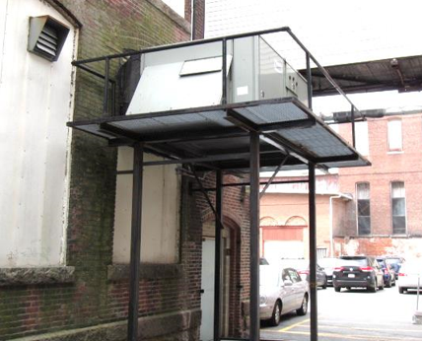
One of two air handling units (AHUs) on exterior wall of building
Picture 2
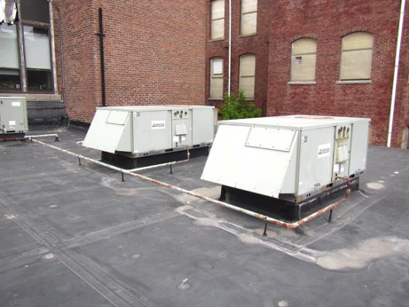
Two of four rooftop air handling units for second floor
Picture 3
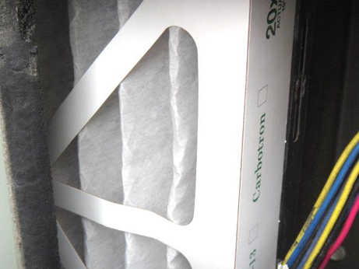
Pleated filters in AHUs
Picture 4
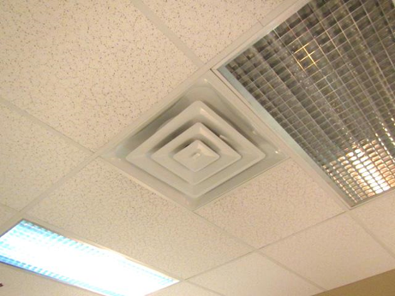
Ceiling-mounted supply diffuser
Picture 5
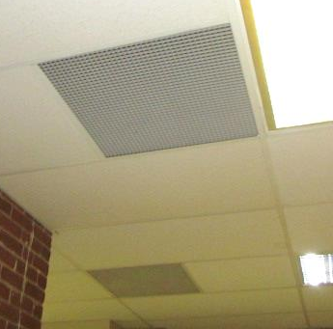
Ceiling-mounted return vents on the first floor
Picture 6
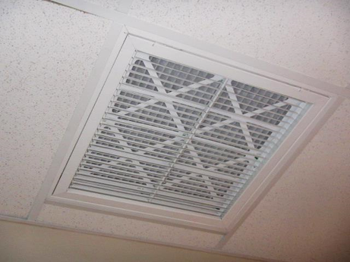
Ceiling-mounted return vents on the second floor, note filters within vents
Picture 7
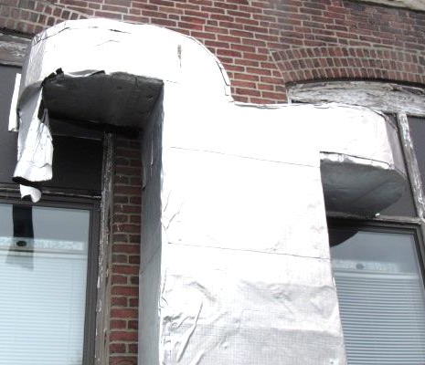
Missing/damaged insulation on second floor ductwork
Picture 8
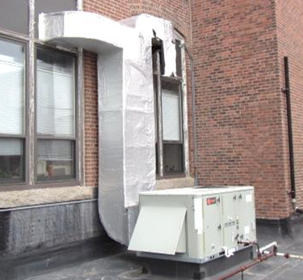
Missing/damaged insulation (arrow) on second floor ductwork
Picture 9
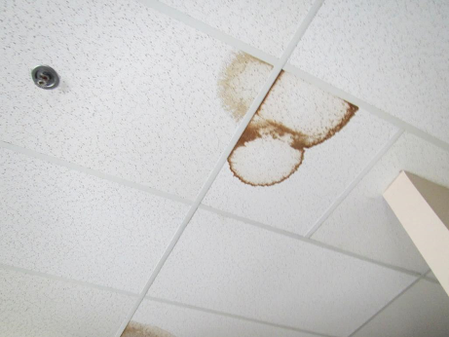
Water-damaged ceiling tiles
Picture 10
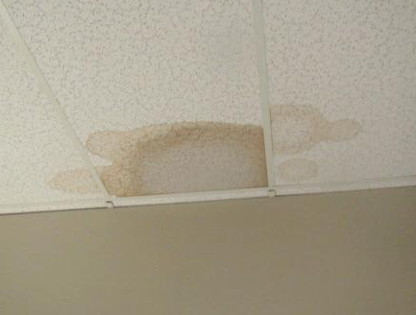
Wet ceiling tiles in room 202
Picture 11
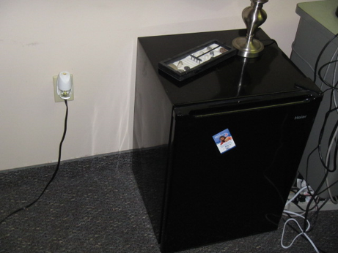
Refrigerator on carpet, and plug-in air freshener
Picture 12
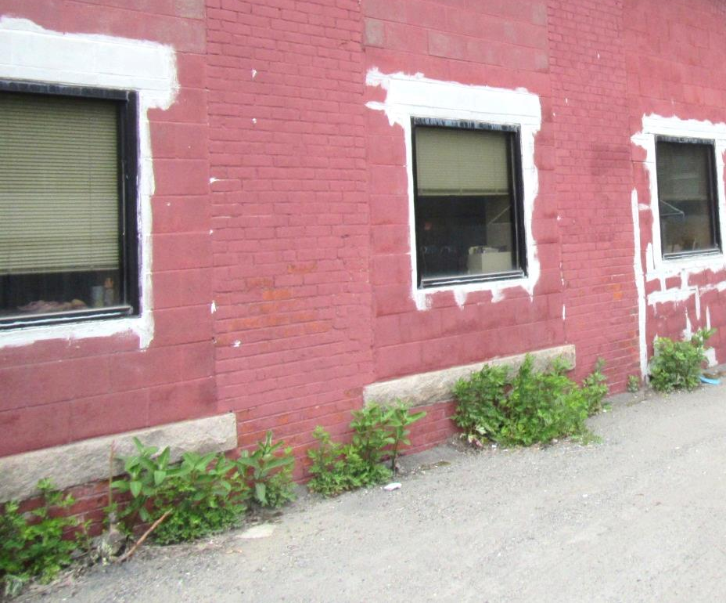
Plants growing against foundation
Picture 13
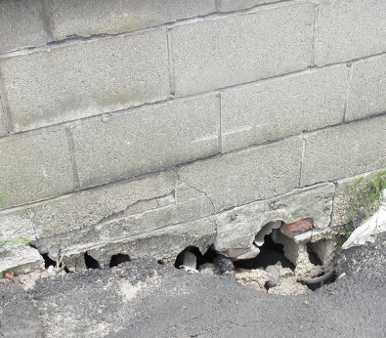
Breaches along foundation
Picture 14
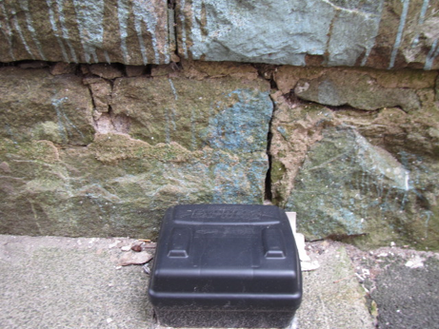
Cracks in foundation masonry, missing/damaged mortar, also note rodent trap
Picture 15
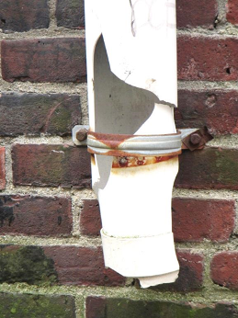
Damaged downspout
Picture 16
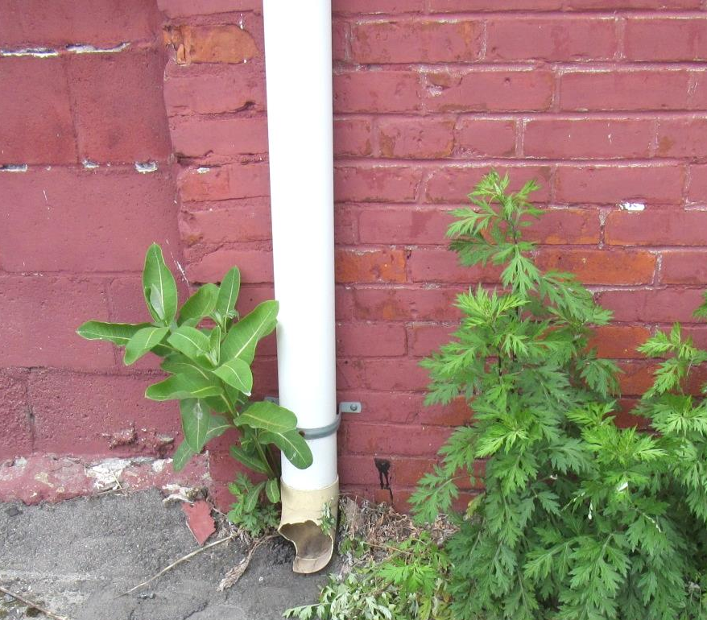
Damaged downspout emptying along foundation
Picture 17
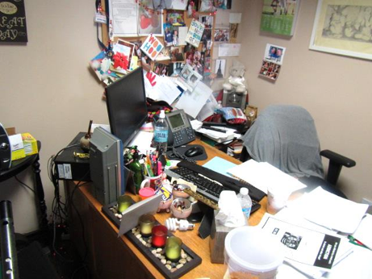
Accumulated items in office
Picture 18
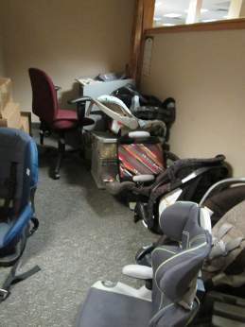
Car seats on floor
Picture 19
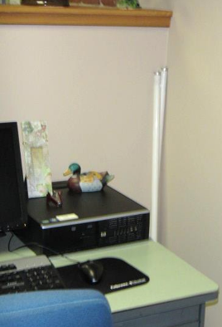
Fluorescent bulbs against wall in workspace

Location | Carbon  Dioxide  (ppm) | Carbon Monoxide  (ppm) | Temp  (°F) | Relative  Humidity  (%) | PM2.5  (µg/m³) | Occupants  in Room | Windows  Openable | Ventilation |  |  | Remarks
 |  |  |  |  |  |  |  | Intake | Exhaust |  | Remarks
Background | 410 | 0.8 | 71.6 | 23 | 8 |  |  |  |  |  | Mixed sun and clouds, windy
Waiting room | 747 | ND | 72 | 40 | 6 | 2 | N | Y |  | Y | Stained/soiled couch with cushions
1st floor files | 687 | ND | 72 | 36 | 10 | 0 | N | Y |  | Y | Boxes on floor, NC, DO
1st floor copy area | 748 | ND | 72 | 37 | 9-20 | 0 | N | Y |  | Y | NC, PC, exhaust may be direct
1st floor conference room A1 | 714 | ND | 71 | 37 | 8 | 0 | N | Y |  | Y | Divider shut to other half of conference room
1st floor case files | 717 | ND | 71 | 37 | 9 | 0 | N | Y |  | Y | NC, food collection (cans)
1st floor office/conference room B | 721 | ND | 72 | 38 | 6 | 2 | N | Y |  | Y | DO, fridge on carpet
1st floor women’s restroom |  |  |  |  |  |  | N | Y |  | Y | CP, exhaust may not be operational
2nd floor women’s restroom |  |  |  |  |  |  | Y | Y |  | Y
2nd floor ADA unisex restroom |  |  |  |  |  |  | Y | Y |  | N
102 | 805 | ND | 73 | 36 | 5 | 0 | N | Y |  | Y | Vacant office
103 | 758 | ND | 73 | 37 | 20 | 3 | N | Y |  |  | Fridge on carpet, CP, AI, plants and flowers
105 office | 760 | ND | 73 | 37 | 11 | 1 | N | Y |  | Y | Plush items, CP
106 | 827 | ND | 74 | 36 | 20-34 | 1 | N | Y |  | Y | Heater, plant
107 | 826 | ND | 73 | 37 | 6 | 3 | N | Y |  | Y | Office area, fridge on carpet, AI, plants, hanging items
108 area | 770 | ND | 74 | 36 | 7 | 1 | N | Y |  | Y | PF
110 office | 762 | ND | 73 | 34 | 8 | 1 | N | Y |  | Y | DEM, DO
111 area | 743 | ND | 73 | 35 | 9 | 3 | N | Y |  | y | PF-dusty, DEM, WD CT, reported WD wall (no stains)
112 area | 738 | ND | 73 | 35 | 5 | 4 | N | Y |  | Y | CPs, AF, dusty by supply vent, plants in poor condition
113 | 662 | ND | 72 | 33 | 6 | 0 | N | Y |  | Y | Fridge on carpet, HS
114 | 762 | ND | 74 | 35 | 7 | 1 | N | Y |  | Y | DO, fridge on carpet, AF
115 | 766 | ND | 73 | 35 | 6 | 1 | N | Y |  | Y | Heater/AP
116 | 721 | ND | 73 | 35 | 8 | 1 | N | Y |  | Y | AP, concerns about dust, reports of moisture on floor periodically, carpet dry
117 | 663 | ND | 71 | 39 | 9 | 1 | N | Y |  | Y | DO
119 | 748 | ND | 72 | 40 | 12 | 1 | N | Y |  | Y
120 | 727 | ND | 72 | 39 | 7 | 0 | N | Y |  | Y
121 | 764 | ND | 72 | 39 | 7 | 2 | N | Y |  | Y
122 | 747 | ND | 73 | 39 | 7 | 3 | N | Y |  | Y | Fluorescent bulb against wall
123 | 750 | ND | 73 | 40 | 8 | 3 | N | Y |  | Y | Mini fridge, coffeemaker
125 | 824 | ND | 72 | 41 | 6 | 2 | N | Y |  | Y | Area rug, DO
126 | 704 | ND | 72 | 41 | 7 | 0 | N | Y |  | Y | Plants, mini fridge, PF, AF
127 | 730 | ND | 72 | 40 | 7 | 0 | N | Y |  | Y
128 | 791 | ND | 72 | 39 | 7 | 0 | N | Y |  | Y | Plants, PF, DO
131 open area | 731 | ND | 72 | 36 | 11 | 3 | N | Y |  | Y | DEM
132 office | 748 | ND | 72 | 37 | 8 | 0 | N | Y |  | Y | DEM
147 interview | 746 | ND | 72 | 37 | 5 | 0 | N | Y |  | Y | NC
148 | 784 | ND | 72 | 37 | 13 | 1 | N | Y |  | Y | Mail equipment, reception
151 kitchen | 716 | ND | 72 | 37 | 6 | 2 | N | Y |  | Y | NC, sink, microwave, small fridge (Clean), PF dusty
170 | 738 | ND | 72 | 41 | 8 | 0 | N | Y |  | Y | DO
202 | 651 | ND | 72 | 34 | 7 | 3 | Y | y |  | Y | Moisture testing: wet CT, rug dry, reported leak has occurred repeatedly
203 | 518 | ND | 71 | 30 | 12 | 1 | Y | Y |  |  | Cans/recycling, reports of mouse droppings, candle
204 | 505 | ND | 71 | 28 | 7 | 4 | Y | Y |  | Y | 3 WD CT, plants
206 office | 499 | ND | 71 | 28 | 7 | 0 | N | Y |  | Y | AI
207 files | 519 | ND | 72 | 28 | 6 | 0 | N | Y |  | N | DO
209 | 613 | ND | 72 | 32 | 19 | 3 | Y | Y |  | Y
209 | 490 | ND | 71 | 27 | 9 | 0 | N | Y |  | Y
210 | 530 | ND | 72 | 26 | 6 | 1 | Y | Y |  | Y | Plant
212 | 560 | ND | 73 | 27 | 5 | 2 | Y | Y |  | Y
213 | 631 | ND | 74 | 30 | 15 | 3 | Y open | Y |  | Y | Fridge on carpet, HS, reports of mold
213 (repeat, window closed) | 633 | ND | 73 | 31 | 22 | 3 | Y | Y |  | Y
214 | 698 | ND | 74 | 31 | 15 | 4 | Y | Y |  | N | Plants
215 | 695 | ND | 74 | 32 | 10 | 3 | Y | Y |  | Y | Fridge on carpet, PF, hanging items
216 office | 735 | ND | 72 | 34 | 10 | 0 | Y | Y |  | N | DO, items on floor, plants, heater, plants, CP, WD CT (reports recent leak)
218 | 646 | ND | 74 | 33 | 7 | 0 |  | Y |  | N | Mini fridge
219 | 729 | ND | 74 | 35 | 7 | 0 |  | Y |  | N | DO, mini fridge
220 | 655 | ND | 73 | 34 | 11 | 0 |  | Y |  | N | AP
222 | 777 | ND | 71 | 35 | 8 | 2 | N | Y |  | Y | Fridge on carpet, plants
223 |  |  |  |  |  |  | Y | Y |  | N
225 | 795 | ND | 70 | 35 | 21 | 2 | Y | Y |  |  | Boxes, moving, CP
225 | 795 | ND | 70 | 36 | 5 | 2 | Y | Y |  | Y | Fridge on carpet, plants
226 area |  |  |  |  |  |  | Y | Y |  | Y | Plants
227 | 790 | ND | 70 | 36 | 7 | 0 | N | Y |  | Y
228 office | 769 | ND | 70 | 35 | 8 | 0 | Y | Y |  | Y
229 | 858 | ND | 70 | 36 | 16 | 6 | Y | Y |  | Y | Reports of cold temperatures, drafty window
230 | 801 | ND | 70 | 35 | 5 | 3 | Y open | Y |  | Y | Window open, fridge on carpet
231 | 728 | ND | 71 | 33 | 6 | 0 | Y | Y |  | Y
234 | 835 | ND | 71 | 39 | 7 | 0 | Y | Y |  | N | Plants, electric heater
235 | 785 | ND | 73 | 37 | 7 | 2 | Y | Y |  | N | Temp/air flow complaints

The service life is the median time during which a particular system or component of …[an HVAC]… system remains in its original service application and then is replaced. Replacement may occur for any reason, including, but not limited to, failure, general obsolescence, reduced reliability, excessive maintenance cost, and changed system requirements due to such influences as building characteristics or energy prices (ASHRAE, 1991).

