INDOOR AIR QUALITY ASSESSMENT
MOLD INVESTIGATION

Department Of Children and Family
810 Memorial Drive
Cambridge, Massachusetts

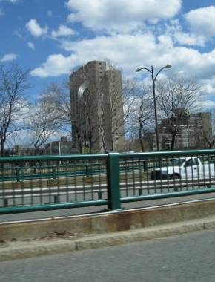

Prepared by:
Massachusetts Department of Public Health
Bureau of Environmental Health
Indoor Air Quality Program
March 2013

Background/Introduction
At the request of David Devine, Project Manager, Division of Capital Asset Management and maintenance (DCAMM), the Massachusetts Department of Public Health (MDPH), Bureau of Environmental Health (BEH) provided assistance and consultation regarding water damage and mold concerns at the Department of Children and Families’ (DCF) Cambridge/Somerville Area Office. The office is located at 810 Memorial Drive, Cambridge, Massachusetts. The DCF occupies space on the third floor of a multi-story high-rise office and apartment complex building.
On December 31, 2012, a fire occurred in an apartment above the DCF offices, activating the fire suppression system that resulting in water damage to areas on lower levels. On January 16, 2013, a visit to conduct an assessment was made by Sharon Lee, an Environmental Analyst within BEH’s Indoor Air Quality (IAQ) Program. At time of the MDPH/BEH visit, DCF staff reported that the building management had conducted extensive remediation work, including: drying of affected areas with industrial fans and dehumidifiers, replacing damaged carpet tiles, repairing/repainting walls, and affixing new wall coving.

Methods
BEH staff performed a visual inspection of building materials for water damage and mold growth. Moisture content of porous building materials [e.g., carpeting, gypsum wallboard (GW)] was measured with a Delmhorst, BD-2000 Model, Moisture Detector equipped with a Delmhorst Standard Probe. Temperature and relative humidity measurements were taken with a TSI, Q-Trak, IAQ Monitor, Model 7565. Air tests for airborne particle matter with a diameter less than 2.5 micrometers were taken with the TSI, DUSTTRAK™ Aerosol Monitor Model 8520.

Results
The DCF has a staff population of 50, with up to 100 people visiting the building daily. Visual observation/evaluation and testing were conducted under normal operating conditions.

Discussion

Temperature and Relative Humidity
Temperature measurements ranged from 69º F to 73º F, which were within or close to the MDPH recommended comfort range in all areas. The MDPH recommends that indoor air temperatures be maintained in a range of 70º F to 78º F in order to provide for the comfort of building occupants. In many cases concerning indoor air quality, fluctuations of temperature in occupied spaces are typically experienced, even in a building with an adequate fresh air supply.
The relative humidity ranged from 28 to 32 percent during the assessment, which was below the MDPH recommended comfort range in all areas surveyed. The MDPH recommends a comfort range of 40 to 60 percent for indoor air relative humidity. Relative humidity levels would be expected to drop during the winter months due to heating and decreased outdoor relative humidity. The sensation of dryness and irritation is common in a low relative humidity environment. Low relative humidity is a very common problem during the heating season in the northeast part of the United States.

Microbial/Moisture Concerns
The areas impacted by water damage included some offices and cubicle area for legal staff. As reported by DCF staff, industrial fans and dehumidifiers were used to dry the area; holes were cut into gypsum wallboard (GW) walls to facilitate drying (Picture 1). Following drying activities, carpet tiles were reportedly replaced, walls were repainted, and coving was reinstalled (Picture 2). At the time of the MDPH assessment, restoration efforts in the DCF space had been completed. BEH staff conducted moisture testing of GW in renovated areas and found no measureable levels of moisture. Some water-damaged items were observed (Picture 3); these items should be replaced if materials were not dried completely.
At the request of Richard Powers, Area Director, the BEH/IAQ staff also examined Unit 3/111 space, an area that is not currently occupied. As reported by Mr. Powers, an air handling unit (AHU) in this space leaked during the summer of 2012. Building maintenance reportedly took steps to remove water and dry the area. BEH staff examined the area for water damage. While no materials were found to be wet, black spots indicative of mold growth were observed behind vinyl wall coving (Picture 4).
Water-damaged ceiling tiles were observed in a few areas (Picture 5). These can be an indication of pipe leaks or water penetration through the building exterior. If wet for a prolonged period of time, water-damaged ceiling tiles can be a source of mold growth. Tiles should be replaced after a leak source is discovered and repaired.
In order for building materials to support mold growth, a source of water exposure is necessary. Identification and elimination of the source of water moistening building materials is necessary to control mold growth. The US Environmental Protection Agency (US EPA) and the American Conference of Governmental Industrial Hygienists (ACGIH) recommends that porous materials be dried with fans and heating within 24 to 48 hours of becoming wet (US EPA, 2001; ACGIH, 1989). If porous materials are not dried within this time frame, mold growth may occur. Cleaning cannot adequately remove mold growth from water-damaged porous materials. The application of a mildewcide to mold contaminated, porous materials is not generally effective.

Particulate Matter
Air monitoring for particulate matter with a diameter of 2.5 micrometers (μm) or less (PM2.5) was conducted to determine whether levels of particles in recently renovated areas were elevated. The United States Environmental Protection Agency (US EPA) has established National Ambient Air Quality Standard (NAAQS) limits for exposure to particulate matter. Particulate matter (PM) is airborne solids that can be irritating to the eyes, nose and throat. The NAAQS originally established exposure limits to PM with a diameter of 10 μm or less (PM10). In 1997, US EPA established a more protective standard for fine airborne particulate matter with a diameter of 2.5 μm or less (PM2.5). This more stringent PM2.5 standard requires outdoor air particle levels be maintained below 35 μg/m3 over a 24-hour average (US EPA, 2006). Although both the American Society of Heating, Refrigeration and Air-Conditioning Engineers (ASHRAE) standard and Building Officials and Code Administrator (BOCA) Code adopted the PM10 standard for evaluating air quality, MDPH uses the more protective PM2.5 standard for evaluating airborne PM concentrations in the indoor environment.
Outdoor PM2.5 concentrations the day of the assessment were measured at 18 μg/m³. PM2.5 levels measured in indoor occupied areas ranged from 2 to 12 μg/m³ (Table 1). Indoor PM 2.5 levels were below the NAAQS PM2.5 level of 35 μg/m³ in all areas surveyed at the time of assessment.

Other Conditions
Staff reported odors in the women’s restroom, which is accessed through the waiting area. BEH/IAQ staff noted a single exhaust vent serving this sizable bathroom. This vent was observed to be occluded with dust (Picture 6), which can hinder removal of odors and moisture. Additionally, loose and missing floor tiles were observed, (Picture 7), which can expose the subfloor to moisture and also present a tripping hazard.

Conclusions/Recommendations
A number of significant steps to remediate water-damaged building materials were completed prior to the BEH assessment. Water damage sustained during the December 31, 2012 incident has been remediated appropriately. Other conditions unrelated to the sprinkler activation were also observed in the office space. At the time of the assessment, BEH staff advised DCF staff of the conditions present in the building. Based on these observations at the time of the assessment, the following recommendations were made:
- Replace any remaining water-damaged office furnishings if items were not dried within an appropriate time frame (i.e. 24 to 48 hours).
- Replace water-damaged wallboard in Unit 3/111 area. Perform construction activities during the weekend, when the building is unoccupied. Care should be taken to ensure the area is thoroughly cleaned after wallboard is replaced to prevent exposure of staff to construction dust.
- Replace water-damaged ceiling tiles.
- Remove dust/debris from exhaust vents.
- Repair loose floor tiles in the women’s restroom.
- Refer to resource manuals and other related indoor air quality documents for additional building-wide evaluations and advice on maintaining public buildings. These materials are located on the MDPH’s website: http://mass.gov/dph/iaq.

References
ACGIH. 1989. Guidelines for the Assessment of Bioaerosols in the Indoor Environment. American Conference of Governmental Industrial Hygienists, Cincinnati, OH.
US EPA. 2001. “Mold Remediation in Schools and Commercial Buildings”. Office of Air and Radiation, Indoor Environments Division, Washington, DC. EPA 402-K-01-001. March 2001. Available at: http://www.epa.gov/iaq/molds/mold_remediation.html
US EPA. 2006. National Ambient Air Quality Standards (NAAQS). US Environmental Protection Agency, Office of Air Quality Planning and Standards, Washington, DC. http://www.epa.gov/air/criteria.html.
Picture 1

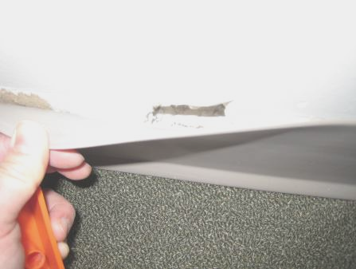

Hole cut in wall to facilitate drying, currently masked by coving

Picture 2

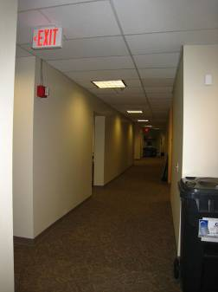

Refinished water-damaged space

Picture 3

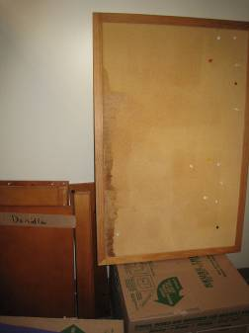

Water-damaged cork board

Picture 4

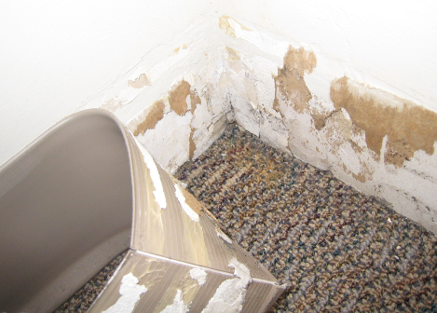

Black spots indicative of mold growth

Picture 5

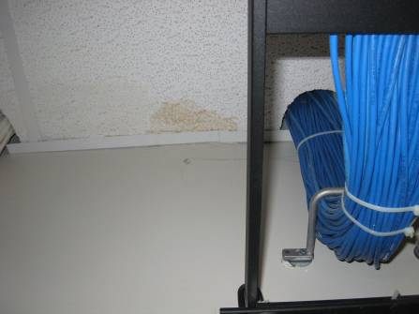

Water-stained ceiling tile

Picture 6

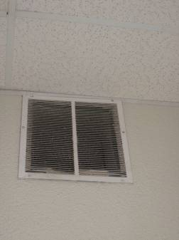

Dusty exhaust vent in women’s bathroom

Picture 7

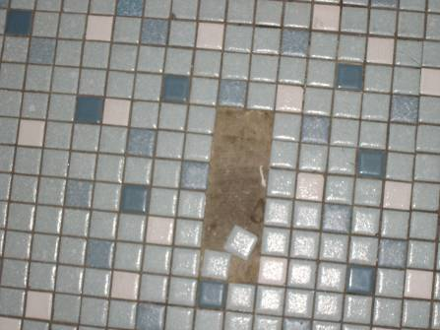

Loose floor tiles

Location | Temp  (°F) | Relative  Humidity  (%) | PM2.5  (µg/m³) | Occupants  in Room | Windows  Openable | Ventilation |  | Remarks
Background | 48 | 63 | 18 |  |  |  |  | Overcast, precipitating
Unit 3/111 |  |  |  |  |  |  |  | Previous leak from AHU, condensation leak currently dry. Some black spots behind coving
Library | 73 | 30 | 7 |  |  |  |  | No damage observed
148 (office) | 69 | 32 | 9 |  |  |  |  | New carpet
146 (office) | 69 | 32 | 9 |  |  |  |  | New carpet
147 | 69 | 32 | 10 |  |  |  |  | New carpet
145 | 71 | 30 | 11 |  |  |  |  | Plants on carpet.
144 | 71 | 30 | 12 |  |  |  |  | New carpet
143 (legal) | 71 | 28 | 7 |  |  |  |  | New carpet
142 (legal) | 72 | 28 | 10 |  |  |  |  | New carpet
153 (legal) | 72 | 31 | 3 |  |  |  |  | new carpet; plant, fridge, on carpet
Supply closet | 72 | 29 |  |  |  |  |  | Items on floor
Server room | 70 | 28 |  |  |  |  |  | WD-CT
156 (conference) | 70 | 29 |  |  |  |  |  | New carpet
155 (kitchen) | 70 | 29
Director’s Office | 71 | 28 | 2

