BACKGROUND

INDOOR AIR QUALITY
POST-OCCUPANCY ASSESSMENT

Department of Children and Families
110 Haverhill Road
Amesbury, MA

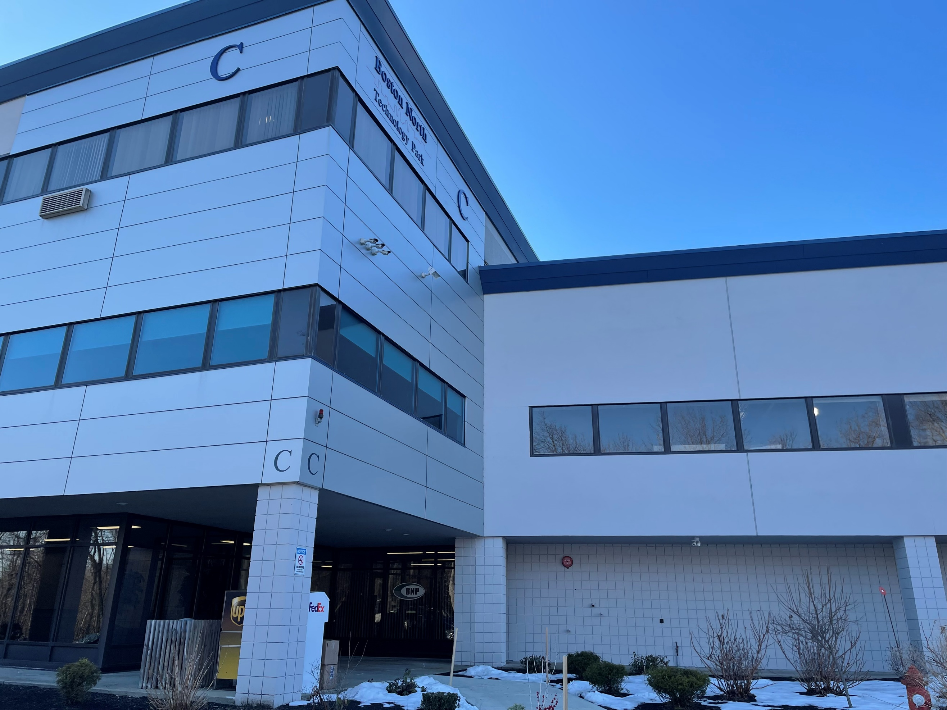

Prepared by:
Massachusetts Department of Public Health
Bureau of Environmental Health
Indoor Air Quality Program
June 2023
Building: | Department of Children and Families (DCF)
Address: | 110 Haverhill Road, Building C, Suite 250 Amesbury, MA
Assessment Requested by: | Jamie Blood, Regional Planner/Project Manager, Division of Capital Asset Management and Maintenance (DCAMM)
Reason for Request: | Post-occupancy assessment
Date of Post-Occupancy Assessment: | March 10, 2023
Massachusetts Department of Public Health/Bureau of Environmental Health (MDPH/BEH) Staff Conducting Assessment: | Jennifer Lajoie, Environmental Analyst, Indoor Air Quality (IAQ) Program
Building Description: | The DCF space is in an office park on the second floor of a two-story office building “Building C”. The office space has been remodeled into meeting rooms, offices and staff dining areas.
Windows: | Not openable

Previous Relevant Environmental History:
Please refer to attached Appendix A- Indoor Air Quality Pre-Occupancy inspection, dated May, 2023.

Surrounding Businesses and Activities:
In addition to the above, the proposed DCF office is located on Route 110 in a small office park surrounded by a mixed use of residential and commercial properties.

METHODS
Please refer to the IAQ Manual for methods, sampling procedures, and interpretation of results (MDPH, 2015).

RESULTS AND DISCUSSION
The following is a summary of indoor air testing results (Table 1).
- Carbon dioxide levels were within or slightly above the MDPH guideline of 800 parts per million (ppm) in all areas tested.
- Temperature was within the MDPH recommended range of 70°F to 78°F in all areas tested.
- Relative humidity was slightly below the MDPH recommended range of 40 to 60% in most areas tested which can be typical during the heating season.
- Carbon monoxide levels were non-detectable (ND) in all areas tested.
- Fine particulate matter (PM2.5) concentrations measured were below the National Ambient Air Quality Standard (NAAQS) limit of 35 μg/m³ in all indoor areas tested.

Ventilation
A heating, ventilating, and air conditioning (HVAC) system has several functions. First it provides heating and, if equipped, cooling. Second, it is a source of fresh air. Finally, an HVAC system will dilute and remove normally occurring indoor environmental pollutants by not only introducing fresh air, but by filtering the airstream and ejecting stale air to the outdoors via exhaust ventilation. Even if an HVAC system is operating as designed, point sources of respiratory irritation may exist and cause symptoms in sensitive individuals.
The HVAC system currently consists of 9 air handling units (AHUs) located on the roof, which draw in outside air and heat/cool it. Conditioned air is ducted to supply vents and returned via other ducted vents (Picture 1).
The MDPH IAQ Program recommends AHU filters of a Minimum Efficiency Reporting Value (MERV) of 8, which are adequate in filtering out pollen and mold spores (ASHRAE, 2012). The rooftop AHU filters in use at the DCF could not be examined at the time of assessment. AHU filters should be changed two or more times annually or per the manufacturer’s recommendations. During filter changes, the AHU cabinet should be cleaned/vacuumed out to remove debris that may be a source of particulates and odors to the indoor air.
The HVAC system is controlled by digital thermostats (Picture 2). The MDPH IAQ Program recommends that the fan be set to the “on” setting to provide continuous circulation/filtration during occupied hours. Airflow is controlled using a fan switch that has two settings, on and auto. When the fan is set to on, the system provides a continuous source of air circulation and filtration. The automatic setting on the thermostat activates the HVAC system at a preset temperature. Once the preset temperature is reached, the HVAC system is deactivated. Therefore, no mechanical ventilation is provided until the thermostat re-activates the system.
In some areas, levels of carbon dioxide were higher than the recommended level (Table 1). The presence of increased levels of carbon dioxide in indoor air of buildings is attributed to occupancy. The greater number of occupants, the greater the amount of carbon dioxide is produced. Carbon dioxide concentration build-up in indoor environments can be attributed to several factors including inefficient/non-functioning ventilation systems, or the need to adjust the system to introduce more fresh air.
To maximize air exchange, the IAQ program recommends that both supply and exhaust ventilation operate continuously during periods of occupancy. To have proper ventilation with a mechanical ventilation system, the systems must be balanced after installation to provide an adequate amount of fresh air to the interior of a room while removing stale air from the room. It is recommended that HVAC systems be re-balanced every five years to ensure adequate air systems function (SMACNA, 1994). The building contractor reported that the system was balanced as part of the renovations.

Microbial/Moisture Concerns
No water-damaged materials or musty odors were observed during the visit. Note that relative humidity in the occupied space was below the MDPH comfort range of 40-60%. Relative humidity levels in the building would be expected to drop during the winter months due to heating. The sensation of dryness and irritation is common in a low relative humid environment. This is a very common problem during the heating season in the northeast part of the United States.

RECOMMENDATIONS
In view of the findings at the time of assessment, the following recommendations are made:

Ventilation recommendations
- Ensure thermostats are activated. Set thermostat timers to the fan “on” setting to provide continuous filtration and ventilation during occupied hours.
- Change AHU filters two to four times annually or per the manufacturer’s instructions. Use MERV 8 or the best quality/highest MERV rated filters that can be used with current equipment.
- During filter changes, vacuum debris from AHU cabinets.
- It is recommended that the HVAC systems be rebalanced every five years (SMACNA, 1994).
- Vacuum/clean dust/debris from supply, return, and exhaust vents as needed.

Other recommendations
- Clean carpeting annually or semi-annually in soiled high traffic areas as per the recommendations of the IICRC (IICRC, 2012).
- Refer to the resource manual and other related indoor air quality documents located on the MDPH’s website for further building-wide evaluations and advice on maintaining public buildings. These documents are available at http://mass.gov/dph/iaq.

REFERENCES
ASHRAE. 2012. American Society of Heating, Refrigeration and Air Conditioning Engineers (ASHRAE) Standard 52.2-2012 -- Method of Testing General Ventilation Air-Cleaning Devices for Removal Efficiency by Particle Size (ANSI Approved). 2012.
IICRC. 2012. Institute of Inspection, Cleaning and Restoration Certification. Carpet Cleaning: FAQ.
MDPH. 2015. Massachusetts Department of Public Health. “Indoor Air Quality Manual: Chapters I-III”. Available at: Indoor air quality - manual and appendices | Mass.gov
SMACNA. 1994. HVAC Systems Commissioning Manual. 1st ed. Sheet Metal and Air Conditioning Contractors’ National Association, Inc., Chantilly, VA.

Picture 1
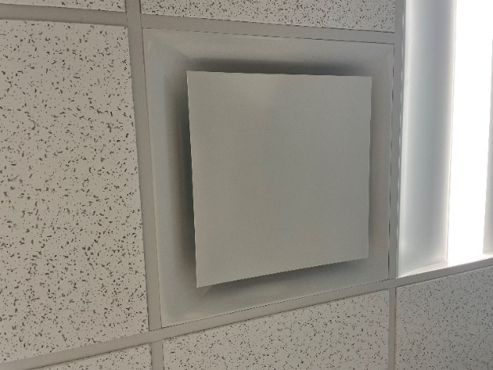
Supply vent
Picture 2

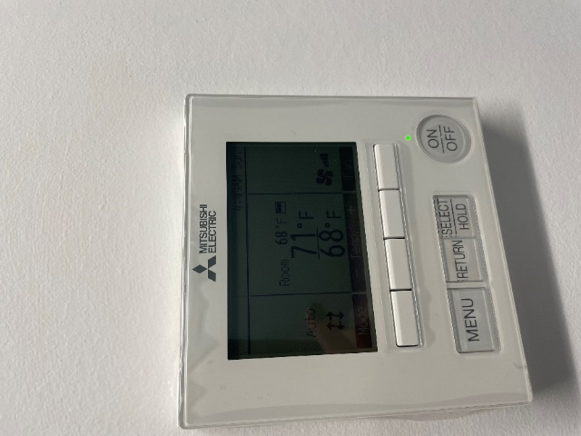
Digital Thermostat

Location | Carbon  Dioxide  (ppm) | Carbon Monoxide  (ppm) | Temp  (°F) | Relative  Humidity  (%) | PM2.5  (µg/m³) | Occupants  in Room | Windows  Openable | Ventilation |  | Remarks
 |  |  |  |  |  |  |  | Supply | Exhaust
Background | 424 | ND | 56 | 45 | ND | 0
2002 | 515 | ND | 72 | 30 | ND | 0 | N/A | Y | Y
Outside cube 2013 | 484 | ND | 72 | 30 | ND | 0 | N/A | Y | Y
2024 | 470 | ND | 72 | 30 | ND | 0 | N/A | Y | Y
2020 | 472 | ND | 72 | 30 | 2 | 0 | N/A | Y | Y
2028 | 486 | ND | 72 | 39 | 3 | 0 | N/A | Y | Y
2030 | 496 | ND | 72 | 30 | ND | 0 | N/A | Y | Y
2034 | 507 | ND | 72 | 30 | ND | 2 | N | Y | Y
2031 breakroom | 426 | ND | 71 | 29 | ND | 0 | N/A | Y | Y
Outside cube 2061 | 720 | ND | 71 | 33 | 1 | 3 | N | Y | Y
2056 | 730 | ND | 71 | 32 | ND | 0 | N/A | Y | Y
2063 | 744 | ND | 72 | 33 | ND | 1 | N | Y | Y
2064 | 745 | ND | 72 | 34 | ND | 0 | N | Y | Y
2068 | 785 | ND | 71 | 33 | ND | 0 | N/A | Y | Y
Cubes outside 2069 | 755 | ND | 71 | 33 | ND | 2 | N | Y | Y
2072 | 765 | ND | 71 | 34 | ND | 0 | N/A | Y | Y
Outside cube 2077 | 824 | ND | 71 | 34 | ND | 2 | N | Y | Y
2073 | 850 | ND | 71 | 36 | ND | 0 | N/A | Y | Y
2070 | 616 | ND | 71 | 31 | ND | 0 | N/A | Y | Y
Mailroom | 554 | ND | 71 | 31 | ND | 1 | N/A | Y | Y
Outside cube 2053 | 636 | ND | 71 | 32 | ND | 0 | N | Y | Y
Outside cubes 2037 | 711 | ND | 72 | 32 | ND | 3 | N | Y | Y
2035 | 714 | ND | 72 | 32 | ND | 0 | N/A | Y | Y
2007 | 535 | ND | 72 | 30 | ND | 0 | N/A | Y | Y
2009 | 538 | ND | 72 | 30 | ND | 0 | N/A | Y | Y
2005 | 522 | ND | 72 | 30 | ND | 0 | N/A | Y | Y
2003 | 512 | ND | 72 | 30 | ND | 0 | N/A | Y | Y

BACKGROUND

INDOOR AIR QUALITY
PRE-OCCUPANCY ASSESSMENT

Department of Children and Families
110 Haverhill Road
Amesbury, MA

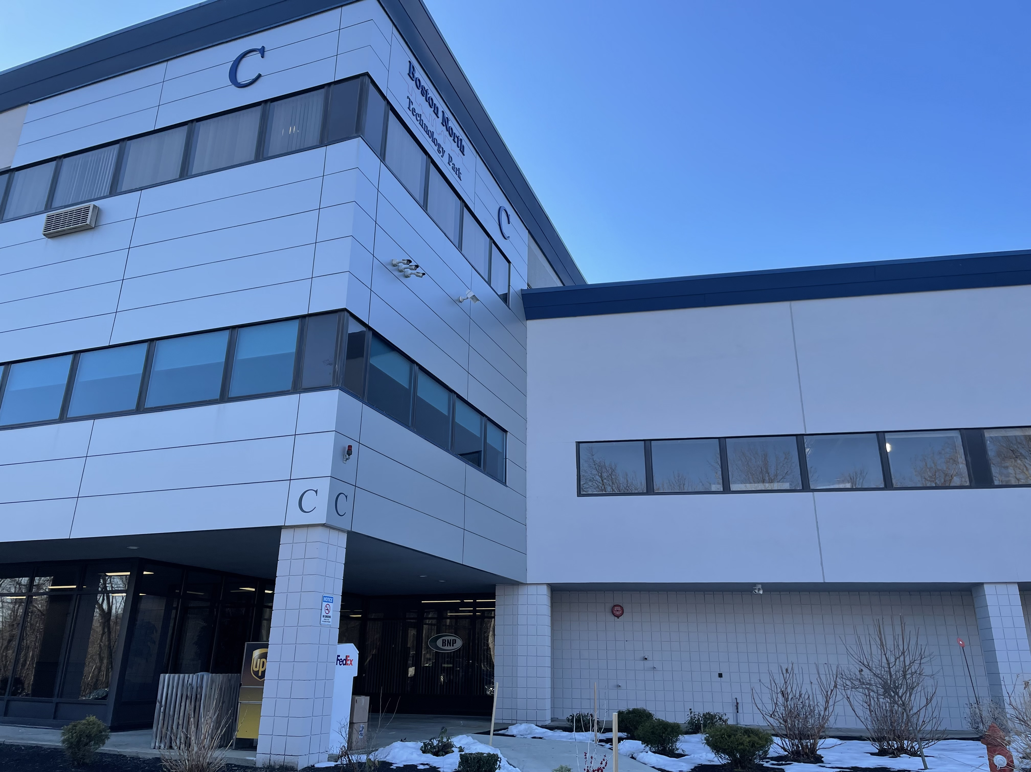

Prepared by:
Massachusetts Department of Public Health
Bureau of Environmental Health
Indoor Air Quality Program
May 2023

Building: | Department of Children and Families (DCF)
Address: | 110 Haverhill Road, Amesbury, MA
Assessment Requested by: | Jamie Blood, Regional Planner/Project Manager, Division of Capital Asset Management and Maintenance (DCAMM)
Reason for Request: | Pre-occupancy air testing prior to opening
Date of Assessment: | January 27, 2023
Massachusetts Department of Public Health/Bureau of Environmental Health (MDPH/BEH) Staff Conducting Assessment: | Michael Feeney, Director, and Jennifer Lajoie, Environmental Analyst, Indoor Air Quality (IAQ) Program
Building Description: | This office is located on Route 110 in a small office park surrounded by a mixed use of residential and commercial properties. DCF office space is located in Building C on the second floor.

At the time of inspection, personnel were moving office equipment in and setting up offices. Business was not yet in operation. Heating, ventilation, and air-conditioning (HVAC) systems were operational.

History:
The property at 110 Haverhill Road was formerly the site of the Brazonics and Antenna & Microwave Divisions of Adams-Russell Electronics Company, Inc. (Brazonics). The Brazionics site is listed as Closed under the Massachusetts Contingency Plan (MCP).
The adjacent property at 104-106 Haverhill Avenue is the former Microfab site, which closed in 1987. This site was tracked by the Massachusetts Department of Environmental Protection (MDEP) under the MCP from 1988, including a number of remedial activities. The site was subsequently listed by the EPA Superfund Program in 2017. Site assessment and remediation activities are ongoing. According to the EPA Fact Sheet on the site, “VOCs detected in groundwater include trichloroethylene (TCE), cis-1,2-dichloroethylene (cis-1,2-DCE), tetrachloroethene (PCE), and vinyl chloride. Metals (including copper, hexavalent chromium, arsenic, lead and nickel), mercury, cyanide, and TCE were detected in soil and sediment.” (USEPA, 2022).
Based on information in the Final Conceptual Site Model Technical Memorandum, elevated levels of VOCs were found in soil gas beneath the existing structure on the Microfab site, but “the known groundwater VOC plume does not underly other existing structures” which would include those on adjacent properties. Maps included with the Conceptual Site Model support this (USEPA 2019).
Note that EPA did not conduct an indoor air study in the commercial building 2 years ago when they first began site investigation because they were not permitted to access the building due to COVID. Instead, they collected data from groundwater monitoring wells and soil gas probes near the building to serve as screening for whether to conduct an indoor air study in the future. VOC levels in groundwater and soil gas have been non-detectable or very low near the building. The groundwater plume appears to skirt the edge of the building; there is no evidence of migration toward the building. Based on data thus far from groundwater monitoring wells and soil gas probes near the building, EPA and MDEP report that they see no indication that the plume is under the building, however they included the caveat that they did not sample directly below the slab. Monitoring of groundwater and soil gas along the edge of the building is ongoing. If future data indicate otherwise, they intend to conduct an indoor air study, which would include sub-slab sampling (LaPointe, 2023).

METHODS
Air tests for carbon monoxide, temperature, relative humidity, and airborne particle matter with a diameter less than 2.5 micrometers were taken with the TSI Q-Trak XP Indoor Air Quality Monitor Model 7585. Screening for volatile organic compounds (VOCs) was conducted using a MiniRAE Lite Photo Ionization Detector. BEH/IAQ staff also performed a visual inspection of building materials for water damage and/or microbial growth and examined the space for the presence of odors or other environmental concerns.
Please refer to the IAQ Manual for additional information on methods, sampling procedures, and interpretation of results (MDPH, 2015).

RESULTS AND DISUSSION
Media sampled |  | MDPH Guideline/  Comparison Value |  | Measured Range |  |  | Comments
 |  |  |  | Outdoors/  Background |  | Indoors
Carbon Dioxide (CO₂) |  | < 800 parts per million (ppm) is preferred |  | 400 |  | 474-710 | Unoccupied apart from a few people performing punch list activities
Carbon Monoxide (CO) |  | Non-detectable (ND) or equal to or below background level measured |  | ND |  | ND
Temperature |  | 70 to 78ºF |  | 48 |  | 65-69
Relative Humidity (RH) |  | 40% to 60% |  | 33 |  | 29-33
Particulate Matter 2.5 (PM2.5) |  | US EPA National Ambient Air Quality Standards (NAAQS) 35 μg/m³ or less |  | ND |  | ND | Construction in lobby outside office
Total Volatile Organic Compounds (TVOCs) |  | Equal to or below background level measured |  | 0.8 |  | 0.6-1.5* | *1.5 measured in lobby directly outside the DCF offices where painting/ spackling/drywall installation activities was currently occurring at the time of the assessment.
ppm = parts per million | µg/m³ = microgram per cubic meter |  | ND = non-detectable

At the time of the assessment, activities related to punch-list items were being conducted. The space had a slight odor of paint from the active construction area just outside the open DCF door. No evidence of water leaks or other moisture concerns were observed or reported.
Tests were taken with the mechanical ventilation system installed. Overall, conditions in the building after renovations appeared to be adequate in terms of mechanical ventilation components. Restrooms include supply and exhaust ventilation.

RECOMMENDATIONS
Based on observations and measurements at the time of the visit, the following recommendations are made:
- Consistent with previously established protocol, once the space has been occupied for a minimum of two weeks, contact the IAQ Program to conduct a post-occupancy assessment of the space. Note that a follow-up visit was conducted on March 10, 2023.
- It is recommended that building management/owners monitor and track any activities regarding hazardous waste remediation at the adjacent Superfund site and track measures if any dust/dirt/debris-generating activity is planned that may impact the building. If such activities occur, it is recommended that building management work with DCAMM and DDS on-site staff to limit any impact that such Superfund site mitigation activities might have on building occupants.
- Refer to the resource manual and other related indoor air quality documents located on the MDPH’s website for further building-wide evaluations and advice on maintaining public buildings. These documents are available at http://mass.gov/dph/iaq.

REFERENCES
LaPointe. 2023. Email from Dalene LaPointe, DPH, Bureau of Environmental Health, Environmental Epidemiology Program (2023), to Michael Feeney, DPH, Bureau of Environmental Health IAQ Program, April 7, 2023.

MDPH. 2015. Massachusetts Department of Public Health. “Indoor Air Quality Manual: Chapters I-III”. Available at: Indoor air quality - manual and appendices | Mass.gov
USEPA. 2022. Former Microfab, Inc. Superfund Site Amesbury, MA https://semspub.epa.gov/work/01/100020313.pdf)

USEPA. 2019. Final Conceptual Site Model Technical Memorandum Microfab, Inc. (Former) Superfund Site Amesbury, Massachusettshttps://semspub.epa.gov/work/01/100016572.pdf)

