**POST-OCCUPANCY**

**INDOOR AIR QUALITY ASSESSMENT**

**Department of Children and Families**

**157 Overland Road**

**Waltham, MA**

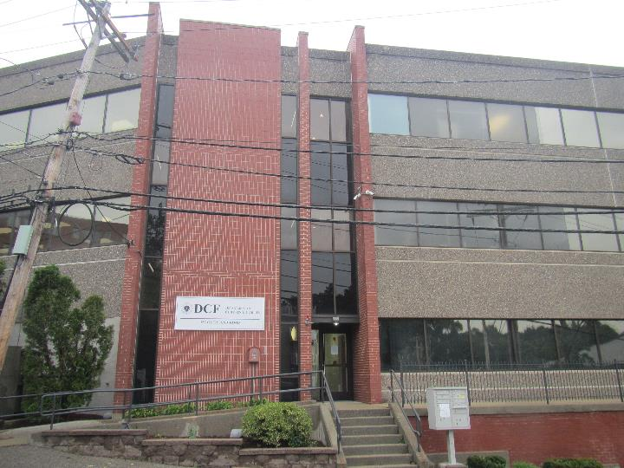

Prepared by:

Massachusetts Department of Public Health

Bureau of Climate and Environmental Health

Indoor Air Quality Program

October 2023

# BACKGROUND

|  |  |
| --- | --- |
| Building: | Department of Children and Families (DCF) |
| Address: | 157 Overland Road, Waltham MA |
| Assessment Requested by: | Jennifer Hart, Project Manager,  Division of Capital Asset Management  & Maintenance (DCAMM), Office of  Leasing and State Office Planning  (OLSOP) |
| Reason for Request: | Post-occupancy indoor air quality (IAQ) assessment of newly leased space |
| Date of Assessment: | September 25, 2023 |
| Massachusetts Department of Public Health/Bureau of Environmental Health (MDPH/BCEH) Staff Conducting Assessment: | Ruth Alfasso, Environmental  Engineer/Inspector, IAQ Program |
| Building Description: | DCF occupies space on the top two floors of a building located on a side street near Interstate 95 in Waltham. The bottom two floors of the building are a parking garage. The building has a flat roof and appears to be partially finished in brick and partially clad in an exterior insulation and finish system (EIFS). The building was originally built in the 1980s. The DCF space includes offices, open work areas, touchdown spaces, interview, visiting, and meeting rooms, storage rooms, and a small kitchenette on each floor. The building was significantly remodeled prior to the DCF occupancy this month. |
| Windows: | Windows are not openable |

# METHODS

Please refer to the IAQ Manual for methods, sampling procedures, and interpretation of results (MDPH, 2015).

# RESULTS AND DISCUSSION

The following is a summary of indoor air testing results (Table 1).

* ***Carbon dioxide*** measurements were below the MDPH guideline of 800 parts per million (ppm) indicating adequate fresh air in the space.
* ***Temperature*** was within the recommended range of 70°F to 78°F in all but one area tested, which was close.
* ***Relative humidity*** was slightly above the recommended range of 40% to 60% in all areas tested, which is reflective of outside conditions over the previous several days.
* ***Carbon monoxide*** levels were non-detectable (ND) in all areas tested.
* ***Fine particulate matter (PM2.5)*** concentrations were below the National Ambient Air Quality Standard (NAAQS) level of 35 μg/m3 in all areas tested.
* ***Total Volatile Organic Compounds (TVOC)*** were non-detectable (ND).

## Ventilation

A heating, ventilating, and air conditioning (HVAC) system has several functions. First, it provides heating and, if equipped, cooling. Second, it is a source of fresh air. Finally, an HVAC system will dilute and remove normally occurring indoor environmental pollutants by not only introducing fresh air, but also filtering the airstream and ejecting stale air to the outdoors via exhaust ventilation. Even if an HVAC system is operating as designed, point sources of respiratory irritation may exist and affect symptoms in sensitive individuals. The following analysis examines and identifies components of the HVAC system and likely sources of respiratory irritant/allergen exposure due to water damage, aerosolized dust, and/or chemicals found in the indoor environment.

Fresh air is provided by air handling units (AHUs) which appear to be located on the roof. They could not be examined at the time of the assessment. Air from the AHUs is filtered, heated/cooled, and delivered to rooms via ducted supply vents (Picture 1). Air is drawn through return vents and returned to the AHUs (Picture 2). The large conference room on the 3rd floor was equipped with two large exhaust vents (Picture 3) which may exhaust air directly from the building during high use periods.

The ventilation system should be on and operating to supply fresh air continuously during occupied periods. Without adequate fresh air supply and removal of stale air, common indoor air pollutants can build up and cause irritation.

It is recommended that HVAC systems be re-balanced every five years to ensure adequate air systems function (SMACNA, 1994). The system was likely balanced during the remodeling prior to occupancy.

## Microbial/Moisture Concerns

Water damage was noted in restrooms on the 3rd floor, including water stains or collected water inside a light fixture (Picture 4). Given the location of the damage, it is likely this is from plumbing issues serving the floor above. If water damage continues to occur, a plumber should be consulted on repairs to supply or drain piping.

There is a portion of space on both the occupied floors that has not been remodeled and is only used by DCF for storage. Water-damaged ceiling tiles were noted in the unused space on the 4th floor. These appear to be old stains, but may indicate locations of ongoing leaks. Carpeting in this area was also stained and potentially water-damaged. The unused areas should be monitored periodically, particularly during wet weather, to ensure that any leaks are noted and remediated promptly.

Plants were noted in a few areas (Table 1). Plants should be well maintained and placed on waterproof drip pans to prevent water damage to building materials.

A musty odor was noted in the file storage room being used for older files. No obvious signs of water damage to boxes or papers were found, but it is likely that some of the old files had been exposed to moisture in the past. If odors continue, items should be inspected and any that have become water-damaged and have a musty odor should be copied and discarded.

The kitchenettes on both floors were newly installed and the appliances were clean and in good condition. Food preparation equipment should be kept clean to prevent odors, water damage, and pests. It was also noted that water dispensers were located on non-carpeted areas throughout the office space which will reduce the chance of spills or leaks damaging carpeting.

A washer and dryer, both front-loading, were installed in a visitation room, (Picture 5). Front-loading washers can develop musty odors if not allowed to dry (with the door open) between cycles. The vent for the dryer could not be accessed. Dryers, unless they are specifically the non-vented kind, need to be vented out of the building to function and to prevent excess moisture in the room. Dryer vents should also be accessible for periodic removal of lint build-up to maintain efficiency and prevent fires.

The exterior of the building was examined for conditions that may lead to water intrusion or other issues. The rear of the property is currently inaccessible and appears to be a wide margin of gravel with grass/weeds (Picture 6). This area should be maintained periodically to keep plants low and reduce pest harborage.

The building appears to have a portion of the exterior clad in an exterior insulation and finish system (EIFS; Picture 7). “An Exterior Insulation and Finish System (EIFS) is a non-load bearing, exterior wall cladding system that consists of an insulation board attached either adhesively or mechanically, or both, to the substrate; an integrally reinforced base coat; and a textured protective finish coat.” (EIMA, 2023) More recent EIFS installations include a drainage plane to allow any water that penetrates the surface to be removed. Given the age of the building, this installation may or may not have a drainage plane.

EIFS systems can fail due to improper installation or damage/weathering over time. If damage is noted to the coating, or water intrusion is noted inside, particularly during wind-driven rain, the cladding may need repair. No issues with water infiltration from the sides of the building, including around windows, were noted at the time of the visit.

## Other IAQ Concerns

Sampling for total volatile organic compounds (TVOC) was conducted, with all readings being non-detect (ND). An examination was conducted for products that may be a source of VOCs in indoor air. Products such as dry erase markers, hand sanitizers, and other cleaners were found in offices and common areas (Picture 8). In the absence of adequate fresh air and exhaust ventilation, VOCs from these products can build up and lead to irritation of the mucous membranes or irritating odors.

As noted above, this location has two levels of garage underneath. While the garages have passive vents to the outside (Picture 7), products of combustion from cars in the garages may impact occupied space. Doors to the stairwells between the garages and the upper floors should be tightly-fitted and equipped with weather-stripping to prevent products of combustion and odors from the garage from entering occupied space. Consider installing a carbon monoxide (CO) sensor with alarm near each garage door to notify occupants of high levels of CO. Signage may also be helpful to discourage idling in the garage area.

Lockers are present in this location for staff to store work-related and personal items (Picture 9). Lockers should be cleaned out periodically to prevent odors or pest issues due to storage of food or other items.

The configuration of some of the workstations leaves aisles between the workstations and the wall (Picture 10). These areas can become cluttered with dropped or stored items, and can become a source of dust, odors, or pest harborage. These areas should be a part of the regular building cleaning program. Clutter/items were also noted in a few offices (Table 1; Picture 11). Having a large amount of items in offices can make it difficult for custodial staff to clean. Items should be stored neatly and excess items removed.

It was noted that this office has several well-equipped storage areas for clothing, files, and other necessary items. The available shelves and cubbies should be used, along with water resistant totes where needed, and items should not be left on floors or stored in offices.

Many of the agency-side offices are carpeted. Carpets should be cleaned regularly in accordance with Institute of Inspection, Cleaning and Restoration Certification (IICRC) recommendations (IICRC, 2012). Area rugs and plush furniture were also noted in some rooms. These should also be cleaned regularly to remove dust and debris.

# CONCLUSIONS/RECOMMENDATIONS

The following are recommendations made to maintain IAQ:

## Ventilation recommendations

1. Operate supply and exhaust ventilation in all areas during occupied periods.
2. Ensure filters are replaced on HVAC units at least twice a year. If feasible, use filters with a minimum efficiency rating value (MERV) of 8 or better.
3. It is recommended that HVAC systems be re-balanced every five years to ensure adequate air systems function (SMACNA, 1994).

## Water damage recommendations

1. Investigate and remediate the source of water damage to third-floor restrooms.
2. Monitor the unoccupied, remodeled spaces on both floors periodically for water intrusion/leaks and remediate promptly. Areas with a history of leaks should not be used for storage.
3. Keep plants well-maintained and place on waterproof drip pans.
4. If odors continue, check items in the long-term file storage room and identify any water-damaged, musty items. Damaged items which need to be kept should be copied to fresh paper.
5. Keep refrigerators and other food-preparation appliances clean.
6. Ensure the washing machine is allowed to dry between loads to prevent odors.
7. Ensure the dryer is vented out of the building and that the vent can be accessed for inspection/lint removal.
8. Ensure that vegetation at the rear of the building is kept short.
9. If issues with water infiltration along the sides of the building occur, consider updating/repairing the cladding.

## Other recommendations

1. Use VOC-containing products in areas with good ventilation and keep tightly closed when not in use. Avoid products with strong scents and avoid mixing incompatible products.
2. Ensure the doors from the garages are tightly fitted and kept closed to prevent migration of products of combustion to occupied areas.
3. Consider adding carbon monoxide sensors near the doors from the garages.
4. Consider adding signage discouraging idling of cars.
5. Ensure lockers are cleaned out periodically.
6. Keep items in offices neat and off of floors for ease of cleaning. Store excess items elsewhere.
7. Continue to use dedicated storage areas for items such as clothing, shoes, and car seats.
8. Clean carpeting in accordance with IICRC recommendations (IICRC, 2012).
9. For buildings in New England, periods of low relative humidity during the winter are often unavoidable. Therefore, scrupulous cleaning practices should be adopted to minimize common indoor air contaminants whose irritant effects can be enhanced when the relative humidity is low. To control dust, a high efficiency particulate arrestance (HEPA) filter equipped vacuum cleaner in conjunction with wet wiping of all surfaces is recommended. Avoid the use of feather dusters. Drinking water during the day can help ease some symptoms associated with a dry environment (throat and sinus irritations).
10. Refer to resource manual and other related IAQ documents located on the MDPH’s website for further building-wide evaluations and advice on maintaining public buildings. These documents are available at: <http://mass.gov/dph/iaq>.

# REFERENCES

EIMA. 2023. EIFS Industry Members Association. About EIFS. <https://www.eima.com/eifs>.

IICRC. 2012. Institute of Inspection, Cleaning and Restoration Certification. Carpet Cleaning: FAQ.

MDPH. 2015. Massachusetts Department of Public Health. Indoor Air Quality Manual: Chapters I-III. Available at: <https://www.mass.gov/lists/indoor-air-quality-manual-and-appendices>.

SMACNA. 1994. HVAC Systems Commissioning Manual. 1st ed. Sheet Metal and Air Conditioning Contractors’ National Association, Inc., Chantilly, VA.

**Picture 1**

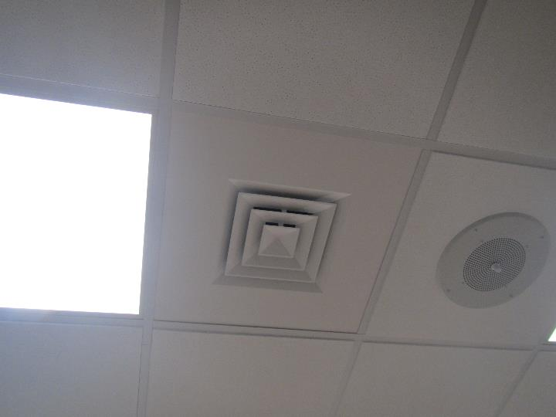

**Typical supply vent**

**Picture 2**

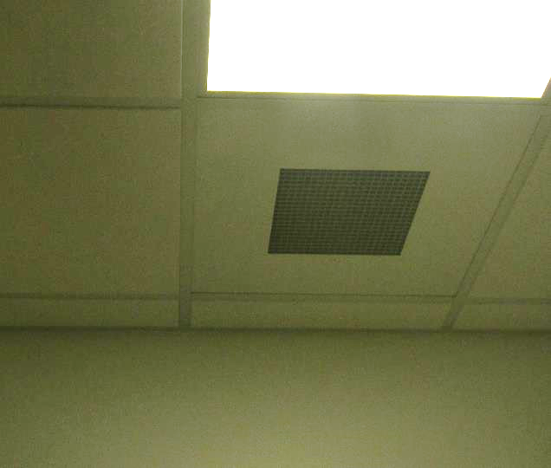

**Typical return vent**

**Picture 3**

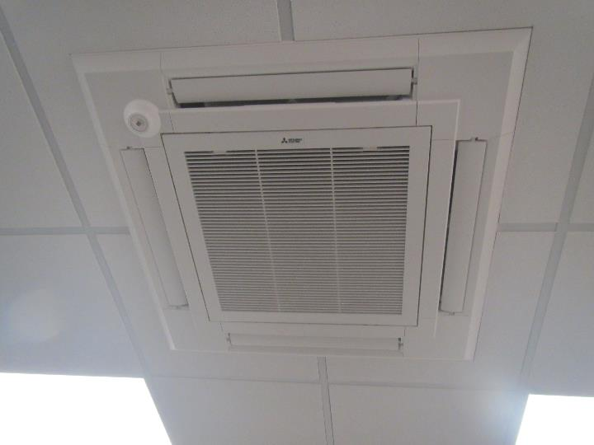

**Extra-large exhaust vent in the 3rd floor conference room**

**Picture 4**

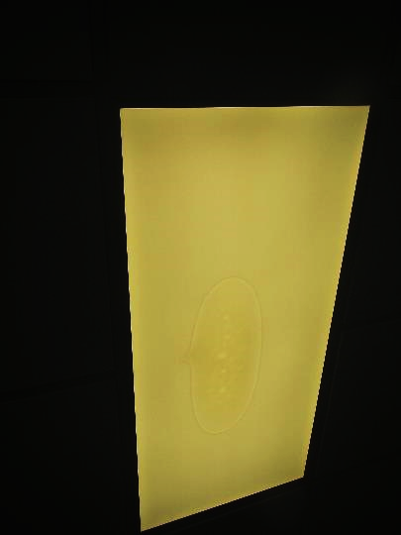

**Water or water stain inside light fixture in a third-floor restroom**

**Picture 5**

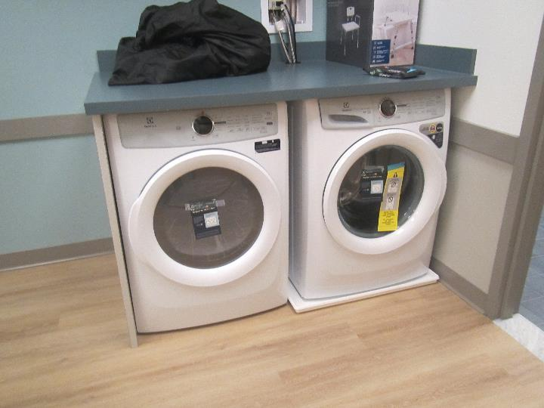

**Washing machine and dryer in visitation room**

**Picture 6**

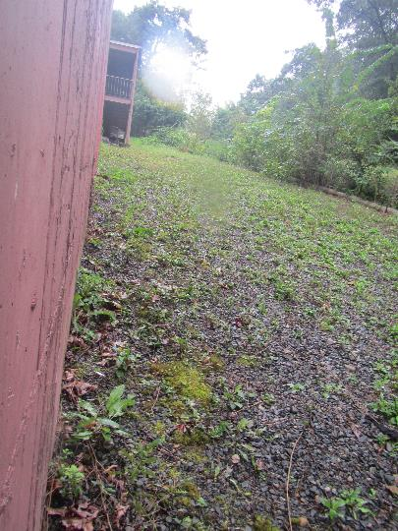

**Rear exterior of the building**

**Picture 7**

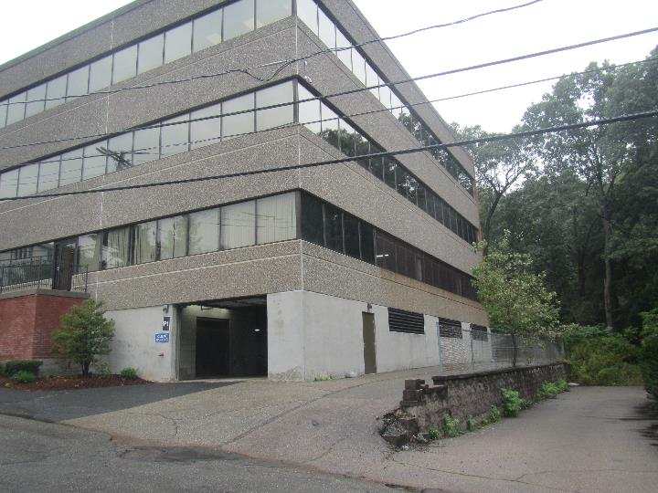

**Exterior showing cladding that may be Exterior Insulation and Finish System (EIFS); also note passive vents to the garage under the occupied building space**

**Picture 8**

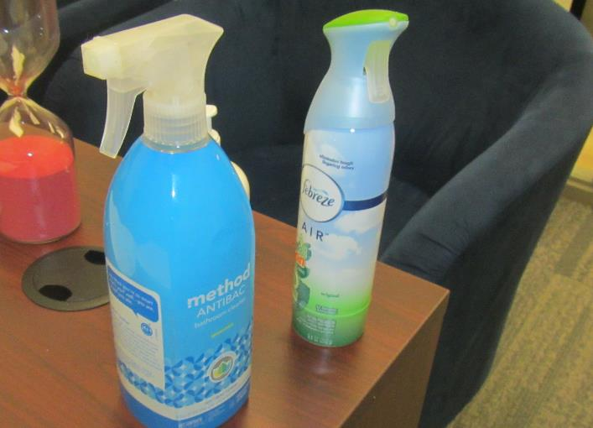

**Cleaning product and air freshener in an office**

**Picture 9**

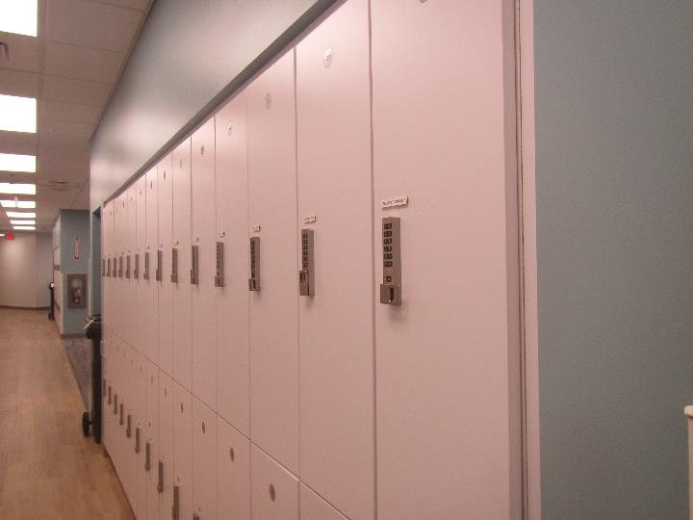

**Lockers in the hallway**

**Picture 10**

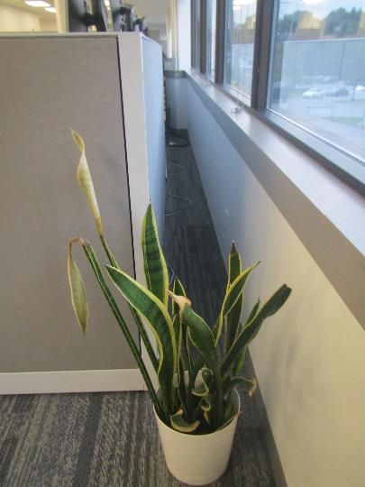

**Aisle between workstation and wall**

**Picture 11**

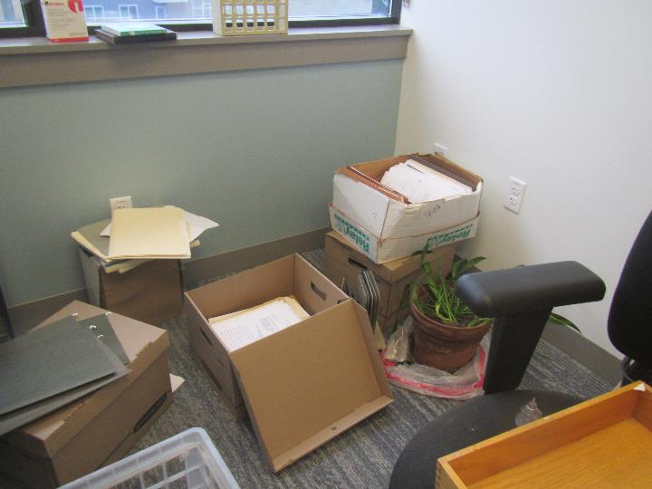

**Clutter on an office floor**

| **Location** | **Carbon**  **Dioxide**  **(ppm)** | **Carbon Monoxide**  **(ppm)** | **Temp**  **(°F)** | **Relative**  **Humidity**  **(%)** | **PM2.5**  **(µg/m3)** | **TVOC**  **(ppm)** | **Occupants**  **in Room** | **Windows**  **Openable** | **Ventilation** | | **Remarks** |
| --- | --- | --- | --- | --- | --- | --- | --- | --- | --- | --- | --- |
| **Supply** | **Exhaust** |
| Background | 363 | ND | 64 | 73 | 13 |  |  |  |  |  | Cloudy and light rain |
| Third Floor | | | | | | | | | | | |
| Large Conference | 409 | ND | 71 | 63 | 2 | ND | 2 | N | Y | Y | 2 extra-large exhaust vents |
| Mail/Copy | 471 | ND | 72 | 62 | ND | ND | 0 | N | Y | Y | Copy machine |
| 361 | 447 | ND | 72 | 61 | 1 | ND | 1 | N | Y | Y |  |
| Mother’s room | 479 | ND | 72 | 61 | 1 | ND | 0 | N | Y | Y | Plush furniture |
| 392 cubes | 470 | ND | 72 | 61 | 1 | ND | 2 | N | Y | Y | Plants/flowers |
| 343 | 493 | ND | 72 | 62 | 1 | ND | 0 | N | Y | Y | Food, personal fan |
| 344 huddle | 479 | ND | 72 | 62 | 1 | ND | 2 | N | Y | Y |  |
| 346 wellness | 445 | ND | 72 | 61 | 1 | ND | 0 | N | Y | Y | Carpet |
| 349 | 434 | ND | 71 | 61 | ND | ND | 0 | N | Y | Y | Boxes on floor |
| 345 | 451 | ND | 71 | 62 | 1 | ND | 1 | N | Y | Y | Food |
| 348 | 452 | ND | 71 | 62 | ND | ND | 0 | N | Y | Y |  |
| 360 | 458 | ND | 72 | 62 | 2 | ND | 0 | N | Y | Y | DEM, bike, NC |
| 363 visitation | 457 | ND | 72 | 62 | ND | ND | 0 | N | Y | Y | Washer and dryer, attached restroom |
| 333 visitation | 450 | ND | 72 | 61 | 2 | ND | 0 | N | Y | Y | Plush couch, area rug |
| 341 | 449 | ND | 72 | 61 | 1 | ND | 0 | N | Y | Y | NC |
| 334 visitation | 426 | ND | 72 | 61 | 2 | ND | 0 | N | Y | Y | Area rug |
| 335 interview | 443 | ND | 71 | 62 | 3 | ND | 0 | N | Y | Y | NC |
| 336 interview | 431 | ND | 71 | 62 | 2 | ND | 0 | N | Y | Y | NC |
| 340 | 429 | ND | 71 | 61 | ND | ND | 0 | N | Y | Y | NC |
| 339 visitation | 432 | ND | 71 | 62 | 1 | ND | 0 | N | Y | Y | Area rug |
| 337 visitation | 431 | ND | 71 | 62 | 1 | ND | 0 | N | Y | Y | Plush chair |
| Public side men’s room |  |  |  |  |  |  |  | N | Y | Y |  |
| Public side women’s room |  |  |  |  |  |  |  | N | Y | Y | Water or water stain in light |
| Waiting area | 446 | ND | 72 | 62 | 1 | ND | 2 | N | Y | Y | NC |
| 357 | 476 | ND | 72 | 62 | 3 | ND | 0 | N | Y | Y | NC |
| 356 | 483 | ND | 73 | 61 | 1 | ND | 0 | N | Y | Y |  |
| 327 huddle | 461 | ND | 72 | 61 | 1 | ND | 0 | N | Y | Y | Carpet |
| 324 IT office | 443 | ND | 72 | 62 | 2 | ND | 0 | N | Y | Y | Carpet |
| Kitchen | 425 | ND | 72 | 61 | 1 | ND | 0 | N | Y | Y | Sink, microwave, fridge, NC |
| 360 clothes storage | 420 | ND | 71 | 62 | 1 | ND | 0 | N | Y | Y | Cubbies and totes for storage |
| 319 | 431 | ND | 71 | 62 | 1 | ND | 0 | N | Y | Y | Plants, carpet |
| Open lounge area | 427 | ND | 71 | 63 | ND | ND | 0 | N | Y | Y | Carpet, couch |
| 370-372 cubes | 438 | ND | 71 | 63 | 2 | ND | 1 | N | Y | Y | Foos, carpeted |
| 376 open area | 439 | ND | 71 | 62 | 1 | ND | 0 | N | Y | Y | Carpet |
| 318 huddle | 436 | ND | 71 | 62 | 1 | ND | 0 | N | Y | Y | Carpet |
| 317 office | 441 | ND | 71 | 63 | ND | ND | 2 | N | Y | Y | Food, plant, walking desk, carpet |
| 316 office | 481 | ND | 71 | 62 | 1 | ND | 0 | N | Y | Y | Plant, carpet |
| 378-382 cubes | 448 | ND | 71 | 62 | 2 | ND | 0 | N | Y | Y | Carpet |
| 315 office | 443 | ND | 71 | 62 | 2 | ND | 0 | N | Y | Y | Carpet |
| 386 touchdown area | 469 | ND | 72 | 62 | 1 | ND | 0 | N | Y | Y | Carpet |
| 389-391 cubes | 468 | ND | 72 | 62 | 2 | ND | 1 | N | Y | Y | Carpet, hand sanitizer |
| 311 | 443 | ND | 72 | 63 | 1 | ND | 2 | N | Y | Y | Food |
| 312 | 501 | ND | 72 | 62 | 2 | ND | 2 | N | Y | Y | Carpet |
| 314 | 499 | ND | 72 | 61 | ND | ND | 1 | N | Y | Y | Carpet |
| 310 teaming | 499 | ND | 72 | 61 | ND | ND | 0 | N | Y | Y | Carpet |
| Restrooms, staff side |  |  |  |  |  |  | 0 | N | Y | Y | Both men’s and women’s similar |
| Fourth floor | | | | | | | | | | | |
| Restrooms, public side |  |  |  |  |  |  | 0 | N | Y | Y | Both men’s and women’s similar |
| Restrooms, staff side |  |  |  |  |  |  | 0 | N | Y | Y |  |
| 432 | 404 | ND | 71 | 63 | 3 | ND | 0 | N | Y | Y | Carpet |
| 433 | 405 | ND | 71 | 63 | 2 | ND | 0 | N | Y | Y | Items/clutter, plant, carpet |
| 434 | 396 | ND | 7 | 63 | 1 | ND | 0 | N | Y | Y | Carpet |
| Kitchenette | 407 | ND | 71 | 63 | 1 | ND | 0 | N | Y | Y | NC |
| 435 | 399 | ND | 71 | 63 | 3 | ND | 0 | N | Y | Y | Carpet |
| 436 management conference rm | 403 | ND | 70 | 63 | 2 | ND | 0 | N | Y | Y | Carpet |
| 439 | 348 | ND | 70 | 64 | 3 | ND | 0 | N | Y | Y | Carpet, DEM |
| 438 | 460 | ND | 70 | 64 | 2 | ND | 1 | N | Y | Y | Carpet, DEM |
| 410 | 446 | ND | 70 | 64 | 1 | ND | 0 | N | Y | Y | Carpet |
| 489-491 cubes | 470 | ND | 70 | 64 | 1 | ND | 1 | N | Y | Y | Carpet |
| 484-488 | 477 | ND | 70 | 65 | ND | ND | 0 | N | Y | Y | Carpet, aisle behind stations |
| 480 cubes | 491 | ND | 70 | 65 | ND | ND | 2 | N | Y | Y | Carpet |
| 472 cubes | 513 | ND | 70 | 65 | 1 | ND | 1 | N | Y | Y | Carpet |
| 419 teaming | 505 | ND | 70 | 65 | ND | ND | 0 | N | Y | Y | Carpet |
| 418 | 493 | ND | 69 | 65 | 2 | ND | 0 | N | Y | Y | Carpet |
| 418 | 502 | ND | 70 | 65 | 1 | ND | 1 | N | Y | Y | Carpet |
| 416 | 620 | ND | 70 | 66 | 1 | ND | 2 | N | Y | Y | Carpet |
| 414 | 568 | ND | 70 | 63 | 1 | ND | 0 | N | Y | Y | Carpet |
| 412 | 470 | ND | 70 | 64 | 1 | ND | 0 | N | Y | Y | Carpet |
| 411 | 551 | ND | 71 | 65 | 1 |  | 1 | N | Y | Y | Carpet |
| 427 | 469 | ND | 71 | 63 | 2 | ND | 0 | N | Y | Y | Carpet |
| Old file storage |  |  |  |  |  |  |  | N | Y | Y | Wet cardboard odor, NC |
| Recent file storage | 446 | ND | 70 | 63 | ND | ND | 0 | N | Y | Y | No odor, NC |
| File archive room |  |  |  |  |  |  |  | N | Y | Y |  |
| 415 | 571 | ND | 71 | 64 | 1 |  | 1 | N | Y | Y | Carpet |
| Unused space | 425 | ND | 71 | 64 | ND | ND | 0 | N | Y | Y | Water-damaged ceiling tiles, old, stained carpet |