INDOOR AIR QUALITY ASSESSMENT

Department of Children and Families
200 Harvard Mill Square
Wakefield, Massachusetts

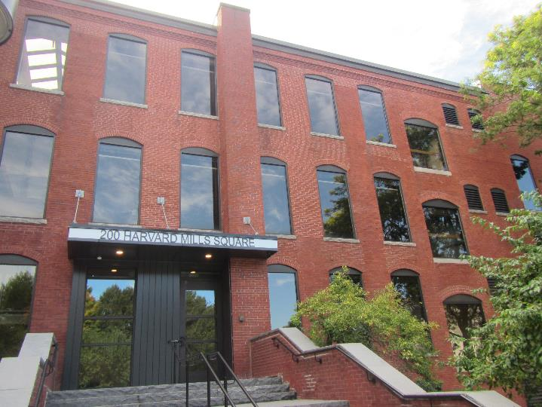

Prepared by:
Massachusetts Department of Public Health
Bureau of Environmental Health
Indoor Air Quality Program
September 2019

Background

Building: | Department of Children and Families (DCF)
Address: | 200 Harvard Mills Square, Wakefield, MA
DCAMM Project Manager: | Debbie Russell, Project Manager, Division of Capital Asset Management and Maintenance (DCAMM)
Reason for Request: | Post-occupancy assessment
Date of Assessment: | August 29, 2019
Massachusetts Department of Public Health/Bureau of Environmental Health (MDPH/BEH) Staff Conducting Assessment: | Jason Dustin, Environmental Analyst/Inspector, Indoor Air Quality (IAQ) Program
Building Description: | The DCF space is located in a large, brick, four-story former mill building. The space is composed of private offices, open work areas, and conference rooms. Most areas have carpet tiles or vinyl flooring.
Windows: | Windows are not openable.

Methods
Please refer to the IAQ Manual for methods, sampling procedures, and interpretation of results (MDPH, 2015).

Results and Discussion
The following is a summary of indoor air testing results (Table 1).
- Carbon dioxide levels were below the MDPH guideline of 800 parts per million (ppm) in all areas assessed.
- Temperature was within the MDPH recommended range of 70°F to 78°F in all areas.
- Relative humidity was within the MDPH recommended range of 40% to 60% in the majority of assessed areas with a few slightly above.
- Carbon monoxide levels were non-detectable (ND) in all indoor areas assessed.
- Fine particulate matter (PM2.5) concentrations measured were below the National Ambient Air Quality Standard (NAAQS) level of 35 micrograms per cubic meter (μg/m³) in all occupied areas.
- Total Volatile Organic Compounds (TVOCs) levels were ND in all areas assessed.

Ventilation
A heating, ventilating, and air conditioning (HVAC) system has several functions. First it provides heating and, if equipped, cooling. Second, it is a source of fresh air. Finally, an HVAC system will dilute and remove normally occurring indoor environmental pollutants by not only introducing fresh air, but by filtering the airstream and ejecting stale air to the outdoors via exhaust ventilation. Even if an HVAC system is operating as designed, point sources of respiratory irritation may exist and cause symptoms in sensitive individuals.
The HVAC system in the DCF space consists of large rooftop air handling units (AHUs) that draw in fresh air from intakes on the roof and supply fresh air to mechanical rooms through round supply ducts. These ducts are not connected to the AHUs so the mechanical rooms act as mixing rooms. Return air is brought back to the AHUs through a combination of return vents, partial ceiling plenums, and passive vents.
To maximize air exchange, the MDPH recommends that both supply and exhaust ventilation operate continuously during periods of occupancy. In order to have proper ventilation with a mechanical supply and exhaust system, the systems must be balanced to provide an adequate amount of fresh air to the interior of a room while removing stale air from the room. It is recommended that HVAC systems be re-balanced every five years to ensure adequate air systems function (SMACNA, 1994).

Microbial/Moisture Concerns
The DCF space has just undergone a complete renovation. New ceiling tiles, gypsum walls, carpet tiles, light fixtures and furnishings were installed.
BEH staff did not observe any water-damaged porous materials. There were no visual signs of mold growth or any musty odors detected during this assessment.
BEH staff noted that water coolers were placed directly on carpeting in some areas (Picture 1). Spills or leaks from these appliances can damage carpeting and may cause microbial growth with chronic moisture.
Plants were noted in some occupied areas (Table 1). Plants can be a source of odors, pollen, and mold. Plants should be kept in good condition, not overwatered, and not placed on porous materials.

Other Issues
Hand sanitizers, scented cleaning products, and air fresheners were noted in some areas of the office space (Pictures 2 and 3). These products can cause irritation of the eyes, nose, and respiratory system of some people.
Most flooring is covered with carpet. The Institute of Inspection, Cleaning and Restoration Certification (IICRC), recommends that carpeting be cleaned annually (or semi-annually in soiled high traffic areas) (IICRC, 2012). Daily vacuuming with a HEPA-filtered vacuum is also recommended.

Conclusions/Recommendations
Based on the observations made during the visit, the following is recommended:
- Operate the HVAC system to provide for continuous fresh air ventilation during occupied hours. Inspect all thermostats to ensure that they are set for “fan on” instead of the “fan auto” setting.
- Ensure that the mechanical rooms are kept clean to prevent entrainment of dust, debris or odors into supply air.
- Place water proof trays under water coolers located directly on carpeting or relocate water coolers to non-carpeted areas.
- Properly maintain plants, including drip pans, to prevent water damage to porous materials. Plants should also be located away from air diffusers to prevent the aerosolization of dirt, pollen, and mold.
- Change filters for HVAC equipment 2-4 times a year. Use pleated filters of MERV 8 (or higher), which are adequate in filtering out pollen and mold spores (ASHRAE, 2012), if these can be used with current equipment.
- Consider adopting a balancing schedule of every 5 years for all mechanical ventilation systems, as recommended by ventilation industrial standards (SMACNA, 1994).
- Reduce or eliminate the use of scented cleaners, hand sanitizers, and personal air fresheners to avoid irritant effects.
- Clean carpeting at least once per year according to IICRC recommendations (IICRC 2012). Regularly vacuum carpeting with a HEPA-filtered vacuum cleaner.
- Refer to resource manuals and other related IAQ documents for further building-wide evaluations and advice on maintaining public buildings. Copies of these materials are located on the MDPH’s website: http://mass.gov/dph/iaq.

References
ASHRAE. 2012. American Society of Heating, Refrigeration and Air Conditioning Engineers (ASHRAE) Standard 52.2-2012 -- Method of Testing General Ventilation Air-Cleaning Devices for Removal Efficiency by Particle Size (ANSI Approved).
IICRC. 2012. Institute of Inspection Cleaning and Restoration Certification. Institute of Inspection, Cleaning and Restoration Certification. Carpet Cleaning: FAQ. Retrieved from https://www.iicrc.org/general/custom.asp?page=SANSIIICRCS100.
MDPH. 2015. Massachusetts Department of Public Health. “Indoor Air Quality Manual: Chapters I-III”. Available at: http://www.mass.gov/eohhs/gov/departments/dph/programs/environmental-health/exposure-topics/iaq/iaq-manual/.
SMACNA. 1994. HVAC Systems Commissioning Manual. 1st ed. Sheet Metal and Air Conditioning Contractors’ National Association, Inc., Chantilly, VA.
Picture 1
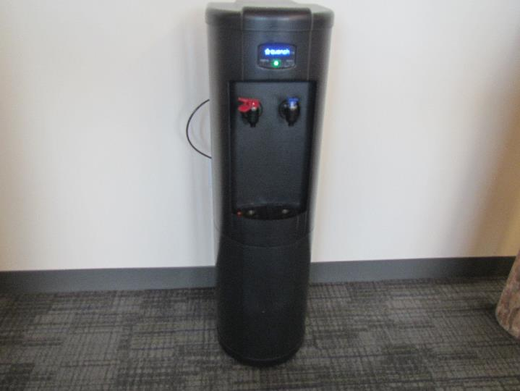
Water cooler located directly on carpeting
Picture 2
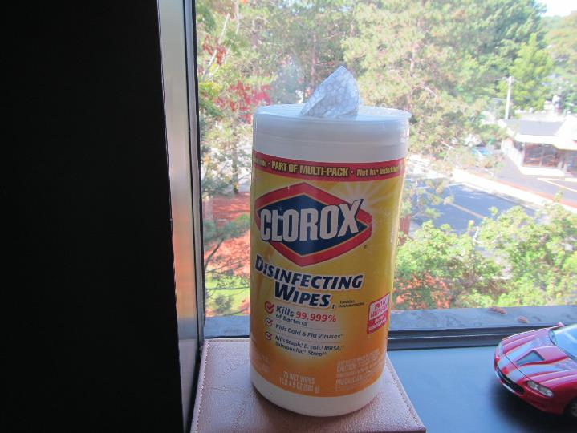
Wipes containing fragrances and VOCs
Picture 3
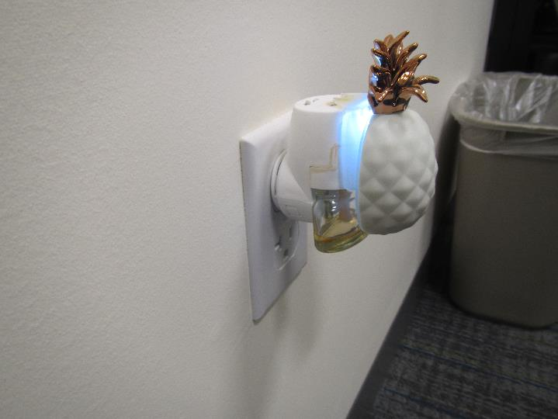
Plug in air freshener in office area

Location | Carbon  Dioxide  (ppm) | Carbon Monoxide  (ppm) | Temp  (°F) | Relative  Humidity  (%) | PM2.5  (µg/m³) | TVOCs  (ppm) | Occupants  in Room | Windows  Openable | Ventilation |  | Remarks
 |  |  |  |  |  |  |  |  | Supply | Exhaust
Background | 316 | ND | 83 | 53 | 9 | ND | - | - | - | - | Partly sunny
4th Floor
Reception | 482 | ND | 74 | 60 | 7 | ND | 4 | N | Y | Y | Vinyl flooring
4204 | 477 | ND | 74 | 60 | 6 | ND | 0 | N | Y | Y | Vinyl flooring
4207 | 467 | ND | 74 | 61 | 6 | ND | 0 | N | Y | Y
4205 | 523 | ND | 74 | 59 | 4 | ND | 1 | N | Y | Y
4208 | 498 | ND | 74 | 59 | 4 | ND | 0 | N | Y | Y | Toys/storage
4210 | 485 | ND | 74 | 58 | 3 | ND | 0 | N | Y | Y
4212 | 469 | ND | 73 | 57 | 2 | ND | 0 | N | Y | Y
4213 | 466 | ND | 73 | 59 | 2 | ND | 0 | N | Y | Y
Inner reception | 502 | ND | 74 | 61 | 2 | ND | 1 | N | Y | Y | Plant, HS
4333 open | 500 | ND | 75 | 61 | 1 | ND | 1 | N | Y | Y | Carpet tiles
4216 | 471 | ND | 75 | 58 | 1 | ND | 0 | N | Y | Y | Couch
4217 | 487 | ND | 75 | 58 | 1 | ND | 0 | N | Y | Y | AI
4218 | 474 | ND | 75 | 59 | 1 | ND | 0 | N | Y | Y | Carpet tile
4219 | 470 | ND | 74 | 55 | 3 | ND | 1 | N | Y | Y
4222 | 467 | ND | 74 | 62 | 4 | ND | 1 | N | Y | Y
4239 | 481 | ND | 74 | 59 | 4 | ND | 1 | N | Y | Y | Mother’s room
4238 | 469 | ND | 74 | 60 | 4 | ND | 0 | N | Y | Y | HS, area rug
4237 | 475 | ND | 74 | 59 | 4 | ND | 0 | N | Y | Y | DEM
4227 | 500 | ND | 74 | 60 | 5 | ND | 0 | N | Y | Y
4226 | 485 | ND | 75 | 59 | 2 | ND | 0 | N | Y | Y | CP
4236 | 478 | ND | 75 | 59 | 3 | ND | 1 | N | Y | Y
4235 | 545 | ND | 75 | 59 | 3 | ND | 0 | N | Y | Y | HS, AI
4228 | 491 | ND | 75 | 59 | 2 | ND | 1 | N | Y | Y
4321 open | 509 | ND | 76 | 58 | 2 | ND | 2 | N | Y | Y
4241 | 513 | ND | 76 | 58 | 3 | ND | 0 | N | Y | Y
4242 | 498 | ND | 76 | 57 | 4 | ND | 0 | N | Y | Y
4243 | 514 | ND | 76 | 57 | 3 | ND | 0 | N | Y | Y
4315 open | 523 | ND | 76 | 58 | 2 | ND | 2 | N | Y | Y
4244 | 516 | ND | 76 | 58 | 3 | ND | 1 | N | Y | Y | AF
4245 | 509 | ND | 75 | 57 | 2 | ND | 0 | N | Y | N | HS, plug in AF
4309 open | 557 | ND | 76 | 58 | 3 | ND | 5 | N | Y | Y
4303 open | 538 | ND | 76 | 57 | 2 | ND | 3 | N | Y | Y | HS, PF
4297 open | 544 | ND | 76 | 57 | 3 | ND | 1 | N | Y | Y
4249 | 566 | ND | 75 | 59 | 3 | ND | 1 | N | Y | Y | Vinyl flooring
4291 open | 588 | ND | 75 | 57 | 4 | ND | 3 | N | Y | Y
4285 open | 608 | ND | 75 | 58 | 3 | ND | 3 | N | Y | Y
4279 | 595 | ND | 75 | 60 | 3 | ND | 3 | N | Y | Y | HS, CP
4273 | 609 | ND | 75 | 61 | 2 | ND | 1 | N | Y | Y | CP
4267 | 632 | ND | 75 | 59 | 3 | ND | 3 | N | Y | Y
4265 | 577 | ND | 77 | 59 | 4 | ND | 1 | N | Y | Y | CPs
4258 | 607 | ND | 76 | 61 | 5 | ND | 0 | N | Y | Y
4255 | 612 | ND | 76 | 60 | 5 | ND | 0 | N | Y | Y | PF, CP
4256 | 638 | ND | 76 | 59 | 6 | ND | 1 | N | Y | Y | DEM
4253 | 690 | ND | 76 | 59 | 5 | ND | 1 | N | Y | Y | HS
3rd Floor
3100 | 535 | ND | 73 | 49 | 4 | ND | 1 | N | Y | Y
Staff support | 605 | ND | 72 | 54 | 4 | ND | 1 | N | Y | Y | Vinyl flooring
3107 | 594 | ND | 72 | 53 | 5 | ND | 0 | N | Y | Y
3144 open | 648 | ND | 73 | 55 | 4 | ND | 0 | N | Y | Y
3138 open | 663 | ND | 73 | 54 | 4 | ND | 4 | N | Y | Y
3106 | 706 | ND | 73 | 54 | 4 | ND | 1 | N | Y | Y | Plug in AF
3137 | 710 | ND | 74 | 53 | 5 | ND | 3 | N | Y | Y
3111 | 685 | ND | 74 | 52 | 4 | ND | 0 | N | Y | Y
3131 | 670 | ND | 74 | 52 | 3 | ND | 2 | N | Y | Y
3113 | 672 | ND | 74 | 51 | 3 | ND | 0 | N | Y | Y
3114 | 713 | ND | 74 | 51 | 4 | ND | 1 | N | Y | Y | HS
3115 | 701 | ND | 74 | 51 | 4 | ND | 0 | N | Y | Y
3125 | 677 | ND | 74 | 50 | 3 | ND | 1 | N | Y | Y
3110 | 682 | ND | 74 | 51 | 3 | ND | 1 | N | Y | Y | HS, CPs
3109 | 681 | ND | 73 | 51 | 4 | ND | 0 | N | Y | Y
3118 | 651 | ND | 73 | 51 | 3 | ND | 0 | N | Y | Y | CPs

